**Project Report: Accurate Analysis**

This document presents a plan for designing, testing, and manufacturing a business computer following the specifications provided by EDC and Synful Computing. The computer will include backwards and forward compatibility for the user to install and execute old and new applications. It will also include extra store capacity, minimum office features and gaming connections.

**Deliverables**

* New business machine according to specifications
* Office business applications
* Emulators for compatibility

**Constraints**

* The cost of the production of 2000 computers must not exceed £500,000
* The time to deliver must not exceed thirteen months
* The quality expressed performance, reliability and functionality must meet the stakeholder's expectations

**Risks**

* Supplier delay
* Insufficient Human Resources
* Low engagement from end-users

**Development Methodology**

**Recommended Approach: Agile**

*‘'Scrum represents the base of agile project management. It makes ongoing project management its central part, and its use is continuously increasing’'* (Rassol et al., 2023).

**Reasons:**

* Flexibility: The system's diverse requirements and operating systems demand an adaptive approach. Agile caters to these changes effectively, also ensuring a short time to market.
* Iterative Development: Agile's sprint-focused development ensures each component receives detailed attention during development, testing, and validation, aligning with the project's early development phase.
* Stakeholder Feedback: Regular sprint reviews in Agile allow for ongoing stakeholder feedback, ensuring the system aligns with their expectations and is easy to follow.
* Risk Management: Agile promotes early risk identification and real-time resolution, essential in a dynamic project environment.
* Scalability/Change: Agile is geared towards accommodating new or evolving requirements efficiently, demonstrating flexibility and adaptability.

**Limitations of Waterfall for this project:**

* Fixed Requirements: Waterfall's rigid structure demands upfront, clear requirements. The system's complexity and dynamic nature make this impractical.
* Late Feedback: In Waterfall, stakeholders only see the end product post-development, which could lead to costly revisions. Agile, in contrast, promotes ongoing stakeholder involvement.
* Delayed Risk Identification: With Waterfall, risks often emerge late, escalating costs and causing delays.
* Limited Scalability: Implementing late-stage changes in Waterfall can be challenging and inefficient.

**Conclusion:** Given the system's complexity, dynamic requirements, and the need for a flexible, stakeholder-friendly approach with a short time to market, Agile is a more fitting methodology than Waterfall.

**Hardware Requirements:**

* Motorola 68k series CPU
* 512Kb RAM
* Keyboard connector
* External display connector
* Portable
* Built-in screen
* SSD storage
* Expansion slots (both native and third party)
* 2kg max
* 2hrs battery
* 4" low power screen
* (multiple) Serial ports

|  |
| --- |
| **Software Requirements:** |

* Forward compatibility
* Office suite
* Multi-tasking, Unix-like OS
* Modular superset of BASIC (HyperBasic, HB)
* Emulate older machines for gaming
* Backwards compatibility
* Boot ldr & HWcfg
* Sys: Kernel
* SYS: Libraries
* SYS: Drivers
* SYS: Extensions
* SYS: GameSnd
* SYS: Graphics
* BAS: Kernel
* BAS: core lib&I/O
* BAS: fs libs
* BAS: Toolkit
* BAS: Examples
* BAS: GUI
* BAS: DOS tools
* Emulator
* OGRE96
* EZ-Suite
* HBConv
* HB96 Compiler

**Business/Personal Requirements**

* Minimise costs
* Undercut competition
* Avoid anything that appears illegal
* Avoid being seen as failure
* Cost price of £250
* Upfront purchase of 2000 machines at cost to the investor (£500,000). Needs to be ready in 13 months

**Gherkin specifications**

**Scenario: Meeting Hardware Specifications**

**Given** system demand 512kb RAM and Motorola 68K series CPU

**When** the system is manufactured

**Then** it should meet the hardware requirements

**Scenario: Peripheral and network connectivity**

**Given** the system demands inclusion of peripheral and network connectivity ports

**When** connecting to peripherals and network

**Then** should work with peripherals and connect to the network

**Scenario: Bundled office suite**

**Given** the system demands a complete office suite

**When** machine is on the market

**Then** it should be complete with the office suite

**Scenario: Portable/lugged form factor**

**Given** machine requirement is portable/lugged form factor

**When** manufacturing machine

**Then** it should be portable and not exceed 2kgs

**Scenario: Operating System Hyperbasic**

**Given** the machine is compatible with other operating systems like UNIX

**When** designing the OS

**Then** it should be compatible

**Scenario: Battery Life**

**Given** the need for portable machine usage

**When** the machine is powered by machine

**Then** it should run for 2 hours

**Scenario: Installation of new applications**

**Given** the install wizard is open

**When** the screens are shown

**And** the user actions the required buttons

**Then** the application gets installed

**Scenario: Execution of new applications**

**Given** the application gets installed

**When** the user executes the application

**Then** the application opens ready to be used

**Assumptions**

* The requirements will not change until delivery.

**Hardware Time and Cost**

**Hardware Assumptions**

Consists of 1 or more ROMS 4 ‘glue chips’ (G1 – G4), A CPU, 4 RAM chips, interface (I/O) chips for serial, keyboard, video output, a keyboard (built-in or external), screen (for portable/ luggable), storage drive(s) and a case.

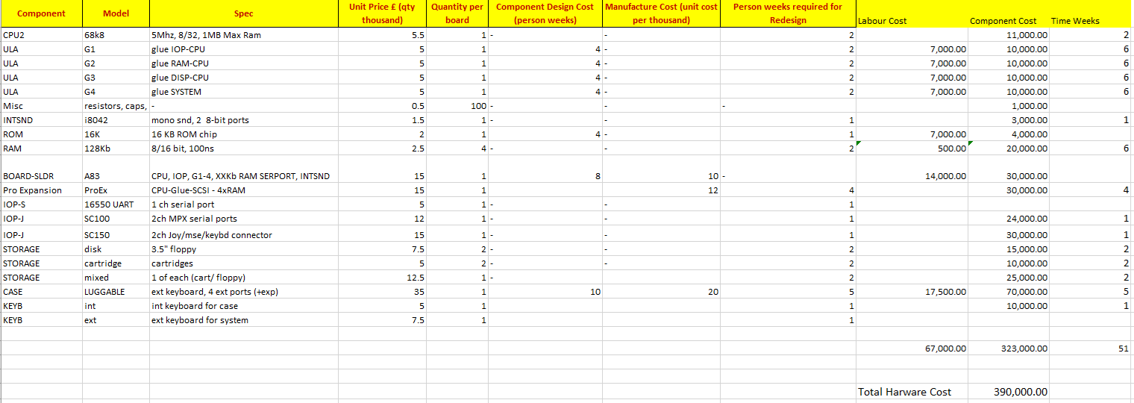

**Software Time and Cost**

Assumptions made for Software

1. We are building the core software for the system
2. We are building the software concurrently since other parts are outsourced. Total weeks therefore is 20 weeks, this includes buffers for redesigning.

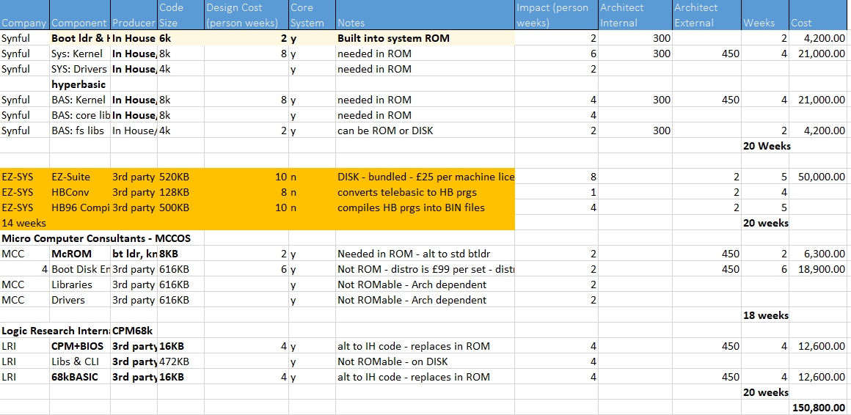

**Gantt Chart for Delivery**

**The total hardware cost is $390,000.00**

**The Total software cost is $150,800.00**

**Therefore the cost of 1 machine = ($390,000.00 + $150,800.00) / 2000 = $270.00**

**References**

* Rassol, N., Hasseb, U., Khan, S., Iqbal, M. (2023) Scrum and  the Agile Procedure’s Impact on Software Project Management. *Jilin Daxue Xuebao (Gongxueban)/Journal of Jilin University (Engineering and Technology Edition)* 42(02-2023): 380-392*.* DOI: <http://dx.doi.org/10.17605/OSF.IO/MQW9P>
* 'Gherkin Test Cucumber'. *Guru99*, [online] Available at: [Gherkin Language: Format, Syntax & Gherkin Test in Cucumber](https://www.guru99.com/gherkin-test-cucumber.html) (Accessed: 30 October 2023).
* Behave (2020) Behaviour Driven Development: The Gherkin Language
* Stellman, A. and Greene, J. (2005). *Applied Software Project Management*. [Sebastopol, CA ]: O'Reilly Media, Inc..
* **Brooks Jr., F. P. (1995). *The Mythical Man-Month: Essays on Software Engineering. Addison-Wesley***.