**Project Title**

Development of the Synputer

**Project Objectives and Goals**

Synful is wokring on a project aimed at creating a high-performance business computer. Recent feedback from EDC has highlighted areas needing improvement, prompting a redesign to align more closely with EDC's particular needs.

The initial aim of the project was to develop a desktop unit with a 68008 CPU, 4 glue chips, 1 x 32KB ROM, 4 x 32Kb RAM chips, (all soldered to the board), 2 Syn cartridge drives, 1 serial port, 1 joystick port, and a desktop case with internal/ integrated keyboard.

Based on feedback from EDC, the scope of work has been expanded to include the following enhancements:

* Implement industry standard operating system
* Assess and upgrade the CPU to at least a 68000, with consideration for upgradability.
* Implement the necessary modifications to support a minimum of 512KB of RAM.
* Integrate at least one industry-standard removable drive.
* Incorporate SCSI expansion capability into the system.
* Add a minimum of two serial ports supporting RS 422/485 standard.
* Integrate support for an external keyboard/connector.
* Ensure compatibility with industry-standard operating systems.
* Modify the board to be ready for a GUI system and mouse integration.

**Project Deliverables**

Develop a synputer desktop unit that meets the above specifications and that meets the new requirements from EDC.

**Cost Analysis**



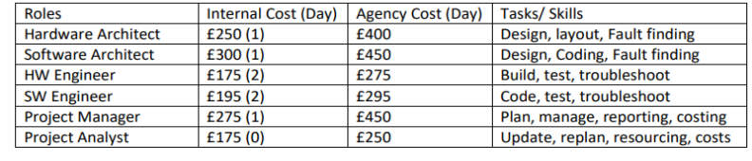

* Case building capacity: maximum 20 per day
* Board production capacity: maximum 25 boards per day

**Gantt Chart/ Timeline for Delivery**

**Risk Assessment**

* Threat to be sued for £1 Million for breach of contract unless the specification of the system is upgraded so the majority (> 80%) of the client requirements are met. Ensure that all EDC requirements are met
* Marketing already advertised the machine for $399.99 before the analysis of all requirements. This may end up selling the machine at a loss. Ensure that requirements are well analysed and we chose the best path with the lowest cost.
* Risk of losing out to competitors if machine developed does not have high-resolution graphics. Ensure that the machine should have GUI and can be driven from the keyboard and/or mouse.