DTN Research Challenges
and

Forward
Insert something

Table of Contents
Forward 2
Introduction 8
Chapter 1 Physical layer 10
Chapter 2 Network layer 12
Section 2.a Xmodem / SEALink / Telink / Zmodem 12
Section 2.a.i Xmodem 12
Section 2.a.ii SEALink 12
Section 2.a.iii TeLink 12
Section 2.a.iv Zmodem 13
Section 2.b AX.25 / Packet Radio 13
Section 2.c UUCP 13
Section 2.d SneakerNet 14
Section 2.d.i IP over Avian Carriers 14
Section 2.e IP Stack 14
Chapter 3 DTN 16
Section 3.a Opportunistic 16
Section 3.b Prophet 16
Chapter 4 Networks Types 18
Chapter 5 Geo-Routing 20
Section 5.a Location Proxies 20
Section 5.b Locating Mobile Nodes with EASE: Learning Efficient Routes from Encounter Histories Alone 20
Section 5.c Distributed Location Management 20
Section 5.d Large Metropolitan-Scale Internetworks 20
Section 5.d.i HomeZone 21
Section 5.e Terminodes Routing 21
Section 5.f GeoHash 21
Section 5.g Geocasting 21
Section 5.h Tahrir project 21
Chapter 6 Distributed hash table (DHT) 24
Section 6.a X-vine 24
Section 6.b Freenet 24
Section 6.c Keyword searching 24
Section 6.d Bootstrapping 24
Chapter 7 DNS (Name Systems) 26
Section 7.a GADs 26
Chapter 8 Content centric networking / Information-centric networking 28
Section 8.a Named Data Networking (NDN) 28
Section 8.b Project CCNx 28
Section 8.c disasters 28
Section 8.d FreeNet 28
Section 8.d.i Papers 29
Section 8.d.ii Freenet keys 29
Section 8.d.ii.a Content Hash Keys 29
Section 8.d.ii.b Signed Subspace Keys 29
Section 8.d.ii.c Updateable Subspace Keys 29
Section 8.d.ii.d Keyword Signed Keys 30
Section 8.e File System 30
Section 8.e.i A Low-bandwidth Network File System 30
Section 8.f Publish/Subscribe 30
Section 8.f.i Usenet / Netnews 30
Section 8.f.ii A Socio-Aware Overlay for Publish/Subscribe Communication in Delay Tolerant Networks 31
Section 8.f.iii Efficient Publish/Subscribe-Based Multicast for Opportunistic Networking with Self-Organized Resource Utilization. 31
COPSS: An Efficient Content Oriented Publish/Subscribe System 31
Section 8.g Time-Aware 32
Section 8.g.i TACO-DTN: A Time-Aware COntent-based dissemination system for Delay Tolerant Networks 32
Chapter 9 Application 34
Section 9.a Lightweight Directory Access Protocol (LDAP) 34
Section 9.b Web browser 34
Section 9.c Email 34
Section 9.c.i ePOST / POST 34
Section 9.c.ii glacier 34
Section 9.c.iii Emails Address 34
Section 9.c.iii.a source routing 34
Section 9.c.iii.b Geo routing 34
Section 9.c.iii.c inCare of routing 35
Chapter 10 web of trust 36
Apendex 1 Existing Projects 38
Section 1.a Websites: 38
Section 1.a.i Nabo 38
Section 1.a.ii IndieWeb 38
Section 1.b Software: 38
Section 1.b.i GNUnet 38
Section 1.c Hardware: 38
Section 1.c.i VillageTelco 38
Section 1.c.ii Mesh Potato 38
Section 1.c.iii Serval Project 38
Section 1.c.iv Serval BatPhone 38
Section 1.c.iv.a Rhizome 38
Apendex 2 Open Questions 40
Section 2.a Video Codecs 40
Section 2.a.i WebM 40
Section 2.a.i.a VP8 40
Section 2.a.i.b VP9 40
Section 2.a.ii Theora 40
Section 2.a.iii H.264 40
Section 2.a.iv Daala 40
Section 2.a.v Dirac 40
Section 2.b Audio Codecs 40
Section 2.b.i Lossy 40
Section 2.b.i.a Codec2 (low bandwidth speech) 40
Section 2.b.i.b Opus 40
Section 2.b.i.c Vorbis 41
Section 2.b.i.d Mp3 41
Section 2.b.ii Lossless 41
Section 2.b.ii.a FLAC 41
Apendex 3 Pet peeve 42
Section 3.a Internet 42
Section 3.b IoT 42
Apendex 4 To be Sorted 44
Section 4.a Ivy: A Read/Write Peer-to-Peer File System 44

Index of Tables
Table 1: Modem speeds 8
Table 2: Our Network Stack 9
Table 3: IP Stack 14
Table 4: ePOST Stack 34
Illustration Index
Drawing 1: Freenet's Key based Routing 30
Drawing 2: Contact sequence 33
Drawing 3: Possible bitrate and latency combinations compared with other audio formats 40
Drawing 4: Comparison of coding efficiency between Opus and other popular audio formats 41

Introduction
- The current Host-centric networking is becoming out-date, the next network well be based on Information-centric networking
- The Internet/APERANET was create in 1970 when time-sharing (Cloud-computing, Web-server farms) was the main way to use computers
- Portable computers with packet radio (eg: bluetooth, Wi-Fi, Cell phone) connections
- every thing has an IP stack as standard even device that should not (Internet of Things)
- Interplanetary Internet

ASCII (teletype)
VT100
Box Drawing ? / block graphics ?

 | Standard
HAM Radio  /  Analog Phone line | 110 baud Bell 101 modem
HAM Radio  /  Analog Phone line | 300 baud (Bell 103 or V.21)
HAM Radio  /  Analog Phone line | 1200 modem (1200 baud) (Bell 202)
HAM Radio  /  Analog Phone line | 1200 modem (600 baud) (Bell 212A or V.22)
HAM Radio  /  Analog Phone line | 2400 modem (600 baud) (V.22bis)
HAM Radio  /  Analog Phone line | 2400 modem (1200 baud) (V.26bis)
HAM Radio  /  Analog Phone line | 4800 modem (1600 baud) (V.27ter)
HAM Radio  /  Analog Phone line | 9600 modem (2400 baud) (V.32)
Mostly used on analog Phone lines | 14.4kbit modem (2400 baud) (V.32bis)
Mostly used on analog Phone lines | 19.2kbit modem (2400 baud) (V.32terbo)
Mostly used on analog Phone lines | 28.8kbit modem (3200 baud) (V.34)
Mostly used on analog Phone lines | 33.6kbit modem (3429 baud) (V.34)
Mostly used on analog Phone lines | 56kbit modem (8000/3429 baud) (V.90)
Mostly used on analog Phone lines | 56kbit modem (8000/8000 baud) (V.92)
Other | >56kbit
Table 1: Modem speeds

CardDAV* or Lightweight Directory Access Protocol (LDAP)*
GNU Alternative Domain System (DNS)*
Freenet / ICN (Key-based routing)**
Geo routing with Location Proxies
Efficient Publish/Subscribe for |  |  | Geo Pub/Sub** / geo-tahrirproject??
Opportunistic |  |  | X-Vine (DHT)*
 |  |  | DB-based* |  |  | IP Stack
DTN |  |  |  |  |  | IP Stack
Xmodem  SEAlink  TeLink  Zmodem | AX.25 | UUCP |  | SneakerNet | IP stack | IP Stack
Physical layer
Table 2: Our Network Stack

Physical layer
The physical layer is unique to each network (Radio, cable, etc)
- Radio
- Cable
- Fibre
- Cat5
- colax

I have two recommends that need to be looked into for MAC layer of Wifi mesh networks
- Mobile Slotted Aloha
- Code division multiple access

Network layer
- Most of the network layers except Sneakernet and IP stack were build with analogue landline modems
- the IP stack was build on a lease line network
- Sneakernet has been the early way of transferring data/documents/letters since the beginning of recoded history (Mail, Pony Express, etc )

Xmodem / SEALink / Telink / Zmodem
I am unsure witch modem file transfer protocol is the best, I am tossing up between Sealink, TeLink and Zmodem

Xmodem
XMODEM is a simple file transfer protocol developed as a quick hack by Ward Christensen for use in his 1977 MODEM.ASM terminal program. It allowed users to transmit files between their computers when both sides used MODEM. Keith Petersen made a minor update to always turn on "quiet mode", and called the result XMODEM.
- https://en.wikipedia.org/wiki/XMODEM

SEALink
SEAlink is a file transfer protocol that is backward compatible with XMODEM but features a sliding window system for improved throughput. SEAlink was written in 1986 as a part of the SEAdog FidoNet mailer written by System Enhancement Associates. It was licensed with a simple "give credit" requirement, but nevertheless was not very widely used except in FidoNet mailers. SEAlink, and most other XMODEM enhancements, were quickly displaced following the introduction of ZMODEM.
- https://en.wikipedia.org/wiki/SEAlink

TeLink
MODEM7 sent the filename as normal text, which meant it could be corrupted by the same problems that XMODEM was attempting to avoid. This led to the introduction of TeLink by Tom Jennings, author of the original FidoNet mailers.
TeLink avoided MODEM7's problems by standardizing a new "zero packet" containing information about the original file. This included the file's name, size, and timestamp, which were placed in a regular 128 byte XMODEM block. Whereas a normal XMODEM transfer would start with the sender sending "block 1", the TeLink header packet was labeled "block 0".
The basic "block 0" system became a standard in the FidoNet community, and was re-used by a number of future protocols like SEAlink and YMODEM.
- https://en.wikipedia.org/wiki/XMODEM

Zmodem
ZMODEM is a file transfer protocol developed by Chuck Forsberg in 1986, in a project funded by Telenet in order to improve file transfers on their X.25 network. In addition to dramatically improved performance compared to older protocols, ZMODEM also offered restartable transfers, auto-start by the sender, an expanded 32-bit CRC, and control character quoting, allowing it to be used on networks that might "eat" control characters. ZMODEM became extremely popular on bulletin board systems (BBS) in the early 1990s, displacing earlier protocols such as XMODEM and YMODEM.
- https://en.wikipedia.org/wiki/ZMODEM

AX.25 / Packet Radio
AX.25 is a data link layer protocol derived from the X.25 protocol suite and designed for use by amateur radio operators. It is used extensively on amateur packet radio networks.
AX.25 v2.0 and later occupies the data link layer, the second layer of the OSI model. It is mainly responsible for establishing connections and transferring data encapsulated in frames between nodes and detecting errors introduced by the communications channel. As AX.25 is a pre-OSI-model protocol, the original specification was not written to cleanly separate into OSI layers. This was rectified with version 2.0 (1984), which assumes compliance with OSI level 2.
In practice, it is not uncommon to find an AX.25 data link layer as the transport for some other network layer, such as IPv4, with TCP used on top of that. Note that, like Ethernet, AX.25 frames are not engineered to support switching. For this reason, AX.25 supports a somewhat limited form of source routing. Although possible to build AX.25 switches in a manner not unlike how Ethernet switches work, this has not yet been accomplished.
- https://en.wikipedia.org/wiki/AX.25
- limited to 1200 bits per second audio frequency-shift keying (AFSK) is this correct?
- very long history of use starting in 1971, lead to birth of the Ethernet standard and all modern wireless digital networks

UUCP
UUCP is an abbreviation of Unix-to-Unix Copy. The term generally refers to a suite of computer programs and protocols allowing remote execution of commands and transfer of files, email and netnews between computers.
- https://en.wikipedia.org/wiki/UUCP

SneakerNet
Sneakernet is an informal term describing the transfer of electronic information, especially computer files, by physically moving removable media such as magnetic tape, floppy disks, compact discs, USB flash drives (thumb drives, USB stick) or external hard drives from one computer to another, usually in lieu of transmitting the information over a computer network. The term, a tongue-in-cheek play on Ethernet,refers to the use of someone wearing sneakers as the transport mechanism for the data.
- https://en.wikipedia.org/wiki/Sneakernet

IP over Avian Carriers
In computer networking, IP over Avian Carriers (IPoAC) is a humorously intended proposal to carry Internet Protocol (IP) traffic by birds such as homing pigeons. IP over Avian Carriers was initially described in RFC 1149, issued by the Internet Engineering Task Force (IETF) written by D. Waitzman and released on April 1, 1990.
IPoAC has been successfully implemented, but for only nine packets of data, with a packet loss ratio of 55% (due to user error),[2] and a response time ranging from 3000 seconds (~54 minutes) to over 6000 seconds (~1.77 hours). Thus, this technology suffers from poor latency. Nevertheless, for large transfers, avian carriers are capable of high average throughput when carrying flash memory devices, effectively implementing a sneakernet. During the last 20 years, the information density of storage media and thus the bandwidth of an avian carrier has increased 3 times as fast as the bandwidth of the Internet.[3] IPoAC may achieve bandwidth peaks of orders of magnitude more than the Internet when used with multiple avian carriers in rural areas. For example: If 16 homing pigeons are given eight 512 GB SD cards each, and take an hour to reach their destination, the throughput of the transfer would be 145.6 Gbit/s, excluding transfer to and from the SD cards.
https://en.wikipedia.org/wiki/IP_over_Avian_Carriers

IP Stack

Application
Transport
Internet/Network
Data Link/Link
Physical
Table 3: IP Stack

DTN

Opportunistic

Prophet

Networks Types
The are two network types DB-based and flooding-based, they both have advantages and disadvantageous.
DB-based:
- Batman [BATMAN] (mesh)
- Prophet [PRoPHET] (DTN)
Flooding-based:
- AODV routing [AODV] (mesh)
- Epidemic routing (DTN)
DB-based advantages:
- efficient routing
DB-based disadvantages:
- Bandwidth for routing DB sharing
- DB Storage
- processing time of routing DB (updating entrys, removing entrys, sorting)
Flooding-based advantages:
- on-demand routing tables
Flooding-based disadvantages:
- Bandwidth for user data
- Storage for user data (DTN)
- bad/wasteful routing

Bibliography
BATMAN: A. Neumann, C. Aichele, M. Lindner, and S. Wunderlich, Better Approach To Mobile Ad-hoc Networking (B.A.T.M.A.N.), 2008, https://tools.ietf.org/html/draft-wunderlich-openmesh-manet-routing-00
PRoPHET: A. Lindgren, A. Doria, E. Davies, and S. Grasic, Probabilistic Routing Protocol for Intermittently Connected Networks, 2012, https://tools.ietf.org/html/rfc6693
AODV: C. Perkins, E. Belding-Royer, and S. Das, Ad hoc On-Demand Distance Vector (AODV) Routing, 2003, https://tools.ietf.org/html/rfc3561

Geo-Routing
As ad-hoc networks become more common, it is very likely that connectivity among the individual ad-hoc networks, as well as connectivity of any given ad-hoc network and the global Internet will be desired. Most likely this will require the introduction of hierarchies, as has been done in the Terminodes [snipped]. However, since the position of individual nodes in an ad-hoc network will change much more frequently than the position of the ad-hoc networks themselves, it could be argued that a hierarchical approach should use a location-based approach at the local level and topology-based routing over long distances and for Internet integration. It is also conceivable that a three level hierarchy could be used. At the lowest layer a proactive routing protocol could be employed to aggregate a small number of nodes and increase the robustness against positional errors. At the next layer a position based approach might be used that scales well to ad-hoc networks with numerous participants. Finally the third layer would use proactive or reactive approaches to connect the ad hoc networks with each other and with the global Internet.
- [posbmadhoc]
I do agree with the authors thinking

Location Proxies
[LocProxies]
- the underlying idea is sound, but the routing algorithm is a concern, this open up two questions
- How do the non-location-aware nodes learn their locations?
- Flood-voting based?
- How do the location-aware node learn about the non-location-aware nodes?
- DHT?
- I am think of two types of location proxies:
- Static
- Mobile

Locating Mobile Nodes with EASE: Learning Efficient Routes from Encounter Histories Alone
- Nice idea but there is no information about getting the location
- Simulation only

Distributed Location Management
[VIMLOC]
- tba

Large Metropolitan-Scale Internetworks

- A bit historic (1987/1988)
- has a congestion-control system
- hierarchy organised
- they were predicting the future:
- router/gateways in every building
- Mobile/Cell phone network
- non-network-centric address
- uses a Manhattan-style city
- two level simulation based on the ARPANET (January 1986 geographic map with approximate latitude and longitude locations for each 48 IMP nodes)

HomeZone
[HZ01]
- Dtn support?
- Is it too bandwidth costly?

Terminodes Routing
[SOTNR]

SubPos - A "Dataless" Wi-Fi Positioning System

GeoHash

Geocasting

Tahrir project

Bibliography
posbmadhoc: M. Mauve, J. Widmer, and H. Hartenstein, A survey on position-based routing in mobile ad hoc networks, 2001
LocProxies: Douglas S. J. De Couto and Robert Morris, Location Proxies and Intermediate Node Forwarding forPractical Geographic Forwarding,
VIMLOC: J. Mangues-Bafalluy, M. Requena-Esteso, J. Núñez-Martínez and A. Krendzel, Virtual Home Region Multi-HashLocation Management Service(VIMLOC) for Large-Scale WirelessMesh Networks, 2011
HZ01: Ivan Stojmenovic, Home agent based location update and destination searchschemes in ad hoc wireless networks, 1999
SOTNR: Ljubica Blazevic , Silvia Giordano , Jean-yves Le Boudec , Self Organized Terminode Routing, 2001

Distributed hash table (DHT)
DHT have a group of issue when run across a DTN Network
put(key,value) and get(key)
- Always On
- mostly Structured
the are two DHT witch may work on DTN network:

X-vine
- [XVINE]

Freenet
- see

Keyword searching
- Inverted Index

Bootstrapping

DNS (Name Systems)

GADs
Currently GNU Alternative Domain System (GADs) [GADs1] [GADs2] is my favourite DNS system, but it has a few issue for a DTN network, the DHT system and .zkey system
- the Distributed hash table (dht) system can be changed to X-vine [XVINE] witch has a few issue for DTN network also
- the .zkey system is not workable in a DTN network

Bibliography
GADs1: Matthias Wachs , Martin Schanzenbach, and Christian Grothoff, On the Feasibility of a Censorship Resistant Decentralized Name System, 2012
GADs2: Martin Schanzenbach, Design and Implementation of a Censorship Resistant and Fully Decentralized Name System, 2012
XVINE: Prateek Mittal, Matthew Caesar, and Nikita Borisov, X-vine: Secure and pseudonymous routing using social networks, 2011

Content centric networking / Information-centric networking

Named Data Networking (NDN)
TBD
- unsuitable: it works similar to BGP (Border Gateway Protocol) in inter-domain IP routing

Project CCNx
TBD

disasters
TDB

A scalable architecture for geo-localized service access in smart cities

https://tools.ietf.org/html/draft-irtf-dtnrg-bpq-00

Bibliography

FreeNet
- 15 years of research and practical use in the real world
- Freenet is routing algorithm works a bit like DHT network
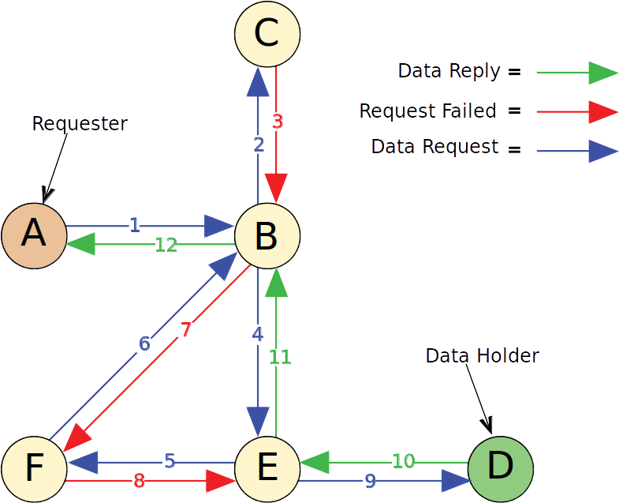Drawing 1: Freenet's Key based Routing

Papers
- Freenet White paper [freenetWP]
- Freenet: A Distributed Anonymous Information Storage and Retrieval System [FreenetDAISRS]
- Protecting Free Expression Online with Freenet [FIOFreenet]

Freenet keys

Content Hash Keys
Content Hash Keys are for files with static content. These keys are hashes of the content of the file. A CHK uniquely identifies a file, it should not be possible for two files with different content to have the same CHK. The CHK consists of three parts:
- the hash for the file
- the decryption key that unlocks the file, and
- the cryptographic settings used

Signed Subspace Keys
Signed Subspace Keys are usually for sites that are going to change over time.It works by using public-key cryptography so you can sign your site. Only the person with the secret key can add updated versions of your site to Freenet.

Updateable Subspace Keys
Updateable Subspace Keys are useful for linking to the latest version of a Signed Subspace Key (SSK) site. Note that USKs are really just a user-friendly wrapper around SSKs, which hide the process of searching for more recent versions of a site.

Keyword Signed Keys
Keyword-Signed Keys (KSKs) allow you to save named pages in Freenet. They are not secure against spamming or name hijacking. Several people could each insert a different file to Freenet, all with the same address. However, there is a collision detection, which tries to prevent overwriting of a once-inserted page.
NOT used

Bibliography
freenetWP: Ian Clarke, FreeNet White Paper, 1999
FreenetDAISRS: Ian Clarke, Oskar Sandberg, Brandon Wiley, and Theodore W. Hong. , Freenet: A Distributed Anonymous Information Storage and Retrieval System, 2001
FIOFreenet: , Protecting Freedom of Information Online with Freenet , 2002

Publish/Subscribe
Small without multimedia
up to 100KBytes
Small with limited multinedia (no-video)
up to 250KBytes
medium
up to 500KBytes

There are three types of Pub/sub
- Channel / Group-based (easy)
- Keyword-based (easy)
- Content-based (hard)

Usenet / Netnews
- rfc5536
- rfc5537
- the usenet / netnews articles standard has be in use since the 1979

A Socio-Aware Overlay for Publish/Subscribe Communication in Delay Tolerant Networks
- Has some interesting ideas for social media network, but it dose not support a festival
- point of interest network
- Wondering if data from Prophet and X-vine could be used?
- Simulation on real world data only

Efficient Publish/Subscribe-Based Multicast for Opportunistic Networking with Self-Organized Resource Utilization.
[epcMc4opsru]
- Opportunistic
- Kasuari-based sinulation:
- 50KBytes storage on nodes
- 1KBytes bundle payload
- RDTN simulation:
- car-follow and traffic-light model
- result: duplicate suppresion over multiple hops is needed
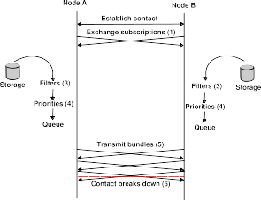Drawing 2: Contact sequence

COPSS: An Efficient Content Oriented Publish/Subscribe System
[COPSS]
- build on top of NDN
- Twitter-like
- Two step communication (snippet and full article)
- I'm on the fence with the two step communication system
- article size Vs time Delay

Time-Aware

TACO-DTN: A Time-Aware COntent-based dissemination system for Delay Tolerant Networks
[TACO-DTN]
- temporal correspondence
- simulation

Application

Lightweight Directory Access Protocol (LDAP)

Web browser

Email

ePOST / POST
Email Client
IMAP | POP3 |  | SMTP
ePOST
POST
PAST |  | Scribe
Pastry
Table 4: ePOST Stack
[ePOST-EuroSys]
[POST-Thesis]
[POST-HotOS]
- the ePOST/POST system has lots of good ideas, but it is TOO depend on the Pastry overlay system

glacier
[glacier]
- the underlying idea could adapted to our project

Emails Address
The emails system supports all modes intermix in one email address

source routing
Not Recommended:

Geo routing
The address can include a Geohash location

inCare of routing

web of trust

File Formates

Incremental Transmission

File System

My thoughts:
- Log-structured file system

A Low-bandwidth Network File System
- Has too many round-trips
- build on top of NFS

Disconnected System Operation in the Coda File

        - Existing Projects
          - Websites:
            - Nabo
- Social media network
- hosted on a server farm / cloud
            - IndieWeb
          - Software:
            - GNUnet
TBA
          - Hardware:
            - VillageTelco
TBA
            - Mesh Potato
TBA
            - Serval Project
- [Serval]
The Serval project is build upon the VillageTelco Mesh Potato, it dose has a lot of good ideas, but I get the Not invented here feeling with some of their Ideas
            - Serval BatPhone
The Serval batPhone has two basic models:
- the VillageTelco's Mesh Potato hardware with custom Serval code
- Android version with custom Serval code

http://developer.servalproject.org/dokuwiki/doku.php?id=content:publications
              - Rhizome
Rhizome is store-and-forwared messaging system like DTN, but is based on Flooding the network with messages.
        - Open Questions
          - Video Codecs
Currently there is no video codec that is good at low bitrates and is open source
            - WebM
              - VP8
              - VP9
            - Theora
            - H.264
            - Daala
            - Dirac

          - Audio Codecs
            - Lossy
Opus is the best all round audio codec unless you are doing 5Kbits voice
              - Codec2 (low bandwidth speech)
Codec2 is a sub 5Kbits voice codec used by the HAM radio Community
              - Opus
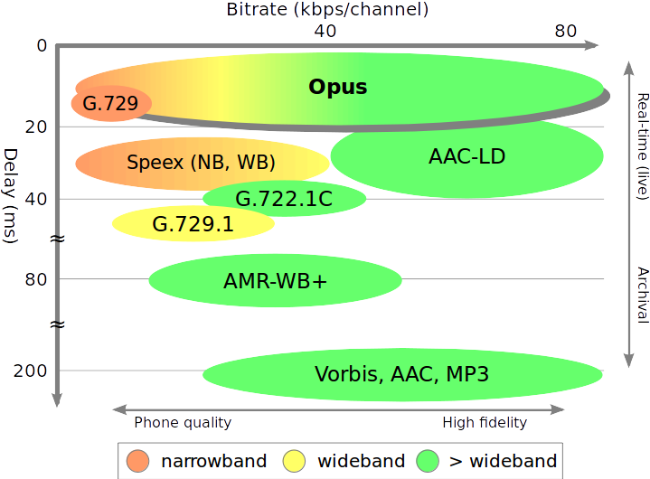Drawing 3: Possible bitrate and latency combinations compared with other audio formats
              - Vorbis
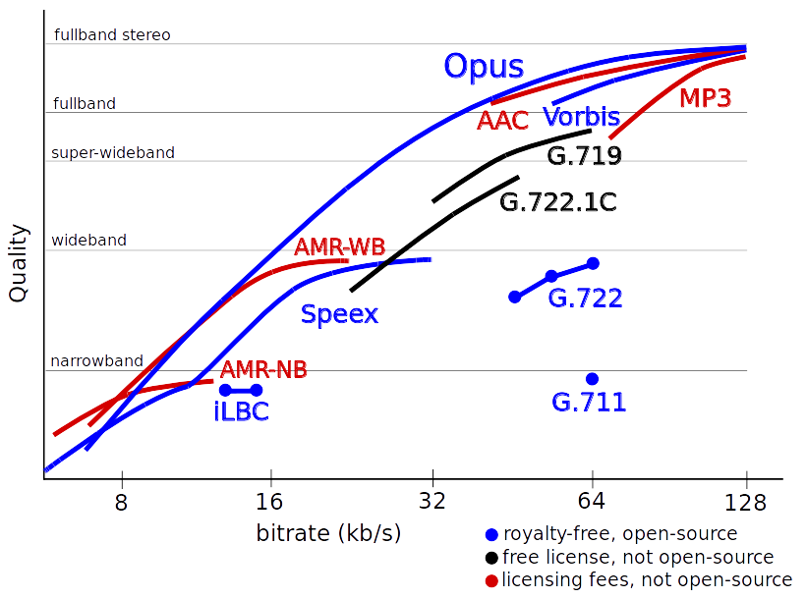Drawing 4: Comparison of coding efficiency between Opus and other popular audio formats
              - Mp3
            - Lossless
              - FLAC
        - Pet peeve
          - Internet

          - IoT

        - To be Sorted
          - Ivy: A Read/Write Peer-to-Peer File System
[lvy]
- I like the ideas, but am not sure how they could be use in dtn environment

AODV routing is not a true flood-based network, the algorithm floods the network to find a path to the destination, then send the user data along that path.
See https://en.wikipedia.org/wiki/Border_Gateway_Protocol#Routing_table_growth and https://en.wikipedia.org/wiki/FidoNet#Nets_and_nodes
We have not seen this issue in wireless mesh networks because radio bandwidth makes the networks unusable before we hit this issue and DTN networks have been too small. People who run wireless mesh network keep adding radio to keep the network functioning as it growing larger and larger
Why did we not go this route for city routing? - Dail-up: Star network - ADSL: Star network - Cable/Fibre: bus network - mobile/cell: geo-star network - Wifi: star network
Yes I know about Unstructured DHT
Freenet is also a Information-centric networking

