Open Questions

Video Codecs
Currently there is no video codec that is good at low bitrates and is open source

WebM

VP8

VP9

Theora

H.264

Daala

Dirac

Audio Codecs

Lossy
Opus is the best all round audio codec unless you are doing 5Kbits voice

Codec2 (low bandwidth speech)
Codec2 is a sub 5Kbits voice codec used by the HAM radio Community

Opus
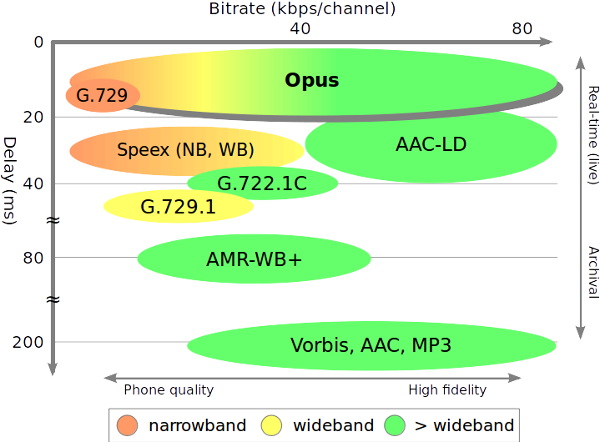Drawing 1: Possible bitrate and latency combinations compared with other audio formats

Vorbis
Drawing 2: Comparison of coding efficiency between Opus and other popular audio formats

Mp3

Lossless

FLAC

