FreeNet
- 15 years of research and practical use in the real world
- Freenet is routing algorithm works a bit like DHT network
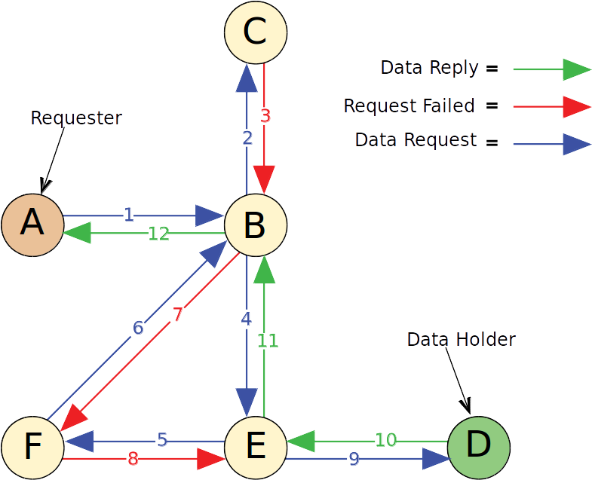Drawing 1: Freenet's Key based Routing

Papers
- Freenet White paper [freenetWP]
- Freenet: A Distributed Anonymous Information Storage and Retrieval System [FreenetDAISRS]
- Protecting Free Expression Online with Freenet [FIOFreenet]

Freenet keys

Content Hash Keys
Content Hash Keys are for files with static content. These keys are hashes of the content of the file. A CHK uniquely identifies a file, it should not be possible for two files with different content to have the same CHK. The CHK consists of three parts:
- the hash for the file
- the decryption key that unlocks the file, and
- the cryptographic settings used

Signed Subspace Keys
Signed Subspace Keys are usually for sites that are going to change over time.It works by using public-key cryptography so you can sign your site. Only the person with the secret key can add updated versions of your site to Freenet.

Updateable Subspace Keys
Updateable Subspace Keys are useful for linking to the latest version of a Signed Subspace Key (SSK) site. Note that USKs are really just a user-friendly wrapper around SSKs, which hide the process of searching for more recent versions of a site.

Keyword Signed Keys
Keyword-Signed Keys (KSKs) allow you to save named pages in Freenet. They are not secure against spamming or name hijacking. Several people could each insert a different file to Freenet, all with the same address. However, there is a collision detection, which tries to prevent overwriting of a once-inserted page.
NOT used

Bibliography
freenetWP: Ian Clarke, FreeNet White Paper, 1999
FreenetDAISRS: Ian Clarke, Oskar Sandberg, Brandon Wiley, and Theodore W. Hong. , Freenet: A Distributed Anonymous Information Storage and Retrieval System, 2001
FIOFreenet: , Protecting Freedom of Information Online with Freenet , 2002

