Preparation for the implementation of test cases

# Setup of the database

The database contains tables for the parking system. You will need some of the tables, when you are reading or saving data from the Java source code.

Please follow this procedure:

1. Download the file PayStationSqlScripts.zip
2. Move the file to a suitable place and unzip the file, it contains 3 sql script files:

1. Open the tool: SQL Server Management Studio
2. Connect to your local server
3. Open the file CreateDatabasePayStation.sql so the content is shown in the “query”. Run the script (execute) and verify that the database was created.
4. 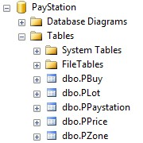Open and run the file CreateTablesPayStation.sql Verify that the tables were created:
5. 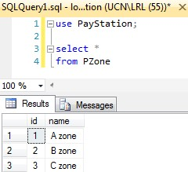Open and run the file InsertTablesPayStation.sql Verify that the data was inserted.

Now the database is ready for use ☺

# Setup the Java project

The Java project contains the code you will be testing and modifying.

Please follow this procedure:

1. Download the files PayStation_StudentVersion_src.zip and JarFiles.zip
2. Move the files to a suitable location and unzip the files.
3. Open your IDE: Eclipse
4. Create a new Java project. Name it: PayStation.
5. Use the tool: Windows Explorer
6. Copy the files from the unzipped PayStation_StudentVersion_**src**.zip file, to the java project **src** folder.
7. Go back into Eclipse. ’Refresh’ the src folder. The copied content should now be visible.
8. 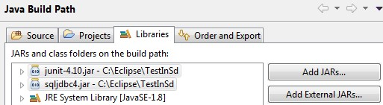Associate the Jar-files sqljdbc4.jar and junit-4.10.jar to the project ’Build Path’ (right click JRE System Library -> Add external JARS -> APPLY and CLOSE)
9. 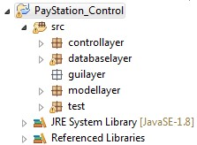Verify that the project has the proper structure, and that there are no errors.   
   Sample below in Eclipse:
10. Check the data used for the connection to the database in DBConnection.java

Try running a Junit test on the entire package. The result should be as shown below:

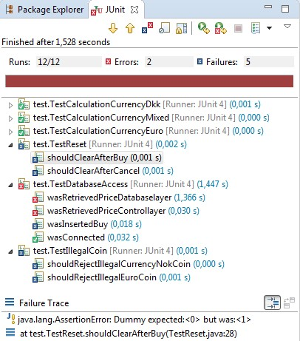

Now the Java project is set up, and there are no more preparations.