Assignment 3: Implementation of Data Model in PostgreSQL
Name:Tomáš Meravý Murárik
Student ID:127232
Submission Date: 27.4.2025

Table of Contents
Assignment 3: Implementation of Data Model in PostgreSQL 1
logical-to-physical mapping of model 2
Update Logical Model 3
Combat Flow Overview 4
Procedures/Functions: 4
enter_combat: 4
run_damage_action: 5
loot_item: 7
reset_round 8
rest_character 9
Created Indexes 10
Differencies from initial design from previous assignment 10
Views example outputs 11
Instructions for loading sample data and executing the acceptance tests 12

logical-to-physical mapping of model

GENERAL CHANGES
- | Created ENUM types: attributes, combat_status, effect_type | Centralized allowed values for critical fields
- | All ID fields implemented as SERIAL | Auto-increment standardized across all tables
- | Added NOT NULL constraints where applicable | Enforced data integrity for required fields
- | Added CHECK constraints | Validations for health >= 0, stats between 1-99, etc.
- | Created sequences for all ID fields | Explicit sequence control for primary keys

Character
Logical Model | Physical Implementation | Changes/Decisions
id INT PK | id SERIAL PRIMARY KEY | Auto-increment added here and to all other id’s
in_combat BOOL | in_combat INT | Changed to store combat_num identifying which combat the character is in(NULL if not in combat)
item_attribute_modifier
Logical Model | Physical Implementation | Changes/Decisions
id INT PK | (No id column) | Removed surrogate key - natural key used (item_id+class_id+attribute)
Action
Logical Model | Physical Implementation | Changes/Decisions
hit BOOL | hit BOOL NOT NULL | Made NOT NULL for data integrity

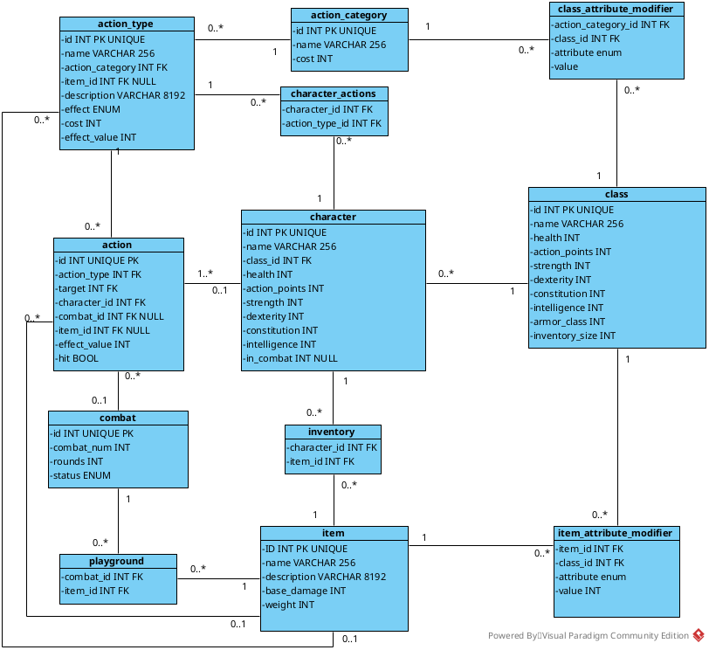

Update Logical Model

Combat Flow Overview

Procedures/Functions:

enter_combat:
- Parameters
  - combat_id
  - character_id
- Flow
  - Validate combat status
  - Validate character isn’t in combat already
  - Update chracter action_points to max and combat to combat_num
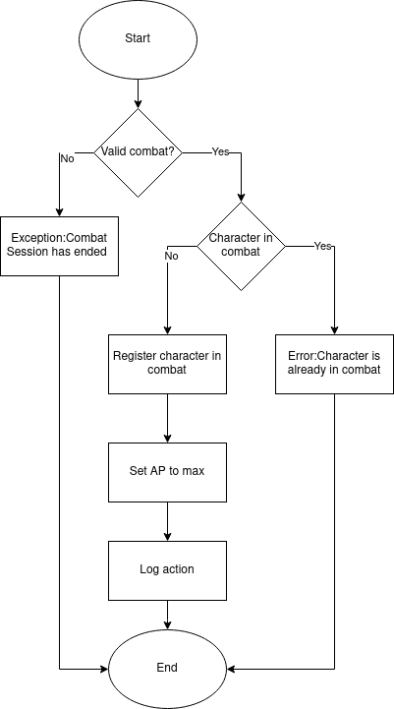
  - Insert log action into action table

run_damage_action:
- Parameters
  - action_type_id
  - target_id
  - character_id
  - item_id
- FlowValidate
  - Validate both characters are in the same combat
  - Validate character owns that action
  - Validate character has enough action points
  - Perform d20 roll adjusted by modifiers to calculate if character hit the target’s
  - Log action
  - Deduct action points from caster
  - Deduct health from target
  - Log death if target died

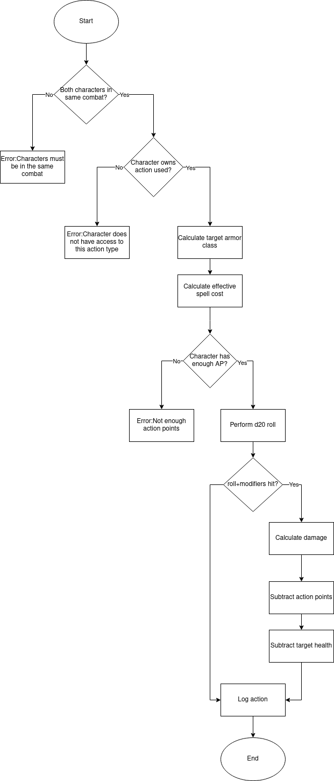
loot_item:
- Parameters
  - character_id
  - item_id
- FlowValidate
  - Confirm that character is in the same combat as item
  - Validate that character has enough inventory space to carry this item
  - Move item from playground to character inventory
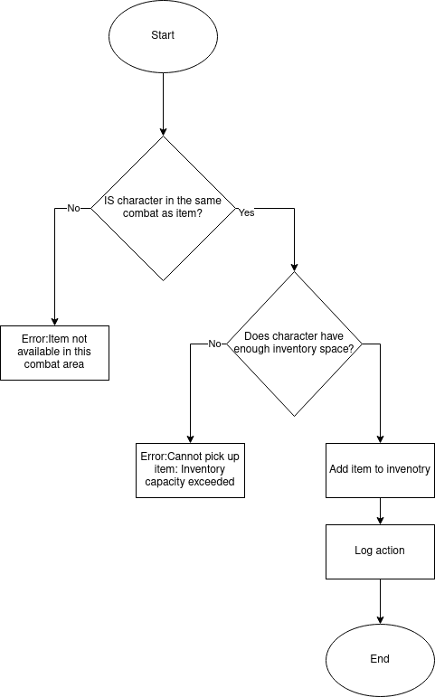
  - Log the action

reset_round
- Parameters
  - combat_id
- FlowValidate
  - Validate combat exists
  - Count number of partisipants
  - Finish combat if <2 participants are in combat
  - Find highest round number and increment it by 1
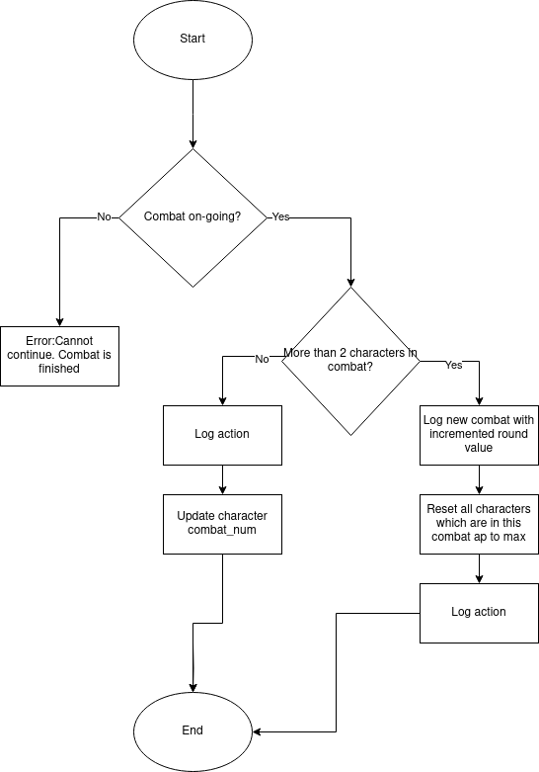
  - Update combat table and character action points

rest_character
- Parameters
  - character_id
- FlowValidate
  - Calculate max health
  - Confirm that character is not in combat
  - Execute healing action
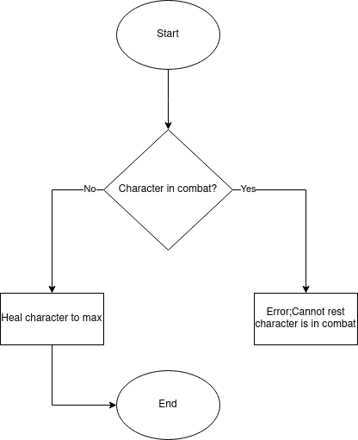

Created Indexes
Character table The second most used table and these are all the most used attributes of that table
CREATE INDEX IF NOT EXISTS idx_character_id ON character(id);
CREATE INDEX IF NOT EXISTS idx_character_in_combat ON character(in_combat);
CREATE INDEX IF NOT EXISTS idx_character_class_id ON character(class_id);

Combat is Third most used table and these are all the attributes I thought necessary to having their Index created.
CREATE INDEX IF NOT EXISTS idx_combat_id ON combat(id);
CREATE INDEX IF NOT EXISTS idx_combat_num_round ON combat(combat_num, round DESC);
CREATE INDEX IF NOT EXISTS idx_combat_status ON combat(status) WHERE status = 'on-going';

Action is the most used table by far in the database and so these are all the attributes that optimize it
CREATE INDEX IF NOT EXISTS idx_action_combat_id ON action(combat_id);
CREATE INDEX IF NOT EXISTS idx_action_character_id ON action(character_id);
CREATE INDEX IF NOT EXISTS idx_action_type_id ON action(action_type);

Other Indexes
CREATE INDEX IF NOT EXISTS idx_character_actions ON character_actions(character_id, action_type_id);
CREATE INDEX IF NOT EXISTS idx_character_combat_num ON character(in_combat) WHERE in_combat IS NOT NULL;
CREATE INDEX idx_item_modifier_composite ON item_attribute_modifier(item_id, class_id);

Differencies from initial design from previous assignment
There weren’t many differences in the physical model compared to logical model and all of them have already listed in logical-to-physical part of my documentation but here is a summary:
- Identifiers have been changed from INT to SERIAL because serial is more suited for primary keys.
- combat_num in character table has been changed to INT that can be NULL because this way one can more easily identify which combat the character is currently in.
- Even tho implied in logical model, all values that don’t have NULL next to them have to be NOT NULL.
- To character table has also been added new constraint to keep health above or equal to 0.
- Removed ID from item_attribute_modifier because it’s a bridge table and hence there is no real use for it.

Views example outputs
v_combat_state
v_strongest_characters
v_most_damage
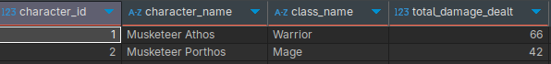
v_combat_damage
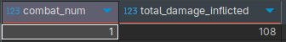

v_spell_statistics
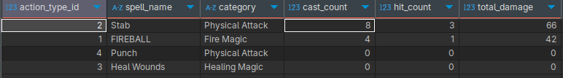

Instructions for loading sample data and executing the acceptance tests
Steps taken to load database and run acceptance tests.

- Create database with any name
- Open all sql files in editor of choice and connect them to your newly created database(if necessary)
- Execute the whole scripts in this order
  - tables.sql
  - functions.sql
  - indexes.sql
  - views.sql
- After executing all of these scripts you need to open example.sql and execute function called define_environment . This function sets default data for classes, characters, actions …
- After executing example.sql you may begin by manual testing with predefined queries in example.sql, examine example scenario made by 3 queries in example.sql file or by running tests in test.sql
Example data provided in example.sql describes this scenario.
2 people join the game and player with id 2 (named Porthos) fires fireball on player 1 (name Athos) putting them both immediately in combat(combat id 1).Immediately player 1 picks up item that was randomly generated on the ground floor. Player 2 first cast of fireball misses and so he casts it 3 more times till hit’s his opponent with 42 damage. Right after that player 1 attempts to swing at player two 3 times but deals damage only once. Both players use the PASS action (action_type id 6) and so new round is started. In that moment another player joins the game and enters their combat. New rival with character.id 3 (name Aramis) stats attacking with punch and so the three of them just attack each other until player 3 dies. Two remaining characters continue attacking each other and player 2 comes victorious. Function reset_combat is executed kicking last player out of combat and since he is no longer in combat he performs rest action.

