SOLO SCENARIO BOOK
This scenario book has three parts. First, there are some general principles that apply to all scenarios, or to a subcategory of scenarios (like cooperative scenarios). In the second part, there are optional variant rules you can use for your game. The third part contains descriptions of the scenarios.

GENERAL PRINCIPLES

MAP SHAPE

In each scenario description, there is a recommended map shape for the various number of players allowed in that scenario.

Wedge Map
This shape uses starting tile A. It is similar to the one in starting scenario, with one extra rule:
- Core (brown) tiles cannot be added to the coastline. (i.e. to the leftmost and rightmost lane of tiles).
The map starts tight, but then opens relatively quickly, and soon it can be wide. The extra rule prevents the Cities being too far from one another.
This map is most suitable for 2 or 3 players. Because of its narrow start, it is not recommended if the players are of different levels of experience: With 3 players, an inexperienced player may get blocked at the start. With 4 players, this risk gets even higher and harder to avoid.

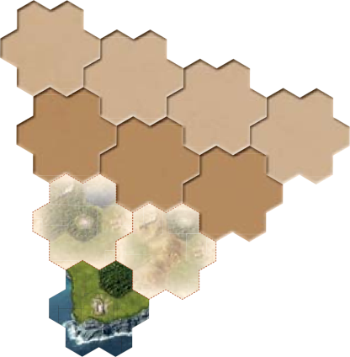

Fully Open Map
A fully open map uses starting tile B, and you deal three tiles adjacent to it at the start. The coastline opens out in a much wider angle here. However, it does not open forever – the map can have a maximum of 5 parallel columns of tiles. Imagine the coastline in each direction breaks after you add two tiles to the starting tile. See the picture.
A fully open map is suitable for a comfortable four player game. For less players, it is a bit too vast, and there may not be enough interaction in later phases of the game.

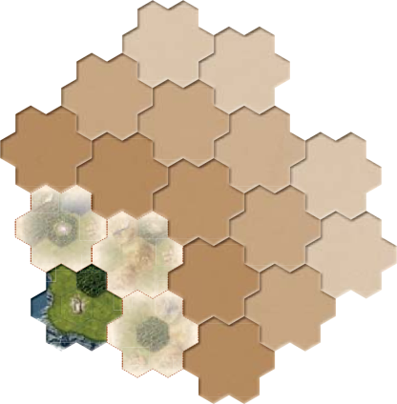

Open Map Limited to 4 or 3 Columns
This is the same shape, except the map is limited to 4 or 3 columns only. (With 4 columns, it opens more to the right than to the left). See the pictures.
The 4 column map is suitable either for a 3 player game, if you do not want the start to be too crowded, or for a 4 player game, if you want more interaction between the players.
Similarly, the 3 column map is suitable for a 2-3 player game, if you want the interaction to be tight during the entire game. Note: If you play with 3 or 4 players here, someone could rush forward and the ones that stay behind may not have enough interesting places to explore and conquer.

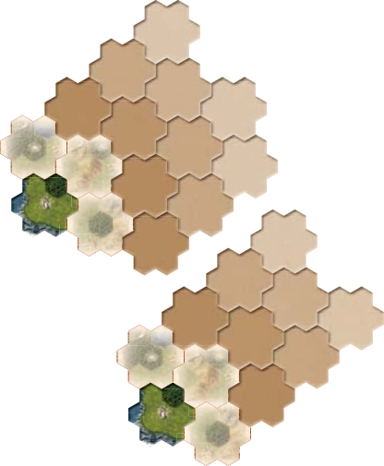

SOLO SCENARIO

Spells
In a Solo game, remove the four competitive Spells (numbered 17-20) from the Spell deck you will not use them.

Dummy Player
In the Mage Knight Board Game, when playing solo the pace of the game is set by the automated Dummy player.

At the start of the game:
- After the player chooses his Hero, randomly choose one of the Heroes that is not in the game as a Dummy player Hero. You only need his Hero card, his Round Order token, and his starting deck of 16 Basic Action cards.
- Take a look at his Hero card. At the bottom, there are three colored dots (for example Goldyx has green, green and blue). Give three crystals of these colors (one for each dot) to the Dummy player’s Inventory. Note: this applies for the Dummy player only. Other characters start with no crystals.
- Shuffle that Hero’s Deed deck, and the Dummy player is ready to go.

When picking Tactics:
- See the Scenario description for how the Dummy player chooses his Tactic card at the start of each Round.
- He does not benefit from the Tactic, it just determines when he plays in Round Order: Arrange the Round Order tokens by the Tactic numbers, as usual.

When it is the Dummy player’s turn:
- If his Deed deck is empty, he announces the End of the Round. Other players have one more turn, and the Round is over.
- If his Deed deck is not empty, µip over three cards from his Deed deck and put them in his discard pile. Check the color of the last µipped card (topmost card of the discard pile):
  - If the Dummy player has no crystals of that color in his Inventory, his turn is over.
  - If he has any crystals of that color, flip as many additional cards as he has crystals of that color. Then, his turn is over (the color of the additionally flipped card(s) does not matter).
- Note: If there are not enough cards in his Deed deck, flip as many as you can. On his next turn, the Dummy player announces End of the Round.

When preparing a new Round:
- When removing the lowest card from the Advanced Action offer, add this card to the Dummy player’s deck instead. Then shuffle the Dummy player’s deck.
- When removing the lowest card from the Spell offer, put it to the bottom of the Spells deck, as usual. In addition, add one crystal of the same color as that Spell card to the Dummy player’s Inventory. Contrary to real players, he can have more than 3 crystals of the same color.
Note 1: The Dummy player does not play too aggressively, so you have enough time to play efficiently. Sometimes, though, the random flips may mean that he goes through his deck much faster. Watch the Dummy player’s deck to adjust your tempo!
Note 2: You have a slight control over the Dummy player’s deck and crystals. It may be advantageous not to let him get crystals and cards of the same color.

Skills
In a Solo game, you also use the set of Skills belonging to the Dummy player’s Hero, except the competitive Skill. Shuffle them and put them face down next to his Hero card.
Every time your Hero has gained a Skill token, also reveal one Skill of the Dummy player, and put it into the Common Skill offer – it is available to you the next time you may gain a Skill token. If you choose such a Skill from the Common Skill offer, you have to take the lowest Advanced Action card, as with usual Level Up rules.

Scoring
In a solo game your final score is calculated by taking your Fame at the end of the game and adding the Achievements as follows:
- Advance Actions: +1 per AA in your deck
- Spells: +2 per Spell in your deck
- Artifacts: +2 per Artifact in your deck
- Crystals: Number of crystals in your inventory divided by 2 (rounded down)
- Unwounded Units: Sum of the Unwounded Units levels
- Wounded Units: Sum of the Wounded Units levels divided by 2 (rounded down)
- Conquered Sites: +2 per Conquered Site (Burned Monastery, Keep and Mage Tower)
- Adventure Sites: +2 per Adventure Site you defeated (Monster Den, Dungeon, Ancient Ruins, Spawning Grounds and Tomb)
- Wounds: -2 per Wound in your deck
Scenarios may also come will additional scoring bonuses. Refer to each scenario rules.

VARIANT RULES

Variants are here to add even more variety to the game, and to adjust it to your tastes. We recommend you follow these rules when picking variants:
- You should play your first few games with the standard rules only, to better understand the game.
- Do not pick too many variant rules at once, as you might easily forget which rules apply and which do not.

MAP VARIABILITY

Map Shape and Number of Tiles
The map shapes and number of tiles for the scenarios are just recommended settings. If you discover that you like some map shapes better, if you want more or less interaction at the start of the game or during it, or if you want more or less tiles to explore, or even cities to conquer, feel free to choose different map shapes and number of tiles.

Random Tiles Orientation
The orientation of tiles is normally fixed, the player having no choice in how to orient them. That’s right, Heroes are just discovering an unknown kingdom, not, say, building a medieval city in the south of France.
However, after many games under your belt, you may notice that limited amount of tiles cause some patterns to repeat in the game from time to time. If you want, you may use this rule:
- When revealing a new tile (at the start of the game, or during it), it is rotated randomly. Add it to the map face down (so no one can see how it is oriented), and then flip it by any axis (choose the axis before seeing the tile content).
Note: The symbols in the corners still have to connect, although now, circles can connect to stars, creating irregular shapes.

Random Cities
The cities have a fixed position. The White city is always by a lake next to a keep, the Red city is in desert surrounded by dragons, etc.

That’s the game story, and it makes the cities different not just by their garrison and bonuses. If you want more variability, though, you can do it a different way:
- Whenever a city tile is revealed, draw a random City card, and put the city of that color on the central space of the tile, regardless of the space color.
Note: You may also use random cities in scenarios where a fixed city is defined (for example: Green city in the “Druid Nights” scenario), as it is usually because of the city surroundings, not the city color itself. In these cases, use the tile the scenario describes, but when it is revealed, put a random city onto it.

DAYTIME VARIABILITY

Each scenario goes Day, Night, Day, Night... You may change this if you wish, just for variety.

Night Arrival
You may start with a Night round. Note this is more difficult: not only it is harder to use mana and travel through forests, but you also do not see who defends keeps and towers, and what dangers lurk in the ruins.
If using this, we recommend you roll the mana dice until there is no gold and no black at the start.

Darkness is Coming
You start with a Day round. At the end of the Round, roll two mana dice. If any of them is black, night falls and it is Night until the end of the game. If not, continue with another Day round, and roll again at its end.

CITY LEVELS

The city levels for a given scenario are shown in the scenario descriptions. Once you are experienced, you may increase the city levels, especially when using rules for a cooperative city assault. Soon, you will see that even a city of level 11 can be conquered by a single player, if he has really strong cards and an army suitable for a city assault.

Megapolis
If you find out that even the highest level of cities is not enough of a challenge for you, or if you just want to spice things up, you may turn one of the cities into a Megapolis. Note: This can only be done in scenarios with three or less cities.
- Once you have agreed the levels of regular cities, also agree on the level of a Megapolis: it can be any number from 2 to 24. It does not have to be higher than 11.
- The Megapolis should be always the last city revealed in the game.
- When a Megapolis is revealed, place its figure and take its City card as usual. Then randomly choose one of the City cards not used yet, and put it to the right of the first City card. Also, take the city figure of that color, and put it on the tile, one space right from the first city. The terrain (and, in the case of the Green city, also the symbol) on the space covered by the city figure is ignored.
- Set the level of each city as half of the Megapolis level. If the number is odd, round up for the city on the left, and round down for the city on the right. (So, the level of the Megapolis is the sum of the both city levels.) Draw garrison tokens for both cities, and add them together as the Megapolis garrison (it does not matter which was drawn for which city).
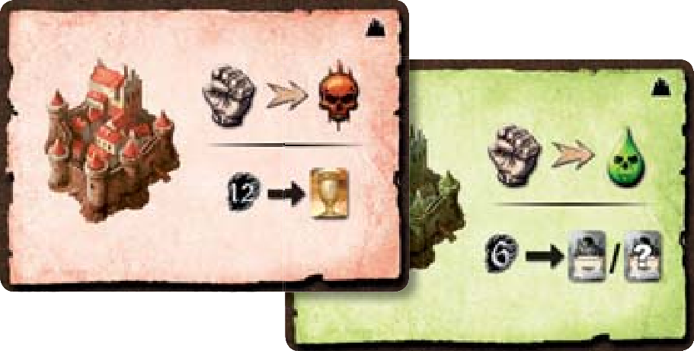
- Treat this pair of cities as one big city:
  - You reveal the entire garrison of the Megapolis from any space adjacent to any of its spaces.
  - You can assault the Megapolis from any space adjacent to any of its spaces.
  - You face the entire garrison of the Megapolis. They are all fortified, and benefit from combat bonuses of both cities simultaneously.
  - In case of a cooperative city assault, players adjacent to any space of the Megapolis can be invited. Randomize and randomly deal all enemies, no matter who stands next to which part of the city.
  - The Megapolis is conquered once all defenders are eliminated. Determine a City leader as normal.
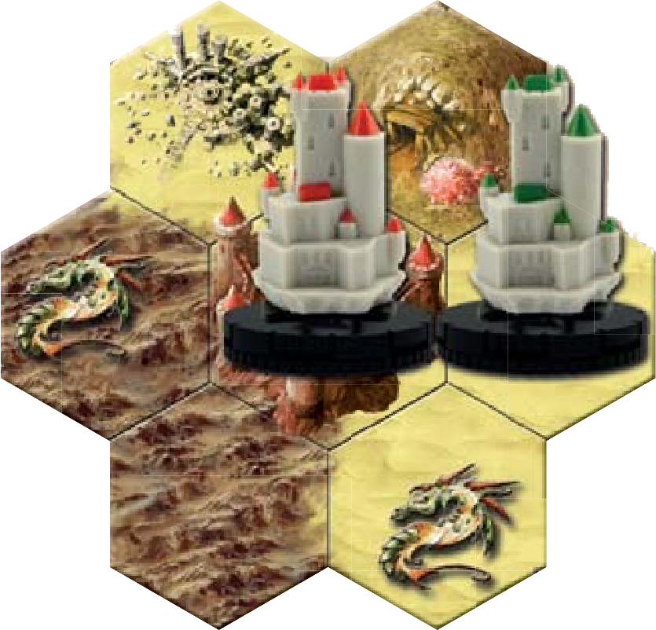
  - If conquered, treat the Megapolis as one big city that has two spaces. A player puts his figure onto the corresponding card to mark which part he is in. He may move from one part to another during movement (for the standard city Move cost of 2), or leave it by entering a space adjacent to the part he is currently in. Also, to challenge a rampaging enemy when in a city, the player has to be on the space adjacent to that enemy.
  - No matter in which part of the city his Hero is, the player may use purchase options of both cities during interaction.
  - During scoring, a Megapolis counts as only one city. Note: Scoring does not take city level into account.
- If you decide to play a scenario with two Megapolis, add a random city to the first revealed city tile. The other two cities will go to the second city tile, even if it happens to be the color you added to the first Megapolis.

RAMPAGE!

This is a kind of side quest. You may add it to any scenario to spice it up.
This kingdom is under heavy raids. Terrorized people are very suspicious and do not trust anyone.
- Your characters start with -2 Reputation (i.e. they have -1 penalty to interaction).
- At the end of each Day, roll a mana die for each space where a rampaging enemy was defeated. If a warm, living color was rolled (red, green or gold), draw a new enemy to that space.
  - If it was gold, also add one brown enemy to the usual green or red token. When fighting this enemy, you have to fight both. The space is considered to contain a rampaging enemy as long as there is at least one of these tokens. You get Reputation +1 for each enemy token defeated.
- At the end of each Night, do the same, except this time cold colors (white, blue or black) count, and you add one extra brown enemy when black is rolled.

More Rampage!
For an even more extreme version of this variant:
- Your characters start with -4 Reputation (i.e. they have -2 penalty to interaction).
- At the end of each Day or Night, you roll a die for each defeated rampaging enemy as above. However the rampaging enemy token is added always, and if a warm (during Day) or cold (during Night) color is rolled, you also add the brown one.

MORE DECKBUILDING

If you feel you would like to have more chance to tune your deck during the game, you may use one of the following variants. We do not recommend them for your first few games. Also, when using these rules, your Hero’s strength rises faster, so you might want to adjust the game difficulty by increasing the city levels.
Note: If using one of these variants or when cards that allow you to gain more Advanced Action cards enter the game early, there is a chance you might run out of Advanced Action cards. In that case, the monastery offer is affected first (do not deal cards there if there are none left). If there are not enough cards to replenish the Advanced Action offer, just use as many as you can. If there are none, the player gets nothing.

Action Upgrades
- At the end of each Night except the final one (i.e. twice during the standard 6-Round scenarios), reveal 2 Advanced Action cards.
- Then, you may (but do not have to) take one of the displayed Advanced Action cards and add it to your deck. At the same time, you also have to throw away one of your Action cards. The new card has to either be of the same color or share at least one type (icon in the upper left corner) as the card thrown away.
- Then, the card or cards no one picked are put to the bottom of the Advanced Action deck.
- You should shuffle your deck well before the next Round.
Note: You might like this variant if you prefer a slower pace of game. It allows you to take a break once or twice during the game (depending on the number of rounds), to examine and review your deck, and to think what it needs to work better.

Drafting at the Start
This variant encourages long term planning. You plan some upgrades for your Hero ahead of time, and can adjust your decisions during the game to suit your plan.
- After choosing your character (but before the map is set, the dice rolled and the offers revealed), take two cards from the Advanced Action deck randomly.
- Choose one of these cards and sets it aside, discarding the other one.
- Continue until you have three cards set aside. Shuffle the ones no one picked back into the Advanced Action deck.
- Keep the cards in a safe place (ideally away from the playing table, so they do not get shuffled into your deck accidentally).
- At the end of each Day round, when you are shuffling your deck, choose one of these cards and shuffle it into your deck.
- Note: You may use these rules even when the scenario has fewer than six rounds. You just do not use all the cards you picked.

SCENARIO LIST

FIRST RECONNAISSANCE

- Credit: Base Game Rulebook
- Expansion required: None
- Length: Four rounds (2 days and 2 nights)
- Purpose: Training scenario. Strongly recommended if you play the game for the first time, as it provides a natural way to learn the game rules and get familiar with them.
On your first mission, you will be sent to an unknown part of the Atlantean kingdom, your task is to locate its Capital. That’s all. All the Fame, any knowledge and treasures you manage to get during your mission are yours to keep.
For a detailed description of this scenario, see the Game
Walkthrough. Here is just a summary:

Setup
- Map Shape: Wedge with no limitations
- Countryside tiles: 8, sorted by numbers
- Core city tiles: 1
- Core non-city tiles: 2
- Cities: Cities cannot be conquered nor entered in this scenario.
- Dummy Player: There is one standard Dummy player (see the General Principles section). However, if you just want to become familiar with the mechanics, you may also ignore the Dummy player in your first game, and enjoy the experience with one hero and no pressure.

Special Rules
- You score 1 Fame whenever you reveal a new tile (no matter which type).
- Gold Units are not used in this scenario.
- You should not reveal Spells and Advanced Action cards until they are needed for the first time.
- When taking Tactics, you always choose first. The Dummy player then takes one random card from those remaining.
- At the end of each Day or Night, remove both used Tactic cards from the game. That means, each Tactic card cannot be picked more than once during the game.

Scenario End
When you reveal a city, you have one last turn. If the Round ends during this, the game ends immediately.

Scoring
Take your Fame as the base. Then apply standard Achievements scoring.

SOLO CONQUEST

- Credit: Base Game Rulebook
- Expansion required: None
- Length: Six rounds (3 days and 3 nights)
- Purpose: Solitaire game. Also suitable for a player who wants to understand the game before explaining it to others.
Yes, that’s true – you are alone now. But the Council still needs these cities to be conquered. Good luck!

Setup
- Map Shape: Wedge
- Countryside tiles: 7
- Core city tiles: 2
- Core non-city tiles: 2
- Cities: the first revealed city is of level 5, the second revealed city is of level 8.
- Dummy Player: There is one standard Dummy player (see the General Principles section).

Special Rules
- When taking Tactics, you always choose first. The Dummy player then takes one random card from those remaining.
- At the end of each Day or Night, remove both used Tactic cards from the game. That means, each Tactic card is picked exactly once during the game.

Scenario End
When all cities are conquered, you have one last turn (the Dummy player does not).

Scoring
If you succeed in defeating all cities, you are victorious. If not, you have failed. In both cases you may count your score, to see how good you were.
Take your Fame as the base. Then apply standard Achievements scoring.
Then score for your goal and for the time to reach it. See the other side of the Scoring card:
- Score 10 points for each city you conquered.
- Score an additional 15 points, if you conquered all cities.
- If you finished the game one or more Rounds before the limit, score 30 points for each such Round.
- Score 1 point for each card in the Dummy player’s Deed deck (that was not yet flipped this Round).
- If the End of the Round was not announced yet in your last Round, score an additional 5 points.

Variants
You may adjust the city levels to set up the right challenge for you.
You may also use a Megapolis.

SOLO BLITZ CONQUEST

- Credit: Base Game Rulebook, BGG user Oxymandias
- Expansion required: None
- Length: Four rounds (2 days and 2 nights)
- Purpose: Shorter scenario that shares most of the mechanics with the standard game, but is faster.
Again, your task is to conquer all cities. You have only two days and two nights this time, so you were imbued with extra power.

Setup
- Map Shape: Wedge, Wedge, or Open limited to 4 columns
- Countryside tiles: 6
- Core city tiles: 2
- Core non-city tiles: 2
- Cities: Each revealed city is of level 3.
- Dummy Player: There is one standard Dummy player (see the General Principles section).

Special Rules
- You start with 1 Fame. Whenever you cross a line on the Fame track, you get 1 extra Fame.
- You start with +2 Reputation (i.e. you have a bonus of +1 for interaction right from the start).
- There are 4 dice in the Source and 4 Units in the offer.
- When taking Tactics, you always choose first. The Dummy player then takes one random card from those remaining.
- At the end of each Day or Night, remove both used Tactic cards from the game. That means, each Tactic card cannot be picked more than once during the game.

Scenario End
When all cities are conquered, you have one last turn (the Dummy player does not).

Scoring
If you succeed in defeating all cities, you are victorious. If not, you have failed. In both cases you may count your score, to see how good you were.
Take your Fame as the base. Then apply standard Achievements scoring.
Then score for your goal and for the time to reach it. See the other side of the Scoring card:
- Score 10 points for each city you conquered.
- Score an additional 15 points, if you conquered all cities.
- If you finished the game one or more Rounds before the limit, score 30 points for each such Round.
- Score 1 point for each card in the Dummy player’s Deed deck (that was not yet flipped this Round).
- If the End of the Round was not announced yet in your last Round, score an additional 5 points.

Variants
You may adjust the city levels to set up the right challenge for you.
You may also use a Megapolis.

SOLO MINES LIBERATION

- Credit: Base Game Rulebook, BGG user Dr. snowMan
- Expansion required: None
- Length: Four rounds (2 days and 2 nights)
- Purpose: A shorter scenario similar to the standard one, but with different goals. Fight in the tunnels!
Mines in this friendly kingdom are occupied by enemies! Without a supply of crystals, Mages cannot serve the land. Go there and regain them.

Setup
- Map Shape: Wedge, Wedge, or Open limited to 4 columns
- Countryside tiles: 7 (4 with mines, 3 without mines).
- Core city tiles: 1 (always the red city)
- Core non-city tiles: 1 (with a mine).
- Cities: The city is friendly. You start with one shield token on it.
- Dummy Player: There is one standard Dummy player (see the General Principles section).

Special Rules
- When a mine is revealed, put one green (if on a Countryside tile) or red (if on a Core tile) enemy token on it, face up. Also, add one brown enemy token, face down. These are enemies controlling the mine (one is hidden in the deeps). Arrange them in a way that the reverse of the brown one is visible, too, to distinguish them from rampaging enemies.
- To liberate a mine, you may enter it from its space (as an Action). Fight both enemies. Night rules apply as in a Dungeon (but you can use your Units). If you do not defeat both, the remaining token(s) stay on the space. They can be attacked again later.
- When you defeat the last enemy, you liberate the mine. Mark it and gains +1 Reputation (+2, if on a Core tile).
- Until liberated, mines produce no crystals. Once liberated, they produce as usual (the production starts immediately, so you get one crystal on the turn you liberated the mine).
- At the start of Day or Night, you gain one crystal from every mine you already conquered, no matter how far away it is on the map. Just a gift from the grateful miners.
- Note: If there are not enough brown tokens, use some substitute for the brown monsters that are on the map but not revealed yet. Draw a new brown monster when it is about to be revealed.
- When taking Tactics, you always choose first. The Dummy player then takes one random card from those remaining.
- At the end of each Day or Night, remove both used Tactic cards from the game. That means, each Tactic card cannot be picked more than once during the game.

Scenario End
When all map tiles are revealed and all mines are liberated, you have one last turn (the Dummy player does not).

Scoring
If you liberated all mines, the mission was successful.
Take your Fame as the base. Then apply standard Achievements scoring.
In addition you score 4 Fame for each of your mines in Countryside and 7 Fame for each mine on Core tiles.

Variants
4 Rounds is a tough challenge. You may adjust the length to 5 rounds (3 days and 2 nights) or 6 rounds (3 days and 3 nights) to lower the difficulty.

SOLO DRUID NIGHTS

- Credit: Base Game Rulebook, BGG user Kin Hassar
- Expansion required: None
- Length: Four rounds (2 days and 2 nights)
- Purpose: A shorter scenario similar to the standard one, but with different goals. How big a challenge dare you encounter?
Have you noticed the mysterious obelisks with engraved symbols on the magical glades around this kingdom? Go and investigate!

Setup
- Map Shape: Wedge, Wedge, or Open limited to 4 columns
- Countryside tiles: 7 (remove only tiles with no magical glades on them).
- Core city tiles: 1 (always the green city)
- Core non-city tiles: 1.
- Cities: The city is friendly. Put one Shield token on it.
- Dummy Player: There is one standard Dummy player (see the General Principles section).

Special Rules
- When ending your movement on a magical glade, you may activate it – mark the glade with your Shield token.
- Once during the first Night, in any of your turns, you may perform an incantation. You may not be at an inhabited space and it counts as your Action for that turn. It summons one monster for each glade you have your Shield token on – draw that many brown enemies and fight them.
  - The ones you defeat bring you twice as many Fame.
  - The ones you do not defeat disappear after the combat (but the Wounds they did do not).
  - Regardless how many of them you defeated, at the end of your turn you get one random crystal for each monster you summoned (roll a die for each, like in a monster den).
- At the end of the first Night, remove all Shield tokens from the glades. You have to mark them again, if you want to use them for an incantation the second night.
- During the second Night, you may do the same, except this time you summon red enemies. The Fame for defeated ones is doubled again, and this time you get two random crystals for each enemy.
- When taking Tactics, you always choose first. The Dummy player then takes one random card from those remaining.
- At the end of each Day or Night, remove both used Tactic cards from the game. That means, each Tactic card cannot be picked more than once during the game.

Scenario End
When you have performed the incantation during the second Night (in that case, you have more turn, but the Dummy player does not), or at
the end of the second Night.

Scoring
Take your Fame as the base. Then apply standard Achievements scoring.
In addition you score 15 Fame for each of incantation you made (even if you defeated no monster).

Variants
You may play an Epic version that lasts 3 Days and 3 Nights. Add one countryside tile and one non-city core tile to the game.. Remove the Shields after the second Night, too. During the third Night, you summon one brown and one red enemy for each magical glade you have marked, and get three crystals for each pair summoned.

DUNGEON LORDS

- Credit: Base Game Rulebook, BGG user Dsnowman
- Expansion required: None
- Length: Five rounds (3 days and 2 nights)
- Purpose: A shorter scenario similar to the standard one, but with different goals. Let’s go underground.
We thought we already controlled this land. We were wrong! There is a vast system of underground tunnels under the kingdom. We do not know who dug these tunnels and why, but we do not care. Go, and seize control of them!

Setup
- Map Shape: Wedge, Wedge, or Open limited to 4 columns
- Countryside tiles: 7 (remove only tiles with no dungeons on them).
- Core city tiles: 1 (always the Blue city)
- Core non-city tiles: 1 (always the desert tile with monastery and tomb).
- Cities: The city is friendly. Put one Shield token on it.
- Dummy Player: There is one standard Dummy player (see the General Principles section).

Special Rules
- Whenever a tile with a village is revealed, choose any accessible non-swamp space adjacent to that village (it can even be on a neighboring tile) that has no site on it. From now on, there is a secret dungeon entrance on this space. Put a face down brown enemy token on the space to mark it.
- •A secret dungeon entrance works like any other dungeon (see its description card). If you conquer it, mark the space and claim your reward. If you fail, discard the monster token and put another random brown enemy on that tile.
- The same applies for monasteries except you put a red enemy token to an adjacent empty space to mark there is a secret tomb.
- The secret tomb works the same way as regular tombs.
- Conquered dungeons and tombs (both regular and secret ones) cannot be entered again to fight for more Fame in this scenario.
- All conquered tombs and dungeons (including the secret ones) are connected.
  - When on a conquered dungeon or tomb space during movement, you may move to any other conquered dungeon or tomb space.
  - These two spaces do not have to be of the same type (you may travel from a regular dungeon to a hidden tomb etc.)
  - To do so, you have to pay 2 Move points plus 1 Move point for each space you traveled.
  - When measuring the distance, you have to go through revealed spaces, and you have to avoid lakes and swamps. If it is not possible, you cannot travel there.
- When taking Tactics, you always choose first. The Dummy player then takes one random card from those remaining.
- At the end of each Day or Night, remove both used Tactic cards from the game. That means, each Tactic card cannot be picked more than once during the game.

Scenario End
When all map tiles are revealed and all dungeons and tombs are conquered, you have one last turn (the Dummy player does not).

Scoring
If you conquered all the dungeon and tombs, the mission was successful.
Take your Fame as the base. Then apply standard Achievements scoring.
When scoring Adventures, also count the secret dungeons and tombs. All dungeons and tombs give 4 points instead of 2.

SOLO TO RETURN

- Credit: Base Game Rulebook, BGG user Kin Hassar
- Expansion required: None
- Length: Four rounds (2 days and 2 nights)
- Purpose: A push your luck scenario for those who want to raid the Atlantean continent.
This is an ultimate test of your power. You are sent to an unknown part of the kingdom and the portal closes after you go through it. After two days and two nights, the portal opens again for a short while. Only by being at the portal at that moment you can return home.

Setup
- Starting Tile: Wedge
- Countryside tiles: 6
- Core city tiles: 1
- Core non-city tiles: 1
- Cities: Each revealed city is of level 3.
- Dummy Player: There is one standard Dummy player (see the General Principles section).

Special Rules
•The portal closes at the end of the Day 1 (if you are on the portal at that time you would be eliminated from the game). From now on, the portal works as an empty plain space.
- When taking Tactics, you always choose first. The Dummy player then takes one random card from those remaining.
- At the end of each Day or Night, remove both used Tactic cards from the game. That means, each Tactic card cannot be picked more than once during the game.

Scenario End
The scenario ends as soon as the second Night is over.

Scoring
If you stand at portal space at the end of the second night, you are victorious. If not, your mission is a failure.
In both cases you may count your score, to see how good you were.
Take your Fame as the base. Then apply standard Achievements scoring.
Then score for your:
- Score 10 points for each city you conquered.
- If you did not return to the portal in due time, halve your score (rounded down).

Variants
You may play an Epic version that lasts 3 Days and 3 Nights. Add one tile of each type to the game. In addition, you may increase the level of cities to 4.

GRAND CONQUEROR

- Credit: BGG user Maciej Krok
- Expansion required: None
- Length: Six rounds (3 days and 3 nights)
- Purpose: A scenario which would allow you to conquer all 4 cities, delivering the feeling that you really own this land before game ends.

Setup
- Starting Tile: Wedge
- Countryside tiles: 5 (numbers: 1, 5, 7, 9, 11)
- Core city tiles: 4 (Blue, Green, Red, White)
- Core non-city tiles: 0
- Cities: Green lvl 2, White lvl 4, Blue lvl 6, Red lvl 8
- Dummy Player: There is one standard Dummy player (see the General Principles section).
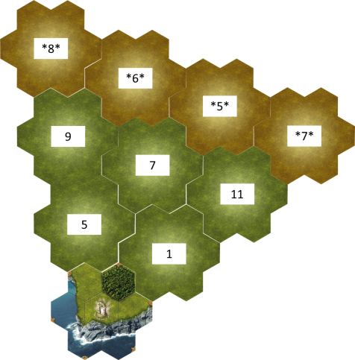

- You should put tiles A, 1 and 5 face up as usual, and place the rest in their places as stated above face down (they still need to be explored to gain access to them). In this scenario rushing to explore core tiles is perfectly legal, so you're not forced to explore all countryside tiles before being able to reach core tiles

Special Rules
- You start with 1 Fame. Whenever you cross a line on the Fame track, you get 1 extra Fame.
- You start with +2 Reputation (i.e. you have a bonus of +1 for interaction right from the start).
- There are 4 dice in the Source and 4 Units in the offer.
- At the start of the game place 4 spells in the offer. Pick one and shuffle it into your deck. Thereafter the spell offer will be 3 cards as usual.
- Start with one black crystal in your Inventory. This is a one-time ability.
- You have night vision for this mission allowing you to reveal Fortification sites as if it is day.
- Instability of the temporal energies makes use of the Portal impossible. The Void Council teleports you directly into the forest adjacent to the Portal.
- When taking Tactics, you always choose first. The Dummy player then takes one random card from those remaining.
- At the end of each Day or Night, remove both used Tactic cards from the game. That means, each Tactic card cannot be picked more than once during the game.

Scenario End
When all cities are conquered, you have one last turn (the Dummy player does not).

Scoring
If you succeed in defeating all cities, you are victorious. If not, you have failed. In both cases you may count your score, to see how good you were.
Take your Fame as the base. Then apply standard Achievements scoring.
Then score for your goal and for the time to reach it. See the other side of the Scoring card:
- Score 10 points for each city you conquered.
- Score an additional 15 points, if you conquered all cities.
- Score 5 additional points for each Mage Tower conquered
- Score 10 additional points if all Mage Towers have been conquered.
- If you finished the game one or more Rounds before the limit, score 30 points for each such Round.
- Score 1 point for each card in the Dummy player’s Deed deck (that was not yet flipped this Round).
- If the End of the Round was not announced yet in your last Round, score an additional 5 points.

Variants
Setup and Special Rules above described the easy mode of this scenario.
If you want to raise the difficulty do as follows:
- Normal: Play as per normal rules instead of blitz rules:
  - You start with no Fame. You don’t get extra fame when you cross a line on Fame Track.
  - You start with 0 Reputation.
  - There are 3 dice in the Source and 3 Units in the offer.
- Hard: Same as normal plus increase cities levels by 1.

SOLO BLITZ CONQUEST: SPELLBOUND

- Credit: BGG user Tokhuah
- Expansion required: None
- Length: Four rounds (1 day and 3 nights)
- Purpose: A fast pace game in the dark with more Mage Towers than usual.
There is an unnatural darkness looming in the East. Two depleted and pitiful cities that have been at war for centuries decided to break their ageless stalemate by invoking things better left hidden. This has been done through a dangerous use of arcane mage powers. They have gone too far and upset the balance of the mystic energies. A darkness is falling, a darkness of endless night enveloping a spellbound world heading into the abyss. The Council of the Void has charged you with the task of breaking the spell by taking control of both Cities and as many Mage Towers as possible.

Setup
- Starting Tile: Wedge
- Countryside tiles: 5 (three with mage tower [4, 9, 11, 13] & two without mage tower)
- Core city tiles: 2 (Blue City & one random)
- Core non-city tiles: 1 (2, 3 or 9 chosen randomly)
- Cities: Each revealed city is of level 1.
- Dummy Player: There is one standard Dummy player (see the General Principles section).

Special Rules
- You start with 1 Fame. Whenever you cross a line on the Fame track, you get 1 extra Fame.
- You start with +2 Reputation (i.e. you have a bonus of +1 for interaction right from the start).
- There are 4 dice in the Source and 4 Units in the offer.
- At the start of the game place 4 spells in the offer. Pick one and shuffle it into your deck. Thereafter the spell offer will be 3 cards as usual.
- Start with one black crystal in your Inventory. This is a one-time ability.
- You have night vision for this mission allowing you to reveal Fortification sites as if it is day.
- Instability of the temporal energies makes use of the Portal impossible. The Void Council teleports you directly into the forest adjacent to the Portal.
- When taking Tactics, you always choose first. The Dummy player then takes one random card from those remaining.
- At the end of each Day or Night, remove both used Tactic cards from the game. That means, each Tactic card cannot be picked more than once during the game.

Scenario End
When all cities are conquered, you have one last turn (the Dummy player does not).

Scoring
If you succeed in defeating all cities, you are victorious. If not, you have failed. In both cases you may count your score, to see how good you were.
Take your Fame as the base. Then apply standard Achievements scoring.
Then score for your goal and for the time to reach it. See the other side of the Scoring card:
- Score 10 points for each city you conquered.
- Score an additional 15 points, if you conquered all cities.
- Score 5 additional points for each Mage Tower conquered
- Score 10 additional points if all Mage Towers have been conquered.
- If you finished the game one or more Rounds before the limit, score 30 points for each such Round.
- Score 1 point for each card in the Dummy player’s Deed deck (that was not yet flipped this Round).
- If the End of the Round was not announced yet in your last Round, score an additional 5 points.

Variants
You may adjust the city levels to set up the right challenge for you.

HUNTING FOR THE ROGUE KNIGHT

- Credit: BGG user Javasrybe
- Expansion required: None
- Length: Four rounds (2 day and 3 nights starting at night)
- Purpose: A solo exploration scenario with a climactic finale.
A Rogue Knight has become sympathetic to the cause of the inhabitants of an Atlantean City, and has become their protector. By doing so, he betrayed the will of theCouncil of the Void. Find him, and Kill him.

Setup
- Starting Tile: Wedge
- Countryside tiles: 6
- Core city tiles: 4
- Core non-city tiles: 0
- Cities: Cities are level 4. The Rogue Knight's City level is taken into account into the Rogue's abilities (see below)
- Dummy Player: There is one standard Dummy player (see the General Principles section). The Dummy player is the Knight you were sent to assassinate. Goldyx is hiding in the Green City, Norowas in the White City, Tovak in the Blue city and Arythea in the Red City.

Special Rules
- When taking Tactics, you always choose first. The Dummy player then takes one random card from those remaining.
- At the end of each Day or Night, remove both used Tactic cards from the game. That means, each Tactic card cannot be picked more than once during the game.
- When you find the Rogue Knight's City, put his figurine and the normal Units on the card.
- When you conquer the Rogue Knight's City, end the round and calculate remaining cards for the Scoring. A special "Duel to the Death" Round then begins.
  - Shuffle all your cards into your Deed Deck and reset "Round" Skills. Do not change the day/night cycle or any Offer (Spell, Action, Unit).
  - The Rogue Knight's Attack Score equals His City's Level + White or Red Crystals, whichever he has the most.
  - His Armor Stat His City's Level + Blue or Green Crystals, whichever he has the most.
  - In addition, he has the following Abilities:
  - Goldyx: Brutal.
  - Arythea: Fire Attack, Cold Resistance.
  - Tovak: Cold Attack, Fire Resistance.
  - Norowas: Swift.
  - Use the "Player VS Player" rules, with the following differences:
    - One on One: You cannot use your Units for the Duel with the Rogue Knight.
    - Up close and personal: There is no Ranged/Siege phase for the Duel, although you can use them normally as Attacks.
    - Play attacks alternatively, starting with your opponent, and Assign Damage as you would for Single Player (i.e. Wounds only occur when there is damage greater or equal to Armor)
    - End the "turn" after each of your attack.(Discard, Reset Source and Skills, Draw, etc.)
    - If you ever accumulate a number of Wounds in hand equal to your Hand Size, you lose the duel and your opponent will finish you off mercilessly.
    - You also lose if you run out of cards.
    - Should you inflict the Rogue Knight a number of Wounds equal to his City's level, he is defeated and you execute him for his betrayal.

Scenario End

This scenario ends in blood, with Rogue Knight's death (or yours).

Scoring
Take your Fame as the base. Then apply standard Achievements scoring.
Then score for your goal and for the time to reach it. See the other side of the Scoring card:
- Score 10 points for each city you conquered.
- Score an additional 15 points, if you conquered all cities.
- If you finished the game one or more Rounds before the limit, score 30 points for each such Round.
- Score 1 point for each card in the Dummy player’s Deed deck (that was not yet flipped before the Duel).
- If the End of the Round was not announced yet in your last Round before the Duel, score an additional 5 points.
If you defeat the Rogue Knight, double your score.
If you did not find the Rogue Knight, halve your score.

Variants
If you want an easier/tougher fight, vary the level of the Rogue's city (affecting his Attack/Armor and Wounds)

Tip
Since you will know from the start which Mage Knight you're facing, shape up your Actions and Spells accordingly! (For instance, Packing up on Cold Blocks before facing Arythea sounds like a good idea...)

REVENGE OF THE DRAGON LORDS

- Credit: BGG user Andrew_zz
- Expansion required: None
- Length: Nine rounds (2 day and 1 night repeated 3 times)
- Purpose:
  - To create a play tested bigger challenge for solo players
  - To make passing a location and returning later a viable option as previously it felt like a one way trek
  - Making choosing tactics cards is a little more interesting as you can ensure you play first, coupled with the dummy player playing a little faster.
  - Creating choices. After gaining a few fame the player is split between aiming to conquer the first city for the elite units or defeating the first dragon for the artifact
The dragon lords have taken control of the four capital cities and you need to recapture them saving the kingdom.

Setup
- Starting Tile: Open Map, 3 Columns
- Countryside tiles: 10
- Core city tiles: 4
- Core non-city tiles: 1
- Tiles are stacked as two countryside tiles followed by a core tile, repeated 5 times. First Core tile is the non-city tile. This means the core tile will be in play from the start of the game, make sure this is the central tile (after this they can be placed anywhere).
- Cities: First City is level 7, Second City is level 11, Third City is level 7 with an extra Draconum and Fourth City is level 11 with an extra Draconum. If a Draconum is defeated but the city is not then the Draconum is replaced.
- Dummy Player: There is one standard Dummy player (see the General Principles section).

Special Rules
- When taking Tactics, randomly deal 3 cards to the Dummy player who takes the middle value one. You then choose your Tactic card between the 3 remaining.
- Before starting the game draw three advanced actions, pick one to add to your deck and place the other two into the dummy player’s deck. Add to the Dummy player card three crystals per card added of the same color as the card (in addition to the 3 regular crystals).
- An assault against a city does not decrease reputation.
- No elite units will be in the offering until at least one city is defeated.
- You may not interact with a monastery until you have defeated at least one dragon. The first time you visit any monastery after defeating a dragon you gain a free artifact.
- You start each turn with two movements even if you have no cards in hand.

Scenario End

When all cities are conquered, you have one last turn (the Dummy player does not).

Scoring
Take your Fame as the base. Then apply standard Achievements scoring.
Then score for your goal and for the time to reach it. See the other side of the Scoring card:
- Score 10 points for each city you conquered.
- Score an additional 15 points, if you conquered all cities.
- If you finished the game one or more Rounds before the limit, score 30 points for each such Round.
- Score 1 point for each card in the Dummy player’s Deed deck (that was not yet flipped before the Duel).
- If the End of the Round was not announced yet in your last Round before the Duel, score an additional 5 points.
If you defeat the Rogue Knight, double your score.
If you did not find the Rogue Knight, halve your score.

Variants
If you want tougher challenge, set time limit to 8 (losing 1 night) or even 7 rounds (losing 1 day and 1 night).

RETURN TO THE VOID

- Credit: BGG user Javasrybe
- Expansion required: None
- Length: Variable (about 4 Rounds)
- Purpose: The object of the game is to reach the portal.
You feel it’s presence as soon as you pass through the portal on your dark mission, though you know not what it means. Dozens of cities have fallen to your might and magic, but this time feels different.
In less than a day, garrisons have fallen, mages cowed, and Orc Khan obliterated. Your speed and might are unparalleled. Across the days, your powers grow and your ranks swell with the disillusioned masses of the Atlantian Empire. By all appearances, everything is as it should be as you approach your waiting target - that towering monolith of a city that your enemies hide within. Even so, an unshakable sense of coming doom stirs in your heart. You become weaker as something within the city saps your strength and renders your powers impotent. All too soon, you discover why. The Atlantian’s have discovered a secret weapon that brings you to your knees.
They call it the Mage Stone, a shimmering rune of unimaginable power, crafted to devour the very essence of the Void. That which made you special, that which made you powerful, is gone. With your Mage Knight powers drained, you fall to the combined forces of Atlantian forces within the city.
…
The Mage Stone can sap the powers of the mightest Mage Knight, but it cannot destroy the resolve of those that rally to his cause. Nary a week after your capture, your prison is liberated by the peasants and town-folk who call you leader. Your only hope now is to escape back to the Void and warn the Council of the coming danger. Time is of the essence however. Your former captors will stop at nothing to hunt you down.

Setup
- Starting Tile: 1 Random City, See below
- Countryside tiles: 8
- Core city tiles: 1-4 (Variable – see below)
- Core non-city tiles: 2-5 (Variable – see below)
- Randomly pick one City Tile as your starting tile. Then mix all remaining Core Tiles and draw 5.
- Cities: Cities are level 1 except starting city which has no enemy at the beginning.
- Set the map as follows:
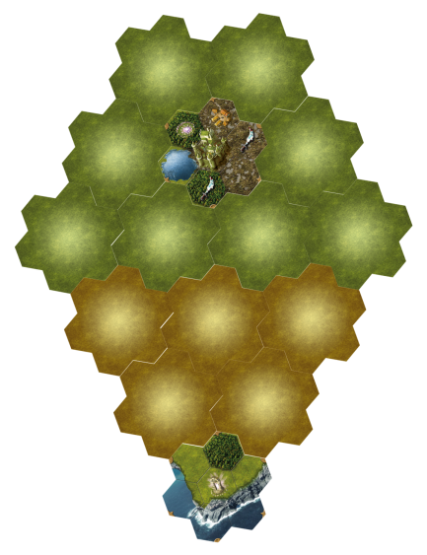

- Tiles are flipped face up when they are explored (by spending 2 movement points)
- Dummy Player: There is no Dummy player.

Round Order:
With your Mage Knight abilities drained, your speed and powers are reduced. While it took you mere days to reach the city, it will take you weeks to return to the portal. Each Round is three days long, and is represented by 6 tactic cards (the first 3 daytime and first 3 nighttime tactics). Form a deck of these tactic cards by arranging them in day/night order from 1 to 3 (Day 1, Night1, Day 2, Night 2, etc.). This is the Round Deck.
To begin the game, reveal the top card from the Round Deck (Day Tactic 1). Play a Turn while this tactic card is revealed. Daytime rules apply when a daytime tactic is showing.
On your next turn, reveal the next card from the Round Deck (Night Tactic 1). Play a Turn while this tactic is revealed. Nighttime rules apply. In this way, you will work your way through the Round Deck until it is depleted. Ignore any text on Tactic cards.
After the third night, when your Round Deck is depleted, the Round is over. If your draw deck is depleted in the middle of the round, you may not act for the remaining "days" of the week. You are exhausted and will need to rest before continuing. The enemy unit, however, will continue to advance on days that you rest (see Hunted section below).

Special Rules
- You start on the revealed city space (random color).
- Use 4 mana dice in the source. They are rerolled each Round (see above).
- Start the game with a Peasants unit. These are the people who liberated you.
- Followers are reactivated each day (before your daytime turn).
- You start the game with 0 fame and 0 reputation.
- All cities revealed are at level 1 and react like roaming monsters to your movements. (They will attack if you move from one adjacent spot to a different adjacent spot.) You lose no reputation if they attack you, but you will lose reputation if you assault the city. If you move into an undefended city (because you already defeated them) you do not lose reputation.
- Advanced Units are added to the offering once a second city tile is revealed.

Hunted
The city forces have been alerted to your escape. On the start of the second day of the first Round, place a white city forces token face down on the city spot. This represents the forces organizing the hunt. On the start of the third day of the first Round (before you move), move the city forces token one space toward your character. On each subsequent "day" turn before you have acted, move them another one space toward your character.
Hunters cannot move on lakes, mountains or spaces occupied by rampaging enemies. However they can go through keeps, cities and mage towers.
When two paths are equivalent, Hunter should always take the northernmost path to force you toward the portal.
This force possesses the Mage Stone and cannot be defeated. If they ever enter the space you are on, you are defeated. You are also weakened by the Mage Stone. If you are Knocked Out at any time during the game, you are defeated.

Scenario End
- If the approaching city forces enter your space, then you lose the scenario.
- If you are knocked out at any time, then you lose the scenario.
- You win by reaching the portal

Scoring
Take your Fame as the base. Then apply standard Achievements scoring.

Variants
You may increase the city levels to get tougher challenge.

REVENGE OF THE DRAGON LORDS

- Credit: BGG user Andrew_zz
- Expansion required: None
- Length: Nine rounds (2 day and 1 night repeated 3 times)
- Purpose:
  - To create a play tested bigger challenge for solo players
  - To make passing a location and returning later a viable option as previously it felt like a one way trek
  - Making choosing tactics cards is a little more interesting as you can ensure you play first, coupled with the dummy player playing a little faster.
  - Creating choices. After gaining a few fame the player is split between aiming to conquer the first city for the elite units or defeating the first dragon for the artifact
The dragon lords have taken control of the four capital cities and you need to recapture them saving the kingdom.

Setup
- Starting Tile: Open Map, 3 Columns
- Countryside tiles: 10
- Core city tiles: 4
- Core non-city tiles: 1
- Tiles are stacked as two countryside tiles followed by a core tile, repeated 5 times. First Core tile is the non-city tile. This means the core tile will be in play from the start of the game, make sure this is the central tile (after this they can be placed anywhere).
- Cities: First City is level 7, Second City is level 11, Third City is level 7 with an extra Draconum and Fourth City is level 11 with an extra Draconum. If a Draconum is defeated but the city is not then the Draconum is replaced.
- Dummy Player: There is one standard Dummy player (see the General Principles section).

Special Rules
- When taking Tactics, randomly deal 3 cards to the Dummy player who takes the middle value one. You then choose your Tactic card between the 3 remaining.
- Before starting the game draw three advanced actions, pick one to add to your deck and place the other two into the dummy player’s deck. Add to the Dummy player card three crystals per card added of the same color as the card (in addition to the 3 regular crystals).
- An assault against a city does not decrease reputation.
- No elite units will be in the offering until at least one city is defeated.
- You may not interact with a monastery until you have defeated at least one dragon. The first time you visit any monastery after defeating a dragon you gain a free artifact.
- You start each turn with two movements even if you have no cards in hand.

Scenario End

When all cities are conquered, you have one last turn (the Dummy player does not).

Scoring
Take your Fame as the base. Then apply standard Achievements scoring.
Then score for your goal and for the time to reach it. See the other side of the Scoring card:
- Score 10 points for each city you conquered.
- Score an additional 15 points, if you conquered all cities.
- If you finished the game one or more Rounds before the limit, score 30 points for each such Round.
- Score 1 point for each card in the Dummy player’s Deed deck (that was not yet flipped before the Duel).
- If the End of the Round was not announced yet in your last Round before the Duel, score an additional 5 points.
If you defeat the Rogue Knight, double your score.
If you did not find the Rogue Knight, halve your score.

Variants
If you want tougher challenge, set time limit to 8 (losing 1 night) or even 7 rounds (losing 1 day and 1 night).

THE APPRENTICE

- Credit: Bruce Clark
- Expansion required: None
- Length: 6 (or 4) rounds
- Purpose: A young aggressive apprentice seeks to take over the mantle as the country's only Mage Knight!
Growing up in your countryside village, you have lived a happy, safe life. Ever vigilant, the Mage Knights would always protect your town from vile Orcs, rampaging draconum, and wandering warlocks. You had looked up to them, wanted to be one someday. You would always practice sparring with your friends, but you eventually grew tired of all the easy combat.
Upon entering adulthood, one of the Mage Knights visiting your village noticed your skill with a weapon, and quickly brought you under his tutelage. He was a firm Master, but fair. He would teach you everything he knew about Mage Knighthood, and you were hungry for more. One day soon you would plan to overtake your Master, and seek out your own conquests.

Setup
- Starting Tile: Special (1,2 and 3), No limitation
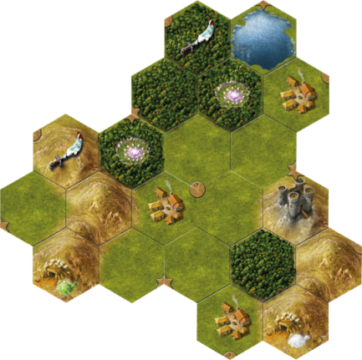
- Countryside tiles: 5 (or 3)
- Core city tiles: 1
- Core non-city tiles: 2
- Tiles are stacked with Countryside tiles on top and the City Tile at the bottom.
- Cities: City is level 4.
- Roll 6 mana dice to fill the source (day side). Re-roll any black mana.
- Your starting hand consists of 2 Wounds and 3 cards from your starting deck
- Start with your character on the village on tile 2.
- Populate Rampaging Orcs and Keep per standard rules (as shown above)
- Choose another Mage Knight to represent your Master. Shuffle the Master’s deck and set to the side face down

Special Rules
- There are no tactics in this game.
- You may use only 1 mana from the source per turn (unless a card says otherwise). Do not return this die at the end of your turn. If all mana from the source is expelled, end the Round after your current turn. The Round may also end if you depleted your deck as per normal rules.
- Each Round has 6 mana. Days always start without black mana. Nights can start with up to 2 mana (re-roll any gold mana).

Play:
- You are an Apprentice Mage Knight, under the tutelage of a Master. You start out weaker than normal, represented by the 2 Wounds in your hand. These 2 Wounds cannot be healed.
  - When you achieve Level 2, you simply remove 1 Wound from play (you will still have 1 un-removable Wound in your hand).
  - At level 3, you will be at full strength, removing the 2nd Wound.
- Your Master will help you on your journey. Move, Attack, Block, and Influence are as normal, but if you need help in battle, reveal the top card from your Master’s Deck.
  - The stronger effect will be free (no mana required), or it can always be played sideways for 1x (as usual). He can only assist in Battle (Block or any kind of attack).
  - If you use his help, reduce fame gained by 2 per card played (to a minimum of 1).
- While you are training, Rampaging Orcs will re-spawn at the start of each new Round (after you successfully overtake your Master, the Rampaging Orcs no longer re-spawn).
- At any time, you may return to your starting Village to challenge your Master (in fact, if you can’t challenge him and win by the end of the 2nd Round, you lose).
  - To challenge him, draw a Purple Enemy Token while at the starting Village and play normally. Your Master won’t help you, of course.
  - Take a -2 penalty to Reputation each time you challenge your Master
After over taking your Master:
Undeterred by his recent loss to his Apprentice, the Master flees to a nearby City. Menacingly, he sends dragons and other units out to hunt down his former pupil, to try to teach him a permanent lesson. The former Apprentice's resolve is hardened and will not rest till he defeats his former mentor one last time. This country is not big enough for 2 Mage Knights.
- At start of a new Round, draw 3 cards from your Master’s deck. Remove 1 of each colored mana from the source, if possible.
- At the start of Rounds 3 and 4, the Master immediately dispatches a Draconum to fight you at the start of each Round (after the Source has been populated). Fight as normal (full starting hand and readied units). If you do not defeat the Draconum, it takes your place and pushes you back 1 space. For now on it is a rampaging enemy. Also add a grey token to the City defenses.
- At the start of Rounds 5 and 6, the Master sends a White enemy (while still adding a grey token to the City defenses). If you do not defeat the White enemy, it takes your place and pushes you back 1 space. For now on it is a rampaging enemy
- When ready, attack the City to win the game, adding any additional grey tokens to the city’s defenses.

Scenario End

If you do not defeat your Master by the end of Round 2, you lose.
If you do not conquer the City by the end of Round 6, you lose.

If you manage to conquer the City you are victorious.

Scoring
Take your Fame as the base. Then apply standard Achievements scoring.

Variants
You may adjust the city level to set up the right challenge for you.

THE GAUNTLET

- Credit: Trevin Beattie
- Expansion required: None
- Length: Six rounds (3 days and 3 nights)
- Purpose: A solitaire game whose goal is to get to the end!
The Council of the Void has taken note of your deeds and selected you to go on a mission to retrieve a rare artifact from the city of the desert. This city can only be reached through a long and treacherous canyon. Hurry, your time is limited!

Setup
- Map Shape: Linear. Use side B of the starting tile. Each new tile extends in the opposite direction from the point of the coast. (The “Random Tiles Orientation” variant is not permitted in this scenario.) The first tile next to the starting tile is revealed as normal.
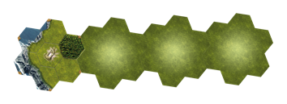
- Countryside tiles: 7. Remove country tile 11 before shuffling and drawing the country tiles.
- Core city tiles: 1, always the red city, at the bottom of the tile stack.
- Core non-city tiles: 3. If playing with the Lost Legion expansion, choose three of the core tile 2, 4, 9, & 10. With just the base game, use tile 2, 4, and one other random tile (remove one with no rampaging site).
- Cities: The city is friendly. Place its city card in play but do not put any shield token on it.
- Dummy Player: There is one standard Dummy player (see the General Principles section).
- Skills: You may use either the competitive or cooperative Skill in the player’s Skill deck.

Special Rules
- When taking Tactics, you always choose first. The Dummy player then takes one random card from those remaining.
- At the end of each Day or Night, remove the Tactic card that you used from the game. Return the Dummy player’s Tactic card to the deck.
- For every second rampaging orc you defeat, in addition to increasing your reputation, add one of your shield tokens to the city.
- When you defeat a rampaging draconum, in addition to increasing your reputation by 2, add one shield token to the city.
You can double-check the number of shield tokens which should be on the city by adding half of the defeated rampaging orc spaces plus all of the defeated rampaging draconum spaces.

Scenario End

The game ends at the end of the turn in which you buy an artifact from the red city, or at the end of the sixth round, whichever comes first.

Scoring
If you succeed in entering the red city and buy an artifact, your mission was successful. If not, you have failed. In both cases you may count your score to see how good you were.
Take your Fame as the base. Then apply standard Achievements scoring.
Then score for your goal and for the time to reach it:
- Score 10 points for entering the red city.
- Score an additional 10 points for buying an artifact from the red city.
- If you finished the game one or more Rounds before the limit, score 40 points for each such Round.
- Score 2 points for each card in the Dummy player’s Deed deck (that was not yet flipped this Round).
- If the End of the Round was not announced yet in your last Round, score an additional 5 points.

STROLLING IN THE DEEP

- Credit: Artemus Maximus
- Expansion required: None
- Length: Six rounds (3 days and 3 nights)
- Purpose: A solitaire game similar to Solo Conquest, but with aggressive moving enemies.
The Council of the Void has sent you back to a kingdom that has already been conquered by a fellow Mage Knight recently. Unfortunately, this Mage Knight, who remains nameless, did not thoroughly cleanse the land of evil. While the White City remains loyal, the rest of the land has fallen under the threat of a dark sorcerer that has usurped rule of the neighboring Red City. He has sent his minions forth to regain control of the land – Orcs once again roam the countryside, marauding the Villages and Monasteries. Terrible monsters from the depths of the underground are emerging in great numbers as well. And what’s worse, the Draconum have returned with a vengeance, scouring the land and destroying anything in their paths. The fortified Keeps and Mage Towers have shut their gates, fearful to let anyone or anything in. You must cleanse this land once again, and retake the Red City.

Setup
- Map Shape: Wedge
- Countryside Tiles: 6 (include tiles 6, 7, 9, & 10)
- Core City Tiles: 2 (the Red and White Cities)
- Core non-City Tiles: 3 (include tiles 1 & 3)
- Cities:
- Dummy Player: There is one standard Dummy player (see the General Principles section).
- You will also need the Dummy player’s Shield Tokens.
- Ancient Ruins Tokens: Remove all tokens depicting Green, Tan, and/or Red enemy tokens to fight for reward. They will not be used.
- Lost Legion Expansion: All components may be included, except:
  - Volkare’s Camp tile
  - Volkare
  - the Ancient Ruins token with 3 green enemies

Special Rules
- When taking Tactics, you always choose first. The Dummy player then takes one random card from those remaining.
- At the end of each Day or Night, remove the Tactic card that you used from the game. Return the Dummy player’s Tactic card to the deck.
Rampaging Enemies
In this scenario, Monsters can emerge out of the dark places – they will not wait for you to come to them!
- When Preparing for a new Round, first check each Monster Den, Dungeon, Spawning Grounds, and Tomb on the map. (except on the first Day)
If the Adventure Site does not contain a shield token, an enemy token, or your hero, an enemy emerges from the depths: place a corresponding enemy token on the space, face-down:
  - Monster Den – 1 Monster (tan) enemy token
  - Dungeon – 1 Monster (tan) enemy token
  - Spawning Grounds - 2 Monster (tan) enemy tokens
  - Tomb – 1 Draconum (red) enemy token
From this point on, all of these enemy tokens (and any other green, tan, or red enemies already on the map) are considered to be Rampaging Enemies – they can be provoked or assaulted from adjacent spaces like normal rampaging enemies.
- This means that you may not explore an Adventure Site on your turn if there is an enemy token on the site already – the rampaging enemy must first be dealt with. After a Rampaging Enemy is destroyed on such a site, then it may be explored as normal.
- When you kill a Rampaging Monster enemy, you gain Reputation +1 at the end of your turn.
- All Rampaging Enemies are always placed face-down when placed on the map. They are revealed at Day when adjacent (whether you move adjacent to the enemy or the enemy moves adjacent to you), or at night when you assault (blind). This includes Orcs and Draconum.
Enemy Movement
Not only are there more Rampaging Enemies in this land and the nature of them hidden, but they also roam freely in the countryside, wrecking havoc, striking fear into the locals!
- After generating Rampaging Monsters at the start of a Round, reroll the source dice, 1 at a time. DO NOT reroll black/gold dice if >1, until all Rampaging Monsters have moved. Keep the 3 dice in the order rolled. Then, one by one, move each Rampaging Enemy (Orcs, Monsters, and Draconum) on the map in the direction below relative to its current location, according to the color rolled on the dice, for each of the 3 dice, in the order rolled (per following diagram)
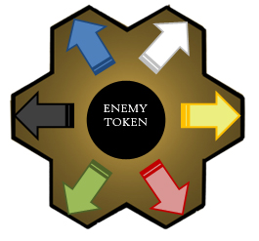
- Draconum move 2 spaces per die. All Draconum on the map should be moved before Orcs and Monsters move. Draconum may not enter the following spaces:
  - Unexplored spaces
- Orcs and Monsters move 1 space per die. They may not enter the following spaces:
  - Unexplored spaces
  - Lakes
  - Mountains
  - Fortified Sites (Keeps, Mage Towers, White City)
  - Through Walls
- If an enemy cannot move in the direction indicated by a die, the enemy remains in its place. Continue to the next die movement or enemy.
- If an enemy enters an inhabited space, it is immediately destroyed! (Village, Monastery, Refugee Camp, Mage Tower, or Keep. Draconum only for the last 2. See below for Cities). Place a Shield Token belonging to the Dummy player on the space. This site is considered to be non-existent for the remainder of the game.
  - The Dummy player’s shield token replaces yours if a Draconum enters a Keep or Mage Tower you control (it is now destroyed), but not if any enemy enters a Monastery site with your shield token on it (it was already burned to the ground by you!)
- If an enemy enters your hero's space, it remains there and attacks you! You must fight the enemy(ies) on your first turn. Level I units may not participate (they are frightened!). If you lose the combat, you may retreat to a safe space, if able. If unable to retreat, you must continue to fight on subsequent turns until the enemies are defeated.
  - If a Draconum enters a fortified site where your hero currently is, the Draconum fights you – the site is not destroyed.
Cities
The White City is loyal to you – the Red City however…
- The White City:
  - Is set to Level 3 when revealed.
  - You may enter this city freely and interact as if you controlled it (you may not attempt to conquer it and you do not control it)
  - If a Draconum enters the White City space while you are not present, reduce its level by 1 (if your hero is present, the Draconum will fight you on your first turn instead). Place a Shield Token belonging to the Dummy player on the White City Reference card.
  - If the White City’s level is reduce to below 1, it is destroyed! It is considered non-existent for the remainder of the game.
- The Red City:
  - Is set to Level 8 when revealed.
  - If any rampaging enemy (Orcs, Monsters, Draconum) enter this city space, they remain in its garrison – place the enemy token on the Red City Reference card. You must defeat this enemy as well when you assault the city.

Scenario End

When the Red City is conquered, you have one last turn (the Dummy player does not). Otherwise, the scenario ends after the third night.

Scoring
If you succeeded in conquering the Red City, you are victorious. If not, you have failed. In either case, count your score.
Take your Fame as the base. Then apply standard Achievements scoring.
Then score for your goal and for the time to reach it:
- Score 15 points if you conquered the Red City.
- Score an additional 15 points, if you conquered all cities.
- If you finished the game one or more Rounds before the limit, score 30 points for each such Round.
- Score 1 point for each card in the Dummy player’s Deed deck (that was not yet flipped this Round).
- If the End of the Round was not announced yet in your last Round, score an additional 5 points.
- Score -3 points for each Dummy player shield token on the map and White City Reference card.
- • Score -3 points for each Orc remaining on the map.
- Score -5 points for each Monster (tan) remaining on the map.
- Score -8 points for each Draconum remaining on the map.
- Score -10 points for each map tile not revealed.

VARIANT
Strongholds:
The Keeps in this land have stronger garrisons, and are led by a Lord. Try this variant if you own the Lost Legions expansion and would like a slightly more difficult challenge with more rewards.
- When setting up the game, remove all 6 Banner Artifact cards from the Artifact deck and create a new face-down Banner Deck.
- Whenever a Keep (Stronghold) is revealed, place 2 grey enemy tokens on it, instead of just 1.
- When you conquer a Stronghold, you also gain a Banner Artifact – draw the top card of the Banner Deck and add it to the top of your Deed Deck.
- You keep the Banner Artifact even if the Stronghold it came from is destroyed by a Draconum later on.

DRAGONSLAYER

- Credit: kittenhoarder
- Expansion required: Lost Legion
- Length: Five rounds (3 days and 2 nights)
- Purpose: Solitaire game that is more open-ended and allows newer players to ease into multi-enemy battles.
Those Draconum are getting out of control. The Council needs you to curb their numbers before we move on to the human population. Be careful--the locals have locked themselves away in fear, and interaction will be difficult until you earn their trust.

Setup
- Map Shape: Wedge, Wedge, or Open limited to 4 columns
- Countryside tiles: 4
- Core city tiles: 1 (Blue City)
- Core non-city tiles: 3 (2, 4 and 9)
- Cities: The city is friendly. You can enter and interact with it freely, but do not receive any leader bonuses.
- Dummy Player: There is one standard Dummy player (see the General Principles section).

Special Rules
- When taking Tactics, you always choose first. The Dummy player then takes one random card from those remaining.
- At the end of each Day or Night, remove both used Tactic cards from the game. That means, each Tactic card cannot be picked more than once during the game.
- The Rampage! variant (see the Variant Rules section) must be used with this scenario. However, you start with -5 reputation (the first -5 space) instead of -2. In addition, if a roll to replace a Rampaging Draconum fails, you may always choose to place a red and brown token there, as if you had rolled a gold/black.
- When you defeat a Draconum, place a shield token on that space. This counts as an Adventure Site for scoring. You can have multiple shield tokens on the same Rampaging Draconum space.

Scenario End

When all red tokens have been defeated (i.e. placed in the discard pile), you have one last turn (the Dummy

Player does not).

Scoring
There is no victory condition; instead, you are trying to achieve the highest score possible by defeating as many Draconum as you can.
Take your Fame as the base. Then apply standard Achievements scoring.
Then score for your goal and for the time to reach it. See the other side of the Scoring card:
- Score an additional 1 point for each adventure site you conquered.
- If you finished the game one or more Rounds before the limit, score 30 points for each such Round.
- Score 1 point for each card in the Dummy player’s Deed deck (that was not yet flipped this Round).
- If the End of the Round was not announced yet in your last Round, score an additional 5 points.

Variants
If you would rather have a defined victory condition, you can set the difficult for yourself--defeat X Draconum to win.
If that is still too easy, the Blue City is not friendly (but counts only as 10 points toward final scoring; do not score the "all cities defeated" bonus).

Solo Scenario Book by Kin Hassar

