portproxy
User's Guide

Author: Tomasz Mrugalski
version 2010-03-14

Table of contents
1 Project overview 4
1.1 Related software 4
2 Project status 4
3 Portproxy overview 5
3.1 Classic NAT-PMP mode 6
3.2 Extended NAT-PMP mode 7
3.3 UPnP UDP mode 7
3.4 UPnP TCP mode 7
3.5 UCI configuration files 8
4 GUI Overview 10
4.1 LuCI overview 10
4.2 Tunnel configuration 11
4.3 Fragmentation 15
4.4 Advanced settings and status 15
4.5 Manual Port forwarding 16
4.6 Manual Port forwarding limits 19
4.7 Portproxy GUI – permanent configuration 20
4.8 Portproxy GUI – temporary configuration 22
5 Compilation 24
5.1 OpenWRT sources 24
5.2 LuCI packages 24
5.3 Portproxy patches 24
5.4 Configuration and compilation 24
6 Configuration 25
6.1 AFTR 25
6.1.1 softwire configuration 25
6.1.2 NAT-PMP/UPnP daemon 25
6.2 OpenWRT box 26
6.2.1 Softwire configuration 26
6.2.2 Running portproxy 26
7 Test Environment 28
7.1 MiniUPNP daemon 28
7.1.1 UPnP client 28
7.1.2 NAT-PMP client 28
8 Testing 29
8.1 NAT-PMP 29
8.1.1 Incoming NAT-PMP request 29
8.1.2 Returning NAT-PMP response 30
8.1.3 NAT-PMP end to end testing 30
8.2 UPnP 30
8.2.1 SSDP announcements 31
8.2.2 Incoming UPNP query 32
8.2.3 Returning UPNP response 33
8.3 UPnP end to end testing 34
8.4 All in one testing 37
9 Portproxy source code 41
9.1.1 Portproxy operation 41
10 LuCI source code 43
10.1 LuCI overview 43
10.2 Lua language 43
10.3 General LuCI architecture 43
10.4 Simple Forms 46
10.5 Services and configuration files 46
10.6 LuCI development environment 47
10.7 Developed LuCI softwire-related pages 47
10.7.1 Softwire overview page 47
10.7.2 Tunnel configuration 47
10.7.3 Fragmentation 48
10.7.4 Advanced settings and status 48
10.7.5 Manual port fordwarding module 49
10.7.6 Manual port forwarding limits 49
10.7.7 Permanent portproxy configuration 49
10.7.8 Temporary portproxy configuration 49
11 Firmware installation 50
11.1 Connecting LinkSys 50
11.2 Firmware upgrade (using original web interface) 50
11.3 Firmware upgrade (using linux console) 51
11.4 Firmware upgrade (TFTP) 52
11.5 Enabling boot_wait phase 53
11.6 First connection 53
11.7 ipk packages 53
11.8 Package installation 53
12 Best practices and debugging tips 54
13 References 55
14 Contact 55

Project overview
This document describes usage, installation and configuration of the software required to setup and run portproxy – a software that resolves port forwarding configuration issues. Also, accompanying GUI for manual port forward configuration is the second goal of this project.
Portproxy is a software used to fill the communication gap between clients located in the LAN and CGN located in ISP network. The primary goal of this project was to a develop software that allows clients to configure port forwarding. Two protocols are used for that purpose: UPnP and NAT-PMP. Goal of this project is to forward UPnP and NAT-PMP traffic between LAN and CGN in a transparent (from the client's perspective) way. Portproxy is a command-line tool that runs on any device that uses OpenWRT as an operating system.
Second phase of this project focuses on manual port configuration. Clients located in LAN should be able to manually configure their home router to forward selected ports. Web-based GUI will be developed for that purpose. GUI should also include other aspects, like tunnel configuration. GUI must be easily extensible.

Related software
This code was developed in 2009 and early 2010. At that time, there was no suitable solution of similar class available. However, recently Port Control Protocol (PCP) was developed in IETF.

Project status
For latest status, list of tasks already completed, work in progress and upcoming tasks, see project web page (http://klub.com.pl/portproxy/) or its repository at github.com website (https://github.com/tomaszmrugalski/portproxy). As of January 2012 the software (both portproxy tool and corresponding GUI) is functional. Author does not have enough time to actively develop or maintain this software. If you are willing to take over this project, please contact author.

Portproxy overview
Portproxy is a flexible command-line tool used for forwarding NAT-PMP and UPnP traffic.
Portproxy provides number of options for tuning its operation. Help is available with -h command.
Result of running portproxy -h command:
root@OpenWrt:/tmp# ./portproxy -h
portproxy 2009-12-20
----------------------

--lan-iface name- defines LAN interface, (br-lan) by default
--wan-iface name- defines WAN interface, (eth0.1) by default
-l <IPv4addr> - defines B4 LAN IPv4 address (e.g. -l 192.168.1.1)
Portproxy will listen for client's messages on this address
-w <IPv4addr> - defines B4 WAN IPv4 address (e.g. -w 192.0.0.2)
Portproxy will use this address to forward messages to the NAT router
-a <IPv4addr> - defines AFTR IPv4 address (e.g. -w 192.0.0.1)
Portproxy will forward incoming messages to this IPv4 address.
--nat-pmp X - Enables(X=1) or Disables (X=0) nat-pmp protocol (default = enabled)
--nat-pnp-ext X - Enables (X=1) or disables (X=0) extended nat-pmp
(NAT-PMP messages are extended with extra 12 bytes that
hold extra information (as defined in AFTR-1.0b1 doc)
--upnp-udp X - enables(X=1) or disables (X=0) uPNP UDP support (default = enabled)
--upnp-tcp X - enables(X=1) or disables (X=0) uPNP TCP support (default = enabled)
-g - become a daemon
-v - increases verbosity level to 2 (more verbose than default 1)
(use twice to further increase verbosity)

Following options are used for extended NAT-PMP solution only.
Please note that extended NAT-PMP and NAT-PMP are mutually exclusive.
-b <IPv6 addr> - IPv6 address on the WAN side. Use as source address for
extended NAT-PMP messages, forwarded to AFTR
-s <IPv6 addr> - AFTR IPv6 address. Extended NAT-PMP messages will be
forwarded to this address.
Following options are for testing/debugging purposes only:
--nat-pmp-port X - specifies UDP port for NAT-PMP protocol (default = 5351)
--upnp-udp-port X - specifies UDP port for uPNP protocol (default = 1900)
--upnp-tcp-port1 X - specifies TCP port1 for uPNP protocol (default = 2869)
--upnp-tcp-port2 X - specifies TCP port2 for uPNP protocol (default = 2857)

Portproxy supports four modes:
- Classic NAT-PMP – Incoming UDP/IPv4 packets from clients are forwarded to AFTR as UDP/IPv4 or UDP/IPv4/IPv6 packets. Used parameters: -l, -w, -a. See Section 3.1 for details regarding this mode.
- Extended NAT-PMP – Incoming UDP/IPv4 packets from clients are forwarded to AFTR as UDP/IPv6. Extra information is added to the UDP content. See Section 3.2 for details regarding format and AFTR-1.0 interoperability.
- UDP traffic of UPnP – This mode supports both multicast and unicast traffic. Multicast announcements from IGD/AFTR received on WAN interface are resent on LAN interface. Also multicast queries received on LAN interface are transmitted to IGD/AFTR on WAN interface. Unicast traffic is also relayed between clients (LAN interface) and IGD/AFTR received from clients is forwarded to IGD/AFTR on WAN interface . See Section 3.3 for details regarding this mode of operation.
- TCP traffic of UPnP – this experimental mode works as Application Level Gateway (ALG), acting as a full proxy between clients and IGD/AFTR. Incoming TCP connections are accepted on LAN interface. For each incoming TCP connection, also new connection is established to IGD/AFTR. Data is forwarded between two relayed connections. See Section 3.4 for details regarding this mode of operation.
Note that classic and extended NAT-PMP support is mutually exclusive. Only one of them can be enabled.
Until recently, classic NAT-PMP and UDP UPnP mode were enabled by default. After consulting with AFTR implementors, new extended NAT-PMP mode was introduced and enabled by default, while other modes were disabled.
Each mode can be enabled or disabled. For example to enable specific mode, use –nat-pmp 1, –nat-pmp-ext 1, –upnp-udp 1 or –upnp-udp 1.
Portproxy by default uses br-lan as LAN interface and eth0.1 as WAN interface. It attempts to guess IPv4 addresses that should be used. Usually, those auto-detection routines are working properly, but it is possible to force specific addresses. Three addresses are used for classic NAT-PMP and both UPnP modes:
- B4 LAN IPv4 address. LAN sockets are bound do that address. Also responses from CGN are sent from this address to clients. Specified with -l option.
- B4 WAN IPv4 address. WAN socket is bound to this address. It is used as a source address when sending forwarded requests to CGN. Specified with -w option. This parameter has default value of 192.0.0.2 (first address reserved for B4, as specified in ds-lite-02 document).
- AFTR IPv4 address. Client requests are forwarded to this address. Specified with -n option. This parameter has default value of 192.0.0.1 (default AFTR address, specified in ds-lite-02 document).
To run portproxy, usually only one option is required: definition of WAN interface. If not specified, eth0.1 will be used for this purpose. To specify that softwire interface should be used, use --wan-iface softwire (if interface name representing the tunnel is called softwire).
It is also possible to increase verbosity level. By default only error messages are printed. To increase details, -v option should be used. It can be specified twice or 3 times to increase details even more.
In extended NAT-PMP mode, traffic is translated from IPv4 (clients) to IPv6 (AFTR). To work in this mode of operation, two additional parameter are added:
- AFTR IPv6 address. Incoming NAT-PMP packets will be forwarded to this IPv6 address. Specified with -s option.
- BR IPv6 address. This IPv6 address will be used as a source IPv6 address. Specified with -b option. This address needs to be locally configured on one of the B4 interfaces.
Portproxy also allows work as a daemon. Simply add -g option to instruct portproxy to detach from console and run as a daemon.
Portproxy also provides built-in brief help. Use -h option to display it. Also, when provided options are invalid, help is displayed.
Although not very useful in production environment, it is also possible to adjust port numbers that portproxy binds and forwards data to. Use --nat-pmp-port 12345, --upnp-udp-port 12345, --upnp-tcp-port1 12345 or –upnp-tpcp-port2 12345 to override default port selection.

Classic NAT-PMP mode
In this mode incoming UDP/IPv4 packets sent by clients to its home gateway (B4) are received on B4 LAN IPv4 address (specified by -l option). Those packets are resent to AFTR IPv4 address (specified by -a option). B4 WAN IPv4 address is used as source (specified by -w option). Those forwarded packets are UDP/IPv4/IPv6 (if AFTR is reachable over DS-Lite tunnel) or UDP/IPv4 (if AFTR is reachable directly, without using tunnel). Returning responses from AFTR are forwarded back to clients. This mode uses parameters: -l, -w and -a. Instead of specifying addresses directly, also interface names may be used (--lan-iface and –wan-iface). In such case, portproxy will use first available IPv4 address on those interfaces.

Extended NAT-PMP mode
In this mode incoming UDP/IPv4 packets (received on LAN, sent by clients) are resent as UDP/IPv6 to AFTR IPv6 address (specified by -s option) over WAN interface. B4 IPv6 address is used as a source (specified by -b option). IPv6 packets are also extended by additional information. Extra 12 bytes are added, so the final UDP packet has following format:
octet 0 – length of extra information. Currently uses value 12.
octet 1 – 'P'
octet 2-3 – defines source port that was used by the client.
octet 4-7 – B4 LAN IPv4 address
octet 8-11 – client IPv4 address
octet 12 and following – original NAT-PMP client request

AFTR is expected to also include this extra shim in its responses. Portproxy will use this information to transmit response to the original client. Response will be sent without extra 12 bytes, so client software update is not necessary.
This mode of operation works with AFTR-1.0b implementation by ISC. See http://www.isc.org/software/aftr.
Patch2 introduced persistent mode. It allows starting portproxy before interface or address is configured and ready to use. Rather than exiting after failed socket binding, portproxy running in persistent mode will wait 10 seconds and retry bindings. Also, if :: address is specified as B4 IPv6 WAN address, portproxy will try to detect is automatically. Make sure that –wan-iface option is used.

UPnP UDP mode
Internet Gateway Device (IGD, a device that provides Internet capability that also supports UPnP protocol) periodically announces its location. This functionality is expected to be provided by AFTR. Portproxy running on B4 will receive IGD's mutlicast announcements and rebroadcast them on LAN interface. This is one of the 2 possible ways clients can discover available IGDs. Second approach starts with clients actively asking for IGDs to reveal themselves by sending multicast packets over LAN network. Portproxy receives such discovery packets and forwards them to IGD, located at AFTR. AFTR responds with resource description (an URL that points to description of available services and features) and transmits its response to portproxy. Portproxy resends the response back to the original client. Once this exchange is complete, client is aware of the IGD and can send control messages directly, bypassing any interaction from portproxy. This mode uses parameters: -l, -w and -a. Instead of specifying addresses directly, also interface names may be used (--lan-iface and –wan-iface). In such case, portproxy will use first available IPv4 address on those interfaces.

UPnP TCP mode
Portproxy also provides preliminary support for TCP forwarding. As this functionality is considered ALG operation, it is disabled by default and currently not used. It is possible, however, to enable it (--upnp-tcp 1). Portproxy will open 2 local TCP sockets and will wait for incoming connections. Once client connects to portproxy, another connection to CGN will be established. All data sent by client will be forwarded to CGN and vice versa. This mode uses parameters: -l, -w and -a. Instead of specifying addresses directly, also interface names may be used (--lan-iface and –wan-iface). In such case, portproxy will use first available IPv4 address on those interfaces.
Note that this mode is considered experimental and provided as is, without any support. It may be developed further, if such need arise.

UCI configuration files
Besides using portproxy from a command line, configuration files are also provided. OpenWRT distribution uses UCI based management for storing persistent (i.e. configured values will be stored after device reboot) configuration parameters. Portproxy stores its configuration in /etc/config/softwire configuration file, that in the future may also be extended to cover other softwire related aspects, like tunnel configuration. Currently, there are 3 sections defined in this configuration file. First is a dummy section intended for storing tunnel configuration modes. Values of this section may be modified using web interface (see Section 4.2). Second section is dedicated for portproxy configuration. This section may be modified using web interface (see Section 4.7). Third section contains limit of maximum allowed port forwarding rules that user is allowed to specify. This single value may be modified using web interface (see Section 4.6). It is also read by web interface allowing users to manually configure port forwarding.
Default values for /etc/config/softwire are:
config 'softwire'
option 'name' 'softwire'
option 'mode' 'static'

config 'limits' 'limits'
option 'maxports' '11'

config 'portproxy'
option 'natpmpext' '1'
option 'aftripv6' '2000::1'
option 'wanipv6' '2000::2'
option 'upnpudp' '0'
option 'upnptcp' '0'
option 'natpmp' '0'
option 'lanipv4' '192.168.1.1'
option 'wanipv4' '192.0.0.2'
option 'aftripv4' '192.0.0.1'
option 'laniface' 'br-lan'
option 'waniface' 'eth0.1'
option 'persistent' '0'

As with any other UCI configuration file, its values are expected to be modified using uci tool. Its direct modification using editor (e.g. vi) is not recommended as the UCI subsystem will not be informed of such modifications.
There is a standard script provided for controlling portproxy, running as a daemon. This script is located in /etc/init.d/portproxy. Its use is similar to any other script available in OpenWRT. To start portproxy as daemon, use following command:
/etc/init.d/portproxy start
To stop portproxy daemon, use command:
/etc/init.d/portproxy stop
Also, daemon may be enabled or disabled. Disabled daemons will not start after device reboot. Following commands may be used to achieve desired state:
/etc/init.d/portproxy enable
/etc/init.d/portproxy disable

GUI Overview
Note: Only parts of this GUI source code is available, but it is not fully functional yet.
Note: This project used L2TP tunnel configuration software that is no longer available. There are still references to /proc/softwire that are probably no longer relevant and should be removed.
Developed web interface is based on a LuCI framework. It is by default used in the latest OpenWRT releases. To access GUI interface, open web brower and go to http://192.168.1.1. (assuming IPv4 address of the OpenWRT box is 192.168.1.1, which is the default value). Make sure that you are able to ping your OpenWRT before attempt connection. Once you are connected LuCI interface will ask for a root password, as presented in Fig. 1. Please use the same password as used during ssh connection to proceed.

LuCI overview
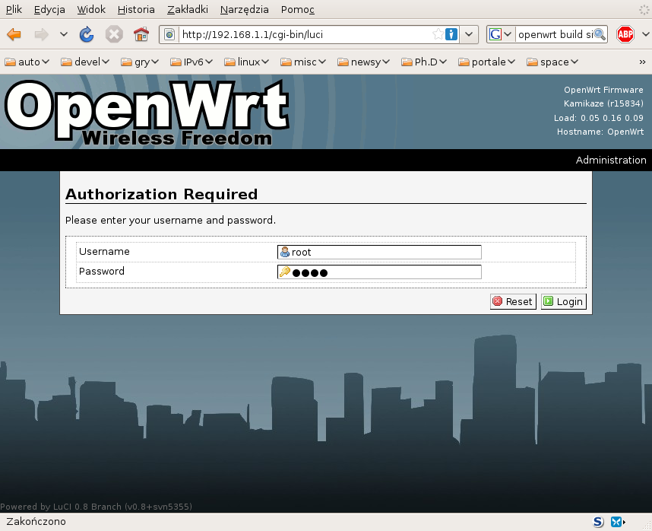Fig. 1: Initial LuCI web interface login.
LuCI is a full featured web-based GUI for routers and small embedded devices. Among others, it supports interface and network monitoring, tracking active connections, browsing and editing routing table, system and kernel log viewers, password manipulation, processes monitoring and maintenance, flashing new firmware, selectable themes and much more. There are numerous packages available as LuCI modules. Notable examples are dnsmasq support (DNS and DHCPv4 service), port forwarding configuration, wireless monitoring, firewall, QOS and others.
Besides numerous features that are already supported by LuCI and its modules, several new functionalities were added. These are stub tunnel configuration module for softwire/DS-Lite tunnels, simplified manual port forwarding with configurable limits on allowed number of ports forwarded, portproxy configuration tool and diagnostic module for temporary portproxy configuration changes. For easier navigation, all new features are grouped in a separate menu called Softwire, as presented in Fig. 2. It should be noted that rearranging pages within GUI interface is trivial, so current layout should be threated as a proposal only.

Tunnel configuration
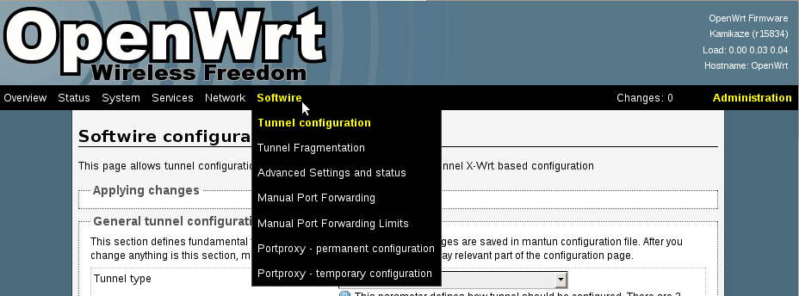Fig. 2: Softwire menu in LuCI interface.
This page is based on GUI interfaced that used X-Wrt interface. It allows configuration of both Softwire and DS-Lite tunnels, both in automatic and manual mode. The whole page is split into sections. First section allows configuration of tunnel type (softwire, DS-Lite, none) and its intended configuration mode (DHCP or manual). This part of the web page is presented in Fig. 3 .
Four sections follow. Each section is dedicated to specific case: automatic Softwire, manual Softwire, automatic DS-Lite and manual DS-Lite. As original code developed by Xavient uses separate configuration file for each case, this order is maintained. For better understanding, each section clearly mentions, which configuration file is going to be modified. Example of Softwire configuration is presented in Fig 4. Another example of DS-Lite configuration is presented in Fig 5.
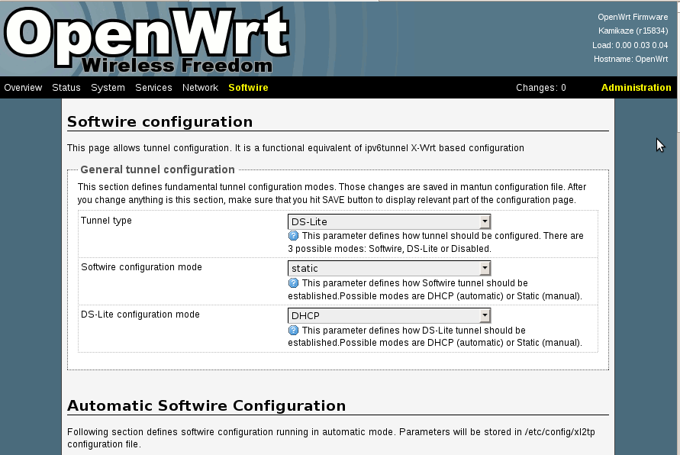Fig. 3: General tunnel configuration
Automatic softwire configuration is stored in /etc/config/xl2tp, manual softwire configuration is stored in /etc/config/xl2tp_static, automatic DS-Lite configuration is stored in /etc/config/overridetunnel and finally manual DS-Lite configuration is stored in /etc/config/mantun. Also tunnel type and its configuration mode are stored in /etc/config/mantun.
Note: Provided firmware image does not contain those required configuration files. They are provided as part of the ipv6tunnel.ipk package. Without this package installed, web page will fail to load properly and will appear empty. Make sure to install this package properly, i.e. install the package using
opkg install ipv6tunnel.ipk -force-overwrite
/tmp/setup.sh
Please refer to the documentation provided with IPv6 tunnel software for details.

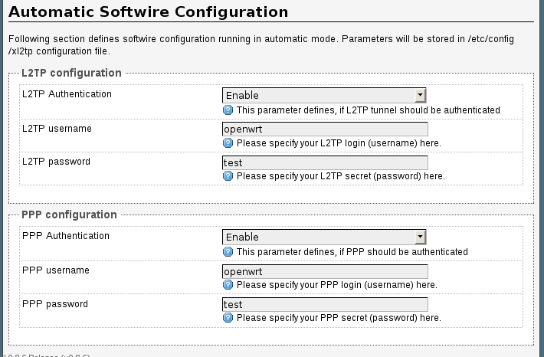Fig. 4: Example automatic softwire configuration
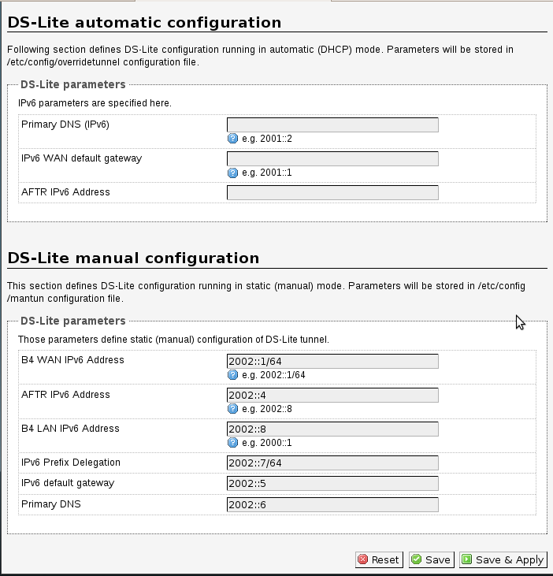Fig. 5: Example DS-Lite configuration
Compared to X-Wrt code, terminology was also updated. Home gateway device running OpenWRT is now designated B4. Also, NAT device located in ISP network (previously CGN) is now called AFTR, as specified in [1].

Fragmentation
The next page is dedication to fragmentation. MTU (Maximum Transfer Unit) can be specified for both IPv4 and IPv6. Depending on tunnel type used, some fields may not be available. Compared to X-Wrt, the only difference is that to avoid specifying of MTU values, 0 must be used rather than empty field. Each field is accompanied by short description with acceptable values, as presented in Fig. 6. As with other changes introduced via GUI, also fragmentation parameters must be confirmed to make them permanent. Please use standard Save&Apply link. Note that specified changes are applied in the system immediately, but without applying they will be lost during next reboot.
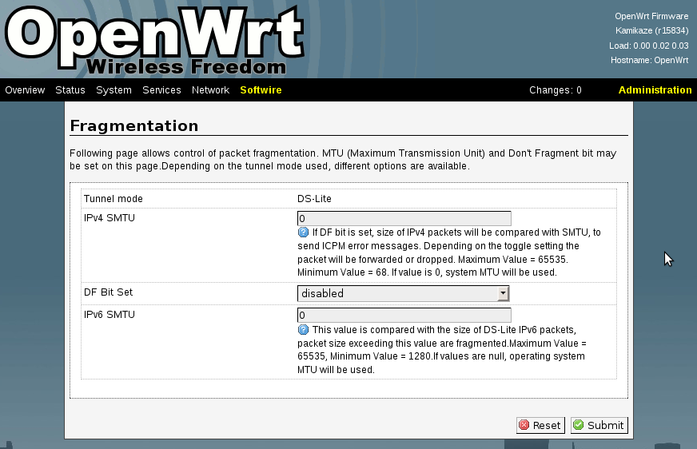Fig. 6: Fragmentation setup

Advanced settings and status
The next section offers two features: service and tunnel monitoring. There are five services that are monitored:
- DHCP client – This service is responsible for automatic configuration. It runs dhclient process and uses /etc/init.d/dhcp script.
- Router Advertisements daemon – radvd daemon is responsible for Router Advertisement announcements, sent periodically over LAN interface. They are used for automatic IPv6 configuration of all hosts.
- DNSMASQ daemon – Control dnsmasq daemon. It is responsible for DHCP configuration to clients, DNS proxy and NAT.
- Tunnel service – This is the essential service for tunnel control. Contrary to other services, there is no single process running. Instead starting or stopping /etc/init.d/tunnelscript service sets in motion chain of events that eventually lead to tunnel establishement. As such, it is not possible to monitor tunnel process status. Therefore at any time both start and stop commands are available.
- Portproxy daemon – controls portproxy daemon. This daemon is responsible for forwarding automatic port configuration protocols (NAT-PMP, UPnP and extended NAT-PMP).
This page also provides tunnel status information. Example status with softwire established is presented in Fig 7.
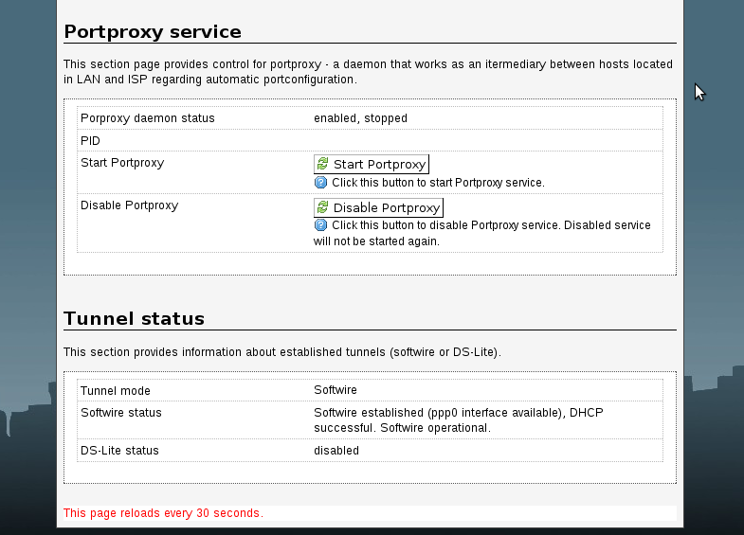Fig. 7: Tunnel status with portproxy control section

Manual Port forwarding
This web interface allows manual configuration of port redirection. It is designed to be simple, yet powerful way of configuring port forwarding capabilities provided by Linux kernel. It allows definition of rules. Each rule defines traffic type (UDP, TCP or both), external port, internal IPv4 address and internal port (optional, if not defined it is assumed to be the same as external port). Maximum number of rules allowed to be defined is configurable.
Initial, empty state has been presented in Fig. 8. To define new rule, “Add Entry” button should be used. Once rule is added, its details can be configured. Example of single configured rule is presented in Fig. 9.
It is worth noting that LuCI framework allows remembering configuration between it is actually applied to the system. Save button may be used for that purpose. Note that this DOES NOT modify permanent configuration in any way. Save button will save those changes in a browser cache only. To actually apply those changes, use Save & Apply button on a relevant page. Alternatively, it is possible to click on red “Unsaved Changes” link to review and confirm (or reject) planned changes. This approach affects the whole LuCI interface, not just port forwarding configuration.
After applying changes, relevant services are restarted automatically, as presented in Fig. 10. In case of port forwarding, these are firewall and qos. LuCI interface executes following commands to achieve this goal:
/etc/init.d/firewall restart
/etc/init.d/qos restart

This is a simplified and extended version of port forwarding configuration utility already available in LuCI. For original version (without rules limits and extra prameters), please nagivate to Network => Firewall => Traffic Redirection page.
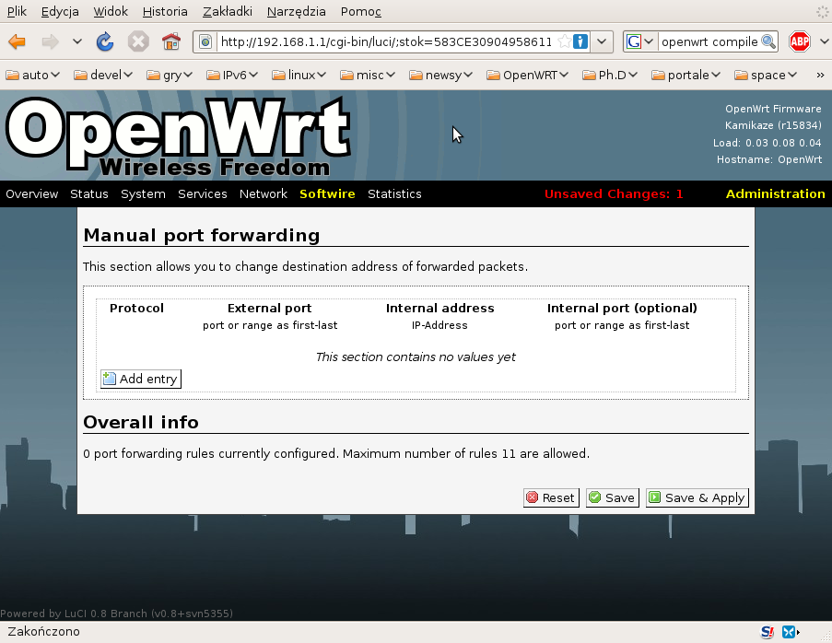Fig. 8: Manual port forwarding (initial empty state)

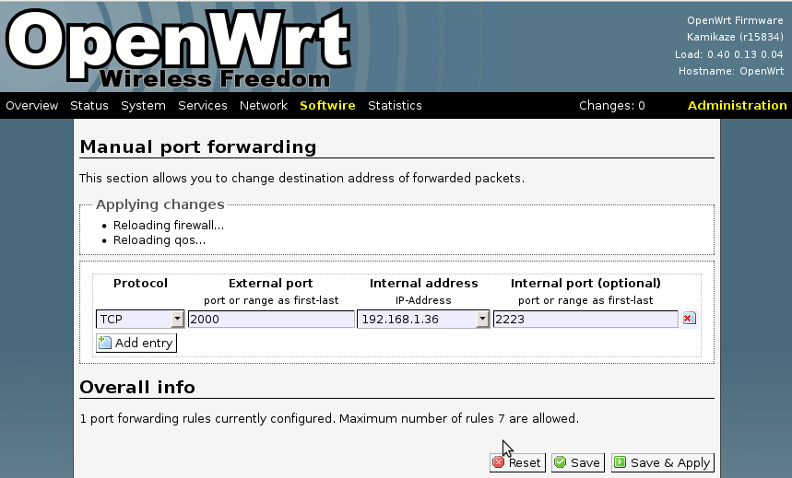Fig. 10: Service restarts after applying changes
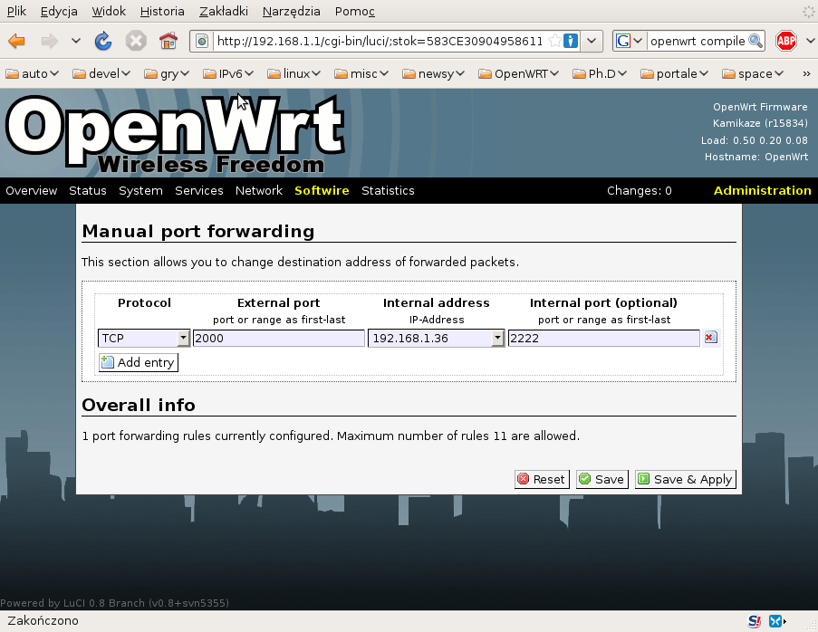Fig. 9: Port forwarding with single TCP redirection

Manual Port forwarding limits
In the default LuCI configuration, user is able to forward arbitrary number of ports. A limit has been introduced to define maximum number of allowed rules. Once user reaches this limit, no additional rules may be defined, as presented in Fig. 11. Please note missing “Add rule” button.
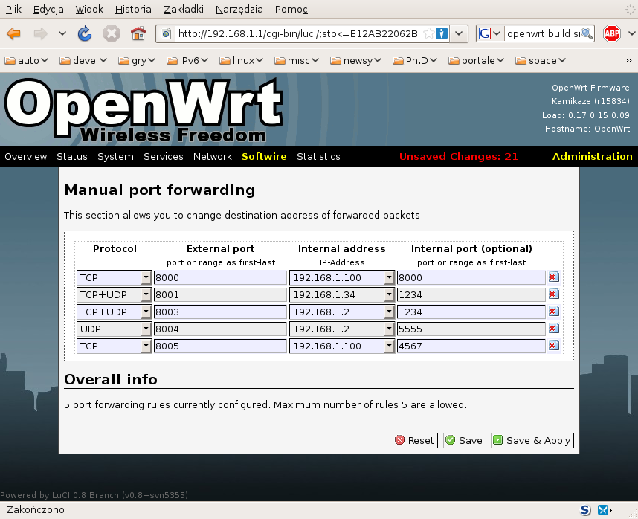Fig. 11: Maximum number of forwarded ports is reached
This limit may be changed on a separate page, presented in Fig. 12. This page is intended for system administrators rather than end users. It is very easy to restrict access to a specific page in LuCI framework. Details are discussed in Section 10.3.
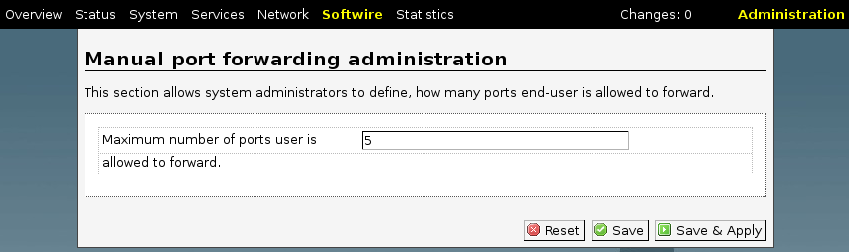Fig. 12: Port forwarding limit

Portproxy GUI – permanent configuration
Portproxy is a command-line tool, but there are scripts provided for easing its use. Also web page to control its operation is provided. This page consists of several sections. First section is dedicated to modes of operation. Support for NAT-PMP, extended NAT-PMP and UPnP may be enabled or disabled. This part of the web page is presented in Fig. 13.
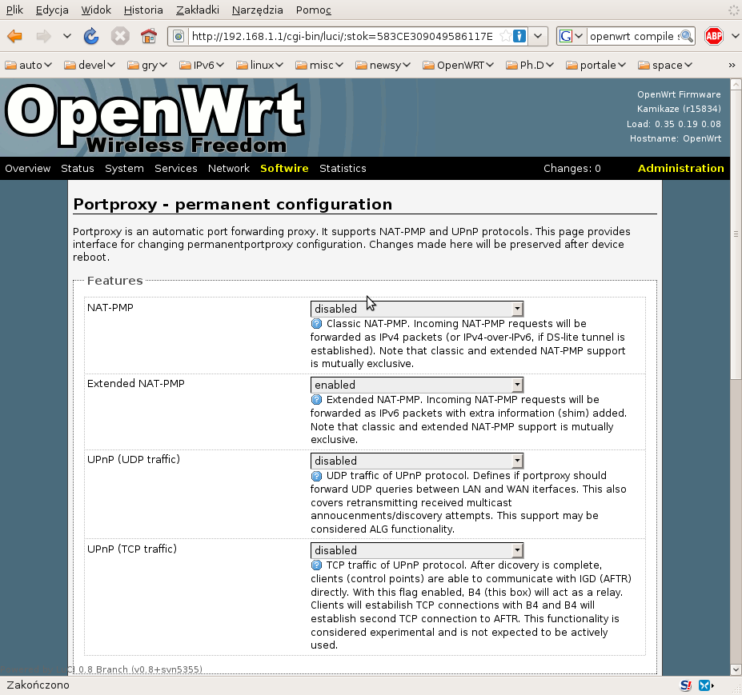Fig. 13: Portproxy configuration, part 1 (features)
Second section of the page is dedicated to extended NAT-PMP parameters. If support for extended NAT-PMP is not enabled, those parameters are ignored. Third section contains parameters used in classic NAT-PMP and UPnP support. These sections are presented in Fig. 14.
After hitting Save & Apply button, portproxy service will be restarted with new parameters. Note that portproxy service must be enabled. Otherwise restart will not be performed. Regardless of service being enabled or not, its parameters will be stored throughout device restarts.
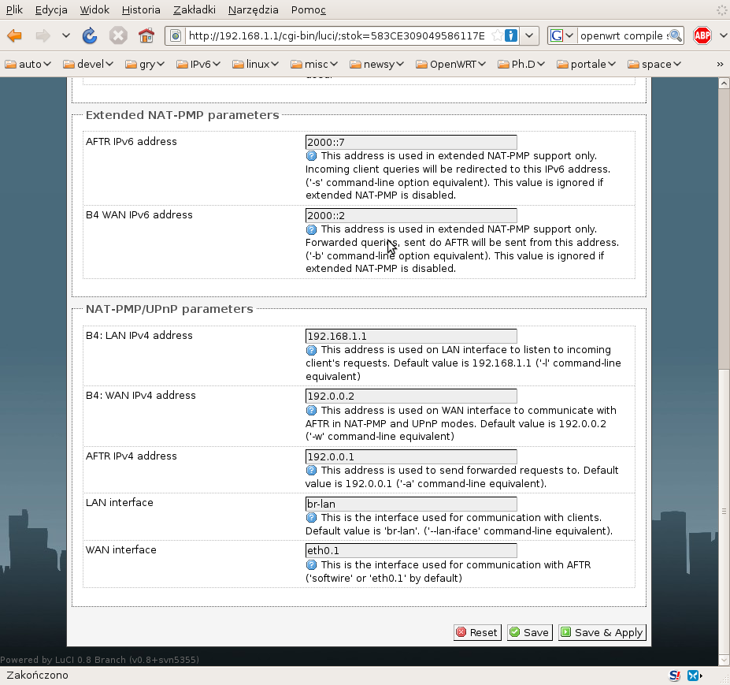Fig. 14: Portproxy configuration, part 2 (parameters)

Portproxy GUI – temporary configuration
For debugging purposes additional page was developed. It allows portproxy monitoring and maintenance, without doing any permanent changes. Its appearance depends on actual state of portproxy daemon. If the service is not running, command line parameters may be specified. This situation is depicted in Fig 15. For a list of available command line options, see Section 3 .
On the other hand, if portproxy process is running, several diagnostic informations are provided. It can also be finished in several ways, as presented in Fig. 16.
Note that any changes made via this page are temporary and affect only current state. They are not saved in any way and will be lost during next reboot.
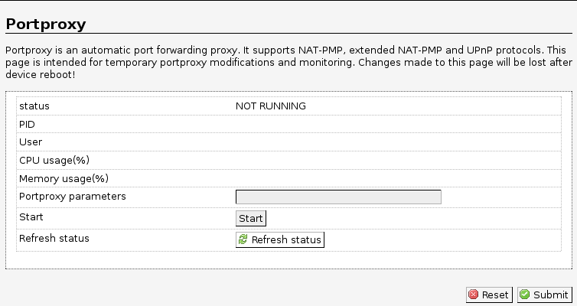Fig. 15: Portproxy status (not running)

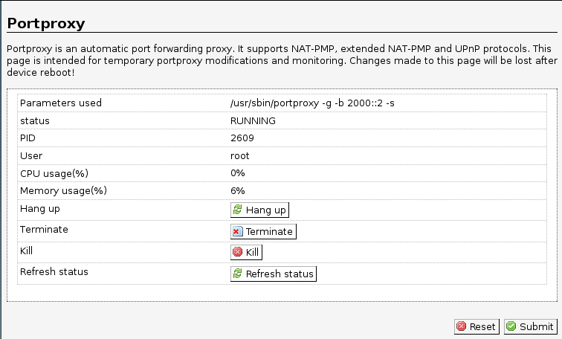Fig. 16: Portproxy status (running)

Compilation
Number of software packages are required to establish test environment. Following sections describe steps required for successful compilation. All parts of the portproxy project and its associated software are distributed as an open source. To successfully build portproxy-enabled OpenWRT images, steps described in following sections are required.

OpenWRT sources
Portproxy project uses development branch (“kamikaze”) of the embedded Linux distribution called OpenWRT. First step to build a firmware for your embedded device is to download OpenWRT. OpenWRT is a set of tools that automate building process of the firmware. There are several ways of obtaining sources. Recommended way is to download stable sources or use SVN repository. For the stability purposes, all development related to portproxy is done on one specific SVN snapshot, revision 15384. To obtain this revision, issue following command:
svn co -r 15384 https://svn.openwrt.org/openwrt/trunk/
Note that /trunk is a “main” branch. Migration to maintenance 8.09 branch (/branches/8.09) is planned.

LuCI packages
After checkout is complete, packages and LuCI modules repository has to be downloaded. This can be achieved using following commands:
./scripts/feeds update packages luci
./scripts/feeds install -a -p luci

Portproxy patches
After that step, project related patches may be applied. In particular, extra definitions for portproxy and luci-app-softwire packages should be added. Such modifications are available on the portproxy webpage as patch. Such patch may also include recommended configuration.

Configuration and compilation
Such configuration is stored in .config file. To view or modify configuration, type:
make menuconfig
Please note that, although using the same framework, that interface is significantly different from a similarly looking, Linux kernel configuration. Also, you may want to postpone this step and install additional patches as described in the following sections.
After configuration is complete, type make to download required source code, build tool chain required for cross-compilation, all target binaries and images. This may take up to several hours, depending on the speed of the network connectivity and CPU. On multicore systems, -j option may speed up compilation significantly. After subsequent rebuilds, this process is much shorter. For extra verbosity level, make V=99 command may be used.
Make sure that the PC has Internet connectivity as OpenWRT downloads multiple additional packages, like kernel source. After compilation is complete, all packages and firmware images are available in the bin/ directory.

Configuration
This section describes configuration required to run portproxy.

AFTR
AFTR (formerly known as Carrier Grade NAT) is located in the ISP network. It acts as a softwire termination point, performed NAT on decapsulated packets and also provides port forwarding services: NAT-PMP and uPNP. To simulate such device, ordinary PC running Linux may be used. Following configuration steps are required.

softwire configuration
It is assumed that softwire is configured over 2000::/64 prefix (AFTR uses address 2000::36/64 and LinkSys box uses 2000::1). Following steps will configure softwire on AFTR:
ip a a 2000::36/64 dev eth0
modprobe ip6_tunnel
ip -6 t a softwire mode ipip6 local 2000::1 remote 2000::36
ip a a 192.0.0.1/24 dev softwire
192.0.0.1 address is configured on softwire for NAT-PMP/uPNP service only.

NAT-PMP/UPnP daemon
For the testing purposes, MiniUPnP daemon was used.
After compilation, miniupnpd must be configured. Example configuration is provided with the sources. Here is the minimal configuration used during tests. Extra parameters and more configuration options are available in example *.conf files distributed with source code:
# cfg-softwire.conf file
# WAN network interface
ext_ifname=eth1
# if the WAN interface has several IP addresses, you
# can specify the one to use below
ext_ip=1.2.3.4

# LAN network interfaces IPs / networks
listening_ip=10.0.0.36/24
# port for HTTP (descriptions and SOAP) traffic. set 0 for autoselect.
port=0

# enable NAT-PMP support (default is no)
enable_natpmp=yes

# enable UPNP support (default is yes)
enable_upnp=yes

# bitrates reported by daemon in bits per second
bitrate_up=1000000
bitrate_down=10000000

# "secure" mode : when enabled, UPnP client are allowed to add mappings only
# to their IP.
#secure_mode=yes
secure_mode=no

# report system uptime instead of daemon uptime
system_uptime=yes

# notify interval in seconds. default is 30 seconds.
notify_interval=60

# unused rules cleaning.
clean_ruleset_interval=600

# uuid : generate your own with "make genuuid"
uuid=fc4ec57e-b051-11db-88f8-0060085db3f6

# serial and model number the daemon will report to clients
# in its XML description
serial=12345678
model_number=1

# UPnP permission rules
allow 1024-65535 10.0.0.0/24 1024-65535
allow 1024-65535 192.168.1.0/24 1024-65535
eth1 and 1.2.3.4 are external interface and its address. This address will be reported to clients.

To start miniupnpd, use following command:

./miniupnpd -d -f cfg-softwire.conf

Debugging mode (-d) instructs miniupnpd that it should not work as a daemon, but rather print messages on the console. Successful start will look like this:

root@billabong:/home/thomson/devel/miniupnpd-20090904# ./miniupnpd -d -f cfg-softwire.conf
miniupnpd[6697]: system uptime is 85640 seconds
miniupnpd[6697]: HTTP listening on port 40381
miniupnpd[6697]: Listening for NAT-PMP traffic on port 5351

Note that required SSDP announcements (M-NOTIFY) will be transmitted. Miniupnpd is now ready to receive queries.

OpenWRT box
OpenWRT box (LinkSys or any other OpenWRT capable device) requires several features to operate properly.

Softwire configuration
After appropriate firmware image is flashed, it is possible to use ssh to connect to the box. Following commands may be used to establish softwire. It is assumed that LAN interface (Ethernet sockets labelled 1-4 on the WRT54GL box) is br-lan and WAN interface (labelled “Internet” on the WRT54GL box) is eth0.1.
ip a a 2000::100/64 dev eth0.1
modprobe ip6_tunnel
ip -6 t a softwire mode ipip6 local 2000::36 remote 2000::1
ip a a 10.0.0.100/24 dev softwire

Running portproxy
Portproxy is part of the firmware provided. No extra package installations are necessary. For details regarding portproxy, see Section 5. Typical use requires only specification of the WAN interface. In this example, it is softwire. Also, it may be convenient to add -v to increase verbosity (-v may be used twice to enable debugging messages). Following command starts portproxy:
root@OpenWrt:/tmp# portproxy -v --wan-iface softwire

Following output will be produced. Portproxy is now able to handle NAT-PMP and UPnP traffic.
root@OpenWrt:/tmp# ./portproxy -v --wan-iface softwire
| Portproxy - NAT-PMP/uPNP proxy, version 2009-10-22
| Author : Tomasz Mrugalski<tomasz.mrugalski(at)gmail.com>
| Licence : GNU GPL v2 only. Developed at Gdansk University of Technology.
| Homepage: http://klub.com.pl/portproxy/
Detected interfaces:
Interface lo, 1 address(es), MAC=00:00:00:00:00:00
IPv4=127.0.0.1
Interface eth0, 0 address(es), MAC=00:1d:7e:bc:41:2a
Interface eth0.0, 0 address(es), MAC=00:1d:7e:bc:41:2a
Interface eth0.1, 0 address(es), MAC=00:1d:7e:bc:41:2a
Interface br-lan, 1 address(es), MAC=00:1d:7e:bc:41:2a
IPv4=192.168.1.1
Interface ip6tnl0, 0 address(es), MAC=00:00:00:00:00:00
Interface softwire, 1 address(es), MAC=20:00:00:00:00:00
IPv4=10.0.0.100
Configuration:
lan=br-lan
wan=softwire
lanIP=192.168.1.1
wanIP=10.0.0.100
routerIP=10.0.0.36
natpmp_udp_port=5351
upnp_udp_port=1900
upnp_tcp_port1=2869
upnp_tcp_port2=2857
fwd_tcp_port1=2869
fwd_tcp_port2=2857
shared_udp_sock=YES
enable_natpmp=YES
enable_upnp_tcp=NO
enable_upnp_udp=YES
Enabling uPNP (UDP)
Creating UDP socket: addr=0.0.0.0, port=1900 on interface br-lan, result=4
UDP(SSDP) socket created: sockid=4, port=1900
Successfully joint multicast group 239.255.255.250 (local IP=192.168.1.1)
Creating UDP socket: addr=0.0.0.0, port=1900 on interface softwire, result=5
UDP(SSDP) socket created: sockid=5, port=1900
Successfully joint multicast group 239.255.255.250 (local IP=10.0.0.100)
Sockets 4(LAN:br-lan) and 5(WAN:softwire) paired.
Enabling NAT-PMP
Creating UDP socket: addr=192.168.1.1, port=5351 on interface br-lan, result=7
UDP: sockid=7, port=5351
Opening single UDP transmission socket (random port)
Creating UDP socket: addr=10.0.0.100, port=0 on interface softwire, result=8
UDP: sockid=8, port=33467

Waiting for incoming packets (timeout: 3600s, 0us), 0 mappings (0 pkts handled)

Test Environment
To test portproxy configuration, several tools had to be prepared.

MiniUPNP daemon
It is open source (BSD license) software, available on http://miniupnp.free.fr/. There are several packages available, but for the CGN, miniupnpd (daemon) is required. 20090904 version was used for that purpose:
http://miniupnp.free.fr/files/download.php?file=miniupnpd-20090904.tar.gz
After downloading, it may be compiled, using following command:
make -f Makefile.linux
Depending on distribution used, errors regarding missing headers libiptc/libiptc.h, iptables.h and linux/netfilter/nf_nat.h may be encountered. Although it is possible that those headers may be provided by distribution specific packages, the best way is to download required iptables package. It seems that miniupnpd is very sensitive to differences in iptables. This practically means that specific miniupnpd version is coupled with only one iptables version. Note that this dependency is true for compilation only. Once compiled, miniupnpd should run properly, regardless of Linux kernel or iptable version installed in system.
Used miniupnpd version used was 20090904. It requires iptables-1.4.1:
http://netfilter.org/projects/iptables/files/iptables-1.4.1.tar.bz2
After extracting, its compilation is simple:
./configure
make
Once the compilation is complete, it is now possible to compile miniupnpd. Path to iptables-1.4.1 is specified in the following way:
IPTABLESPATH=/home/thomson/devel/iptables-1.4.1 make -f Makefile.linux
Optionally, following line may be added to Makefile.linux to ease consecutive compilations:
IPTABLESPATH=/home/thomson/devel/iptables-1.4.1
After compilation is complete, miniupnpd binary is ready to use.

UPnP client
MiniUPNP client that supports port forwarding using UPnP protocol. Version 20090921 was used during testing:
http://miniupnp.free.fr/files/download.php?file=miniupnpc-20090921.tar.gz
Its compilation is very simple:
make
There are 2 binaries: upnpc-shared and upnpc-static. Share version requires installation of libminiupnpc.so, so it is more convenient to use static version.

NAT-PMP client
NAT-PMP support was added recently to miniupnpd. There is a separate subproject decicated to that purpose. Simple NAT-PMP client is included. Libnatpmp-20090713 was used:
http://miniupnp.free.fr/files/download.php?file=libnatpmp-20090713.tar.gz
After extracting the archive, compilation is simple:
make
Once again, static and shared clients will be compiled. It is easier to use static version: natpmpc-static.

Testing
After test environment setup is complete (see Section 7 ), tests can be started. Following sections demonstrate operational status of the portproxy.

NAT-PMP
NAT-PMP is a UDP based protocol, defined in http://tools.ietf.org/html/draft-cheshire-nat-pmp-03. It is strictly local, i.e. communication never spans more than one network and clients send queries to their default gateway. UDP messages is sent to UDP port 5351. Each query is responded by the NAT-PMP capable with a UDP response.

Incoming NAT-PMP request
To initiate client NAT-PMP exchange, run following command:
./natpmpc-static
Client sends NAT-PMP request. It is received by portproxy, running on OpenWRT box. Incoming packet is received on LAN interface. It is being forwarded over softwire and mapping for expected response is added.
Waiting for incoming packets (timeout: 3600s, 0us), 0 mappings (8 pkts handled)
Received UDP packet: 2 bytes (sock-id=7): 192.168.1.2/port 48184 -> 192.168.1.1/port 5351
Mapping UDP: src=192.168.1.2/port 48184,dst=192.168.1.1/port 5351 => src=10.0.0.100/port 47877,dst=10.0.0.36/port 5351 (sock=7/8)
Forwarding UDP query (2 bytes) to 10.0.0.36/port 5351

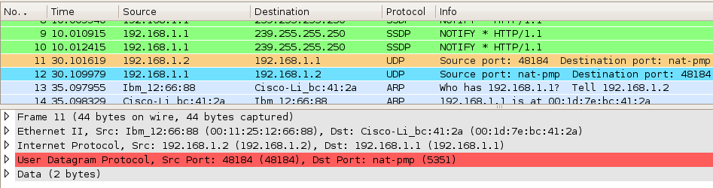Fig. 17 : NAT-PMP request (as seen over LAN)
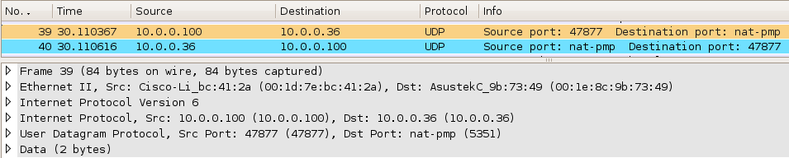Fig. 18: NAT-PMP request (as seen over DS-Lite tunnel)

Returning NAT-PMP response
Forwarded packet causes NAT-PMP daemon, running on CGN, to generate response. As the original request was sent from OpenWRT box, response is also transmitted to OpenWRT box. Returning NAT-PMP response is received over softwire. Appropriate mapping is found and final destination address can be decided. Packet is then forwarded to LAN interface. As mapping is no longer required, it is deleted. Statistics are increased.
Waiting for incoming packets (timeout: 10s, 0us), 1 mappings (9 pkts handled)
Received UDP packet: 12 bytes (sock-id=8): 10.0.0.36/port 5351 -> 10.0.0.100/port 47877
Handling response using following mapping:
Mapping UDP: src=192.168.1.2/port 48184,dst=192.168.1.1/port 5351 => src=10.0.0.100/port 47877,dst=10.0.0.36/port 5351 (sock=7/8)
Forwarding UDP response (12 bytes) to 10.0.0.36/port 48184

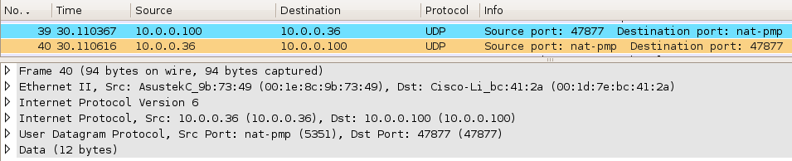Fig. 19: NAT-PMP response (seen over DS-Lite tunnel)
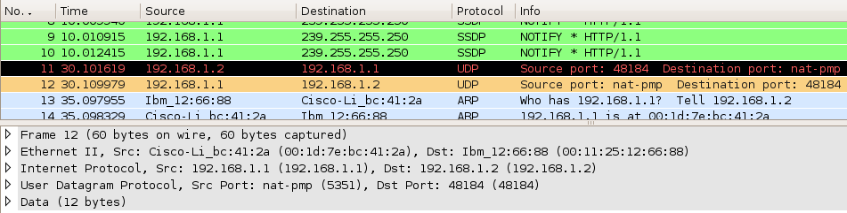Fig. 20: NAT-PMP response (seen over LAN)

NAT-PMP end to end testing
As NAT-PMP messages are forwarded in both directions, client eventually receives response from CGN:
thomson@ecwm0tmrugals:~/devel/libnatpmp-20090713$ ./natpmpc-static
initnatpmp() returned 0 (SUCCESS)
sendpublicaddressrequest returned 2 (SUCCESS)
readnatpmpresponseorretry returned 0 (OK)
Public IP address : 1.2.3.4
epoch = 76257
closenatpmp() returned 0 (SUCCESS)

UPnP
Universal Plug-and-Play is protocol defined by UPnP Forum. Specification is available at http://upnp.org/standardizeddcps/default.asp. There are number of defined devices that this protocol supports, like media servers, printing devices or Internet Gateway Devices (IGD). There are several communication modes that are defined by the standard. First is a SSDP protocol. It uses multicast address 239.255.255.250 to discover IGD. Also IGD periodically announces its presence sending advertisements to this address. To control available UPnP capable devices (e.g. IGDs), UPnP defines UPnP control points. They may have been called clients. IGD announces location of its resource description, defined as a URL (e.g. Location:http://10.0.0.36:37989/rootDesc.xml). Such location URL is sent in announcements and in responses to clients. Once client receives such URL, it establishes HTTP connection to specified port. This connection is used for various operations. Getting external address, setting port forwarding and getting already configured port forwarding rules are most notable examples.

SSDP announcements
Each IGD is expected to periodically (and during initialization phase) announce its presence. Such SSDP packets are sent to multicast address 239.255.255.250. As IGD is located on CGN box, those announcement are received over softwire. They must be forwarded to LAN interface, so clients will be able to discover available IGD. Responses are not expected, so mapping is not required.
Waiting for incoming packets (timeout: 3600s, 0us), 0 mappings (6 pkts handled)
Received UDP packet: 333 bytes (sock-id=5): 10.0.0.36/port 51608 -> 239.255.255.250/port 1900
Mcast pkt received on WAN interface (pkt->sock=5)
Forwarding SSDP multicast to LAN

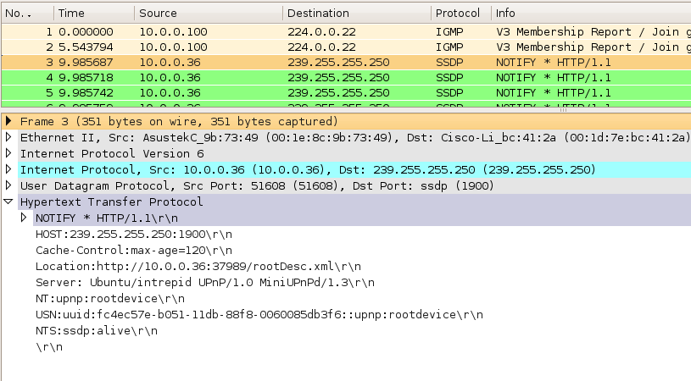Fig. 21: SSDP NOTIFY message (as seen over DS-Lite tunnel)

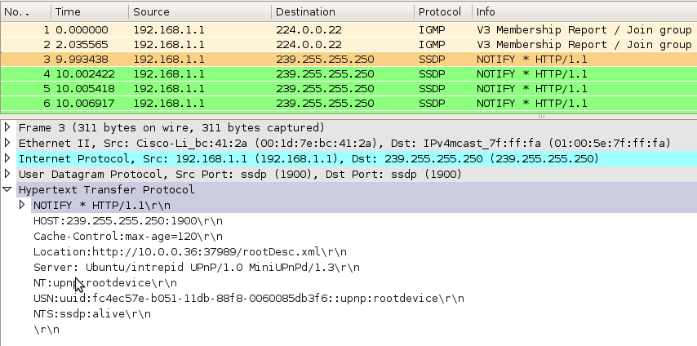Fig. 22: SSDP NOTIFY message (as seen over LAN)

Incoming UPNP query
Clients may also actively try to discover available IGDs. To do so, they transmit M-SEARCH UDP packet to multicast (239.255.255.250) address. Portproxy receives such packets on LAN interface and forwards it over softwire. As response from IGD is expected, appropriate mapping is added.
Waiting for incoming packets (timeout: 3600s, 0us), 0 mappings (10 pkts handled)
Received UDP packet: 137 bytes (sock-id=4): 192.168.1.2/port 35602 -> 239.255.255.250/port 1900
Mapping UDP: src=192.168.1.2/port 35602,dst=239.255.255.250/port 1900 => src=10.0.0.100/port 47877,dst=239.255.255.250/port 1900 (sock=4/8)
Forwarding UDP query (137 bytes) to 239.255.255.250/port 1900

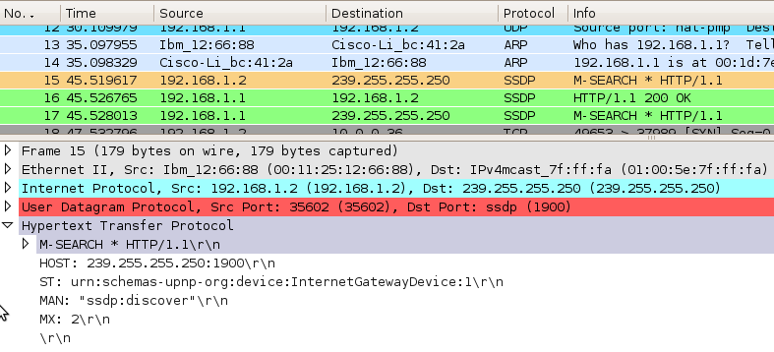Fig. 23: UPnP/SSDP M-SEARCH request (over LAN)

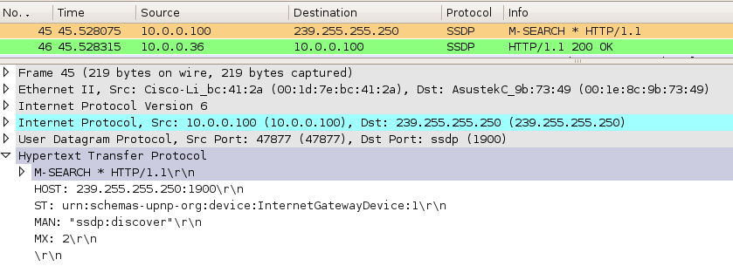Fig. 24: SSDP M-SEARCH message (as seen over DS-Lite tunnel)

Returning UPNP response
After IGD (located at CGN) receives M-SEARCH packet, it sends standard HTTP 200 OK response. This packet is received by portproxy, corresponding mapping is found and packet is finally sent do original client.
Waiting for incoming packets (timeout: 10s, 0us), 1 mappings (11 pkts handled)
Received UDP packet: 306 bytes (sock-id=8): 10.0.0.36/port 1900 -> 10.0.0.100/port 47877
Handling response using following mapping:
Mapping UDP: src=192.168.1.2/port 35602,dst=239.255.255.250/port 1900 => src=10.0.0.100/port 47877,dst=239.255.255.250/port 1900 (sock=4/8)
Forwarding UDP response (306 bytes) to 239.255.255.250/port 35602
This message contains URL with exact IGD resources location, so from now on, client is able to contact remote IGD without any further assistance from portproxy.

Fig. 25: UPnP response (over DS-Lite tunnel)
Fig. 26: UPnP response (over LAN)

UPnP end to end testing
Client requests forwarding external port 9929 to local IP 10.0.0.7/port 8288. Following command sends this request:
./upnpc-static -a 10.0.0.7 8288 9929 tcp

After successful communication through portproxy, client completes UPnP port forwarding configuration process. It does not involve portproxy. Once client learns IGD resource location, it is able to communicate directly.
After discovery process is complete, following direct operations between client and IGD are executed. Client sends “ GET /rootDesc.xml” command and gets response from IGD. Client reviews IGD capabilities and sends “HTTP/POST GetStatuInfo:WANIPConnection:1” command. IGD responds. Client sends “HTTP/POST WANIPConnection:1#GetExternalIPAddress” command and gets response from IGD. Finally client sends “HTTP/POST WanIPConnection:1#AddPortMapping” command that instructs IGD to add mapping entry. After this operation is complete, IGD sends response. The client used during tests (upnp-static) also verified that mapping was really configured. It did so by sending “HTTP/POST WANIPConnection:1# GetSpecificPortMapping Entry”. IGD responded with appropriate response.
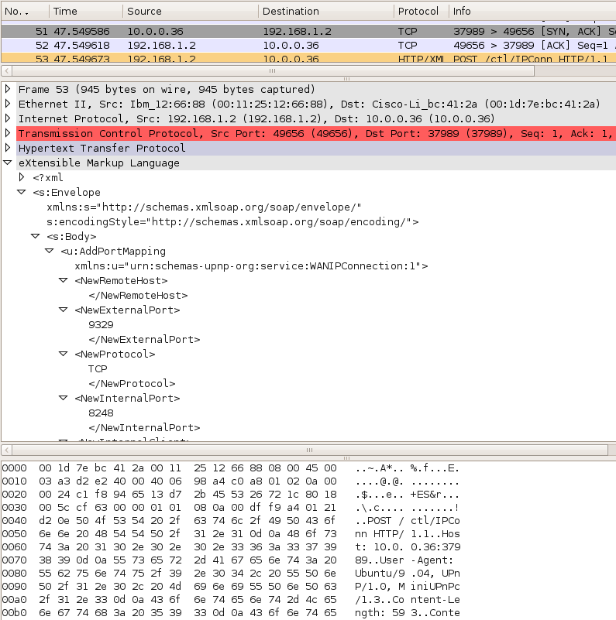Fig. 27: Port Forward request (seen on LAN)
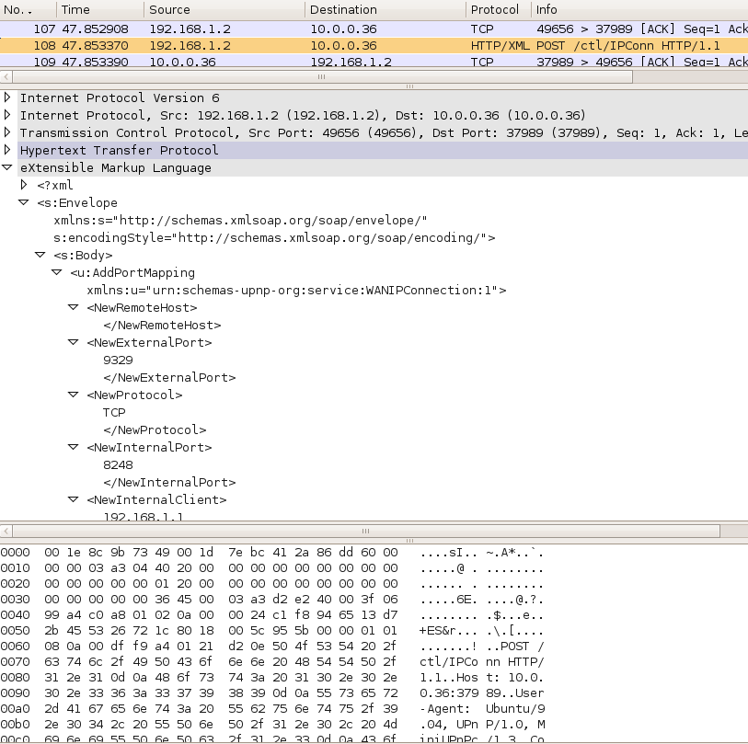Fig. 28: Port Forward request (seen over softwire)

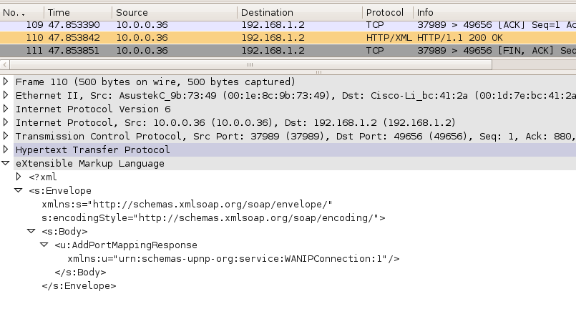Fig. 29: Port Forward response (over softwire)

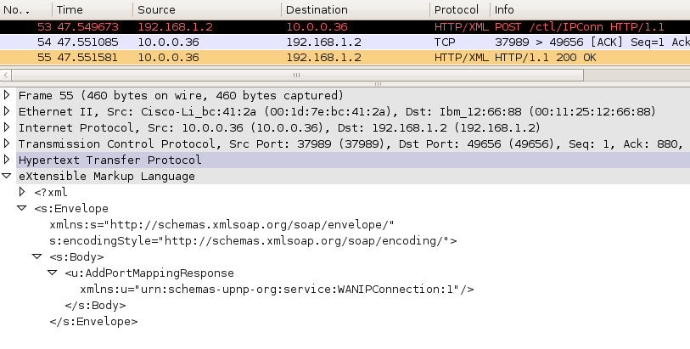Fig. 30: Port Forward response (over LAN)
Following log file contains record of UPnP port forwarding request issued by upnp-static. It requests forwarding external TCP 9929 port to internal port 8288. Second part of this log file contains another example of forwarded port.
thomson@client:~/miniupnpc-20090921$./upnpc-static -a 10.0.0.7 8288 9929 tcp
upnpc : miniupnpc library test client. (c) 2006-2009 Thomas Bernard
Go to http://miniupnp.free.fr/ or http://miniupnp.tuxfamily.org/
for more information.
List of UPNP devices found on the network :
desc: http://10.0.0.36:52164/rootDesc.xml
st: urn:schemas-upnp-org:device:InternetGatewayDevice:1

Found valid IGD : http://10.0.0.36:52164/ctl/IPConn
Local LAN ip address : 192.168.1.2
ExternalIPAddress = 1.2.3.4
InternalIP:Port = 10.0.0.7:8288
external 1.2.3.4:9929 TCP is redirected to internal 10.0.0.7:8288

thomson@ecwm0tmrugals:~/devel/miniupnpc-20090921$ ./upnpc-static -a 192.168.1.1 8248 9329 tcp
upnpc : miniupnpc library test client. (c) 2006-2009 Thomas Bernard
Go to http://miniupnp.free.fr/ or http://miniupnp.tuxfamily.org/
for more information.
List of UPNP devices found on the network :
desc: http://10.0.0.36:37989/rootDesc.xml
st: urn:schemas-upnp-org:device:InternetGatewayDevice:1

Found valid IGD : http://10.0.0.36:37989/ctl/IPConn
Local LAN ip address : 192.168.1.2
ExternalIPAddress = 1.2.3.4
InternalIP:Port = 192.168.1.1:8248
external 1.2.3.4:9329 TCP is redirected to internal 192.168.1.1:8248
thomson@ecwm0tmrugals:~/devel/miniupnpc-20090921$ ./upnpc-static -a 192.168.1.1 8248 9329 tcp

All in one testing
Following section describes all in one testing, including NAT-PMP and UPnP running together.
This section contains log file produced by portproxy, run from command-line. There are only two parameters specified. Verbosity level is increased (-v) and external interface is specified to be “dslite”.
Note: After support for extended NAT-PMP protocol was introduced, default behavior has changed. NAT-PMP and UDP traffic of UPnP is not longer supported by default. Extended NAT-PMP is the only feature enabled by default.
root@OpenWrt:/tmp# ./portproxy -v --wan-iface dslite
| Portproxy - NAT-PMP/uPNP proxy, version 2009-10-22
| Author : Tomasz Mrugalski<thomson(at)klub.com.pl>
| Licence : GNU GPL v2 only. Developed at Gdansk University of Technology.
| Homepage: http://klub.com.pl/portproxy/
Detected interfaces:
Interface lo, 1 address(es), MAC=00:00:00:00:00:00
IPv4=127.0.0.1
Interface eth0, 0 address(es), MAC=00:1d:7e:bc:41:2a
Interface eth0.0, 0 address(es), MAC=00:1d:7e:bc:41:2a
Interface eth0.1, 0 address(es), MAC=00:1d:7e:bc:41:2a
Interface br-lan, 1 address(es), MAC=00:1d:7e:bc:41:2a
IPv4=192.168.1.1
Interface ip6tnl0, 0 address(es), MAC=00:00:00:00:00:00
Interface dslite, 1 address(es), MAC=20:00:00:00:00:00
IPv4=10.0.0.100
Configuration:
lan=br-lan
wan=dslite
lanIP=192.168.1.1
wanIP=10.0.0.100
routerIP=10.0.0.36
natpmp_udp_port=5351
upnp_udp_port=1900
upnp_tcp_port1=2869
upnp_tcp_port2=2857
fwd_tcp_port1=2869
fwd_tcp_port2=2857
shared_udp_sock=YES
enable_natpmp=YES
enable_upnp_tcp=NO
enable_upnp_udp=YES
Enabling uPNP (UDP)
Creating UDP socket: addr=0.0.0.0, port=1900 on interface br-lan, result=4
UDP(SSDP) socket created: sockid=4, port=1900
Successfully joint multicast group 239.255.255.250 (local IP=192.168.1.1)
Creating UDP socket: addr=0.0.0.0, port=1900 on interface dslite, result=5
UDP(SSDP) socket created: sockid=5, port=1900
Successfully joint multicast group 239.255.255.250 (local IP=10.0.0.100)
Sockets 4(LAN:br-lan) and 5(WAN:dslite) paired.
Enabling NAT-PMP
Creating UDP socket: addr=192.168.1.1, port=5351 on interface br-lan, result=7
UDP: sockid=7, port=5351
Opening single UDP transmission socket (random port)
Creating UDP socket: addr=10.0.0.100, port=0 on interface dslite, result=8
UDP: sockid=8, port=47877

Waiting for incoming packets (timeout: 3600s, 0us), 0 mappings (0 pkts handled)
Received UDP packet: 269 bytes (sock-id=5): 10.0.0.36/port 51608 -> 239.255.255.250/port 1900
Mcast pkt received on WAN interface (pkt->sock=5)
Forwarding SSDP multicast to LAN

Waiting for incoming packets (timeout: 3600s, 0us), 0 mappings (1 pkts handled)
Received UDP packet: 341 bytes (sock-id=5): 10.0.0.36/port 51608 -> 239.255.255.250/port 1900
Mcast pkt received on WAN interface (pkt->sock=5)
Forwarding SSDP multicast to LAN

Waiting for incoming packets (timeout: 3600s, 0us), 0 mappings (2 pkts handled)
Received UDP packet: 337 bytes (sock-id=5): 10.0.0.36/port 51608 -> 239.255.255.250/port 1900
Mcast pkt received on WAN interface (pkt->sock=5)
Forwarding SSDP multicast to LAN

Waiting for incoming packets (timeout: 3600s, 0us), 0 mappings (3 pkts handled)
Received UDP packet: 317 bytes (sock-id=5): 10.0.0.36/port 51608 -> 239.255.255.250/port 1900
Mcast pkt received on WAN interface (pkt->sock=5)
Forwarding SSDP multicast to LAN

Waiting for incoming packets (timeout: 3600s, 0us), 0 mappings (4 pkts handled)
Received UDP packet: 349 bytes (sock-id=5): 10.0.0.36/port 51608 -> 239.255.255.250/port 1900
Mcast pkt received on WAN interface (pkt->sock=5)
Forwarding SSDP multicast to LAN

Waiting for incoming packets (timeout: 3600s, 0us), 0 mappings (5 pkts handled)
Received UDP packet: 331 bytes (sock-id=5): 10.0.0.36/port 51608 -> 239.255.255.250/port 1900
Mcast pkt received on WAN interface (pkt->sock=5)
Forwarding SSDP multicast to LAN

Waiting for incoming packets (timeout: 3600s, 0us), 0 mappings (6 pkts handled)
Received UDP packet: 333 bytes (sock-id=5): 10.0.0.36/port 51608 -> 239.255.255.250/port 1900
Mcast pkt received on WAN interface (pkt->sock=5)
Forwarding SSDP multicast to LAN

Waiting for incoming packets (timeout: 3600s, 0us), 0 mappings (7 pkts handled)
Received UDP packet: 333 bytes (sock-id=5): 10.0.0.36/port 51608 -> 239.255.255.250/port 1900
Mcast pkt received on WAN interface (pkt->sock=5)
Forwarding SSDP multicast to LAN

Waiting for incoming packets (timeout: 3600s, 0us), 0 mappings (8 pkts handled)
Received UDP packet: 2 bytes (sock-id=7): 192.168.1.2/port 48184 -> 192.168.1.1/port 5351
Mapping UDP: src=192.168.1.2/port 48184,dst=192.168.1.1/port 5351 => src=10.0.0.100/port 47877,dst=10.0.0.36/port 5351 (sock=7/8)
Mapping UDP: src=192.168.1.2/port 48184,dst=192.168.1.1/port 5351 => src=10.0.0.100/port 47877,dst=10.0.0.36/port 5351 (sock=7/8)
Forwarding UDP query (2 bytes) to 10.0.0.36/port 5351

Waiting for incoming packets (timeout: 10s, 0us), 1 mappings (9 pkts handled)
Received UDP packet: 12 bytes (sock-id=8): 10.0.0.36/port 5351 -> 10.0.0.100/port 47877
Handling response using following mapping:
Mapping UDP: src=192.168.1.2/port 48184,dst=192.168.1.1/port 5351 => src=10.0.0.100/port 47877,dst=10.0.0.36/port 5351 (sock=7/8)
Forwarding UDP response (12 bytes) to 10.0.0.36/port 48184

Waiting for incoming packets (timeout: 3600s, 0us), 0 mappings (10 pkts handled)
Received UDP packet: 137 bytes (sock-id=4): 192.168.1.2/port 35602 -> 239.255.255.250/port 1900
Mapping UDP: src=192.168.1.2/port 35602,dst=239.255.255.250/port 1900 => src=10.0.0.100/port 47877,dst=239.255.255.250/port 1900 (sock=4/8)
Mapping UDP: src=192.168.1.2/port 35602,dst=239.255.255.250/port 1900 => src=10.0.0.100/port 47877,dst=239.255.255.250/port 1900 (sock=4/8)
Forwarding UDP query (137 bytes) to 239.255.255.250/port 1900

Waiting for incoming packets (timeout: 10s, 0us), 1 mappings (11 pkts handled)
Received UDP packet: 306 bytes (sock-id=8): 10.0.0.36/port 1900 -> 10.0.0.100/port 47877
Handling response using following mapping:
Mapping UDP: src=192.168.1.2/port 35602,dst=239.255.255.250/port 1900 => src=10.0.0.100/port 47877,dst=239.255.255.250/port 1900 (sock=4/8)
Forwarding UDP response (306 bytes) to 239.255.255.250/port 35602

Waiting for incoming packets (timeout: 3600s, 0us), 0 mappings (12 pkts handled)
Received UDP packet: 137 bytes (sock-id=5): 10.0.0.100/port 47877 -> 239.255.255.250/port 1900
Mcast pkt received on WAN interface (pkt->sock=5)
Forwarding SSDP multicast to LAN

Waiting for incoming packets (timeout: 3600s, 0us), 0 mappings (13 pkts handled)
Received UDP packet: 149 bytes (sock-id=5): 10.0.0.36/port 51608 -> 239.255.255.250/port 1900
Mcast pkt received on WAN interface (pkt->sock=5)
Forwarding SSDP multicast to LAN

Waiting for incoming packets (timeout: 3600s, 0us), 0 mappings (14 pkts handled)

Portproxy source code
Following section provides overview of the internal operation of portproxy tool. Provided information is not required for normal use, but may prove to be useful for future developers or troubleshooters.

Portproxy is a command-line tool written in C. Its purpose is to handle port forwarding control protocols between LAN and AFTR. To compile portproxy, simply type make. Necessary makefiles for cross-compilation for OpenWRT is also provided.

Portproxy source code consists of mainly 3 files: portproxy.c, framework.c and lowlevel-linux.c. Portproxy.c contains initialization routines and command-line parser. This file also contains default values. One of the more important operation performed here is context initialization. Context_t is a large structure that contains all configuration and operation parameters: protocols to be supported, list of interfaces, list of opened sockets, IPv4 and IPv6 addresses and so on. Definition of Context_t structure is located in portproxy.h. Lowlevel-linux.c provides unified API to socket and interface operations, like extracting addresses from existing interfaces or adding and binding sockets. This code was reused from the Dibbler project. The last significant element of the architecture is framework.c. It contains as processing and protocol handling routines, like receiving traffic, adding and maintaining mappings and transmitting responses.

Initially portproxy was supposed to support NAT-PMP and UPnP protocols only. As both protocol are IPv4 only and datagram may be transmitted and received over DS-Lite tunnel as with any other interface, no IPv6 support was required. During development it became evident that scalability of this approach is not sufficient, so support for extended NAT-PMP protocol was added. It receives IPv4 control messages (NAT-PMP) from clients and transmits them as IPv6 extended NAT-PMP messages to AFTR. As such, IPv6 support was added.

Portproxy uses several routines extracted from ip tool (part of the iproute package). These are mainly RTLINK socket functions that return list of available network interfaces. Those functions are located in libnetlink.c, ll_map.c, utils.c and corresponding header files.

Portproxy code is documented. Some functions have comments in Doxygen format. It is possible to generate documentation for the code using Doxygen tool. Please refer to [8] for details. Unfortunately, due to time constraints source code comments are not complete.

Portproxy operation
During initialization (sockets_bind() function) sockets are opened for specified protocols and ports. After sockets are ready, run() function is executed in loop. It calls wait_for_traffic() function that receives incoming traffic on all sockets. Once incoming packet is received, corresponding pkt_t structure is allocated. It is handled in handle_packet() function. After each iteration, ctx_mappings_remove_expired() function is called to remove outdated mappings.

wait_for_traffic() function uses select() to pool opened sockets (both IPv4 and IPv6) for incoming traffic. Once packet is received, designated ( sock_udp_receive(), sock_udp6_receive(), sock_tcp_accept() or sock_tcp_receive() ) function is used to receive actual packet.

handle_packet() function is responsible for dealing with received packet. If incoming packet is TCP, then handle_tcp_packet() or handle_tcp_close() functions are called. For each incoming TCP connection, a separate socket is created. Also corresponding connection to AFTR is established. This functionality may be part of Application Level Gateway (ALG) and is considered experimental at this time.

Fo incoming UDP packet, corresponding mapping (mapping_t structure) is searched (mapping_find() function). If found, packet is forwarded to original sender (response_send() function) and mapping is deleted (mapping_delete() function). Otherwise, if packet is valid (packet_valid() function), new mapping is added (mapping_create() function) and packet is sent to AFTR (query_send() function).

If support for UPnP is enabled, also appropriate sockets are bound to multicast addresses. There are two cases, when multicast traffic needs to be supported. First is IGD (Internet Gateway Device, a functionality provided by AFTR) announcements. IGD periodically announces itself by sending multicast message. This message will be received over WAN or DS-Lite interface. It should be retransmitted over LAN interface. Second case, when multicast is used is when UPnP control point (UPnP terminology used for client description) wants to discover available IGDs. Portproxy will receive such announcements and transmit them to IGD. As there is a response expected, portproxy will add mapping with necessary information (like original address or source port).

Extended NAT-PMP traffic is done in a stateless manner, i.e. state of the forwarded packet is not remembered as it is stored in the extra information (“a shim”) added to the extended NAT-PMP packet itself. Incoming IPv4 packets from clients are prefixed with extra information and sent to AFTR (handle_nat_pmp_ext_fromclient() function) as IPv6 traffic. Returning IPv6 responses are stripped from their extra 12 bytes and forwarded to original clients (handle_nat_pmp_ext_fromserver() function).

LuCI source code
Following section provide essential information about internal operation of LuCI web interface. It is not necessary for end users, but may be very useful for engineers who want to troubleshoot, or extend LuCI interface.

LuCI overview
LuCI [9] is a GUI framework developed in lua [10]. Although other possible applications are possible, its main purpose is to work on top of OpenWRT network devices. LuCI is available from [9] website, but it is also closely integrated with OpenWRT. LuCI is currently used in OpenWRT latest (kamikaze) branch as default GUI.
There are number of features that favor LuCI, compared to other available GUI frameworks (like X-Wrt). It is written as clean, extensible and modular interface. It uses MVC (Model-View-Controller) design pattern that separates display (HTML), content validation (Model) and access (Controller). This results in an elegant and clean code. Thanks to rich set of available libraries, development of new pages is quick and efficient.

Lua language
LuCI is written in lua – a lightweight, reflective, imperative and functional programming language. Its syntax is somewhat similar to PHP and C. There are number of good tutorials available. Beginner user is encouraged to read [11].

General LuCI architecture
Each page consists of at least 2 and sometimes 3 components. First component is Controller. It defines the general page as a whole, defines its location in menu, maintains access control and points out to its actual content. Following example is a simplified controller for softwire-related pages. It should be called portproxy.lua and stored in controller/softwire directory.
module("luci.controller.softwire.portproxy", package.seeall)

function index()

local page = entry({"admin","softwire"}, template("softwire/overview"), "Softwire", 80)
page.dependent=false

local page = entry({"admin","softwire", "test1"}, call("action_test1"), "Script test", 10)
page.dependent=false

local page = entry({"admin", "softwire", "tunnel"}, cbi("softwire-tunnel"),
"Tunnel configuration", 20)
page.dependent=false

end

function action_test1()
luci.http.prepare_content("text/plain")
luci.http.write("Portproxy configuration ready.")
end

First line defines new module. Package.seeall defines that this module will be accessible by all logged users. Each module has to have index() function defined. This function in turn defines all pages. In this example, there are 3 pages defined. First page is titled “Softwire”. It has order of 80. This order is used for sorting menu. It can be used to rearrange pages very easily. Every page registered in LuCI, has its own path. In this example, path to “Softwire” page is “admin/softwire”. This path will be visible to end user as part of the URL. Once user navigates to this page, template (“view”) located in softwire/overwiew will be displayed. Such view is a HTML code with minor extra Lua snippets. For example, here is the view/softwire/overview.htm file:
<%+header%>
<h2>Softwire configuration</h2>

<p>This section of the Web GUI is dedicated to tunnel configuration:
Softwire (IPv6 over IPv4) or <abbr title="Dual-Stack
Lite">DS-Lite</abbr> (IPv4 over IPv6). Related topics -
fragmentation, <abbr title="Maximum Transmission Unit">MTU</abbr>,
services and tunnel status, portproxy (a tool used for automatic port
configuration, using NAT-PMP and UPnP) and manual port forwarding
configuration are also available.</p>

<%+footer%>

Another interesting feature is the ability to create simple pages using functions. Second page called “Script test” is an example of this feature. Note that path specified for this page is admin/softwire/test1. As it is nested deeper than previous page, it will be displayed as sub-menu. Once user navigates to that page, action_test1() function will be executed and its content sent back to user. Even though this functionality is rarely used in actual framework, it was presented here for the sake of completeness.

The last way of creating pages are so called CBI models that are described in the next section.
CBI models
The most powerful feature of LuCI interface is CBI concept. It is a representation of one or more UCI configuration files (typical OpenWRT configuration files, located in /etc/config directory). Here is simplified version of model/cbi/softwire-tunnel.lua CBI model:
mantun = Map("mantun", "Tunnel configuration", "This page allows tunnel configuration. ")

m = mantun:section(NamedSection, "general", "general", "General tunnel configuration",
"This section defines fundamental tunnel configuration modes.")

Dsliteauto = m:option(ListValue,"DsliteAuto", "Tunnel type",
"This parameter defines how tunnel should be configured.")
Dsliteauto:value("0","Softwire")
Dsliteauto:value("1","DS-Lite")
Dsliteauto:value("2","Disable")
Dsliteauto.default = "DS-Lite"

l2tpusername = l2tpSection:option(Value,"l2tpusername", "L2TP username","L2TP login here.")
l2tpusername:depends("Dsliteauto","0")
l2tpusername.rmempty = false

mtu = softw:option(Value, "mtu", "MTU", "Remember that: 1280 < MTU < 1460!")

return mantun
This page specifies creates Map object called mantun. It will create necessary form for editing mantun configuration file, will display “Tunnel configuration” as a form title and provide description “This page allows tunnel configuration”. Each map should consist of one or more sections. In this case, user is able to edit section named “general” of type “general”, located in “mantun” configuration file. From this section several parameters are editable by user. First is Dsliteauto – a parameter that specifies tunnel type. It is defined as ListValue, so user will be choose one of provided values. Parameter will be assigned 0, 1 or 2, but user will be presented with values “Softwire”, “DS-Lite” or “Disable”. Default value may be specified. Default value is also taken from the configuration file, if not explicitly specified.

Next field is l2tpusername. It is specified as user editable field (“Value”) that corresponds to “l2tpusername” entry in configuration file. It is dependent on Dsliteauto having value of “0” (i.e. it is only possible to edit L2TP username if tunnel type is softwire). It is also defined that this field should not be removed from configuration file, if user provides empty username. It is possible to extend this simple form with additional code that will verify if provided values are valid:
function mtu:validate(value)
local v = tonumber(value)
if v==nil then -- provided value was not valid number
return 1460
end
if v<1280 then -- too small
return 1280
end
if v>1460 then -- too large
return 1460
end
return v -- return specified value
end

This function will be called every time user clicks Save or Save&Apply button. Note unusual comment convention used in Lua. Single line comments are starting with double minuses.

Once user clicks Save, changes are going to be added as scheduled change. Before finally commiting them, it is possible to review all changes or even revert them. Once user applies a change it becomes permenent and it is not possible anymore to return to previous value.

Another interesting thing is the ability to perform special actions if certain field is modified. For example mtu field can be extended with the following code:
function mtu.write(self, section, value)
if value~="0" then
-- non zero values
os.execute("echo "..value.." > /proc/softwire/smtu")
os.execute("echo 1 > /proc/softwire/overridesmtu")

--[[ luci.fs.writefile("/proc/softwire/smtu",value)
luci.fs.writefile("/proc/softwire/overridesmtu","1") ]]--
else
-- zero value (user specified 0, let system decide on its own)
os.execute("echo 0 > /proc/softwire/overridesmtu")
os.execute("uci set proc_vars.procentities.overridesmtu=0")
end
If mtu is set to non-zero value, new MTU is written to /proc/softwire/smtu and /proc/softwire/overridesmtu is set to 1. Otherwise, overridesmtu is set to 0.

There are many more other possibilites that such forms may be extended. It is also worth noting that one page may contain more than one form. Here is a simplified code that edits several configuration files on one page:
mantun = Map("mantun", "Tunnel configuration", "This page allows tunnel configuration. ")
-- put mantun parametere here

xl2tp = Map("xl2tp", "Softwire Configuration", "Specify Softwire parameters here.")

return mantun, xl2tp

Please note that return may use more than one object. This feature is used in Lua on many occasions. Some functions return two or more values. Although strange at first glance, it is very useful and greatly simplifies many tasks.

CBI reference is available in [13]. It lists all available object properties and methods. There are four maps that correspond to different Softwire/DS-Lite automatic/manual cases. Patch2 introduced a JavaScript that hides not relevant maps and displays one the relevant ones.

Simple Forms
In some cases webpage does not necessarily corresponds to a configuration file. In such cases SimpleForm object may be used.
form = SimpleForm("processes", "Portproxy", "Portproxy control.”)
form.reset = false

pid = 1000

form:field(DummyValue,"status","status").value = “Not active”

kill = form:field(Button, "_kill", "Kill")
kill.inputstyle = "reset"
kill.value = pid

function kill.write(self, section)
luci.sys.process.signal(self.value, 9)
end

params = f:field(Value,"params","Portproxy parameters")

return form
Simple form is defined with “Portproxy” as name and “Portproxy control” as description. By default simple forms have “submit” and “reset” buttons. It is possible to disable those buttons. SimpleForm may contain DummyValue – a fake, read-only field that is not editable by user. Another useful type is Button. It may be connected with write method that will execute specified task once the button is pressed. Another example is a normal field (“Value”) that can be edited by user. Keep in mind that this value is not stored anywhere once submitted. Without any special code that handles its value it will be lost once user navigates away from this page.

There is a good tutorial available that explains basic code development up to separate LuCI page. See [12].

Services and configuration files
There are many configuration files, like dhcp, mantun or xl2tp. They are stored in /etc/config directory. There are also several services that are connected to those configuration files. For example, /etc/init.d/dhclient uses /etc/config/dhcp configuration file. Once change is made to a configuration file, affected services should be restarted. Mapping between files and services is stored in /etc/config/ucitrack. Excerpt from ucitrack is provided below:
config network
option init network
list affects dhcp

config wireless
list affects network

config mantun
option init tunnelscript
For example the last section instructs LuCI to restart tunnelscript any time when mantun configuration file is modified. There are certain conditions that must be met, however. First and foremost, specified script must exist and be executable (/etc/init.d/tunnelscript in this example). This service must also be enabled (i.e. link to it must be available in /etc/rc.d/ directory). It is easy to enable script. For example, to enable dhclient script, use following command:
/etc/init.d/dhclient enable
For details regarding script restarts, please review /sbin/luci-reload script.

LuCI development environment
LuCI comes with good development environment that may be run under any Linux distribution on any PC that provides extra debugging capabilities. Once code development is complete, page may be copied over to OpenWRT box with ease. LuCI development environment setup is described in [14]. Quick download and installation may be completed using following commands:
svn co http://svn.luci.subsignal.org/luci/trunk
cd trunk
make runhttpd
LuCI will be compiled and HTTP server will be run. It will be accessible on http://localhost:8080/. Additional details regarding file location are specified in [12].
Note: LuCI modules may be extended with debugging messages. It is possible to add print() calls to the code. If run via make runhttpd, those print messages will be printed on console. Also, in case of exceptions or parser errors, appropriate error message is presented in browser. When code is run on OpenWRT, such errors are silently discarded and user sees only blank page.

Developed LuCI softwire-related pages
Following section briefly describes each new developed page and its internal organization.

Softwire overview page
That is a simple non-interactive page that displays brief overview of the Softwire menu. It displays view/softwire/overview.htm file.

Tunnel configuration
This is the most important page. It is dedicated to tunnel configuration. It uses model/cbi/softwire-tunnel.lua CBI model. This model contains several utility functions like tunnelMode() that returns specified tunnel mode (softwire, DS-Lite or none), softwireMode() that returns softwire configuration mode (DHCP or manual) and dsliteMode() that returns DS-Lite configuration mode (DHCP or manual). It consists of 5 maps. Those maps are stored in returnForms array. This feature may be useful, if certain maps should be hidden.

First map represents mantun configuration file and allows changing tunnel type and mode.
Second map represents xl2tp configuration file that contains parameters for softwire tunnel running in automatic mode. L2TP and PPP parameters may be specified here. Each field is marked with rmempty=false property that prevents LuCI from deleting corresponding field, if user enters empty value. Values from this form are used only if tunnel is softwire and its configuration mode is set to DHCP.
Third map represents xl2tp_static configuration file that covers static (manual) softwire configuration. Available fields are the same as in previous form with the notable addition on Softwire server IPv4 address. Values from this form are used only if tunnel is softwire and its configuration mode is set to manual.
Fourth map represents overridetunnel configuration file. It covers DS-Lite configuration running in automated mode.

Note: Those parameters may be configured in fully automated mode, i.e. using DHCPv6 DS-Lite tunnel endpoint option, DNS server option and RA advertisements. This would probably require extra work on DHCPv6 client and server, however.

Fifth, final map represents mantun configuration file. This configuration file is shared between two maps: mantun (first, general tunnel setup) and mantunDsLite (fifth, manual DS-Lite configuration). Each map changes only specific fields, so there is no conflict between them.

Note: This page requires edited configuration files to be present. They are part of the ipv6tunnel.ipk package. If this package is not installed, this page will not function properly!

Fragmentation
This page is dedicated to parameters related to fragmentation. Depending on tunnel mode used, certain fields may not be visible. The logic here follows X-Wrt interface. SimpleForm is used as interface. There are several utility function defined. TunnelMode() returns tunnel type. TunnelModeText() returns text name of currently used tunnel type. getSMTU4() returns current value of SMTU for IPv4 (reads from /proc/softwire/smtu or value specified in the web form). GetSMTU6() performs similar function for IPv6 SMTU. getDF() returns status of Don't Fragment bit. There are also functions defined for SMTU values validation: smtu4.validate() and smtu6.validate(). Each change of SMTU or DF bit values are processed by smtu4.write(), smtu6.write() and dfBit.write() functions. CBI model is stored in model/cbi/softwire-misc.lua.

Advanced settings and status
This page covers two topics: control of related services and tunnel status. There are several utility functions defined. Started() function returns status, if specified service is currently started or not. Pid() function returns process ID of specified process (or nil if process is not running). Text representation of process status is generated by status() function.

There are five forms dedicated for separate services: DHCP client (dhclient service), RADVD daemon (radvd service), dnsmasq service (dnsmasq service), tunnel (tunnelscript service) and portproxy (portproxy). For each service, there are two buttons available. Depending on current status, they allow start, stop, enabling or disabling specified service.

Note that depending on certain conditions, e.g. started(“dhclient”)==true, some fields are visible or not. As tunnelscript is not a real daemon, but rather set of scripts, its control is slightly different. It is always possible to start and stop this service.

The last SimpleForm provides tunnel status. Similar to other forms, this one is read-only, too. As such, there are no submit or reset buttons. There are two functions that return status of softwire or DS-Lite tunnel: softwireStatus() and dsliteStatus(). Interesting code here reads list of network interfaces and tries to find “softwire” or “dslite” interfaces. Also softwire status is based on presence or absence of /tmp/gotvaluefrmdhcp file.

This page uses CBI model stored in model/cbi/softwire-adv.lua. This page is refreshed every 10 seconds.

Note: This page may be considered for split into two separate pages: one for services management and second for tunnel status.

Manual port fordwarding module
This page provides means for manual port forwarding configuration. It is modified version of model/cbi/luci_fw/redirect.lua. Modification include removing rule naming, zone specification and external edition. Also limits are added. It is possible to configure maximum number of rules allowed to be configured. The default value is 11, but this can be changed. This CBI model is stored in model/cbi/softwire-portfwd.lua. It uses modified view stored in view/softwire/customtbl.htm. Maximum number of allowed rules is stored in /etc/config/softwire configuration file, in “limits” section, “maxports” field.

Manual port forwarding limits
This page is a very simple map that edits single field from /etc/config/softwire configuration file. This CBI model is stored in model/cbi/softwire-portfwd-limits.lua.

Permanent portproxy configuration
This page covers permanent portproxy configuration. It covers single configuration file (/etc/config/softwire) and is split into several sections. First section enables or disables support for NAT-PMP, UPnP and extended NAT-PMP protocols. Separate section for each protocol follows. After any change is introduced in this page, portproxy service is restarted. That operation is achieved by corresponding entry in /etc/config/ucitrack. See section 10.5 for details.
This CBI model is stored in model/cbi/softwire-portproxy-perm.lua file.

Temporary portproxy configuration
This last page is intended for temporary monitoring of portproxy process. It uses SimpleForm to display various process information, like process ID or CPU load. If the process is running, it is possible to affect it in certain ways (e.g. terminate or kill it). If process is not running, it is possible to specify command-line parameters for one time process start. Note that any changes made via this page are temporary and will be lost after reboot. It may be considered a debugging tool. CBI model for this page is stored in model/cbi/softwire-portproxy.lua.
Note: Code that checks if process is running is not elegant. Similar, but much cleaner code is available in “advanced settings and status” webpage.

Firmware installation
There are no special techniques required to install provided firmware. Reader familiar with the firmware flashing on WRT devices may skip this section. It is provided as a reference for less experienced users.

Connecting LinkSys
Before any configuration or firmware modification, make sure that you have full connectivity to your LinkSys device. LinkSys devices by default use 192.168.1.1 address, so to communicate with it, another address from 192.168.1.0/24 pool is required. For example, PC may be configured to use 192.168.1.100/24 address. To check if you have connectivity with LinkSys device, use following command:

ping 192.168.1.1
Make sure that you have LinkSys connected using the rightmost socket. See Fig.31 below.
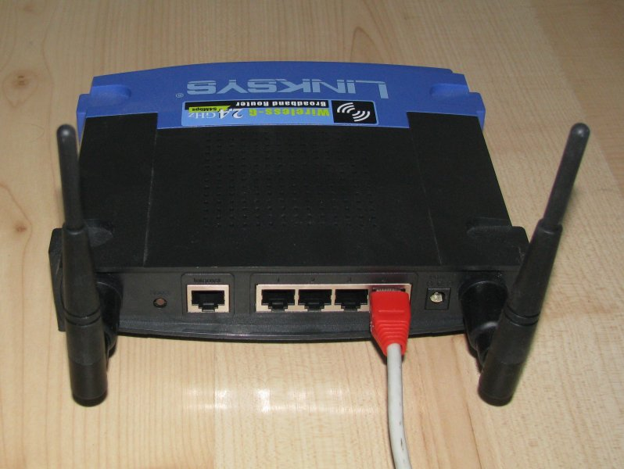Fig. 31: Connecting LinkSys to LAN
Note: IPv4 address set to 192.168.1.1 is a LinkSys' default setup. It reverts to this configuration after every firmware upgrade. Also it is its default factory configuration.

Firmware upgrade (using original web interface)
Before attempting to install Linux on LinkSys device, make sure that this particular model is supported. Please consult http://wiki.openwrt.org/TableOfHardware . Note that even small deviations are important. Sometimes version 1.0 and 1.1 are quite different. See Fig. 2 for example how to check your particular model. In general, at least 4MB flash and 16MB ram is required.
Linux installation on Linksys is being performed as a firmware upgrade. During the first installation, original web interface (provided by LinkSys) should be used. From PC using the same address space (see section 3.1), use web browser to connect to your LinkSys web interface. See Fig.32 below.
Select appropriate firmware image (i.e. file that ends with -squashfs.bin and is corresponding to the name of used device). There are some sanity checks in the firmware upgrade procedure, but using wrong image may result in rendering the router unusable. You may want to check supported hardware list: http://wiki.openwrt.org/TableOfHardware?action=show&redirect=toh Please verify that you are using proper firmware. After firmware was uploaded, flashing takes place. It can take up to 2 minutes. After completion, router will reboot. Make sure to not reboot or power off the router before it finishes flashing.
It also may be beneficial to read following OpenWRT installation guide: http://wiki.openwrt.org/InstallingWrt54gl

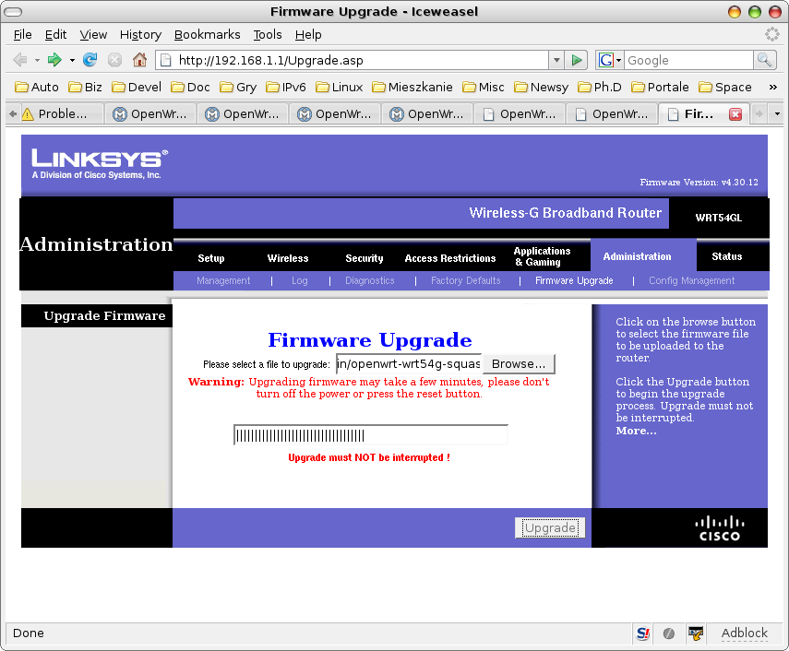Fig. 32: Firmware upgrade using original web interface

Firmware upgrade (using linux console)
Firmware upgrade from OpenWRT (i.e. when your LinkSys device was flashed already) is done by using mtd tool. Copy openwrt-brcm47xx-squashfs.trx file to the /tmp directory. Note that this is a different image file than used in the web interface. Copy it to your LinkSys device:
scp openwrt-brcm47xx-squashfs.trx root@192.168.1.1:/tmp
This command will copy required firmware image to /tmp directory. Change to that directory and begin flashing, using following command:
cd /tmp
mtd -r write openwrt-brcm47xx-squashfs.trx linux
After flashing is complete, device will reboot. It takes up to 2 minutes to finish flashing and rebooting. Please note that after such firmware upgrade, all changes made to the router configuration will be lost. That includes all software packages installed and all configuration changes.
Note: .bin and .trx firmware image files contain the same image, but .trx is a "raw" image, while .bin has extra headers for the purpose of being recognized as a valid image by the original web interface.
Note: mtd is a command-line tool. As most of the OpenWRT software it may come pre-installed or as a separate package. If the mtd is missing, simply install mtd_7_mipsel.ipk package. It is a good idea to always include mtd package in the firmware image.

Firmware upgrade (TFTP)
Another way to install new firmware is to use TFTP protocol. When boot_wait phase is enabled (see section 3.5), it is possible to upload new firmware using TFTP protocol. On a Linux box that uses IPv4 address from the same class (see section 3.1), use TFTP client to send firmware. For example:
tftp 192.168.1.1
tftp>binary
tftp>rexmt 1
tftp>timeout 60
tftp>trace
Packet tracing on.
tftp> put openwrt-wrt54g-2.4-squashfs.bin
In the example above, client will try to send firmware at 1 second intervals. It will give up after 60 seconds. After those commands are typed, shut down and then boot your device. Following messages should be displayed:
$tftp 192.168.1.1
tftp> binary
tftp> rexmt 1
tftp> timeout 120
tftp> trace
Packet tracing on.
tftp> put openwrt-wrt54g-squashfs.bin
sent WRQ <file=openwrt-wrt54g-squashfs.bin, mode=octet>
sent WRQ <file=openwrt-wrt54g-squashfs.bin, mode=octet>
sent WRQ <file=openwrt-wrt54g-squashfs.bin, mode=octet>
sent WRQ <file=openwrt-wrt54g-squashfs.bin, mode=octet>
sent WRQ <file=openwrt-wrt54g-squashfs.bin, mode=octet>
sent WRQ <file=openwrt-wrt54g-squashfs.bin, mode=octet>
received ACK <block=0>
sent DATA <block=1, 512 bytes>
received ACK <block=1>
sent DATA <block=2, 512 bytes>
...
received ACK <block=3592>
sent DATA <block=3593, 32 bytes>
received ACK <block=3593>
Sent 1839136 bytes in 15.1 seconds
Note: bin images are expected to be uploaded via TFTP, not the raw trx images. Attempt to upload trx image (or in fact any other file that does not have proper headers) will cause bootloader to reject the file:
received ACK <block=0>
sent DATA <block=1, 512 bytes>
received ACK <block=0>
sent DATA <block=1, 512 bytes>
received ERROR <code=4, msg=code pattern incorrect>
Error code 4: code pattern incorrect

Enabling boot_wait phase
Most embedded devices have multi-stage boot process. After the device is powered up, it runs bootloader. Its main task is to check if flash memory contains proper firmware, load and run it. Broken, corrupted or non-functional firmware may cause the endless loop of firmware loading and reboots or device crash. This state of device being unusable is often referred to as “bricked”. There are basically 2 methods of recovering such device:
- Use JTAG connector to upload new firmware
- Use TFTP to upload new firmware via network
As the first option requires hardware modification (most if not all LinkSys devices come without JTAG connector, so soldering and extra JTAG cable is necessary), it is much easier to use TFTP transfer.
Bootloader may be configured to wait specified period for incoming TFTP packets. However, this waiting phase delays device boot, so vendors often disable this feature. Fortunately, it can be reenabled. To enable boot_wait phase, use following commands from the command-line:
nvram set boot_wait=on
nvram commit
Note: this feature works under Linux kernels 2.4 only. For that purpose, you may want to use any stable OpenWRT firmware that is kernel-2.4 based. Once boot_wait is enabled, it is safe to experiment with new firmware images (kernel 2.6 based for example). One way to obtain 2.4 based firmware is from OpenWRT homepage: http://downloads.openwrt.org/kamikaze/7.09/

First connection
After performing firmware upgrade, it is possible to connect to the router using telnet command. Please run following command: telnet 192.168.1.1 from a PC console. See fig. 3 for example session. There is no root password. Please change root password by issuing passwd command. After this operation, telnet service will be disabled. SSH will be enabled instead. Note that ssh requires some time (~30 seconds) to generate keys, so it will reject any connection attempts at that time.

ipk packages
OpenWRT provides wide set of network related tools. Due to flash memory constraints, often only a limited set of tools may be installed. They are managed as ipkg or opkg packages. ipkg was older package management tool that was replaced with opkg.
During firmware compilation, every piece of software may be selected to be built as part of the firmware <*>, separate package <M> or not built at all < >. It is advisable to include in the base firmware only those really necessary packages, as packages built-in into firmware cannot be deinstalled. (It is possible to remove them using opkg remove command, but they will only become invisible and still take up precious space on flash memory).

Package installation
Software installation is being done using ipk packages. To install a package please copy it to /tmp directory, e.g. using scp command (run on a PC):
scp mtd_7_mipsel.ipk root@192.168.1.1:/tmp
After package is transferred to the device, use following command:
opkg install /tmp/package_name.ipk
to install package. For example, to install mtd, use following command :
opkg install /tmp/mtd_7_mipsel.ipk
Following packages are currently recommended for the ip46nat project:
- kernel_2.6.25.16 – dummy package that is required by other packages.
- mtd - mtd is a tool used to flash router. That is the preferred way to flash router, once Linux have been installed.
- ip - powerful tool used for network configuration. Part of the iproute2 suite. For example, interfaces, addresses and tunnels are configured using this tool.
- iptables - optional package, may be used to configure IPv4 firewall and/or IPv4 only NAT.
- ip6tables - optional package, may be used to configure IPv6 firewall and/or IPv6 only NAT.
- uclibcxx - C++ library required to run all software written in C++, e.g. dibbler software
- dibbler-client - DHCPv6 client, used to retrieve configuration and configure the device.
- dibbler-server - DHCPv6 server, used to distribute addresses and configuration parameters to other nodes.
Kernel modules are also handled as ipk packages. To distinguish between user-space software and kernel modules, the latter use kmod- prefix. Here is a list of useful kernel modules:
- kmod-ipv6 – module that provides IPv6 capability.
- kmod-ip46nat – provides IPv4-to-IPv6 NAT functionality.
- kmod-ip6-tunnel – provides IPv4 over IPv6 tunneling. Requires iptunnel6 module to be present.
- kmod-iptunnel6 – this module is required by ip6-tunnel. It also requires IPv6 module.
- iptables – firewall and advanced routing tool
- ip6tables – IPv6 version of the iptables
For information how to compile additional software, see section 7.
Also keep in mind available space on the device. Use df -h command, if necessary. According to OpenWRT homepage, when base partition is full, various errors start to appear and firmware may get corrupted.

Best practices and debugging tips
This section provides recommendations, useful observations and best practices.
- Before you start any risky firmware upgrade, make sure that boot_wait is enabled (see section 3.5). Firmware with Linux kernel 2.4 is required.
- Network configuration is specified in the /etc/config/network file. It contains information regarding port assignments, used IPv4 addresses and vlan assignments. For details, see section 4.
- When modifying scripts for OpenWRT, keep in mind that it uses ash instead of bash. The differences are rather minimal (e.g. different function definitions). For details regarding ash environment, see: http://www.thelinuxblog.com/linux-man-pages/1/ash

References
Following links are recommended reading:
- http://www.ietf.org/id/draft-ietf-softwire-dual-stack-lite-03.txt – DS-Lite broadband deployments post IPv4 exhaustion, internet draft, 03 revision
- http://tools.ietf.org/html/draft-cheshire-nat-pmp-03 – NAT-PMP draft (expired)
- http://klub.com.pl/portproxy/ - Portproxy project homepage
- http://upnp.org/standardizeddcps/default.asp – UPnP specification
- http://downloads.openwrt.org/kamikaze/docs/openwrt.html - OpenWRT manual
- http://miniupnp.free.fr/ - MiniUPnP project homepage
- http://miniupnp.free.fr/libnatpmp.html – libnatpmp homepage
- http://doxygen.org – Doxygen code documentation tool
- http://luci.subsignal.org/ - LuCI project homepage
- http://www.lua.org/docs.html – Lua documentation
- http://lua-users.org/wiki/TutorialDirectory - Lua tutorials
- http://luci.subsignal.org/trac/wiki/Documentation/ModulesHowTo - LuCI module tutorial
- http://luci.subsignal.org/trac/wiki/Documentation/CBI – LuCI CBI reference
- http://luci.subsignal.org/trac/wiki/Documentation/DevelopmentEnvironmentHowTo – LuCI development environment HowTo

Contact
Author of this project can be reached using e-mail mailto:thomson(at)klub(dot)com(dot)pl.

