# VISVESVARAYA TECHNOLOGICAL UNIVERSITY

### JNANA SANGAMA, BELAGAVI- 590019



A PROJECT REPORT ON

“**Title: Intravenous Drip Monitoring and Control System using IOT**”

Submitted in partial fulfillment of the requirements for the award of the degree of

**BACHELOR OF ENGINEERING**

**In**

**ELECTRONICS AND COMMUNICATION ENGINEERING**

For the academic year 2022 -2023 Submitted by

**Adarsh Ujjual (1JS20EC002) Sambhav Pathak (1JS20EC075) Sumit Kumar (1JS20EC097) Vikash Yadav (1JS20EC106)**

**Under the Guidance of**

**Mrs. Gouri S Katageri** Assistant Professor **DEPT. OF E&C**

**JSSATE-BANGALORE-60**



DEPARTMENT OF ELECTRONICS AND COMMUNICATION ENGINEERING

JSS ACADEMY OF TECHNICAL EDUCATION

JSS Campus, Dr Vishnuvardhan Road, Bengaluru-60.

I

# VISVESVARAYA TECHNOLOGICAL UNIVERSITY

### JNANA SANGAMA, BELAGAVI- 590019



A PROJECT REPORT ON

“**Title: Intravenous Drip Monitoring and Control System using IOT**”

Submitted in partial fulfillment of the requirements for the award of the degree of

**BACHELOR OF ENGINEERING**

**In**

**ELECTRONICS AND COMMUNICATION ENGINEERING**

For the academic year 2022 -2023 Submitted by

##### Adarsh Ujjual (1JS20EC002) Sambhav Pathak (1JS20EC075) Sumit Kumar (1JS20EC097) Vikash Yadav (1JS20EC106)

**Under the Guidance of**

**Mrs. Gouri S Katageri** Assistant Professor **DEPT. OF E&C**

**JSSATE-BANGALORE-60**



DEPARTMENT OF ELECTRONICS AND COMMUNICATION ENGINEERING

JSS ACADEMY OF TECHNICAL EDUCATION

JSS Campus, Dr Vishnuvardhan Road, Bengaluru-60.

# J.S.S ACADEMY OF TECHNICAL EDUCATION

#### JSS Campus, Dr Vishnuvardhan Road, Bengaluru-60.

**Department of Electronics & Communication Engineering**

**CERTIFICATE**



#### A PROJECT REPORT

On

**“Intravenous Drip Monitoring and Control System using IOT”**

This is to certify that the project entitled “**Intravenous Drip Monitoring and Control System**” is a bonafide work carried out by **ADARSH UJJUAL(1JS20EC002)**, **SAMBHAV PATHAK(1JS20EC075), SUMIT KUMAR(1JS20EC097), VIKASH YADAV(1JS20EC106)** in

partial fulfillment for the award of degree of **Bachelor of Engineering** in **Electronics & Communication Engineering** of **Visvesvaraya Technological University,** Belagavi during the year 2023. It is certified that all corrections/suggestions indicated for Internal Assessment have been incorporated in the report deposited in the departmental library. The project report has been approved as it satisfies the academic requirements in respect to project work prescribed for the Bachelor of Engineering degree.

|  |  |  |
| --- | --- | --- |
| **Signature of the guide MRS. Gouri S Katageri**  **Assistant Professor** | **Signature of HOD**  **Dr.P.M. Shivakumaraswamy**  **HOD and Professor** | **Signature of Principal Dr. Bhimasen Soragaon** |
| **Dept of ECE, JSSATEB** | **Dept of ECE, JSSATEB** | **Principal JSSATEB** |
| Name of the Examiners | **External Viva** | Signature with date |

1.

2.

**ACKNOWLEGEMENT**

No work is complete without due recognition being given to people who made it possible. This project is no exception. We would like to place on record our profound gratitude for those who have helped us complete this project.

We thank his holiness **Jagadguru Sri Shivarathri Deshikendra Mahaswamiji** for his blessings to this venture.

We are grateful to **Dr. Bhimasen Soragaon**, Principal and **Dr.P.M. Shivakumaraswamy**, HOD, Department of Electronics and Communication Engineering, for their support and encouragement towards the presentation of this project.

We would like to thank **Dr. Usha S.M** and **Mrs. Latha B.N,** Project Coordinators for their able guidance. With their help and suggestions, the completion of this project has beeneasier for us.

We would like to thank **Mrs. Gouri S Katageri,** Project Guide whose modesty, adaptability and cheerful disposition are laudable. She inculcated in us an enduring interest to delve further into the topic.

We also express our deep sense of gratitude to all the Teaching and non-teaching staff of Electronics and Communication Engineering Department for their valuable guidance.

We would like to express our sincere thanks to our family and friends who, in their own ways helped us to finish this project.

**ABSTRACT**

Intravenous Drip System is used mainly in hospitals for patients who were dehydrated, nutrient deficient or unable to take medications orally. In our current medical care system, monitoring of patients in a hospital throughout the day is a tire-some process. Sometimes doctors or nurses are too busy, so they cannot monitor each patient. This causes many problems. The health-related work should be done properly and with accurate manner. An example of such type of work in our hospital is injecting saline or intravenous fluids into the vein of patient. If the drip system is not monitored on time, it will cause problems like backflow of fluid, blood loss etc. In order to reduce the workload of nursing staff and to overcome such critical situation in the area of an intravenous drip monitoring system, we proposed a system called IV Drip Monitoring and Control System.



# J.S.S ACADEMY OF TECHNICAL EDUCATION

**JSS Campus, Dr Vishnuvardhan Road, Bengaluru-60.**

**Department of Electronics & Communication Engineering**

**DECLARATION**

We **Adarsh Ujjual, Sambhav Pathak, Sumit Kumar, Vikash Yadav**, of Bachelor of Engineering in Electronics and Communication, JSS Academy of Technical Education, Bengaluru, hereby declare that the project entitled **Intravenous Drip Monitoring and Control System** has been carried out independently by us at JSS Academy of Technical Education, Bengaluru, under the guidance of **Mrs. Gouri S Katageri**, Assistant Professor, Department of Electronics and Communication JSSATE, Bengaluru.

|  |  |
| --- | --- |
| Student Names | USN |
| ADARSH UJJUAL | 1JS20EC002 |
| SAMBHAV PATHAK | 1JS20EC075 |
| SUMIT KUMAR | 1JS20EC097 |
| VIKASH YADAV | 1JS20EC106 |

DATE: 08-07-2023

PLACE: JSSATE BANGALORE

### CONTENTS

|  |  |
| --- | --- |
| **TITLE** | **PAGE NO.** |
| **ACKNOWLEDGEMENT** | III |
| **ABSTRACT** | IV |
| **DECLARATION** | V |
| **TABLE OF CONTENTS** | VI |
| **LIST OF FIGURES** | VII |
| **CHAPTER 1: INTRODUCTION** | 1 - 2 |
| **CHAPTER 2: OBJECTIVE** | 3 |
| **CHAPTER 3: LITERATURE SURVEY** | 4 - 5 |
| **CHAPTER 4: METHODLOGY AND IMPLEMENTATION** | 6 - 20 |
| **CHAPTER 5: RESULTS** | 21 - 22 |
| **CHAPTER 6: CONCLUSION AND FUTURE SCOPE** | 23 - 24 |
| **REFERENCES** | 25 |
| **APPENDIX** | 26 - 28 |

|  |  |  |  |
| --- | --- | --- | --- |
| **LIST OF FIGURES** | | | |
| **Figure No.** | **Name of the Figure** | **Page No.** |  |
| Figure 1 | Methodology Block diagram | 6 |
| Figure 2 | Flowchart of the system | 7 |
| Figure 3 | NodeMCU ESP32 | 8 |
| Figure 4 | HX711 Load Cell Amplifier | 10 |
| Figure 5 | Load Cell | 12 |
| Figure 6 | Servo Motor | 14 |
| Figure 7 | Buzzer | 16 |
| Figure 8 | Connection of ESP32 and Servo Motor | 20 |
| Figure 9 | Circuit diagram of the System | 20 |
| Figure 10 | Output - 1 | 21 |
| Figure 11 | Output - 2 | 21 |
| Figure 12 | Output - 3 | 22 |
| Figure 13 | Output - 4 | 22 |
| VI | | | |

1. **History:**

## CHAPTER 1 INTRODUCTION

Intravenous (IV) therapy, also known as infusion therapy, has been a critical component of modern healthcare for decades. It involves the administration of fluids, medications, or nutrients directly into a patient's bloodstream through a vein. The development of IV therapy has revolutionized medical treatment, allowing for rapid and precise delivery of therapeutic substances. Over time, advancements in medical technology have led to the creation of sophisticated intravenous drip systems, which are designed to ensure accurate dosing and patient safety. One important aspect of these systems is the monitoring and control of the infusion process, which has become a crucial concern for healthcare professionals.

#### Background:

Intravenous drip monitoring and control systems are designed to provide real-time monitoring and precise control of IV therapy. These systems typically consist of a combination of hardware and software components that work together to accurately regulate the flow rate of fluids or medications being administered intravenously. They incorporate various sensors, infusion pumps, and control algorithms to deliver the prescribed dose and monitor the patient's response.

Traditionally, IV therapy monitoring and control were performed manually by healthcare professionals, requiring frequent observation and adjustment of the infusion rate. However, this method is prone to human error and can lead to serious complications, such as over or under-infusion, which can be harmful to the patient. To address these challenges, automated intravenous drip monitoring and control systems have been developed to improve the accuracy, safety, and efficiency of IV therapy.

#### Motivation:

The motivation behind the development of intravenous drip monitoring and control systems stems from the need to enhance patient safety and optimize the delivery of intravenous medications and fluids. Manual monitoring and control can be time-consuming, labor-intensive, and subject to human error. By automating these processes, healthcare providers can reduce the risk of adverse events, improve the precision of dosage delivery, and enhance overall patient care.

Moreover, the use of advanced monitoring and control systems allows healthcare professionals to gather real- time data on the patient's vital signs, such as heart rate, blood pressure, and oxygen saturation. This information can be integrated with the infusion system to enable dynamic adjustments based on the patient's condition, ensuring the therapy remains appropriate and effective.

Additionally, these systems can aid in the optimization of resource utilization, as they enable more efficient allocation of healthcare staff. Automated monitoring and control free up healthcare professionals from constant vigilance over IV therapy, allowing them to focus on other essential tasks while still ensuring the accuracy and safety of the infusion process.

In conclusion, intravenous drip monitoring and control systems have evolved to address the limitations of manual infusion management, offering improved accuracy, safety, and efficiency in delivering IV therapy. By automating the monitoring and control processes, these systems aim to enhance patient care, reduce human errors, and optimize the administration of fluids and medications intravenously.

#### PROBLEM STATEMENT

Intravenous therapy is treatment that infuses intravenous solutions directly into vein. It is an effective and fast acting way to administer fluid in an emergency situation, and for patients who are unable to take medications orally. IV drip system is commonly used in healthcare system; however, IV drip system need to be regularly monitored and replaced. In order to reduce the workload of nursing staff and overcome critical situations like backflow of blood, we proposed a system called Automated IV Monitoring and Control System based on IoT technology. The proposed system can overcome a number of problems during the IV therapy, which implies less patient concern and greater efficiency of medical staff with less effort and greater satisfaction.

**OBJECTIVE:**

## CHAPTER 2 OBJECTIVE

The objective of the Intravenous Drip Monitoring and Control System project is to develop a robust and efficient system that can accurately monitor and control the infusion of fluids and medications during intravenous therapy. The primary goal is to enhance patient safety, improve the precision of dosage delivery, and optimize the overall administration process. The system should automate the monitoring of vital signs, enable real-time adjustments based on patient condition, and minimize the risk of human error.

#### SCOPE:

The scope of the project includes the development of a comprehensive intravenous drip monitoring and control system that incorporates both hardware and software components. The system should be capable of:

1. Monitoring: The system should monitor the flow rate of fluids or medications being administered intravenously, as well as the patient's vital signs, such as heart rate, blood pressure, and oxygen saturation. It should be able to detect any anomalies or deviations from the prescribed parameters and provide real-time alerts.
2. Control: The system should have the capability to precisely control the infusion process based on the prescribed dosage and the patient's condition. It should be able to automatically adjust the flow rate and dosage as needed, ensuring accurate and safe administration.
3. Integration: The system should be able to integrate with existing hospital infrastructure, including electronic health records (EHR) systems and other monitoring devices. This integration will allow for seamless data exchange and provide a comprehensive view of the patient's medical information.
4. User Interface: The system should have a user-friendly interface that allows healthcare professionals to easily monitor and control the infusion process. It should provide real-time data visualization, configurable alarms, and easy-to-use controls for adjusting infusion parameters.
5. Safety and Compliance: The system should adhere to relevant safety standards and regulatory requirements for medical devices. It should prioritize patient safety, incorporate fail-safe mechanisms, and maintain data privacy and security.
6. Scalability and Adaptability: The system should be designed to accommodate different healthcare settings and patient needs. It should be scalable to handle various infusion rates and adaptable to different types of intravenous therapies, including both continuous and intermittent infusions.
7. Testing and Validation: The project should include rigorous testing and validation procedures to ensure the accuracy, reliability, and effectiveness of the system. This includes verification of hardware components,

validation of control algorithms, and simulation of real-world scenario.

#### Paper 1

**Author: Hikaru Amano**

## CHAPTER 3 LITERATURE SURVEY

##### “A remote drip infusion monitoring system employing Bluetooth” Date Added to IEEE Xplore: 10 November 2012

This system consists of several infusion monitoring devices and a central monitor. The infusion monitoring device employing a Bluetooth module can detect the drip infusion rate and an empty infusion solution bag, and then these data are sent to the central monitor placed at the nurses’ station via the Bluetooth. The central monitor receives the data from several infusion monitoring devices and then displays graphically. Therefore, the developed system can monitor intensively the drip infusion situation of the several patients at the nurses’ station

**Paper 2**

##### Author: Raghavendra B

**“Intravenous drip meter & controller by” Date Added to IEEE Xplore: 24 March 2016**

In this system, IV drip usage and a solution is proposed to enable monitoring and control of IV drip based on sensing of drops falling through the drip chamber. Such a device will potentially reduce complication and provide peace of mind to users of IV drip system. Here embedded system technology was used and system was run without a regulator to save battery power. The device displays the flow rate and also has alarms which operate when the rate deviates from pre-set value. A power management circuit along with a battery will be used to provide power to various components and circuits.

#### Paper 3

**Author: M. Anand**

##### “Intravenous Drip Monitoring System by M. Anand” Date Added to IEEE Xplore: March 2018

In this system, the IV fluid monitoring system automatically sends a message to the nurse through GSM technology. This technology reduces the work of the nurse instead of keep on watching of an IV fluid system. The automation circuit is built around the Arduino Uno R3; Solenoid valve is used to cut off the fluid drip system. The control system can be better in time consumption; the system can easily control the hardware by use the Arduino controller. This project provides the advantages for nurse/assists in healthcare system and control of notice board generally.

#### Paper 4:

##### Author: Ms. Sincy Joseph

**“Intravenous Drip Monitoring System for Smart Hospital using IOT” Date of Conference: 10 July 2019**

In this system, the focus on controlling of flow rate manually by making use of a mobile app and monitor level of IV fluid in the bag and give warning to the medical personnel to change the bottle. If abrupt changes are coming, it will alert the medical personnel by buzzer technique. The system uses Arduino-ATMEGA328 microcontroller, Bluetooth module, IR fluid level sensor. Here developed the hardware such as Arduino embedded with sensor to fetch data like fluid level, patient physical parameter such as BP, Temperature, Heart rate etc.

#### Paper 5:

##### Author: Mohammed Arfan

**“Design and Development of IOT enabled IV infusion rate monitoring and control device for precision care and portability” Date of Publication: 01 November 2019**

This paper proposes a drip monitoring and control device that fits on the existing Intravenous setup. Normally, doctors and nurses use their experience to estimate the time required for a drip bottle to be empty and for setting drip rate. This makes the IV infusion method to be vulnerable to human error and there are also other risks like back flow of blood and many others if not attended when empty. This paper proposes an IoT monitoring and control platform for IV infusion setup which enables doctors and nurses to monitor as well as control the IV infusion setup wirelessly while keeping the cost low and making the device highly reliable.

## CHAPTER 4 METHODLOGY AND IMPLEMENTATION

**METHODOLOGY:**

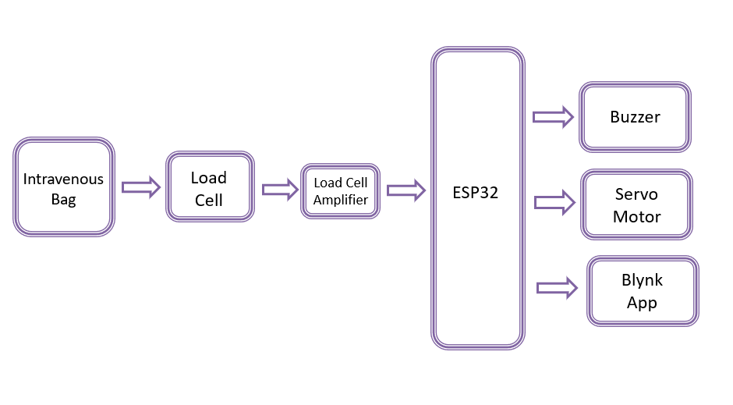

**Flow Chart:**

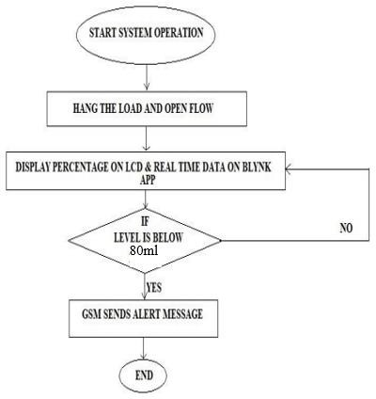

# HARDWARE COMPONENT SPECIFICATION:

## NodeMCU ESP32:

The NodeMCU ESP32 is a versatile development board based on the ESP32 microcontroller. It provides a platform for building IoT (Internet of Things) projects and offers a range of features and capabilities. Specifications of the NodeMCU ESP32:

**Microcontroller:** The NodeMCU ESP32 is powered by the ESP32-D0WDQ6 microcontroller, which is a powerful dual-core processor with Wi-Fi and Bluetooth capabilities.

**Processor Cores:** It features two Tensilica LX6 microprocessor cores, each clocked at up to 240 MHz. These cores can be individually controlled, allowing for efficient multitasking and handling of complex tasks.

##### Memory:

* **SRAM:** The NodeMCU ESP32 has 520 KB of internal SRAM (Static Random Access Memory) available for data storage and program execution.
* **Flash Memory:** It is equipped with 4 MB of built-in flash memory for storing firmware, code, and other data.

**Wi-Fi Connectivity:** The board supports 2.4 GHz Wi-Fi 802.11b/g/n, providing wireless connectivity for IoT applications. It can function as a station (client), access point, or both simultaneously.

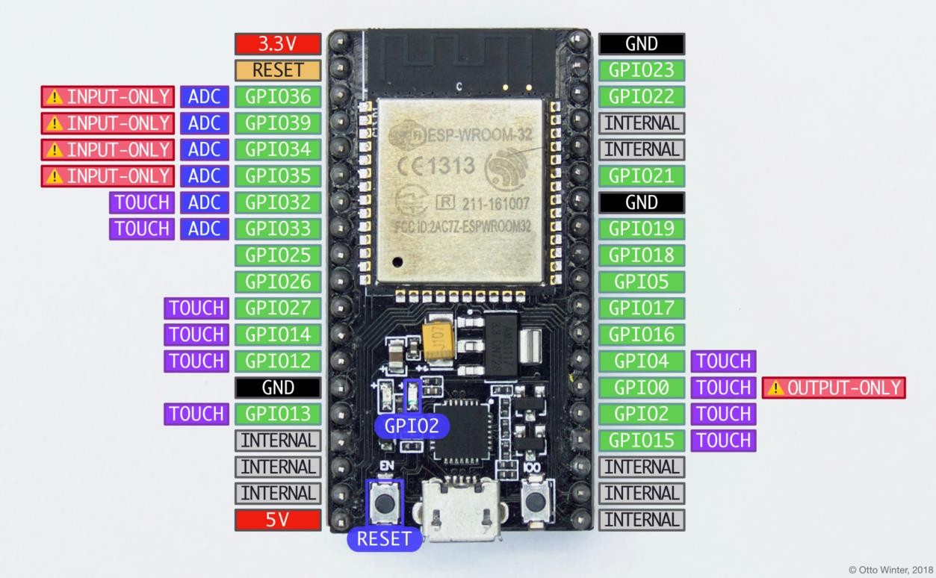

**Bluetooth Connectivity:** The NodeMCU ESP32 has integrated Bluetooth 4.2 capabilities, supporting both the classic Bluetooth and Bluetooth Low Energy (BLE) protocols. This enables seamless communication with other Bluetooth devices and expands the range of applications.

**GPIO Pins:** It features a total of 36 general-purpose input/output (GPIO) pins, which can be configured and used for various purposes, including digital input/output, PWM (Pulse Width Modulation), I2C, SPI, and more.

**Analog Inputs:** The board provides 18 analog-to-digital converter (ADC) channels, allowing for the measurement of analog voltages. The ADC resolution is 12 bits, providing good accuracy for analog sensing applications.

**UART, SPI, and I2C Interfaces:** The NodeMCU ESP32 has multiple hardware interfaces for serial communication (UART), SPI (Serial Peripheral Interface), and I2C (Inter-Integrated Circuit). These interfaces enable communication with other devices and sensors.

**USB:** It includes a micro-USB port for power supply, programming, and data transfer. The board can be connected to a computer or USB power source for these purposes.

**Power Supply:** The NodeMCU ESP32 can be powered using a micro-USB cable or an external power source connected to the VIN pin. The input voltage range is 5V, and it has a built-in voltage regulator to provide stable 3.3V output for the board and connected peripherals.

**Onboard LED:** There is a built-in LED on the board that can be used for various purposes, such as indicating the board's power status or as a visual output in your projects.

**Operating Voltage:** The board operates at a voltage of 3.3V, and it is important to note that the GPIO pins are not 5V tolerant. Therefore, it is recommended to use level shifters or voltage dividers when interfacing with 5V devices.

**Programming:** The NodeMCU ESP32 can be programmed using the Arduino IDE (Integrated Development Environment) or other compatible development environments. It supports the Arduino programming language, making it easy to develop and upload code.

**Dimensions:** The dimensions of the NodeMCU ESP32 board are typically around 48mm x 26mm, although there may be slight variations depending on the manufacturer.

## HX711 Load Cell Amplifier:

The HX711 is a precision amplifier specifically designed for load cells and strain gauge sensors. It provides accurate and reliable measurement of small changes in resistance, allowing for precise weight and force measurements. Specifications of the HX711 load cell amplifier:

##### ADC (Analog-to-Digital Converter):

* Resolution: The HX711 has a selectable resolution of 24-bit or 16-bit. The 24-bit mode offers higher precision

and finer resolution for more accurate measurements.

* Sampling Rate: The maximum data output rate is typically 80 samples per second (SPS) in the 24-bit mode and 10 SPS in the 16-bit mode. This rate can be adjusted for different application requirements.

##### Gain Settings:

* The HX711 offers selectable gain settings of 128 and 64. These gain settings allow for amplification of small voltage changes from the load cell, ensuring accurate and measurable readings.
* The gain can be set by configuring the appropriate pins on the HX711 chip, usually through a microcontroller or other control circuitry.

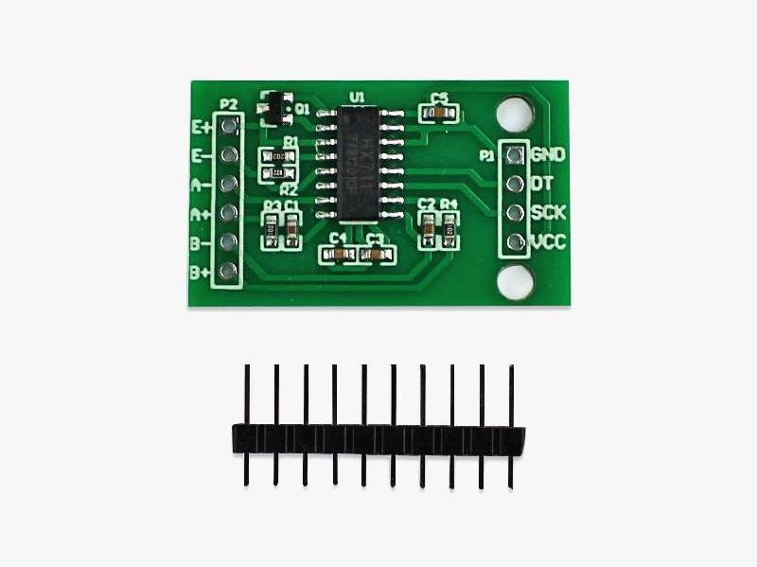

Input Channels: The HX711 supports differential input signals, allowing for the connection of strain gauge-based load cells or other sensors with bridge configurations. It typically has two differential input channels for connecting the load cell's bridge configuration.

##### Operating Voltage:

* The HX711 operates at a wide voltage range, typically from 2.6V to 5.5V. This makes it compatible with a variety of power sources, including common supply voltages used in microcontroller-based systems.
* It has an on-chip voltage regulator that provides a stable operating voltage for the load cell and other internal circuitry.

##### Interface:

* Digital Interface: The HX711 uses a two-wire serial interface (clock and data) to communicate with microcontrollers or other devices. This interface allows for easy integration into various systems.
* Communication Protocol: The communication protocol used by the HX711 is typically a simplified version of the SPI (Serial Peripheral Interface) protocol.

##### Zero Drift and Offset Compensation:

* The HX711 incorporates a programmable offset and zero-drift compensation feature. This feature helps in minimizing errors caused by temperature variations, component tolerances, and other factors.
* The offset and drift compensation can be performed through software by periodically updating the calibration values based on reference measurements.

##### Power Consumption:

* The power consumption of the HX711 is relatively low, especially in standby mode. This makes it suitable for battery-powered applications or situations where power efficiency is important.

##### Package and Pin Configuration:

* The HX711 is available in different package types, including SOP (Small Outline Package) and LGA (Land Grid Array). The pin configuration may vary depending on the specific package type.

##### EMI (Electromagnetic Interference) Protection:

* The HX711 includes measures for EMI protection, such as internal shielding and filtering techniques. These help in minimizing the impact of electromagnetic interference on the amplifier's performance.

## Load Cell:

A load cell is a transducer that converts a force or load applied to it into an electrical signal. It is commonly used in various applications for measuring weight, force, tension, compression, and torque. Specifications of a load cell:

##### Capacity/Range:

* Load cells are available in various capacity ranges, which determine the maximum load they can measure. Common capacities range from a few grams to several hundred tons.
* The capacity is usually specified as the maximum rated load or maximum load that the load cell can safely handle without damaging its performance.

##### Sensitivity:

* Sensitivity refers to the ratio of the output electrical signal to the applied load. It indicates how much the load cell's output changes in response to a given change in load.
* Sensitivity is typically expressed as millivolts (mV) per volt (V) per unit load (e.g., mV/V/kg or mV/V/lbf).

##### Accuracy:

* Accuracy represents the closeness of the load cell's output to the actual applied load. It is usually expressed as a percentage of the full-scale output or as a maximum deviation from the true load.
* The accuracy of a load cell depends on factors such as manufacturing tolerances, linearity, hysteresis, repeatability, and environmental conditions.

##### Linearity:

* Linearity refers to the load cell's ability to provide an output signal that is directly proportional to the applied load over its entire range.
* A perfectly linear load cell would have a straight-line relationship between load and output signal, but in reality, there might be slight deviations from linearity.

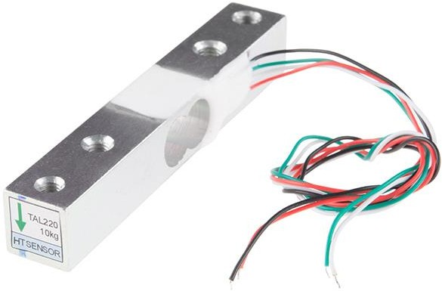

##### Hysteresis:

* Hysteresis is the difference in output readings for the same load applied successively, depending on whether the load is increasing or decreasing.
* Hysteresis is caused by material properties and mechanical tolerances within the load cell and can introduce some measurement error.

##### Repeatability:

* Repeatability refers to the load cell's ability to provide consistent output readings when the same load is applied repeatedly under the same conditions.
* It is a measure of the load cell's stability and is typically expressed as a percentage of the full-scale output or as a maximum deviation.

##### Temperature Effects:

* Load cells can be affected by temperature changes, which may lead to variations in their output. Temperature effects can include zero drift (change in output at zero load) and sensitivity drift (change in output per unit load).
* Load cell specifications often include information about the temperature range within which they maintain their specified performance.

##### Construction and Type:

* Load cells can be constructed using different principles, including strain gauge, hydraulic, pneumatic, and piezoelectric. The most common type is the strain gauge load cell, which uses strain gauges bonded to the load cell structure to measure the strain caused by the load.
* Load cells can also have different mechanical configurations, such as tension, compression, bending beam, shear beam, and canister load cells, depending on the application requirements.

##### Electrical Output:

* Load cells produce electrical signals proportional to the applied load. The output can be in various formats, including analog voltage (mV/V), analog current (4-20 mA), or digital signals (such as RS-232 or RS-485).

##### Environmental Protection:

* Load cells may have specific environmental protection ratings to indicate their resistance to dust, moisture, and other environmental factors. These ratings are typically defined by standards such as IP (Ingress Protection) ratings.

##### Mounting and Connection:

* Load cells are designed to be mounted and connected to the system or structure where the load is being measured. They may have threaded holes or other mounting features for easy installation and proper load application.
* Load cells typically have electrical terminals or connectors for connecting to measurement instrumentation or data acquisition systems.

## Servo Motor:

A servo motor is a type of rotary actuator that is widely used in various applications, including robotics, automation, RC vehicles, and more. It provides precise control over angular position, velocity, and acceleration. Specifications of a typical servo motor:

##### Operating Voltage:

* Servo motors have a specified operating voltage range within which they function optimally. Common operating voltages include 4.8V, 6V, 7.2V, and 12V.
* It is essential to provide the servo motor with a power supply within its specified voltage range to ensure proper operation.

##### Torque:

* Torque is the rotational force generated by the servo motor's output shaft. It is typically measured in units like ounce-inches (oz-in), kilogram-centimeters (kg-cm), or Newton-meters (Nm).
* Servo motors are available in various torque ratings, ranging from low-torque micro servos to high-torque servos capable of exerting significant force.

##### Speed:

* Speed refers to the angular velocity at which the servo motor can rotate its output shaft. It is usually specified in revolutions per minute (RPM) or degrees per second.
* The speed of a servo motor depends on the specific model and is influenced by factors such as motor design, gear ratio, and applied voltage.

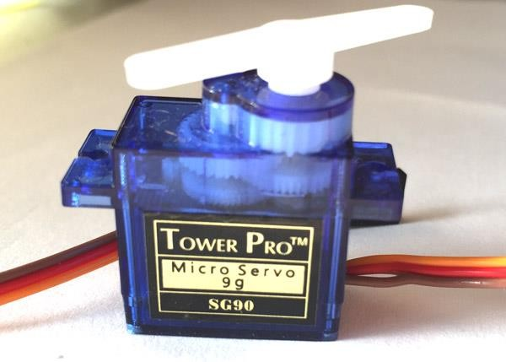

##### Resolution:

* Resolution represents the smallest incremental movement or step that a servo motor can make. It determines the level of positional accuracy and precision.
* Servo motors typically offer resolution in degrees per pulse. For example, a servo motor with 0.1-degree resolution means that it can move in steps as small as 0.1 degrees.

##### Control Signal:

* Servo motors are controlled using pulse width modulation (PWM) signals. The control signal typically consists of a repeating pulse with a fixed frequency (usually 50 Hz or 60 Hz) and a variable pulse width.
* The pulse width corresponds to the desired position of the servo motor's output shaft, with a wider pulse indicating a different position.

##### Operating Angle:

* The operating angle of a servo motor refers to the range of rotation it can achieve. Most standard servo motors have an operating angle of 180 degrees, which means they can rotate from 0 to 180 degrees.
* However, servo motors with extended operating angles, such as 270 degrees or 360 degrees, are also available for specific applications.

##### Dimensions and Weight:

* Servo motors come in various sizes and form factors. They can range from miniature servos suitable for small- scale applications to larger, more robust servos for industrial use.
* The dimensions and weight of a servo motor depend on its design, torque rating, and intended application.

##### Feedback Mechanism:

* Servo motors often incorporate a built-in position feedback mechanism, such as a potentiometer or an optical encoder. This mechanism provides information about the actual position of the output shaft, allowing for closed- loop control and positional accuracy.

##### Mounting:

* Servo motors typically have mounting features, such as threaded holes or brackets, that facilitate easy installation and attachment to mechanical systems or structures.

##### Noise Level:

* The noise level of a servo motor can vary depending on its design and quality. Some servo motors are designed for reduced noise operation, which is particularly important in noise-sensitive applications.

##### Durability and Lifespan:

* The durability and lifespan of a servo motor depend on factors such as the quality of its internal components, motor design, and operating conditions. Higher-quality servo motors tend to have longer lifespans and better

overall reliability.

## Buzzer:

A buzzer is an audio signaling device that generates sound in the form of a continuous tone or intermittent beeps. It is commonly used in alarms, electronic devices, and communication systems specifications of a typical buzzer:

##### Operating Voltage:

* Buzzer operates within a specific voltage range. Common operating voltages include 3V, 5V, 9V, or 12V.
* It is essential to provide the buzzer with a power supply within its specified voltage range to ensure proper operation.

##### Sound Output:

* Buzzer produces sound output measured in sound pressure level (SPL) units, typically expressed in decibels (dB).
* Sound output can vary from low SPL buzzers (around 70-80 dB) to high SPL buzzers (over 100 dB).
* The sound output determines the loudness or volume level of the buzzer.

##### Frequency:

* Buzzer emits sound at a specific frequency, which is the number of sound waves produced per second, measured in Hertz (Hz).
* Buzzer frequencies can range from low frequencies (typically around 1 kHz) to higher frequencies (up to 4 kHz or more).
* The frequency of the buzzer determines the pitch or tone of the sound produced.

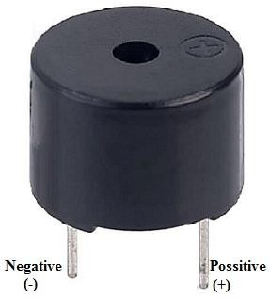

##### Current Consumption:

* Buzzer consumes electrical current during operation, which is measured in milliamperes (mA) or amperes (A).
* The current consumption can vary depending on the design and specifications of the buzzer.
* It is important to consider the current requirements of the buzzer when selecting a power supply or designing the circuitry.

##### Operating Temperature Range:

* Buzzer has an operating temperature range within which it functions reliably.
* The specified temperature range indicates the environmental conditions in which the buzzer can operate without performance degradation or damage.
* Typical operating temperature ranges can be from -20°C to +70°C or wider, depending on the buzzer model.

##### Mounting Type:

* Buzzer can have different mounting types, such as through-hole, surface mount, or panel mount.
* The mounting type determines the method of installation or attachment to a PCB (Printed Circuit Board), enclosure, or other surfaces.

##### Construction:

* Buzzer can be constructed using various technologies, including electromagnetic, piezoelectric, or electrostatic principles.
* Electromagnetic buzzers use an electromagnetic coil and diaphragm to produce sound, while piezoelectric buzzers utilize a piezoelectric crystal or element.
* Each construction type has its advantages and characteristics, such as power consumption, sound output, and frequency response.

##### Control Method:

* Buzzer can be controlled using a simple direct current (DC) voltage signal or through a pulse width modulation (PWM) signal for generating different tones or patterns.
* The control method may vary depending on the specific model and application requirements.

##### Size and Dimensions:

* Buzzer is available in various sizes and form factors. They can range from small surface mount packages to larger through-hole packages.
* The dimensions of the buzzer are typically specified in millimeters (mm) and include parameters such as length, width, and height.

##### Compliance and Certifications:

* Some buzzers may comply with specific industry standards or certifications, such as RoHS (Restriction of Hazardous Substances) compliance or CE (Conformité Européene) marking.
* These compliance and certifications indicate adherence to certain environmental or safety regulations.

**Implementation:**

**Explanation of IOT Intravenous Bag Monitoring and Controlling System:**

The IoT IV Bag Monitoring and Controlling System utilizes various components, including the NodeMCU ESP32, HX711 Load Cell Amplifier, Load Cell, Servo Motor, Buzzer, and the Blynk app for notification purposes.

#### Load Cell and HX711 Load Cell Amplifier:

* + The Load Cell is a sensor that measures the weight or mass applied to it. It consists of strain gauges that change their resistance proportional to the applied force.
  + The Load Cell is connected to the HX711 Load Cell Amplifier, which amplifies the small electrical signal from the Load Cell and converts it into a digital value that can be read by the NodeMCU ESP32.

#### NodeMCU ESP32:

* + The NodeMCU ESP32 is a microcontroller board that acts as the main control unit of the system. It is responsible for collecting data from the Load Cell via the HX711 Load Cell Amplifier and performing necessary computations.
  + The NodeMCU ESP32 communicates with the Load Cell via the HX711 Load Cell Amplifier using digital signals.

#### Servo Motor:

* + The Servo Motor is used to control the flow of fluid in the IV bag. It is connected to the NodeMCU ESP32, which sends control signals to the Servo Motor based on the weight measurements from the Load Cell.
  + Based on predefined weight thresholds, the NodeMCU ESP32 can rotate the Servo Motor to adjust the flow of fluid or completely stop it when needed.

#### Buzzer:

* + The Buzzer is used as an audio indicator to provide audible alerts or notifications. It can be triggered by the NodeMCU ESP32 based on certain conditions or events, such as low fluid level or system errors.
  + The NodeMCU ESP32 activates the Buzzer to produce sound output, alerting users or medical staff about critical situations or system malfunctions.

#### Blynk App:

* + The Blynk app is a mobile application that allows for remote monitoring and control of the IoT IV Bag system.
  + The NodeMCU ESP32 is connected to the Blynk app via Wi-Fi or the internet, enabling real-time data monitoring and providing notifications to users.
  + The Blynk app can send push notifications to users' smartphones or devices when specific events occur, such as low fluid level or abnormal system conditions.

# Circuit Diagram:

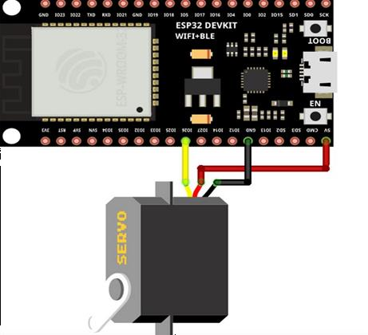

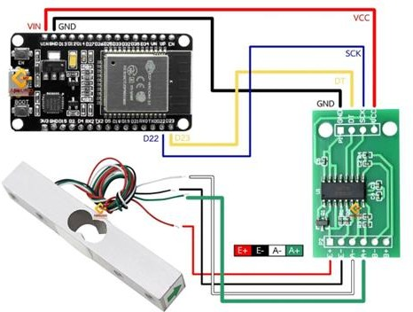

.

## CHAPTER 5

**RESULTS AND IMPLEMENTATION**

##### STEP 1: INITIAL WEIGHT IS ZERO STEP 2: WEIGHT OF THE SALLINE ADDED

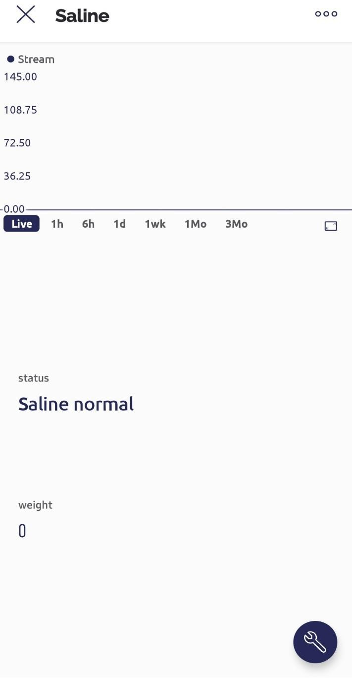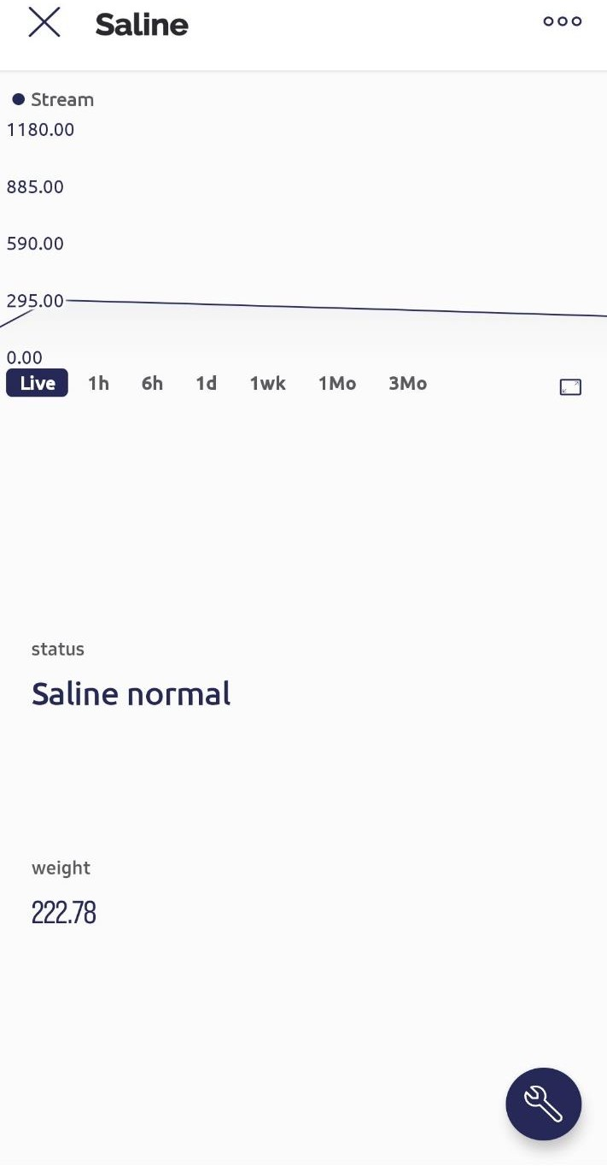

**STEP 3: CURRENT WEIGHT AFTER SOME STEP 4: WHEN THE WEIGHT REACHES BELOW TIME 80g**

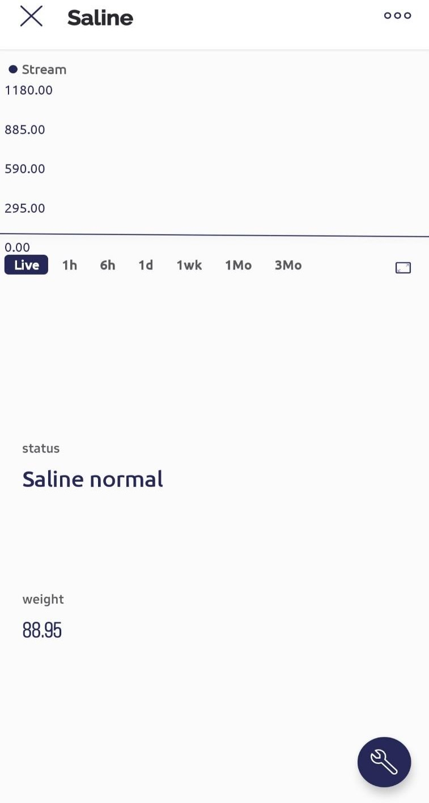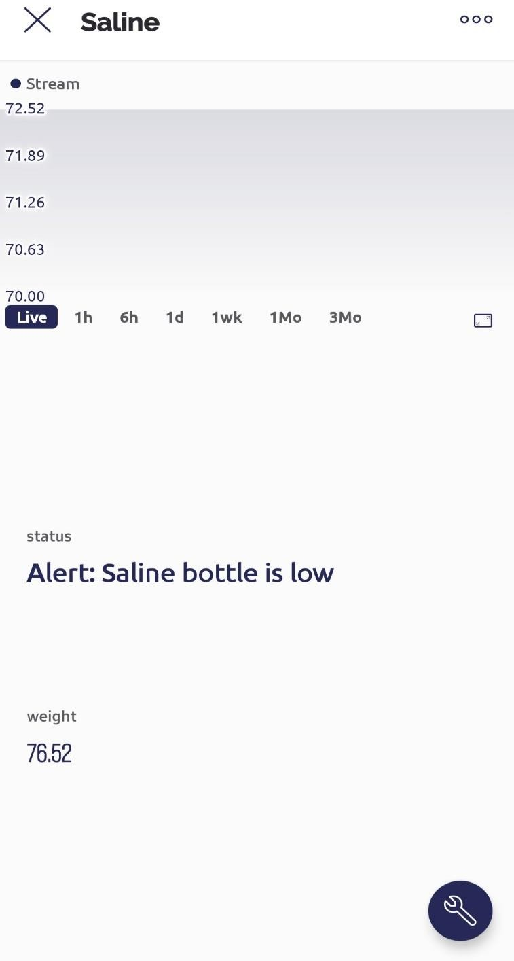

**CHAPTER 6**

**CONCLUSION AND FUTURE SCOPE**

#### Conclusion:

The IV Drip Monitoring and Controlling System is designed and tested successfully. The system includes NodeMCU ESP32 Controller, Load Cell, Servo Motor with clam, Saline Bottle, Buzzer, and Blynk App. The system is designed to capture the changes in the level of saline bottle and determine the level of saline bottle which is continuously being displayed oven the blynk application. When the determined level is less than predefined threshold weight, then the buzzer sounds to notify the nursing staff and the supply of the fluid through the pipe to the patient is stopped. A warning is also issued on the blynk application.

In conclusion, the development of the Intravenous Drip Monitoring and Control System has successfully addressed the need for improved accuracy, safety, and efficiency in intravenous therapy. By automating the monitoring and control processes, the system has enhanced patient safety by minimizing the risk of human errors and ensuring precise dosage delivery. The integration of real-time monitoring of vital signs has enabled dynamic adjustments based on the patient's condition, optimizing the therapy's effectiveness.

The project has demonstrated that an automated intravenous drip monitoring and control system can significantly improve patient care and resource utilization. The system's ability to seamlessly integrate with existing hospital infrastructure, provide a user-friendly interface, and adhere to safety standards further supports its viability and practicality in healthcare settings.

#### Future Scope:

Although the Intravenous Drip Monitoring and Control System project has achieved significant advancements in intravenous therapy management, there are several potential areas for future exploration and development:

1. Enhanced Data Analysis: Integrating advanced data analysis techniques, such as artificial intelligence and machine learning, can enable the system to detect patterns, predict patient responses, and optimize infusion parameters. This can further enhance precision and customization in dosage delivery.
2. Remote Monitoring: Expanding the system's capabilities to enable remote monitoring of intravenous therapy can provide flexibility for patients receiving treatment at home or in remote locations. This would require the development of secure communication protocols and remote access to system controls.
3. Interoperability and Standardization: Continuously improving the interoperability of the system with different medical devices and information systems, as well as adhering to standardized protocols, will facilitate seamless data exchange and compatibility across healthcare settings.
4. Integration of Smart Devices: Integrating the system with wearable devices or smart sensors can enable continuous monitoring of patient parameters, providing a holistic view of the patient's health status and facilitating proactive interventions.
5. Expanded Therapy Support: Expanding the capabilities of the system to support a wider range of intravenous therapies, including specialized treatments and infusions with complex protocols, will broaden its applicability in various medical specialties.
6. Long-Term Monitoring and Data Analytics: Enabling long-term monitoring and data analytics can help identify trends, optimize treatment plans, and contribute to research on the efficacy and outcomes of intravenous therapy.
7. User Feedback and Iterative Improvements: Gathering feedback from healthcare professionals and incorporating their insights into iterative improvements of the system will ensure its continued relevance and effectiveness in real-world healthcare environments.

By exploring these future directions, the Intravenous Drip Monitoring and Control System can evolve into a comprehensive and intelligent solution that maximizes patient safety, streamlines workflow efficiency, and improves patient outcomes in intravenous therapy management.

# REFERENCES

1. H. Amano, Hidekuni Ogawa, W. Caldwell, “A remote drip infusion monitoring system employing Bluetooth,” 2012 Annual International Conference of the IEEE Engineering in Medicine and Biology Society, 2012. DOI:10.1109/EMBC.2012.6346356.
2. Raghavendra B, Vijayalakshmi K, Manish Arora, “Intravenous drip meter & controller,” 2016 8th International Conference on Communication Systems and Network (COMSNETS), 2016.

DOI:10.1109/COMSNETS.2016.7440024

1. M, Anand and MM, Pradeep and Manoj, S and Raj, Marcel Arockia and Thamaraikani, P., “Intravenous Drip Monitoring System,” 2018 Indo-Iranian Journal of Scientific Research (IIJSR), 2018. DOI:10.2139/ssrn.3536333
2. Since Joseph, Navya Francis, Anju John,” Intravenous Drip Monitoring System for Smart Hospital Using IoT,”2019 2nd International Conference on Intelli-gent Computing, Instrumentation and Control Technologies (ICICICT), 2019. DOI: 10.1109/ICICICT46008.2019.8993241
3. Mohammed Arfan, M Srinivasan, Adithya Gowda Barager, “Design and Development of IOT enabled IV infusion rate monitoring and control device for precision care and portability,” 2020 4th International Conference on Electronics, Communication and Aerospace Technology (ICECA), 2020. DOI: 10.1109/ICECA49313.2020.9297376
4. Pranshul Sardana, Mohit Kalra, Amit Sardana, “Design, Fabrication, and Testing of an Internet Connected Intravenous Drip Monitoring Device,” J. Sens. Actuator Netw. 2019, 8(1), 2; DOI: 10.3390/jsan8010002
5. Antika Cahyanurani, Sugondo Hadiyoso, Suci Aulia, “Muhammad Faqih4 Design and development of a monitoring and controlling system for multi-intravenous infusion,”2019 International Conference on Engineering, Technology and Innovative Researches Journal of Physics, 2019. DOI:10.1088/1742-6596/1367/1/012075

**APPENDIX**

#define BLYNK_TEMPLATE_ID "TMPL3R0LDTh35"

#define BLYNK_TEMPLATE_NAME "saline"

#define BLYNK_AUTH_TOKEN "NS8uKUMaawJukOm96Zm9Dp_lhClr0TQD"

// Comment this out to disable prints and save space #define BLYNK_PRINT Serial

#include <WiFi.h> #include <WiFiClient.h>

#include <BlynkSimpleEsp32.h>

char auth[] = BLYNK_AUTH_TOKEN; BlynkTimer timer;

// Your WiFi credentials.

// Set password to "" for open networks.

char ssid[] = "M33";

char pass[] = "123456780"; #include <ESP32Servo.h>

Servo myservo1; #include <HX711.h>

HX711 scale; // Initializes library functions. int buzzer = 15;

int calibration_factor = 300000; // Defines calibration factor we'll use for calibrating.

//int calibration_factor = 750000; // Defines calibration factor we'll use for calibrating.

void setup()

{

Serial.begin(9600); // Starts serial communication in 9600 baud rate.

Serial.print("Connecting to "); Serial.println(ssid); WiFi.begin(ssid, pass);

int wifi_ctr = 0;

while (WiFi.status() != WL_CONNECTED) { delay(500);

Serial.print(".");

}

Serial.println("WiFi connected"); Blynk.begin(auth, ssid, pass, "blynk.cloud", 80);

myservo1.attach(18); pinMode(buzzer,OUTPUT);

scale.begin(32,33); // Initializes the scaling process.

// Used pins are A0 and A1. scale.set_scale();

scale.tare(); // Resets the scale to 0.

}

void loop()

{

Blynk.run();

timer.run();

scale.set_scale(calibration_factor); // Adjusts the calibration factor. float scalval=scale.get_units()*1000; Blynk.virtualWrite(V1,scalval);

Serial.print("Reading: "); // Prints weight readings in .2 decimal kg units. Serial.print(scalval);

Serial.println("gm");

Serial.print("Calibration factor: "); // Prints calibration factor. Serial.println(calibration_factor);

if(scalval>20 && scalval<80)

{

Blynk.virtualWrite(V2,"Alert: Saline bottle is low"); digitalWrite(buzzer,HIGH);

delay(5000); myservo1.write(0); digitalWrite(buzzer,LOW);

}

else

{

myservo1.write(40); Blynk.virtualWrite(V2,"Saline normal");

}

if(Serial.available()) // Calibration process starts if there is a serial connection present.

{

char temp = Serial.read(); // Reads users keyboard inputs.

if(temp == '+') // Increases calibration factor by 10 if '+' key is pressed. calibration_factor += 10;

else if(temp == '-') // Decreases calibration factor by 10 if '-' key is pressed. calibration_factor -= 10;

else if(temp == 'c' || temp == 'C')

scale.tare(); // Reset the scale to zero if 'C' key is pressed.

}

scale.power_down(); // Puts the scale to sleep mode for 5 seconds. delay(5000);

scale.power_up();

}