Hybrid Machine Learning Model for Efficient Botnet Attack Detection in IoT Environment

ABSTRACT
With the rapid expansion of Internet of Things (IoT) networks, botnet attacks have emerged as a major cybersecurity threat, compromising connected devices and causing significant operational and financial damages. The evolving nature of botnets and the variety of their attack vectors make detection increasingly complex. This project proposes a hybrid machine learning model integrating Support Vector Machine (SVM), Logistic Regression (LR), and Random Forest (RF) classifiers to efficiently detect botnet attacks in IoT environments. The system is designed to classify network traffic into five distinct labels: DoS, DDoS, Reconnaissance, Normal, and Theft. The hybrid approach leverages the strengths of each base model to improve detection accuracy, generalizability, and robustness. Experimental evaluation using the UNSW-NB15 dataset demonstrates that the proposed model effectively captures attack patterns and exhibits high performance across multiple metrics, including accuracy. This work offers a practical solution to strengthen IoT security frameworks against sophisticated and evolving botnet threats.
Index Terms: Internet of Things (IoT), Botnet Detection, Hybrid Machine Learning, Support Vector Machine (SVM), Logistic Regression (LR), Random Forest (RF), Cybersecurity, Network Traffic Classification, UNSW-NB15, DoS, DDoS, Reconnaissance.

EXISTING SYSTEM
The existing method proposed in the study is a deep learning-based botnet detection system that integrates multiple neural network architectures into a unified model called ACLR. This model combines Artificial Neural Network (ANN), Convolutional Neural Network (CNN), Long Short-Term Memory (LSTM), and Recurrent Neural Network (RNN) through stacking, a technique where outputs from individual models are combined to improve classification performance. The system is trained and evaluated using the UNSW-NB15 dataset, which includes nine diverse types of attacks and normal traffic. The proposed ACLR model is assessed both individually and in comparison with its component models using metrics such as accuracy, K-fold cross-validation, ROC-AUC, and PR-AUC, with results showing significant improvement in botnet detection.
Traditional Methods:
Traditionally, botnet detection has been handled through signature-based and rule-based intrusion detection systems (IDS). These methods rely on known patterns or signatures of previously detected botnet behavior or static rules defined by experts. Some approaches use statistical analysis, machine learning algorithms like Decision Trees or SVM, or manual thresholding of traffic metrics such as packet size, flow frequency, and port numbers.

.

DISADVANTAGES
- Computational Complexity: Combining multiple deep learning models (ANN, CNN, LSTM, RNN) significantly increases the computational load, requiring powerful hardware and more training time.
- Model Interpretability: Deep ensemble models act as black boxes, making it difficult to interpret how decisions are made or to identify which specific model contributed to detection.
- Dataset Dependency: The model’s high performance is heavily dependent on the UNSW-NB15 dataset, which may not represent all real-world botnet variations or zero-day attacks.
- Overfitting Risk: The complexity of the stacked model can lead to overfitting, especially if the dataset is imbalanced or lacks diversity in attack samples.
- Deployment Challenge: Implementing such a complex model in real-time IoT environments or on edge devices with limited resources is impractical due to memory and speed constraints.

PROPOSED SYSTEM
In the present work, a hybrid machine learning-based botnet detection system is proposed to enhance cybersecurity in Internet of Things (IoT) networks. Unlike deep learning-based models that are computationally intensive and less interpretable, the proposed system integrates three lightweight yet powerful classifiers—Support Vector Machine (SVM), Logistic Regression (LR), and Random Forest (RF)—to form a robust ensemble detection framework. The model is trained to accurately classify network traffic into five labels: DoS, DDoS, Reconnaissance, Normal, and Theft. This ensemble approach effectively leverages the strengths of each algorithm: SVM for handling high-dimensional data, LR for probabilistic interpretation, and RF for managing non-linearity and avoiding overfitting. The hybrid model improves both detection accuracy and model generalizability across varied attack scenarios. Experimental results show that the system not only achieves high performance in identifying complex threats but also addresses key limitations of deep learning-based systems.

ADVANTAGES
- Low Computational Cost: Unlike deep learning models, the hybrid ML model significantly reduces training and inference time, making it ideal for real-time detection in resource-constrained IoT environments.
- Improved Interpretability: Logistic Regression provides clear probabilistic outputs, and decision boundaries in SVM and decision paths in RF enhance transparency in threat classification.
- Better Generalization: The use of ensemble methods like Random Forest mitigates overfitting and improves robustness across diverse network traffic patterns and attack types.
- Flexible and Scalable: The model can be easily deployed on various platforms, including edge devices, and retrained with new data without needing specialized hardware.
- Multi-Attack Detection: Unlike systems trained on limited attack categories, this model handles multiple attack types—DoS, DDoS, Reconnaissance, Theft—enhancing its real-world applicability.

SYSTEM ARCHITECTURE
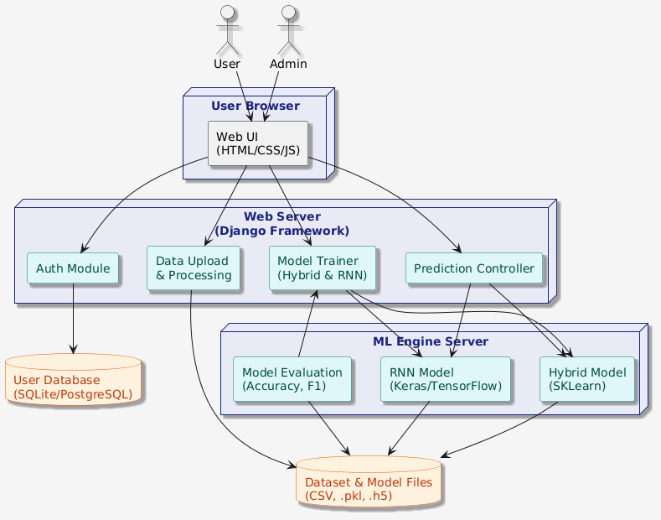
System Architecture

SYSTEM REQUIREMENTS
H/W SYSTEM CONFIGURATION:
- Processor - Pentium –IV
- RAM - 4 GB (min)
- Hard Disk - 20 GB
- Key Board - Standard Windows Keyboard
- Mouse - Two or Three Button Mouse
- Monitor - SVGA

SOFTWARE REQUIREMENTS:
- Operating system : Windows 7 Ultimate.
- Coding Language : Python.
- Back-End : Django-ORM
- Designing : Html, css, javascript.
- Data Base : MySQL / (WAMP Server).

