**LIBRARY MANAGEMENT SYSTEM DATABASE PROJECT**

**PROJECT REPORT**

Dongwei Qi

230002618

1. Project Description

This project is aimed at building a library management system.

Basic idea:

A student and faculty can issue books. The number of days will be distinct in the case of students and teachers for issue any book. Each book will have different ID. Entry of all the book will be done, who issue that book and when and also duration. Detail of Fine(when the book is not returned at a time) is also stored.

Details of project:

Two kind of users can use this library management system. Users can login as a student or a faculty. The database already logged 1000+ students and 200+ faculties from different department with basic information like gender and email.

Each user has unique identification thus a student cannot get access to the system as a faculty. Once the password does not correspond to the user id, user cannot get into the system either.

Different limits of rental are set for different users. A student can borrow a book up to 4 months, while a faculty can borrow a book up to 1 year. All users will be fined once passed the due time to return a borrowed book. The fine is defined as $0.1 per day to all users.

All books has been added to the database already, with information of book title, authors and current status. Currently we have 1000+ books in storage. The default status for all books has been set ‘available’. Once the book has been borrowed, the status will become ‘unavailable’. Users are only allowed to borrow books available. Once user try to borrow an unavailable book, a message box will show up with a warning message.

Once the return date of the book passed the due date, a fine ticket with certain amount will be added to the user’s account.

Details of implementation:

The database is built based on MySQL. This library management system is build on python with pymysql module to connect with MySQL server and tkinter to implement the GUI.

This application provides several interfaces to interact with users, including login interface, user interface, borrow interface.

All interactions will be prompted with messages showing if the operation has been successfully conducted or warning of misconduct.

1. E-R Diagram
2. Table Normalization
3. Data Collection
4. User Interface

User login:

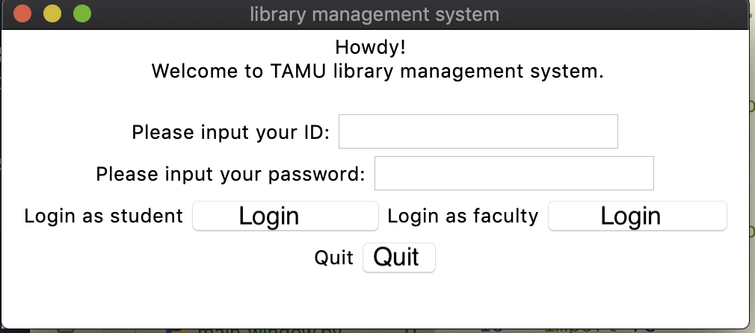

Users can input their user_id and password(which is the same as their user_id by default) and select to login in as a student or a faculty.

Or click quit to close the window.

We can input 230004501 to login in as a student.

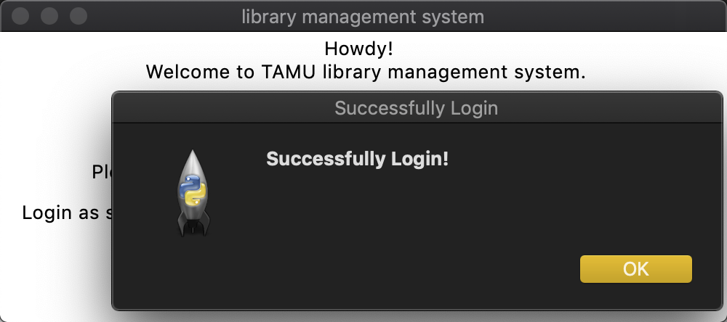

Once the user_id and password is correct, there will be a system message box to send an information demonstrate successfully login.

Otherwise an waring message will be sent to ask user to try again.

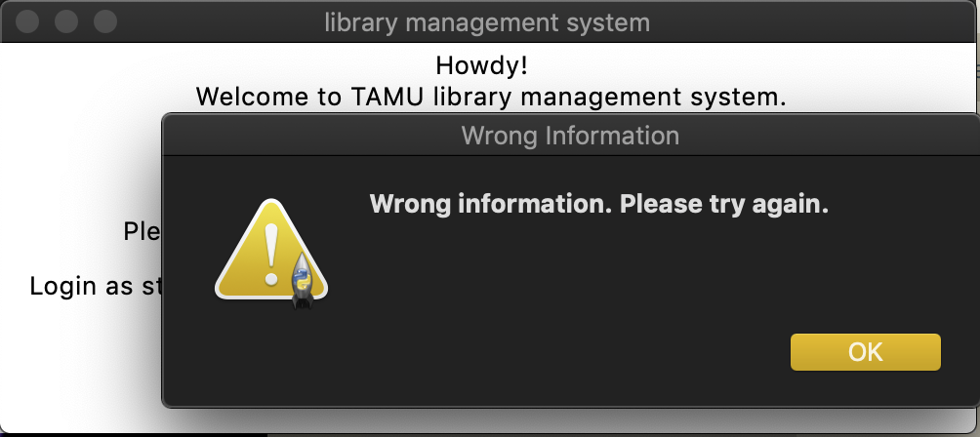

Once successfully logged in, a system welcome interface will show up and prompt user to search for a book by book id or by book title.

User can also choose to return a borrowed book or check for fine tickets.

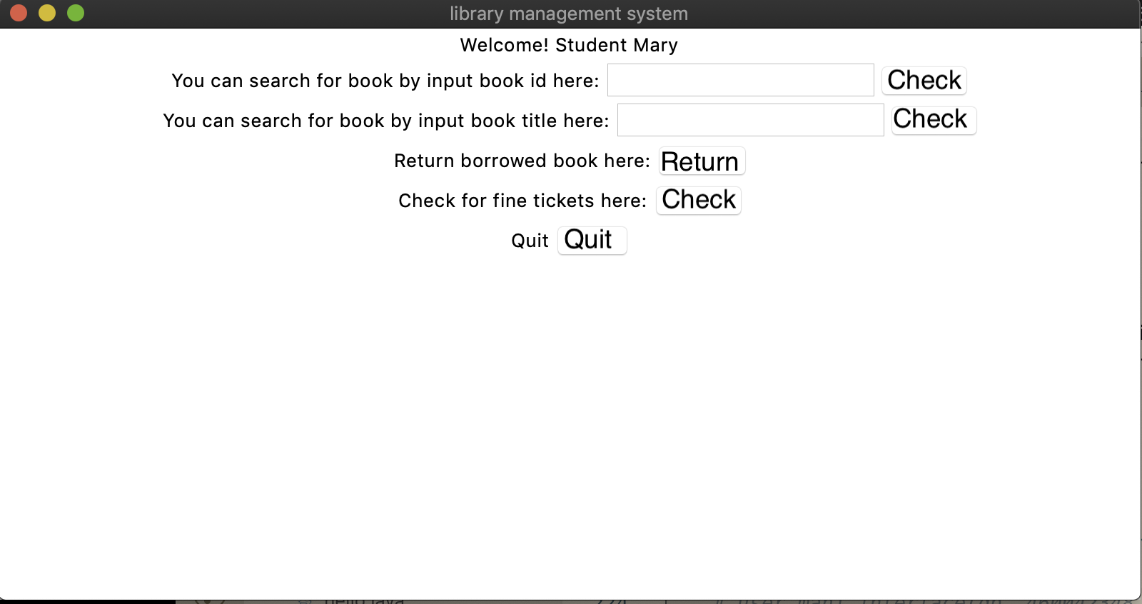

A message box will show up to prompt the information of the book and its current status. If the book is available, a borrow button will show up then user can click to borrow it.

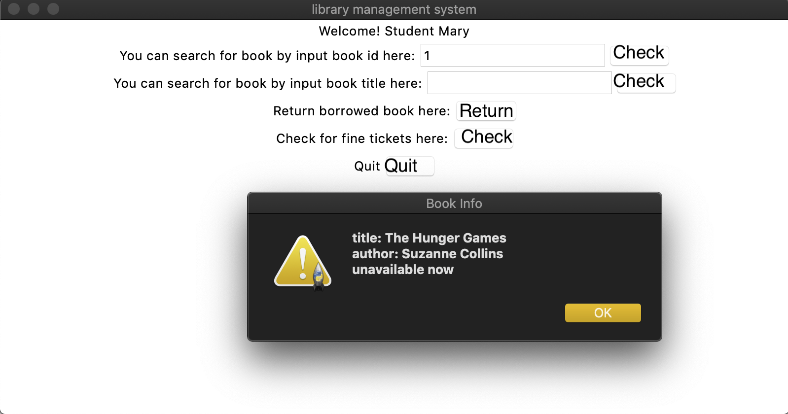

Search a book by id. This book is unavailable now.

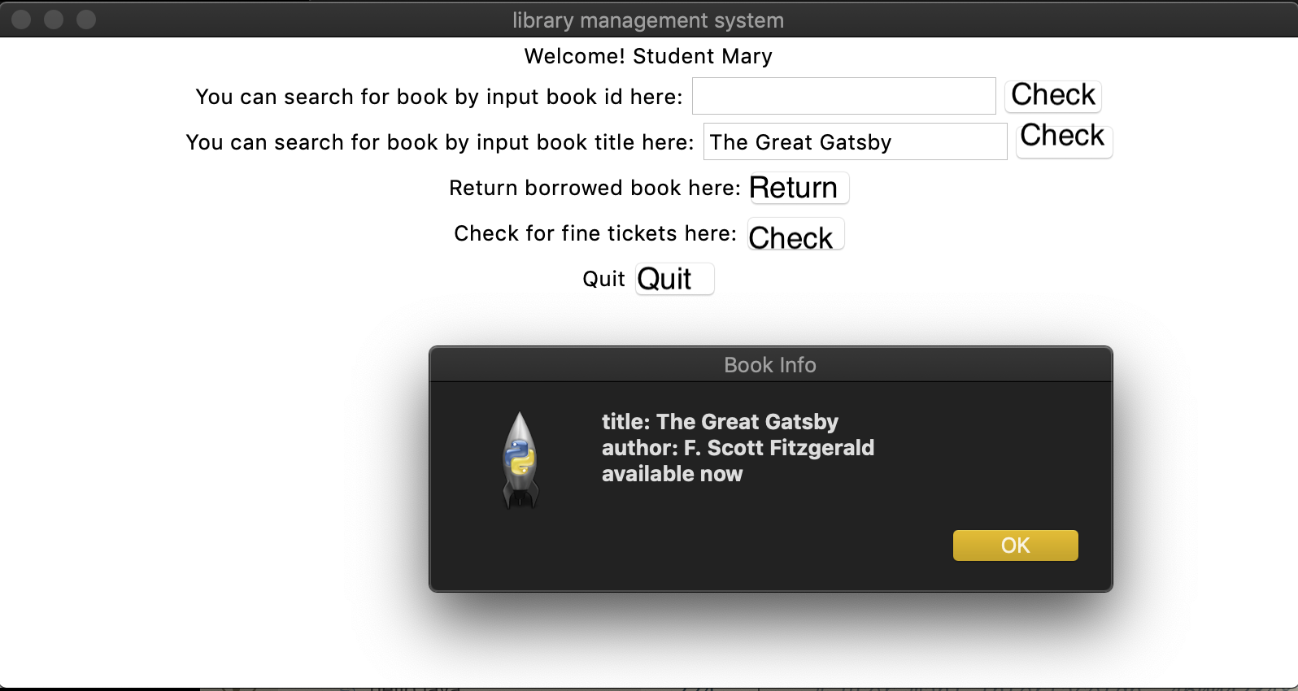

Search a book by title. This book is available now and we can click the borrow button. A message box will come out and tell user when to return the book.

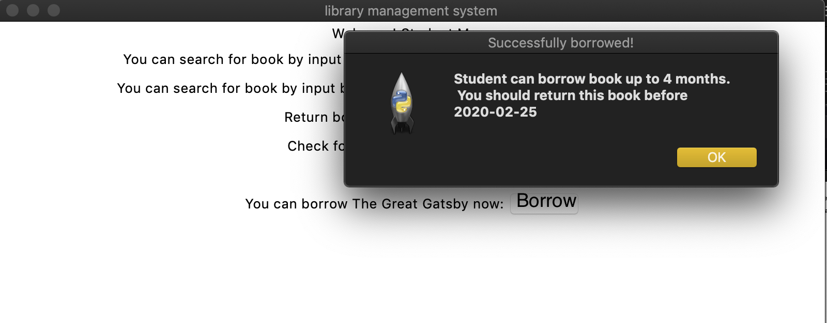

After click the return book button, user will be lead to a return book interface, with lists of borrowed book. User can choose a book and click return to return the book. Or go back to the last interface.

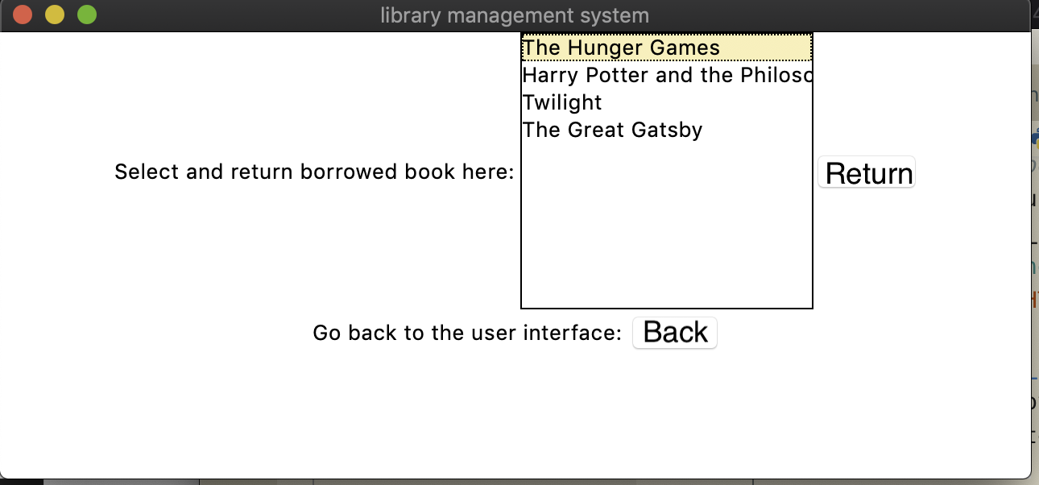

Once a book is returned, a message box will show up to prompt a message showing successfully returned.

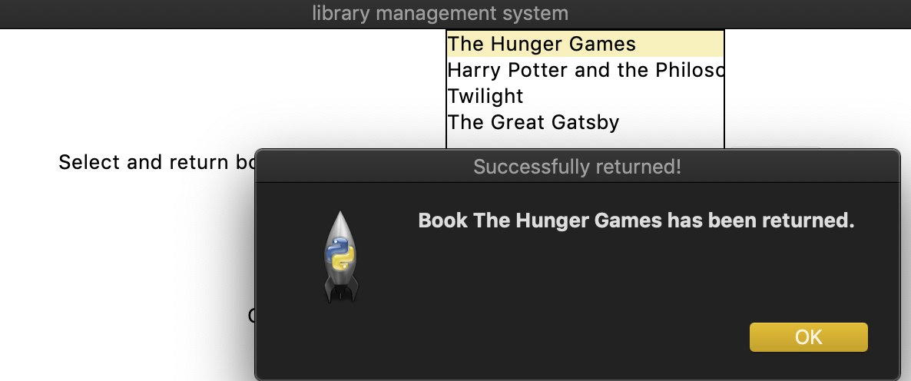

Once the user passed the due date of a book to be returned, a warning message will show up to prompt user to check the fine tickets.

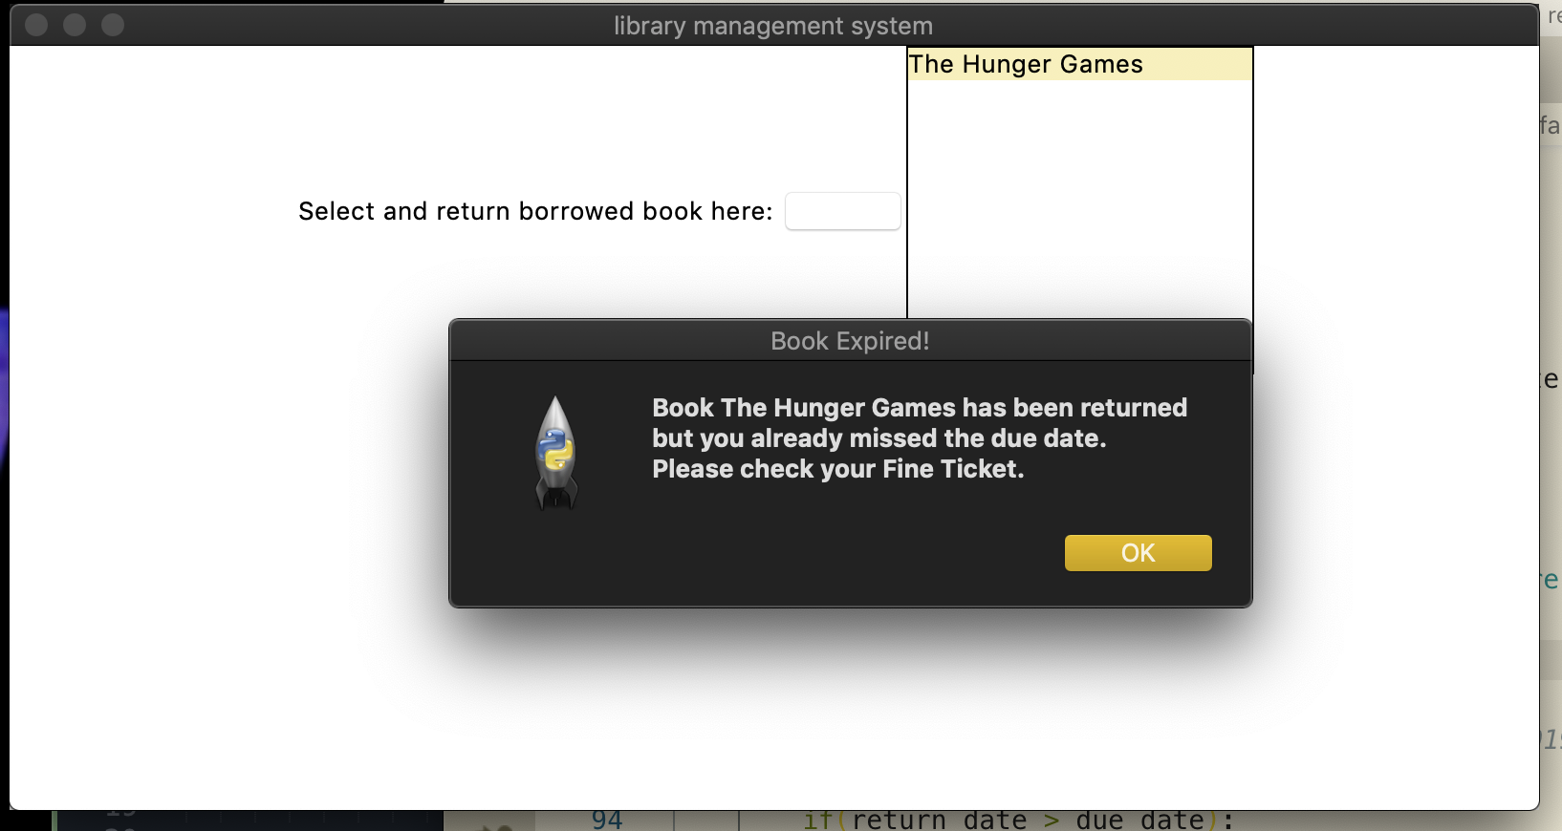

After user

1. Project Source Code
2. Disccusion