Review Questions for
AQUACULTURE

1. Republic Act 8550
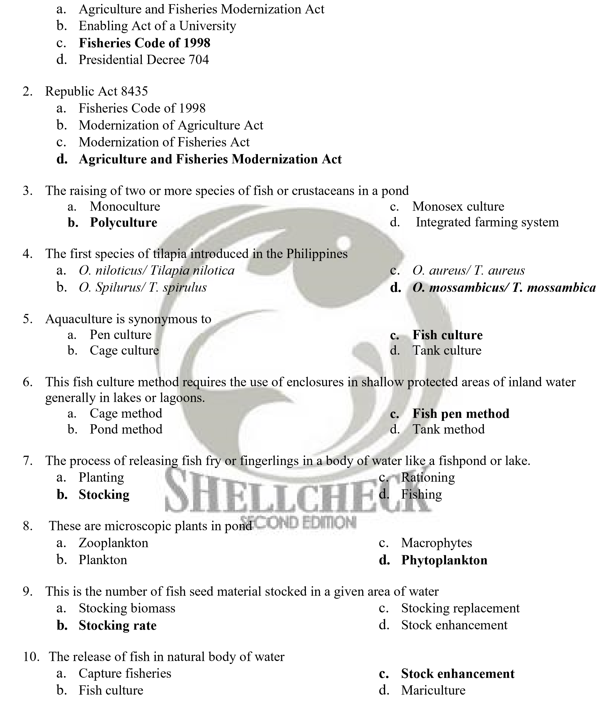
- Fish with uniform size are stocked in progressively larger ponds as more space is needed
  - Multi-size stocking c. Mono-size stocking
  - Multi-stage stocking d. Double cropping

- Includes fish, all other aquatic flora and fauna and other living resources of the aquatic environment, including, but not limited to salt and corals
  - Coastal area c. Aquatic resources
  - Artificial reefs d. Coral reefs
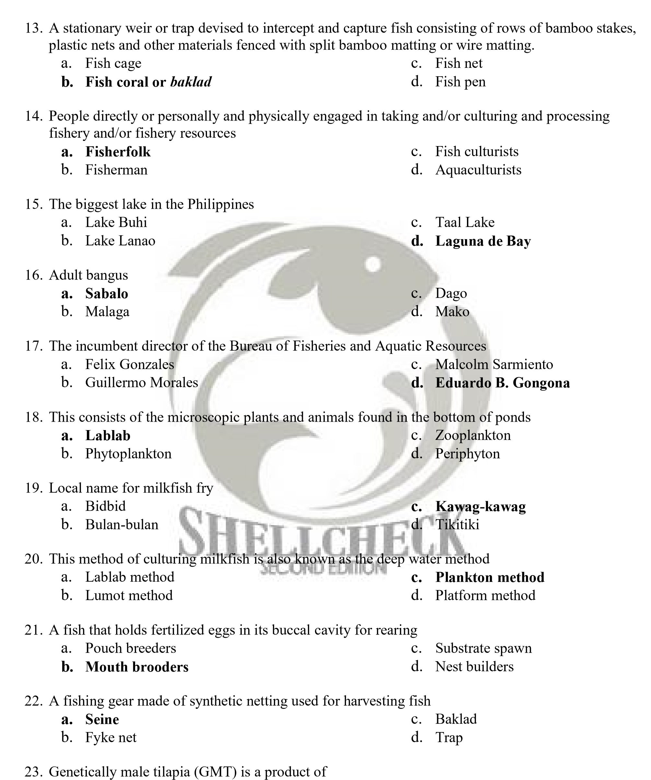
  - GIFT Technology c. Monosex
  - Sex-reversal d. YY-male technology

- An act providing for the development, management and conservation of the fisheries and aquatic resources. Integrating all laws pertinent thereto, and for other purposes
  - Republic Act 8435 c. Republic Act 7210
  - Republic Act 8550 d. Republic Act 8120

- The art and science of catching fish for livelihood
  - Aquaculture c. Fish capture
  - Fisciculture d. Sea ranching

- The process of preserving foods in hermetically-sealed containers like tin cans and jars or bottles through the application of heat to sterilize the food and the container
  - Drying c. Canning
  - Boiling d. Salting

- This is the method of processing fish by lowering its water content through exposure to the sun
  - Fermentation c. Salting
  - Drying d. Smoking

- This is defined as the total amount of salt in grams contained in one kilogram of seawater (SW) when all the carbonate has been converted to oxide, bromine, and iodine, replaced by chlorine and organic matter less completely oxidized
  - Alkalinity c. Hardness
  - Salinity d. pH

- Inversion of prospective genetic tilapia females by feeding a male synthetic hormone
  - YY-male technology c. Sex reversal
  - Radiation d. Sterilization

- This is defined as the amount of feed needed to produce a kilo of flesh
  - Feed ration c. Feed conversion efficiency
  - Feed conversion ratio d. Feed coefficient


- Nets in the form of a conical bag with the mouth kept open by various devices and the entire gear towed, trailed or trawled usually in the bottom of the sea to capture submerged species that naturally stay near the sea bottom
  - Tuck seines c. Trammel net
  - Trawls d. Ring net

- Baited devices made of bamboo, rattan, or chicken wire formed into regular receptacles and having a non-return value which provides easy entrance but difficult exit of fish
  - Fish pot c. Fish corrals
  - Fish shelter d. Fish nets

- Variously shaped and framed small bag nets used entirely by hand or partly by mechanical power in which fish are captured by scooping
  - Hoop nets c. Drag seine
  - Dip nets d. Fyke nets

- A mixture of freshwater (FW) and seawater (SW)
  - Freshwater c. Marine water
  - Brackishwater d. Saline water

- The sperm of the fish
  - Milk c. Milt
  - White liquid d. Semen

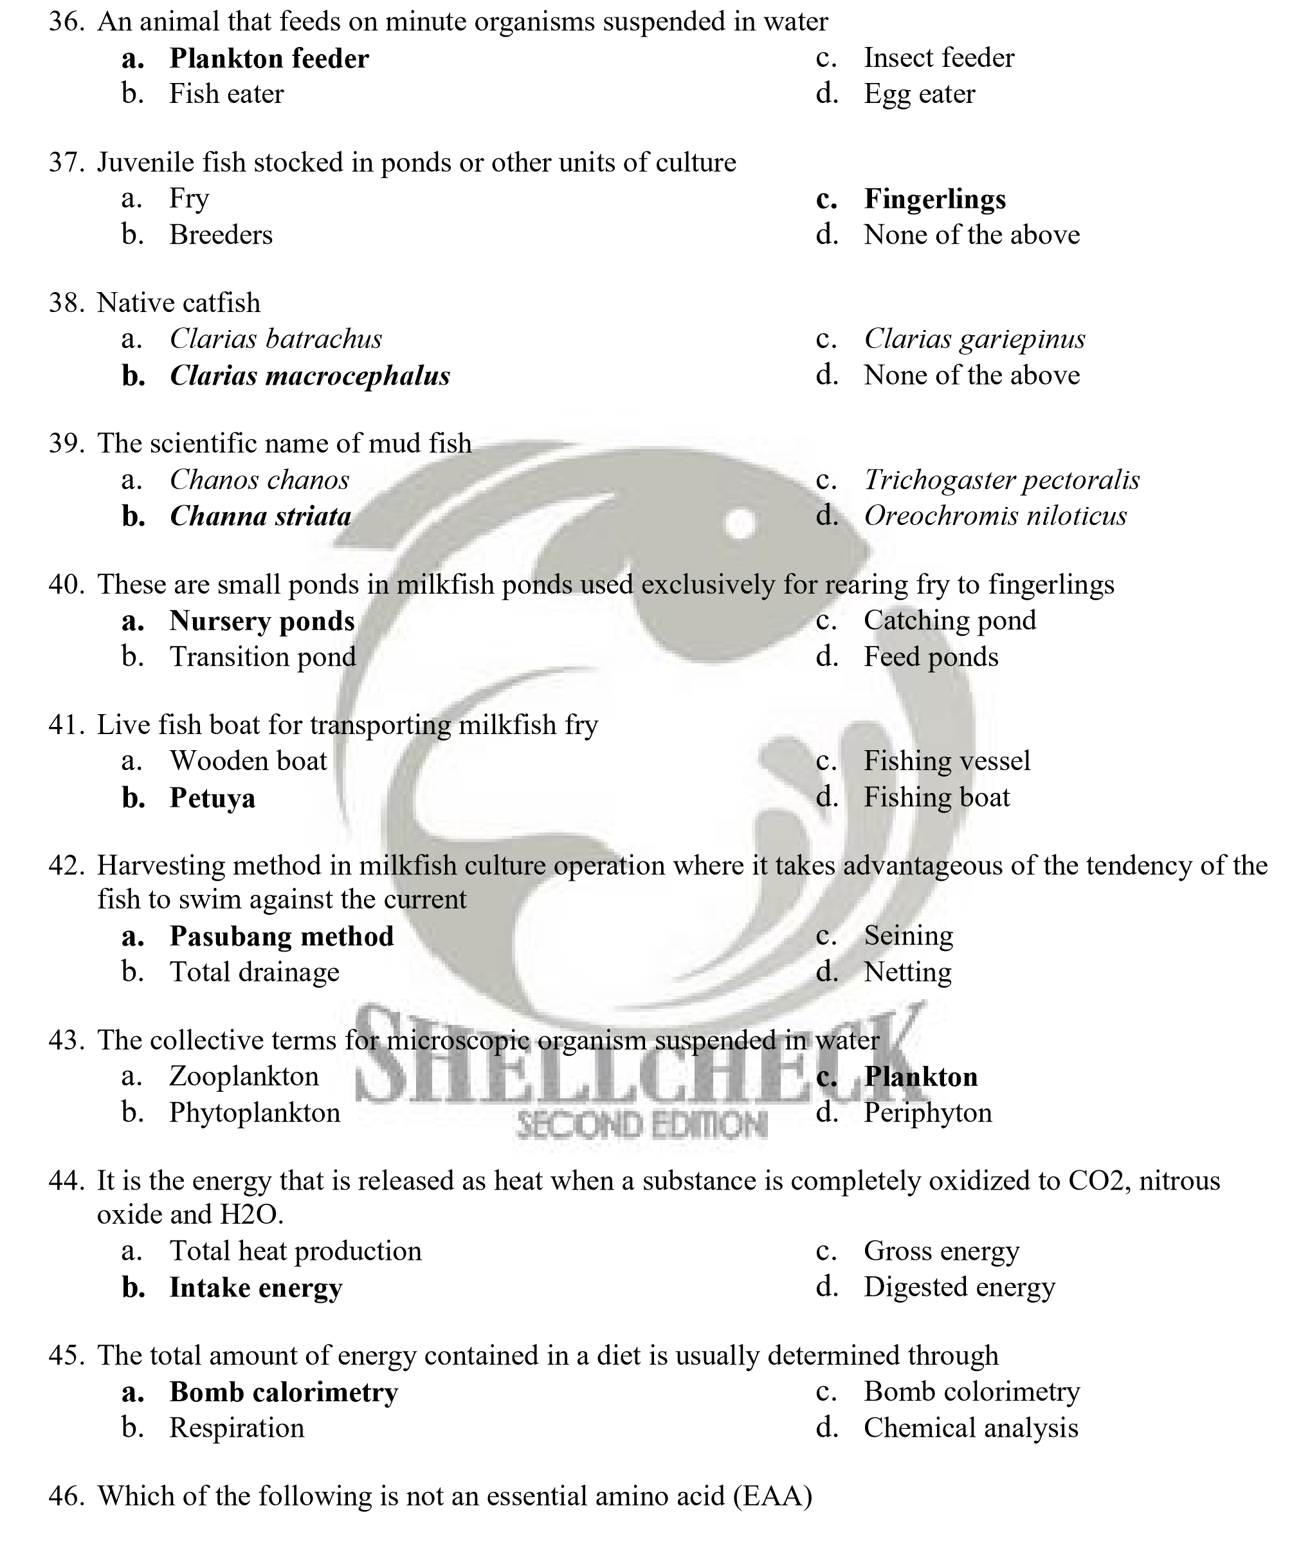a. Lysine c. Valine
b. Tyrosine d. Methionine

- The carbohydrate storage molecules found in plants is
  - Glycogen c. Sugar
  - Starch d. Cellulose

- The breakdown of glucose liberating energy is known as
  - Gluconeogenesis c. Glycolysis
  - Glycogen synthesis d. Glycogenolysis

- It is an expression which relates the gram of weight gained to the grams of crude protein fed
  - Net protein utilization c. Protein nutritional value
  - Protein efficiency ratio d. Conversion ratio

- Are the major lipid components biological membrane
  - Triglycerides c. Fatty acids
  - Sterols d. Phospholipids

- Are organic molecules that act as cofactors or substrates in some metabolic reactions
  - Proteins c. Minerals
  - Vitamins d. Lipids

- Insulin is important in fish for
  - Amino acid metabolism c. Glucose level in blood
  - Carbohydrate metabolism d. Lipid metabolism

- The ratio of the length of the digestive tract to body length of fish is known as
  - Relative gut length c. Ratio of gut length
  - Intestinal length d. Gut body length ratio

- Which of the following plays very important role in fat digestion?
  - Pancreas c. Intestine
  - Stomach d. Liver

- Marine fish oils are dietary sources of essential fatty acids (EFA) of the
  - n-9 series c. Stomach
  - n-6 series d. Intestine

- Freshwater fish from cold water have an essential requirement for fatty acids of
  - n-3 series c. n-9 series
  - n-6 series d. Both n-3 and n-6 series

- Which of the following is not a function of carbohydrates in aquaculture diets
  - Cheap source of protein c. Binding agent

  - Cheap source of energy d. Enhance palatability of feeds

- Which of the following is a fat-soluble vitamins
  - Ascorbic acids c. Vitamin B₁₂
  - Tocoperol d. Inositol
- One calorie is equal to
  - 4.184 joules c. 4.814 joules
  - 4.481 joules d. 4,841 joules

- Which of the following is not a wet feed
- Whole trash fish  - Chopped trash fish | - Fish silages  - Fish meals

- Which of the following is a major mineral required by fish?
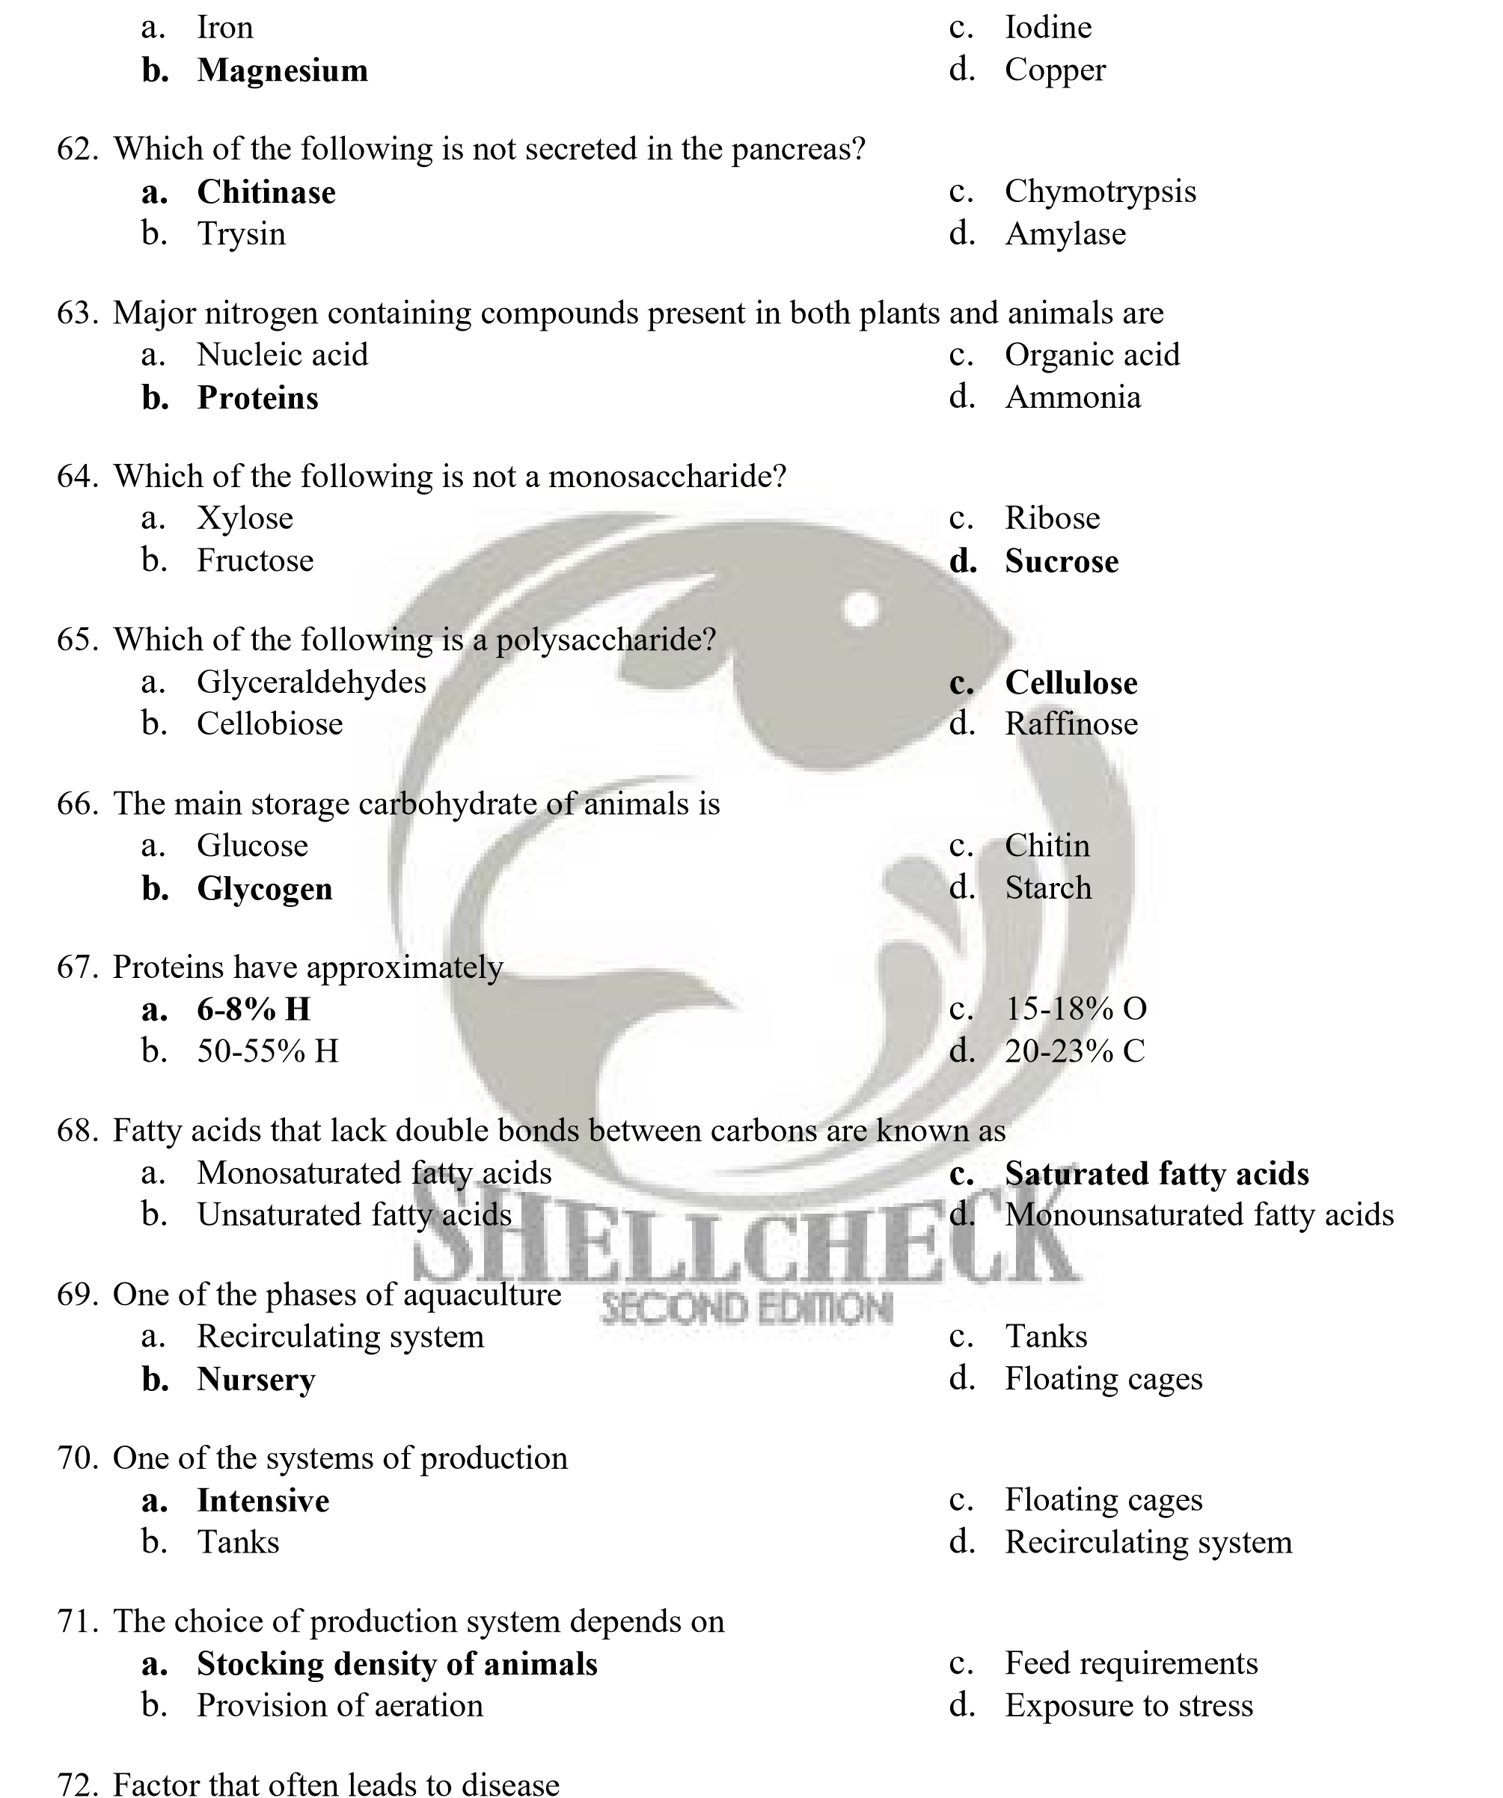
  - Host c. Environment
  - Pathogen d. Exposure of the animal to stress

- One advantage of tilapia pond culture is that the fish
  - Able to swim freely c. Able to breathe freely
  - Feed on natural food d. Able to be captured easily

- The study of genes and genotypic frequencies within a population
  - Quantitative genetics c. Mendelian genetics
  - Population genetics d. Molecular genetics

- Component that is due to the additive effects of the genes
  - Additive variance c. Dominance variance
  - Epistatic variance d. Additive and dominance variance

- Variance that is due to the interaction of alleles between two or more loci
  - Additive variance c. Dominance variance
  - Epistatic variance d. Additive and dominance variance


- It is a breeding program in which individuals or families are chosen in an effort to change the population mean in the next generation
  - Hybridization c. Selection
  - Cross breeding d. Triploidy

- Variance that is transmitted in a predictable and reliable manner
  - Additive variance c. Dominance variance
  - Epistatic variance d. Genetic variance

- The raw material with which the animals breeder most work
  - Genetic variation c. Environmental variation
  - Phenotypic variation d. Genetic and environmental variation

- The proportion of individuals in the population with a particular genotype
  - Genotypic frequency c. Allele frequency
  - Gene frequency d. Effective population number

- Component that is due to the interaction of the alleles at each locus
  - Additive variance c. Epistatic variance
  - Dominance variance d. Genetic variance

- The observable or measureable differences among individuals within a population for a particular
trait
  - Genetic variation c. Environmental variation
  - Phenotypic variation d. Additive variation

- Only a small random sample of parents‟ variance is inherited by its progeny
  - Additive variance c. Epistatic variance
  - Dominance variance d. Non-additive variance

- Considered as the governor in any selection program
  - Realized response c. Heritability
  - Genetic variance d. Epistatic

- Describes a diploid organism that carries two different alleles at one or more genetic loci
  - Homozygous c. In-breeding
  - Heterozygous d. Gene pool

- Offspring of two different varieties or two different species
  - Diploid c. Hybrid
  - Polyploidy d. Triploid

- Organism that has been genetically engineered to contain one or more novel genes, taken from one or more different species and inserted into its genome
  - Transgenic c. Hybrid
  - Selected line d. Triploid

- Loss or alteration of genetic identity in wild population of organisms that may result from interbreeding of genetically distinct stocks introduced to the wild either intentionally or accidentally
  - Genetic engineering c. Gene probe
  - Genetic plasticity d. Genetic dilution

- Feed cost is not a major expense item under this culture system
  - Cage culture c. Extensive culture
  - Tank culture d. Intensive culture

- The most likely effect of a subsidy on inputs in fish production
  - Increase in output price c. Increase in demand
  - Increase in production d. Increase in profit

- Cultivation of only one target species at a given time and place
  - Fish culture c. Monoculture
  - Polyculture d. Simultaneous culture


- A sequence of organism, each of which provides food for the next, beginning with primary producers and extending to carnivores
  - Food chain c. Food web
  - Photosynthesis d. Food channel

- The process by which green plants algae and other primary producers produce food for their own growth, plus oxygen from CO2, water, and sunlight
  - Photoinhibition c. Photolytic
  - Photosynthesis d. Phototactic

- Most are of earthen construction
  - Tanks c. Ponds
  - Pen d. Cages

- It must be available in the necessary quantity and quality
  - Water c. Fertilizer
  - Soil type d. Pond vegetation

- A culture system where two or more agricultural commodities are simultaneously grown in a certain area
  - Polyculture c. Integrated farming
  - Multi-stock d. Multi-cropping

- This is the best way to maintain the water quality for fish production
  - Aeration c. Biofiltration
  - Water exchange d. Recirculation
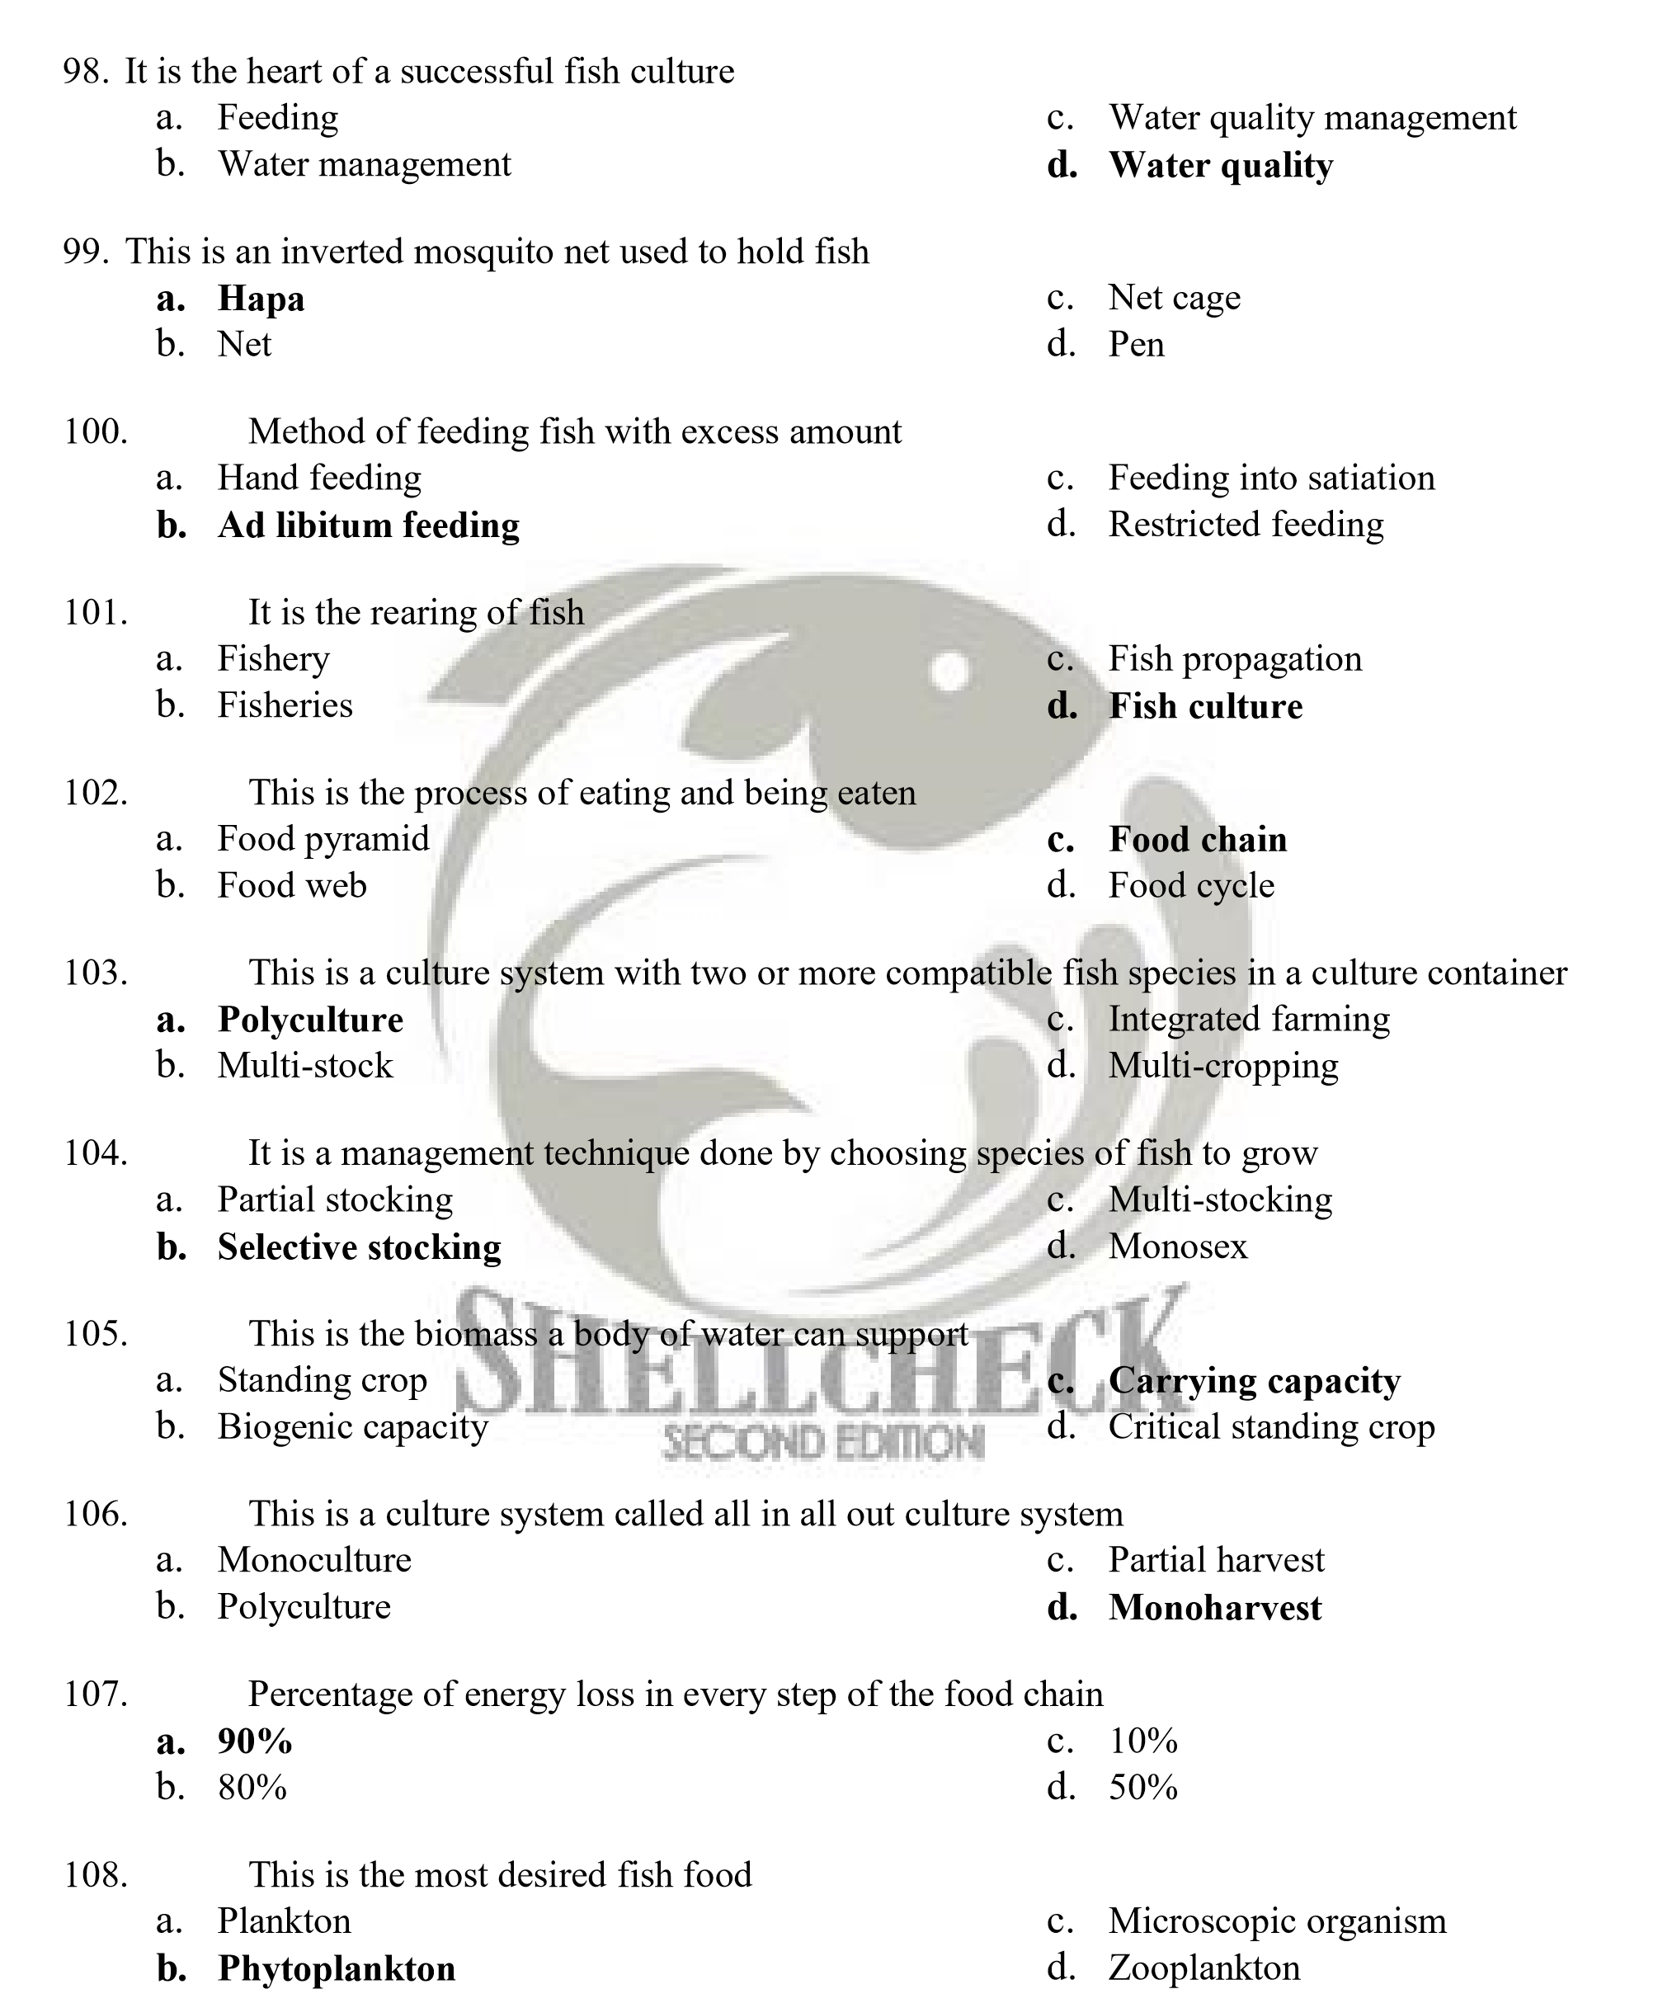

- This is the limiting nutrient in fish culture
  - Carbon dioxide b. Nitrogen

c. Phosphorus Oxygen

- The main goal of aquaculture development is
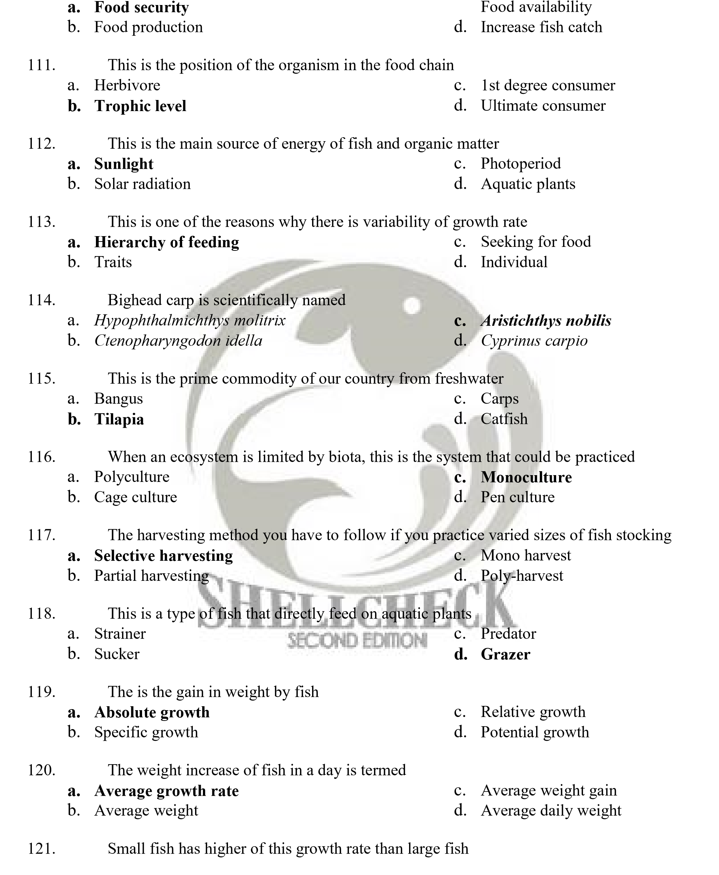
c.
  - Specific growth c. Optimum growth
  - Absolute growth d. Relative growth

- This is the King of Fishes in China
- Bighead carp  - Grass carp | - Common carp  - Crucian carp

- Development of aquaculture commenced in what century?
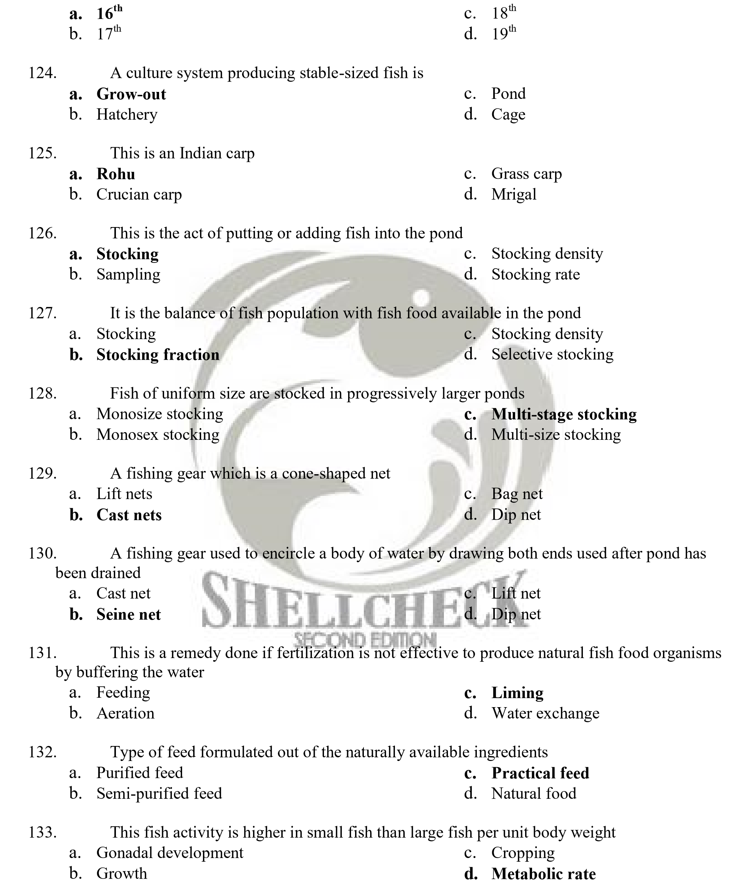

- This is affected by the quality of ration given to fish
  - Amount of fish waste b. Size of fish
c. Quality of fish Food preference

- It is also known as “bintol”
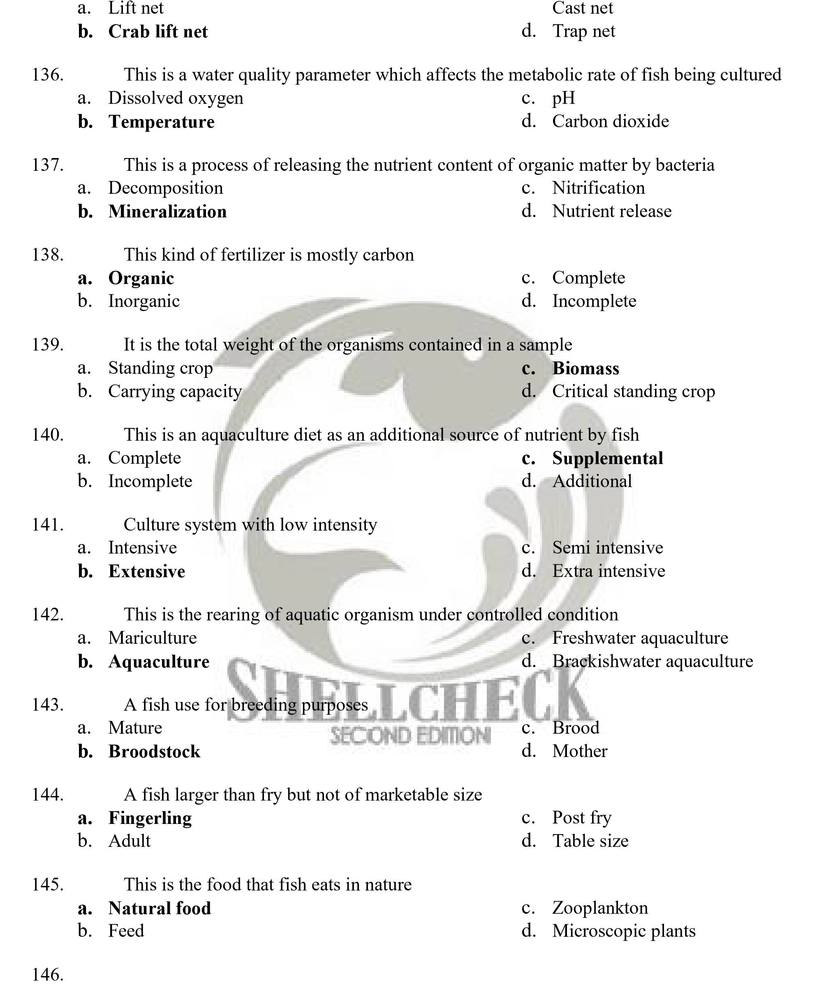
c.
The taxonomy or identification and classification of Philippine fishes and other living aquatic resources started by the first American group of scientists who came to the Philippines to initiate fisheries work. The American who made extensive collections of fish all over the country and wrote several publication monographs describing the different fish collections is
  - Dr. Albert W.C. T. Herre b. Dr. Wallace Adams
c. Dr. Alvin Scale d. Dr. Henry Fowler

- A Filipino, a Zoology graduate from University of Chicago who wrote the first report in the family Mugilidae, a first checklist of Philippine fishes and identification of marine protozoans
  - Dr. Hilario A. Roxas c. Dr. Herminigildo Rabanal
  - Dr. Deogracias V. Villadolid d. Mr. Domiciano K. Villaluz

- A Filipino graduate from Stanford University who wrote the first reports on Philippine flatfishes
  - Dr. Hilario A. Roxas c. Dr. Herminigildo Rabanal
  - Dr. Deogracias V. Villadolid d. Mr. Domiciano K. Villaluz

- The father of tilapia sex reversal in the Philippines
  - Dr. Tereso A. Abello c. Dr. William Shelton
  - Dr. Rafael D. Guererro III d. All of the above

- The first Philippine University/College who first initiated fisheries education is
  - University of the Philippines in the Visayas
  - University of the Philippines-Los Banos
  - Central Luzon State University
  - Iloilo State College of Fisheries


- The Bureau of Fisheries and Aquatic Resources (BFAR) started as a small agency in 1901 under the name
  - Bureau of Government Laboratories, Department of Interior of the Philippine
Commission
  - Division of Fisheries, Department of Interior of the Philippine Commission
  - Fish and Game Administration
  - Fisheries Division, Department of Agriculture and Commerce

- The oldest fish culture practiced in the Philippines
  - Milkfish c. Mudfish
  - Carp d. Tilapia

- The first demonstration fish farm established in 1931 in the Philippines was
  - Oyster Farm in Hinigaran, Negros Occidental
  - Molino Freshwater Demonstration Fish Farm, Bacoor, Cavite
  - Dagat-dagatan Saltwater Fisheries Experimental Station, Malabon/Navotas, Rizal
  - Freshwater Fish Hatchery, Laguna de Bay, Tanay, Rizal

- The leading commercial producers of milkfish in the world are
  - Taiwan, Indonesia, Philippines c. Indonesia, Thailand, Philippines
  - Taiwan, Indonesia, Thailand d. Indonesia, Thailand, Brunei

- It is a system in bangus culture used to effect stock manipulation and increase stocking rates
  - Modular system c. Nursery system
  - Transition pond system d. Hatchery system

- It is an assemblage of phytoplankton and zooplankton which serves as a food for milkfish in brackishwater ponds
  - Lumot b. Lablab
c. Nostoc Plankton

- It is a major farmed penaeid shrimp in the Philippines
  - Penaeus monodon c. Penaeus merguiensis
  - Penaeus indicus d. Metapenaeus ensis

- It is an illegally-introduced shrimp species in the country that is now a subject of legal controversy
  - Metapenaeus ensis c. Macrobrachium resenbergii
  - Litopenaeus vannamei d. Cherax quadricarinatus

- A species of tilapia that is cold tolerant and also called as blue tilapia
  - Oreochromis spilurus c. Oreochromis mossambicus
  - Oreochromis aureus d. Oreochromis niloticus

- A herbivorous tilapia species in the Philippines which is also called as yellow tilapia
  - Oreochromis galileus c. Tilapia ensis
  - Tilapia zillii d. Oreochromis maritimus

- An introduced crayfish from Australia being mass cultured presently in Iloilo, Philippines
  - Procambarus clarkii c. Macrobrachium lanchesteri
  - Cherax quadricarinatus d. Macrobrachium idella

- A herbivorous crayfish species from Louisiana, USA being marketed as a pet in the aquarium fish trade industry in the Philippines
  - Procambarus clarkii c. Macrobrachium lanchesteri
  - Cherax quadricarinatus d. Macrobrachium idella

- Which shrimp species is indigenous in Philippine waters?
  - Macrobrachium rosenbergii c. Macrobrachium ensis
  - Macrobrachium idella d. Macrobrachium maritimus

- A popular aquaculture prawn species whose reproduction and larval rearing occur in saltwater but adult grows in freshwater
  - Macrobrachium rosenbergii c. Macrobrachium ensis
  - Macrobrachium idella d. Macrobrachium maritimus

- A commonly-cultured mudcrab in brackishwater and has a high aquaculture potential and market value
  - Scylla serrata c. Scylla olivacea
  - Scylla tranquebarica d. Scylla paramamosain

- The first mariculture park in the country was established in August 2001 at
  - Samal Island, Davao del Norte c. Leyte
  - Honda Bay, Palawan d. Zamboanga


- A pest of the cultured seaweed Kappaphycus and Eucheuma which is an epiphyte that grows on and entirely covers the affected seaweed. It is locally known as “balahibo” or “balbas” because of its hairy appearance. It competes for nutrients and light with the host.
  - Polynia sp. c. Polygonum sp.
  - Polymorpha sp. d. Polyponia sp.

- A dominant carp species cultured in the fish pens of Laguna de Bay
  - Hypophthalmichthys molitrix c. Ctenopharyngodon idella
  - Aristichthys nobilis d. Cyprinus carpio


- This is a species of abalone with a good foreign market and its hatchery developed by SEAFDEC/AQD. Locally known as “lapas” or “sobra-sobra”. This species is also called cocktail abalone because of its small size (maximum shell length at 10-11 cm). It is the fastest growing abalone in the world since a marketable size of 5-6 cm can be attained in one year compared with five years for some temperature species.
  - Haliotis asinina c. Haliotis diversicolor
  - Haliotis varia d. Haliotis discus hannai

- The leading abalone producer from aquaculture in the world is Taiwan. What is this abalone species?
  - Haliotis asinine c. Haliotis diversicolor
  - Haliotis varia d. Haliotisdiscus hannai

- The largest species of abalone prized as food and extensively marketed
  - Haliotis rufescens c. Haliotis diversicolor
  - Haliotis varia d. Haliotis discus hannai

- A mussel species extensively farmed in the Philippines, Thailand, and New Zealand
  - Brown mussel Perna perna c. Green mussel Perna viridis
  - Green-lipped mussel Perna canaliculus d. Mussel Mytilus edulis

- A newly-introduced freshwater (FW) mussel in the country from Thailand and found in
Pampanga. A human food with aquaculture potential
  - Pilsbyochoncha exilis c. Anodonta woodiana
  - Cristaria plicata d. Vivipara costata

- It is a freshwater mussel that can be used as food and pearl culture. It is called in Japanese as
“karasu”
  - Hyriopsis schlegeli c. Cristaria plicata
  - Hyropsis cumingii d. Anadonota woodiana

- A saltwater pearl oyster species also called as tipay that can be used for pearl aquaculture in the Philippines. It produces the famous and expensive South Sea pearl
  - Silver-lipped pearl oyster Pinctada maxima
  - “Akoya” pearl oyster Pinctada fucata
  - Black-lipped pearl oyster Pinctada margaritifera
  - “Mabe” pearl oyster Pteria penguin

- A saltwater (SW) pearl oyster species also called as tipay bato that can be used for pearl aquaculture in the Philippines. It produces black pearl
  - Silver-lipped pearl oyster Pinctada maxima
  - Akoya pearl oyster Pinctada fucata
  - Black-lipped pearl oyster Pinctada margaritifera
  - Mabe pearl oyster Pteria penguin

- It is the fastest growing pearl oyster species (also called as wasay-wasay) that can be used for pearl aquaculture and it produces pink pearls.
  - Silver-lipped pearl oyster Pinctada maxima

  - Akoya pearl oyster Pinctada fucata
  - Black-lipped pearl oyster Pinctada margaritifera
  - Mabe pearl oyster Pteria penguin

- A tiny bivalve cultivated in the province of Capiz in the island of Panay, west central
Philippines as live feed for shrimp and mudcrab, and sometimes for tilapia and milkfish
  - Agiis c. Taklobo
  - Imbao d. Tahong

- A mangrove clam locally known as imbao which is widely distributed in the Indo-West Pacific, from East and South Africa, including Madagascar and the Red Seam to eastern Polynesia; north to southern Japan and Hawaii, and south to New South Wales. It inhabits the muddy bottom of mangrove area, or the adjacent mudflats. It grows to a maximum size 8-9 cm shell length, total weight of 180-210 g and is a potential aquaculture species
  - Anadonta edentula c. Anodonta plicata
  - Anadonta woodiana d. Anodota maritimus


- A bivalve mollusk locally called as kapis, commercially and economically important because of its translucent shell. They can be made into beautiful handicrafts and they can be used for making animals glue, chalk, shellack, soldering lead, and paint. The shellcraft product is exported to US, Japan, West Germany and other European countries. They can be cultured or transplanted in suitable areas and there are 27 kapis beds in the Philippines
  - Placuna placenta c. Conus geographus
  - Tridacna gigas d. Helmet shell

- A freshwater gastropod that belongs to the family Pilidae that was introduced in the Philippines in the 1980‟s as a source of food but eventually became pest in rice fields
  - Pomacea cuprina c. Pomacea cananiculata
  - Pomacea insularis d. Pomacea maxima

- A pond system design that allows for the continuous program of pond preparation and harvest of milkfish in brackishwater (BW) but this system is input and labor intensive and requires an area of about 8 hectares.
  - Traditional pond system c. Nursery pond system
  - Modular pond system d. Transition pond

- A parasitic isopod that is a major pest in the cage culture of Nile tilapia in Taal Lake
  - Alitropus typus c. Prosthodisplosthomum sp.
  - Lernea sp. d. Monogean parasite

- A fungus-associated disease that affects FW and estuarine warm water fishes that was first reported in farmed "ayu" in Japan and severe outbreaks occurred in grey mullet Mugil cephalus in Australia. Some important culture species like tilapia, milkfish and carps are found to be resistant to this disease
  - Epizootic Ulcerative Syndrome c. Spring Viranemia
  - Lymphocysts d. Haemorrhagic Septicemia

- A kind of mycotoxin found in feeds
  - Aflatoxin c. Cytotoxins
  - Fungal toxin d. Neurotoxin

- The ratio of feed consumed to the fish biomass gained is called

  - Feed conversion ratio c. Feed conversion efficiency
  - Food conversion ratio D. Food conversion efficiency

- The physiological capacity of the fish to convert feeds to fish flesh is termed
  - Feed conversion efficiency c. Energy feed efficiency
  - Feed conversion ratio d. Feed conversion

- Fishes with no stomachs have
  - No acid phase of digestion c. Extensive intestine
  - Acid phase of digestion with long d. None of the above intestine

- In fishes with stomach, the transport of food from the stomach into the midgut is controlled by a muscular sphincter called
  - Pylorus c. Midgut sphincter
  - Esophageal sphincter d. None of the above

- The stomach of voracious fish produces pepsin and the pH is

a. 4 c. 3 b. 5 d. 2


- For carnivorous (e.g. Trout and dalag) and non-carnivorous (e.g. Tilapia and carp) fishes, the feeding practices are as follows
  - Large meals and less frequent feeding and small meals and more frequent feeding, respectively
  - Small meals and less frequent feeding and large meals and less frequent feeding, respectively
  - Large meals and have frequent feeding, respectively
  - None of the above

- The tilapias are cichlid species which are endemic to the
  - Middle East and Africa c. Southeast Asia and the Pacific
  - Middle East and Africa d. All of the above

- Sex reversal is one of the methods to produce all-male tilapia. This method is done by the oral administration of the hormone called
  - 17 á-methyl testosterone c. Methyl androgen
  - Diesterol alpha d. All of the above

- The chromosomes of the normal male and female tilapia are
  - XY and XX, respectively c. XY and YY, respectively
  - XX and XY, respectively d. All of these

- A process that strips oxygen from an ecosystem.
  - Photosynthesis c. BOD and COD
  - Respiration d. All of the above

- One of the following statements is incorrect.
  - Autotrophs produce their own food.
  - Heterotrophs are primary producers
  - Photosynthesis builds up carbohydrates
  - Most larval stages of fish are either omnivorous or carnivorous.

- A lotic aquaculture system is exemplified by
  - Recirculating system c. Flow through system
  - Open pond with water exchange d. All of the above
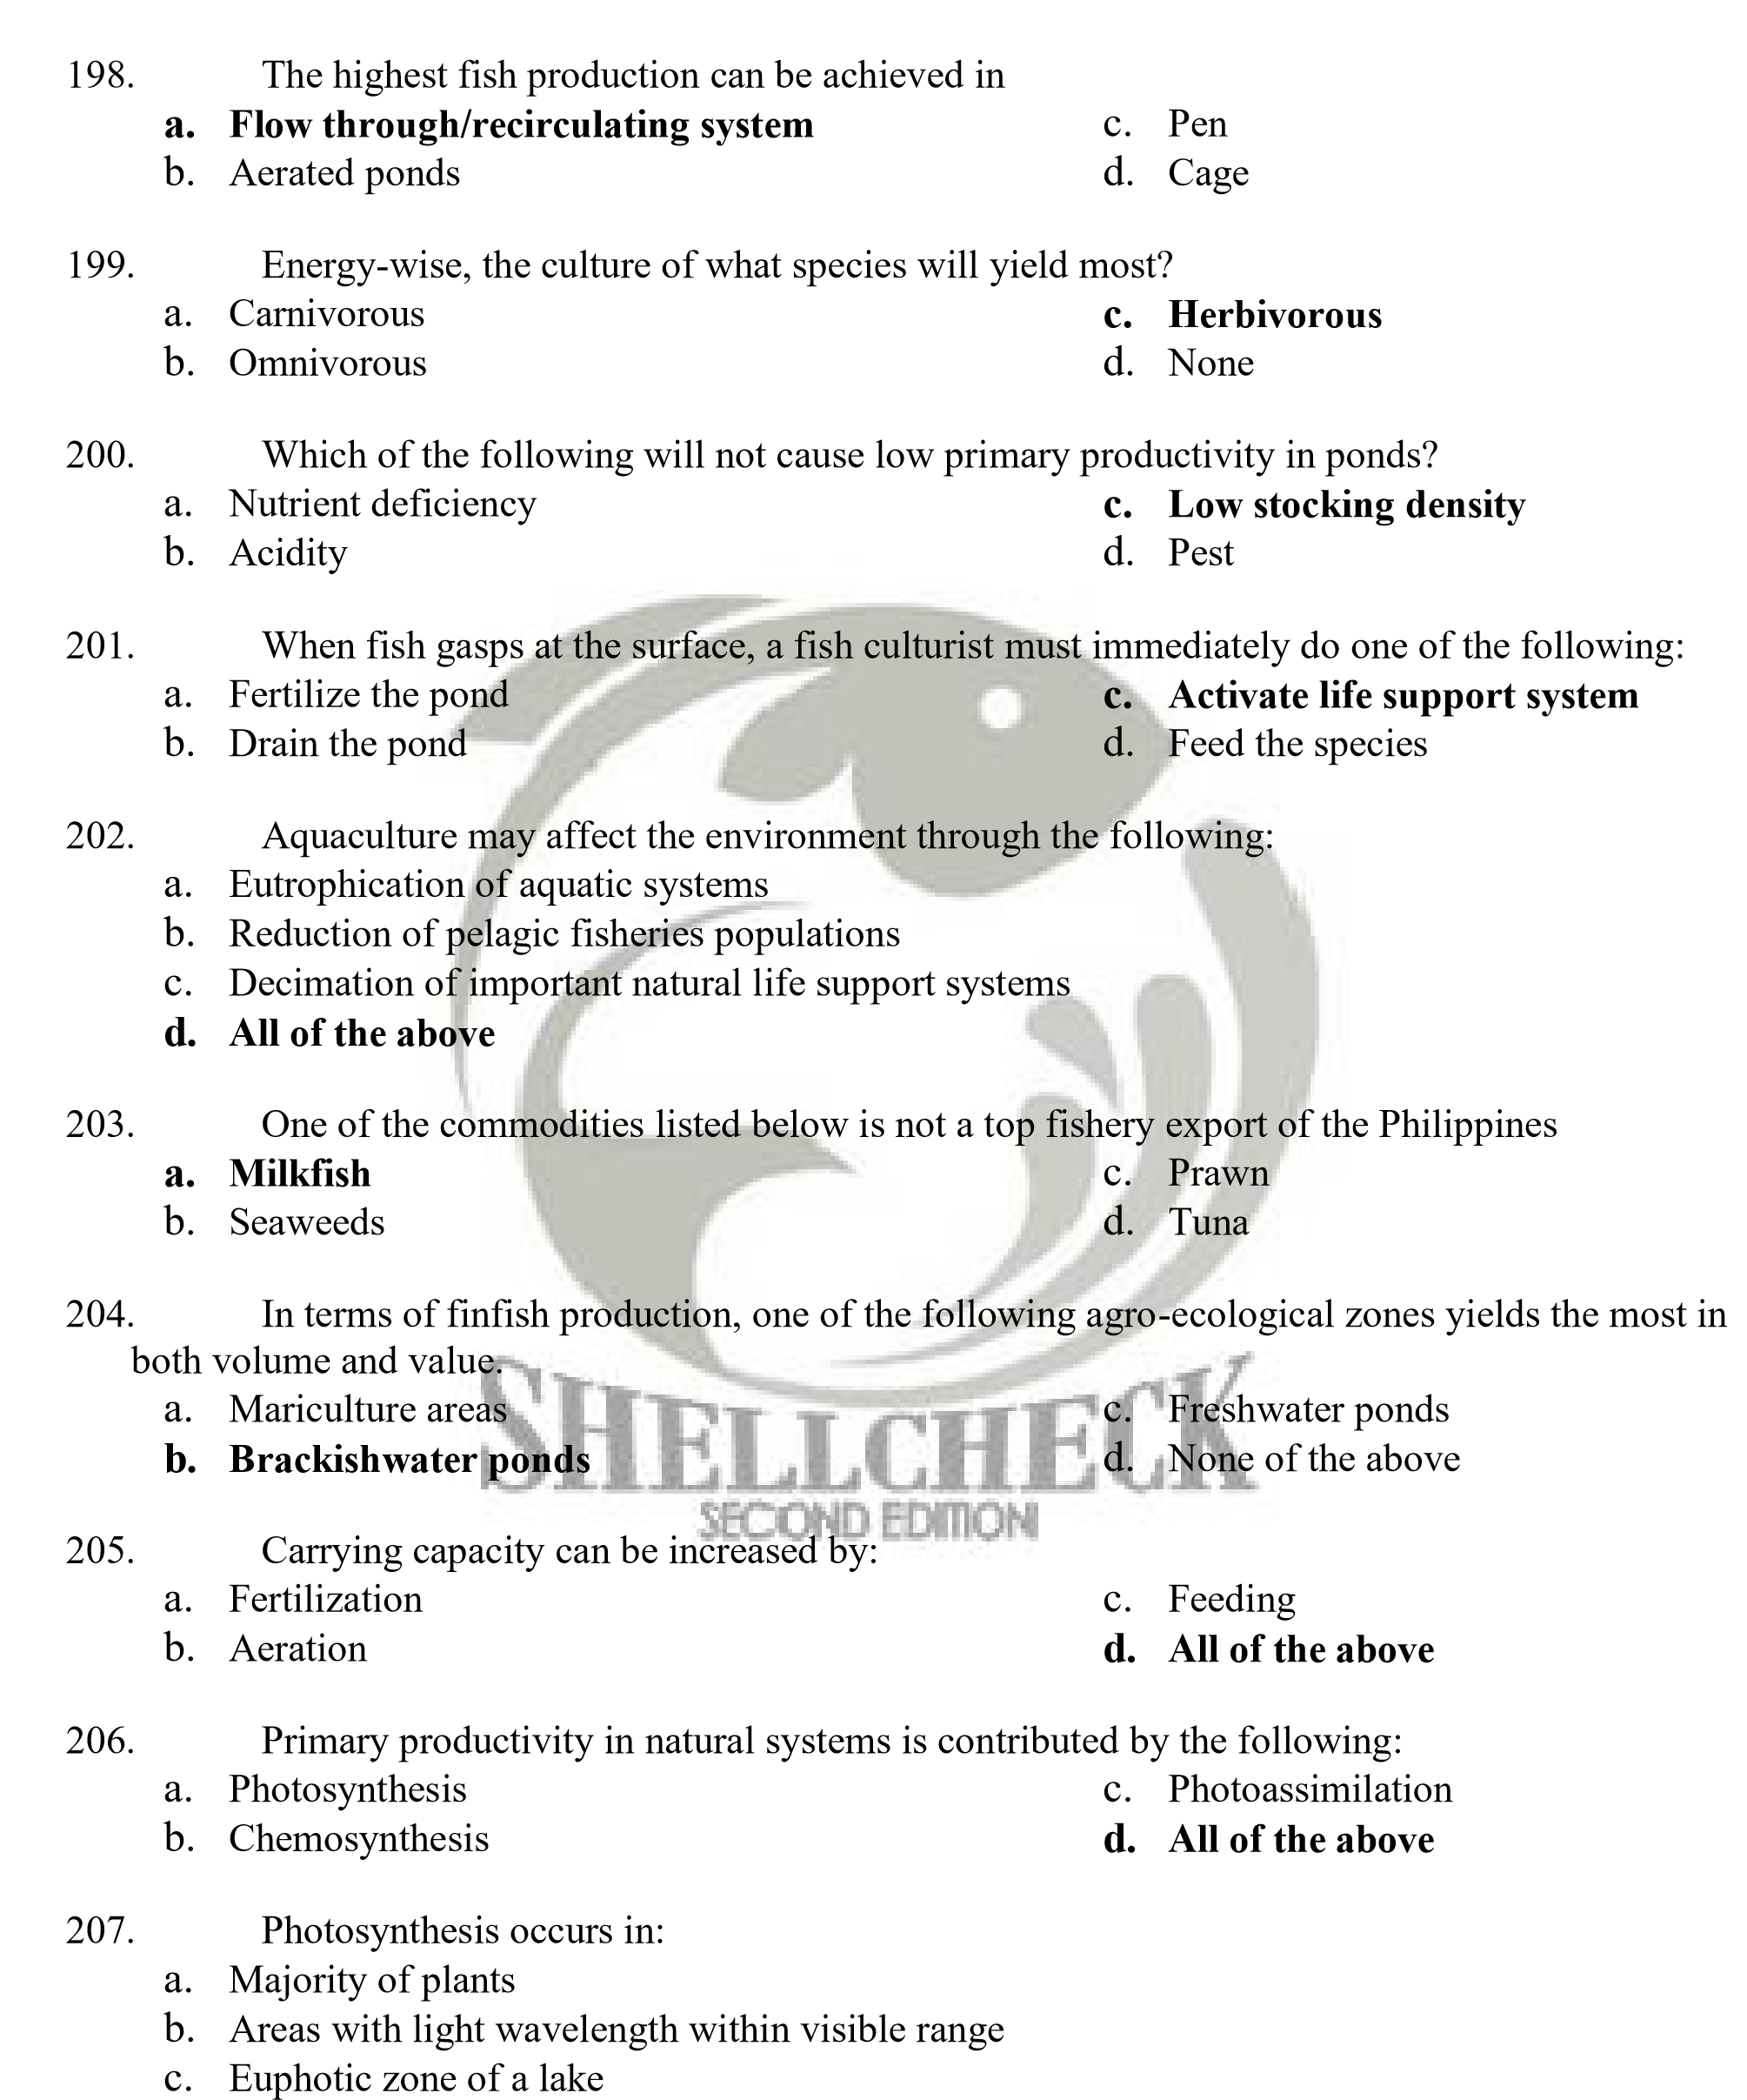
d. All of the above

- A pond deficient with nitrogen must not be fertilized with
  - Urea c. Solophos
  - Ammonium sulphate d. Ammonium phosphate

- Plankton method of growing food requires a minimum depth of:
  - 15-20cm c. 15-30cm
  - 75-100cm d. Below 15cm

- A gaseous biogeochemical cycle that is self- replenishing, almost a perfect cycle.
  - Nitrogen cycle c. Carbon cycle
  - Phosphorous cycle d. Carbon Dioxide cycle

- Fish grows isometrically when their Length-Weight relationship yields a b value of:
  - 1 c. < or > 1
  - 3 d. < or > 3

- Cost of fish production can be improved by:
  - Improvement of FCR c. Proper feeding
  - Efficient feed formulation d. All of the above

- Feeds that contain ingredients of precisely known composition and formulated from synthetic substances.
  - Practical diets c. Purified diets
  - Complete diets d. Balance diets

- Suitable range of water pH for fish growth.
  - 5-8 c. 6.0-9.0
  - 6.5-9 d. 6.5-11

- Which of the following statements is correct?
  - All biogeochemical cycles are self-replenishing
  - The lower the FCR the better
  - Carrying capacity is the ability of the pond to produce natural foods
  - Growth potential of a fish can be exceeded with proper maintenance of growth related factor

- A type of parasitic crustacean that is caused by parasitic copepod, worm-like adults buried in the body and only female species infect the fish
  - Lerneasis c. Skin fluke
  - Fish lice d. Gill fluke

- Protogyny, in which female species turn into males, is common to this family except:
  - Labridae c. Serranidae
  - Scaridae d. Monocantidae


- This is a phenomenon caused by low salinity, temperature and light intensity. This health condition of seaweed wherein it exudes organic substances, which is mucilaginous in nature and with the presence opportunistic bacteria in the water column aggravates the whitening of the branches.
  - Tip discoloration c. Die off
  - Ice-ice disease d. Tip darkening

- Kjeldahl digestion is the method of analysis of what major fraction of feeds and feedstuff?
  - Crude protein b. Moisture
c. Crude fat d. Crude fiber

- Weed control is one of the different strategies in pond management. Which of the following is not an adverse effect of weeds?
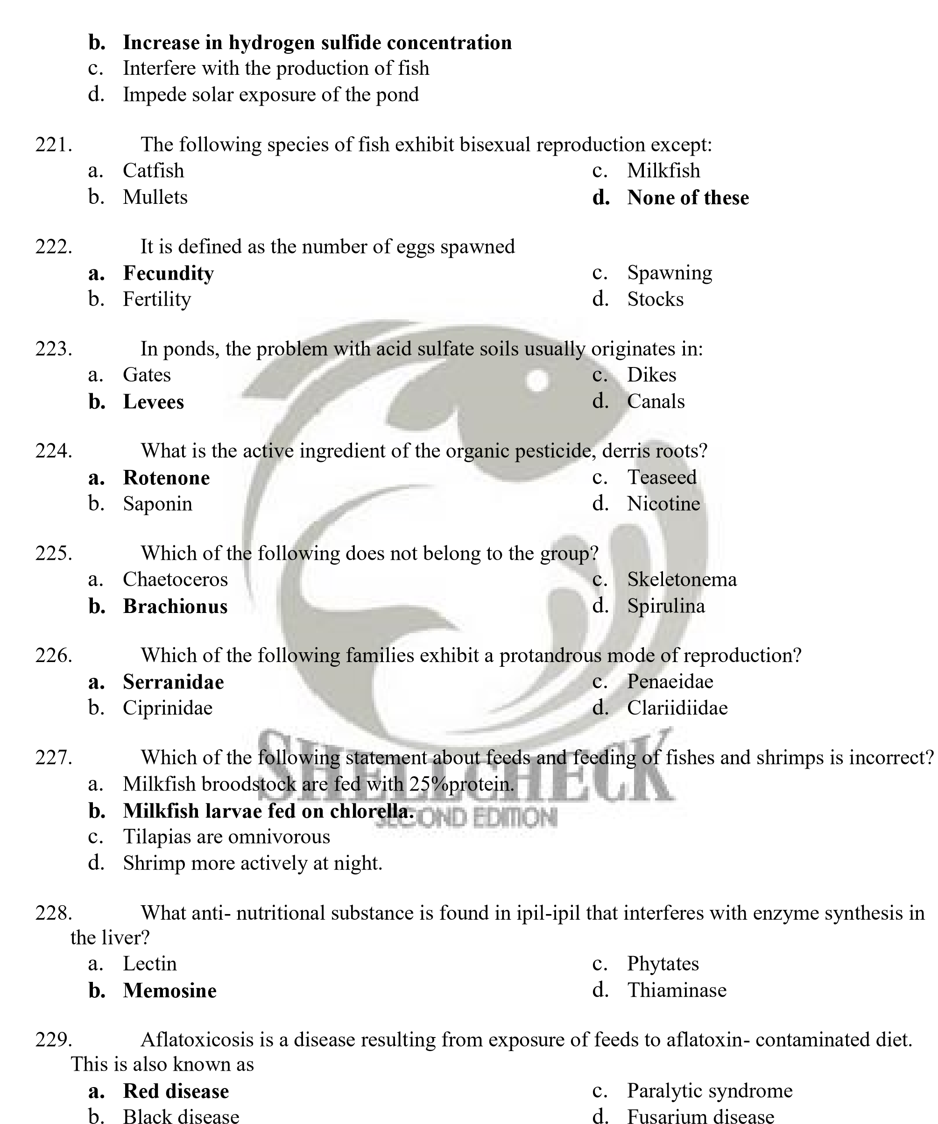a. Utilize soil nutrients

- Anti- nutritional substance that is found in cassava that releases poisonous hydrocyanic acid upon hydrolysis.
- Peroxide  - Cyanogens | - Tannin  - Phytates

- Which of the following minerals is considered as macro-element and required in the diet in
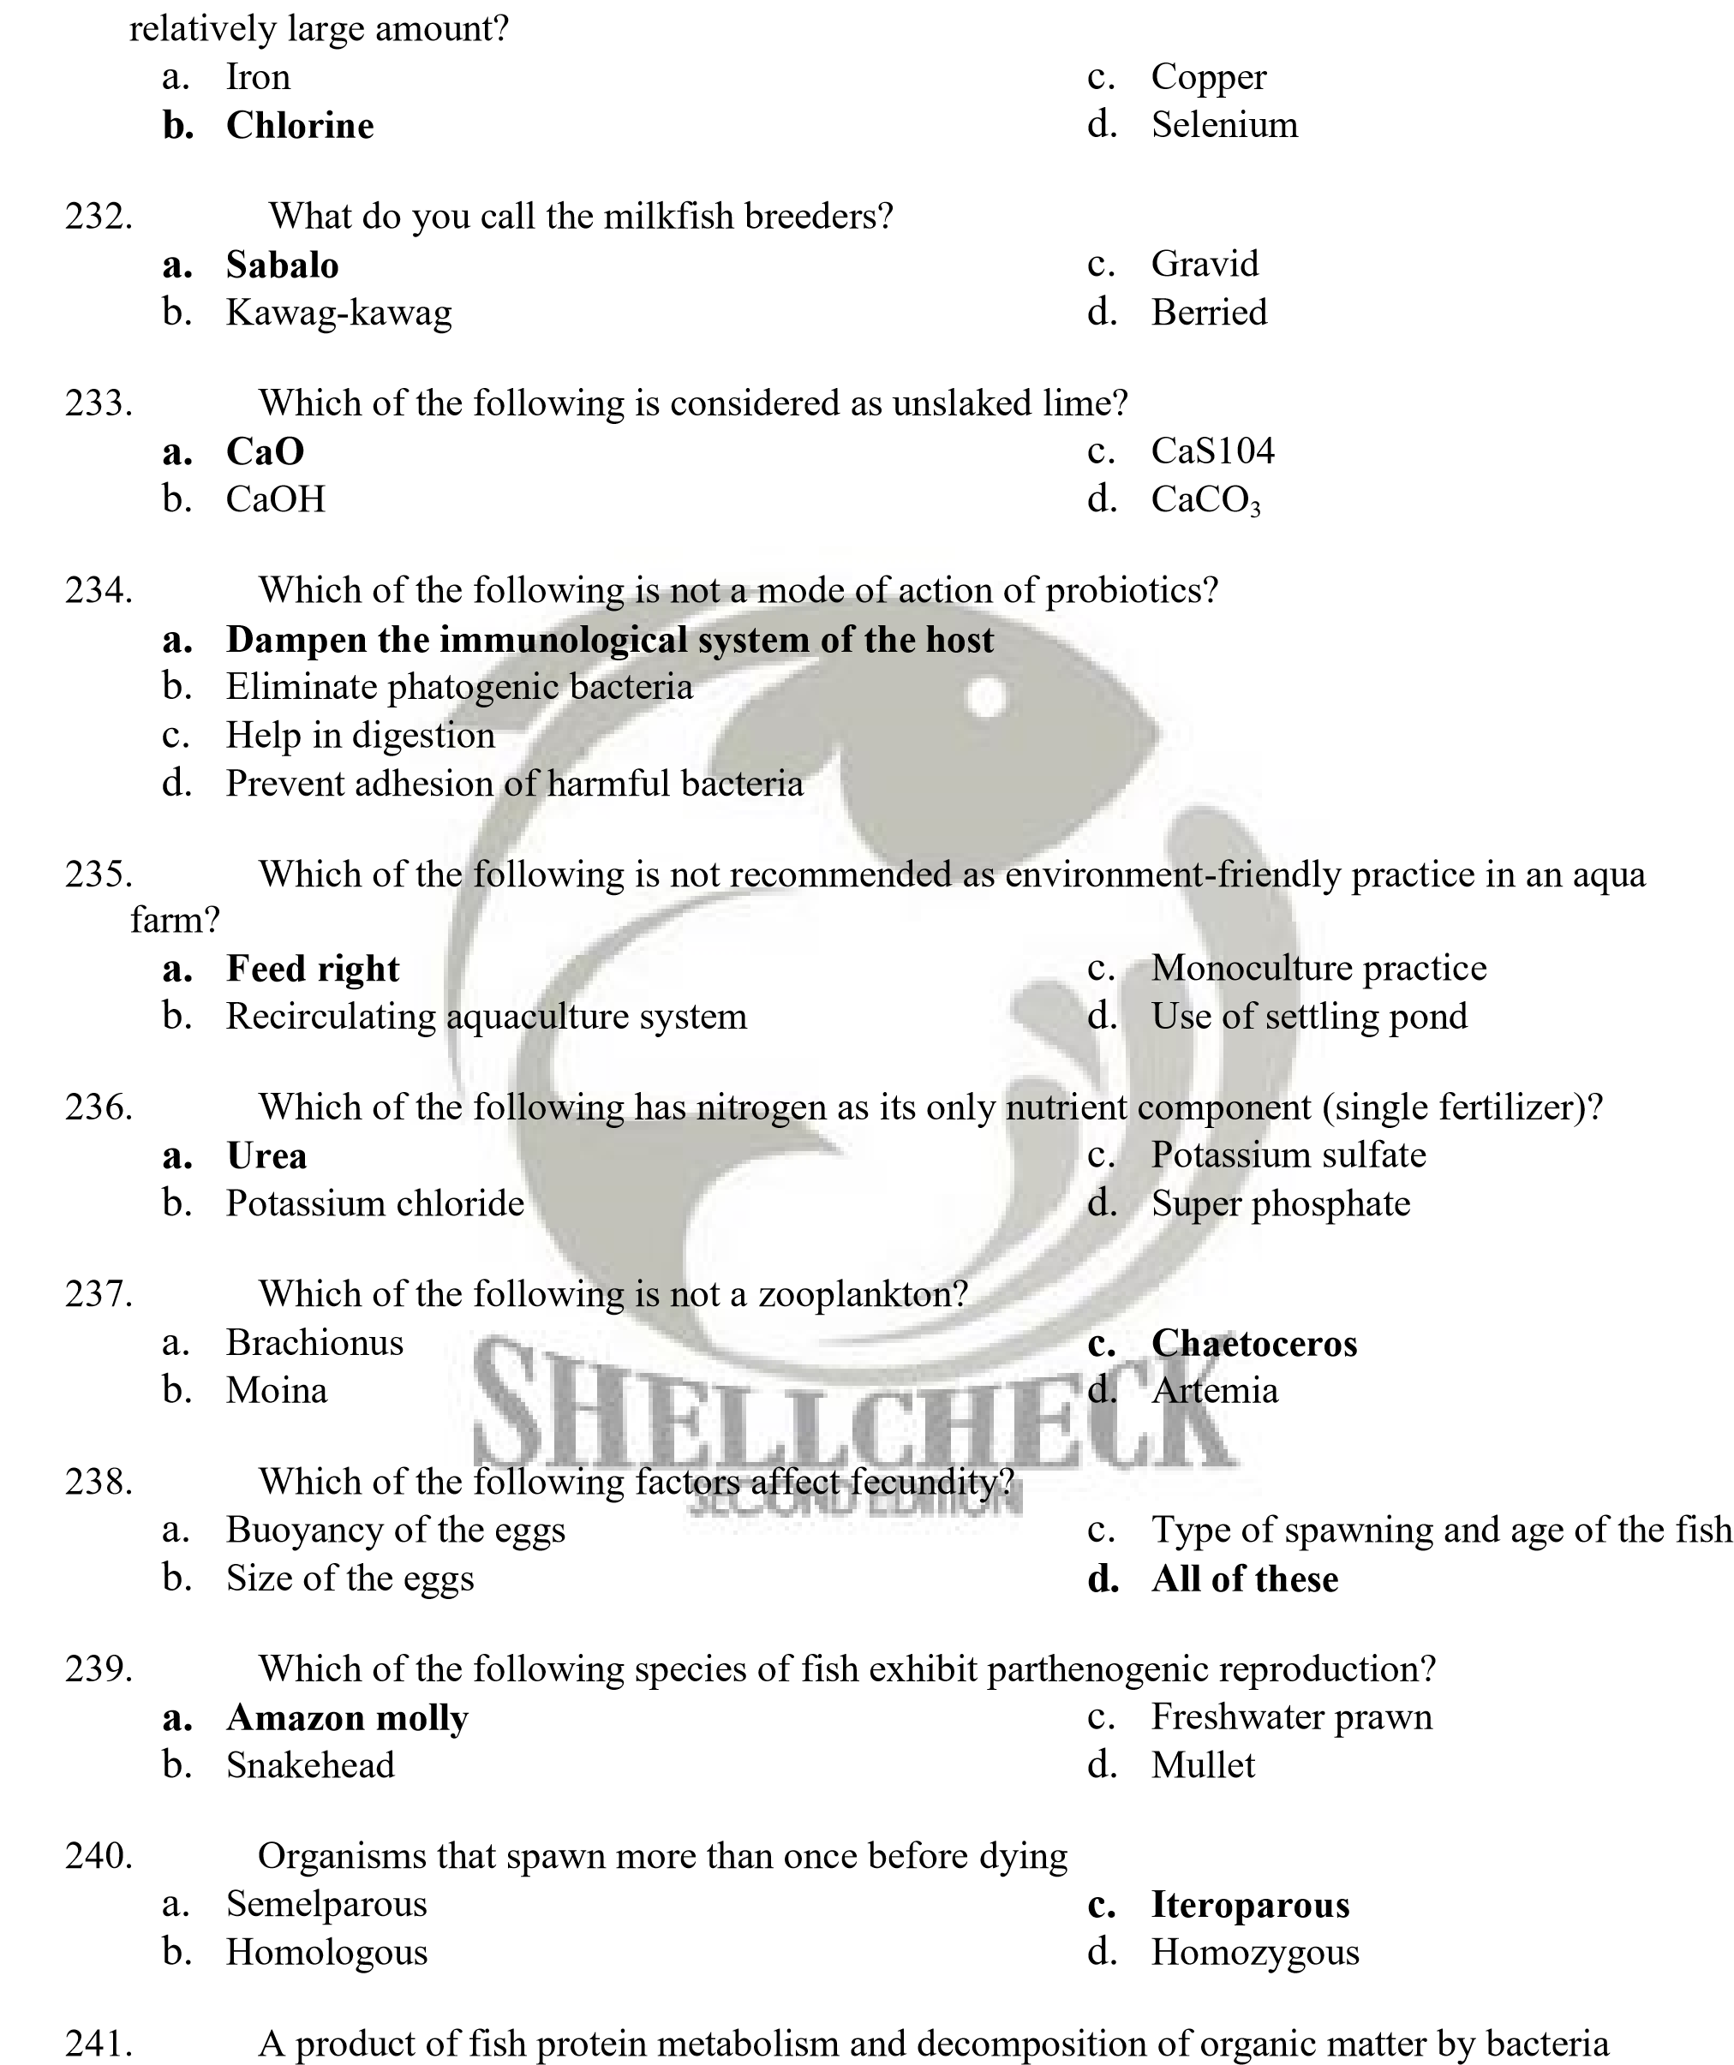
  - Urea c. Potassium
  - Phosphorous d. Ammonia

242. Which of the following environmental stimuli affect spawning of tropical species?
- Rainfall and floods c. Temperature
- Courtship behavior d. All of these

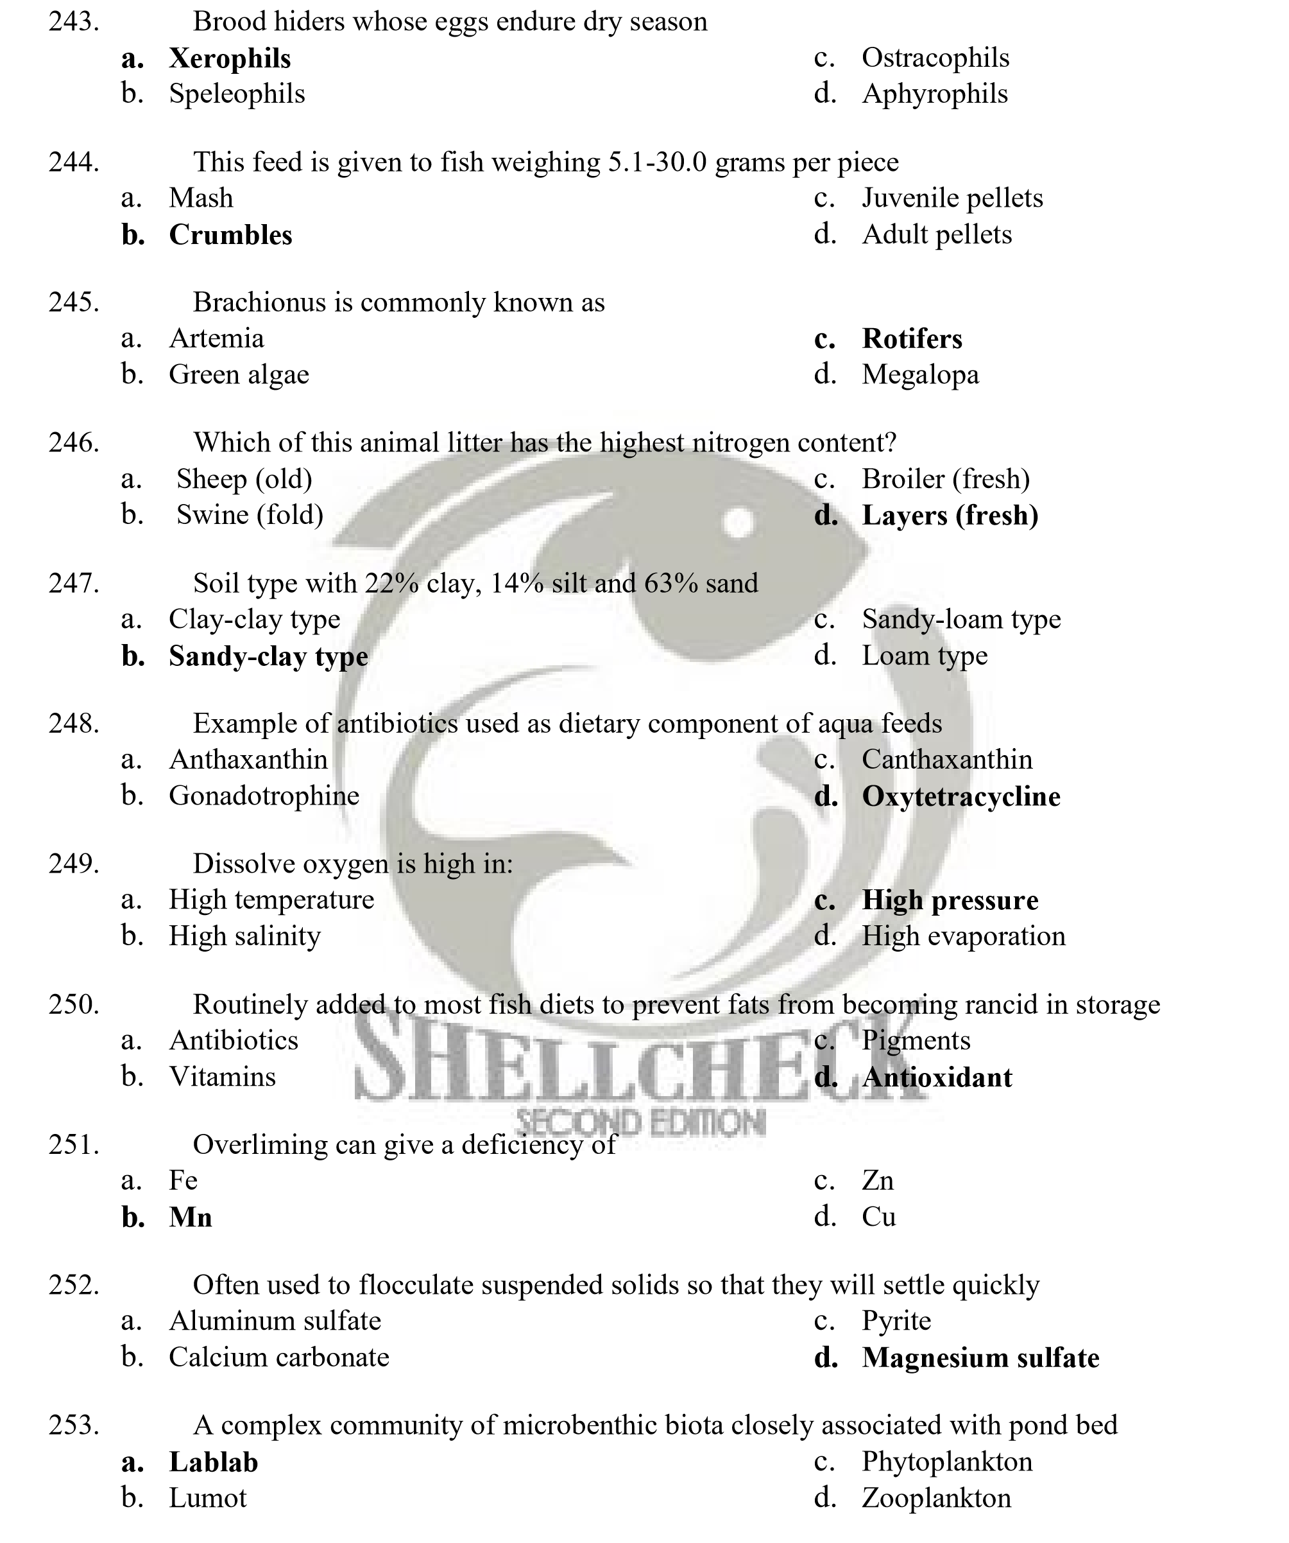
- Which of the following feedstuff has the highest apparent protein digestibility?
  - Gelatin c. Corn starch
  - Yeast d. Fish meal

- Substances added to feeds to make it stable in water
  - Vitamins c. Antibiotics
  - Fillers d. Binders

- Refers to the layer of the land or the changes in the surface and elevation of the ground
  - Soil pH c. Soil texture
  - Soil area d. Topography

- Vibriosis occurs in the following conditions except:
  - High temperature c. High oxygen
  - High salinity d. High organic load

- Localized tissue anemia due to obstruction of the inflow of blood.
  - Lethargy c. Anemia
  - Necrosis d. Ischemia

- Abnormal protrusion of the eyeball of the fish
  - Exophthalmia c. Ischemia
  - Ulceration d. Necrosis

- Origin of Red tilapia
  - Thailand c. Egypt
  - Singapore d. Taiwan

- Origin of aquaculture
  - China c. United States
  - Japan d. Greece

- Which of the following is the chemical commonly used as treatment for viral infections?
  - Copper sulfate c. Magnesium oxide
  - Oxylinic acid d. None of these

- This is a normal free-living organism either in water or the fish, but is capable of adopting pathogenic role under certain circumstances.
  - Primary or obligate pathogen c. Isopod infestation
  - Opportunistic pathogen d. Bacterial hemorrhagic septicemia


- Condition characterized by a deficiency of hemoglobin, packed cell volume, or erythrocytes in the blood
  - Thrombosis c. Dystrophy
  - Anorexia d. Anemia

- Luminous Bacterial Disease is caused by what strains of Vibrio?
  - V. harveyii and V. splendidus c. V. fluvialis and V. harveyii
  - V. penaeicida and V. damsel d. V. alginolyticus and V. splendidus

- This is caused by opportunistic gram-negative bacteria like Vibrio, Aeromonas,
Pseudomonas and members of Enterobacteriaceae
  - Isopod infestation c. Bacterial Hemorrhagic Septicemia
  - Infections of acid fast bacteria d. Epizootic Ulcerative Syndrome

- The following are examples of major viral infections in fish except:
  - Spinning Tilapia Syndrome c. Yellow Head Virus Disease
  - Lymphocystis Disease d. Epizootic Ulcerative Syndrome

- Best known viral disease of marine and freshwater fish
  - Herpesvirus c. Viral Nervous Necrosis
  - Lymphocystis d. White spot disease

- Several species of crabs are now of commercial value and can be obtained from the natural habitat or hatchery. Which of the following is considered the native crab?
  - Scylla tranquebarica c. Scylla olivacea
  - Scylla serrata d. Scylla paramamosain


- White Spot Syndrome Virus (WSSV) Disease, a major viral infection in penaeid shrimp, is caused by
  - Parvovirus c. Rhabdovirus
  - Baculovirus d. Nodavirus

- Which of the following water management methods is stressful to shrimps during culture?
  - Frequent water exchange c. Application of lime
  - Application of Probiotics d. Production of green water

- The egg-carrying females of common crustaceans such as prawn and crabs are termed
  - Elated c. Berried
  - Pregnant d. Matured

- Larval stage of Penaeus after nauplius
  - Post larvae c. Zoea
  - Broodstock d. Fingerlings

- Which of the following is incorrect about the sex determination of Siganus canaliculatus?
  - Males are generally smaller than females
  - Abdomen of female is distinctly plump
  - Whitish fluid come from the abdomen of male once pressed
  - Female is more active than male

- Known as the giant/king mud crab
  - Scylla paramamosain c. Scylla tranquebarica
  - Scylla olivacea d. Scylla serrata

- A serious viral problem to grouper culture which was first reported in Japan in 1991 and 1994.
  - Viral Nervous Necrosis c. White Spot Disease
  - Taura Syndrome Virus d. Lymphocystis disease

- Which of the following is not a right technique in handling and transporting prawn spawners?
  - Place the organism in plastic bag with oxygen pressure
  - Place the spawner in freshwater with continuous aeration
  - Put certain amount of ice outside the plastic bag to be use
  - All of these

- Which of the following statements is incorrect about male crab?
  - It has 4 pairs of gonopods
  - It has semi-circular abdomen
  - It has semi-circular abdomen and it has smaller cheliped than female d. All of these

- The following species of Siganus make use of coral reef as its habitat except:
  - punctatus c. luridus
  - vermiculatus d. None of these

- Berried crabs should be:
  - Disinfected through formalin bath c. Stocked in tank with freshwater
  - Fed with 30-40% biomass daily d. All of the above

- Walking legs of prawn
  - Periopods c. Pleopods
  - Uropods d. Gonapods

- Crustacean parasite known as fish louse (freshwater)
  - Argulus c. Ergasilus
  - Caligus d. Lernea

- Viral Nervous Necrosis (VNN), common among groupers and related species is caused by:
  - Rhabdovirus c. Baculovirus
  - Parvovirus d. Nodavirus

- This is a serious finfish disease in Asia affecting more than 100 species of wild and cultured fish and to a lesser extent brackishwater fishes.
  - Infectious Acid Fast Bacteria c. Epizootic Ulcerative Syndrome
  - Bacterial Hemorrhagic Septicemia d. Fungal disease


- Tilapia nests can be natural or constructed cavities. What do you call this kind of ecological spawning?
  - Psammophils c. Aphrophils
  - Phytophils d. Speleophils

- The following are gross signs of Spinning Tilapia Syndrome except:
  - Do not feed c. Swim in spiral pattern
  - Scale loss d. Gasping for air

- What is the right water management for semi-intensive culture of tilapia in ponds?
  - Frequent water change c. 50% water change after 2 months
  - Flow-through d. 5-10% daily water change

- Common carp spawns between 2-8am and eggs hatched in __________days.
  - 1-2 c. 2-3
  - 4-5 d. 5-6

- At how many months do catfish reach maturity?
  - 4-5 months c. 6 - 8 months
  - 1 - 3 months d. More than 1 year

- The species of carp which is flat head, sub-inferior mouth, herbivore and widely introduced for weed control.
  - Ctenopharyngodon idella c. Cyprinus carpio
  - Ctenopharyngodon nobilis d. Hypothalmichtys molitrix

- He introduced Tilapia in the Philippines in 1950
  - Guerrero c. Genomar
  - Tayamen d. Villadolid

- The success of the milkfish culture in fishpens in Laguna de Bay could be attributed to the following except:
  - Occurrence of algal bloom c. Mixed water
  - Absence of true plankton feeders d. Bottom is sandy and coralline

- First maturation of common carp occurs within how many months.
  - 3-5 c. 8-12
  - 6-8 d. 4-8

- Carp, catfish, and snakehead are usually inflicted with cestode, and endoparasitic tapeworm with ribbon-like body. Causative agent is:
  - Echinocephalus c. Argulus
  - Alitropus d. Botriocephalus

- The local pattern of tide curve (better known as design tide curve) upon which fishpond design is based can be obtained from an analysis of the tide record drawn along ______________
  - Zero datum which is mean lower low water
  - Zero datum which is mean low water
  - Zero datum which is mean high water
  - Zero datum which is mean higher high water

- It serves as the foundation of the structure and its elevation for main gates must be lower than the pond bottom elevation and is slightly lower than the lower tide of the site
  - Dikes c. Catching pond
  - Levees d. Floor

- The broadened and extended part of the floor. It serves as protection to scouring and future seepage of water at the gates sides.
  - Dike c. Crown
  - Floor d. Apron


- This is built against the side walls to support or reinforceit; it also helps in reducing seepage flow along the sidewalls
  - Wing wall c. Catwalk
  - Buttress d. Apron

- Reinforced concrete slab or thick wooden planks that span the sidewalls
  - Wing wall c. Catwalks
  - Buttress d. Apron
- They are generally wooden planks used to control the amount of water flowing through the gate
  - Flash boards/slabs b. Apron
c. Screen d. Buttress

- Framed bamboo strips or polyethylene meshes fitted into the groves, used to prevent the exits of cultured organisms and the entry of predators
  - Pillars c. Screens
  - Braces d. slabs

- These provides the control of water to and from the control canal and into the different pond components such as catching pond or nursery pond
  - Main gate c. Blocks
  - Main dike d. Secondary/tertiary dike


- A more recent innovation in pond construction which convey water across the dikes and similar embankments, it is smaller and less expensive made of concrete hollow blocks or asbestos cement, it may or may not have wing walls.
  - Gate c. Culvert
  - Canal d. Stand pipe

- It helps retain water for use in the fish farming operation as well as to protect everything within it from destruction
  - Dikes c. Slabs
  - Gates d. Perimeter dike

- The design of perimeter dike must be based on sound engineering principles and economic feasibility. There are generally two types of perimeter dike design, what are those?
  - For exposed area and for protected area
  - For domestic and export market
  - For commercial and for backyard farming
  - For hatchery and for grow-out

- In the formula H_{m}= (H_{at} –G_{s})+M_{f} + F , H_{at} pertains to______________
1-(%S/100)
  - Height of astronomical tide c. Height of agricultural terrain
  - Height of allowable tide level d. None

- These structure in fish pond usually starts from the main gate and transverse the central portion of the farm.
  - Supply canal c. Main water supply canal
  - Water supply canal d. Tertiary water supply canal

- Usually, these structures are the veins supplying the nursery and transition pond in fish farm.
These can be modified to serve as catching pond.
  - Diversion canal c. Tertiary canal
  - Nursery supply canal d. Drainage canal

- These canals are built primarily for the purpose of protecting the farm from being flooded with runoff water coming from the watershed
  - Diversion canal c. Tertiary canal
  - Nursery supply canal d. Drainage canal
- These canals are built to facilitate flow-through system in intensive farming
  - Diversion canal c. Tertiary canal
  - Nursery supply canal d. Drainage canal

- Refers to configuration of the ground surface
  - Topography c. Ground level
  - Surface d. Slope

- The following are factors to be consider in selecting brackishwater pond except
  - Water supply c. Vegetation
  - Trend of supply and demand d. Topography

- The suitable site for fishpond is brackishwater/mangrove swamps. This preliminary step in the construction is done to kill the trees by filling up the pond water.
  - Under-brushing c. Uprooting
  - Watering d. Withering

- Tool/equipment in piling soil blocks
  - Digging blade c. Tagad
  - Bolo d. Cover

- Digging blade in the Philippines is called ____________
  - Sarap c. Pacul
  - Sekop d. Sorok

- Soil/mud blocks are transported from the digging site by means of the following except:
  - Bamboo raft c. Flat boat
  - Dug-out boat d. Petuya

- This tool is used to compact the soil blocks, made of a short log
  - Drag line c. Digging blade
  - Tamping device d. Sarap

- A track-mounted crane particularly good for dike construction, canal digging and deepening.
  - Wooden mallet c. Tamping device
  - Drag line d. Transit line


- Manual method in transporting soil blocks where workers forms a single line positioned at 1-2m apart, extending from the source to the dike construction site relaying the blocks to each man until it reaches the pile.
  - Line system c. Flat boat system
  - Sliding system d. Raft system

- Another manual method in transporting soil blocks applicable when the source of blocks is close to the site, the workers throw the blocks on the board letting the blocks to slide down to the base of the dikes.
  - Line system c. Flat boat system
  - Sliding system d. Raft system

- Final step in fishpond construction
  - Drying c. Leveling
  - Watering d. Cracking

- The following are functions of pumps in aquaculture except
  - As a total or supplementary means of obtaining waters
  - As aerators
  - For lifting water in sites where elevation is beyond the ample reach of tidal fluctuation
  - Strictly for supplementary means

- This refers to the vertical distance from the surface of the water to centerline of the pump impeller
  - Suction head c. Total dynamic head
  - Discharge head d. Drawdown

- A vertical distance from the centerline of impeller to the point of discharge
  - Suction head c. Total dynamic head
  - Discharge head d. Drawdown

- The sum of suction head, discharge head, hydraulic head losses and velocity
  - Suction head c. Total dynamic head
  - Discharge head d. Drawdown

- The lowering of water surface below the static level during pumping
  - Suction head c. Total dynamic head
  - Discharge head d. Drawdown

- The water level before pumping begin
  - Static level c. Discharge
  - Hydraulic loss d. Performance curve


- Reduction of water level due to several uncontrolled factors taking place as operation goes on and thereafter.
  - Static level c. Discharge
  - Hydraulic loss d. Performance curve

- Refers to the rate of flow or the volume of water pumped per unit time
  - Static level c. Discharge
  - Hydraulic loss d. Performance curve

- Refers to the variation of the head with capacity at a constant impeller speed
  - Static level c. Discharge
  - Hydraulic loss d. Performance curve

- Pump that is characterized by operating at low head and low discharge
  - Centrifugal pump c. Propeller
  - Deep-well turbine d. Hydraulic pump

- A pump that is capable of operating at high head and low to high discharge
  - Centrifugal pump c. Propeller
  - Deep-well turbine d. Hydraulic pump
- This pump has the characteristic of operating at low head but delivering large volume of flow
  - Centrifugal pump b. Deep-well turbine
c. Propeller d. Hydraulic pump
- A special type of pump which delivers water into the pond by using a wooden trough equipped with series of blades connected by flexible joints powered by windmill.
  - Propeller c. Dragon-wheel pump
  - Centrifugal pump d. Push pump

- Special type of pump suitable for lifting water at an inclination of not more than 20°. The water is being pushed up by means of propeller through a tube or pipe.
  - Propeller c. Dragon-wheel pump
  - Centrifugal pump d. Push pump

- Shrimp fry are also gathered using push pump with less than 20% mortality. The collected fry are treated with _____________, an active ingredient from soy bean, which selectively kills finfish species but not shrimp fry.
  - Quinaldine c. Clove oil
  - MS222 d. Saponin


- Which of the following components of pumping plant serves as a basin provided at the foot of the pump column suction head, this protects the system against excessive debris, floats and also minimizes silting.
  - Pump and prime mover foundation c. Distribution canals
  - Suction sump d. Push pump

- The following are components of pumping plants in coastal fish farms. Which among them does the carrying of weight of the pump and engine?
  - Pump and prime mover foundation c. Suction sump
  - Distribution canals d. Push pump

- In fish farms with accessible supply of electricity where there are no frequent power interruptions occur, preferably, the type of prime mover to be used is __________________?
  - Engine-powered c. Hydraulic-powered
  - Electric-powered d. Diesel-powered

- One of the accessories in propeller pumps which change the direction of the drive from vertical to horizontal, change input and provide alternative horizontal drive where there is already a vertical electric motor during the pump.
  - Gear drive c. Pump columns
  - Cross joints and shafts d. Hydraulic driven pump

- This is a system where a prime mover drives a hydraulic pump and the high pressure transmitted through hydraulic hoses which drives a hydraulic motor attached to the impeller.
  - Pump columns c. Gear drive
  - Cross joints and shafts d. Hydraulic driven pump

- Comprise about 50-70% of total developmental cost in coastal fishpond development
  - Construction cost c. Feasibility planning and designing
  - Estimating development cost d. Contingencies

- A part of budget normally set aside specifically intended for unexpected additional expenses
  - Construction cost c. Feasibility planning and designing
  - Estimating development cost d. Contingencies

- Considered as the simplest culture system in shrimp culture where the stocking density ranges from 2,000-5,000 fry/hectare.
  - Traditional culture system c. Semi-intensive method
  - Improved traditional culture system d. Intensive method

- pH is generally considered as one of the most important factors to be considered in aquaculture. In shrimp culture, the preferable water ph range from______________
  - 7.5-8.5 c. 7.5-10
  - 7.5-9 d. 3.5-14

- Most ponds developed along the coastal areas with dense mangrove vegetation often have acid-sulfate problem during the first few years of operation. This is due to the accumulation of?
  - Organic materials c. Pyrite
  - Hydrogen sulfide d. Methane

- Perennial fish ponds in the Philippines is characterized by acid sulfate soil and during pond leveling the pyrites (iron sulfide) are oxidized producing ___________________ which acidifies the soil correspondingly reducing the natural productivity.
  - Acidic water c. Sulphuric acid
  - Acidic substances d. Hydrogen sulfide

- A remedy done to neutralize acidic soil
  - Fertilization c. Ploughing
  - Drying d. Liming

- After neutralizing acidic soil with lime, acid are removed through ________________
  - Fertilization c. Crack drying
  - Flushing d. Ploughing

- Tiger shrimp
  - Penaeus japonicus c. Penaeus indicus
  - Penaeus merguiensis d. Penaeus monodon

- What differentiates Penaeus indicus from Penaeus merguiensis?
  - Meristic traits c. Behavioral response
  - Body proportion d. Feeding habit

- Metapenaeus ensis are able to tolerate water temperature of 25-45°C, therefore they are ____
  - Euryhaline c. Eurythermal
  - Euryphagous d. Polythermal


- The determination of soil class is still maid in the field mainly by feeling the soil with fingers. If the soil you squeezed in moist will for a cast but will crumble when touch, then the type of your soil is…
  - Sandy c. Loam
  - Sandy loam d. Silty loam

- This type of soil will form a “long, flexible ribbon” when pinched between thumb and fingers, a fine textured soil that usually form very hard lump when dry.
  - Clay loam b. Sandy loam
c. Silty loam d. Clay
- This type of fine, textured soil will form a “ribbon” when pinched between fingers but will break readily barely sustaining its own weight.
  - Clay loam c. Silty loam
  - Sandy loam d. Clay

- The amount of each soil separate in a soil mixture determines its texture. The most reliable method in determining the amount of each soil is…..
  - Petersen method c. Laboratory test
  - Buoyocous mechanical test d. Field test

- A simple device use in soil sampling
  - Corer c. Digging blade
  - Digger d. Auger

- It is the most important physical property of soil in fishpond engineering which helps determine its ability to resist seepage, attainable compaction and load bearing capacity.
  - Texture c. Acid-forming substance
  - pH d. Permeability

- Refers to the lay of the land
  - Slope c. Topography
  - Elevation d. Pond lay out


- A zone in coastal edge as probable site for fishpond characterized by its marginal land along edges of cultivation, seeded by seawater at highest high tide, highly elevated and generally no acid sulfate soils.
  - Zone A c. Zone C
  - Zone B d. Zone D

- A probable site for fishpond which is generally elevated, vegetated with many swamp areas, some are earth mounds and some portions are acid sulfate soils.
  - Zone A c. Zone C
  - Zone B d. Zone D

- A zone which is generally low elevation, densely vegetated and with high occurrences of pyrite build-up.
  - Zone A c. Zone C
  - Zone B d. Zone D

- This zone has low elevation, it is very exposed to wave action which may require expensive big dikes and wave protection structure, and it has no acidity problem, hence, ideal for shrimp culture.
  - Zone A c. Zone C
  - Zone B d. Zone D

- In what type of vegetation does an aquaculturist prefer to build his brackishwater pond?
  - Rhizophora vegetated zone c. Nypa zone
  - Mangal zone d. Avicennia zone

- A zone with this type of vegetation indicates a productive soil because of its less dense root system compared to other vegetation.
  - Mangrove zone c. Avicennia zone
  - Rhizophora zone d. Bruguiera zone

- Refers to incoming/rising tide
  - Spring tide c. Flood tide
  - Neap tide d. High tide

- Refers to outgoing/falling tide
  - Ebb tide c. Flood tide
  - Neap tide d. Spring tide

- Refers to the time interval between two successive high waters
  - Tidal range c. Tidal inequity
  - Tidal period d. Spring tide

- Refers to differences between highest high waters and lowest low waters
  - Tidal range c. Diurnal inequity
  - Tidal period d. Spring tide

- Refers to the differences in height of the two high waters or of the two low waters of each day
  - Tidal range c. Diurnal inequity
  - Tidal period d. Spring tide

- Tides that occur under syzygy condition
  - Tidal range c. Diurnal inequity
  - Tidal period d. Spring tide


- These are extra high spring tide which occur twice a year at the time of vernal and autumnal equinoxes.
  - Highest high tide c. MHHW
  - Equinoctial autumnal equinoxes d. MLLW

- A method in determining the height of tide which involves plotting of the tide curve.
  - Graphical method c. Plotting technique
  - Chart plotting method d. Tide plotting

- This refers to the area/space provided for ecological consideration as well as physical protection against flooding and wave action. In the Philippines, it is at least 100m from the sea.
  - Perimeter dike c. Miscellaneous structural zone
  - Drainage canal d. Sanctioned buffer zone

- A smallest unit in pond system where fry are stocked before allowed passing to nursery pond.
  - Catching pond c. Nursery pond
  - Fry acclimatization pond d. Preparatory pond

- One of the following is not appropriately described by the following statement: is located adjacent to the nursery pond in order to have efficient and quick transfer of fingerlings
  - Transition pond b. Withholding pond
c. Stunting pond d. Holding pond
- The largest compartment in pond system comprising 80% of the total area.
  - Holding pond c. Catching pond
  - Kitchen pond d. Grow out

- This portion of the pond is strictly intended to augment the availability of food
  - Holding pond c. Catching pond
  - Kitchen pond d. Grow out

- Plankton production
  - Shallow water method c. Lablab method
  - Deep water method d. Plankton method

- Lablab production
  - Shallow water method c. Lablab method
  - Deep water method d. Plankton method

- A complex community of micro-benthic biota closely associated with pond bottom.
  - Lablab c. Periphyton
  - Plankton d. Algae

- Which of the following term corresponds “sanction buffer zone”?
  - Buffer zone c. Perimeter dike
  - Drainage canal d. Salvage zone

- This compartment distributes the tidal inflow to the various ponds and provides independence in the operation of individual pond compartment.
  - Reservoir pond c. Housing site
  - Division pond d. Sedimentation basin

- These structures are located near the water source before the incoming tide enters the pond.
It is intended to settle suspended solids carried by the flowing waters.
  - Reservoir pond c. Housing site
  - Division pond d. Sedimentation basin

- These spaces are set aside for farm personnel and for storehouses.
  - Salvage zone c. Miscellaneous zone
  - Buffer zone d. Housing


- A versatile piece of instrument which is use for measuring vertical and horizontal distances, angles, for prolonging lines and for leveling operations.
  - Levels c. Leveling rod
  - Engineer’s transit d. Range poles

- Are slender round poles usually made of metal or wood painted with alternative bands of red and white, these are stuck along the line of survey in order to establish a straight line of sight
  - Levels c. Leveling rod
  - Engineer‟s transit d. Range poles

- Refers to the normal length of step or stride of an individual
    - Pace c. Phase
    - Pacing d. Phage


- It is defined as the ratio of the measured distance in the number of paces made to cover the measured distance.
    - Pacing c. Pace factor
    - Paces d. All of the above

- The quick and accurate way of measuring distance is by ……
    - Stadia method c. Topographic survey
    - Pace factor d. Contour survey

- Distance
    - Upper stadia minus lower stadia divided by stadia constant multiplied to a hundredth
    - Lower stadia minus upper stadia divided by stadia constant multiplied to a hundredth
    - The product of upper and lower stadia divided by stadia constant multiplied to a hundredth
    - The quotient of upper and lower stadia added to stadia constant divided to a hundredth

- In measuring the distance using a modern stadia rod, distance is equal to…….
    - Upper stadia minus lower stadia divided by stadia constant multiplied to a hundredth
    - Lower stadia minus upper stadia divided by stadia constant multiplied to a hundredth
    - Upper stadia minus lower stadia multiplied to a hundredth
    - Lower stadia minus upper stadia multiplied to a hundredth

- The line in between upper and lower stadia
    - Stadia hair c. Intersections
    - Cross lines d. Horizontal cross hairs

- The difference between upper and lower stadia reading…
    - Distance c. Equinox
    - Contour line d. Stadia interval

- The following are instruments used for angle measurement except…
    - Plane table c. Sextant
    - Alidade d. DSRT

- Angles that are measured in vertical plane
    - Vertical angles c. Angular angles
    - Azimuth d. Back azimuth

- Angles that are measured along horizontal plane
    - Front azimuth c. Horizontal angles
    - Angular angles d. Interior angles

- An angle that has been referred from North and South and can never be greater than 90°
    - Interior angles c. Deflection angle
    - Bearing d. Angular angle

- Refer to the angle between a line and the prolongation of the preceeding line
    - Interior angle c. Deflection angle
    - Bearing d. Angular angle

- Angles that are determined by clockwise measurement
    - <’s to the right c. Right angle
    - Clockwise angle d. Interior angle

- Angle inside a given figure
    - <‟s to the right c. Right angle
    - Clockwise angle d. Interior angle

- A method used in computing area wherein boundaries of the farm are plotted to scale and area is determined by the use of planimeter
    - Planimeter method c. Trapezoidal rule
    - Double-meridian distance d. Plotting into geometric figure

- A method use in computing area where area is calculated from coordinates of the farm
    - Planimeter method c. Trapezoidal rule
    - Double-meridian distance d. Plotting into geometric figure

- This method is applicable for calculating areas of land bounded by irregular curves
    - Planimeter method c. Trapezoidal rule
    - Double-meridian distance d. Plotting into geometric figure

- A method in computing area which include plotting the boundaries of the scale involving mathematical computation
    - Planimeter method c. Trapezoidal rule
    - Double-meridian distance d. Plotting into geometric figure


- This kind of survey requires technical know-how and skill in leveling operation. The ultimate objective in doing this survey is to reflect on map the relief or changes in elevation of the fish farm site including other relevant features.
    - Levelling survey c. Lay-outing
    - Topographic survey d. Double-meridian survey

- The basic operation in engineering survey that leads to the production of topographic map
    - Levelling survey c. Lay-outing
    - Topographic survey d. Double-meridian survey

- A kind of direct levelling which determines the difference in elevation of two points which are distant apart.
    - Distant levelling c. Profile levelling
    - Differential levelling d. Double-point levelling

- A kind of direct levelling which determines the differences in elevation of points along a prescribed line and at measured intervals.
    - Distant levelling c. Profile levelling
    - Differential levelling d. Double-point levelling

- Refers to the vertical distance of the ground
    - Slope c. Benchmark
    - Topography d. Elevation

- Refers to the station or point in the ground of known elevation and of permanent nature, this point provides the reference/ baseline point of elevation from where other station is calculated.
  - Slope c. Benchmark
  - Topography d. Elevation
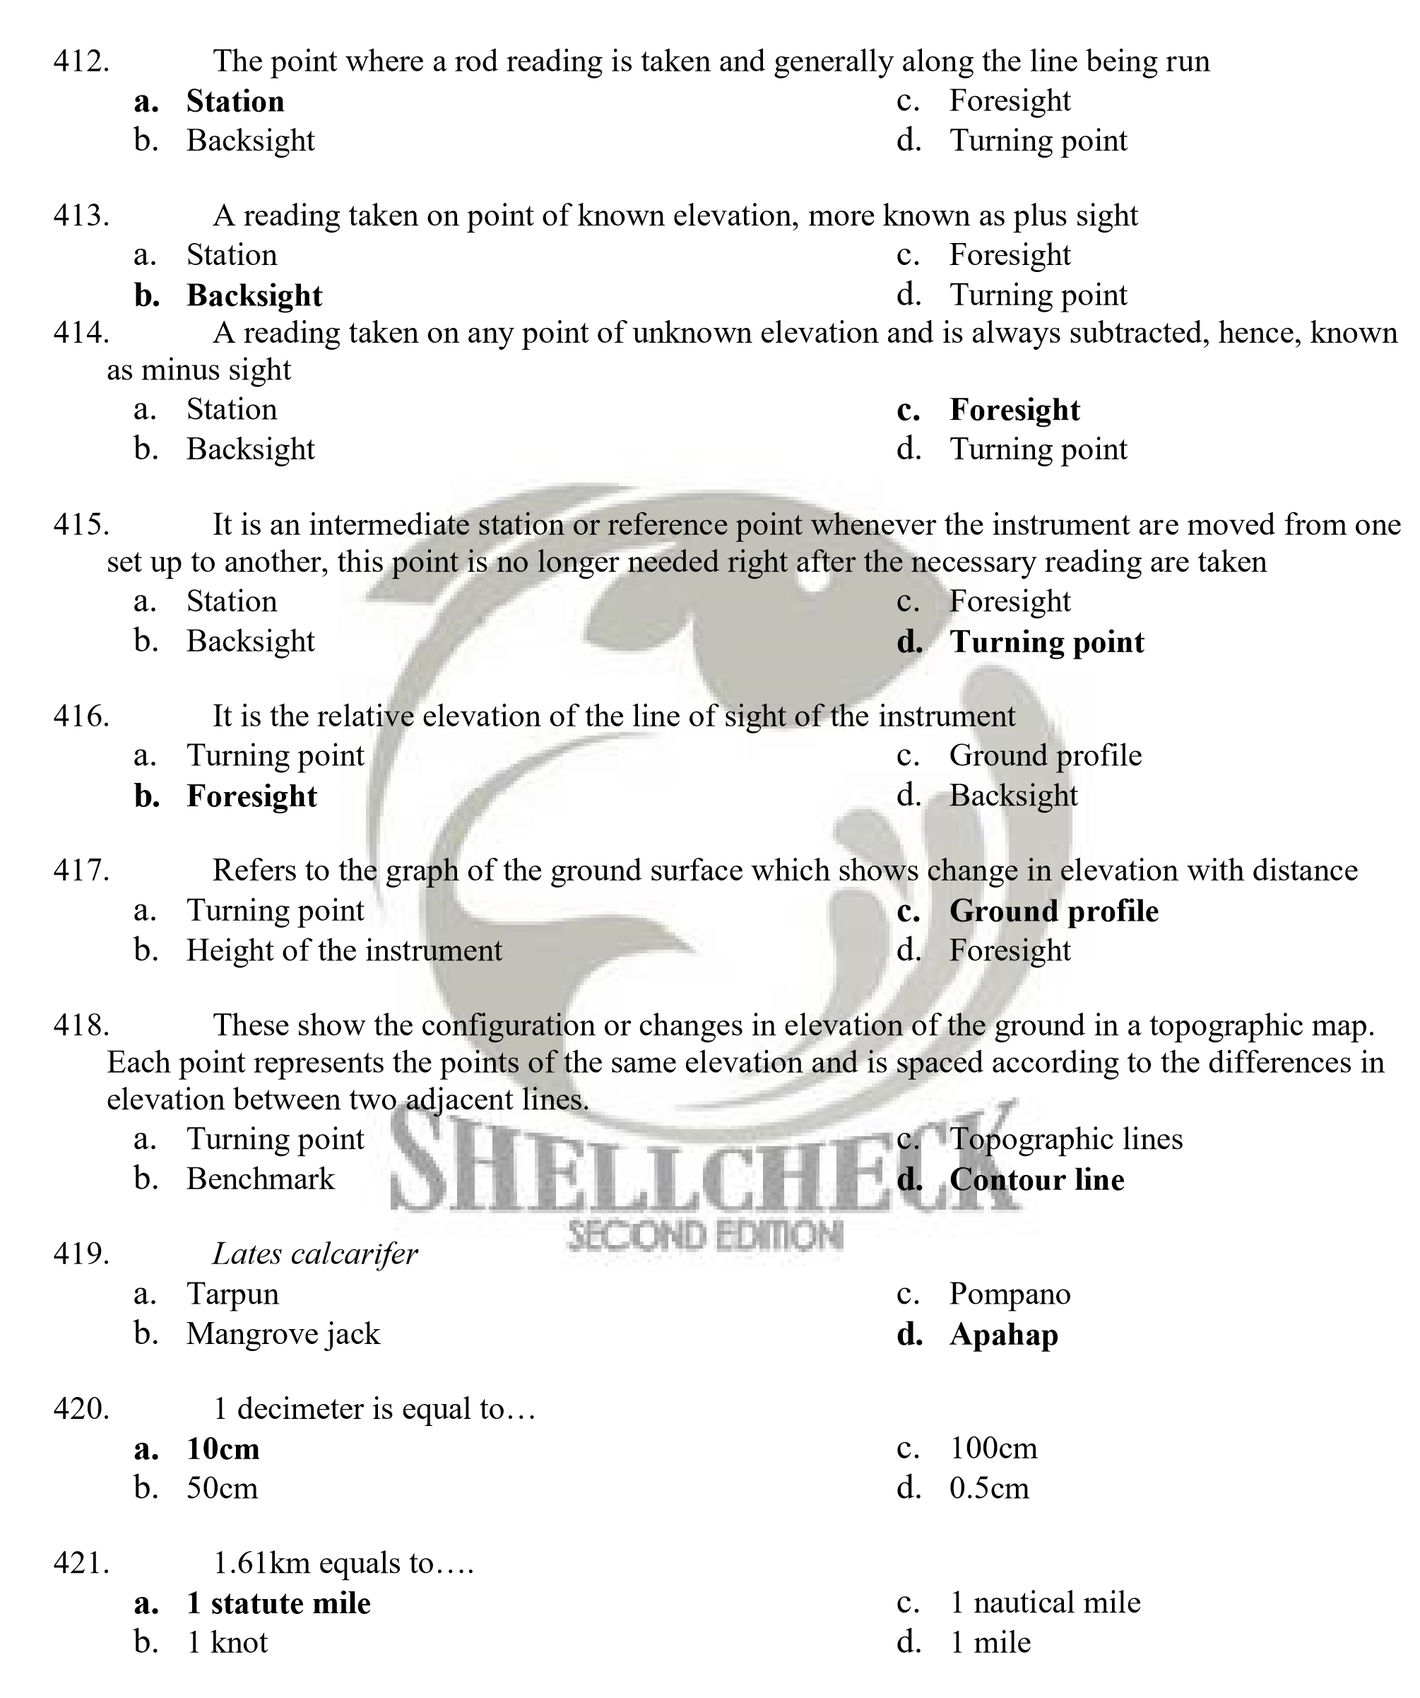
- 1.85km equals to…
  - 1 statute mile c. 1 nautical mile
  - 1 knot d. 1 mile

- 1 hectare
  - 2.47 acres c. 0.54 acres
  - 1 acres d. 2.2 acres
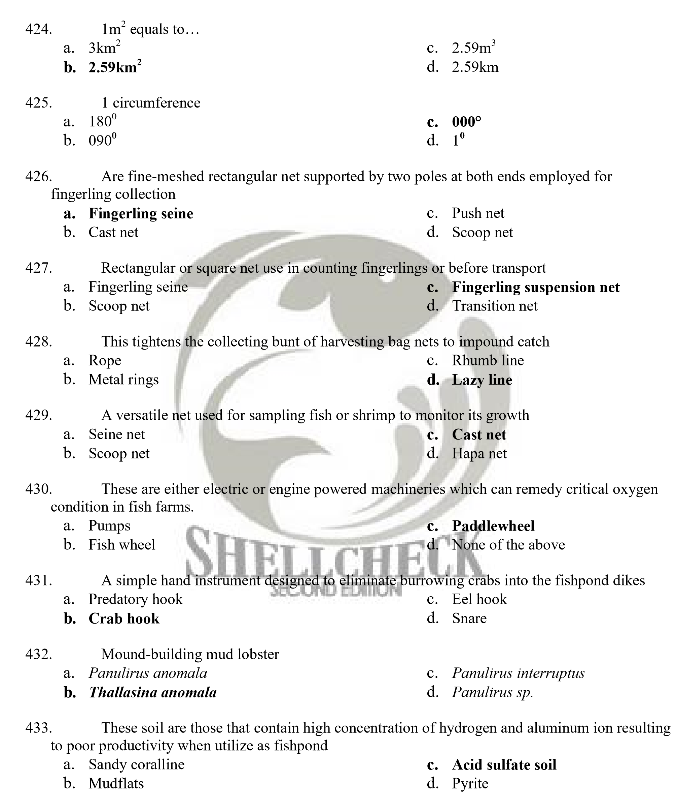
- Acid sulfate soil results from the formation of___________
  - Hydrogen sulfide c. Acid sulfate
  - Pyrite d. Methane

- Upon bacterial decomposition in perennial brackishwater pond, abundant sulfate from seawater is reduced to sulfides which then undergo chemical reaction forming crystals known as?
a. Pyrite c. Crystalline nodules
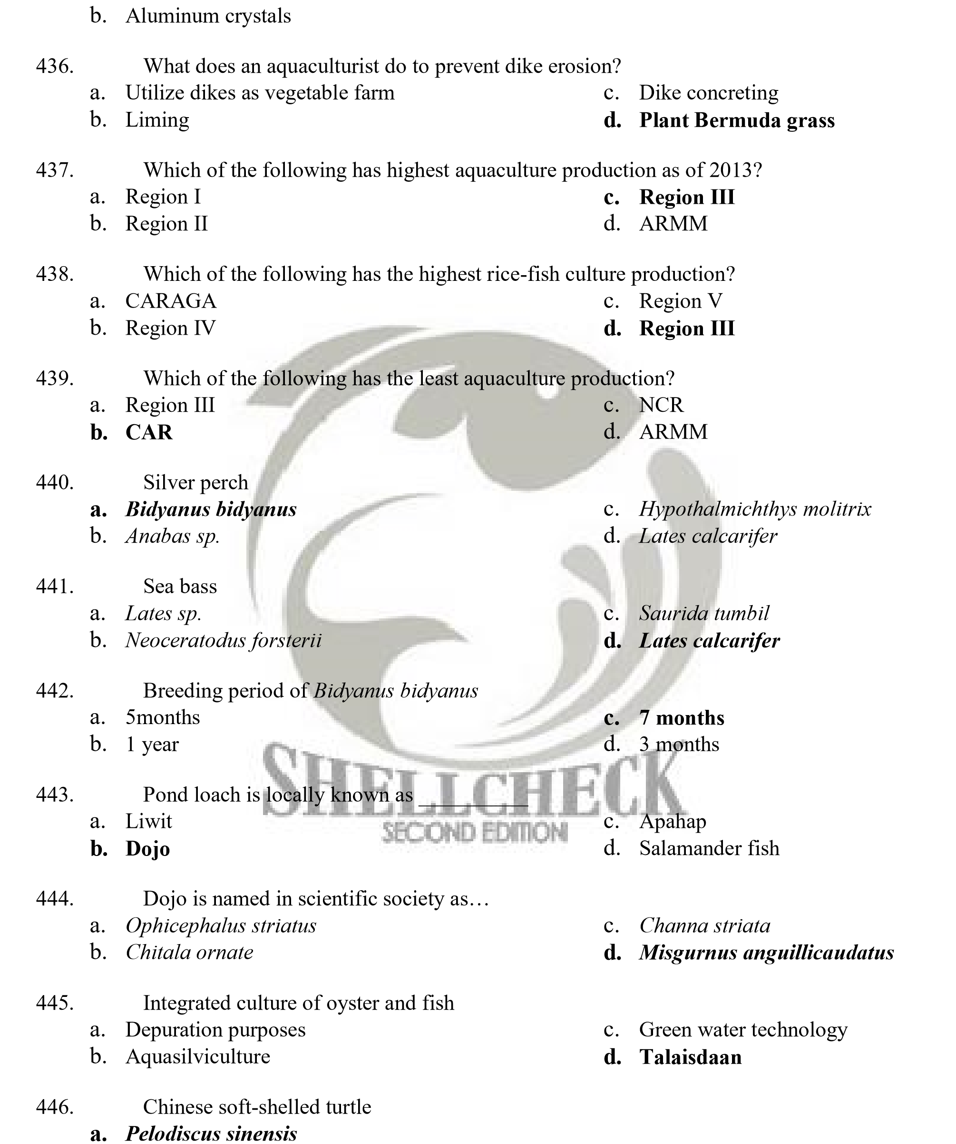
d. Mineral pyrites
c. Potamochelys sp.
b. Trionyx schlegelii d. Erythmochelys imbricate

- Female mud crab is called…
  - Sire c. Dame
  - Jennies d. Bucks

- Male mud crab is called…
  - Sire c. Dame
  - Jennies d. Bucks

- A chemical attractant release by mature female to get noticed by males
  - Pheromone c. Ova
  - Secondary substance d. Ovules

- Which of the following statement about fertilization is incorrect?
  - Ponds which have excessive water flow can be efficiently fertilized.
  - Do not fertilize ponds with extensive areas less than two feet deep. The added nutrients will promote the growth of undesirable rooted aquatic vegetation in areas.
  - Do not fertilize ponds with no history of weed problems and very light fish harvests. It serves no purpose to increase pounds of fish in the pond if very few are going to be.
  - Do not fertilize commercially fed ponds. Added nutrients promote excessive phytoplankton blooms that could lead to dissolved oxygen depletions, resulting in fish.


- Refers to the ability of lake to dilute material whether they are naturally occurring from the watershed or from a human-induced spill is termed as…
  - Carrying capacity c. Dilution capacity
  - Competence d. Dissolution

- Are graphs used to provide a visual representation of the relationship between the surface area of a certain ecosystem and its depth, able to give us accurate information at a glance?
  - Hypsographic curves c. Hypsographic arc
  - Hydrographic curves d. Hydrographic arc

- It is represented in scientific literature as V..
  - Velocity c. Volume
  - Number five d. Angle

- It is represented in scientific society as A
  - Area c. Radius
  - Hypsographic arc d. Circumference

- Ź in scientific literature means…
  - Mean depth c. Area
  - Circumference d. Distance

- Some organisms are motile throughout their lives, but others are adopted to move or to be moved at precise, limited phases of their life cycle. This particular stage in their lives is known as
  - Dispersive phase c. Density-independent dispersal
  - Density-dependent dispersal d. Natal dispersal

- A situation where an individual, often juveniles, move away from where it was born
  - Dispersive phase c. Density-independent dispersal
  - Density-dependent dispersal d. Natal dispersal

- A situation where an individual, often adult, moves away from one breeding location to breed elsewhere
  - Dispersive dispersal c. Breeding dispersal
  - Natal dispersal d. Density-dependent dispersal
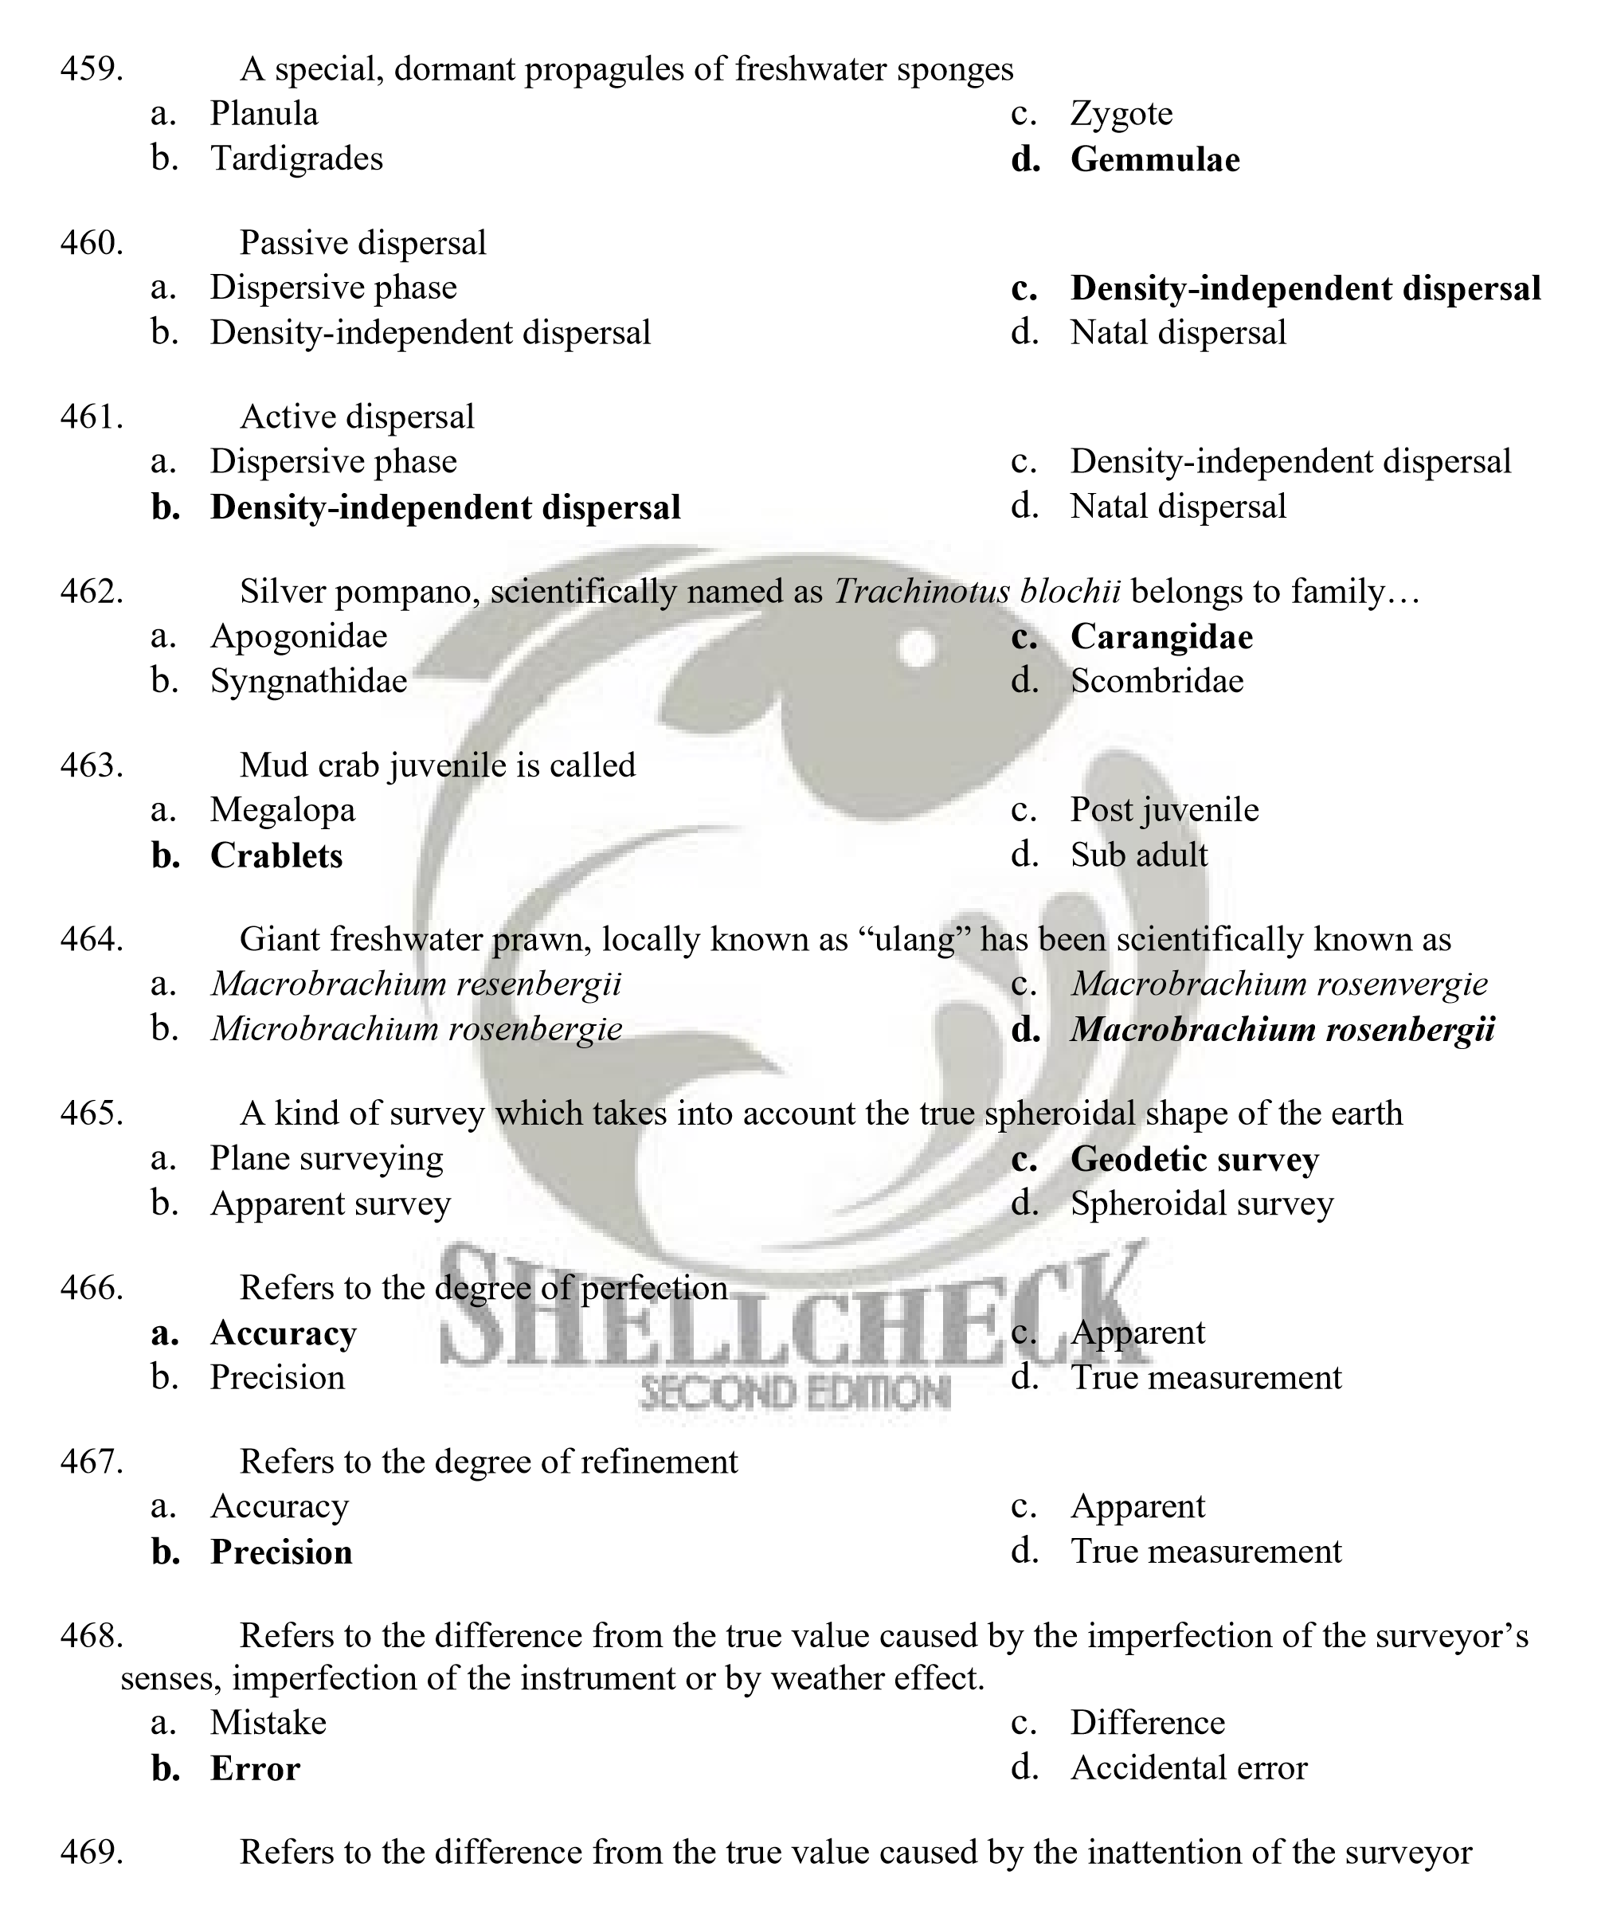a. Mistake c. Difference
b. Error d. Accidental error

- This refers to the horizontal angle with respect to a reference line which is read clockwise
  - Direction c. Meridian
  - Horizontal angle d. True meridian

- Refers to the fixed line of reference
  - Direction c. Meridian
  - Horizontal angle d. True meridian

- It is an angle formed by the intersection of two lines in a horizontal plane
  - Direction c. Meridian
  - Horizontal angle d. True meridian


- This refer to the direction of a line passing through the geographic North and South poles and the surveyors position
  - Meridian c. Magnetic meridian
  - True meridian d. Assumed meridian

- This is the direction taken by the magnetized needle of the compass at the surveyor‟s position
  - Meridian c. Magnetic meridian
  - True meridian d. Assumed meridian

- This is an arbitrary direction taken for convenience
  - Meridian c. Magnetic meridian
  - True meridian d. Assumed meridian

- Refers to the series of successive straight lines that are connected together
  - Traverse c. Latitude
  - Contour line d. Meridian

- Crucian carp
  - Carassius auratus c. Lepomis macrochirus
  - Carassius carassius d. Labeo ruhita

- Blue gill sun fish
  - Carassius auratus c. Lepomis macrochirus
  - Carassius carassius d. Labeo ruhita

- Round scad, as of 2011, is the top species in commercial fisheries and is scientifically known as?
  - Decapterus macrosoma c. Rastrelliger brachysoma
  - Selar crumenopthalmus d. Nemipterus sp.

- Mosquito fish
  - Ophicaphelus striatus c. Gambusia affinis
  - Periopthalmus sp. d. Monopterus albus

- A fish that is closely associated with mangrove area, which behaves more like an amphibian than fish
  - Ophicaphelus striatus c. Gambusia affinis
  - Periopthalmus sp. d. Monopterus albus
- Knife fish
  - Chitala ornata c. Misthicthyes luzonensis
  - Channa striata d. Leptoceris kalayaanensis

- Smallest fish which measures 7.9 cm in adult size, found in Sumatra, Indonesia
    - Misthichthyes lozunensis c. Carapus bermudensis
    - Pandaca pygmea d. Paedocypris progenetica
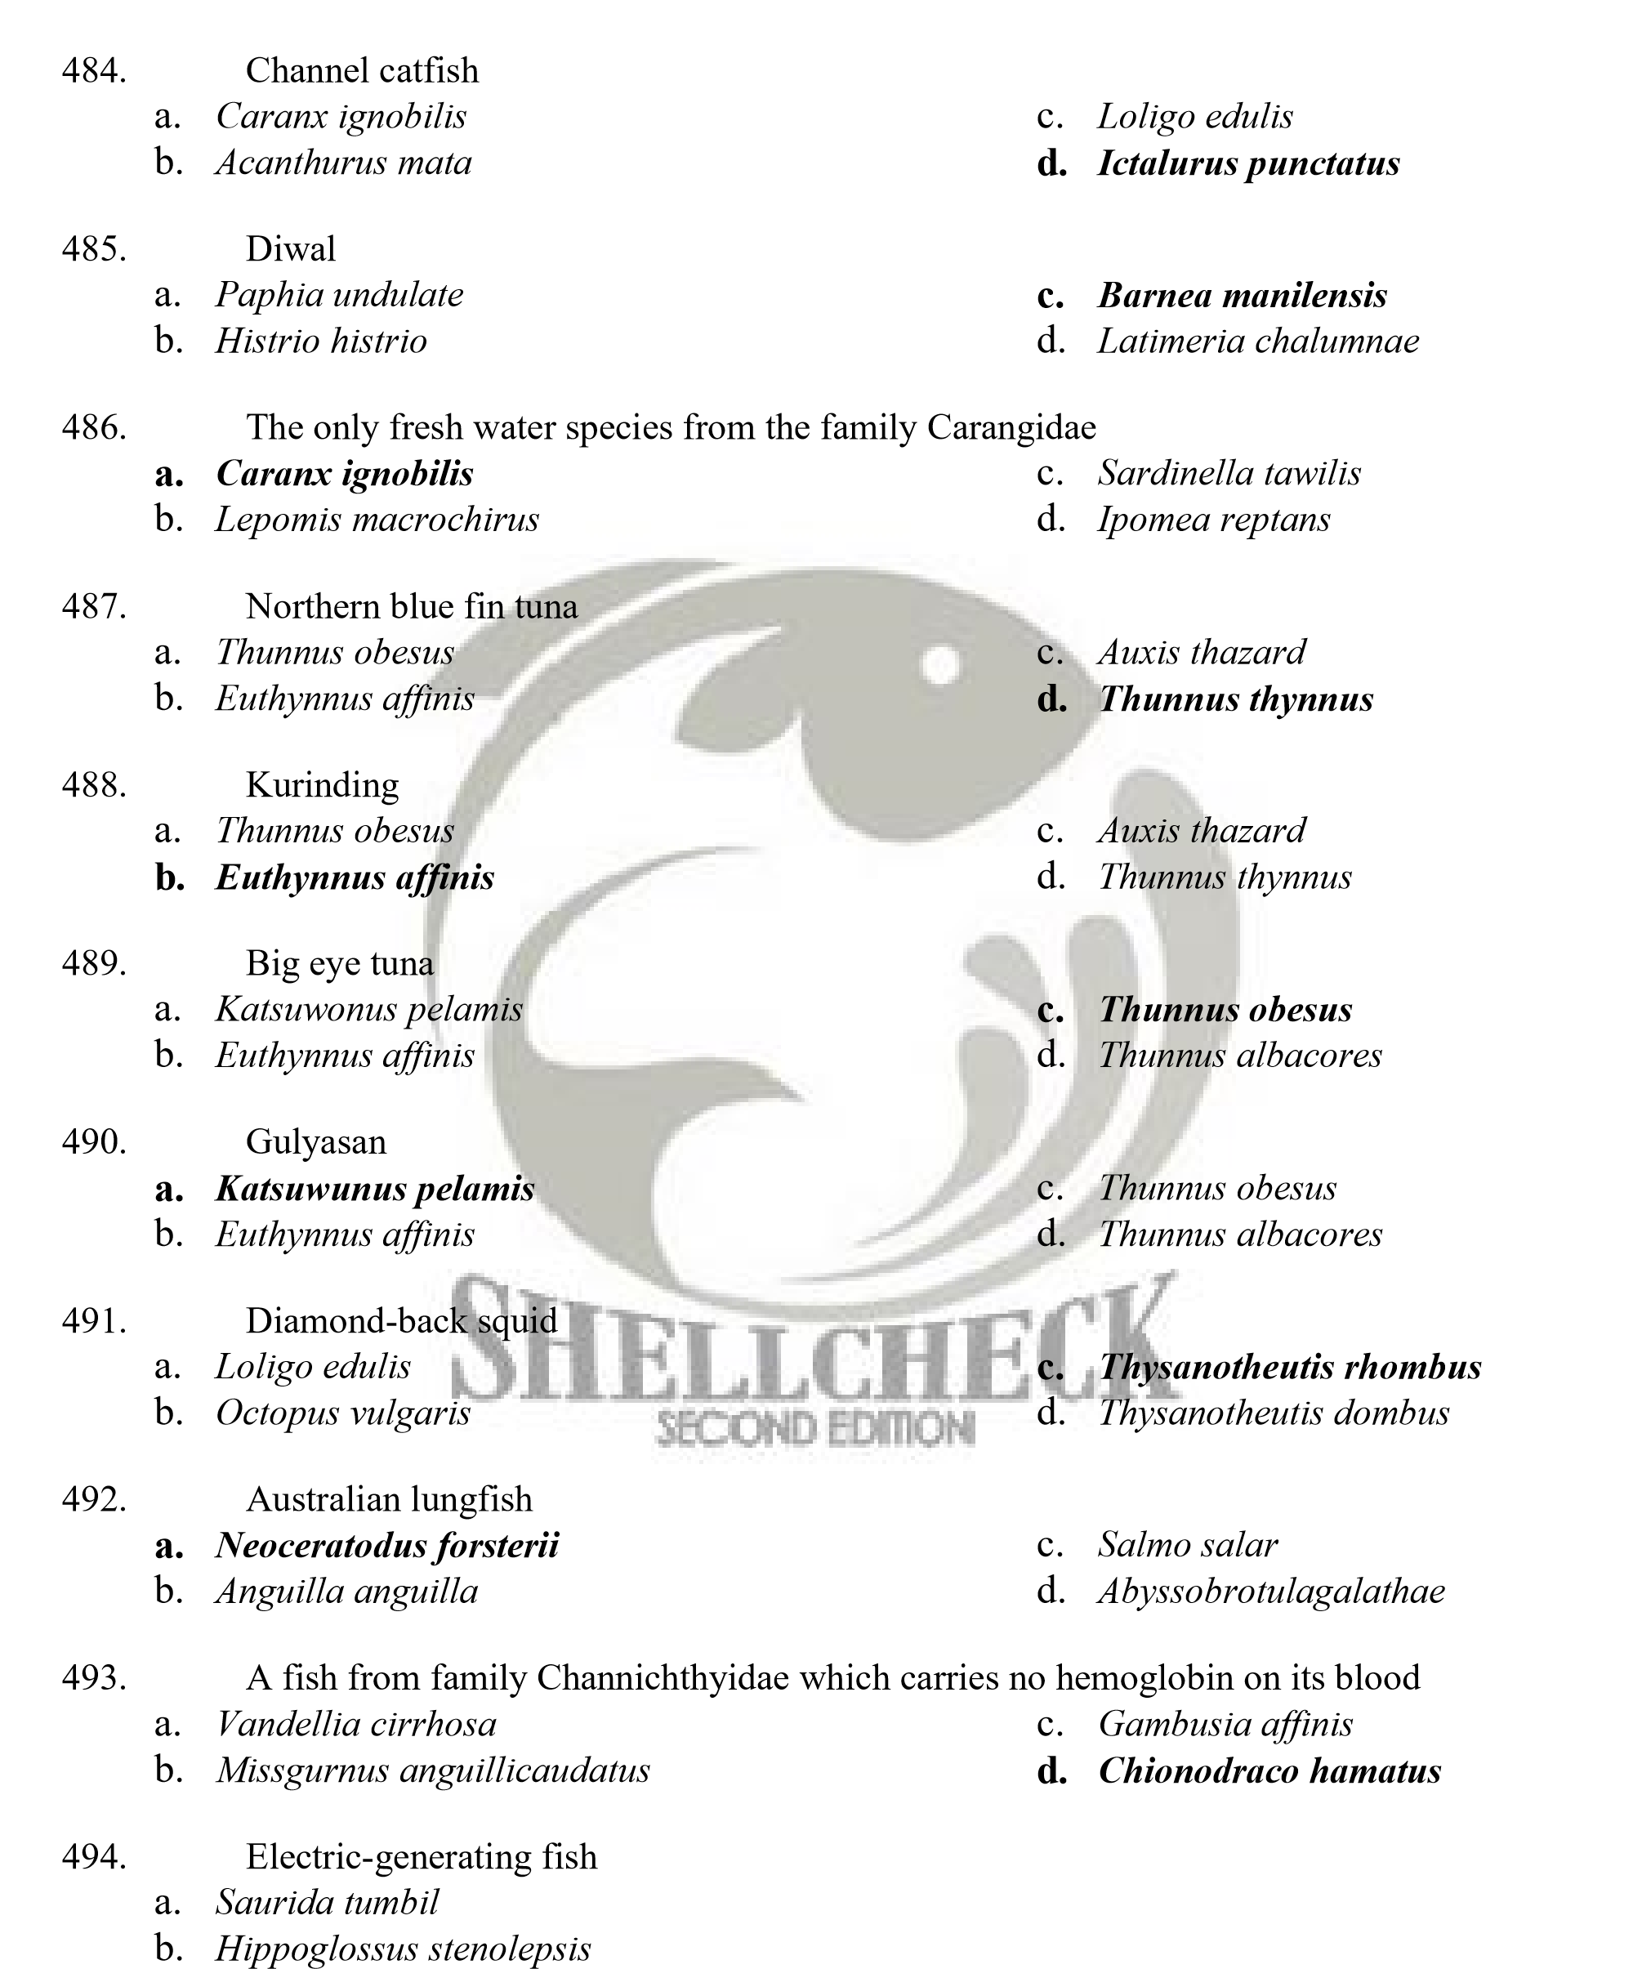
    - Scarus ghoban
    - Electrophorus electricus
- One of the following is phases in aquaculture
  - Intensive c. Semi-intensive
  - Extensive d. Grow out

- In aquaculture, the choice of culture system depends on _________.
  - Desired quantity of animals to be stocked in a given area
  - Amount of feed
  - Water availability
  - All of these

- The following are production system in aquaculture except for _____.
  - Supra-intensive c. Semi-intensive
  - Extensive D. Intensive

- Any abnormality in structure or function displayed by living organisms through specific or non-specific sign.
  - Symptoms c. Disease
  - Stress d. Paranormal behavior

- The development of disease in a particular aquaculture system involves several factors; the farmed fish (host), the disease causing organism (pathogen) and ____________.
  - Viruses c. Culture system
  - Implications d. Environment

- Resistance/susceptibility of the host depends on ________________
  - Age/size of host organism c. Defense mechanisms employed
  - Species and health of the fish d. All of these

- Major characteristics of infectious disease
  - Capability for direct transmission and ability to multiply in the host tissue
  - Mode and ability for transmission
  - Resistance
  - Virulence and resistance

- Defined as the sum of physiological responses the fish makes to maintain or regain its normal balance
  - Response c. Acclimatization
  - Stress d. Alarm stage

- The following are phases of responses and adaptation of an organism to stress except for
  - Acclimatization stage c. Adaptive stage
  - Alarm stage d. Exhaustion stage

- An organisms‟ response to stress by which the fish attempts to escape from the problem
  - Adaptive stage c. Alarm stage
  - Exhaustion stage d. Acclimatization stage


- An organisms‟ response to stress by which the organism tries to adjust to change and reach a new equilibrium, both physiologically and behaviorally, to survive the new environmental condition.
  - Adaptive stage c. Alarm stage
  - Exhaustion stage d. Acclimatization stage
- Under the situation where the organism can no longer adapt the existing condition and the fish finally dies having reached the final stage of its stress response.
  - Adaptive stage b. Exhaustion stage
c. Alarm stage d. Acclimatization stage

- Involves recognizing the occurrence of an abnormality and identifying its cause
  - Disease diagnosis c. Biological Assay
  - Disease monitoring d. Presumptive test

- The following are list of „on-site‟ procedures to investigate disease outbreaks except for?
  - Examine fresh materials from healthy, moribund and dead fish then collect fish tissue sample
  - Measure environmental condition and investigate factors and rearing condition
  - Gather information on the time-course of mortalities and deliver suitable samples with accompanying information to the diagnostic laboratory
  - Presumptive identification of pathogen

- The following are list of laboratory procedures to investigate disease outbreaks except for?
  - Presumptive identification of pathogen
  - Positive identification and confirmation and testing for dry sensitivity and effectiveness
  - Evaluation of recommendations and reports of additional analysis
  - Collect fish tissue samples

- Widespread outbreaks of fish disease
  - Coenocytic c. Zoonotic
  - Epizootic d. Chronic

- Viruses are ultramicroscopic organisms with size ranges of up to 10-300nm. In order for a virus to visualize, _____________ is required
  - Electron microscope c. Compound microscope
  - Microfilters d. Computer

- The compound viral component of a virus is called nucleocapsid which might be enveloped or naked. This envelope is _________________ in nature
  - Protein c. DNA
  - Lipid d. RNA

- Mode of disease transmission by which the infectious agent transfer from parent to offspring
  - Vertical transmission c. Direct transmission
  - Horizontal transmission d. Indirect transmission

- Mode of transmission by which the pathogen comes in contact from the environment
  - Vertical transmission c. Direct transmission
  - Horizontal transmission d. Indirect transmission

- The resulting destruction of a virus-infected cell
  - Cytophatic effect c. Occulation
  - Infection d. None of these


- The focal site of cytophatic effect induced by each virion will cause a development of a clear zone called _________. The number of which indicates the estimated viral particles in given sample.
  - Hemorrhage c. Opaque
  - Occlusion d. Plaque

- Causative agent of a viral disease in fishes
  - Aeromonas, Hydrophila, Aphanomyces
  - Aquariovirus
  - Iridovirus
  - Harpesvirus

- A major viral disease in penaid shrimp with Baculovirus as causative agent
  - Yellow Head Virus Disease c. White Spot Syndrome Virus Disease
  - Monodonbaculovirus d. All

- Bacterial disease particularly in fishes is hard to diagnose. Why is that so?
  - Most bacterial disease shows similar signs
  - Bacterial infection may appear on the skin or fins
  - Because of inflammation
  - Because preventive measures are costly


- These are enzymes produce by bacteria which are highly toxic to the host because it contains proteases, hemolysins, exohemogglutins and cytotoxins.
  - Plasmalemma c. Extracellular product
  - Peptodoglycan d. Nucleocapsid

- Most common method used to detect the presence of bacteria
  - Gram stain c. PCR
  - Gram stain d. ELISA

- Bacteria are ubiquitous. This means __________.
  - Bacteria are resistant
  - Bacteria has the ability to multiply under physical and chemical conditions of the host tissue
  - Bacteria can be found or present almost everywhere
  - All of the above

- Bacteria can be secondary opportunistic invader. This means _______.
  - Causing death to a host
  - Attacking only when the host is weakened or injured
  - All of the above
  - None of the above

- One of the following is important bacterial disease in fishes.
  - Spinning Tilapia Syndrome c. EUS
  - Channel Catfish Virus Disease d. Columnaris disease

- Bacterial disease in crustaceans occur as
  - Bacteria fouling of surfaces c. Internal or systemic infections
  - Cuticular or subcuticular localized d. All infections

- Bacterial disease of penaeid shrimp with Vibrio harveyii and Vibrio splendidus as causative agent
  - Filamentous bacterial disease c. Saprolegnosis
  - Luminous Bacterial Disease d. EUS
- Straminipilous organisms
  - Fungal-like organisms c. Virulence
  - Pathogenic organisms d. Filamentous organism

- Hyphae constitute the body of a fungus that is either septate or non-septate. Network of septate are called ________
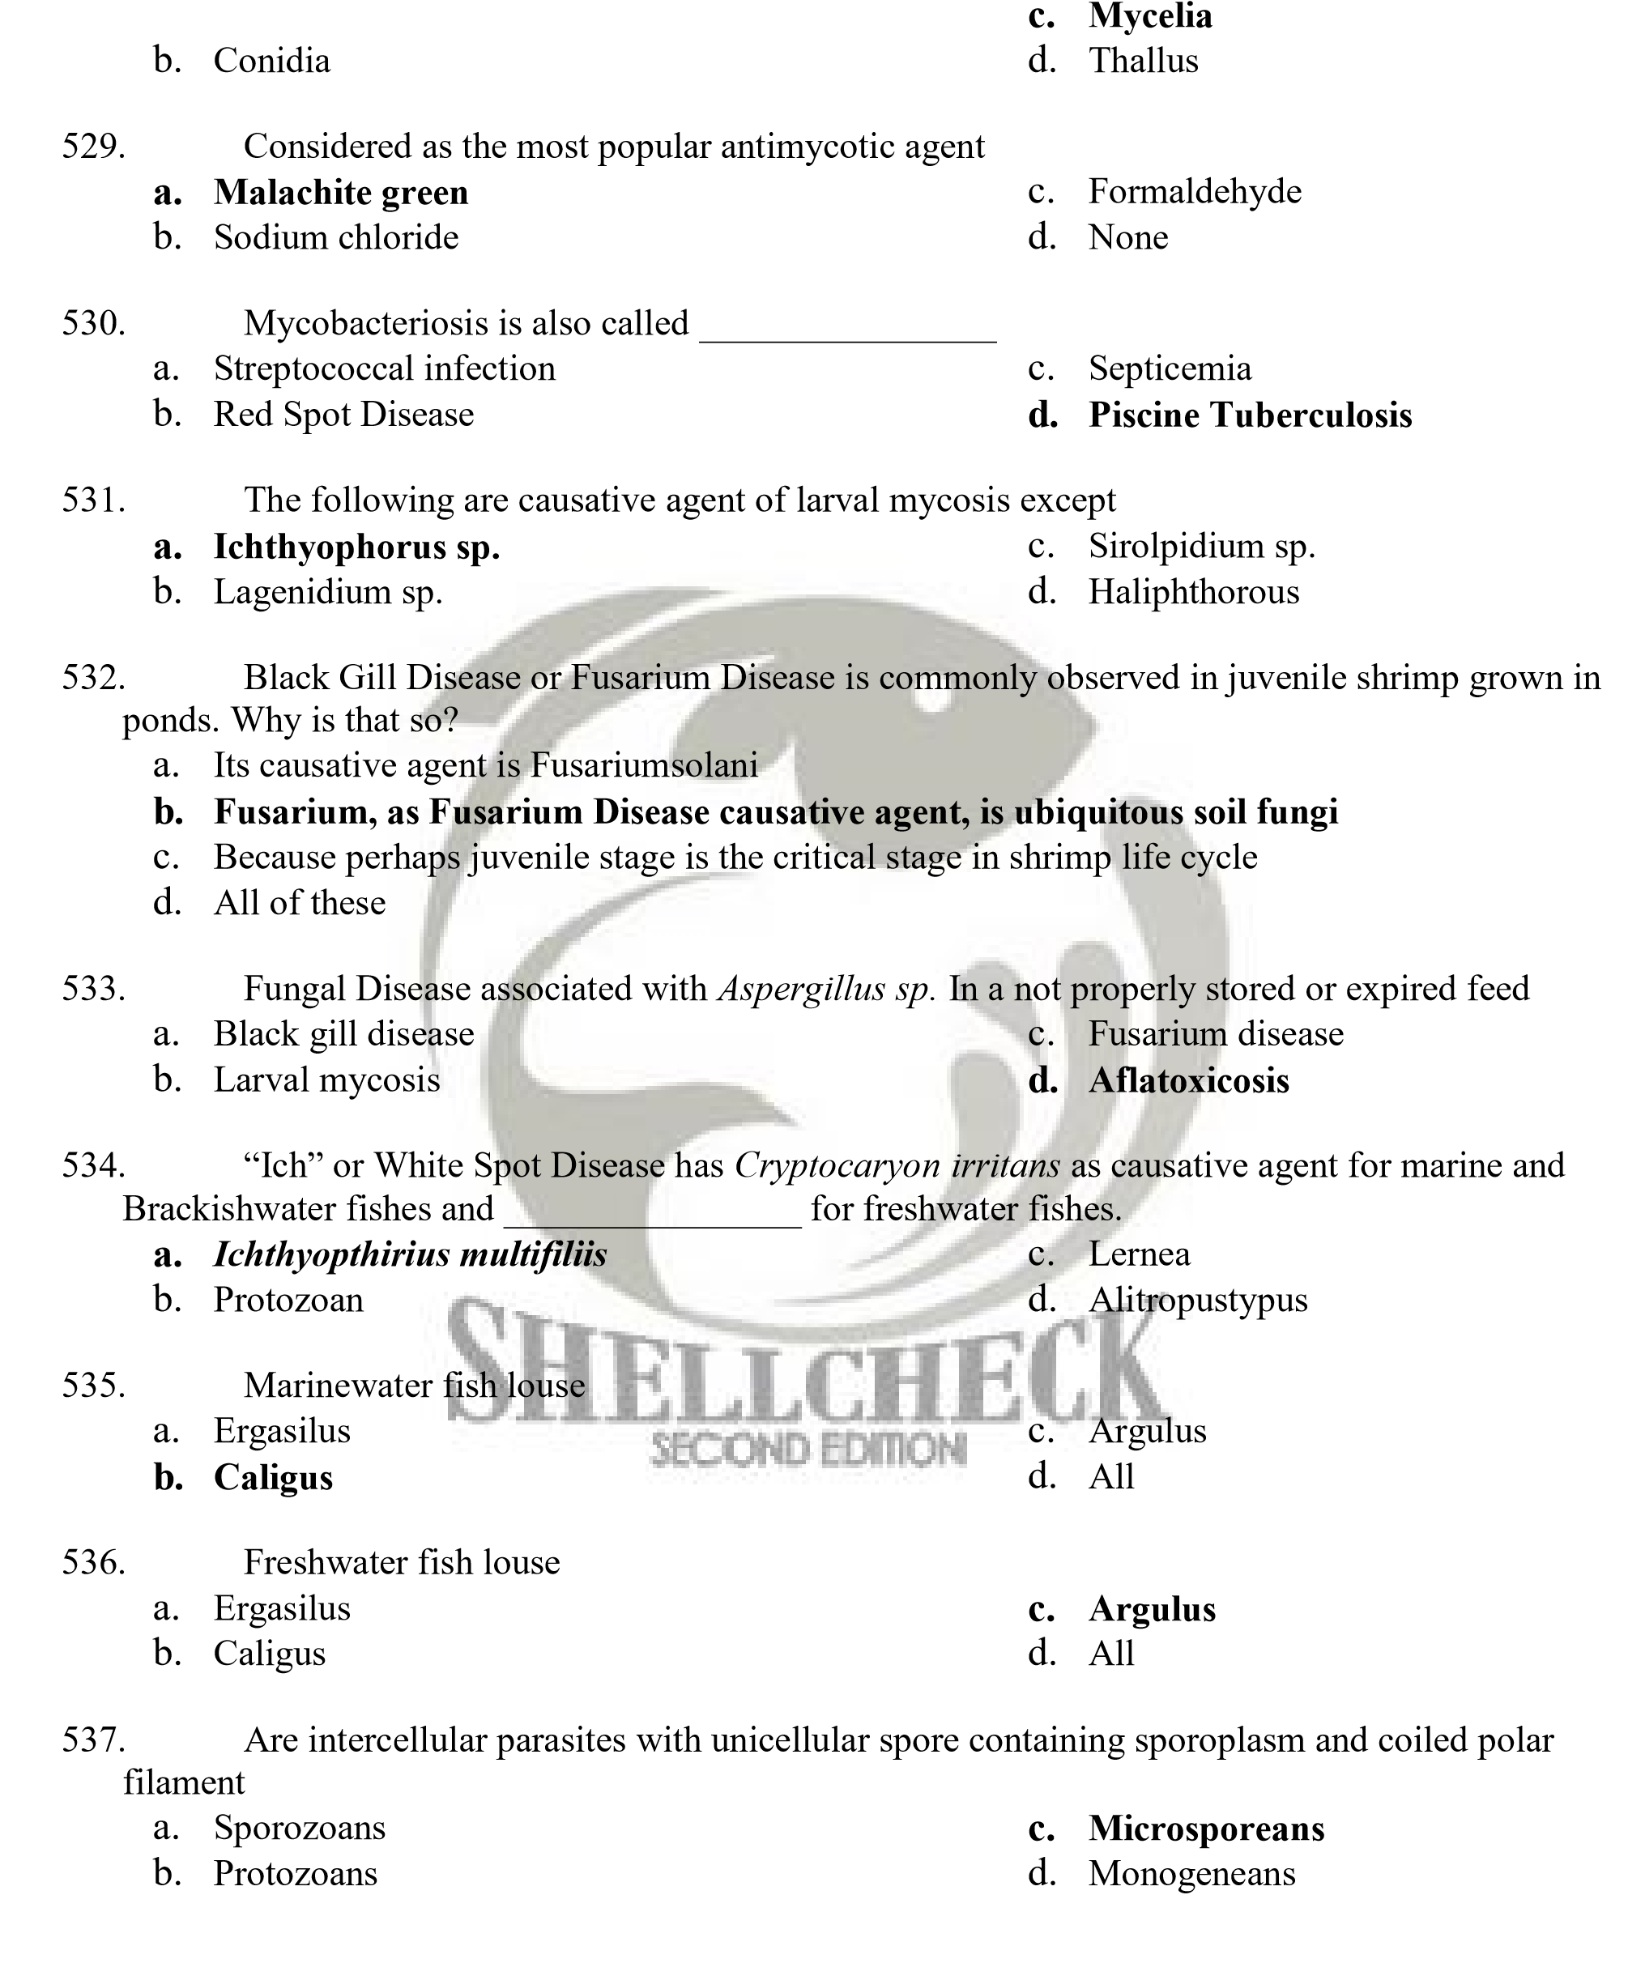a. Coenocytic
- Whish of the following sequences is true
  - Theronts – Trophont – Tomont - Tomites
  - Trophont-tomont-tomites-theronts
  - Tomont-tomites-trophont-theronts
  - Tomites-throphont-tomont-therons

- Life cycle of a parasite wherein only one host is needed to complete its life cycle
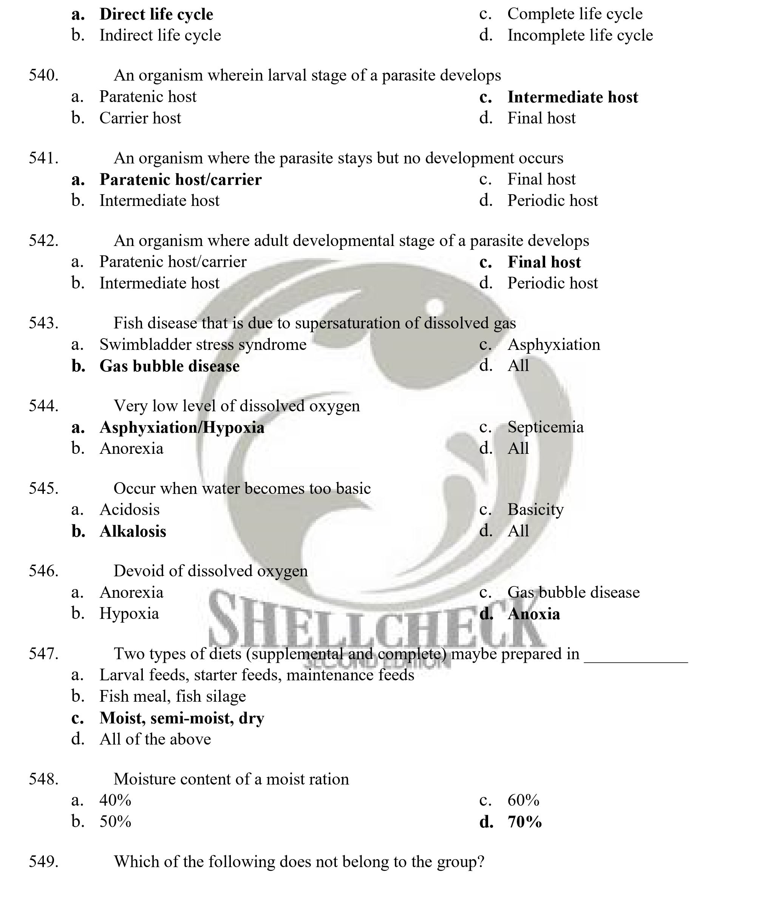
  - Calcium, phosphorous, sulfur c. Potassium, magnesium
  - Sodium,chlorine d. Iron, copper, zinc
- Black-death disease of shrimp/prawn
  - Mineral deficiency c. Lipid and fat deficiency
  - Vitamin C deficiency d. Amino acid deficiency

- Primary organ affected by Aflatoxicosis in shrimp
  - Liver c. Hepatopancreas
  - Swimmerets d. Carapace

- Untreated cottonseed meal
  - Gossypol c. Phytic acid
  - Memosine d. Tannin

- Anti-nutritional substance of soybean meal
  - Phytic acid c. Rotenone
  - Tannin d. Mimosine

- Untreated/raw fish meal
  - Phytic acid c. Chitinase
  - Thiaminase d. Memosine

- Which of the following statement is not correct?
  - Cleanliness improves the general standard of health
  - Stress plays a major role in the susceptibility of fish disease
  - Quarantine measures are critically important to prevent international spread of disease
  - Termination procedure can never be used to control fish disease


- Are protective or defense measures designed to prevent a disease from occurring. They are used to combat external parasite and stress-mediated bacterial diseases
  - Disinfection c. Quarantine method
  - Prophylactic method d. Chemotherapy

- Cheapest disinfectant
  - Ozone c. Drugs
  - Trifularin d. Chlorine

- Most powerful oxidizing agent
  - Triatomic oxygen c. Drugs
  - Treflan d. Hypochlorite

- It involves the use of drugs or chemicals for treating infectious diseases. It is considered as the method of „last retort‟ in any disease control program
  - Turbidostat c. Ozonation method
  - Microcosm d. Chemotherapy

- Method of chemical treatment
  - External method c. Parenteral method
  - Systemic method d. All of the above

- Method of chemical treatment used to control Ectoparasite. It can be topical or by Immersion
  - External method c. Parenteral treatment
  - Systemic method d. Flow through treatment
- Method of chemical treatment employed for systemic infections where chemicals are added to a feed.
  - External method c. Parenteral treatment
  - Systemic method d. Flow through treatment

- Direct and most effective route of drug administration, accurate dosage but is labor intensive
  - External method c. Parenteral treatment
  - Systemic method d. Flow through treatment

- An external method of chemical treatment wherein the chemical is added at a constant rate by a constant flow device, the chemicals moves through and out of the container to be replace by a new, clean water.
  - Topical c. Long bath
  - Dip d. Flow through

- An external method of chemical treatment wherein the chemical solution is added in concentrated form at the inlet and allowed to pass through the water flow system and out of the effluent pipe.
  - Short bath method c. Long bath
  - Flow through d. Flush method


- An external method of chemical treatment where the fish are scooped out and suspended in the chemical solution for a few second to 3min. Then rinsed well with clean water and return to the clean/disinfected holding facility.
  - Dip method c. Flush method
  - Short bath method D. Flow through

- Parenteral method of chemical treatment wherein the needle is inserted into space posterior to the dorsal fin above the midline of the body
  - Intramuscular c. Intravenous
  - Intraperitoneal d. External

- Parenteral method of chemical treatment wherein the needle is inserted into the visceral cavity or the belly of the fish
  - Intramuscular c. Intravenous
  - Intraperitoneal d. External

- Parenteral method of chemical treatment wherein the needle is inserted either by direct cardiac puncture or through the caudal artery
  - Intramuscular c. Intravenous
  - Intraperitoneal d. External

- A procedure involving use of responses of an organism to detect or measure the presence or effect of one or more substances, wastes or environmental factor.
  - Chemical treatment c. Biological Assay
  - Chemotherapy d. All of these

- A bioassay procedure that is almost always a flow through test. It determines the maximum allowable toxicant concentration.
  - Short term c. Intermediate
  - Long term d. Long lasting

- Method of adding test solution where the test animal remains in the same test concentration for the duration of the test.
  - Static c. Recirculation
  - Renewal d. Flow through

- Method of adding test solution where the test animals are transferred to test solution of the same composition at periodic intervals.
  - Static c. Recirculation
  - Renewal d. Flow through

- Fish immune system
  - Innate (non-specific) c. All of the above
  - Adaptive (specific) d. None of the above

- A fish immune system which refers to various physical and cellular attributes that collectively represents the fish first line of defense.
  - Soluble barriers c. Innate immunity
  - Physical barriers d. Adaptive immunity


- A fish immune system which is able to recognize and response selectively and has the ability to respond preferentially to foreign substances and has the ability to respond better to repeated exposure.
  - Soluble barriers c. Innate immunity
  - Physical barriers d. Adaptive immunity

- A foreign substance, known as immunogen because it induces the immune response.
  - Abscess c. Antigen
  - Antibody d. Defense mechanism

- A glycoprotein produce in response to the introduction of an antigen, it has the ability to combine with the antigen that stimulated its production, it is sometimes referred to as immunogen.
  - Abscess c. Antigen
  - Antibody d. Defense mechanism

- The process of facilitating phagocytosis of bacteria by coating them with protein.
  - Encapsulation c. Inhibition
  - Opsonization d. Agglutinization

- The observable condition that accompanies damage to the body. It is a localized response to tissue injury and to invading micros.
  - Barrier c. Encapsulation
  - Inhibition d. Inflammation

- A specialized-white blood cell produced by higher vertebrates, which has the capacity to kill tumor cells and cells infected by virus.
  - Lectins c. Encapsulation
  - Cytotoxin d. Phagocytosis

- The study of antigen-antibody reaction „in vitro‟
  - Cytotoxicity c. Serology
  - Ichthyotoxism d. Diagnosis

- This technique is widely used method in fish immunology and combines electrophoresis with immune-precipitation.
  - Immuno-electrophoresis c. Double diffusion
  - Single diffusion d. Diagnosis

- Type of harmful and toxic algal bloom that basically produces harmless water discoloration, but contributes greatly to oxygen depletion.
- Type A species c. Type C species
- Type B species d. Type D species
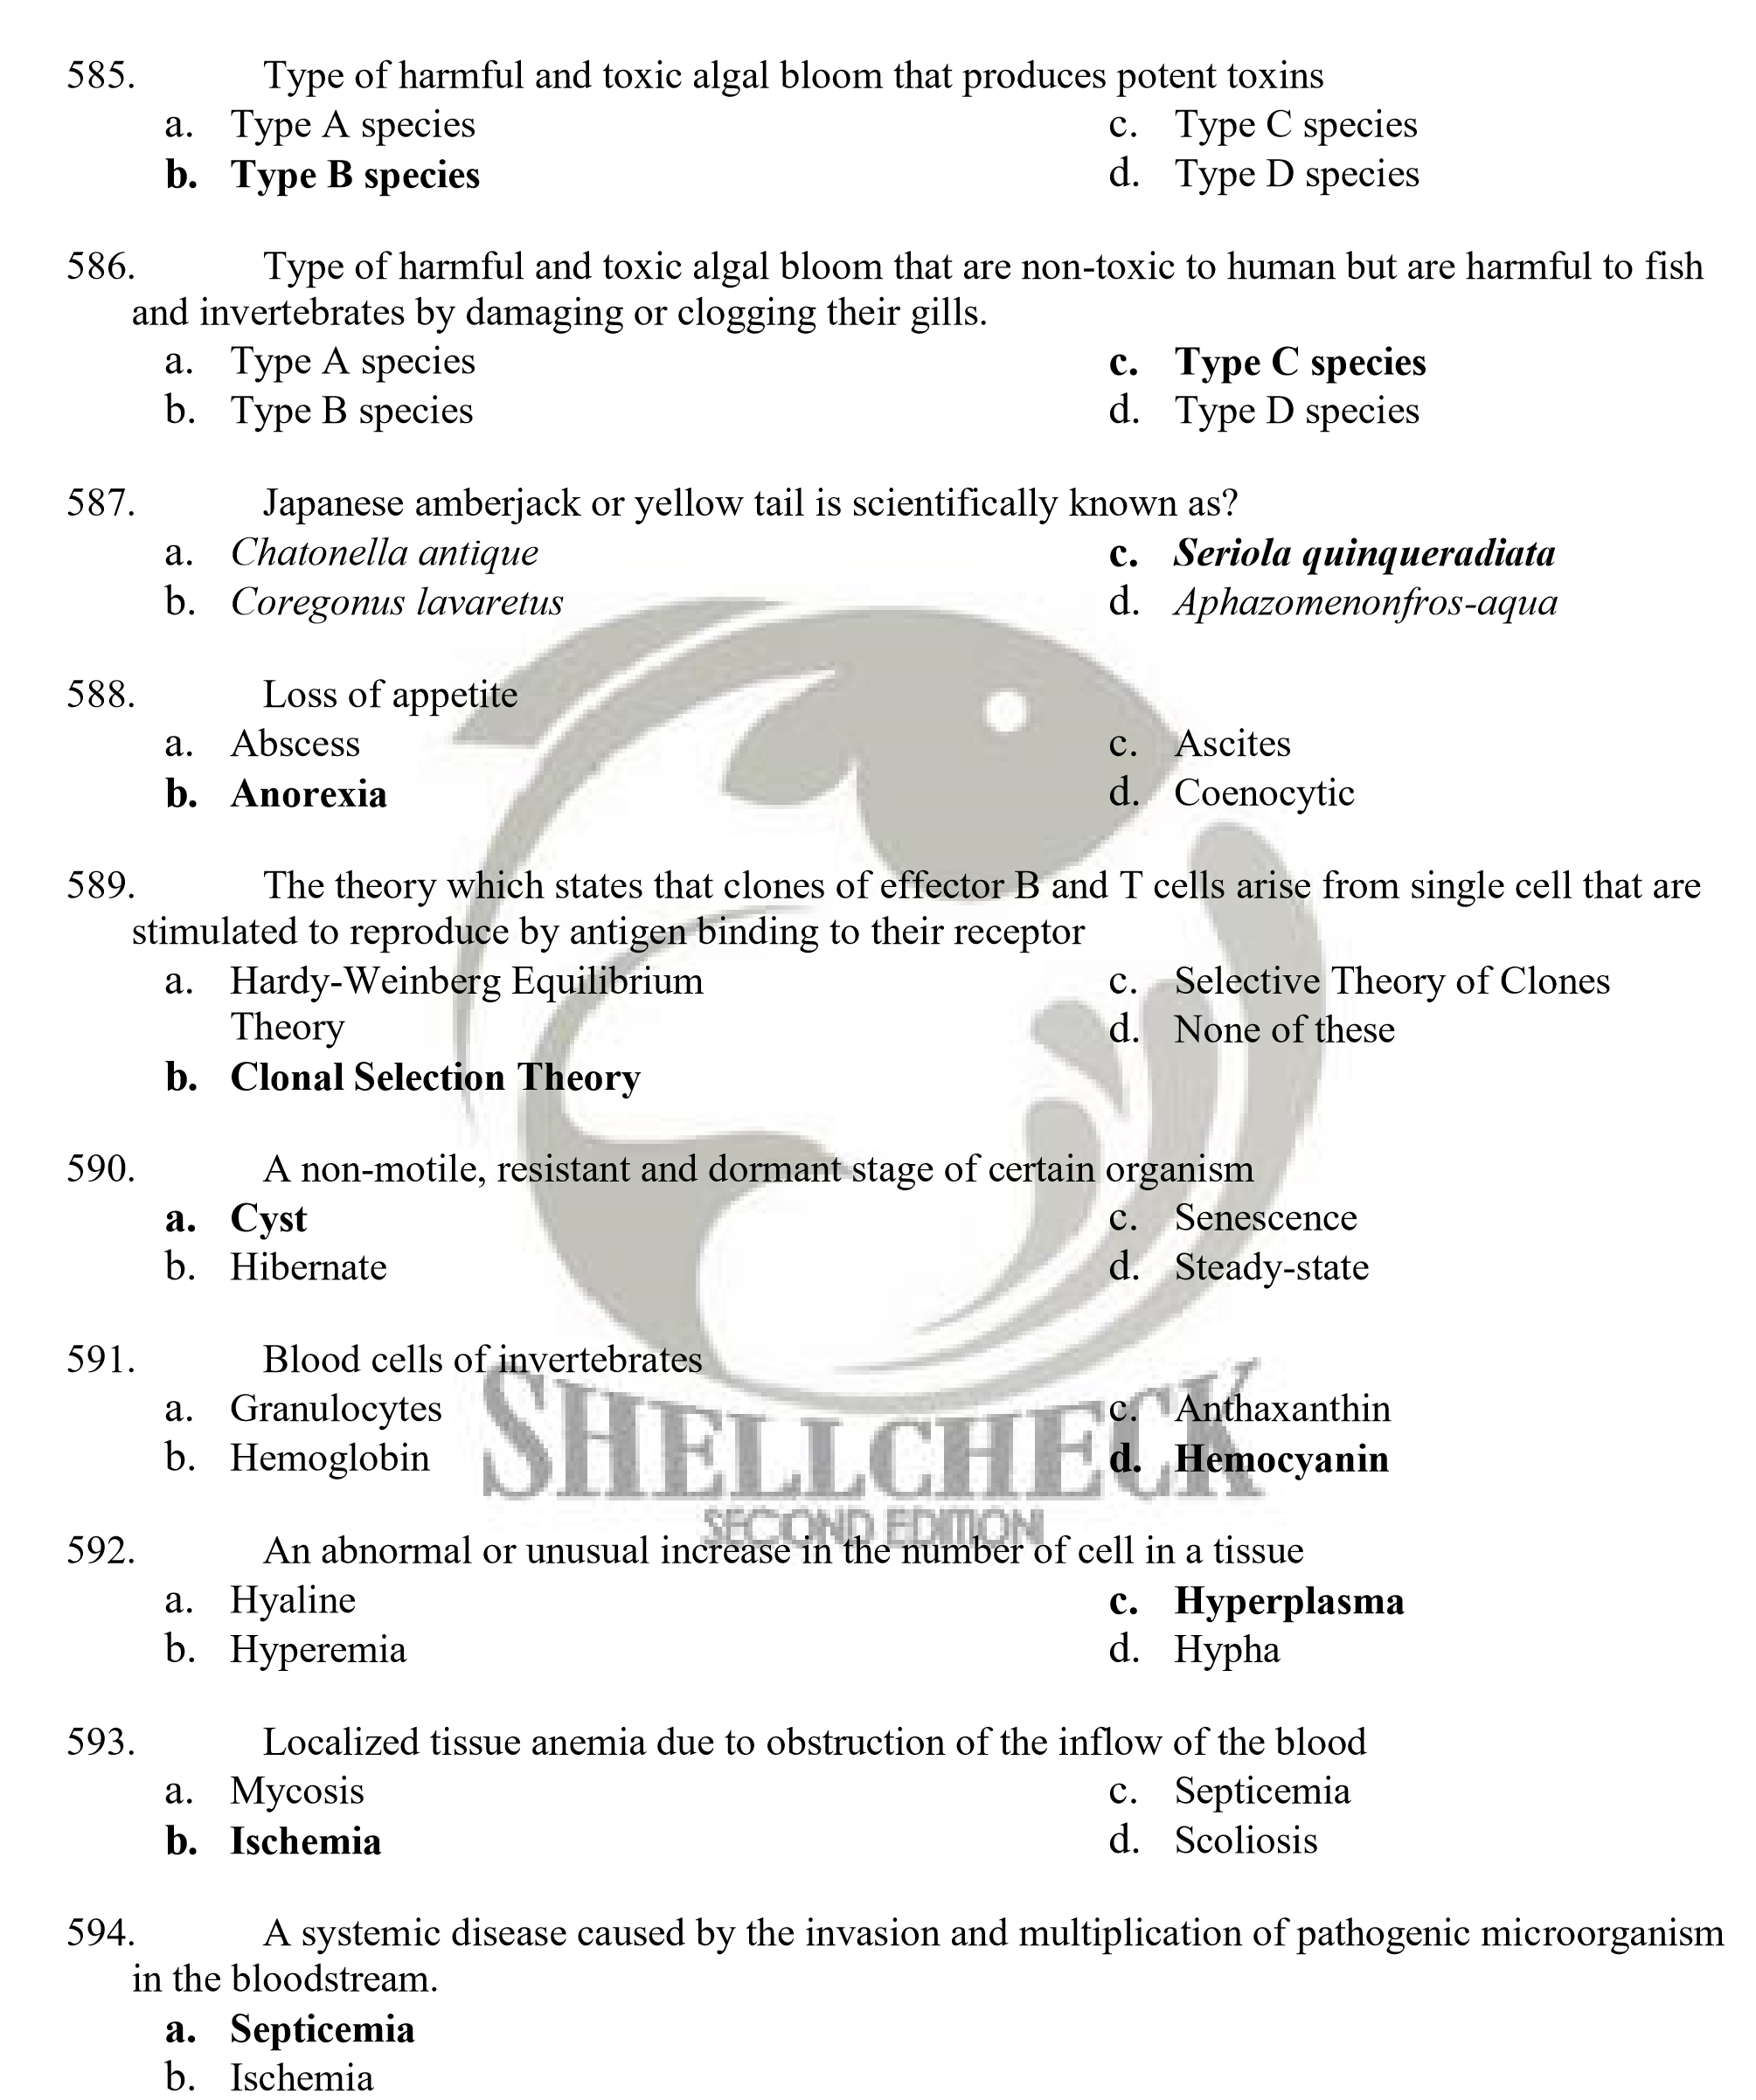
- Mycosis
- Scoliosis
- Fish farm waste consists of
  - Solid matter c. All of the above
  - Dissolved matter d. None of the above

- The following are sustainable approaches to aquaculture except
    - The search for alternatives to fish meal and fish biomass and the need to reduce feed cost
    - The greater use of supplementary feeds and supplementary feeding systems
    - The need to promote high value commercial feeds
    - Integration of feed development and feeding management practices with environmental awareness

- Three of the following choices are components of the general structure of amino acid. Which does not belong to the group?
    - Covalent bond c. Amino group
    - Carboxyl group d. Alkyl group

- Which does not belong to the group?
    - Methionine c. Cysteine
    - Histidine d. Lysine

- The following are Non-Essential Amino Acids except for
    - Alanine c. Tyrosine
    - Serine d. Threonine

- Protein that issoluble in aqueous system
    - Simple protein c. Conjugated protein
    - Globular protein d. Derived protein

- Proteins that are highly insoluble and resistant to action of digestive enzyme
    - Simple protein c. Fibrous protein
    - Globular protein d. Derived protein

- Which of the following statements is true?
    - Protein is absorbed from the intestine mainly as amino acid
    - Fish tissues contain about 50% protein in dry weight basis
    - The carbon chains are oxidized to produce energy or synthesized into tissues
    - Disruption of any level of molecular organization leads to proper functions of protein

- The amino acid lacking in protein is known as
    - Degenerated amino acid c. Excreted amino acid
    - Digested amino acid d. Limiting amino acid

- Which of the following is incorrect?
    - Lysine is limiting in corn while methionine is limiting in soy bean
    - Excess amino acid are used as energy source or converted to fat
    - Amino acid profile is of no use to aquaculture
    - The closer the profile to the requirement, the higher is the nutritional value


- A method used to determine whether an amino acid is essential or non-essential wherein it uses a series of amino acid test diet containing crystalline-L amino acid as source of nitrogen and a 10-week feeding trial conducted
- Amino acid profile method  - Growth response method | - Radioisotope method  - Quantitative method

- A method used to determine the essentiality of amino acid wherein the fish is injected with radioactively labeled 14C glucose and fed on a natural diet for one week
    - Amino acid profile method c. Radioisotope method
    - Growth response method d. Quantitative method


- This indicates the growth response of a fish to graded levels of an essential nutrient in their diet. This method assumes that weight gain is linearly related to increasing dietary levels of the EAA at/or below the required level
    - Broken line analysis c. Amino acid profile method
    - FCR d. Dose response curve

- It has been used to estimate the essential amino acid requirements. It assumes a linear relation between growth and dietary level of the essential amino acid at/or below the required level
    - Broken line analysis c. Amino acid profile method
    - FCR d. Dose response curve

- The following statements are true except
    - Amino acid imbalance has nothing to do with reduced growth in animals
    - In young growing animals, the greatest proportion of the body weight is in the form of muscle
    - Some of the amino acid may leach out during feeding before they can be taken up
    - The limiting amino acid in one source can be supplemented by another source

- In broken line analysis, the linearly ascending line instantly breaks to horizontal and the point is claimed as
    - Turning point c. Breakpoint
    - Basal point d. Linear point

- Another way of meeting the EAA needs of an animal is by supplementing the practical diet with
    - Protein supplement c. Crystalline L-amino acid
    - Soybean meal d. Binders

- Nutrient leaching can be minimized by using water stable diet through the use of ________
    - Efficient binder c. All of the above
    - Employing appropriate formulation d. None of the above

- Dietary amino acid imbalance which occurs when some amino acids are fed in excess of the required levels causing an increase in the requirement for another amino acid of similar structure
    - Amino acid deficiency c. Amino acid toxicity
    - Amino acid antagonism d. All of the above

- A dietary amino acid imbalance which occurs when excess amount of certain amino acids are fed and the negative effects cannot be improved by adding other sources in the diet
    - Amino acid deficiency c. Amino acid toxicity
    - Amino acid antagonism d. All of the above

- How will you determine the quantity of protein or amino acid in a feedstuff
    - Chemical method c. Response method
    - Biological method d. Response analysis method

- In this method of protein evaluation, body weight gain and nitrogen retention are used as criteria for protein quality which is considered as more accurate
    - Chemical method c. Response method
    - Biological method d. Response analysis method

- Used to measure biological value of protein
    - Protein Efficiency Ratio c. Net Protein Utilization
    - Biological value d. All of the above

- The minimum amount of dietary protein needed for optimum growth of most cultured aquatic species
    - 27% - 60% c. 40% -45%
    - 30% - 38% d. 30% - 40%

- Which of the following has the highest protein biological value?
    - Gelatin c. Soybean meal
    - Egg protein d. Casein

- The absorbed amino acid is used as _____________
    - Incorporated into the metabolic pool, mixed with free amino acids originating from various tissues and synthesized into tissue proteins
    - Synthesized into nitrogen-containing tissue constituents
    - Deaminated, resulting in a carbon chain and amino group
    - All of the above

- "Deamination" refers to ________________________
    - Incorporation of amino acid c. Removal of nitrogen
    - Production of amino acid d. Utilization of nitrogen

- The following are causes of amino acid deficiency except_____________
a. EAA’s are naturally costly and incorporation of which to feedstuff is labor intensive b. Presence of chemicals
    - Excessive heat treatment during manufacture
    - Leaching


- Carboxyl (COOH), amino (NH) and alkyl (R) group, as constituents of general structure of amino acid are attached to ____________
    - OH c. Alpha carbon
    - Acid d. Alpha base

- Are diverse group of organic compounds that are important components of all living matter.
They are insoluble in water but soluble in non-polar, organic solutes such as ether and alcohol
    - Vitamins c. Minerals
    - Lipids d. Carbohydrates

- The following are functions of dietary lipid except
    - Source of metabolic energy c. Involve in alkaline digestion
    - Source of essential fatty acid d. None of the above

- Are type of lipids that accumulate in the adipose or fat tissues; they are the primary means by which animals store energy
    - Phospholipids c. Steroids
    - Waxes d. Triglycerides

- Main component of biological membrane
    - Phospholipids c. Steroids
    - Waxes d. Triglycerides
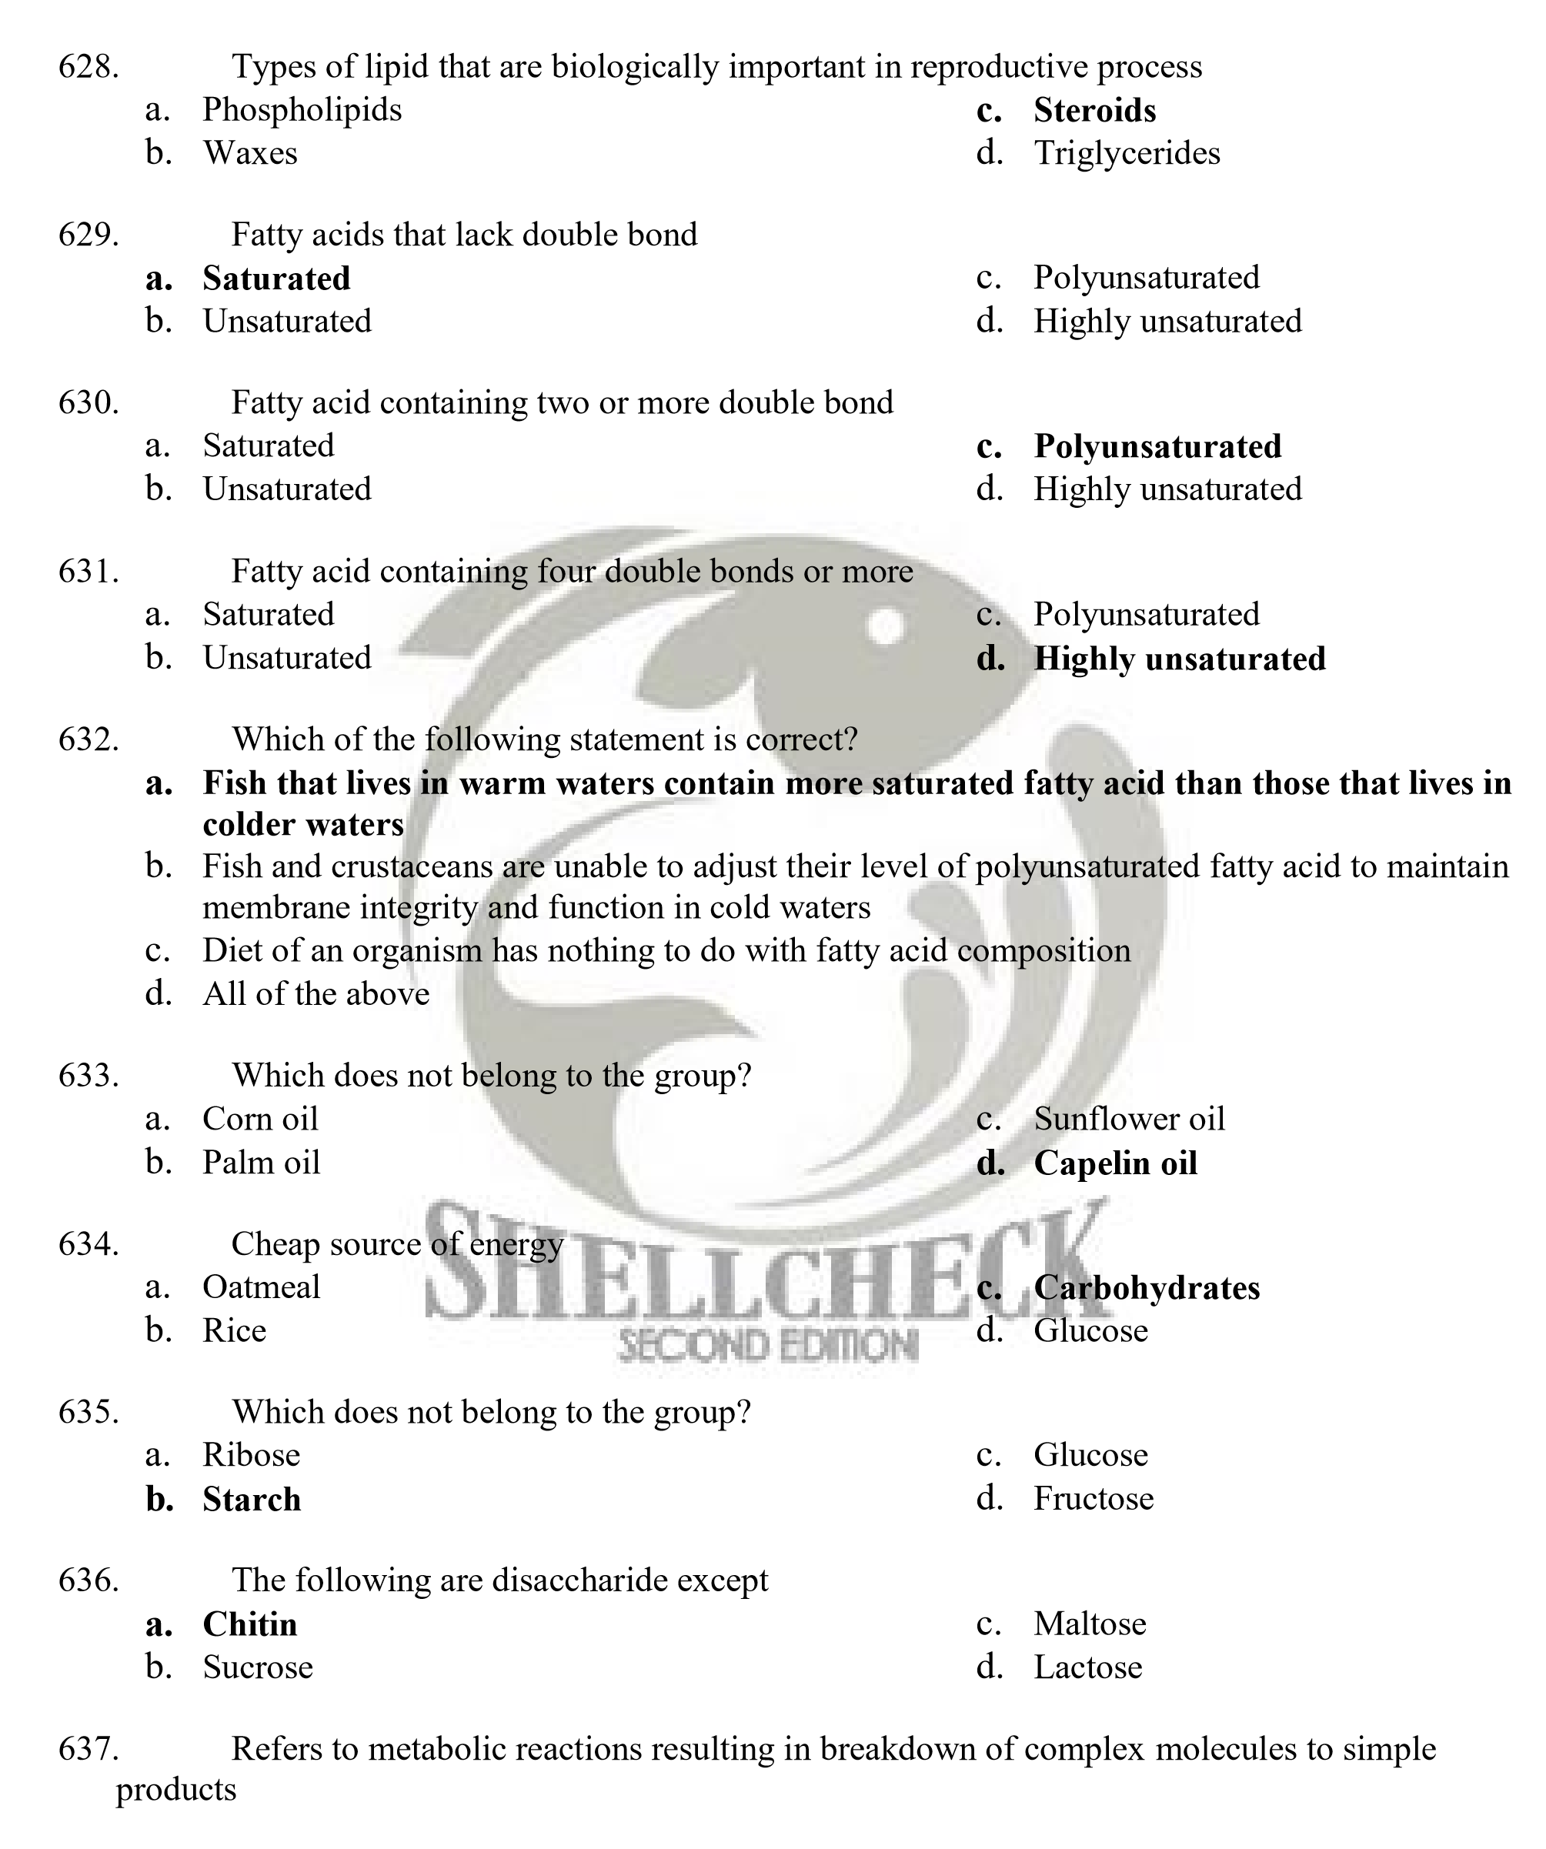a. Anabolism c. Absorption
b. Digestion d. Catabolism

- Refers to metabolic reactions resulting into synthesis of more complex compound from simple precursors
  - Anabolism c. Absorption
  - Digestion d. Catabolism

- Natural desire to satisfy hunger
  - Satiation c. Feeding
  - Appetite d. Forage

- Why is it important to provide optimal proportion of non-protein energy source in fish diets?
  - Because deficiency in non-protein energy source in a diet may result in rapid growth
  - Because deficiency in non-protein energy source protein whose function is mainly for tissue repair, will be used as energy source

  - Because non-protein energy source easily leach out in water, hence, limiting the organisms appetite
  - None of the above

- Water soluble vitamins B complex and C are excreted in _____________
  - Feces c. Gills
  - Urine d. None of the above

- Lipid soluble vitamins, A, D, E and K, are excreted in _______________
  - Feces c. Gills
  - Urine d. Respiration

- Which does not belong to the group?
  - Thiaminase c. Panthotenic acid
  - Cyanocobalamin d. Menadione

- Which does not belong to the group?
  - Retinol c. Pyridoxine
  - Sunshine vitamin d. Alpha Tocopherol

- Onchorynchus mykiss
  - Rainbow trout c. Sockeye salmon
  - Pacific salmon d. Sea bream

- What is the stable storage form of vitamin C in fish tissue?
  - L-ascorbic acid c. Ascorbate-2-sulfate
  - Crystalline acid d. Ascorbate-2-monophopshate

- What vitamin is essential for maintenance of normal blood clotting for bone formation?
  - Panthotenic acid c. Menadione
  - Sunshine vitamin d. Ascorbate -2- polyphosphate

- Minerals required in a diet in relatively large quantities
  - Macrominerals c. Essential minerals
  - Microminerals d. Noon-essential minerals
- Refers to the degree of damage caused by organism
  - Phatogenicity c. Disease
  - Virulence d. Stress

- Refers to the ability of the pathogen to cause damage
  - Phatogenicity c. Disease
  - Virulence d. Stress

- The following pairs are correct except
  - Ciliophora– ciliated c. Myxozoa - spore-forming
  - Sarcomastigophora– flagellated d. Flagella – flagellated

- Generally, minerals in fishes serve as components of tissue and cofactors or activators of enzymes. The following are functions of more soluble minerals except
  - Essential component of visual pigment
  - Membrane potentials
  - Maintenance of acid-base balance
  - Functions in osmoregulation


- Most fishes are highly adaptable in their feeding habits and utilize the most readily available food, hence, the key factor in determining what the fish will eat is _____________
  - Fish appetite c. Manner of feeding
  - Food availability d. Relative gut length

- The breakdown of complex organic substances into simpler substances so that they are available for metabolism
  - Ecdysis c. Absorptioon
  - Digestion d. Ingestion

- Mechanisms in nutrient absorption in fishes
  - Simple diffusion c. Pinocystosis
  - Active transport d. All of the above

- Mechanism in nutrient absorption in fish where solutes pass through the membrane from an environment of high to low solute concentration without using energy
  - Simple diffusion c. Pinocystosis
  - Active transport d. All of the above

- Mechanism in nutrient absorption in fish requiring a continuous supply of energy and transports solute only in one direction
  - Simple diffusion c. Pinocystosis
  - Active transport d. All of the above

- Mechanism in nutrient absorption in fish involving the process by which materials are taken into the cell through an invagination and subsequent dissolution of a part of a cell membrane
  - Simple diffusion c. Pinocystosis
  - Active transport d. All of the above

- An enzyme that catalyzes the digestion of starch
  - Amylase c. Pepsin
  - Proteases d. Bromelin
- Other complex carbohydrates that are potential sources of energy but are not readily digested are cellulose which is a component of plant cell wall and ___________________________________ a. Chitin, component of trout
  - Chitin, component of crustacean exoskeleton
  - Chitin, component of hepatopancreas
  - All of the above

- Provision of unlimited amount of feed until satiation
  - Supplemental feeding c. Ad libitum feeding
  - Feeding to satiation d. Dietary feeding

- Fishes with no stomach has _____________
  - No acid phase of digestion c. No feeding pattern
  - A pH of 4 d. No classical conditioning

- Stomach of sharks
  - Y-shape c. J-shape
  - U-shape d. No shape

- The choice of feed ingredient in aquafeed formulation depends on __________
  - Content of essential nutrient and cost
  - Digestibility, bioavailability and commercially available
  - Absence of anti-nutritional factors and toxic substances
  - All of the above

- The following are feed binders except __________
  - Vitamin C c. Hemicelluloses
  - Alpha starch d. Lignosulfates

- Anti-nutritional substance of soybean and other legumes that destroys red blood cell
  - Thiaminase c. Gossypol
  - Cyanogens d. Lectins

- Anti-nutritional factor of poorly stored and unprotected oils which binds proteins and
Vitamins in a diet
  - Phytates c. Peroxides
  - Estrogens d. Lectins

- What would be the remedy for the removal of toxin gossypol in cottonseed meal to avoid binding of phosphorus and proteins in a diet?
  - Solvent extraction c. Proper storage
  - Addition of iron salts or phytase d. Autoclaving


- Soybean is good source of protein in a diet. Untreated soybeans and other legumes, though, have trypsin inhibitor which binds trypsin to form an inactive compound in a diet. What would be the remedy for the inactivation of trypsin inhibitor in a soybean?
  - Autoclaving c. Soaking
  - Dry heating or cooking d. Solvent extraction

- Method of evaluating feedstuff and aqua feeds using senses to detect the presence of adulterants in the feed
  - Physical c. Microbiological
  - Chemical d. Biological

- Method of feed evaluation which quantifies the amount of a given compound present in the feed
  - Microbiological c. Chemical
  - Physical d. Biological

- Method of feed evaluation using microorganisms
  - Chemical c. Microbiological
  - Physical d. Biological

- Method of feed evaluation which involves feeding experiment, but is more tedious and expensive yet more accurate
  - Chemical c. Microbiological
  - Physical d. Biological


- These are important components in any feed formulation since they determine how fast and how much of a feed will be taken in by the animals
  - Protein c. Attractants
  - Binder d. Food color

- One of the following is the simplest method in determining water stability of pellets a. Weight-loss determination
  - Crumbling the pellet by hand or checking for rough edges
  - Use of wire baskets
  - Determination of % water stability

- An index to the nutritive value of feed and feedstuff
  - Chemical evaluation c. Moisture content
  - Crude protein d. Proximate analysis

- High moisture content can lead to growth of molds during storage hence, feedstuff and aqua feeds should be dried to contain less than ____% of moisture
  - 5% c. 15%
  - 10% d. 20%

- Method used in determining crude protein content
  - Proximate analysis c. Liquid chromatograph
  - Kjeldahl method d. Titration method

- The quality of lipid contained in feedstuff is determined by its fatty acid composition which is obtained through ____________
  - Liquid chromatograph c. Kjeldahl method
  - Proximate analysis d. Gas chromatographic analysis

- Oxidative deterioration of lipids has been shown to cause rancid flavor in stored feedstuff and the degree of oxidation can be determined through
  - Peroxide value c. Thiobarbituric acid q number
  - Free fatty acid value d. All of the above

- An instrument used to measure the caloric content of feed sample
  - Bomb calorimeter c. Peroxide value
  - Bomb calorimetry d. Fatty acid value

- Gossypol is an endogenous toxin present in the gland of cottonseed. This persists during production, unless the _______________
- Cottonseed is glandless c. Feedstuff is pelleted
- Feedstuff is well mixed d. Feedstuff is not used in feeding
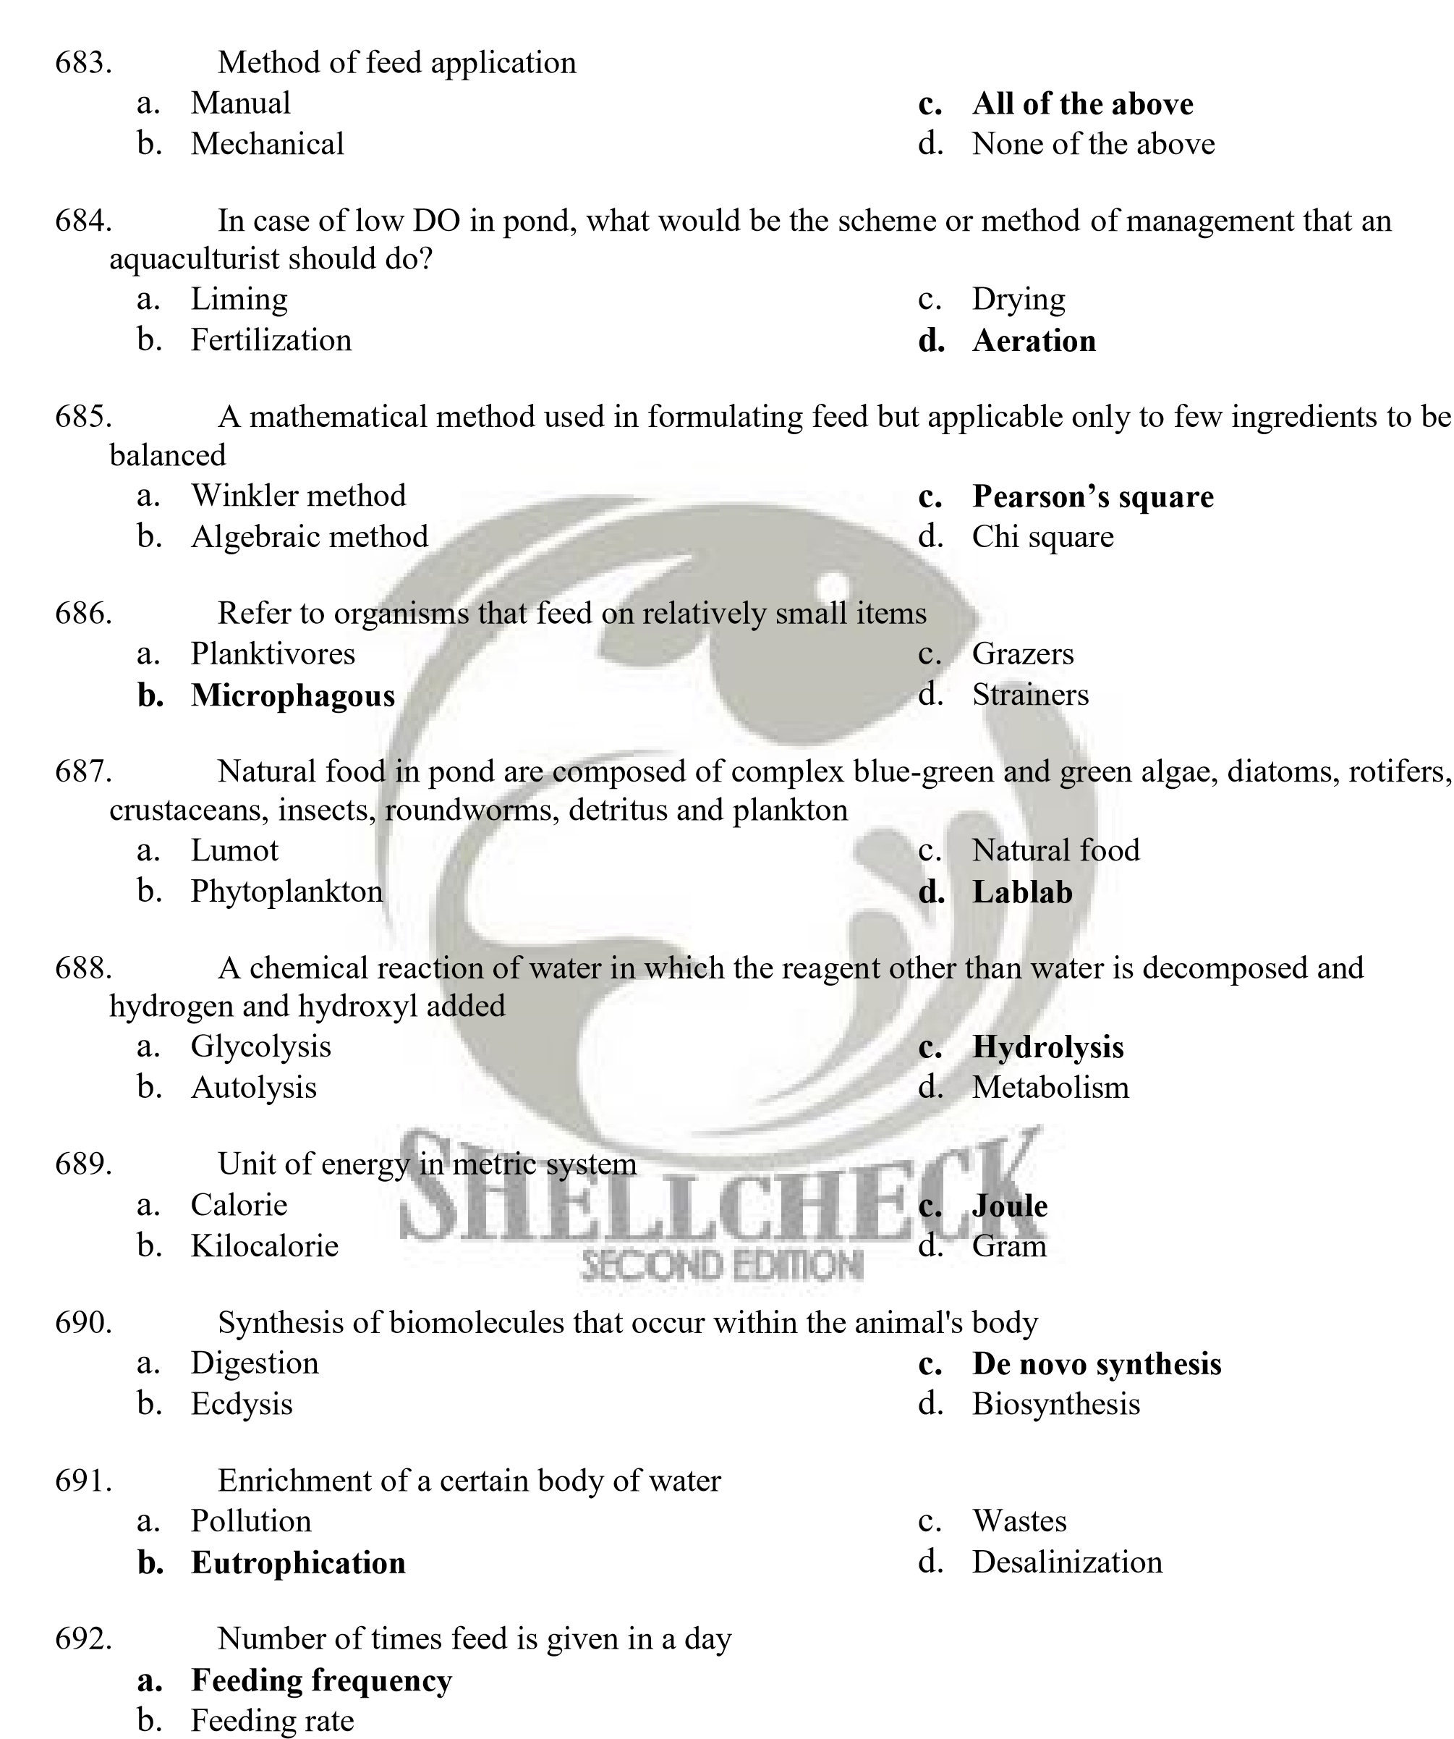
- Feeding chart
- Feed formulation
- Feeds that are intended for aquaculture species
  - Feed c. Supplemental feed
  - Fish feed d. Aquafeed

- Any of various seafishes that has low market value as human food
    - Catch c. Trash fish
    - Angler fish d. Wet fish
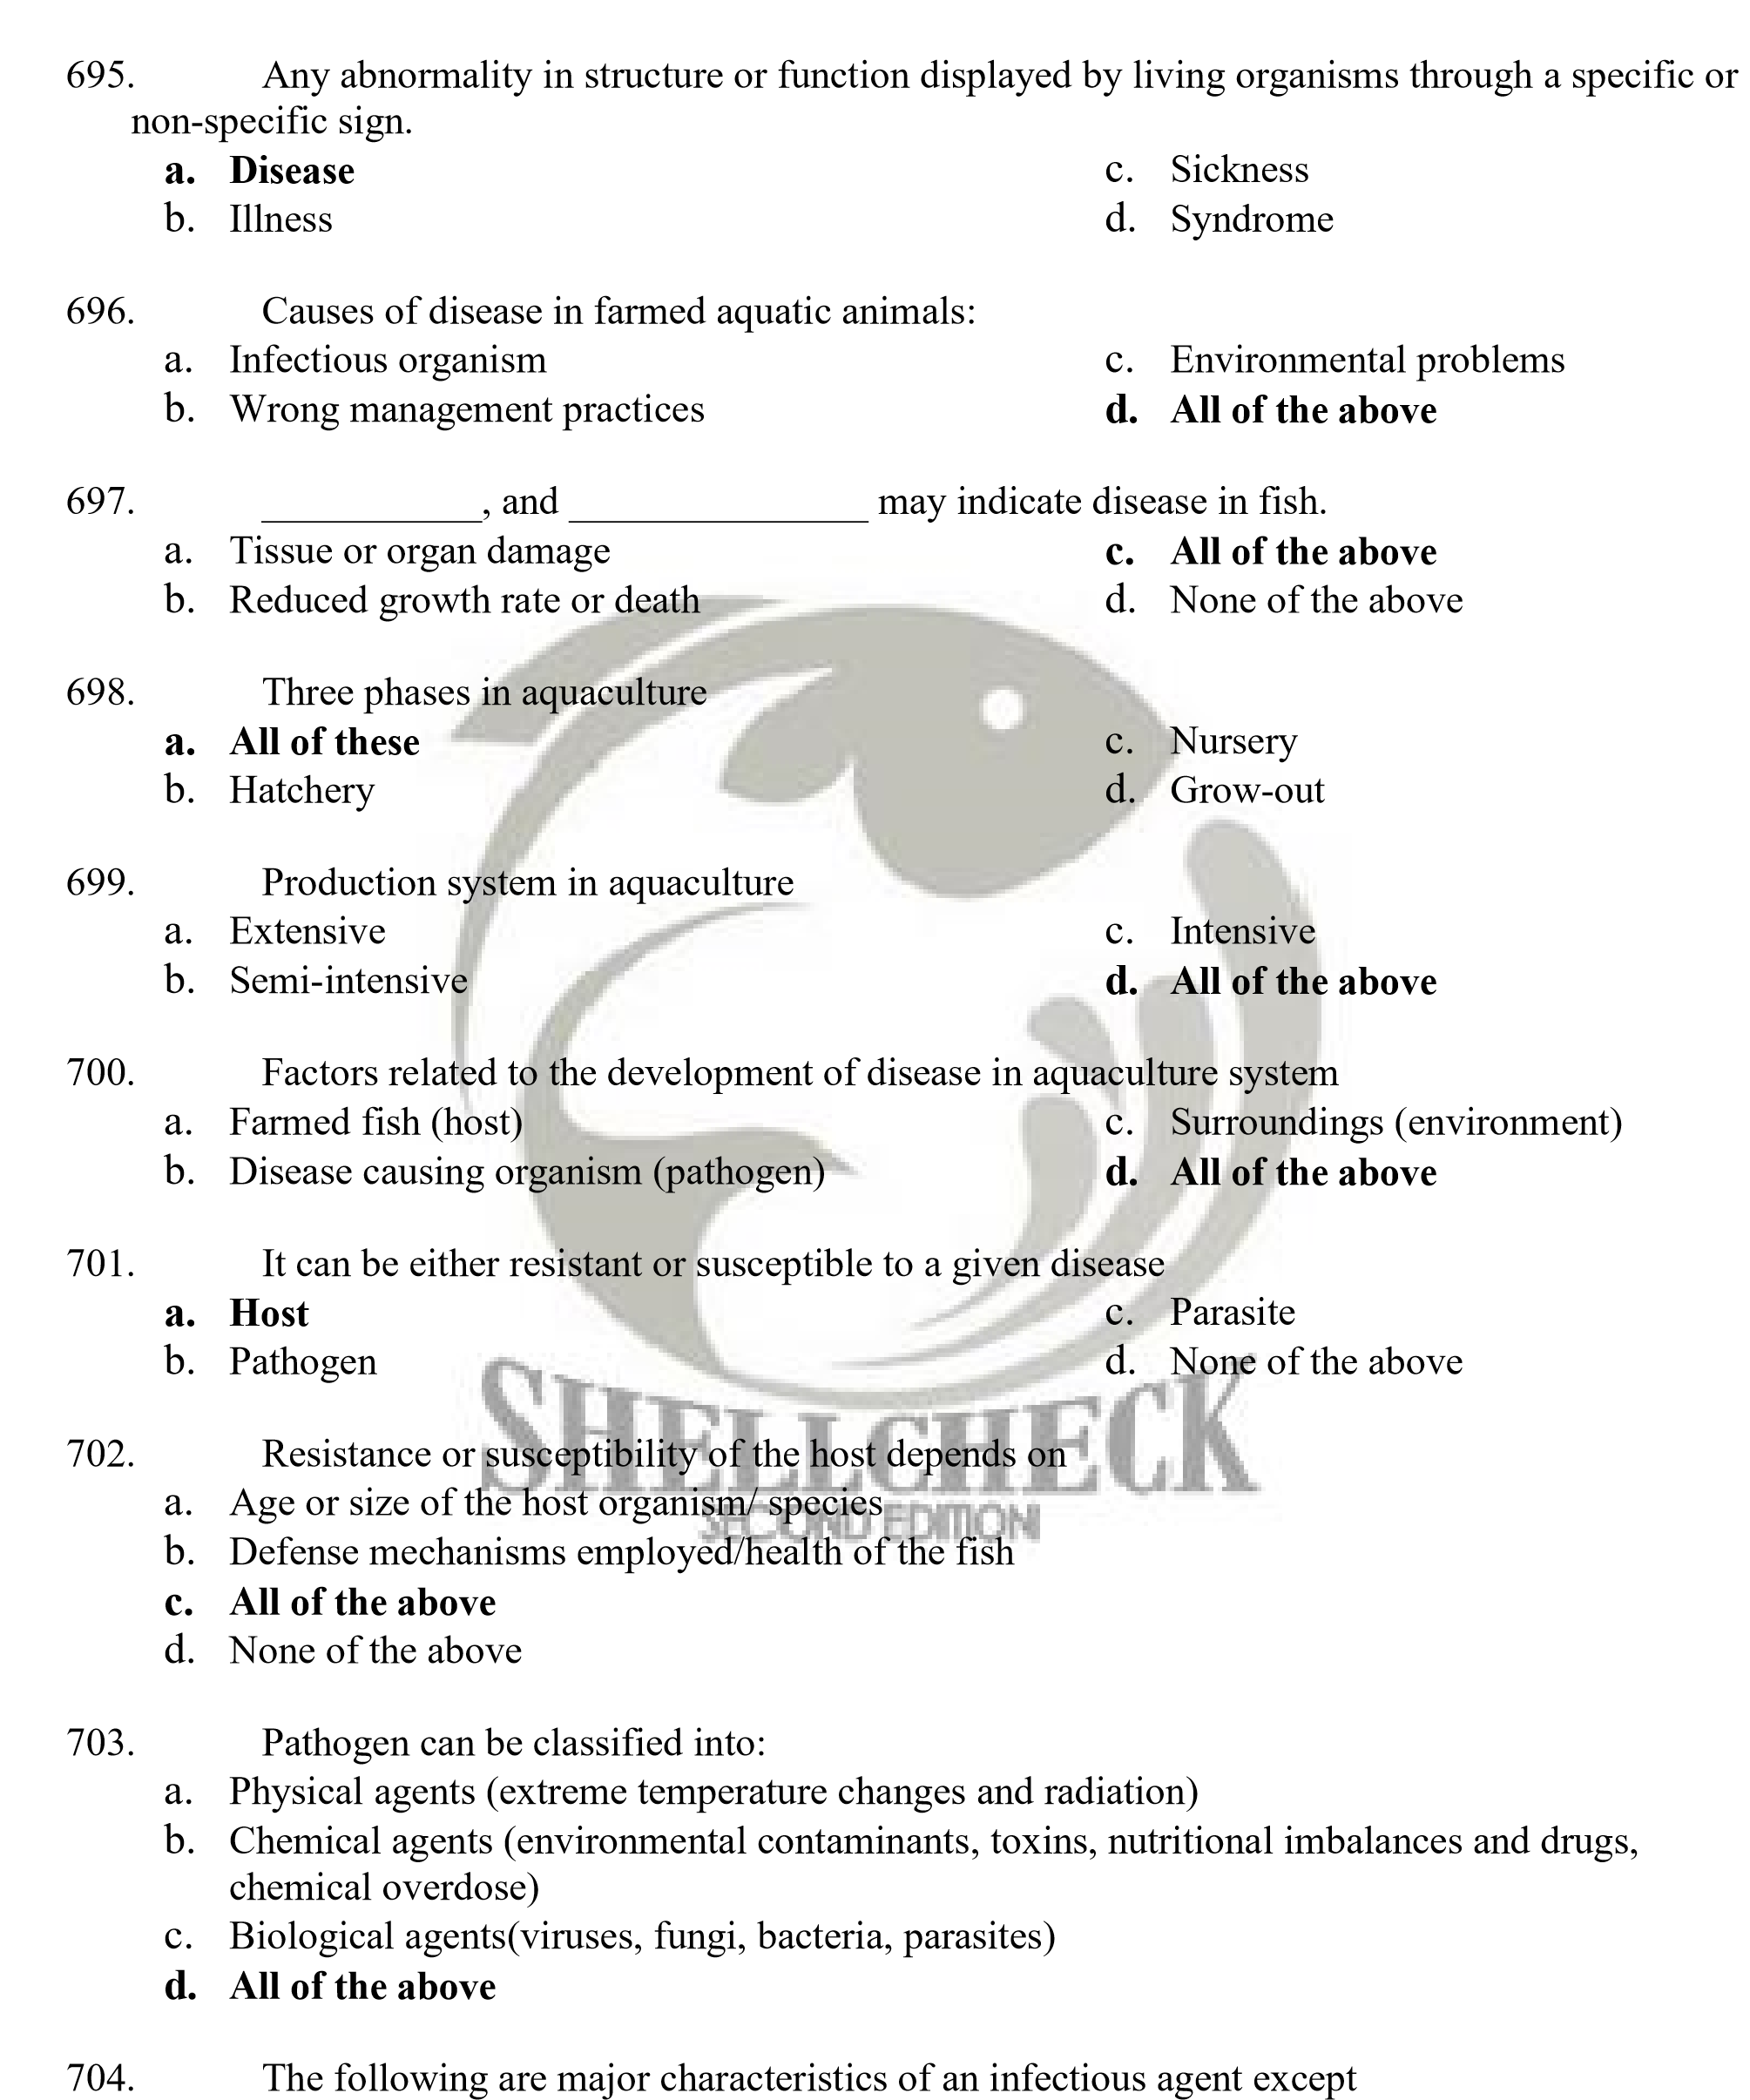
    - Ability to multiply in the host tissue c. All of the above
    - Capability for direct transmission d. None of the above

- Mode of transmission of pathogen
  - Vertical transmission c. All of the above
  - Horizontal transmission d. None of the above

- Pathogen transmission where infectious agents transfer from parent to offspring
  - Vertical transmission c. Parallel transmission
  - Horizontal transmission d. Linear transmission


- Pathogen transmission where infectious agent comes in contact with the hosts through the water, feeds or through carrier animals that is in the environment
  - Parallel transmission c. Horizontal transmission
  - Vertical transmission d. Linear transmission

- Essential to the prevention and control of disease
  - Stability of the environment
  - Understanding the role of the environment in affecting nature and cause of disease c. All of the above
d. None of the above

- An important consideration in the farming of aquatic animals
  - Knowledge c. Human behavior
  - Human attitude d. Human element

- Aquaculture technicians and other personnel should have _______________ and
_____________of the species they culture to assure the success of an aquaculture operation.
  - Adequate knowledge and trustworthy
  - Very good performance and honest
  - Adequate knowledge and understanding
  - Good in communication and understanding

- These may lead to costly mistakes and poor yield in farming of aquatic animals
  - Financial problem or lack of facilities
  - Lack of experience or insufficient personnel
  - Lack of knowledge of understanding
  - All of the above

- The sum of the physiological responses the fish makes to maintain or regain its normal balance.
  - Exhaustion c. Malnutrition
  - Stress d. Disease
- The act of identifying the cause of disease.
  - Dissecting c. Surgery
  - Diagnosis d. All of the above

- Sign of diseases
  - Reduced feeding/ abnormal changes in fish color and behavior
  - Fish may stay away from the school or swim at the surface or along the tanks sides exhibit flashing/scraping on the bottom of projecting objects
  - Darting/ whirling or twisting
  - All of the above

- This is essential in selecting the best management approach to correct the problem and the best possible treatment for the disease.
  - Correct treatment c. None of the above
  - Correct diagnosis d. All of the above

- This is vital in monitoring the health status of any cultured population.
  - Consistent record keeping c. Daily examination
  - Regular monitoring d. All of the above

- The keeping of records is necessary to enable the farm personnel to
  - Identify environmental problems c. To minimize production costs
  - Learn from past mistakes d. All of the above

- One of the biggest deterrents to sustainable production in aquaculture.
  - Disease occurrence c. Sanitation
  - Health management d. None of the above


- A minute infectious agent which can be resolved or viewed clearly only under a high power microscope. It lacks independent metabolism, and is able to replicate only within a living cell.
  - Microbes c. Virus
  - Fungi d. Detritus

- A microscope used to visualize viruses.
  - Mechanical microscope c. Light Microscope
  - Electron microscope d. Dissecting microscope

- Basic structure of a virion, which encloses a nucleic acid genome
  - Hypha c. Envelope
  - Capsid d. Nucleocapsid

- The identical protein subunits of capsid
  - Capsomeres c. Amino acid
  - Nucleic acid d. Nucleocapsid

- The full set of genes present in a cell or virus; all the genetic material in an organism.
  - Gene c. Envelope
  - Nucleic acid genome d. Genome

- Virus that do not have an envelope.
  - Naked virus c. Viral infection
  - Virus d. None of the above

- RT-PCR is acronym of
  - Reverse Transciptase-Polymerase Chain Reactions
  - Reserve Transciptase-Polymerase Chain Reactions
  - Reversing Transciptase- Polymerase Chain Reactions
  - Reserve Transciptase- Polymerase Chain Reacting

- A complex disease attributed to Rhabdavirus, the bacterium Aeromonas hydriphila, and the fungus Aphanomyces invadans.
  - Channel Catfish Virus Disease (CCVD)
  - Grass Carp Hemorrhagic Disease (GCHD)
  - Epizootic Ulcerative Syndrome (EUS)
  - Viral Nervous Necrosis Virus (VNN)


- These diseases consist of a chronic, necrotic, and mycotic granulomatous inflammatory response.
  - Epizootic Ulcerative Syndrome
  - Viral Nervous Necrosis
  - Infectious Hemanotopoetic Hepatopancreatic Necrosis Virus
  - Lymphocystis disease

- Causative agent of channel catfish virus disease (CCVD).
  - Herpesvirus ictaluri c. Flavobacterium columnares
  - Aeromonas hydrophila d. Aphanomyces sp.

- Clinical sign of channel catfish virus disease (CCVD).
  - Abdominal distension
  - Exophthalmia, pale or hemorrhagic gills,
  - Petechial hemorrhage at the base of the fins and throughout the skin
  - All of the above

- Aquareovirus is a causative agent of what viral infections disease?
  - Grass carp hemorrhagic disease c. Spinning Tilapia Syndrome
  - Channel Catfish Virus Disease d. Sleepy Grouper Disease

- Effect of grass carp hemorrhagic disease (GCHD) on host:
  - The disease consists of a chronic, necrotic, and mycotic granulomatous inflammatory response.
  - Hemorrhages occur in the musculature, oral cavity, intestinal tract, liver, spleen and kidney
  - Diseased of fish pale livers, empty digestive tracts, the intestine filled with greenish to brownish fluid and the spleens are red spotted.
  - All of the above

- Causative agent of Spinning Tilapia (ST) syndrome.
  - Nodavirus c. Bacoluvirus
  - Rhabdovirus d. Iridovirus

- Gross signs of spinning tilapia syndrome (STS).
  - All of these
  - Affected tilapia fry and fingerlings swim in a spiral pattern
  - Sink to the bottom then rise and hang at a 45 degrees angle just under the water surface, gasping for air
  - They do not feed and darker in color

- The causative agent of viral nervous necrosis (VNN)
  - Nodavirus c. Aquareovirus
  - Iridovirus d. Rhabdovirus

- The gross signs of this viral infection are: affected larvae and juveniles show lethargy, pale color, loss of appetite, thinness, loss of equilibrium and corkscrew swimming and some fish sink to the bottom then float to the surface again.
  - Lymphocystis Disease c. Viral Nervous Necrosis
  - Spinning Tilapia Syndrome d. Sleepy Grouper Disease

- This viral infection is also known as paralytic syndrome, viral encephalopathy and retinopathy, spinning grouper disease, piscine neuropathy, or fish encephalitis.
  - Viral Nervous Necrosis c. Spinning Tilapia Syndrome
  - HPV d. Sleepy Grouper Disease

- Infected fish have clusters of pear-like nodules up to 5mm in diameter that develop on the skin, gills or fins resulting from an enlargement of tissue cells and its causative agent is Iridovirus.
  - Lymphocytis Disease c. Grouper Iridovirus Of Taiwan Disease
  - Spinning Tilapia Syndrome d. Sleepy Grouper Disease

- Diseased fish swim in circles and are anemic; fish losses appetite then become underweight and lethargic.
  - Spinning Tilapia Syndrome c. Sleepy Grouper Disease
  - Whirling Disease d. Grouper Iridovirus of Taiwan disease (GITV)
- Species of fish affected by Sleepy Grouper Disease.
  - Epinephelus coiodes c. Epinephelus malabaricus
  - Epinephelus tauvina d. Epinephelus fuscogutatus


- Fish exhibits extreme lethargy and low appetite, swims alone or hung at the water surface or remains at the bottom.
  - Sleepy Grouper Disease c. Channel Catfish Virus Disease
  - Taiwan Grouper Iridovirus Disease d. Epizootic Ulcerative Syndrome

- The presence of distinct white cuticular spots most apparent at the exoskeleton and epidermis of diseased shrimp about 2 days after onset.
  - White Spot Syndrome Virus c. Monodon-baculovirus Disease
  - Yellow Head Virus Disease d. Epizootic Ulcerative Syndrome

- The causative agent of White Spot Syndrome Virus Disease.
  - Nodavirus c. Baculovirus
  - Iridovirus d. Rhabdovirus

- Infected shrimps show light yellowish, swollen cephalothorax; gills appear whitish, yellowish or brown.
  - Monodon-baculovirus diasease c. White Spot Syndrome Virus
  - Yellow Head Virus Disease (YHV) d. Spinning Tilapia Syndrome

- Affected shrimps exhibit pale-bluish-gray to dark blue -black coloration, sluggish and inactive swimming movements, loss of appetite and retarded growth.
  - White Spot Syndrome Virus c. Spinning Tilapia Syndrome Virus
  - Monodon Baculovirus (MBV) d. Yellow Head Virus Disease
Disease

- Monodon Baculovirus causative agent:
  - Baculovirus b. Aeromonas hydropilla
c. Peneaus monodon-type Baculovirus d. Iridovirus

- What stages of shrimp wherein Monodon Baculovirus was first (viral infections) diagnosed? a. Egg, larvae; juveniles, and adult
  - Mysis, postlarvae, juveniles and adult
  - Nuplius, mysis, postlarvae and sudadult
  - Mysis, postlarvae, juveniles and spawner

- The causative agent of this disease is parvovirus:
  - Monodonbaculovirus
  - Infectious Hypodermal and Hematopoietic Necrosis Virus (IHHNV) Disease
  - Hepatopancreatic parvo-like Virus
  - White Spot Syndrome Virus


- This disease shows erratic swimming behavior of shrimp, rising slowly to the water surface, hanging and rolling over until the ventral side is up, and eventually sinks to the bottom.
  - Monodon Baculo Virus
  - Hepatopancreatic parvo-like virus
  - Infectious Hypodermal and Hematopoietic Necrosis Virus (IHHNV) Disease
  - Spinning Tilapia Syndrome

- This disease develops loss of appetite and retards growth.
  - Infectious Hypodermal and Hemtopoietic Virus Disease
  - Hepatopancreatic Parvo-like virus (HPV) disease
  - Spinning Tilapia Syndrome
  - None of these

- Causative agent of Hepatopancreatic Parvo-like virus (HPV) disease is
  - Parvovirus c. Nodavirus
  - Baculovirus d. Iridovirus

- One-celled microorganisms which lack well-defined nucleus.
  - Pathogens c. Virus
  - Fungi d. Bacteria

- These bacterial pathogens are capable of living for a long time in the tissues of their host without causing injury.
  - Obligatory pathogens c. Secondary Pathogen
  - Opportunistic Pathogens d. Primary Pathogen

- In all animal production systems, one of the major problem facing production, development and expansion of the aquaculture industry is
  - Virus Disease c. Bacterial disease
  - Sickness d. Illness

- These microorganisms are of very small dimensions, usually between 0.5 and 10 microns.
  - Microbes c. Virus
  - Bacteria d. Host

- A living organism harboring another organism.
  - Host b. Parasites
c. Fungus d. Prey

- Weakness or sluggishness
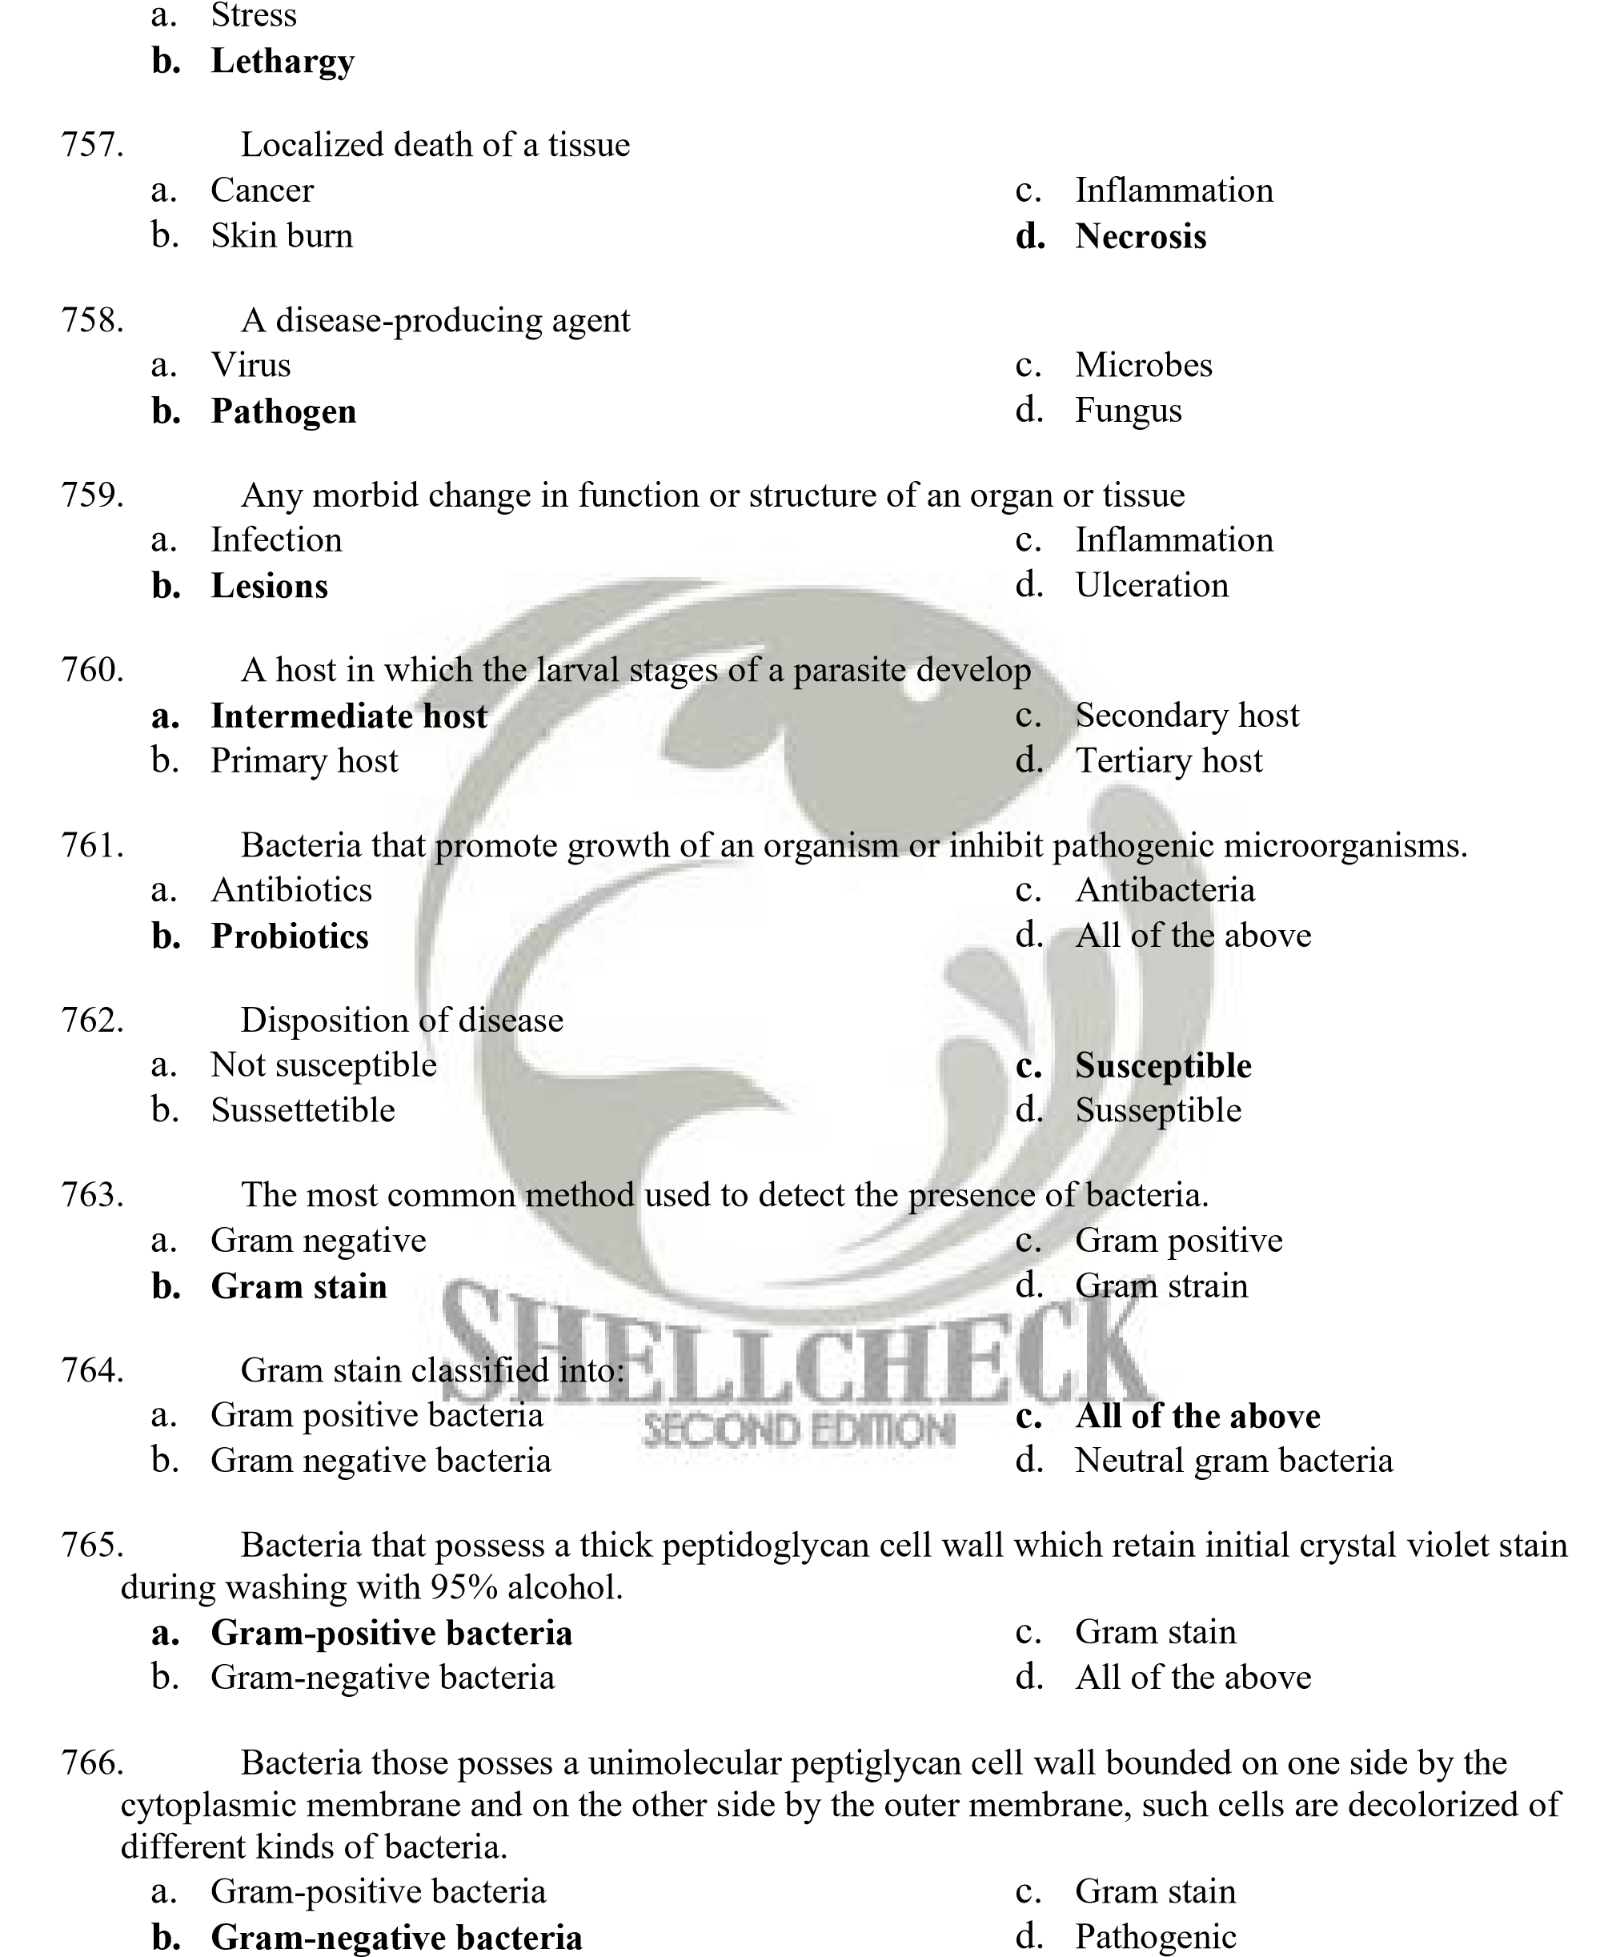
    - Drying
    - Weak

- Three distinct forms of bacteria:
  - Spiral b. Bacilli
c. Cocci d. All of the above

- Isolated bacterium suspected of causing the disease.
  - Causative agent c. Causative bacteria
  - Causative organism d. Causative microbes


- The appearance of a white spot on some parts of the head, gills, fins or body; distinct reddish tinge; lesions are circular, more necrotic on gills, develop hemorrhagic ulcers in skins, with an overlying serum of bacterial cells and necrotic tissue, are the first indications of infection of:
  - Aflatoxicos c. Red disease
  - Mycobacteriasis d. Columnaris disease

- An opportunistic pathogen widely distributed in the water, and it is the causative agent of columnaris disease characterized by yellow-green, flat, and rough spreading colonies that adhere to the media when it grows in solid media.
  - Flexibacter sp. c. Aeromonas sp.
  - Flavobacterium columnare d. Vibrio splendidus

- Edwardsiella tarda is the causative agent of:
  - Edwarsiella septicaemia or c. Edwadsiella sp.
Edwarsiellosis d. All of the above
  - Edwarsiella tarda

- Infections of this organism manifest itself by the presence of small, 3-5 mm cutaneous or skin lesions located dorso-laterally on the body.
  - Edwarsiella tarda c. Vibrio sp.
  - Edwarsiella sp. d. Vibrio vulfinis

- Causative agent of vibriosis:
  - Vibrio alginolyticus c. V. vulnificus
  - V. anguillarum d. All of the above

- The presence of red spots in tanks is a sign of
  - Skin infection c. Vibrio infection
  - Microbial infection d. Fungal infection

- This disease causes the darkening in color, enlargement of the abdominal area to an extensive superficial reddening of a large area of the body, often with necrosis of fins or tail and extensive ulceration over a considerable portion of the flanks or dorsum.
  - Pseudomonad Septicemia c. Protozoan Infestation
  - Lymphocystis disease d. Motile aeromonad septicemia

- Causative agent of Motile Aeromonad Septicaemia:
  - Aeromonas hydrophila c. A. sobria
  - A. caviae d. All of the above

- This organism enters the host either through the oral route or through broken or abraded skin and damaged gills, then carried throughout the fish body by the blood stream; their toxin destroy body tissues, organs and functions, and it dysfunction may lead to mortality of up to 70%.
  - Aeromonas sp. c. Flexibacter sp.
  - Vibrio sp. d. Pseudomonas spp.

- This disease causes small hemorrhages in the skin around the mouth and opercula and along the ventral or abdominal surfaces and body surfaces may ooze blood and slime in severe cases but there is no reddening of the fins and anus.
  - Pseudomonad Septicaemia or c. Lerneasis
Red Spot Disease d. Red Disease
  - Motile Septicaemia Disease


- This disease caused erratic swimming, darkening of body color, unilateral or bilateral exophthalmia, corneal opacity, hemorrhages on the opercula and the bases of the fins and ulceration of the body surface.
  - Vibriosis c. Mycobacteriosis
  - Piscine Tubercolosis d. Streptococcal Infection

- Causative agent of streptococcal infection:
  - Pseudomonas fluorescens c. Vibrio vunificus
  - Aeromonas hydrophila d. Streptococcus sp.

- The effect of Streptococcus sp. on host/fish:
  - Swim in spiraling motion c. All of the above
  - Spleen and kidney are enlarged d. None of the above

- To prevent and control the infection of streptococcus sp. It is necessary to:
  - Avoid overcrowding, overfeeding and unnecessary handling or transport
  - Remove and slaughter promptly all moribund fish in ponds or net cages
  - Apply erythromycin at 25-50mg/kg body weight of fish for 4-7 days
  - All of the above

- A systematic, chronic, progressive disease presenting various clinical features depending species and ecological conditions. It show gray white lesions of various sizes on most organs and tissues but the kidney and liver are most often involved.
  - Mycobacteriosis c. Piscine Mycobacteriosis
  - Streptococcal Infection d. Columnaris Disease

- A chronic progressive disease which may take several years to progress from the asymptomatic state to clinical illness.
  - Columnaris Disease c. Piscine Mycobacteriosis
  - Mycobacteriosis d. Vibriosis

- The primary method of controlling Mycobacteriosis.
  - Sanitation c. Destruction of carrier of fishes
  - Disinfection d. All of the above

- Species of shrimps affected by Filamentous Bacterial Disease are:
  - All of these c. P. merguiensis
  - Penaeus monodon d. P. Indicus

- Presence of fine, colorless, thread-like growth on the body surface and gills as seen under the microscope; infected eggs show a thick mat of filaments on the surface, which may interfere with respiration or hatching.
  - Filamentous Bacterial Disease c. Luminous Bacterial Disease
  - Shell Disease d. Non-luminous Vibrios

- Causative agent of Filamentous Bacterial Disease
  - Leucothrix sp./Thiothrix sp. c. Flavobacterium sp.
  - Flexibacter sp./Cytophaga sp. d. All of the above

- Filamentous Bacterial Disease can be prevented and controlled by:
  - Maintain good water quality
  - Apply cutrine plus at 0.15 ppm copper in 24 h flow through treatments
  - Apply 0.5 ppm copper in 4 to 6-h static treatments for PL 2 and older
  - All of the above

- The disease manifests itself as brownish to black, single or multiple eroded areas on the general body cuticle, appendages and gills; a cigarette butt-like appearance and blister containing cyanotic gelatinous fluid.
  - Shell Disease, Brown/Black Spot, Black Rot/Erosion, Blisters, Necrosis of Appendages b. Red Spot Disease
  - Blue Disease
  - Luminous Bacterial Disease

- This disease shows erratic or disoriented swimming; loss of appetite; opaqueness of abdominal muscle, anorexia and expansion of chromatophores; hepatopancreas show degrees of inflammation, hemocytic infiltration and fibriosis.
  - Luminous Bacterial Disease c. Filamentous Bacterial Disease
  - Red Spot Disease d. Non-Luminous Vibrios

- The best precaution against the occurrence of bacterial infections
  - All of these
  - Provide fish with optimum environmental conditions
  - Adequate amounts of the right kinds of food
  - Avoidance stress, including overcrowding

- The use of ____________ should always be an option of last resort.
  - Vitamins c. Antibiotics
  - Probiotics d. All of the above

- The unit structure of fungi and a tubular filament.
  - Hyphae c. Fungus
  - Hypha d. Cilia


- The process of introducing a suspension of disease-producing microorganisms modified by killing or attenuation so that it will not cause disease and can stimulate the formation of antibodies upon inoculation.
  - Injection c. Vaccination
  - Dissection d. Medication

- Organism that obtains their food from dead or decaying organic matter.
  - Detritus c. Salps
  - Benthos d. Saprotrophs

- Organism that is capable of living on dead organic materials as shown by their ability to grow on synthetic media.
  - Obligate Parasites or biotrophs b. Facultative Parasites or Saprobes
c. All of the above d. None of the above

- Organism which cannot be cultured in synthetic media.
  - Obligate Parasites or biotrophs c. All of the above
  - Facultative Parasites or Saprobes d. None of the above

- Formations of white cottony growth on fish eggs and on affected tissues of fish.
  - Branchiomycosis c. Ichthyophoniasis
  - Epizootic Ulcerative Syndrome d. Saprolegniosis

- The chemical used for the prevention and treatment of saprolegnian infections of fishes and fish eggs
  - Chemotherapeutants c. Benzalkonium chloride
  - A chelated copper compound d. Copper sulfate


- This disease causes darker discoloration and loss of appetite; fish float just below the water surface; fish may be hyperactive with a very jerky movement; and ulcerative lesions throughout the body.
  - Branchiomycosis c. Ichthyophoniasis
  - Epizootic Ulcerative Syndrome d. Saprolegniasis

- The causative agent of Epizootic Ulcerative Syndrome
  - Saprolegnia sp. c. Aeromonas sp.
  - Brachiomysis sp. d. Aphanomyces invadans

- Useful treatment for (Epizootic Ulcerative Syndrome (EUS)
  - 5 ppm Coptrol (a chelate copper compound) and 0.1 mg/l malachite green
  - Zinc-free malachite green
  - Copper sulfate
  - Sodium chloride

- Gills become pale with brownish areas due to hemorrhage and thrombosis, or grayish as a result of ischemia.
  - Saprolegniasis c. Epizootic Ulcerative Syndrome
  - Ichthyophoniasis d. Branchiomycosis (Gill Rot)

- The causative agent of Gill Rot
  - Aphanomyces invadans c. Aeromonas hydrophila
  - Saprolenia sp. d. Branchiomyces spp.

- The chemicals that have been used to treat branchiomyces are
  - Malachite green; benzalkonium chloride c. All of the above
  - Copper sulfate; sodium chloride d. None of the above

- Erratic swimming behavior and swelling of abdomen; internal organs become swollen with numerous whitish nodules up to 2mm diameter.
  - Branchiomycosis c. Saprolegniasis
  - Ichtyophoniasis d. Lerneasis
- This disease cause sudden onset of mortalities in larval stages of shrimps and crabs.
  - Red disease c. Black Gill Disease
  - Larval Mycosis d. Red spot Disease

- This disease causes black spot appearance that preceded mortalities in juvenile shrimps grown in ponds.
  - Black Gill Disease c. Blue disease
  - Larval Mycosis d. Red Disease

- This disease cause yellowish, and eventually reddish discoloration of the shrimp body and appendages; become lethargic with weak swimming activity and soft shelling.
  - Shell Disease c. Red Spot Disease
  - Aflatoxicosis (red disease) d. Larval Mycosis

- A relationship that benefits one or both parties or living together.
  - Mutualism c. Parasitism
  - Commensalism d. Symbiosis

- No party is harmed and both could live without the other.
  - Mutualism c. Parasitism
  - Commensalism d. Ectoparasites

- A relationship where both parties benefits from each other and neither could live without the other.
  - Mutualism c. Parasitism
  - Commensalism d. Symbiosis

- A one-way relationship in which one party depends upon, and benefits from, the other partner, biochemically and physiologically.
  - Mutualism c. Parasitism
  - Commensalism d. Parasites

- Parasites that live on the external surfaces of the host.
  - Endoparasites c. Parasites
  - Ectoparasites d. Host

- Parasites that found in the internal organs.
  - Endoparasites c. Parasites
  - Ectoparasites d. Host

- These are unicellular, microscopic organisms with specialized structures for locomotion, food gathering, attachment and protection.
  - Ciliates c. Flagellates
  - Protozoans d. Cilia


- Have short, fine cytoplasmic outgrowths called cilia as a locomotory organelle and are either attached or motile and mainly ectoparasites.
  - Protozoan c. Host
  - Flagellates d. Ciliates

- This disease is also known as ichthyophthiriasis("Ich") or White Spot Disease because of the presence of a few to numerous whitish or grayish spots on the skin and gills; loss their appetite, lethargic, with dull, opaque or hemorrhagic eyes.
  - Protozoan infestation c. Dinegean Infestation
  - Monogenean Infestation d. Cestode Infestation

- The causative agents of the protozoan infestation
  - Ichthyophthirius multifilis in freshwater
  - Cryptocaryon irritans in marine and brackishwater
  - All of the above
  - None of the above


- They have one or longer, hair-like structures called flagella used as a locomotory organelle; they occur on the skin, gills, intestinal organs and blood of fish.
  - Ciliates c. Cilia
  - Flagellates d. Spores

- These parasites can cause sluggishness, pale gills, and emanciated body when it attached to the fish.
  - Trypanosoma, Cryptobia, Ichthyobodo
  - Ichthyophthirius multifiliis, Cryptocaryon irritans
  - Myxidium, Myxobolus, Myxosoma
  - Gyrodactylus, Dactylogyrus, Pseudorhabdosynochus

- This disease can cause white cysts formed on the skin, gills, muscle, rain, heart, ovaries or other internal organs of fish and cysts produce thick milky exudates when ruptured.
  - Flagellates c. Nematode Infestation
  - Protozoans Infestation d. Myxosporeans

- This infestation can cause pale skin and gills with increased mucus production, frayed fins, and the cornea may become opaque.
  - Dinegean Infestation c. Cestode Infestation
  - Monogenean infestation d. Nematode Infestation

- The presence of small, white to yellow or brown to black cysts on the skin, fins, gills, muscle, stomach or intestine.
  - Cestode Infestation c. Dinegean Infestation
  - Monogenean Infestation d. Nematode Infestation

- This infestation show sluggish, with emaciated body because of non-feeding and commonly found in intestine of fish.
  - Acanthocephalan Infestation c. Cestode Infestation
  - Caligus Infestation d. Argulus Infestation

- This parasite causes necrotic hemorrhagic ulcers in the intestine of the host and it is caused by Acanthocephalus and Pallisentis.
  - Caligus Infestation c. Protozoan Infestation
  - Larnaeid Infestation d. Acanthocephalan Infestations

- These parasites have segmented bodies covered by shell with jointed appendages.
  - Isopod Infestation c. Crustacean parasite
  - Mollusc parasites d. Marine Leech Infestation

- This infestation show the parasite attached to the skin, fins, buccal or opercular mucosa with two conspicuous black spots and attachment area hemorrhagic or ulcerated.
  - Argulus infestation (fish louse) b. Caligus Infestation
c. Ergasilid Infestation d. Crustacean Infestation

- This is transparent parasite that appears like white patches, but is not permanently attached to the skin, fins, and gills and may cause skin ulcer, hemorrhagic, and infested areas have no scales.
  - Lernaeid Infestation c. Caligus Infestations
  - Argulus Infestation d. Ergasilid Infestation

- The infestation where parasites attaches to gills and body surface of the host; white to dark copepods and the affected fish have emaciated body.
  - Lernaeid Infestation c. Crustacean Infestation
  - Argulus Infestation d. Ergasilid Infestation

- These parasites can be seen protruding from nostrils, skin, bases of fins, gill, buccal cavity.
  - Caligus c. Ergasilus
  - Lernaea d. Argulus


- The effect of this parasite to the host/fish, skin and muscle are swollen, ulcers may develop and result to muscle necrosis.
  - Lernaeid infestation c. Crustacean Infestation
  - Mollusc Infestation d. Protozoan Infestation

- Isopod infestation resulting to reduced opercular movements, loss of appetite, anemia, and slow growth rate.
  - Zeylanicobdella arugamensis c. Glochidia
  - Alitropus and Nerocila d. Lernaea

- The Zeylanicobdella arugamensis attaches to the skin, fins, eyes, nostrils, operculum and inside the mouth of the fish and it may cause hemorrhagic.
  - Mollusc Infestation c. Protozoan Infestation
  - Marine infestation d. Crustacean Infestation

- Signs of this protozoan infestation are fuzzy mat on gills and body surface a. Glochidia
  - Gregarines
  - Nosema, Agmasoma, Pliestophora, Glugea and Ichthyosporidium
  - Vorticella, Zoothamnium, Epistylis, Acineta and Ephelota

- Parasites needing only one host to complete its life cycle.
  - Indirect Cycle c. Intermediate host
  - Parasites Life Cycles d. Direct Life Cycle

- Parasites may also have more than one host to complete its life cycle.
  - Indirect Life Cycle c. Direct Life Cycles
  - Intermediate Host d. Paratenic host

- Non-infectious diseases are caused by:
  - Adverse environmental conditions c. Genetic defects
  - Nutritional disorders d. All of the above

- These diseases may be caused by low dissolved oxygen, high ammonia, high nitrite, or natural or man-made toxins in the aquatic environment.
  - Non-infectious Disease c. Skin Disease
  - Environmental disease d. None of the above

- This is due to supersaturation of dissolved gases; supersaturation may be due to leaks in pump or valve systems in hatcheries; dense algal bloom that presumably caused oxygen depletion at night and supersaturation during the day.
  - Sunburn Disease c. Hypoxia
  - Gas Bubble Disease d. Asphyxiation


- This is associated with malfunction of the swimbladder and also associated with a combination of handling, high ambient temperature, high ambient illumination, dense algal bloom that presumably cause oxygen depletion at night and supersaturation during the day.
  - Gas bubble Disease c. Hypoxia
  - Swimbladder Stress Syndrome d. Anorexia

- Very low levels of dissolved oxygen.
  - Asphyxiation/hypoxia c. Anoxia
  - Anorexia d. Hyperoxia

- This is caused by a drop in the ph to a level too low for the species.
  - Acid sulfate c. Salinity
  - Acidosis d. Alkalinity

- This is due to excessive levels of ultraviolet irradiation from sunlight when fish are stocked in shallow uncovered raceways under intense sunlight.
  - Inflammation c. Gill disease
  - Skin disease d. Sunburn disease

- This is a shrimp disease caused by temperature and salinity shock, low oxygen levels, overcrowding, rough handling and severe gill fouling.
  - Black Gill Disease c. Body Cramp
  - Muscle Necrosis d. Hypoxia

- Associated with handling of shrimp in warm, humid air much warmer than culture water and mineral imbalance.
  - Bent/cramped tails or Body Cramp c. Red Disease
  - Soft Shelling d. Muscle Necrosis

- Closely associated with low temperature of culture water, that may cause the presence of old exoskeleton attached to the newly molted larvae, especially in appendages
  - Acid Sulfate Disease Syndrome c. Black Gill Disease
  - Chronic Soft Shelling Disease d. Incomplete Molting

- This is caused by low water and soil ph, which show poor growth, low molting frequency and yellow to orange to brown discoloration of the gill and appendage surfaces.
  - Red Disease c. Chronic Soft-Shell Syndrome
  - Acidosis/Acid Sulfate Disease d. Incomplete Molting syndrome

- . This is due to chemical contaminants, heavy siltation and ammonia or nitrite in rearing water; high organic load due to residual feed, debris, and fecal matter on the pond bottom which show the blackening of the gill discoloration and gill filaments become totally black.
- Black Gill Disease  - Block Gill Disease | - Muscle Necrosis  - Acidosis


- This is associated with high application of lime in the pond that gives it a high initial ph; prolonged exposure to low salinity, which affected shrimp have red short streaks on gills or abdominal segments, yellowish to reddish discoloration of the body and increased fluid in the cephalothorax, emitting foul odor.
  - Red Spot Disease c. Black Gill Disease
  - Acid Sulfate Disease Syndrome d. Red Disease

- Associated with exposure of normal hard-shelled shrimps to pesticides and piscicides, which shows shell that is often dark rough and wrinkled and affected shrimps are weak.
  - Incomplete Molting
  - Chronic Soft-Shell Syndrome/Soft-Shelling
  - Red Disease
  - Molting

- Diets designed to add nutrients to food obtained from the pond or aquarium environment.
  - Complete feeds c. Incomplete feeds
  - Supplemental feeds d. Artificial feeds

- Feeds for intensively reared fishes that do not get nutrients supplied from the environment.
  - Complete feeds c. Artificial feeds
  - Incomplete feeds d. Natural feeds

- Various stages of fish require various sizes of feeds classified as:
  - Larval feeds; starter feeds c. Broodstock feeds; maintenance diets
  - Grower feeds; finisher feeds d. All of the above

- The most expensive ingredient in fish feed, it may be tempting to economize on this ingredient.
  - Vitamin c. Carbohydrates
  - Minerals d. Protein

- This is used as energy food supply.
  - Carbohydrates c. Vitamins
  - Proteins d. Fats

- It is necessary for absorption of some vitamins and constitutes a relatively cheap energy source.
  - Proteins c. Lipids
  - Carbohydrates d. Amino acids

- These are complex organic substances that are essential to a wide variety of metabolic processes and are divided into two classes: fat-soluble and water-soluble.
  - Vitamins c. Protein
  - Fats d. Minerals

- This is required to fish for maintenance of osmotic balance between body fluids and their environmen
  - Water c. Vitamins
  - Fats d. Minerals

- Useful in diagnosing feeds problems
  - Nutritional deficiency signs c. Internal disease signs
  - Gross signs d. None of the above

- Components of feeds which are important binders in commercial fish feed production.
  - Fats c. Vitamins
  - Antioxidant d. Carbohydrates

- Reduction or cessation of growth is the common sign of what nutritional deficiency of fish?
  - Fats and lipids deficiency c. Vitamin imbalances
  - Amino acid deficiency method d. Minerals deficiency

- This deficiency usually seen in fish fed on trash fish or pelleted diets in which part of lipid component has gone rancid.
  - Fats and lipids deficiency c. Minerals deficiency
  - Amino acid deficiency method d. Vitamin imbalances

- Depletion of the body storage of any single vitamin can be responsible for specific or general disease signs.
  - Amino acid deficiency method c. Fats and lipids deficiency
  - Minerals deficiency d. Vitamin imbalances

- This disease is characterized by necrosis and degeneration of the natural musculature of fish and associated with vitamin deficiency and with lipid peroxides in the diet.
  - Nutritional myopathy syndrome c. Fats and lipids deficiency
  - Vitamin imbalances d. Mineral deficiency


- This nutritional deficiency occur in juvenile to sub adult penaeid shrimp cultured intensively in tanks and is caused by low level of vitamin C in the diet, lack or absence of algal growth or other vitamin C sources in the culture system.
  - Vitamin Imbalances c. Minerals imbalances
  - Vitamin C deficiency d. Fats and lipids deficiency

- This syndrome causes shrimps to become weak, prone to epibiotic fouling and cannibalism and have reduced market value.
  - Molting c. Chronic soft-shell syndrome
  - Blue shell syndrome d. Underfeeding

- This disease syndrome is light blue rather than grayish brown in color.
  - Black gill disease c. Vitamin imbalances
  - Blue disease or blue shell syndrome d. Body cramp

- This refers to a syndrome of uncertain etiology; occur together with striated muscles as the organ.
  - Body cramp or cramped tail syndrome c. Underfeeding
  - Muscle necrosis d. Shell disease

- This syndrome is indicated by the loss and oversized shells due to the reduction of the muscular mass in the abdominal region.
  - Underfeeding c. Overfeeding
  - Vitamin imbalances d. Under size feeding

- These organisms grow on the feeds, cause spoilage and produced toxins such as aflatoxin.
  - Aspergillus c. Bacillus
  - Micrococcus d. Salmonella

- This organ is responsible in the digestion, absorption and storage of food, damage in its tissues lead to slow growth.
  - Hepatopancreas c. Intestine
  - Stomach d. Kidney

- These occur as contaminants in fish meal and can cause mortality when present in fry feeds.
  - Copper c. Manganese
  - Chlorine d. Chlorinated hydrocarbons

- Leaves from ipil-ipil contain a poisonous amino acid, which cause pathological changes in the storage cells of the shrimp's digestive organ.
  - Saponin c. Nicotine
  - Memosine d. Gossypol


- These are present in the water and some of them cause disease only when the host have been weakened through exposure to stressful environmental conditions.
  - Diatoms c. Fungi
  - Plankton d. Microorganism

- These can be removed by ultraviolet radiation and through the process of microfiltration.
  - Potential pathogens c. Biofiltration
  - Chemical pollutants d. Carbon filtration

- Chemical pollutants can be eliminated by:
  - Carbon filtration c. Water dilution
  - Biofiltration d. All of the above

- This refers to fish free of all species- specific pathogens.
  - Specific pathogenic organisms (SPF) c. Coded pathogenic organism
  - Specified disease d. Uncontrolled fish

- This includes fish free of all diseases appearing in a list drawn up by an international agreement.
  - Specific pathogenic organism c. Coded pathogenic organisms (CPF)
  - Specified disease d. Uncontrolled fish

- This relate to fish reared in water supplies in which pathogenic organisms could exist, multiply and be disseminated by wild life fish.
  - Specific pathogenic organism c. Specific disease (SDF)
  - Coded pathogenic organism d. Uncontrolled fish

- This consists of fish not checked for the presence of disease or pathogens.
  - Specific pathogenic organism c. Specific disease (SDF)
  - Coded pathogenic organism d. Uncontrolled fish

- Have recommended policy measures dealing with the introduction of the aquatic species and guidelines for implementation, including methods to minimize the possibility of disease transfers, this is ICES which stand for:
  - International Council for the Exploration of the Seas
  - Integrated Council for the Exploration of the Seas
  - International Council for Exploring the Seas
  - International Council for the Exploration of the Species

- The primary objective of this method is to protect the host by intercepting the pathogen or cutting its pathway to the host.
  - Environmental methods c. Physical methods
  - Chemical methods d. None of the above

- This should be accessible by road to avoid excessively long transport time of the larvae or fish.
  - Farmhouse c. Hatchery/farm
  - Facilities d. None of the above

- It is crucial in the hatchery or pond; it can spell the difference between success and failure of the aquaculture enterprise.
  - Management c. Temperature
  - Good water quality d. Good management practice

- This provides aeration in ponds and in a large settling reservoir it reduces the organic and particulate load before it is directed into ponds.
  - Puddle wheel c. Paddle wheel
  - Surface aerator d. Aerator

- The target organ of infection by Luminous Bacterial Disease.
  - Liver c. Hepatopancreas
  - Lungs d. Stomach

- This mode vaccination delivery is commonly practiced with very small fish where it is convenient and highly cost-effective method of vaccine administration.
  - Spray administration c. Injection
  - Per-oral administration d. Direct immersion

- This variation of the immersion method suitable for larger fish than those given immersion treatment.
  - Spray administration c. Injection
  - Pre-oral administration d. Direct immersion

- A chemical compound that activates the immune system of animals and increases their resistance to infectious diseases.
  - Antibiotics c. Stimulant
  - Immuno-stimulants d. Synthetic


- This oral route of administration of vaccine as feed additive should have many clear advantages like the absence of handling stress, no scars on the fish to lower its value, freedom to choose vaccination dates, no safety risk to the operator, and no risk of spreading infection through needles.
  - Per-oral administration c. Spray administration
  - Direct immersion d. Injection

- This is the route of administration commonly used throughout the salmon industry; a single of this can provide a high degree of protection throughout the whole length of the culture period or production cycle and this process allows fish to be graded, counted and monitored for abnormalities and signs of disease.
  - Vaccination c. Examination
  - Diagnosis d. Injection

- This is extracted from the exoskeleton of shrimps and other crustaceans.
  - Peptides c. Enzymes
  - Chitosan d. Substance

- It is a ubiquitous by-product in an aquatic environment; also the main excretory product of water-breathing animals and the end product of the decay of organic matter.
  - Ammonia c. Oxygen
  - Ammonium d. Waste product


- Group of food and feed products for both human and animal consumption and are also known as direct feed microbial or bacteria that promote the growth of an organism or inhibit pathogenic microorganisms.
  - Probiotics c. Yogurt
  - Antibiotics d. None of the above

- The practice of keeping different species in the same pond.
  - Monoculture c. Polyculture
  - Aquafarming d. Aquafarming

- It is the use of bacteriophage to treat bacterial disease.
  - Chemotherapy c. Phage therapy
  - Therapy d. None of the above

- The study of antigen-antibody reactions in vitro and is important in clinical diagnostic microbiology.
  - Serology c. Homology
  - Immunology d. Microbiology

- This test is used to detect and identify a specific antigen or antibody associated with a disease-causing organism.
  - Immunodiagnostic test c. Agglutination test
  - Diagnostic test d. None of the above

- Two basic methods for identification of unknown organisms by using sera containing various antibodies:
  - Positive and Negative reactions
  - Agglutination for particulate antigen and Precipitation for soluble antigen
  - Antigen and Antibody
  - None of the above

- These are among the most easily performed of immunological tests.
  - Precipitation reactions c. Agglutination reactions
  - Immunoassay method d. Antigen-antibody reactions

- This is used to describe the concentration of antibody in serum, which is the reciprocal of the highest dilution producing a definite reaction.
  - Serum b. Autoagglutinate
c. Titer d. Antigens

- The reaction between antibody and soluble antigen resulting in a visible mass of antibody antigen complexes.
  - Single diffusion c. Agglutination reactions
  - Antigen-antibody reactions d. Precipitation reactions

- Precipitation reactions that can be done in semisolid medium (agar):
  - All of these c. Double diffusion
  - Single diffusion d. Immunoelectrophoresis

- This method is used to quantitate the concentration of antibody and antigen in a solution.
  - Double diffusion c. Immunoelectrophoresis
  - Single diffusion d. Immunoassay


- This method can be used either to detect the number of major components in an antigenic mixture or identify the presence of homologous and heterologous molecules in an antigenic extract based on the specific recognition capacity of a prepared antiserum.
  - Single diffusion c. Immunoelectrophoresis
  - Double diffusion d. Immunoflourescence

- This technique is widely used method in fish immunology and combines electrophoresis with immunoprecipitation and the components of antigen in this system will first be separated by electrophoresis.
  - Immunoflourescence c. Immunochemical techniques
  - Immunoassay test d. Immunoelectrophoresis

- This technique generally detects surface-associated antigens.
  - Enzyme-Linked Immunosorbent Assay (ELISA)
  - Antibody-capture Assay
  - Fluorescent Antibody Technique (FAT)
  - Western Blotting

- This is widely used for the detection of antigen or antibody in fish, typing and identification of a range of microorganisms.
  - Immunoflourescence c. Immunoassay test
  - Immunoelectrophoresis d. Immunochemical techniques

- One of the most powerful of all immunochemical techniques, it employ a wide range of methods to detect and quantitate antigens or antibodies and to study the structure of antigens.
  - Direct fluorescent antibody techniques (DFAT)
  - Indirect fluorescent antibody techniques (IFAT)
  - Enzyme-Linked Immunosorbent Assay (ELISA)
  - Fluorescent Antibody Techniques (FAT) 912. The three classes of ELISA test are:
  - All of these c. Antigen capture assays
  - Antibody capture assays d. Two-antibody sandwich assays

- These can be used to detect and quantitate antigens or antibodies and compare the epitopes recognized by different antibodies.
  - Antibody capture assay b. Antigen capture assay
c. Two-antibody sandwich assay d. Immunoassay test

- These are used primarily to detect and quantitate antigens.
  - Antibody capture assay c. Two-antibody sandwich assay
  - Antigen capture assay d. Bioassay

- These are used primarily to determine the antigen concentration in unknown samples and require two antibodies that bind to non-overlapping epitopes on the antigen.
  - Antibody capture assay c. Antigen capture assay
  - Two-antibody sandwich assays d. Bioassay

- This is a rapid and sensitive assay for the detection and characterization of proteins
  - Bioassay c. Western Blotting
  - Antibody capture assay d. Immunoassay test

- This is used to describe the degree of base pair matching that determines if the strands stay together.
  - Homology c. Etiology
  - Serology d. Cytology

- Temperature under the specific reaction conditions where one half of the hybridized strands are still hybridized and the other half are denatured.
  - Maximum temperature c. Melting temperature
  - Minimum temperature d. None of the above

- The two molecular-based techniques are
  - Gene probe and Polymerase Chain Reaction (PCR)
  - Ribonucleic acid and Deoxyribonucleic acid
  - Nucleic acid and Deoxyribonucleic acid
  - Nucleic acid and Polymerase chain Reactions

- The DNA is extracted from a sample and binds it to a filter where it can be hybridized with the labeled probe.
  - Filter hybridization c. Dot blot hybridization
  - Nucleic acid hybridization d. Prehybridization

- The sample DNA is directly placed on the filter with the aid of a vacuum manifold, which has slot-like spaces for each sample.
  - Dot blot hybridization c. Prehybridization
  - Filter hybridization d. Slot blot or dot blot hybridization


- It is rapid, simple technique for the quantification of RNA or DNA target sequences without prior electrophoretic separation.
  - Dot blotting c. Southern blot hybridization
  - Western blotting d. Prehybridization

- The sample DNA may be first separated according to size and configuration by electrophoresis on a gel and then transferred to filter.
  - Western blotting c. Dot blotting
  - Northern blot hybridization d. Southern blot hybridization

- In this process, RNA molecules can be separated on the basis of size by gel electrophoresis and can be immobilized on membranes.
  - Southern blot hybridization c. Northern blot hybridization
  - Western blotting d. Dot blotting

- The DNA is not extracted but rather kept in the intact cell where in may bind to the probe.
  - Post hybridization c. Prehybridization
  - In situ hybridization d. Hybridization

- These are extensively used as diagnostic tools to detect White Spot Syndrome Virus (WSSV);
Infectious Hypodermal and Hematopoietic Necrosis Virus (IHHNV); and Hepatopancreatic Parvovirus (HPV) of penaeid shrimp and Viral Hemorrhagic Septicemia Virus (VHSV) and Infectious Hematopoietic Necrosis Virus in fish.
  - Polymerase chain reactions c. Gene probe assay
  - Gene probes d. Bioassay

- An enzymatic method for amplifying exponentially specific preselected fragment of DNA; an in vitro technique use to synthesize large quantities of specific nucleotide sequences from small amounts of DNA.
  - Gene probe c. Molecular biology techniques
  - Polymerase Chain Reaction (PCR) d. Gene probe assay


- In aquaculture, this is a valuable tool for the prevention, control and management of various diseases; the test can be carried out non-destructively by using body fragments, blood or feces from fish and shrimp tested.
  - FAT c. PCR
  - ELISA d. DFAT

- PCR amplification is subdivided into steps which are repeated in cycles
  - Melting or Denaturation c. Extension
  - Annealing d. All of the above

- Bacteria that lives in hot spring.
  - Thermophilic bacteria c. Thermus aquaticus
  - Thermuphilus sp. d. Thermus maritimus

- These are important food for filter feeding bivalves and for the larvae of commercially important crustacean and fishes.
  - Macroscopic algae c. Microscopic algae
  - Filamentous algae d. Zooplankton

- It can cause severe economic losses to aquaculture, fisheries and tourism and have major impact on health and environment.
  - Pollution c. Illegal logging
  - Algal blooms d. Climate change
- These conditions developed due to high respiration by the algae at night or in dim light during the day but most probably bacterial respiration during decay of the bloom caused it.
  - Oxygen depletion c. High pressure
  - Red tide d. Algal bloom

- One of first recorded fatal cases of human poisoning after eating shellfish contaminated with dinoflagellate toxins was in 1793 in ________________.
  - Manila Bay c. Orion Bataan
  - Poison Cove in British Columbia d. Egypt

- In the Philippines, red tide was reported in 1908 in Manila Bay due to ___________ blooms.
  - Peridinium c. Alexandrium
  - Pyrodinium bahamense var. compressa d. Gymnodinium

- In 1987, the presence of dinoflagellate blooms caused by _________________ was detected in the coastal waters of Masinloc, Zambales, extending from Subic to Sta. Cruz.
  - Peridinium c. Alexandrium
  - Gonyaulax d. Pyrodinium bahamense var. compressa


- This condition is affected by upwelling whereby transport of deep water to the euphotic zone is driven by a force mainly originated from an eddy, enriching the coastal water column and initiating plankton bloom.
  - Eutrophication in the open sea c. Nutrient circulation in surf zones
  - Stratification of water d. Terrestrial nutrition supplies

- This condition is caused by an imbalance in atmospheric pressure and sea temperature between western and eastern parts of the Pacific Ocean,
  - Trade wind c. El Niño
  - Low pressure d. La Niña

- Types of harmful and toxic algal blooms
  - Type A species c. Type C species
  - Type B species d. All of the above

- These are species that produce basically harmless water discoloration; under exceptional conditions in sheltered bays, blooms can grow and cause indiscriminate kills of fish and invertebrates from oxygen depletion; these blooms represented by dinoflagellate species and Cynobacterium.
  - Types B species c. Type A species
  - Types C species d. All of the above

- These produce potent toxins that find their way through the food chain to human, causing a variety of gastrointestinal and neurological illness such as PSP, DSP, NSP, ASP, CFP and CTP.
  - Type A species c. Type C species
  - Type B species d. All of the above

- Species of this type are non-toxic to human but harmful to fish and invertebrates by damaging or clogging their gills, e.g., diatom, dinoflagellate, prymnesiophytes, and raphidophytes.
  - Type B species c. Type A species
  - Type C species d. All of the above

- Strategies in coping with the problem of harmful and toxic algal blooms
  - Red tide monitoring/ information dissemination
  - Regulation/ medical management of PSP cases
  - Government assistance program /recommendations
  - All of the above

- Deficiency of oxygen
  - Asphyxiation b. Anorexia
c. Hypoxia d. Hyperoxia

- To clean by reversing water flow
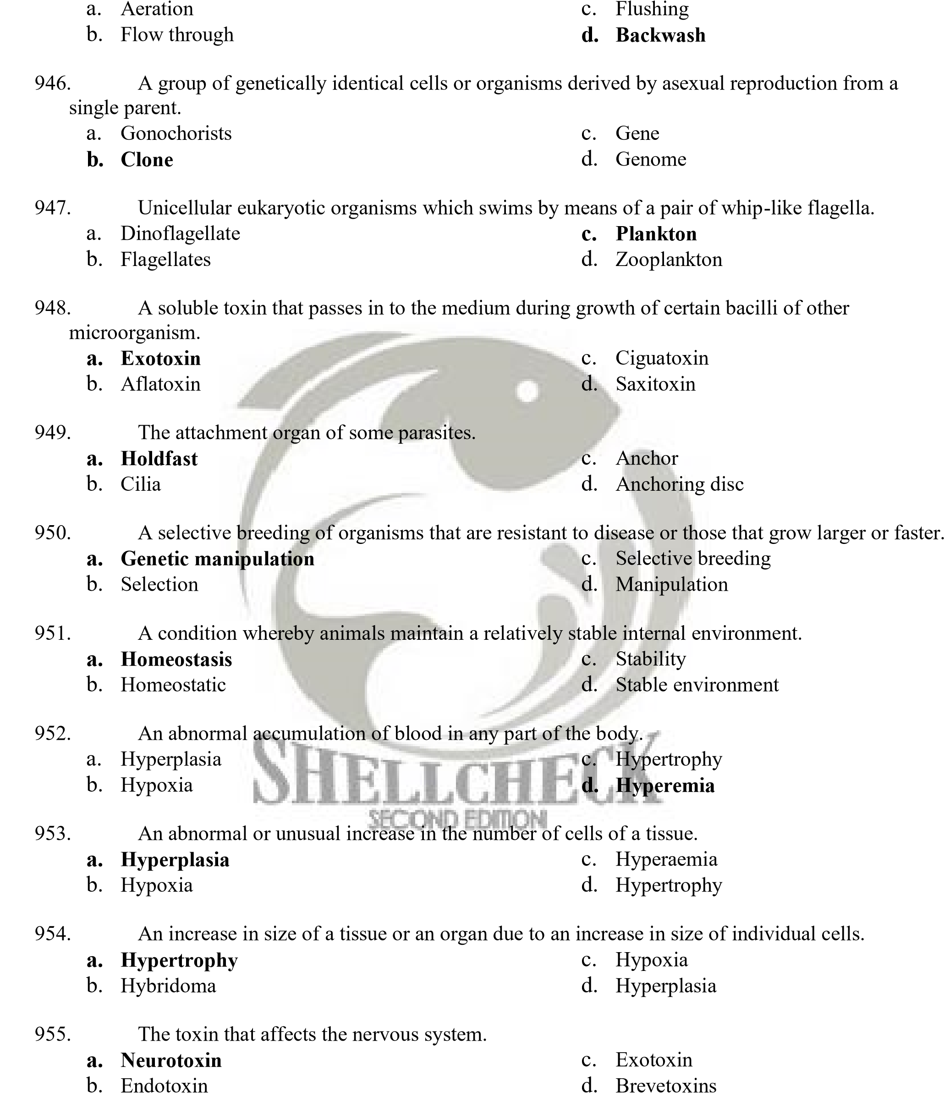
- Preventive action
  - Antibiotic c. Anticancer
  - Probiotics d. Prophylaxis

- Deposition to disease
    - Stress c. Depress
    - Susceptible d. None of the above
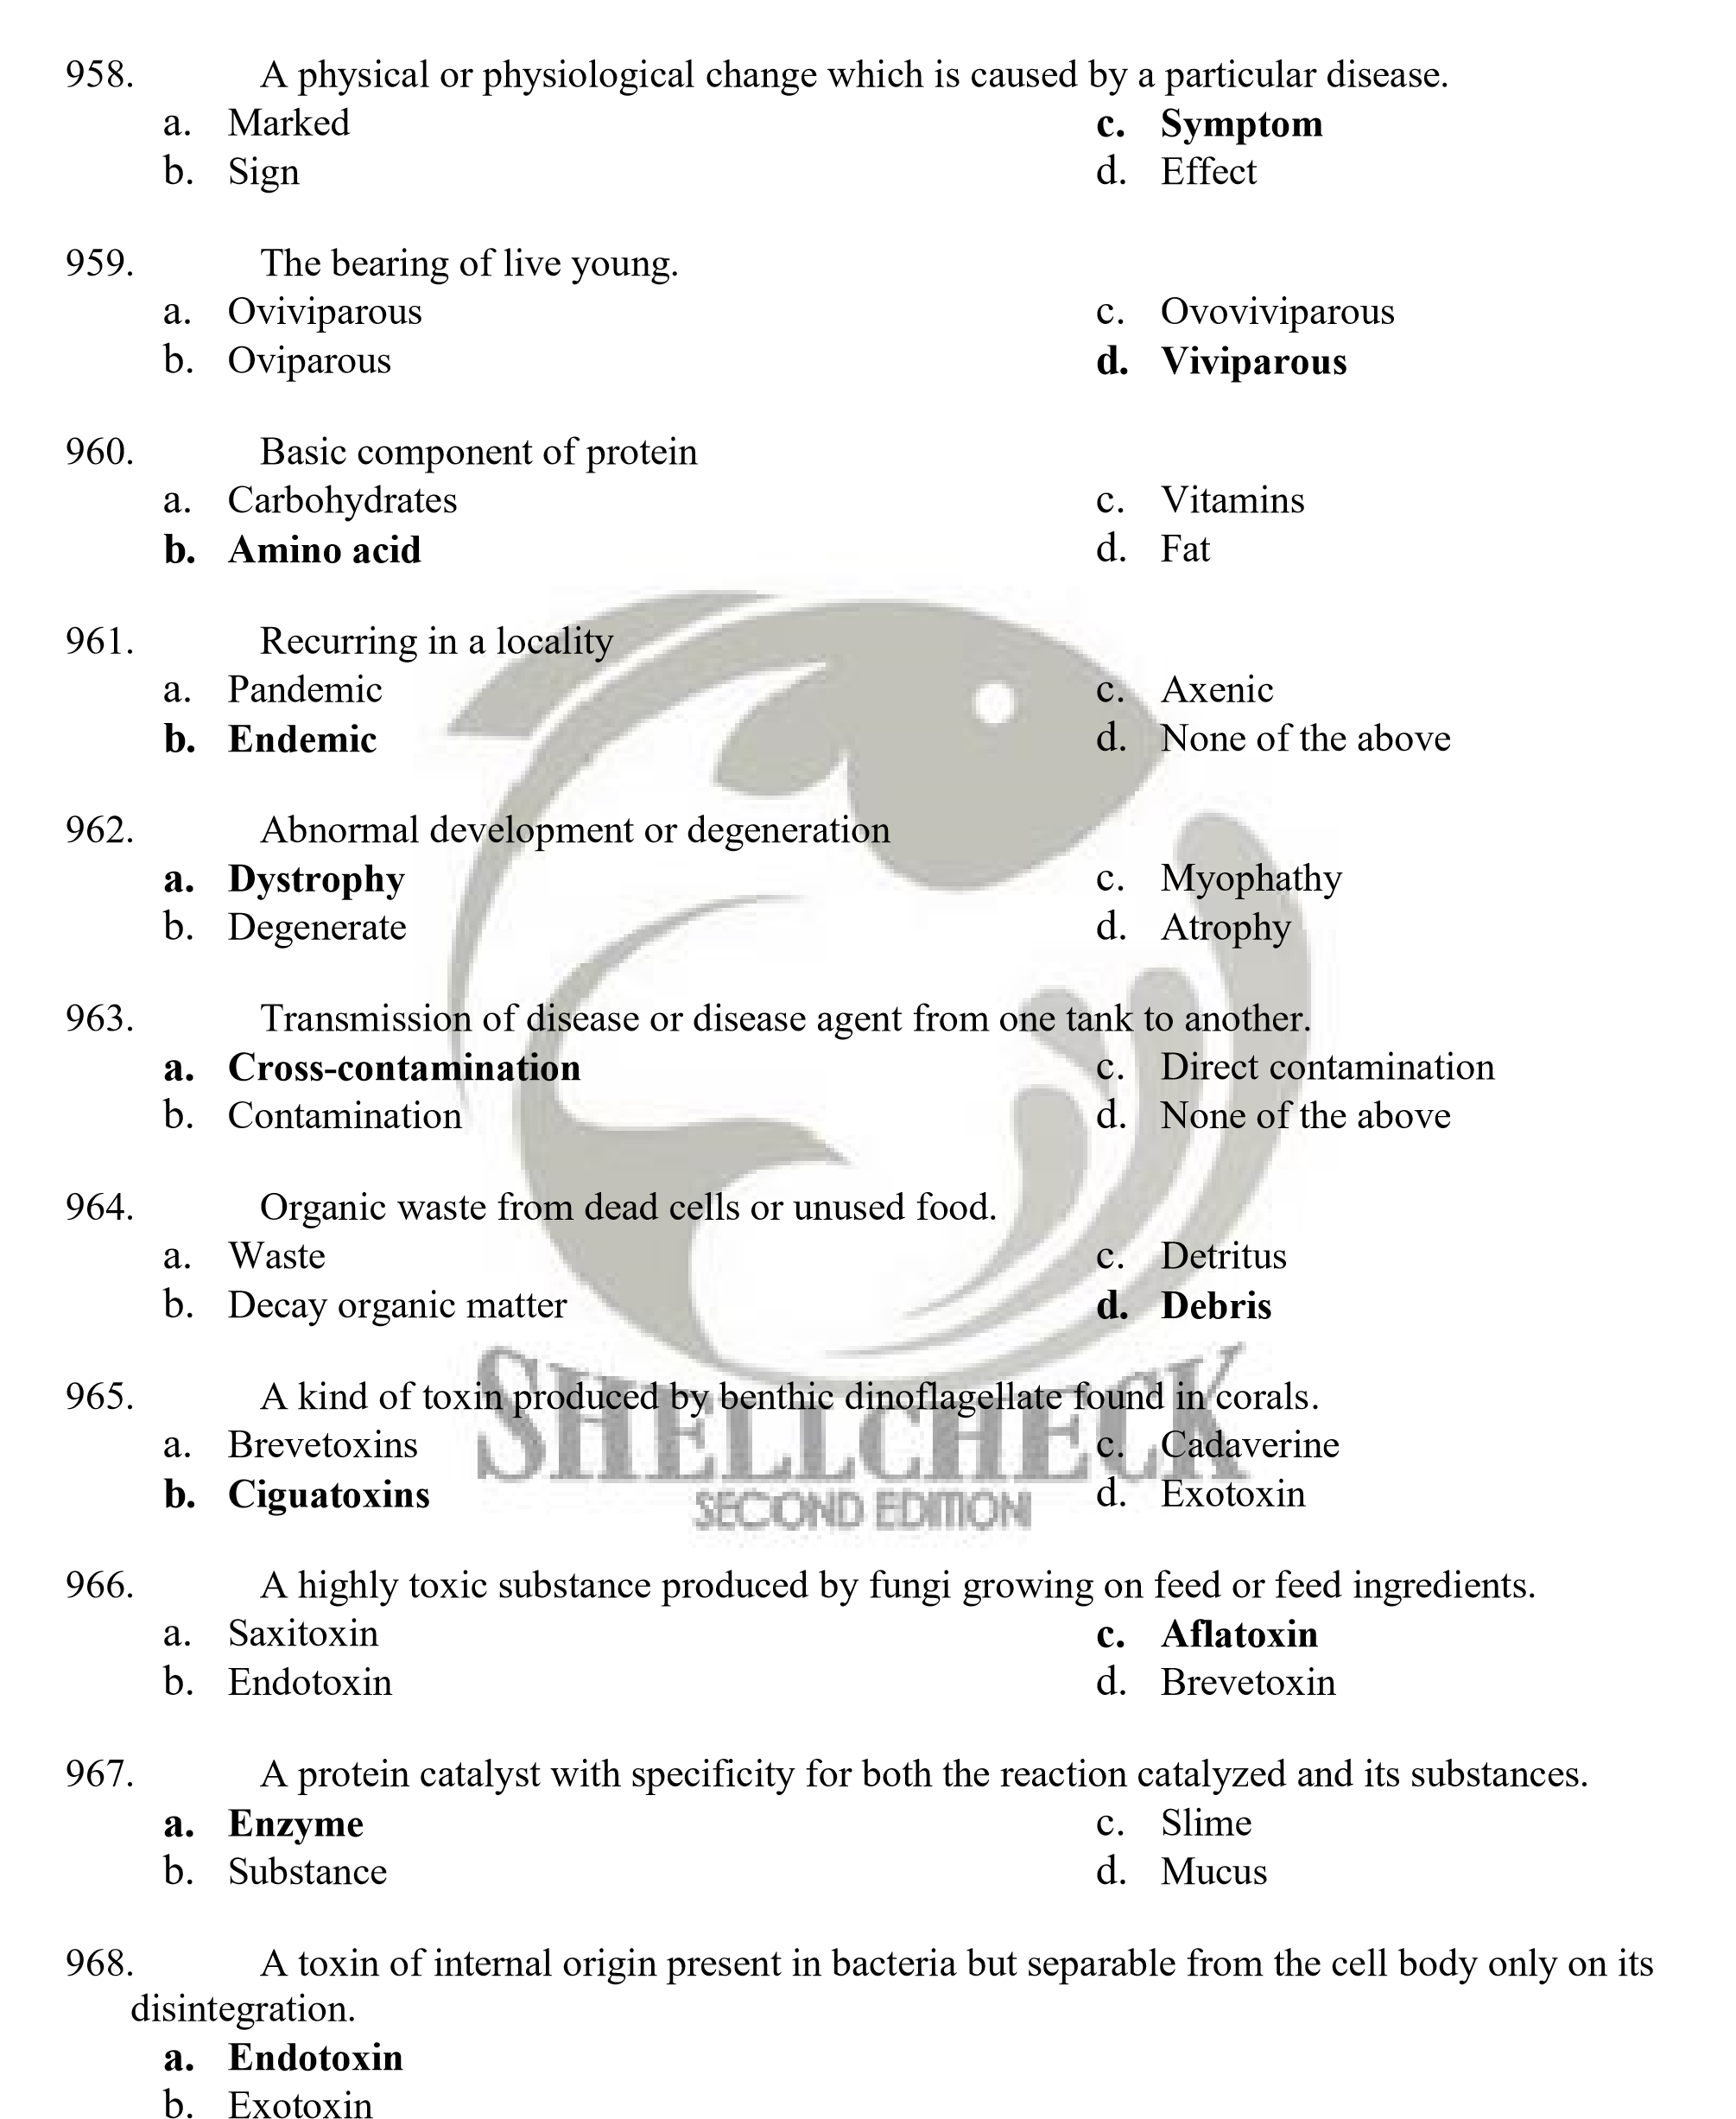
    - Neurotoxin
    - Saxitoxin

- A 37% solution of formaldehyde.
- Isopropyl alcohol  - Ethyl alcohol | - Formalin  - All of the above

- A colorless copper-containing respiratory pigment found in solution in the blood plasma of
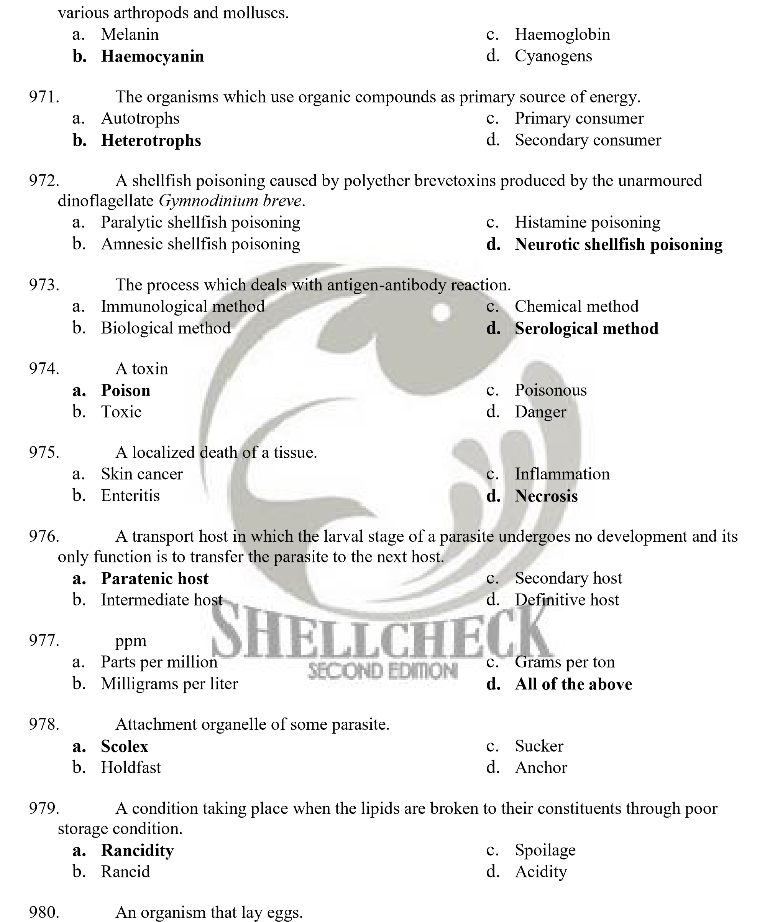
  - Oviparous c. Ovoviviparous
  - Viviparous d. Oviparity

981. An organism that lives at the expense of another, usually invading it and causing disease.
Bacteria c. Fungi
b. Parasite d. Intermediate host
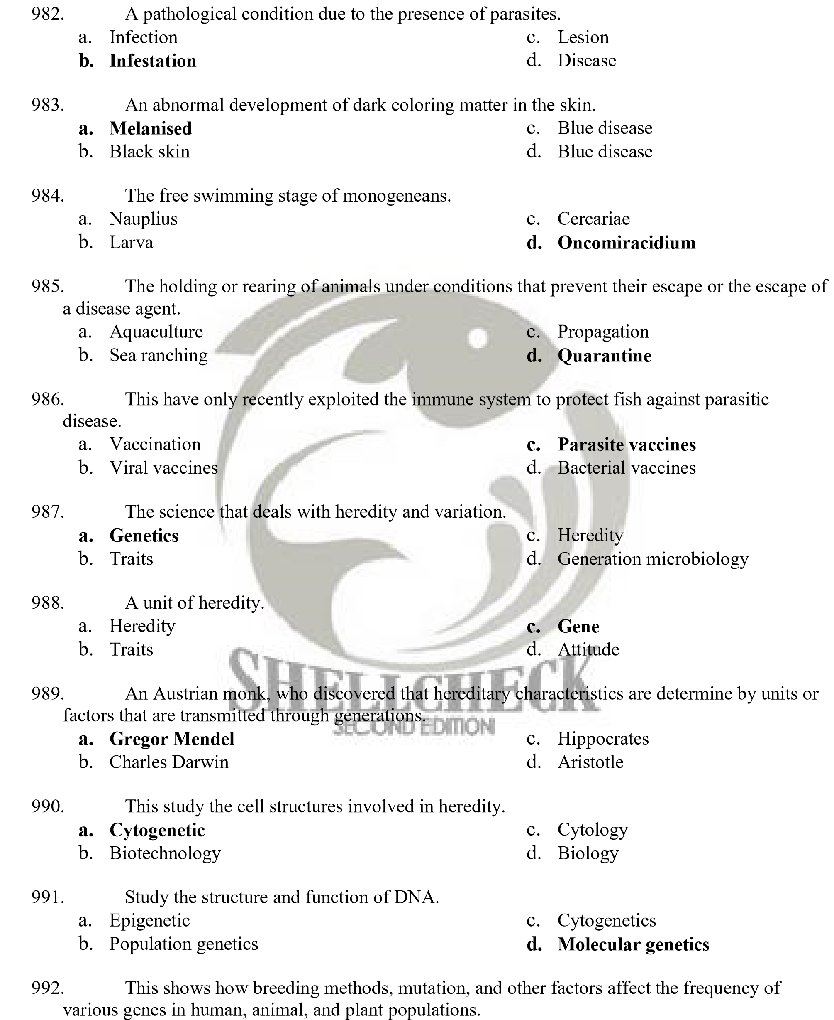
- Molecular genetics c. Genetics population
- Population genetics d. None

993. This involves altering and rearranging the genes of an organism.
  - Biotechnology c. Genetic engineering
  - Engineering d. Mechanical engineering
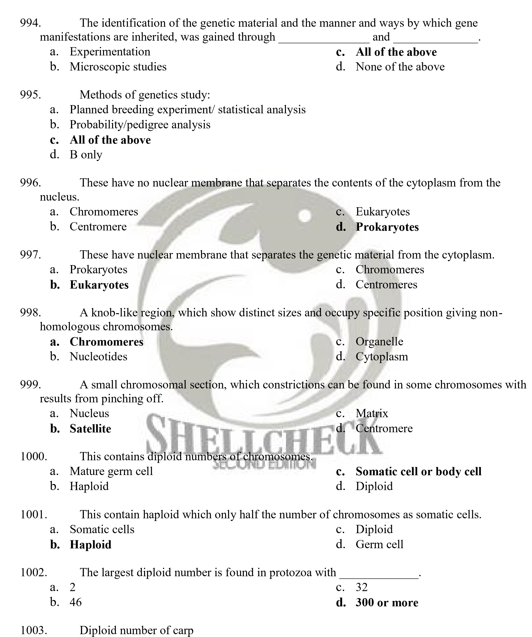
  - 104 c. 20
  - 36 d. 32

- Diploid number of starfish
38 c. 36 b. 45 d. 23
- Diploid number of green algae

a. 1 c. 46
b. 20 d. 109

- The phases in the process of mitosis which is characterized by the alignment of the chromosomes at the equatorial plane.
  - Prophase c. Anaphase
  - Interphase d. Metaphase

- The phase in the process of mitosis which the sister chromatid separate and move as daughter chromosomes to the spindle poles.
  - Interphase c. Metaphase
  - Anaphase d. Prophase

- The phases in the process of mitosis which consist of process associated with growth and preparation of mitosis.
  - Prophase c. Anaphase
  - Interphase d. Metaphase


- The phases in the process of mitosis which chromosomal fibers extend from one pole to each chromosome.
  - Metaphase c. Prophase
  - Interphase d. Anaphase

- The process by which chromosomes are separated during the formation of sex cells and their number, reduced from the diploid to the haploid condition.
  - Meiosis c. Nuclear division
  - Mitosis d. Cell division

- A number, as well as size and shape of the chromosomes of a species.
  - Karyotype c. Cytokinesis
  - Karyokenisis d. Diakenisis

- The point at which exchange of the material occurs between nonsister chromatids is evidenced by more or less X- shaped configurations.
  - Organelle c. Chiasmata
  - Cytoplasm d. Cell plate

- The two sister's chromatids connected together in their centromere regions.
  - Monads c. Chromatids
  - Dyads d. Tetrad
- Each chromatid separates from its sisters and moves to the opposite pole.
  - Dyads c. Chromatids
  - Tetrads d. Monads

- The cross by which involves contrasting expressions of one trait.
  - Dihydrid cross b. Monohybrid cross
c. Hybrid cross d. Testcross

- An inherited factor that determines a biological characteristics of an organism.
  - Allele c. Gamete
  - Gene d. Genome

- The two individual genes in a particular gene pair.
  - Gamete c. Recessive
  - Alleles d. Dominant

- A gene pair in an organism contains two identical alleles.
  - Dominance c. Homozygous
  - Heterozygous d. Recessive

- The two different alleles are present in a single gene pair.
  - Dominance c. Heterozygous
  - Recessive d. Homozygous


- This refer to the appearance of an organism or all biological appearances including chemical structural, and behavioral attitudes, that one can observe about an organism but excludes its genetics constitution.
  - Genotype c. Karyotype
  - Phenotype d. Homozygote

- This refers to the genetics factors that influence the appearance or define only the complement of genetic material that an organism inherits from its parent.
  - Genotype c. Heterozygote
  - Phenotype d. Homozygote

- The determination of the dominant and the recessive genes allows one to predict the characteristics of the offspring of a given cross.
  - Dihybrid cross c. Hybrid cross
  - Monohybrid cross d. Testcross or backcross

- This law hold the probability of the simultaneously occurrence of two independent events equal the product of the probabilities of their separate occurrences.
  - Principle of segregation c. Mendel‟s Law of Segregation
  - Law of Independent Assortment d. Product Law of Probability

- This illustrated where the heterozygote exhibits a mixture of the phenotypic characters of both homozygotes, instead of a single intermediate expression.
  - Codominance c. Complete dominance
  - Dominance d. Incomplete dominance

- This is one that causes of the death of an organism.
  - Dominant lethal c. Modifier gene
  - Lethal gene d. Gene interaction

- Genes that change the phenotypic effects of other genes in a quantitative fashion.
  - Gene interaction c. Modifier gene
  - Phenotype d. Genotype

- One of the common diagrams used to predict the result of crossbreeding.
Pearson‟s square c. Chi-square
b. Punnett square d. Analysis of Variance
- Modifiers which exist and completely suppress the phenotypic expression of the mutant gene
  - Suppressors c. Complete dominance
  - Modifier genes d. Incomplete dominance

- The degree to which an organism's genes contribute to a complex trait.
  - Hereditary c. Heritability
  - Heredity d. Genetics

- The full set of hereditary material in an organism.
  - Genotype c. Phenotype
  - Genome d. Epistasis

- The organism that have only one copy of each chromosome.
  - Diploid c. Allele
  - Haploid d. Recessive

- The organism contains two of each chromosome and thus two copies of every gene.
  - Dominance c. Haploid
  - Recessive d. Diploid


- The process by which the cells divided, full genome is copied and each daughter cell inherits one copy and it simplest form of reproduction and basis for asexual reproduction.
  - Meiosis c. Cell division
  - Mitosis d. Nuclear division

- The offspring that is genetically identical to their parents.
  - Gene c. Allele
  - Clones d. Recessive

- This law state that genes for different characters are inherited independently of one another or that member of one pair of alleles segregate independently to the other pairs.
  - Principle of Segregation c. Law of Independent Assortment
  - Product Law of Probability d. Mendel‟s law of Segregation

- The mating of individuals differing in two pairs of genes.
  - Dihybrid cross c. Backcross
  - Monohybrid cross d. Hybrid cross

- The type of interaction whereby one gene pair hide the effect of the other and the novel phenotype does not appear.
  - Epistasis c. Phenotypic
  - Recessive epistasis d. Duplicate dominant epistasis

- Any one of three or more genes may occupy a given locus in a particular pair of homologous chromosomes.
  - Multiple alleles c. Homozygote
  - Allele D. Homozygous

- A number of genes seem to be involved in the rejection or tolerance of tissue transplants.
  - Histocompatibility genes or loci c. Dominant
  - Modifier genes d. Recessive


- These define as genes with a small effect on a particular character that can supplement each other to produce observable quantitative changes.
  - Phenotype c. Trait
  - Recessive d. Polygenes

- This is a group of related symptoms characterizing a certain disease.
  - Sign c. Disease
  - Symptoms d. Illness

- A condition where some hermaphrodites show cells containing both XX and XY chromosomes.

  - Genetic mosaicism c. Genetic hybrid
  - Genetic dilution d. Genetic frequency

- Linkage where genes are so closely associated that they are always inherited together, linkage between them.
  - Incomplete linkage c. Complete linkage
  - Sex linkage d. X-linked gene

- Linkage where not complete and genes pairs assort at least partially independent of each other
  - Incomplete linkage c. Sex-linked inheritance
  - Complete linkage d. Sex linkage

- The process of exchange of part between the homologous chromosomes.
  - Shipment c. Back cross
  - Inversion d. Crossing-over

- The genes that located exclusively on the X-chromosomes.
  - Sex-linked genes c. Holandric genes
  - Mutator genes d. Sex-limited genes

- Genes that occur only on the Y chromosome can produce their effect only in males.
  - Sex-linked genes c. Holandric genes
  - Mutator genes d. Sex-limited genes

- These are those whose phenotypic expression is determined by the presence or absence of one of the sex hormones.
  - Sex-limited genes c. Sex-linked genes
  - Sex-influenced genes d. Sex-linkage
- These are those whose dominance is influenced by the sex of the bearer.
  - Sex-limited genes c. Sex-limited genes
  - Sex-influenced genes d. Complete linkage

- The relationship between sex determination and presence of particular chromosomes.
  - Sex-linkage genes c. Sex-linkage
  - Sex-limited linkage d. Incomplete linkage

- This refers to changes involving the whole genome or the entire set of chromosomes.
  - Aeuploidy c. Euploidy
  - Polyploidy d. Allopolyploid


- This is occurring when one or more chromosomes of normal set are lacking of characterized by incomplete genome.
  - Allopolyploid c. Aeuploidy
  - Euploidy d. Polyploidy

- These refer to any organism in which the number of complete set exceeds that of the diploid.
  - Polyploidy c. Allotetraploid
  - Aeuploidy d. Allopolyploid

- This is occurring when polyploids may develop and be developed from hybrids between different species.
  - Polyploidy c. Allopolyploids
  - Euploidy d. Allotetraploid

- This refers to the organism which has two genomes from each of the two ancestral species.
  - Allotetraploids c. Polyploidy
  - Allopolyploids d. Euploidy

- The presence of a section in chromosomes in excess of the normal amount.
  - Inversion c. Translocation
  - Duplication or Repeats d. Transversion

- The rotation of a chromosome segment to a full 180⁰
  - Transversion c. Translocation
  - Inversion d. Duplication

- The transfer of a location of one chromosome to a non-homologous chromosome.
  - Transversion c. Inversion
  - Translocation d. Repeats

- This refers to the point mutation or a result of base pair substitution.
  - Mutation c. Mutagenic agent
  - Modifier genes d. Gene mutation

- These refer to genes that cause cancer.
  - Edward's syndrome c. Controlling element
  - Down Syndrome d. Oncogenes

- The sequence of bases in one strand of the double helix accurately predicts the sequence of bases in the other complementary strand.
  - Replication fork c. Genetic Information
  - Transfer RNA d. DNA Replication

- The junction between the separate strands and the remaining double helix.
  - Replication fork b. DNA replication
c. Genetic information d. Transfer RNA

- These carried by DNA from cell to cell and from generation to generation.
  - Heredity c. Genetics
  - Evolution d. Genetic information

- An intermediate molecule that carries the information from DNA in the nucleus to the ribosome in the cytoplasm.
  - Deoxyribonucleic Acid c. Ribosomal RNA
  - Ribonucleic Acid d. Transfer RNA

- These refer to the information stored in DNA and ultimately translated into amino acid sequence of proteins.
  - Transfer RNA c. Genetic Information
  - Messenger RNA d. Genetic code

- A messenger RNA triplet that code for each amino acid.
  - Code c. Ribosome
  - Codon d. Cytoplasm

- This has been named transcription, meaning "to copy over".
  - Ribosomal RNA c. Transfer RNA
  - Messenger RNA d. RNA synthesis


- A long, single-stranded molecule that includes the codons that will be translated into the amino acid sequence of a protein.
  - Ribosomal RNA c. RNA synthesis
  - Transfer RNA d. Messenger RNA

- A complex molecules, twisted about into a shape something like three-leaf clover with a stem.
  - RNA synthesis c. Messenger RNA
  - Ribosomal RNA d. Transfer RNA

- This refers to which the genes for relations function lie next to one another.
  - Operons c. Introns
  - Exons d. Enhancer

- This is the coding segments which are express in protein.
  - Introns c. Operons
  - Exons d. Enhancer

- This is the non-coding segment which they intervene between the exons.
  - Exons c. Introns
  - Enhancer d. Operons

- This regulates binding of RNA polymerase to the promoter.
  - Enhancer c. Operons
  - Exons d. Introns

- This referred to as recombinant DNA or molecular cloning.
  - Cloning b. Hybridization
c. Recombinant DNA technology d. Genetic engineering

- An offspring possessing of only maternal chromosome
  - Gynogen c. Genome
  - Transgenic d. Hybrid

- Which of the following is the most salt tolerant tilapia species?
  - Java tilapia c. Oreochromis hornotum
  - Nile tilapia d. Oreochromis aureus

- The method of chromosomal manipulation wherein both set of chromosomes came from paternal parent.
  - Polyploidy c. Transgenesis
  - Haploidy d. Androgenesis

- Synthetic male hormones that is used for direct hormonal sex reversal to sexually undifferentiated tilapia
  - Super phosphate c. Methyl testosterone
  - Methyl estrogen d. Propyl testosterone

- A group of individuals derived from a common genetic origin
  - Strain c. Transgenic
  - Phylogeny d. Stock

- A mating in which a hybrid is crossed with a parental type
  - Sex reversal c. Gynogen
  - Back cross d. Transgenic

- Male parent in a cross
  - Dame c. Breeder
  - Sire d. Smolt

- An approach to selective breeding where top performing individuals from a mixed population are selected
  - Mass selection c. Inbreeding method
  - Hybridization d. Transgenic manipulation


- A technique for genetic improvement where a specific recombinant genes is inserted for rapid improvement of growth (when inserted with specific genes associated with growth control)
  - Ploidy manipulation c. Androgenetic
  - Hybridization d. Transgenic manipulation

- A selection method which aim to reduce variation within a population
  - Directional selection c. Disruptive selection
  - Stabilizing selection d. Random selection

- The spontaneous process that produces a gene or chromosome set differing from the wild-type
  - Mutation c. Cloning
  - Gene transfer d. Genetic manipulation

- In this system, sex is determined by the presence of Y chromosome
  - Heterogametic male/ homogametic female system
  - Homogametic male/ heterogametic female system
  - Autosomal system
  - Environmental system
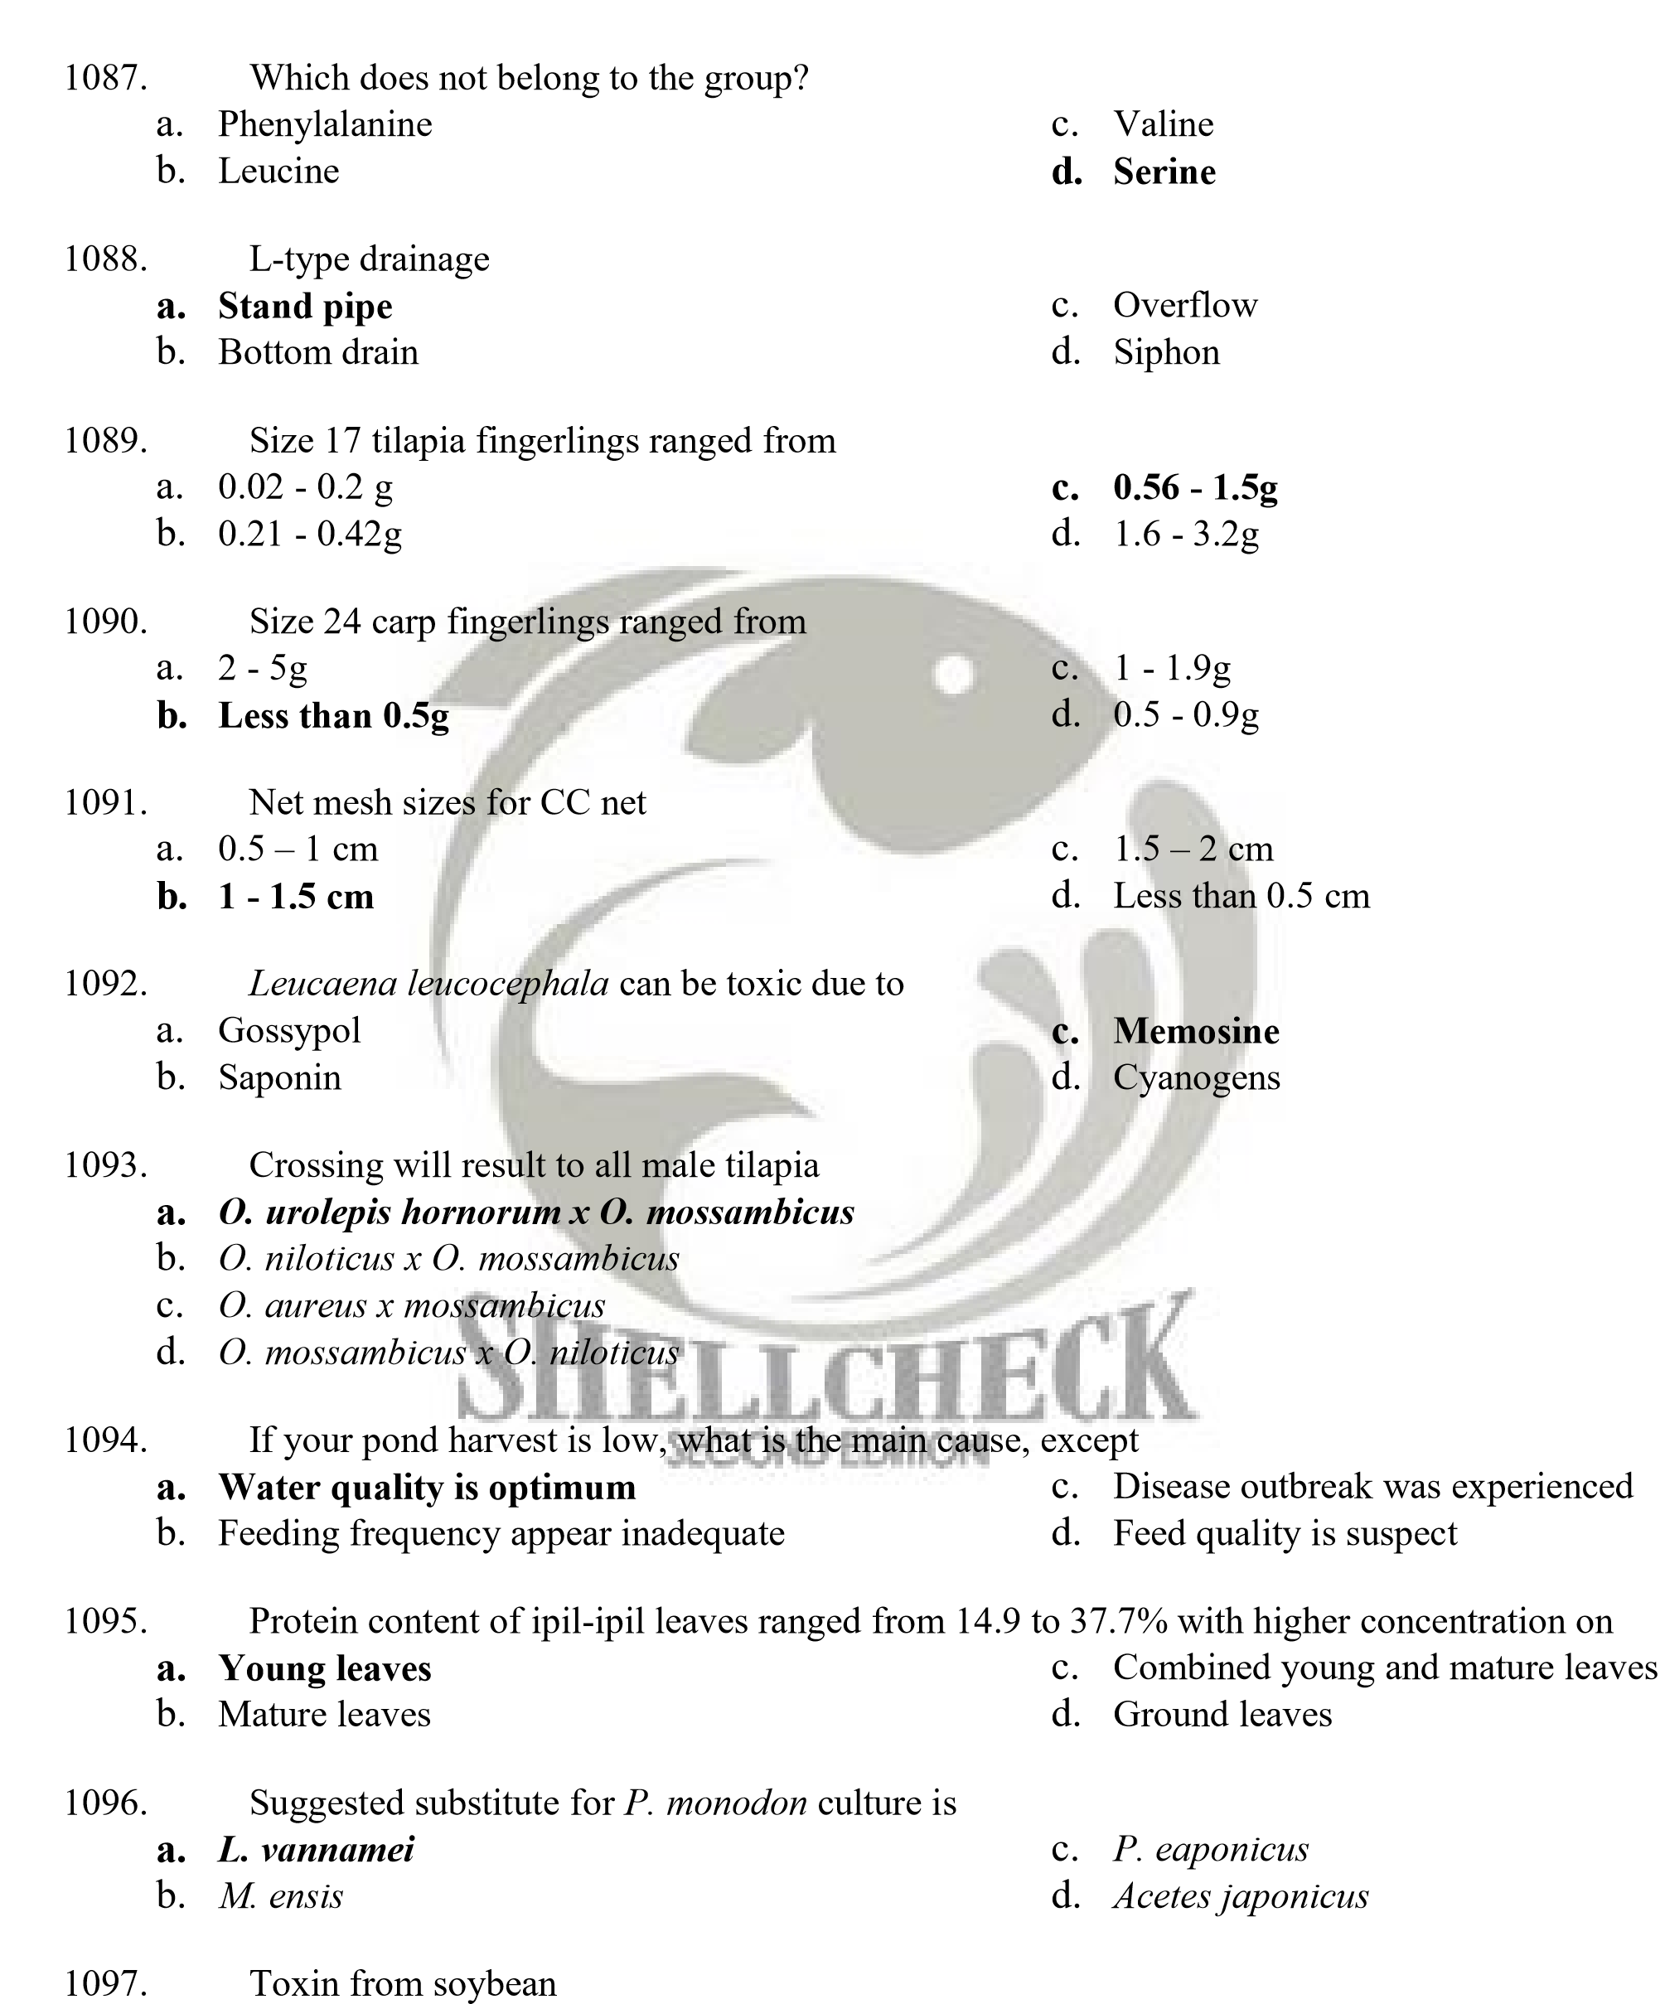
  - Saponin c. Memosine
  - Cyanogens d. Aflatoxin

1098. In peanuts, aflatoxin is produced by the mold
- Aspergillus paraliticus c. Aspergillus flavus
- Fusarium d. Trichoderma

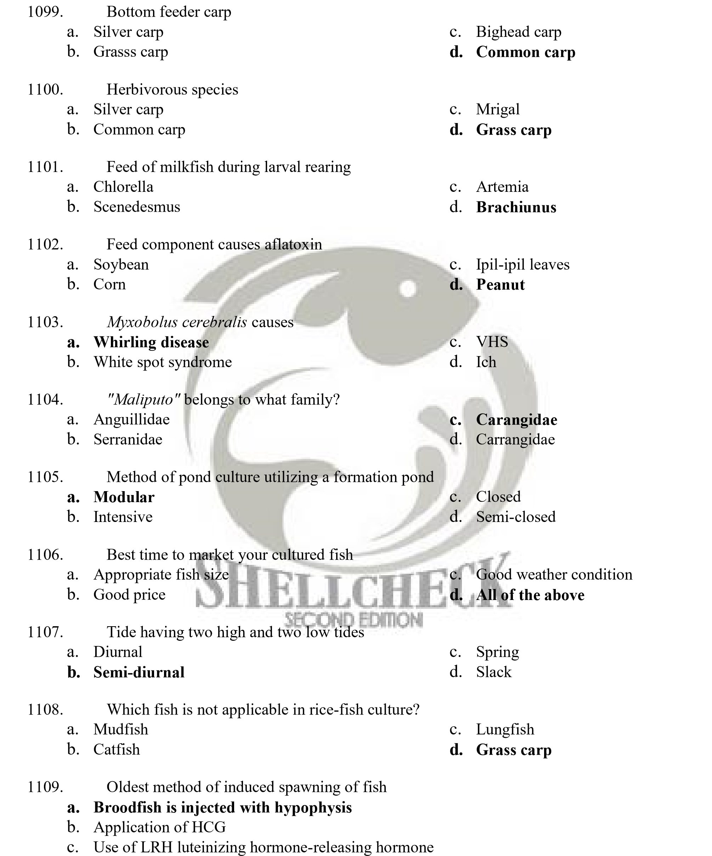
d. Use of LRH analogue

- Fish mark-recapture method is used to

  - Determine population mortality
  - Calculate fish production

  - Estimate population size
  - Compute immigration rate

- What progeny will be produced if O. urolepis hornorum and O. mossambicus are crossed?
    - All female c. All-male progeny
    - 50-50 male-female d. None of these

- Scientific name of tawes?
    - Clarias batrachus c. Arius sp.
    - Seriola quinqueradiata d. Puntius javanicus

- What is the correct order of the stages of crab development?
    - Egg-zoea-megalopa-crab instar-mature crab
    - Egg-megalopa-zoea-crab instar-mature crab
    - Egg-zoea-crab instar-megalopa-mature crab
    - Egg-mature crab

- Which of the following indicates a good FCR value?
    - 1.25 c. 1.75
    - 1.5 d. 2.0

- . Which of the following culture system relies only on natural food for nutrition?
    - Extensive culture c. Intensive
    - Semi-intensive d. Super intensive

- Freshwater species that can be cultured in sea cages?
    - Freshwater catfish c. Freshwater carp
    - Freshwater prawn d. None of the above

- This disease is characterized by white necrotic areas in the abdominal muscles and in severe cases, muscle decay occurs, causing reddening. This disease is caused by IMNV.
    - White spot disease c. Necrotizing hepatopancreas
    - Infectious myonecrosis d. All of the above

- Which of the following culture system relies on protein-rich feeds with supplemental natural food?
    - Extensive c. Intensive
    - Semi-intensive d. Super-intensive

- Which of the following device measures water turbidity?
    - Monochrome plate c. Turbidometer
    - Secchi disc d. None of the above


- A pond was stocked with 2,500 pieces fingerlings weighing 2 grams each. By the end of the rearing period, the stock consumed 600 kilos of feed. The average body weight of the stock is 200 grams. Compute for the feed conversion ratio.
    - 1.8 c. 1.2
    - 1.5 d. 1.0

- Which of the following is used to increase pond alkalinity?
    - Lime c. Pesticide
    - Fertilizer d. All of the above

- What is the main cause of feed rancidity?
    - Lipid oxidation c. Moisture loss
    - Protein denaturation d. None of the above

- How many hours does it take to hatch Pangasius eggs?
    - 12-18 c. 27-32
    - 34-38 d. 8-12

- This is a method of promoting growth of natural food using cow/chicken manure placed in sack with holes and are placed in the water inside the pond/cage.
    - Hanging method c. Manure dispersion
    - Teabag method d. None of the above

- Which of the following culture schemes stocks two or more species of fish in one pond during the same culture period?
    - Polyculture method c. Competitive culture
    - Integrated fish farming d. None of the above


- A pond is stocked with 2,500 pieces fingerlings. The average body weight of the stock is 50 grams and needs 4% feed requirement. Mortality is 10%. Compute for the amount of feed to be given in one day.
    - 4.0 kgs c. 4.5 kgs
    - 0.5 Kg d. 5.5 kgs

- Which of the following is not considered as live feed for nursery culture?
    - Moina c. Infusoria
    - Artemia d. None of the above

- A 1Ha pond was excavated and is to be filled with water to a depth of 0.6m. How much water must be stocked to achieve the said water level?
    - 60,000sq.m. c. 60,000cu.m.
    - 6,000sq.m. d. 6,000cu.m.

- Refers to one of the gross signs of grass carp hemorrhagic disease where a fish suffers from the protrusion of the eyeball.
    - Exovisua c. Exophthalmia
    - Popping eyes d. Ichthyothalmia

- What is the top producing region for seaweed in 2009?
    - ARMM c. Region VI
    - Region IV-B d. NCR

- What are the three important elements in fertilizers necessary for natural food growth?
    - O-C-H c. Au-FI-Xe
    - N-P-K d. All of the above

- Sea ear are marine gastropods belonging to the genus:
    - Haliotis c. Mammalia
    - Crassostrea d. None of the above

- Which of the following culture species has the highest value?

    - Milkfish
    - Tilapia

- FAO 205 is:
- Grouper
- All of the above

    - Pricelist of tilapia fingerlings and breeders and carp fingerlings for sale by the Bureau of
Fisheries and Aquatic Resources
    - Guidelines in the implementation of HACCP system
    - Insurance for aquaculture crops/stocks
    - None of the above

  - Which of the following culture method is used in seaweed culture?
    - Lantay method c. Raft method
    - Floating monocline d. All of the above

  - Family of tilapia which is generally carnivorous
    - Mugilidae c. Serranidae
    - Cichlidae d. Angullidae

  - Successful technology in catffish (C. batrachus)
    - Philippines c. Vietnam
    - Indonesia d. Thailand

  - Successful technology and production in M. vannamei
    - Thailand c. Sri Lanka
    - Philippines d. Vietnam

  - Species of sea cucumber cultured in the Philippines
    - Holothuria nobilis c. Thelenota ananas
    - Holothuria fuscogilva d. Holothuria scabra

  - Component of PNAP project is a lying-in set-up for what species?
    - Penaeus monodon c. Scylla serrata
    - Mugil cephalus d. Portunus pelagicus

  - It is caused by the refraction, reflection, and dispersion of light through ice particles suspended within thin, wispy, high altitude cirrus or cirrostratus clouds. As light passes through these hexagon-shaped ice crystals, it is bent at a 22 degree angle, creating a halo 22 degrees in radius (or 44 degrees in diameter).
    - Moon ring c. Moon albedo
    - Lunar hao d. Lunar circle

  - Local name of pond loach
    - Tamasak c. Dojo
    - Bayawak d. All of these

  - The African night crawler (ANC), known scientifically as_____________, is considered as the most efficient composting earthworm in the tropics. Introduced by Dr. Guerrero III in 1982, it was used for vermicomposting in the tropics, widely used in mesophilic production of compost.
    - Eisenia fetida c. Lumbricus rubellus
    - Dendrobaena veneta d. Eudrilus eugeniae

  - Also known as gulfweed and sea holly because of its highly branched thallus with hollow, berrylike floats (pneumatocysts) and many leaflike sawtooth-edged blades. It is used as fertilizer.
    - Caulerpa c. Macrocystis
    - Laminaria d. Sargassum

  - The lab measurements based on the classic Winkler titration method developed by Lajos
Winkler in 1888 is used to measure
    - Phosphate c. Ammonia
    - Oxygen d. Salinity

  - A live microbial feed supplement which beneficially affects the host animal by improving its intestinal balance.
    - Antibiotics c. Probiotics
    - Enzyme d. Immunostimulants

  - Lactobacillus is often referred to as a
    - Antibiotics c. Antigen
    - Probiotics d. Antimicrobials

  - Common species of brackishwater pond snail in the Philippines
    - Trochus snail c. Cerithidia cingulata
    - Pila luzonica d. Pomacea spp.

  - Commonly used lime
    - Quicklime c. Agricultural lime
    - Dolomite d. Hydrated lime


  - Naturally occurring soils, sediments or organic substrates that are formed under waterlogged conditions. These soils contain iron sulfide minerals (predominantly as the mineral pyrite) or their oxidation products. However if the soils are drained, excavated or exposed to air by a lowering of the water table, the sulfides react with oxygen to form sulfuric acid.
    - Sandy c. Loamy
    - Acid sulfate d. Acid phosphate

  - Back azimuth of 135 degrees
    - 315 c. 531
    - 513 d. 351

  - Highly sensitive and rapid method that can be used for rapid detection of shrimp pathogens such as whitespot syndrome virus (WSSV) and Vibrio spp.
    - Staining c. Polymerase chain reaction
    - Microscopy d. X-ray

  - Nutrient values in inorganic fertilizers expressed as total percentage of weight of each fertilizer as packaged. If you don-t potassium, what fertilizer combination will you use?
    - 14-14-14 c. Urea
    - 16-20-0 d. Ammonium sulfate

  - The second biggest lake in the Philippines
    - Lanao c. Paoay
    - Buhi d. Naujan

1155. Milkfish harvesting method in which the rheotactic behavior of the species is taken into advantage by the aquaculturist
- Gill netting c. Partial draining
- Total draining d. Pasubang
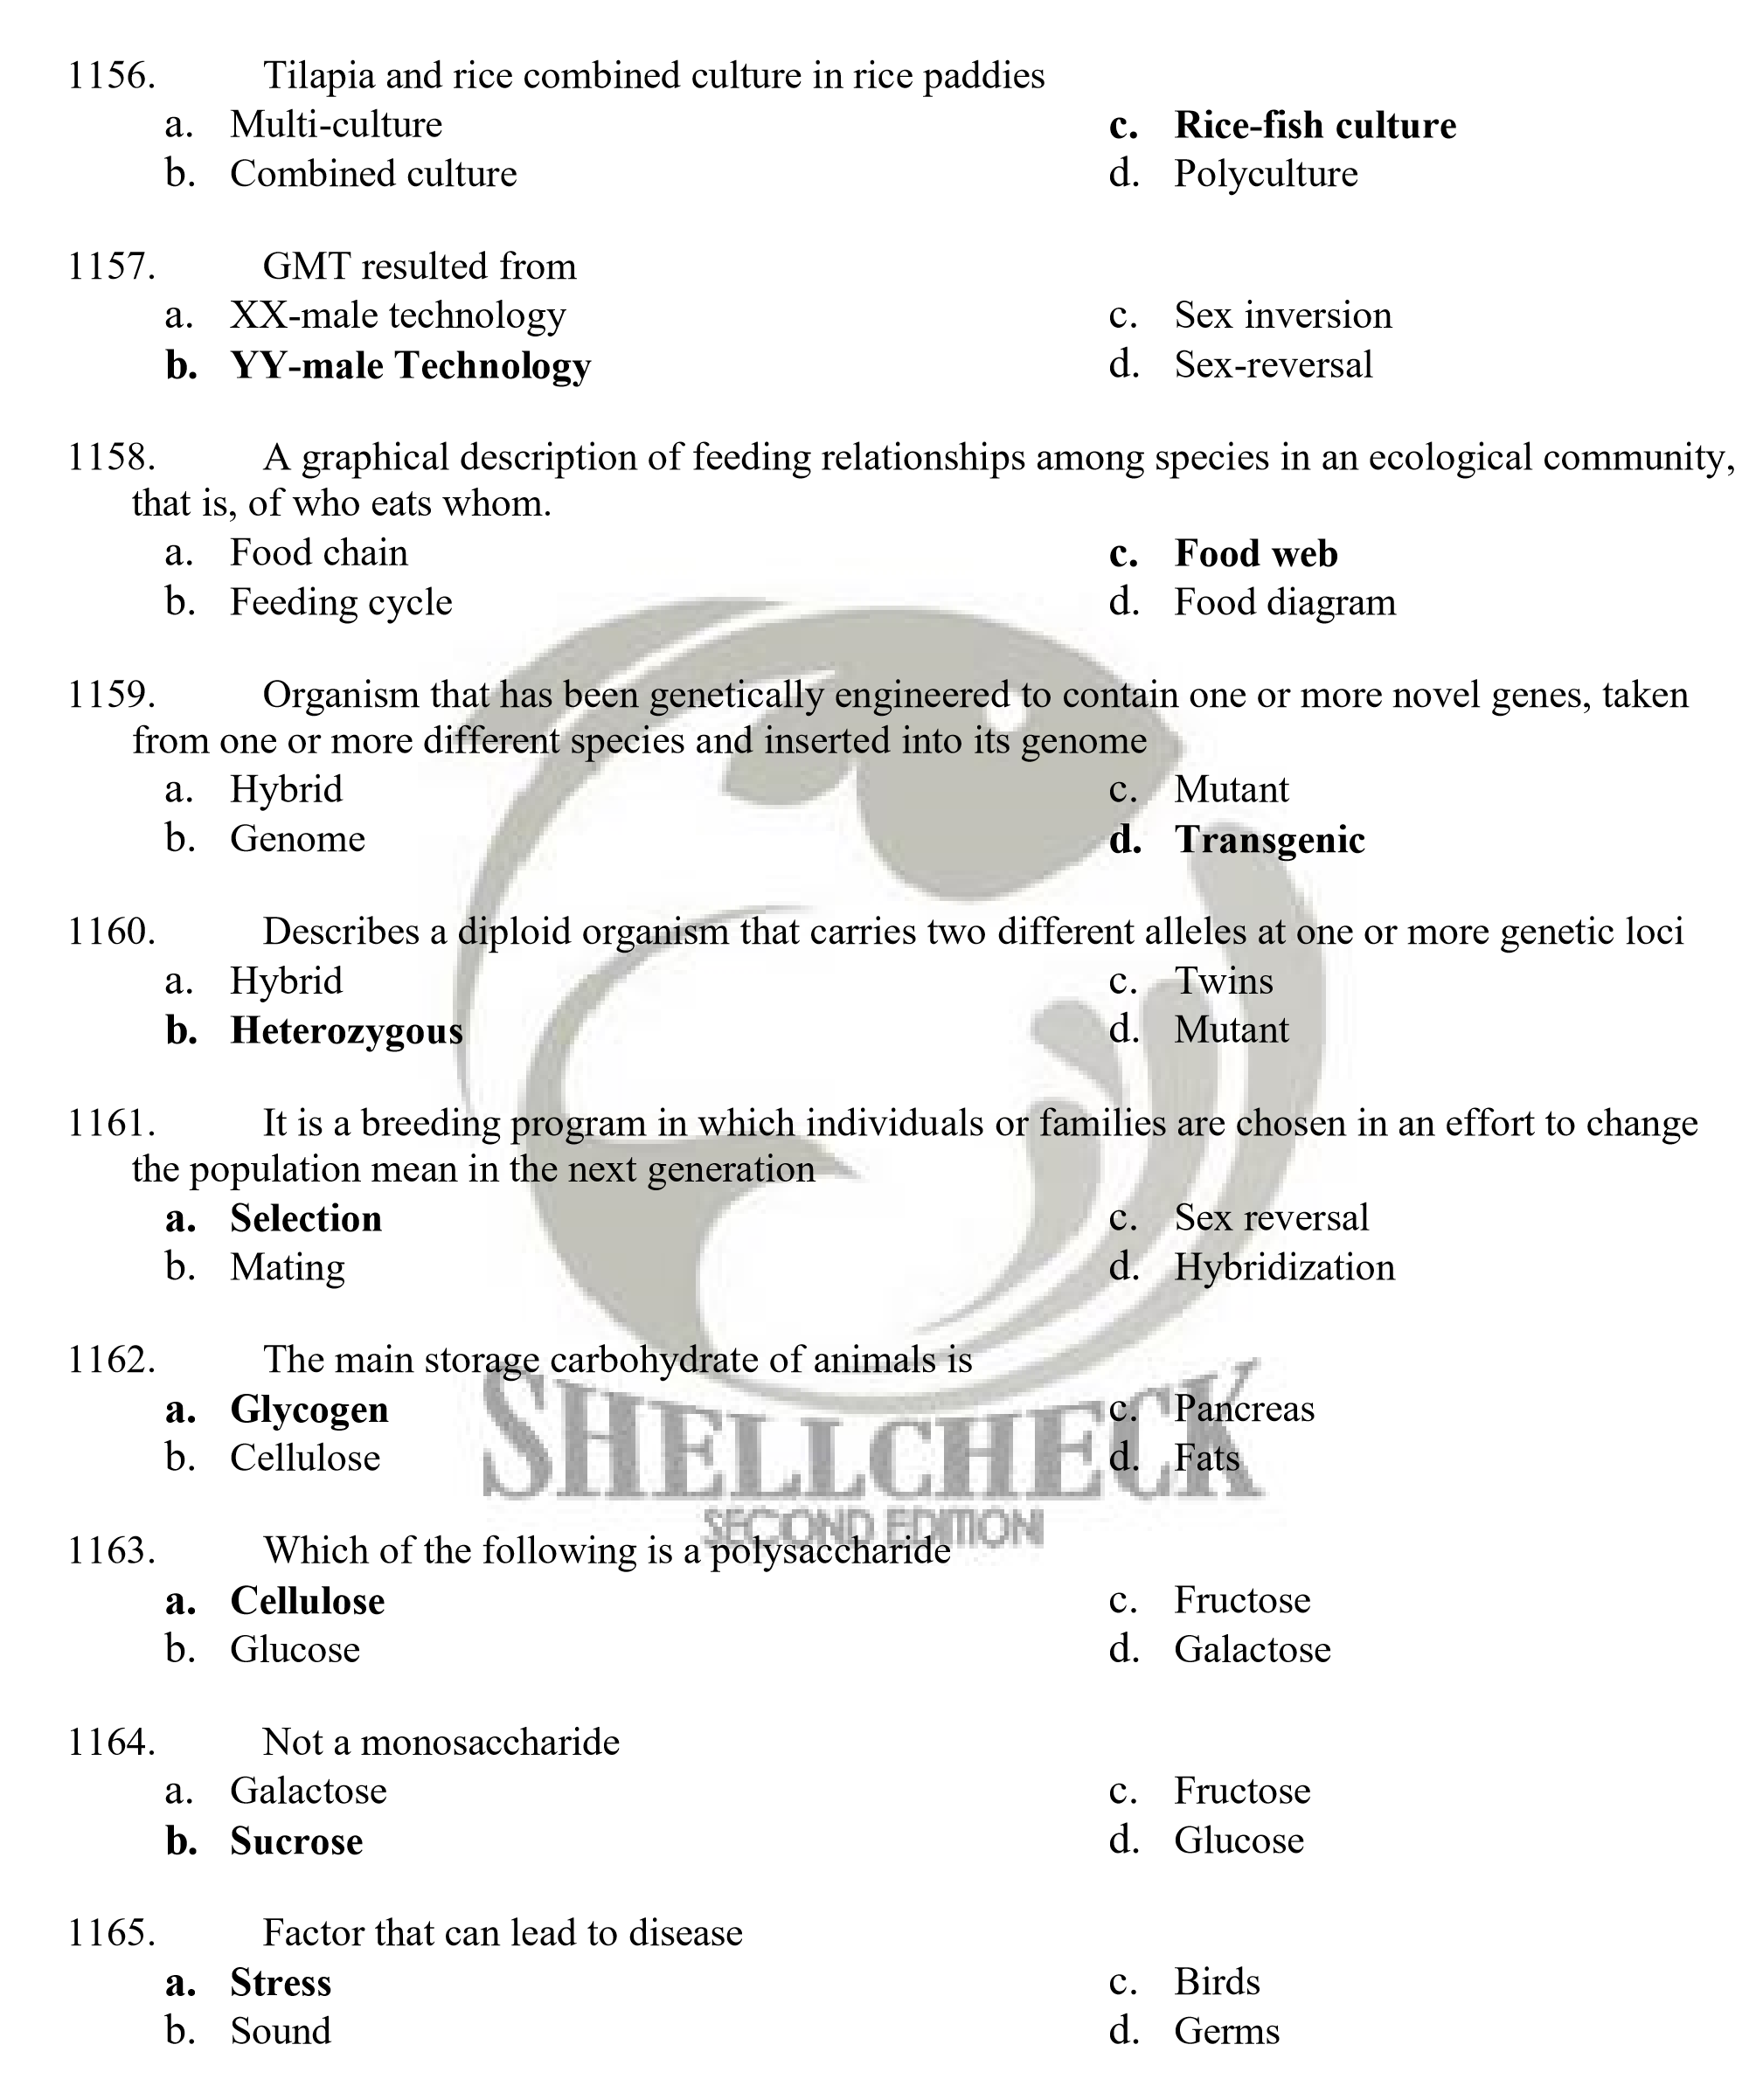
- Higher dikes
  - Zone A c. Zone C
  - Zone B d. Zone D

- This silvofisheries model is characterized by mangroves which are separate from the ponds
    - Type I c. Type III
    - Type II d. Type IV

- This mangrove zonation (Watson 1928), is characterized by tidal height 11-13 ft. With a frequency of 20-45 times/month and is flooded by normal high tides
    - Class 1 c. Class 3
    - Class 2 d. Class 4

- Mangrove zonation related to tidal data (low to high)
    - Sonneratia-Rhizophora-Nypa-Bruguiera
    - Sonneratia-Bruguiera-Nypa-Ryzophora
    - Avicennia-Rhizophora-Bruguiera-Nypa
    - Avicennia-Rhizophora-Nypa-Bruguiera

- After flowering and pollination, many mangroves develop viviparous seeds called
    - Propagules c. Seedstock
    - Seedlings d. Mangrovecules

- Sea urchin cultured in the Philippines is of the species
    - Eucidaris tribuloides c. Arbacia lixula
    - Tripneustis gratilla d. Diadema antillarum

- Which does not belong to the group?
    - Swaki/kuden-kuden c. Maritangtang
    - Santol-santolan d. Bukol-bukol

- Spiny lobster or "banagan" is scientifically called
    - Sylla serrata c. Panulirus sp.
    - Penaeus monodon d. Macrobrachium sp.

- Known as Brackishwater Frog; Palakang Palayan; Palakang Bukid
    - Rana catesbeiana c. Rana cancrivora
    - Platymantis guentheri d. Limnonectes magnus


- Knife fish is an introduced species reared by hobbyists that accidentally escaped and found its way into Laguna de Bay and is classified as an invasive species. It is scientifically called
    - Chitala sp. c. Hypseleotris agilis
    - Pterygophlichthys pardales d. Gambusia affinis

- Suckermouth catfish
    - Janitor fish c. Knife fish
    - Jaguar cichlid d. African catfish

- Species of freshwater clam in the Philippines that has a good potential for culture in ponds and is locally known as "paros"
    - Corbicula fluminea c. Perna viridis
    - Pilsbryoconcha exilis d. Quadrula mitchelli

- Based on DAO No. 34 s. 1990 of the DENR, under Fresh Surface Water Category, fishery water for the propagation and growth of fish, is classified under Class _________.
    - Class AA c. Class B
    - Class A d. Class C

- Based on DAO 34 s. 1990 of DENR, under the category "Coastal and Marine Waters", waters suitable for the propagation, survival and harvesting of shellfish for commercial purposes is categorized under Class _________
    - Class SA c. Class SC
    - Class SB d. Class SD

- Equipment used for measuring vertical and horizontal distances; vertical and horizontal angles, for prolonging lines, for levelling operations, and others.
    - Sextant c. Planimeter
    - Telescope d. Engineer’s transit

- Just like the transit, levels vary from simple or less accurate models of hand levels up to the sophisticated and precision models such as the self-levelling level. These are used mainly for measuring vertical and horizontal distances in levelling operations. Some models are equipped with horizontal circle to measure horizontal angle.
    - Planimeter c. Levels
    - Sextant d. Bubble


- It‟s essential features are: (i) a compass box with circle graduated from 0° to 90° in both directions from the N and S points and usually having the E and W points interchanged: (ii) a line of sight in the direction of the SN points of the compass box: and (iii) a magnetic needle supported freely on a pivot. The whole compass can be attached to a tripod by a ball and socket joint.
    - Magnetic compass c. Planimeter
    - Odometer d. Radar

- Also called target rod, this is usually made of wood graduated either in English or metric units for measuring vertical distances in conjunction with the transit or level. This comes in lengths of 2 to 4 m.
    - Levelling rod c. Distance rod
    - Range rod d. Angle rod

- These are slender round poles usually made of metal or wood painted with alternate bands of red and white. These are stuck along the line of survey in order to establish a straight line of sight.
    - Levelling pole c. Target pole
    - Distance pole d. Range poles

- Used for direct measurements of horizontal distances
    - Meter stick c. Ruler
    - Tapes d. Telescope
- A quick way of measuring distance using the transit or level instruments, having telescope provided with hairs and levelling rod.
    - Stadia method c. Radar
    - Psychrometer d. Planimeter

- It is the angle that is referred from the North and South, whichever is nearest with the added designation of east or west, whichever applies. It can never be greater than 90°.
a. Angular orientation b. Azimuth
c. Angles to the right d. Bearing

- Its line is a clock wise angle measured from a reference direction usually North. The South end of the North-South line is also being used as reference direction in geodetic surveys.
    - Bearing c. Quadrant
    - Angle d. Azimuth

- Refers to the vertical distance of a ground point from the reference datum plane (MLLW).
    - Zero datum c. Bench mark
    - Elevation d. Contour

- Soils that contain a high proportion of hydrogen and aluminum ions compared to the hydroxyl ions.
    - Acid sulfate c. Clay
    - Loam d. Silt

- Soils that result from the formation of pyrite.
    - Loam c. Clay
    - Acid sulfate d. Loam-clay

- Pale yellow mottles overlying the subsoil and red coloration of pond bottom when drained are characteristics of __________ soils.
    - Loam c. Silt
    - Clay d. Acid sulfate


- In identifying actual and potential acid sulfate soils, variation in elevation and occurrence of mounds, especially of mud lobster are some of the considerations. Scientific name of mud lobster is
    - Panularis sp. c. Thallasia
    - Sylla serrata d. Thalassina anomala

- The area of a portion of a field that is bounded by an irregular curve in one side such as a river can easily be determined by using the
    - Planimeter c. Transit
    - Trapezoidal rule d. GPS

- _______ show the configuration or changes in elevation of the ground in a topographic map
    - Map c. Contour lines
    - Profile levelling d. Topographic grid

- Each __________ represents points of same elevation and are spaced according to the difference in elevation between two adjacent lines.
    - Contour line c. Grid
    - Profile level d. All of these

- It is a common situation in coastal fish farm site to conduct topographic survey on an area that is under shallow tidal water. The usual method used is by __________
    - Secchi disc c. Echo sounder
    - Stadia rod d. Sounding

- Fishponds should be planned in such a way that the length of the pond is positioned __________ to the prevailing wind direction.
a. Perpendicular b. In line
c. Parallel d. Against

- Is the smallest unit in a pond system usually 4 to 8 m².
    - Nursery pond c. Kitchen pond
    - Formation pond d. Fry pond

- In the Philippines, a sanctioned buffer zone of at least __________ from the sea to the main perimeter dike and 20 m along river banks is spared for ecological consideration as well as physical protection against flooding and wave action.
    - 100m c. 200m
    - 150m d. 250m

- This pond serves as a concentration area or basin for the fish during harvest.
    - Catching pond c. Seining pond
    - Concentration pond d. Formation pond


- A compartment set aside for growing live food organisms at high density. This is intended to augment the availability of food in fishpond areas where natural food organisms does not grow well or in farm set-up where high density stocking of cultured fish is used.
    - Rearing pond c. Kitchen pond
    - Special pond d. Formation pond

- In this system, specified number of milkfish fingerlings from the transition pond are stocked in the smallest production pond, then moved to the next bigger then to the largest pond.
    - Radiating c. Multiple stock/harvest
    - Modular or Progression System d. Conventional

- In this milkfish pond layout, there is no transition pond. Instead holding canal for fingerlings is allocated for each rearing pond.
    - Radiating c. Multiple stock/harvest
    - Modular d. Conventional

- Used as a fishmeal replacer
    - Ipil-ipil c. Poultry discards
    - Corn d. Soybean

- Which does not belong to the group?
    - Vitamin A c. Vitamin C
    - Vitamin D d. Vitamin K

- The yellow mottles found in most acid sulphate soils
    - Pyrite c. Calcium oxide
    - Jarosite d. Copper

- In general, a perennial fishpond is
    - Acidic c. Neutral
    - Basic d. Highly fluctuating

- In shrimps, Vibrio harveyi and V. splendidus causes
    - White Spot Syndrome c. Monodon Baculovirus Disease
    - Luminous Bacterial Disease d. Hepatopancreatic Parvo-like Virus

- White Spot Syndrome Disease could be detected using
    - Microscopy c. Spectrophotometer
    - Staining d. PCR

- Taura Syndrome in Litopenaeus vannamei is caused by
    - Vibrio fischeri c. Vibrio splendidus
    - Vibrio harveyii d. Aparavirus

- Milkfish and shrimp could be polycultured with what species of seaweeds?
    - Porphyra sp. c. Gracilaria
    - Codium sp. d. Kappaphycus alvarezii

- In China, fish culture in rice field has a long history which can be dated as far back as the mid Han Dynasty about 100 AD. The species of fish used is
    - Milkfish c. Tawes
    - Clarias gariepinus d. Common carp

- Active ingredient of rotenone?
    - Derris root c. Ipil-ipil
    - Cassava d. None

- Nitrogen toxic to fish
    - Ammonia c. Nitrite
    - Nitrate d. None of these

- Scientific name of green mussel is
    - Piridis verna c. Crassostrea iridalei
    - Crassosterea malabonensis d. None of these

- Practical method of measuring turbidity in ponds
    - Secchi disc c. Sounding
    - Meter stick d. Manual

- First mariculture project in the Philippines was established in
    - Tacloban city c. Puerto Princesa City
    - Pangasinan d. Mindoro


- A live microbial adjunct which has a beneficial effect on the host by modifying the hostassociated or ambient microbial community, by ensuring improved use of the feed or enhancing its nutritional value, by enhancing the host response towards disease, or by improving the quality of its ambient environment.
    - Antibiotic c. Pathogen
    - Antigen d. Probiotic
- Expressed by the letter K, it is another measure of an individual fish‟s health that uses standard weight by assuming that the standard weight of a fish is proportional to the cube of its length
    - Standard weight c. Growth
    - Fulton’s Condition Factor d. Weight-Length Relationship

- In fish, a graph of log W against log L forms a straight line with a slope of b and a Y-axis (log W) intercept of log a. Invariably, b is close to 3.0 for all species. Hence, if b = 3, growth is said to be ______
a. Allometric b. Isometric
c. Parametric d. Trigonometric

- Not an indigenous species in the Philippines
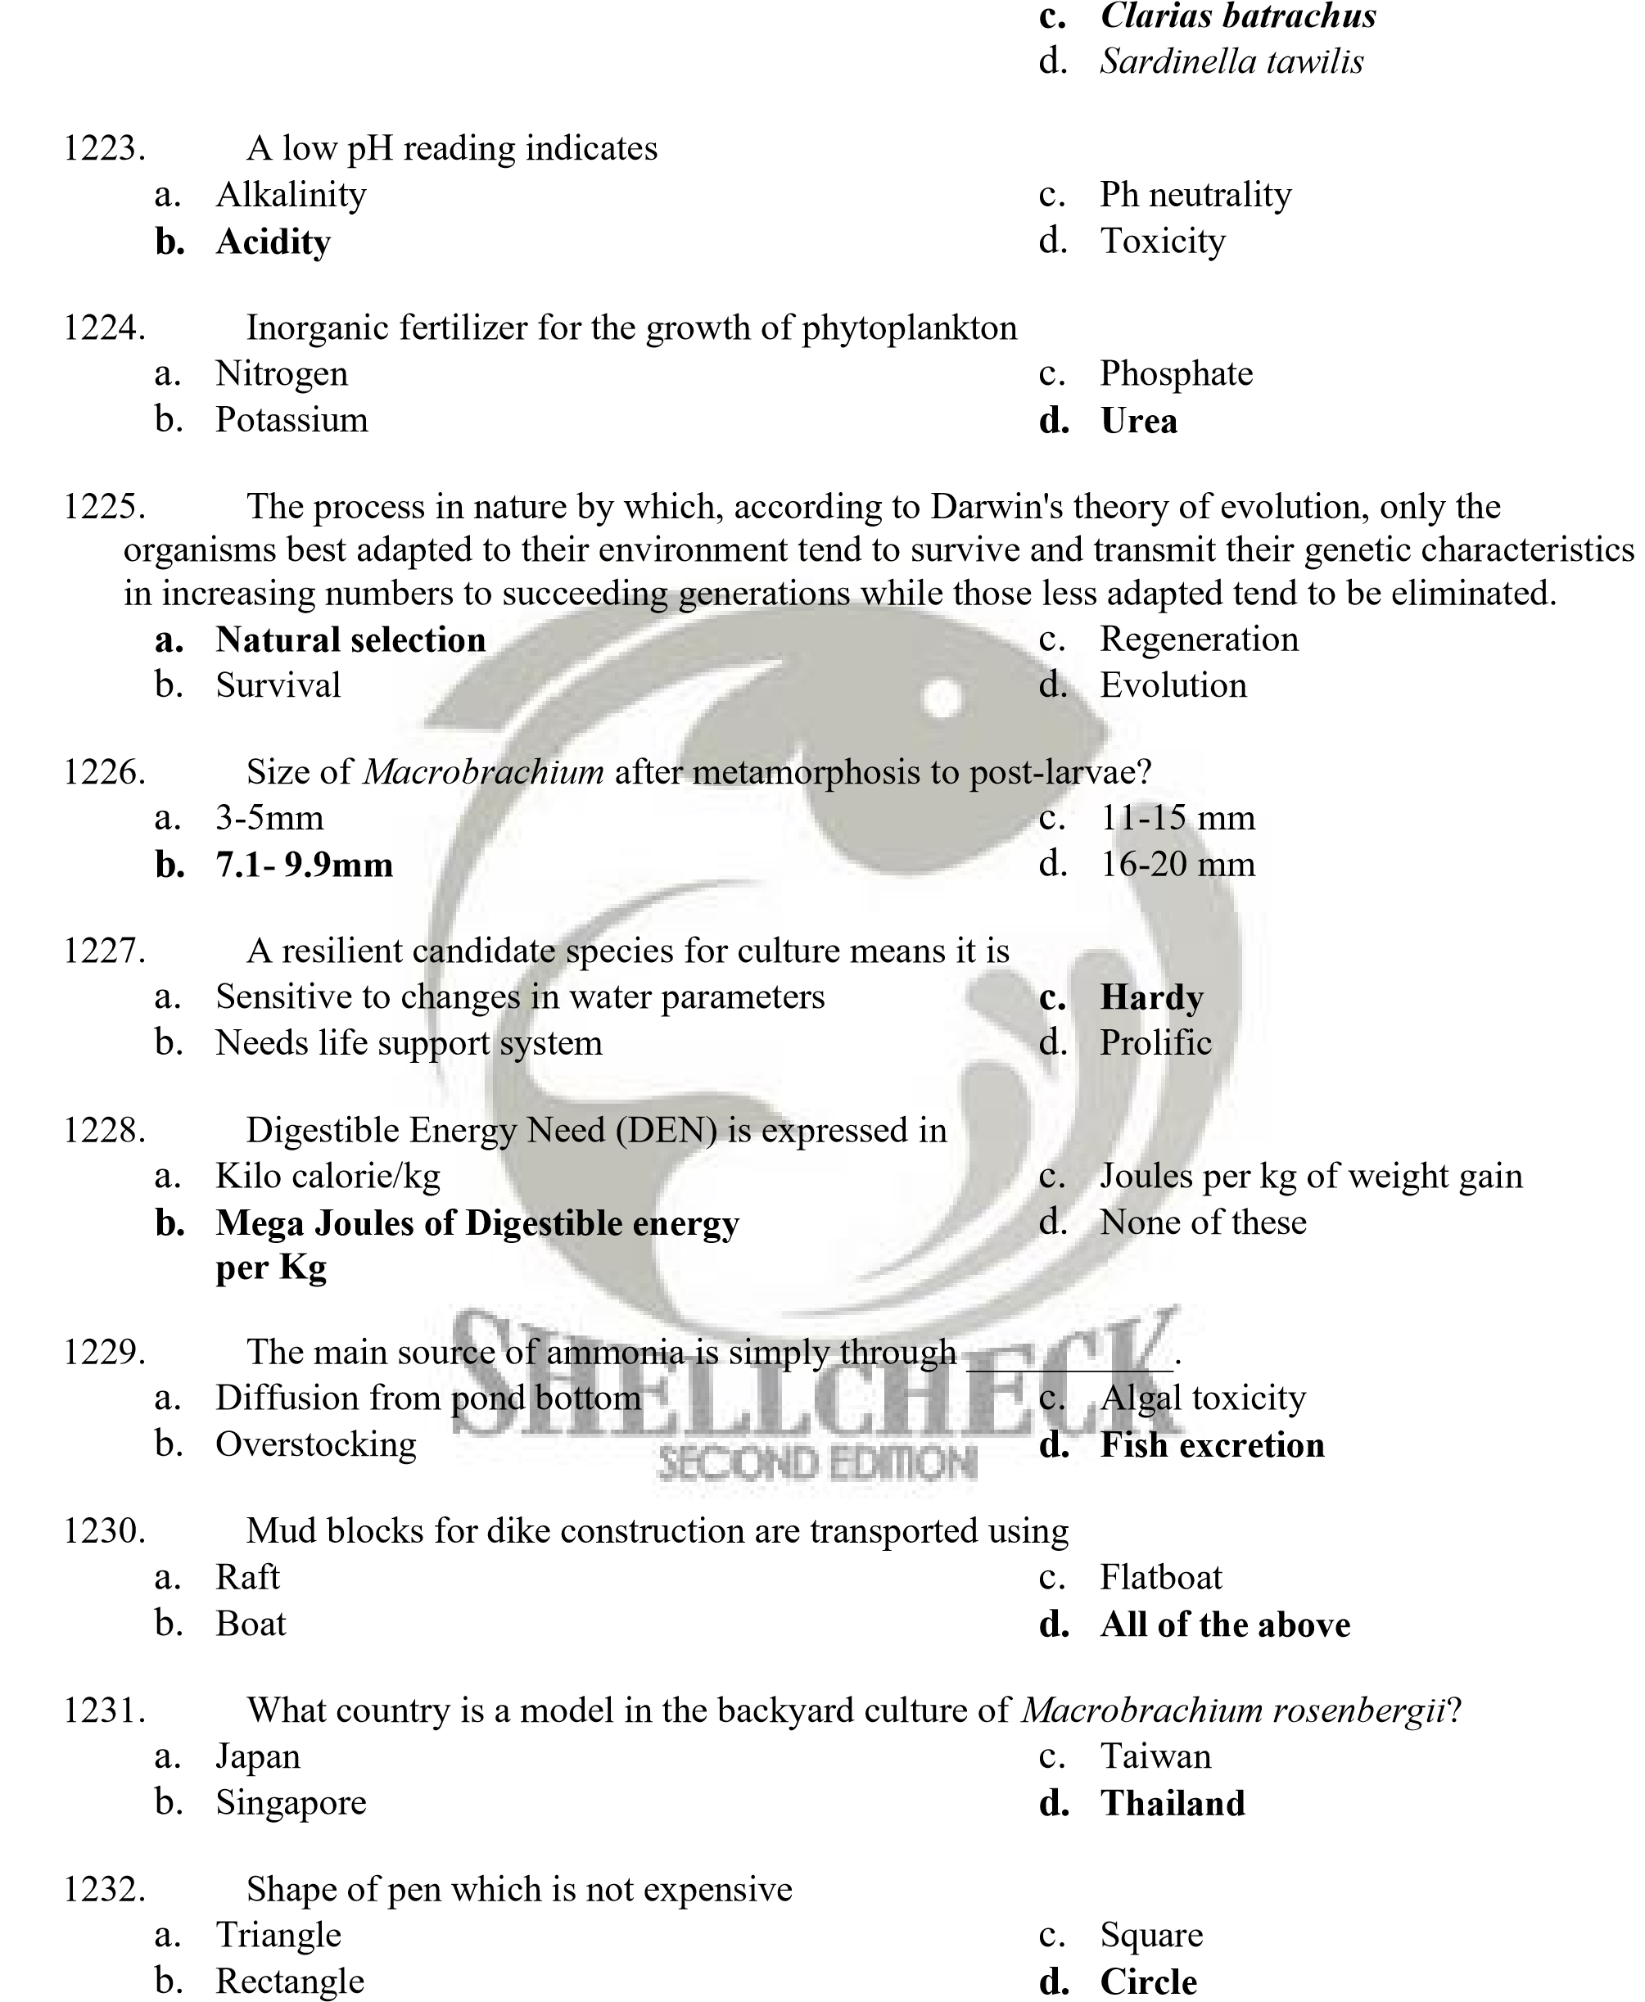
    - Penaeus monodon
    - Chanos chanos

- Instrument used to measure how much a chemical substance absorbs light by measuring the intensity of light as a beam of light passes through sample solution. The basic principle is that each compound absorbs or transmits light over a certain range of wavelength.
  - Spectrophotometer c. Barometer
  - CTD d. Infrared camera

- Has least crude protein
  - Fish meal c. Soybean
  - Rice bran d. Sunflower

- Could be used to eliminate unwanted fish and harmful insects from fish pond, except
  - Ammonium sulfate and lime c. Teaseed cake
  - Tobacco dust d. Brestan

- Within the plankton, this group spends their entire life cycle as plankton (e.g. Most algae, copepods, salps, and some jellyfish).
  - Holoplankton c. Nanoplankton
  - Meroplankton d. Phytoplankton

- UV rays are used in aquaculture to
  - Provide light to aquaculture set-up
  - Used for filtration purposes
  - Disinfects or sterilizes the water
  - Provide heat to set-up to maintain optimum water temperature

- Least expensive feed for mudcrab
  - Fish meal c. Chopped fish
  - Entrails d. Golden apple snail

- Town/City in Pangasinan that don't have fish cage mariculture?
  - Bolinao c. Alaminos City
  - Dagupan City d. Sison

- Fish kills have previously been reported on the following lakes in the Philippines, except
  - Taal c. Bito
  - Sebu d. Paoay

- Crustaceans, annelids, protozoans and mollusks are example of
  - Invertebrates c. Aquatic Invertebrates
  - Vertebrates d. Insects

- Practical technology in skyponds dependent only on rain for water
  - Fish pen c. Cage culture
  - Mariculture d. Integrated culture


- A specialized branch of aquaculture involving the cultivation of marine organisms for food and other products in the open ocean, an enclosed section of the ocean, or in tanks, ponds or raceways which are filled with seawater.
  - Aquaculture c. None of these
  - Sea ranching d. Mariculture

- Characteristics of sea cucumber include, except
  - Feeding on microorganisms associated with sediment particles
  - They pass out strings of indigestible material such as sand grains and shell fragments
  - They are omnivorous
  - Sea cucumbers browse slowly over the bottom

- How will you improve nitrogen concentration in your fishpond? a. Aeration
  - Application of Nitrogen fertilizer
  - Repeated flushing
  - Application of ammonium sulphate and lime

- Which does not belong to the group?
  - Urea (45-0-0) c. Ammosul (21-0-0)
  - Complete (14-14-14) d. Ammophos (16-20-0)

- Causes of climate change, except
  - Continental drift/volcanoes c. Resource depletion due to overfishing
  - Earth's tilt/ocean currents d. Greenhouse gases and their sources

- Optimum crude protein content of grouper feed should be about
  - 45-55% c. 65-75%
  - 10-20% d. 25-35%

- Percent protein in flesh of Grouper
  - 15-20 c. 35-40
  - 25-30 d. 5-13

- This prawn live in turbid freshwater, but its larval stages require brackish water to survive
  - Penaeus monodon c. Penaeus semisulcatus
  - Metapenaeus ensis d. Macrobrachium rosenbergii

- Milkfish hatchery started in 1968 in
  - Pangasinan c. Sumilon Island
  - Laguna de Bay Fish pen d. Naujan, Mindoro

- He developed the modular pond system in 1954 to optimized pond utilization and natural food production.
  - Dr. Saturnino Abesamis c. Arsenio S. Camacho
  - Crispino A. Saclauso d. Efren Ed C. Flores


- Pond preparation consists of drying, pest eradication then liming and fertilization. For pest control, two methods are recommended; one is tobacco dust at 300 to 400 kg per ha the other one is a. Eugenol
b. Mixture of hydrated lime and ammonium sulfate fertilizer (21-0-0) at a ratio of 5:1 c. Clove oil
d. A mixture of agricultural lime and urea

- He introduced floating fish cage in the Philippines in order to maximize the utility of the country's marine waters, showing that one can moor its own culture facility even in deep waters. The cages he has brought to the country was originated from Norway.
  - Rogelio Juliano c. Romeo D. Fortes
  - Mr. Maximo Abesamis d. Bonifacio Villanueva

- In 2003, Three Congressmen of United States pass a bill renaming Pangasius pangasius

(riverine catfish) as _____________________ so as not to confuse with the U.S.' farm-raised catfish. a. Pangasius hypopthalmus
c.

Pangasius bocourti

d.

Ictalurus punctatus

b. Pangasius ictaluri

