SECUREFACULTY:A SYSTEMATIC RECORDS MANAGEMENT PORTAL
WITH OCR-POWERED METADATA EXTRACTION AND
SECURE DATA ARCHIVING

A CAPSTONE PROJECT
PRESENTED TO THE FACULTY OF THE
COLLEGE OF INFORMATION AND COMMUNICATIONS TECHNOLOGY
ILOILO STATE UNIVERSITY OF FISHERIES SCIENCE AND TECHNOLOGY
MAIN CAMPUS – POBLACION SITE,
BAROTAC NUEVO, ILOILO

IN PARTIAL FULFILLMENT OF THE REQUIREMENTS FOR THE DEGREE
BACHELOR OF SCIENCE IN INFORMATION TECHNOLOGY

By

Levy Mikhail B. Aguilar
Rae Jan B. Corneja
Eljay Muyco
Dolores Concepcion Lopez
Mary Grace Angel Prias

APRIL 2026

CHAPTER I
INTRODUCTION
Project Context
The CICT Department of ISUFST is moving toward a more modern and paperless way of working. This project is a step toward digital transformation, replacing old physical filing with a high-performance digital portal. By using this system, the department can help faculty members organize their professional records more easily and stay “audit-ready” at all times. This shift focuses on efficiency and transparency, ensuring that faculty achievements are safely stored in a digital environment that matches the high standards of our IT institution.
Purpose and Description
SecureFaculty is a web-based application designed to modernize faculty record-keeping. It utilizes a Hybrid Ingestion Engine to process certificate images, multi-page PDFs, and Word documents(.docx), converting them into structured, searchable digital data. By automatically extracting titles, dates, and issuing authorities, the system mitigates manual data entry errors and provides a secure digital repository for both faculty and the administration.

Objectives
General Objective:
The main goal of this study is to develop and implement SecureFaculty, a systematic records management portal featuring OCR-powered metadata extraction and secure data archiving for the CICT department.
Specific Objectives:
To fulfill the requirements of a secure and automated portal, the study specifically aims to:
- Design and implement a secure “One-Gate” login system utilizing Role-Based Access Control (RBAC) to ensure data confidentiality;
- Integrate an Optical Character Recognition (OCR) engine to automatically parse metadata from uploaded certificates, research publications, and professional documents;
- Develop a “Conversion Gate” module to perform Targeted Rasterization of multi-page documents and optimize high-resolution uploads for efficient API processing;
- Architect a centralized Administrative Dashboard featuring a System Quota Monitor for real-time institutional auditing;
- Adopt a Model-View-Controller (MVC) architectural pattern and incorporate automated Audit Logs to ensure system and cryptographic storage to ensure system scalability and compliance with RA 10173 (Data Privacy Act).

Conceptual Framework
The study utilizes the Input-Process-Output (IPO) model to trace the flow of data through the SecureFaculty ecosystem. The IPO cycle for this study is illustrated in Figure 1.1, located in Appendix A. The model outlines how Input(Faculty credentials, digital certificate assets, and raw document files) is managed via verification, optimization, and extraction by the Process tier, generating the required Output(a structured digital repository and the Dean’s Analytic Dashboard).
Scope and Limitations
The system supports JPG, PNG, and multi-page PDF/DOCX formats. While metadata extraction requires an internet connection for the API Handshake, all archived records remain fully accessible offline via the local XAMPP server, ensuring 24/7 availability within the CICT network.
Significance of the Study
The following stakeholders will find this research significant:
For the Dean: Provides instant access to verified digital records, streamlining departmental oversight and institutional accreditation readiness.
For the Faculty: Offers a secure, centralized repository for professional career mapping and milestone tracking.

Definition of Terms
To ensure a precise understanding of the system’s technical components, the following terms are defined both conceptually and operationally.
One-Gate Security: A centralized authentication gateway utilizing Role-Based Access Control (RBAC) to provide a single entry point for all system users, ensuring that security protocols and audit logging are applied uniformly across the entire platform.
Targeted Rasterization: The process of converting the primary metadata page of a PDF or DOCX into processable image for extraction.
Sequential Batching: An automated method where multiple files are uploaded at once but processed one-by-one to maintain data integrity and stay within API limits.
Conversion Gate: A module for dynamic image optimization and local format transformation of Word Documents.
Smart Pipeline: The automated sequential workflow governing document ingestion and processing.
Granular Searchability: The capability to locate specific individual records within the database, regardless of whether they were uploaded as a single image or part of a multi-page Sequential Batch.
Data-at-Rest Encryption: The process of encoding archived files using a cryptographic key (AES-256) so they cannot be read by unauthorized users even if the physical hard drive is accessed.
Just-in-Time Decryption: The automated process where the system temporarily unscrambles an encrypted file only when an authorized user requests to view it through the portal.

CHAPTER II
REVIEW OF RELATED LITERATURE/SYSTEMS
In developing SecureFaculty, we analyzed the current record management landscape to meet departmental needs. This review evaluates nine systems-from traditional methods to enterprise cloud solutions-all within the required five-year timeframe (2021-2026).
Traditional Manual Filing (2026)
The baseline for institutional record-keeping is the physical filing system. While this method remains reliable during power outages, it is the primary source of the “Administrative Latency Gap”. Physical folders lack any form of instant searchability and are highly susceptible to environmental damage. In a modern academic setting, the time required to manually locate a single document during an urgent audit highlights the clear need for a digital transition [6].
Google Drive and Passive Cloud Storage (2024)
Many academic departments have moved toward basic cloud storage to save physical space. While Google Drive offers excellent sharing capabilities, it remains a “unstructured data repository”. It lacks the internal intelligence to perform character recognition on uploaded assets. Consequently, faculty members must still perform manual data entry to make records searchable, which does not fully address the administrative burden.
CamScanner and Mobile Capture Utilities (2023)
The rise of mobile scanning applications has modernized how faculty members digitize their certificates. These tools provide high-quality image processing and filtering. However, they are designed as personal productivity tools rather than institutional solutions. They lack a centralized “One-Gate” database, leading to data fragmentation where the administration cannot easily oversee the records of an entire department.
DocuWare Enterprise Document Management(2022)
DocuWare represents the enterprise-grade benchmark for automated document indexing. While its features are powerful, its high cost makes it inaccessible for local academic departments. SecureFaculty aims to emulate this enterprise-level efficiency at a localized scale, providing the CICT department with high-end OCR intelligence without the institutional financial burden.
LinkedIn Professional Profiling (2025)
Public platforms like LinkedIn are widely used by faculty to showcase their professional milestones. However, these platforms are social networks, rather than record-keeping systems. They do not adhere to the strict institutional privacy requirements defined by the Data Privacy Act of 2012. A university department requires a private, encrypted vault that is not visible to the general public.

Moodle Resource Management (2023)
Learning Management Systems(LMS) like Moodle are excellent for storing classroom materials, but they are not build for systematic record management. These systems lack the specialized metadata indexing needed for academic certificates. When a dean needs to generate a compliance report across all faculty members, an LMS is often too disorganized to provide rapid, structured data.
Institutional Research Information Systems(IRIS)(2022)
Some large-scale universities use IRIS platforms to track faculty research and profiles. While these comprehensive, they are notorious for being “data-entry intensive”. They require faculty members to manually type in every detail of every certificate they earn. SecureFaculty improves on this by using OCR to do the “reading” and “typing” for the user, significantly reducing human effort.
Adobe Acrobat Sign and Proprietary OCR(2024)
Adobe provides high-quality OCR features that can transform images into searchable text. However, relying on proprietary, paid software for a whole department can be financially unsustainable over time. By building a custom portal using the OCR.space API, the CICT Department can maintain a high-functioning system without the burden of expensive per-user monthly licensing fees.

e-Gov PH National Digital Initiatives(2025)
The Philippine government’s “e-Gov PH” initiative shows a strong national move toward digital records. While this is an excellent step for national identity, it does not currently provide a granular, private portal for localized departmental use. SecureFaculty aligns with this national vision for digital transformation while providing the specific CICT department with a tool they can fully control locally.

Synthesis and Gap Analysis
The evaluation of these nine systems reveals a recurring “Technical Paradox.” Systems are either too unstructured and “passive” (like Google Drive), requiring heavy manual labor to organize, or they are too complex and expensive(like DocuWare), making them inaccessible for a local department.
SecureFaculty fills this specific gap by creating a unique “Middle Ground” solution. It merges the automated intelligence of OCR metadata extraction with a secure, private departmental portal. Unlike the systems reviewed, it utilizes a Conversion Gate specifically designed to bridging the gap between unstructured static documents and automated extraction, making it as smart as enterprise software but as cost-effective as local filing.

CHAPTER III
Technical Background
Network Topology and Technical Basis
The system utilizes a Client-Server Architecture hosted on a localized network, centralized around the departmental XAMPP local server which manages all internal traffic and database transactions, and security protocols, including salted password hashing and Audit Logs to ensure full accountability [1], [5].
As shown in Figure 3.1, authorized faculty workstations connect to this server via the CICT Local Area Network (LAN). To perform metadata extraction, the local server initiates an encrypted HTTPS handshake with the cloud engine [2]. This Star-Hybrid setup ensures Data Sovereignty, where sensitive original files are processed and stored locally, while only temporary optimized snapshots are transmitted externally for character recognition.
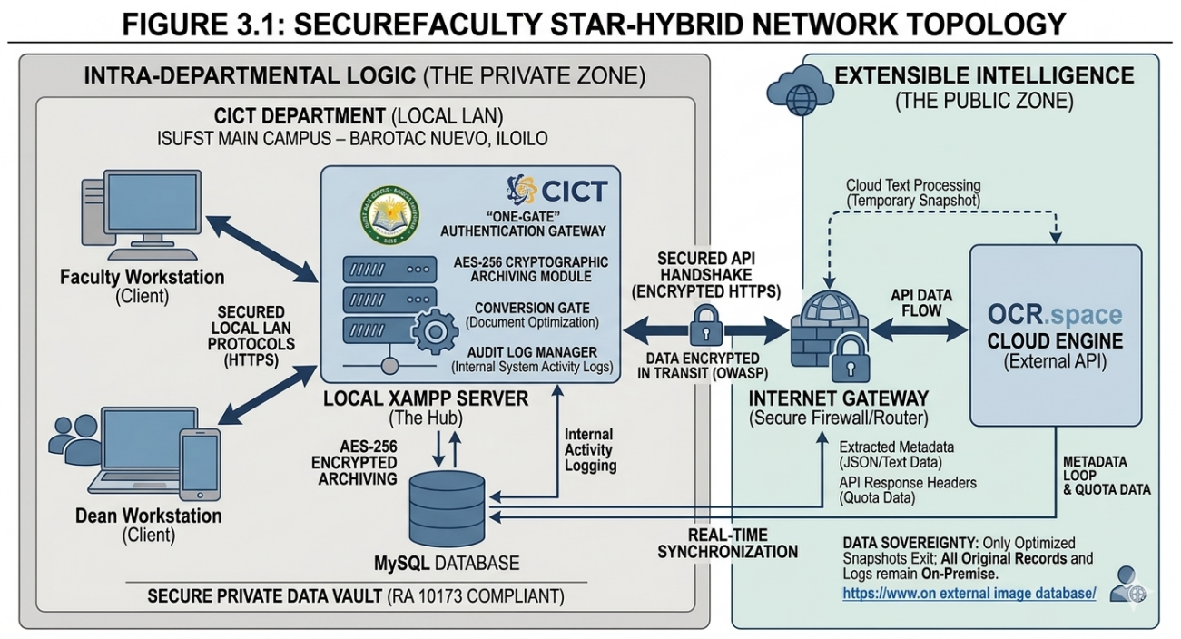 Figure 3.1:SecureFaculty Star-Hybrid Topology

Technology Selection
PHP [3]: Serves as the server-side engine governing the core system logic, including the Conversion Gate and Targeted Rasterization, and AES-256 cryptographic loops.
MySQL [4]: Serves as the Relational Database Management System(RDBMS) for secure data persistence and granular metadata indexing.
OCR.space API [2]: Utilized for character recognition; the system specifically tracks API Response Headers to provide real-time usage monitoring and quota synchronization.
Tailwind CSS: Utilized to architect a modern, responsive, and intuitive user interface(UI) that adheres to modern usability standards.

System Requirements
To ensure the reliable deployment of the portal within CICT department, the following minimum requirements are established:
Server Host: A dedicated workstation with at least 8GB RAM, an Intel Core i5(or equivalent) processor, and 500GB of SSD storage to handle XAMPP environment, AES cryptographic processes, and local file archiving.
Client Workstations: Standard office terminals equipped with modern web browsers (Chrome, Edge, or Firefox).

Connectivity: A stable internet connection(minimum 5 Mbps) is required for the API Handshake. The system features a built-in Quota Monitor on the Dean’s Dashboard to track the 25,000 monthly request threshold.

Software Architecture
The project adopts the Model-View-Controller (MVC) pattern to achieve a clear separation of concerns. The Model manages the data structures and database interactions; the View renders the user interface; and the Controller facilitates the logic flow between user actions and the data tier.
Legal and Technical Basis
The system is strictly engineered to comply with the Data Privacy Act of 2012 (RA 10173). Technical security is governed by Advanced Encryption Standards (AES-256) for document storage and Bcrypt (256-bit) hashing for user credentials. The system implements Data-at-Rest Encryption, ensuring all uploaded documents are cryptographically scrambled before storage and accessible exclusively via Just-in-Time Decryption during authorized sessions. [1], [5].

CHAPTER IV
METHODOLOGY, RESULTS AND DISCUSSIONS
Requirements Analysis
The primary technical constraint is the OCR API’s 5MB payload limit. To ensure that faculty can upload high-resolution smartphone photographs and multi-page documents, a Conversion Gate was engineered. This module performs dynamic optimization, automatically resizing and transforming files before they are processed by the logic tier.
Requirements Documentation
Functional:
- Multi-Format Metadata Ingestion: The system must perform automated OCR extraction to parse titles,dates, and issuing authorities from images (JPG/PNG), multi-page PDFs, and Word documents(DOCX).
- Cryptographic Archiving: The system must execute automated AES-256 encryption on all ingested document assets prior to local storage to ensure data-at-rest security.
- On-the-Fly Decryption: The system must provide a Just-in-Time decryption mechanism that unscrambles and renders protected files exclusively during authenticated and authorized user sessions.
- Operational Quota Monitoring: The system must implement a real-time tracking engine to monitor OCR API consumption and display remaining usage thresholds via the Dean’s Analytic Dashboard.

Non-Functional:
- Regulatory Compliance: Full adherence to RA 10173 (Data Privacy Act of 2012) and National Privacy Commission standards regarding the encryption and handling of personal professional records.
- Performance& Latency: The system must achieve Just-in-Time Decryption and document rendering in under 2 seconds to maintain a seamless and responsive user experience.
- High Availability & Sovereignty: The portal must ensure 24/7 localized accessibility via the CICT Local Area Network (LAN), maintaining document retrieval capabilities independent of external internet connectivity .
- System Integrity: The architecture must utilize Bcrypt(256-bit) password hashing and Audit Logging to ensure that all administrative actions are traceable and user credentials remain unreadable in the event of a database compromise.
Design of Software and Processes
The core functionality is driven by a custom, three-tier System Architecture (Appendix B, Figure 4.1). This design executes the Smart Pipeline workflow: Upload↓ Dynamic Optimization↓ Metadata Extraction↓ User Validation↓ Database Committal. The architecture integrates the PHP GD library [3] for on-site image processing and the OCR.space API [2] for character recognition, synchronized through an Encrypted HTTPS Handshake.

The Smart Pipeline:Upload and Extraction Process
To ensure high data integrity and accuracy, the system follows a structured logic:
Step 1: File Selection: The user selects multiple files (JPG, PNG, PDF, or DOCX) for the Sequential Batching queue.
Step 2: Conversion & Local Pre-processing: DOCX files are transformed into PDFs, and multi-page documents undergo Targeted Rasterization to extract the primary metadata page.
Step 3: Secure Handshake: The system optimized snapshots are transmitted to the cloud engine via an outbound HTTPS connection.
Step 4: Quota Capture: The system parses the API response headers to update the System Quota Monitor on the Dean’s Dashboard.
Step 5: User Verification Loop: Extracted strings (Title, Date, Issuer) are displayed for review. The user must “Approve” the data to ensure 100% accuracy.
Step 6: Archiving & Logging: Upon approval, the metadata is committed to the MySQL database, and a transaction record is generated in the Audit Logs.
Step 7: Decryption for Retrieval: When a record is accessed through the Personal Digital Vault, the system performs an on-the-fly-decryption to render the document visible to the authorized user.

The internal logic of this automated pipeline is visualized in the activity diagram in Figure 4.5.
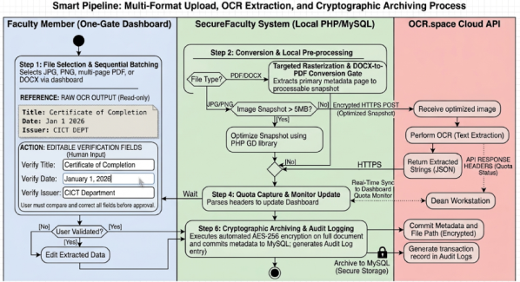
Figure 4.5: Activity Diagram of the SecureFaculty Smart Pipeline

Description of the Proposed Prototype
The proposed SecureFaculty prototype is designed a responsive web portal optimized for desktop and tablet views. The interface features a Centralized Command Dashboard for administrators (the Dean) and a Personal Digital Vault for faculty members. The Core functionality is driven by the Smart Pipeline, which includes a real-time progress indicator during the compression and OCR extraction phases to ensure a transparent user experience.
The visual interface of the prototype, including secure login and the centralized dashboard, is illustrated in Figures 4.2 through 4.4, with a full gallery of responsive views provided Appendix D.
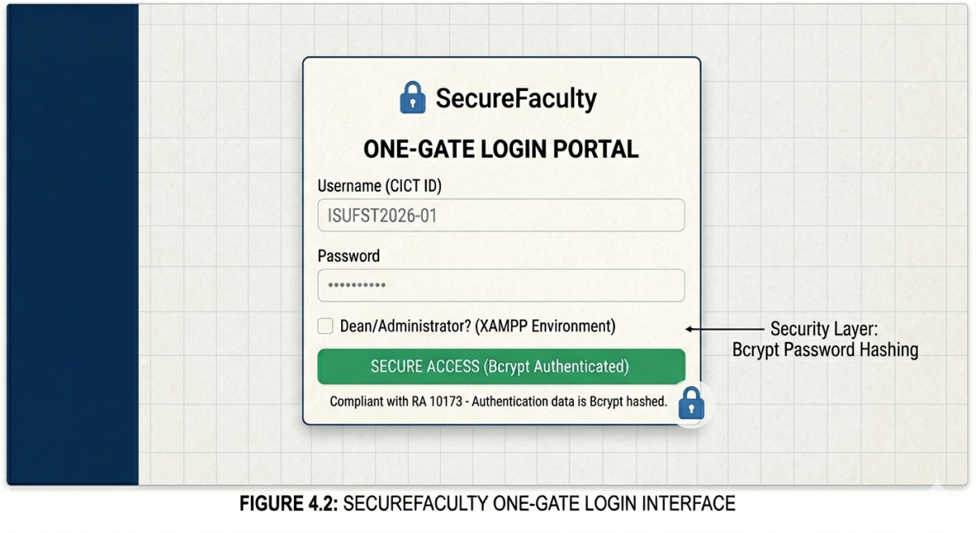
Figure 4.2: SecureFaculty One-Gate Login Interface
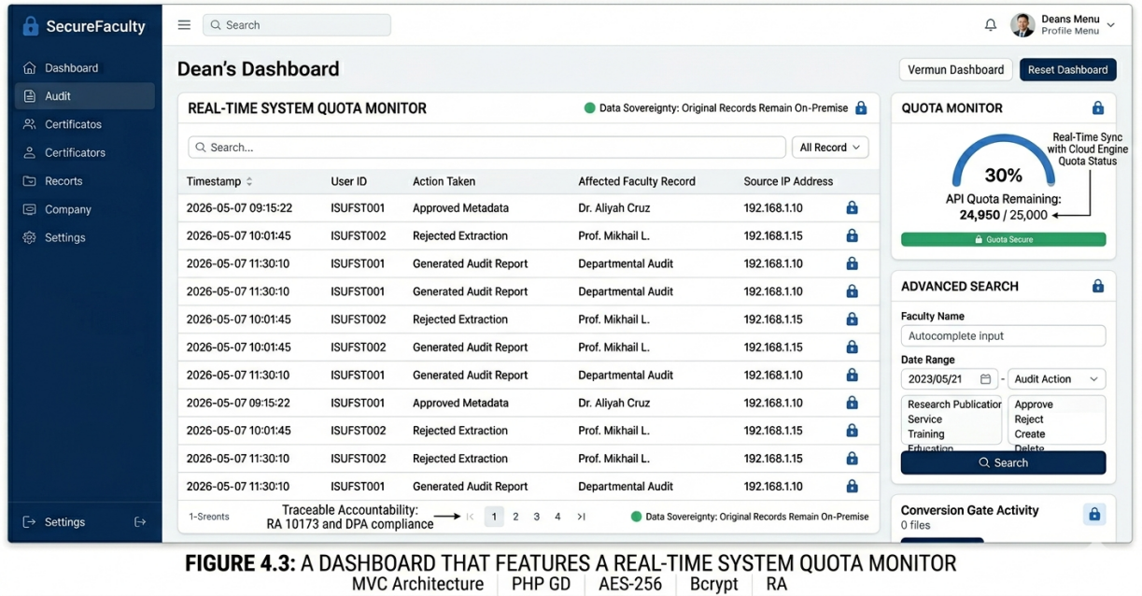
Figure 4.3: A dashboard features real-time System Quota Monitor
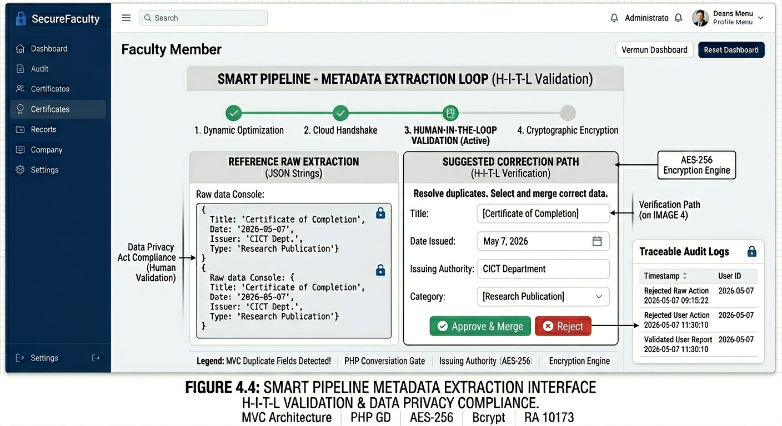
Figure 4.4: Smart Pipeline Metadata Extraction Interface

Implementation Plan (Infrastructure and Deployment)
The system will be deployed via a Local Area Network (LAN) installation on a dedicated workstation using XAMPP. This strategy ensures Data Sovereignty, keeping sensitive records physically within the university’s control while eliminating external hosting costs.
Current Limitations and Strategic Recommendations
While the current prototype meets all primary objectives, the proponents suggest the following for future optimization:
Hybrid OCR Architecture: Exploring the integration of a local engine (eg., Tesseract) as a Failover Mechanism during internet outages.
Advanced One-to-Many-Mapping: Refining the database logic to allow a single publication file to automatically populate multiple faculty profiles simultaneously.
Automated Compliance Alerts: Implementing a notification that alerts the Dean when faculty members reach specific professional milestone or when quotas are nearly exhausted.
Integration of a Localized RAG Framework: To transform the portal into a Decision Support System(DSS), the proponents suggest the integration of Retrieval-Augmented Generation (RAG) using Open-Source Local LLMs. By hosting the model on the existing CICT infrastructure, the system can provide intelligent recommendations and accreditation reports at zero operational cost. This approach ensures financial sustainability while maintaining strict data sovereignty and privacy compliance.

REFERENCES
- OWASP Foundation, “OWASP Top 10:2021 - The Most Critical Web Application Security Risks,” 2021. [Online]. Available: https://owasp.org/www-project-top-ten/
- OCR.space, “OCR API Documentation: Free Online OCR Service,” 2025. [Online]. Available: https://ocr.space/ocrapi
- The PHP Group, “PHP: Hypertext Preprocessor Documentation,” 2024. [Online]. Available: https://www.php.net/docs.php
- Oracle Corporation, “MySQL 8.0 Reference Manual,” 2024. [Online]. Available: https://dev.mysql.com/doc/refman/8.0/en/
- National Privacy Commission, “Republic Act No. 10173: Data Privacy Act of 2012,” 2012. [Online]. Available: https://privacy.gov.ph/data-privacy-act/
- Yulianto, et al., “Evaluation of the efficiency of electronic filing systems in handling records, “Taylor and Francis Online, 2025. [Online]. Available: https://www.tandfonline.com/action/doSearch?AllField=electronic+filing+systems
- Google, “Google Drive Help: How to use Google Drive”, 2024. [Online]. Available: https://support.google.com/drive#topic=14950478
- INTSIG Information Co., Ltd., “CamScanner-PDF Scanner App Features,” Google Play Store, 2026. [Online]. Available: https://play.google.com/store/apps/details?id=com.intsig.camscanner

- DocuWare, “Document Management and Workflow Automation Features,” 2022. [Online]. Available: https://start.docuware.com/
- LinkedIn, “About LinkedIn: Professional Networking and Career Milestones,” 2025. [Online]. Available: https://about.linkedin.com/
- Moodle Docs, “Resources: Working with Files and Folders,” 2023. [Online]. Available: https://docs.moodle.org/en/Resources
- World Health Organization, “Iris Home: Institutional Repository for Information Sharing,” 2026. [Online]. Available: https://iris.who.int/home
- Adobe, “Optical Character Recognition (OCR) for PDF’s | Adobe Acrobat,” 2024. [Online]. Available: https://www.adobe.com/acrobat/features/ocr-pdf.html
- Department of Information and Communications Technology, “e-Gov PH: The National Digital Initiative,” 2025. [Online]. Available: https://e.gov.ph/

APPENDICES
APPENDIX A
Detailed Conceptual Framework (The IPO Cycle)
This framework illustrates the logical transformation of data through the SecureFaculty ecosystem, following the standard Input-Process-Output (IPO) model:
1. Input (Data Collection)
The cycle begins with the acquisition of raw digital assets and authentication parameters required for system entry:
Faculty Credentials: Encrypted authentication parameters for secure “One-Gate” access.
Digital Assets: Multi-format document streams including JPG, PNG, multi-page PDF, and DOCX files.
System Constraints: Real-time API Quota thresholds(25,000 monthly limit)and file size parameters.
2. Process (The Intelligence Layer)
This stage represents the core technical logic where raw input is optimized and converted into structured information:
Optimization & Targeted Rasterization : Utilizing PHP GD libraries to dynamically resize images exceeding 5MB and converting multi-page documents into processable snapshots.
Asynchronous OCR Handshake: Secure transmission of optimized data to the OCR engine for character recognition.
Verification Path: A human-in-the-loop validation step where users review and approve extracted to ensure 100% accuracy and institutional accountability.
Data Encryption & Mapping: The process of hashing sensitive information and mapping extracted text to the Certification Matrix for organized storage.

3. Output (The Result)
The final stage delivers the functional requirements of the system to the stakeholders:
Granularly Searchable Repository: Structured, encrypted metadata mapped to individual faculty records.
Dean’s Analytic Dashboard: A centralized interface featuring the System Quota Monitor and auditing tools.
Compliance Audit Logs: A chronological record of the transaction (Who, What, When) to satisfy the accountability requirements of RA 10173 (Data Privacy Act of 2012).

INPUT PROCESS OUTPUT

- Optimization & Targeted Rasterization

- Asynchronous OCR Handshake

- User-Validation Loop(Verification Path)

- Data Encryption & Mapping

- Faculty Credentials

- Digital Assets

- System Constraints

- Granularly Searchable Repository

- Dean’s Analytic Dashboard

- Compliance Audit Logs

User Feedback

Figure 1.1 Conceptual Framework of SecureFaculty

APPENDIX B
Detailed System Architecture (The Smart Pipeline)
The system architecture follows a three-tier model to ensure modularity and security :
User Interface Tier (The View): Built with Tailwind CSS, providing a responsive “Drag-and-Drop” interface and real- time upload progress feedback.
Logic Tier (The Controller):The core Smart Pipeline governing the PHP Conversion Gate, Sequential Batching Queue Manager, and the cloud-based OCR Handshake.
Security and Data Tier (The Model): Manages the MySQL RDBMS, the AES-256 Cryptographic Engine, and the Audit Log Manager, ensuring all stored assets are encrypted at rest and all actions are logged for full accountability.
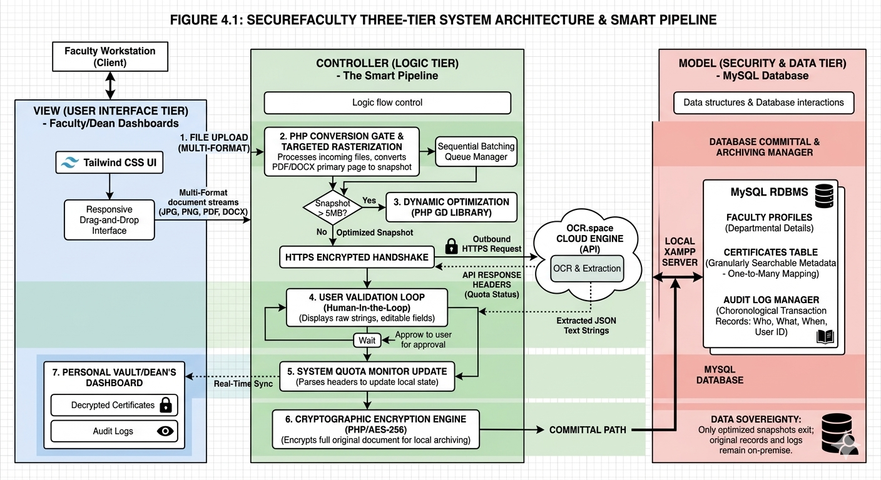
Figure 4.1:Three-tier System Architecture and Smart Pipeline

APPENDIX C
Detailed Entity Relationship Diagram (ERD) and Logic
The database is structured to maintain strict relationships without unnecessary complexity:
Table: Users: Manages authentication via Bcrypt hashing; maintains a 1-to-1 relationship with Faculty Profiles.
Table: Faculty_Profiles: Contains departmental details; maintains a 1-to-Many relationship with Certificates table.
Table: Certificates: Utilizes One-to-Many Mapping; enables a single uploaded file path to link to multiple distinct metadata records (Title, Date, Issuer). This ensures that multi-certificates(e.g., 5-page PDF) are indexed and searchable as individual,atomic entries.
Table: Audit_Logs: Tracks system-wide transactions (Insert, Update, Delete, View) to ensure full compliance with the Data Privacy Act. 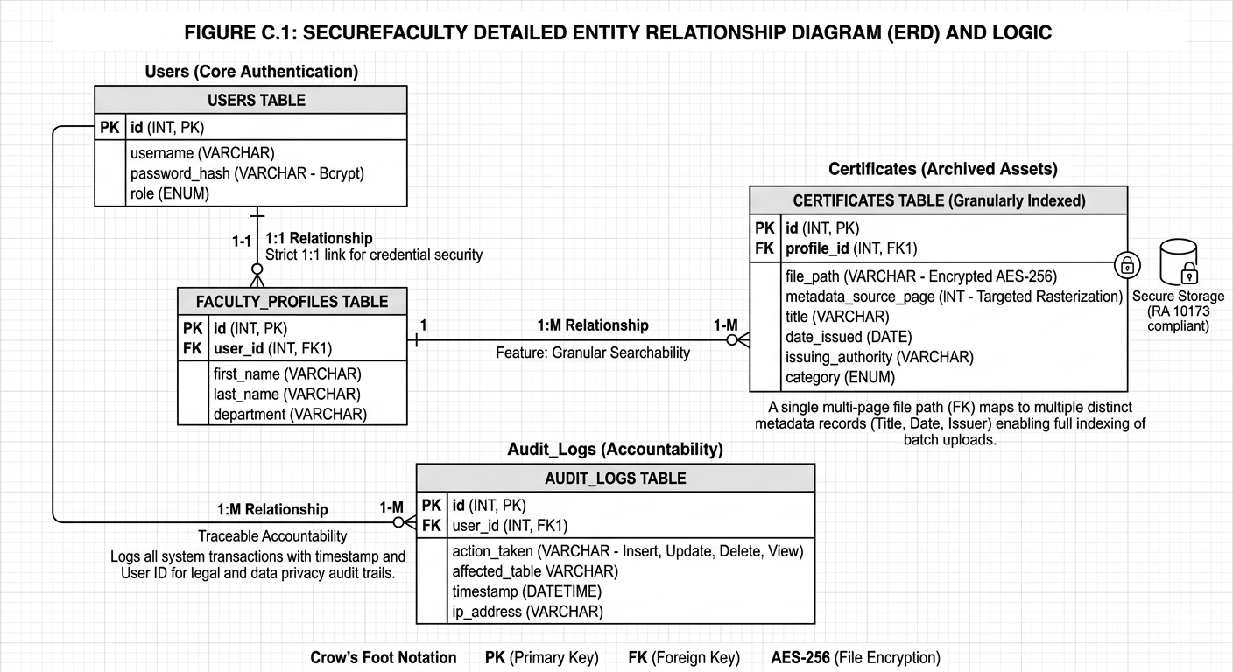
Figure C.1. SecureFaculty Entity Relationship Diagram (ERD) illustrating the 1:M relationship between faculty profiles and granularly indexed certificates.

APPENDIX D
Full Prototype Screenshots and Responsive Views
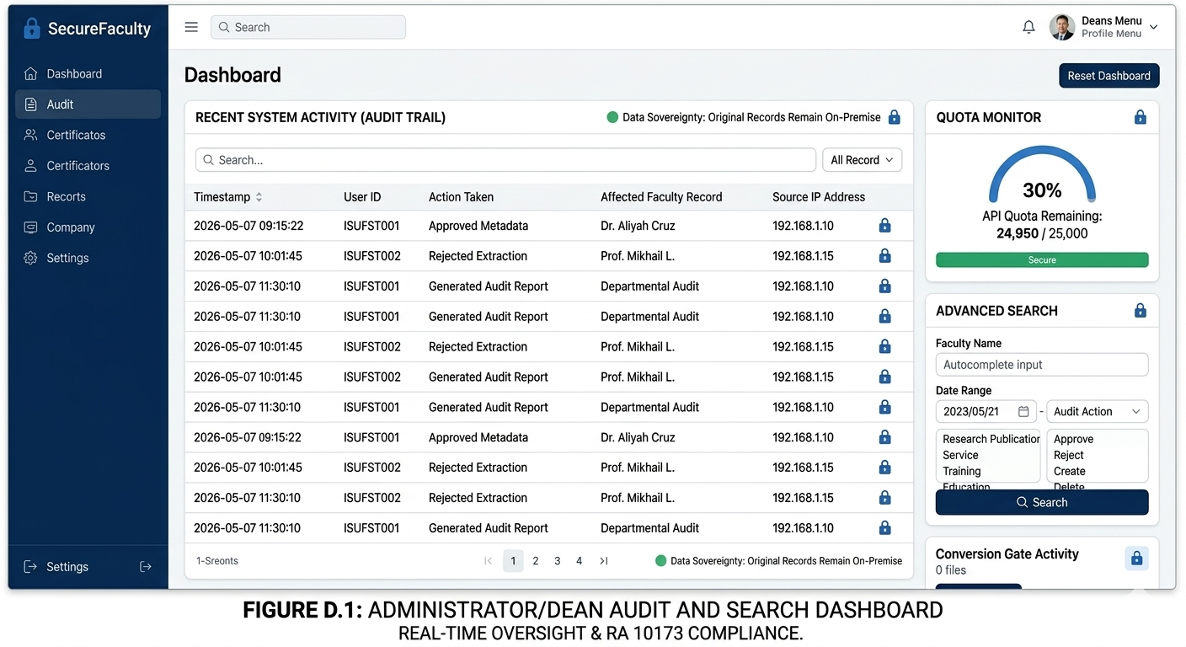
Figure D.1: Administrator/Dean Dashboard featuring the Real-Time Quota Monitor and Centralized Audit Trail for departmental oversight.

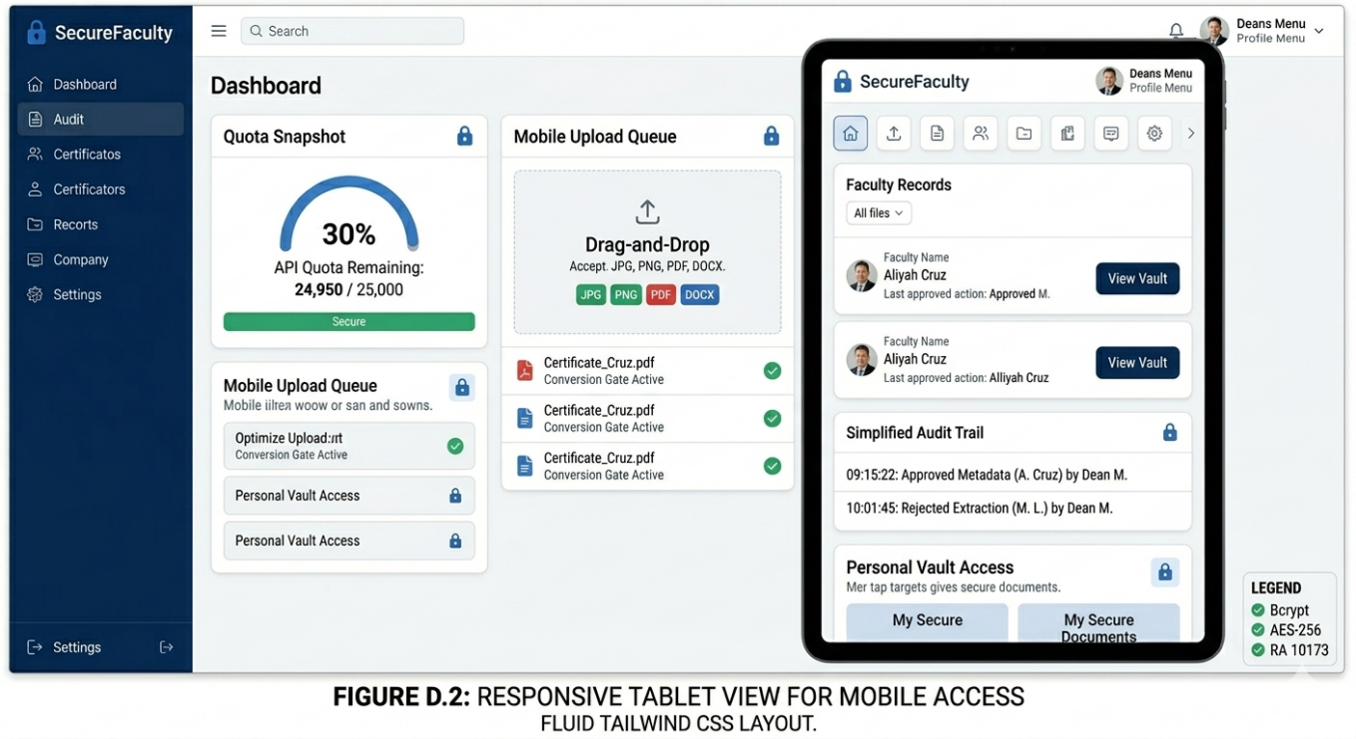
Figure D.2: Responsive Tablet Interface demonstrating the fluid layout of the Tailwind CSS UI for mobile administrative access.
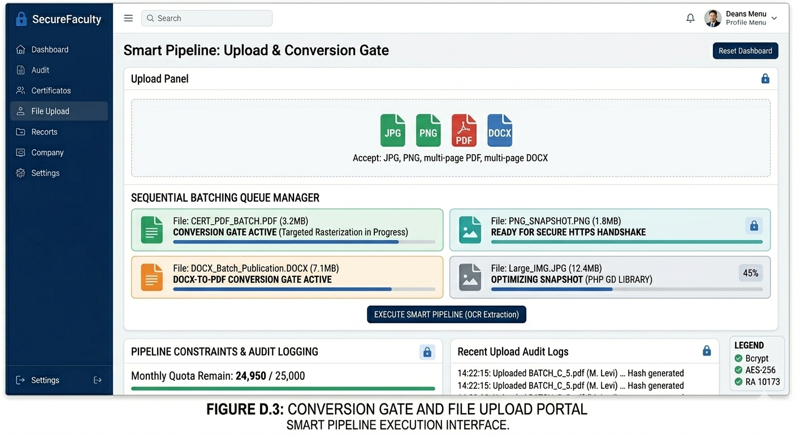
Figure D.3 The Smart Pipeline Interface (Conversion Gate) illustrating the multi-format upload queue and sequential batching progress.

