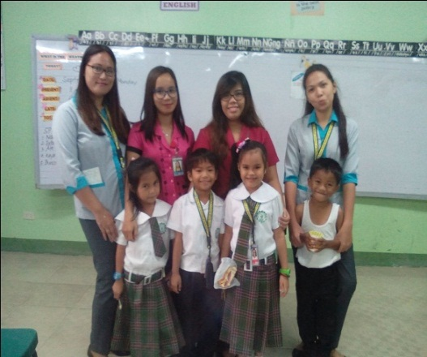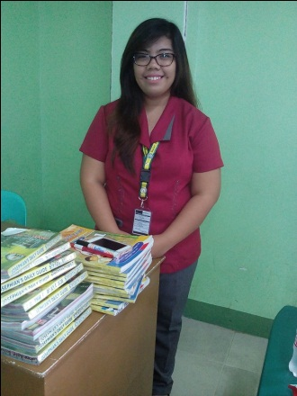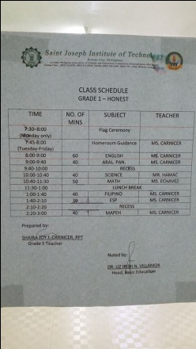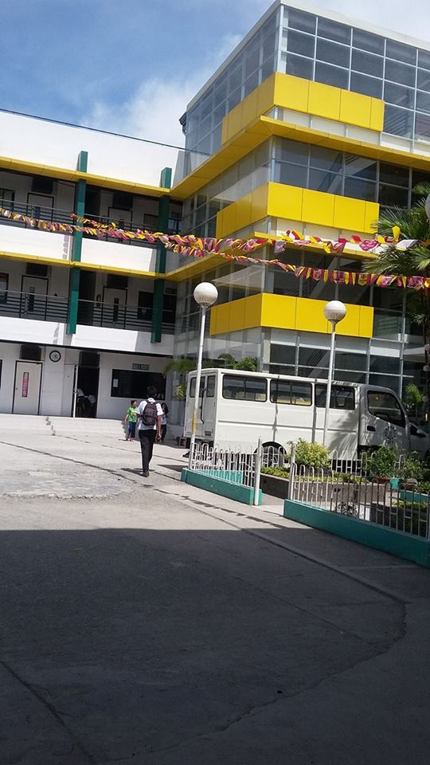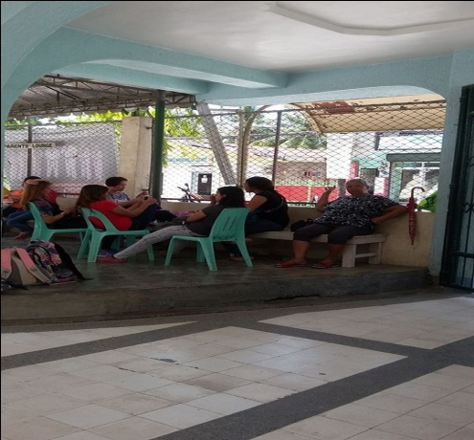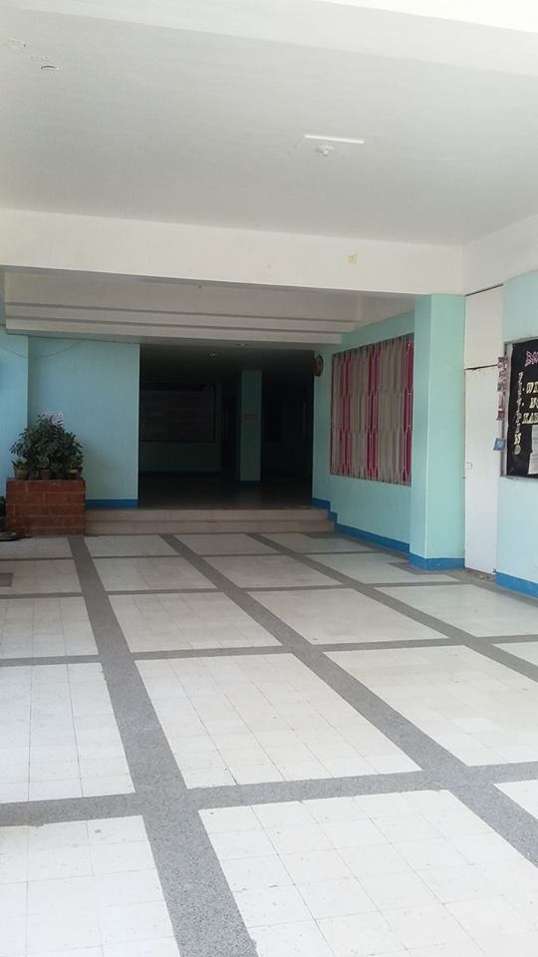

**Student Teacher with grade 1 pupil’s**

**(From the left Ms. Ecleo,Ms. Baquiano,Teacher Shaira and Ms.Chua)**

**Teacher Shaira’s Class Schedule**

**Teacher Shaira**

Parent’s Lounge

BE Lobby

SJIT Annex new Building