**Exercise #10:**

1. Display the sum of ages of employees working at Bignet.

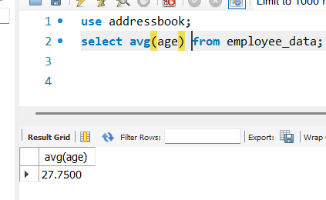

1. How would you calculate the total of years of service the employees of Bignet have in the company?

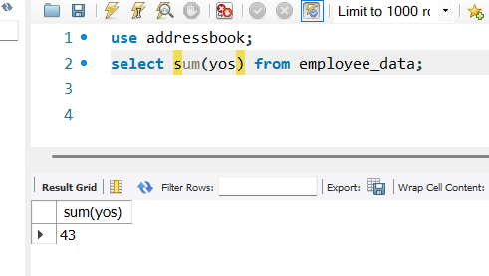

1. Calculate the sum of salaries and the average of employees who hold “Programmer” title.

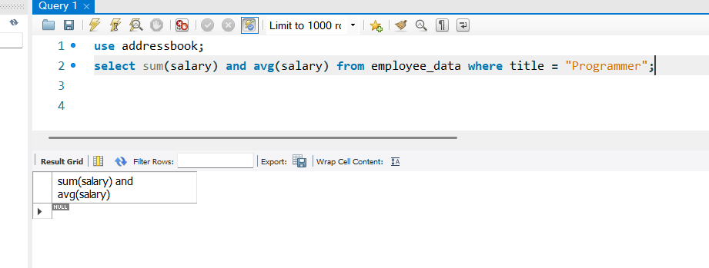

1. What do you understand from the following statement?

Select (SUM(perks) / SUM(salary) * 100) from employee_data;

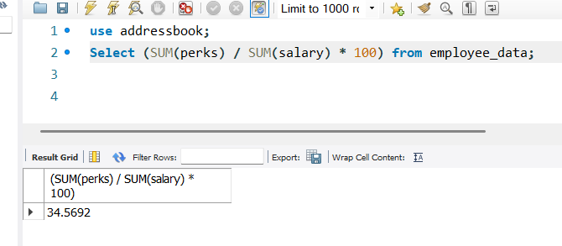

The statement gets the sum of all employees perks and the sum of all employees salaries and divides both then multiplies the result with 100.