**Exercise #2:**

1. Write the SELECT statement to extract the ids of employees who are more than 30 years of age.

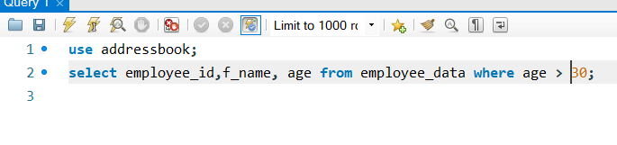

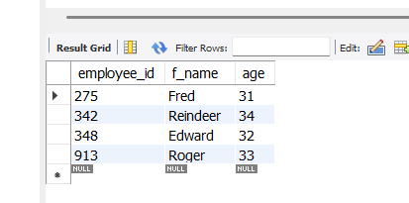

1. Write the SELECT statement to extract the first and last name of all web designers.

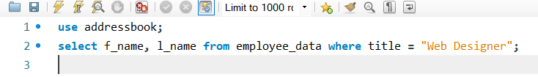

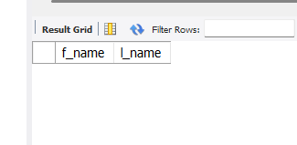

When I made the table I didn’t add any web designers to any of the employees so nothing will show when I run the statement.

1. What will the following SELECT statement display:   
   SELECT * from employee_data where salary <= 100000;

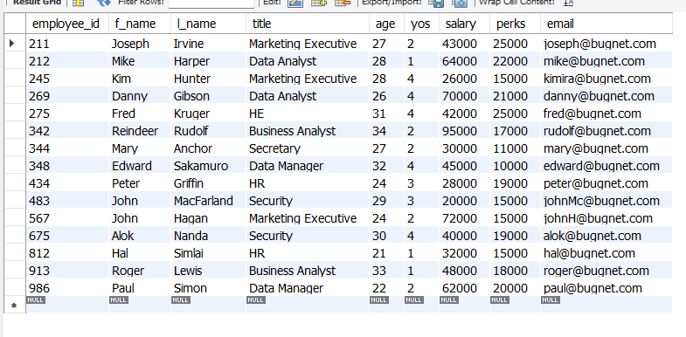

Every employee with a salary less than or equal to 100k will be displayed.

1. How will you display the salaries and perks for employees who have more than $16000 as perks?

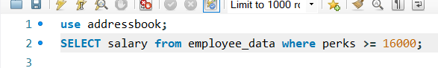 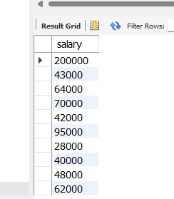

1. List all employees names (last name followed by first name) who hold the title of **Marketing Executive.**

