**Exercise #3:**

1. List all employees whose last name begin with p.

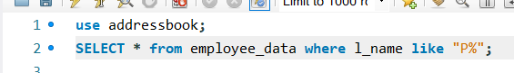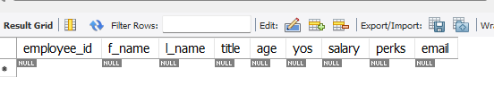

1. Display all names of all employees in the marketing division

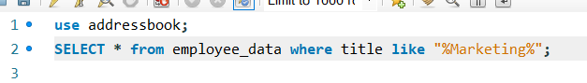

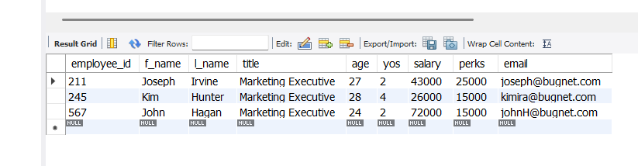

1. What will the following statement display:  
   SELECT f_name, l_name, salary from employee_data where f_name like ‘%k%’;

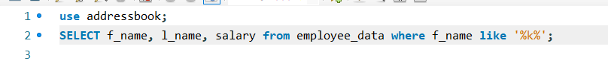

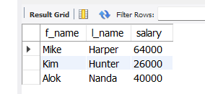

The statement displays all employees that contain the letter “k”.

1. List the last names and titles of all programmers.

