**Exercise #4:**

1. List the first and last names of all employees who draw less than or equal to $90000.

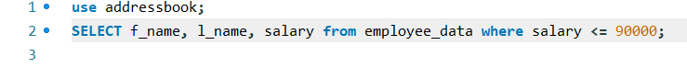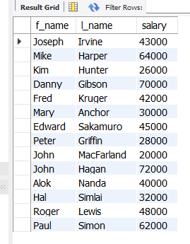

1. What is displayed by the following statement?  
   SELECT l_name, f_name from employee_data where title NOT LIKE ‘%marketing%’

AND age < 30;

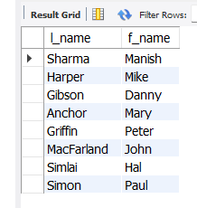

1. List all ids and names of all employees between 32 and 40 years of age.



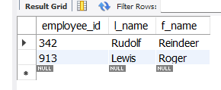

1. Select names of all employees who are 32 years of age and are not programmers.

