**Exercise #5:**

1. List all employees who hold the titles of “Senior Programmer” and “Multimedia Programmer”



1. List all employee names with salaries for employees who draw between $70000 and $90000



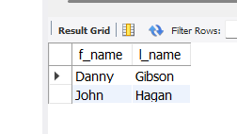

1. What will the following statement display?

SELECT f_name, l_name, title from employee_data where title NOT IN (‘Programmer’, ‘Senior Programmer’, ‘Multimedia Programmer’);

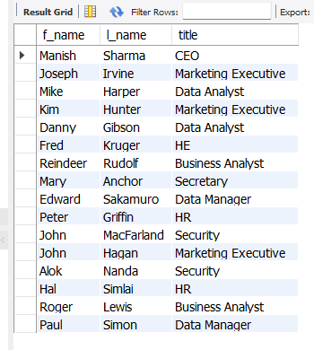

The statement displays all employees that are not in the Programmer division.

1. Here is a more complex statement that combines both BETWEEN and IN. What will it display?

SELECT f_name, l_name, title, age from employee_data wher title NOT IN (‘Programmer’, ‘Senior Programmer’, ‘Multimedia Programmer’) AND age NOT BETWEEN 28 and 32;

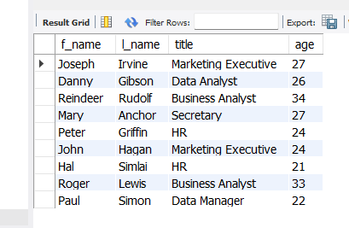

The statement displays all employees that are not in the programmer division and are not between the ages of 28 and 32