**Exercise #6:**

1. Order all employees on the basis of the salary they draw.

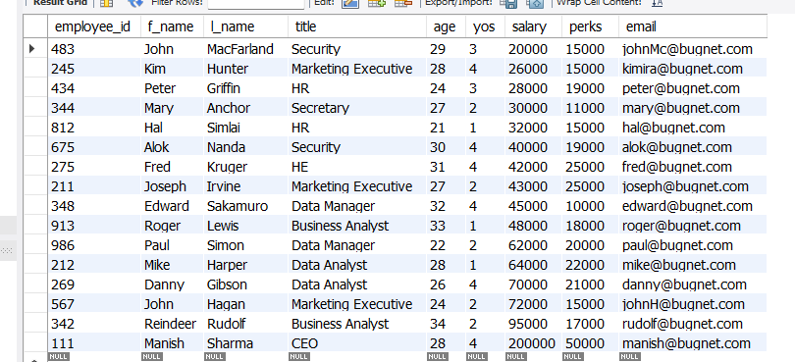

1. List all employees in descending order of their years of service.



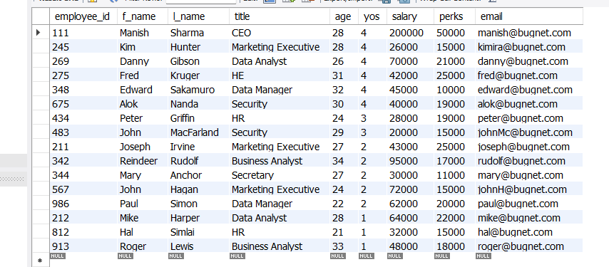

1. What does the following statement display?

SELECT emp_id, l_name, title, age from employee_data ORDER BY title DESC, age DESC

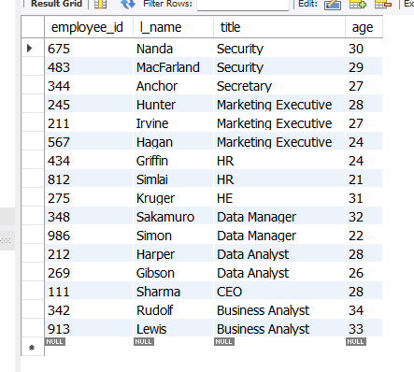

The statement displays the employees first and last name with their employee ids in descending order by their age.

1. Display employees (last names followed by first names) who hold the title of either “Programmer” or “Web Designer” and sort their last names alphabetically.

 