**Exercise #8:**

1. How many unique salary packages does our company, Bignet, offer? List them in descending order?

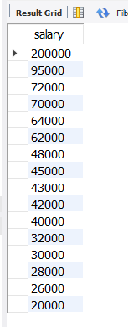

There are 16.

1. How many distinct first names do we have in our database?

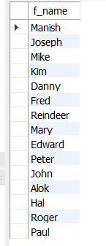

There are 15.