**Exercise #9:**

1. List the minimum perks package.

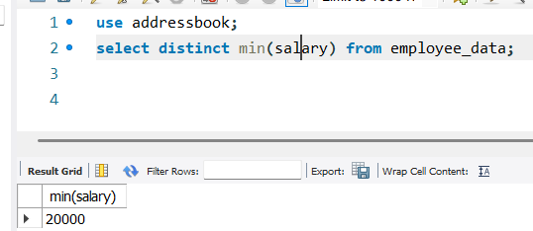

1. List the maximum salary given to a “Programmer”.

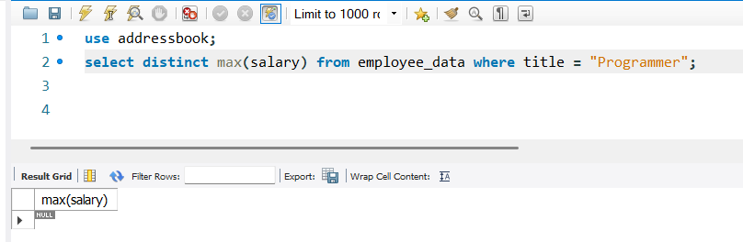

1. Display the age of the oldest “Marketing Executive”

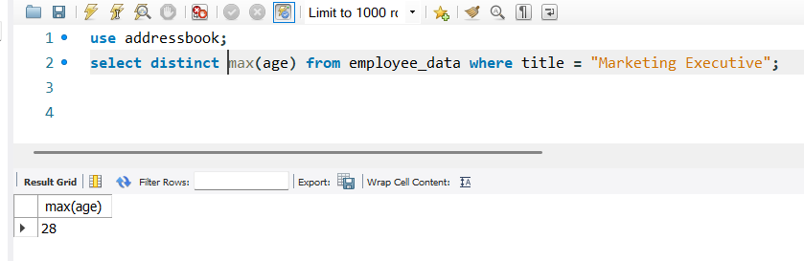

1. (Tricky!) Find the first and last names of the oldest employee.

