Team A
CPSC 2720 Spring 2018
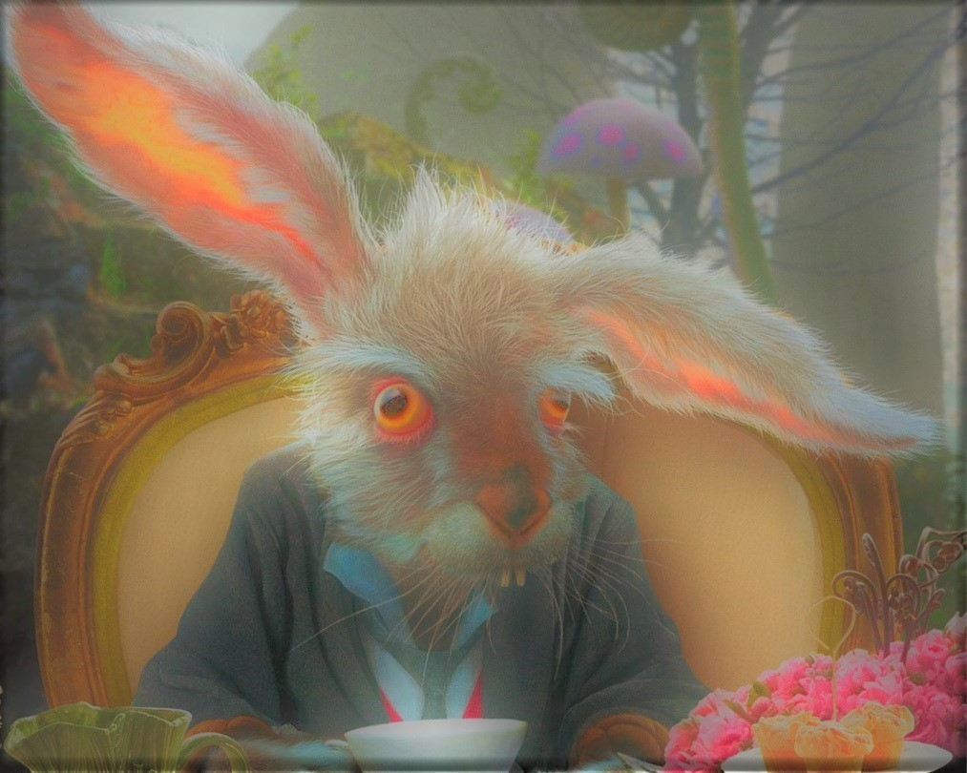
Alice: Topsie Texty

Team Hatter

Nicole Vachon
Anshul Abraham
Thomas Richardson

February 16, 2018

Table of Contents

- Revision History - - - - - - - - - - - - - - - - - - - - - - - - - - - - - - - - - - - pg 3

- Introduction - - - - - - - - - - - - - - - - - - - - - - - - - - - - - - - - - - - - - - - pg 4

- Project Management- - - - - - - - - - - - - - - - - - - - - - - - - - - - - - - - pg 4

- Team Organization - - - - - - - - - - - - - - - - - - - - - - - - - - - - - - - - - pg 4

- Risk Management - - - - - - - - - - - - - - - - - - - - - - - - - - - - - - - - - - pg 5

- Development Process - - - - - - - - - - - - - - - - - - - - - - - - - - - - - - - pg 5

- Software Design - - - - - - - - - - - - - - - - - - - - - - - - - - - - - - - - - - - pg 5

- Design - - - - - - - - - - - - - - - - - - - - - - - - - - - - - - - - - - - - - - - - - - pg 5

- Design Rationale - - - - - - - - - - - - - - - - - - - - - - - - - - - - - - - - - - -pg 5

- Appendices - - - - - - - - - - - - - - - - - - - - - - - - - - - - - - - - - - - - - - pg 6

- Appendix A - - - - - - - - - - - - - - - - - - - - - - - - - - - - - - - - - - - - - - pg 6

Revision History
Revision Date | Changes Made | Name

Introduction

This is a text based adventure game which follows the basic plot of Lewis Carroll's Alice’s Adventures in Wonderland. You choose between Alice, the Mad Hatter, and the White Queen as the main character you will use on your journey. You will need to find hidden items and solve riddles to defeat the Queen of Hearts in the final battle. You will run into some other characters such as the Cheshire cat, the card soldiers, and the Jabawaki on your way. This design document includes how we will address team organization, risk management, the development process, including code review, and software design.

Project Management
For the our Project Management we have partitioned this section into two parts, Team Organization, and Risk Management. In the Team Organization section we have outlined our team structure and defined roles. While in the Risk Management section we have contemplated what possible risks are associated with the design process and how we will prevent and address such problems.

Team Organization

We have decided on a Open or Democratic team structure for Design with the following defined individual roles:

Thomas: Team Lead

Nicole: Quality Assurance / Organizational Lead

Anshul: Documentation Lead

Risk Management
Some foreseeable problems include falling behind schedule, difficulties implementing the elements of the game, scheduling conflicts, and design limitations, such as rooms, characters, actions, etc.

We plan to prevent these possible risks through proper time management and the implementation of formal communication channels e.g. weekly meetings, facebook chat. This will ensure unity, proper development practices, and effective short term goal setting.

If these risks still occur, we plan on addressing the problem together and delegate work as needed. We expect to implement several of the stated strategies due to our similar level of experience with Gitlab, IDEs, and development practices.

Development Process
We plan on developing the software by splitting the game into manageable sections and distributing them among the teammates equally or as equally as we all agree on. Pull requests will be handled by the Team Lead or the Quality Assurance Lead. We will be using a facebook group chat as well as face to face as our main forms of communication. We will share the responsibility to triage reports so we all understand the bug as well as the solution implemented.

Software Design

Design
See appendix A.

Design Rationale

Our group chose to take elements from Lewis Carroll's Alice’s Adventures in Wonderland to focus primarily on game implementation. This allowed us to have set characters for ease of class development, such as breaking down characters into sub categories of villains and main characters. By use of abstraction we are choosing to use the map class as our primary interface in which characters interact. We have broken our map into four rough sections which have respective unique functions. We believe that this will be the easiest way to implement our design to build a functioning text based adventure game.

Appendices

Appendix A
