Team A
CPSC 2720 Spring 2018
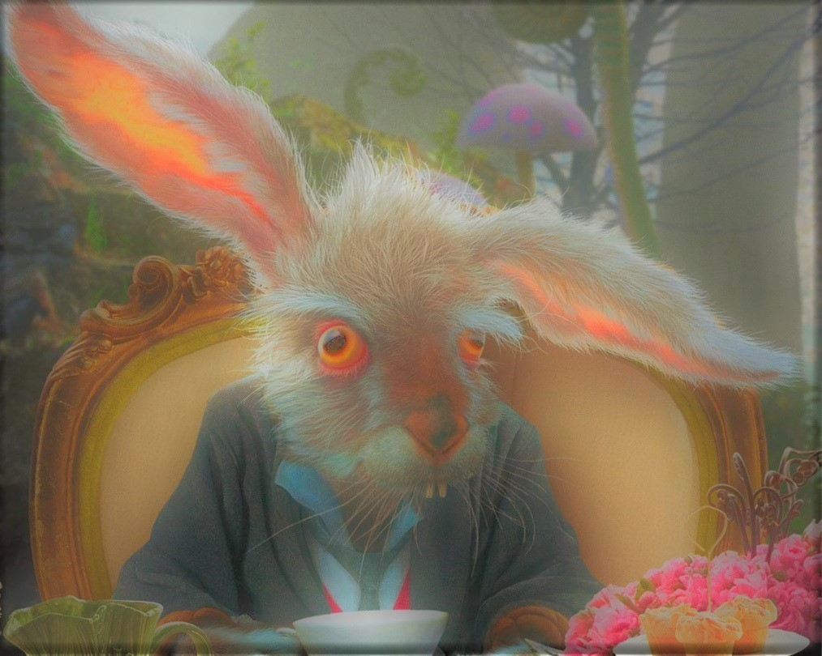
Alice: Topsie Texty

Team Hatter

Nicole Vachon
Anshul Abraham
Thomas Richardson

March 19, 2018

Table of Contents

- Revision History - - - - - - - - - - - - - - - - - - - - - - - - - - - - - - - - - - - pg 2

- Introduction - - - - - - - - - - - - - - - - - - - - - - - - - - - - - - - - - - - - - - - pg 3

- Project Management - - - - - - - - - - - - - - - - - - - - - - - - - - - - - - - pg 3

- Team Organization - - - - - - - - - - - - - - - - - - - - - - - - - - - - - - - - - pg 3

- Risk Management - - - - - - - - - - - - - - - - - - - - - - - - - - - - - - - - - - pg 4

- Development Process - - - - - - - - - - - - - - - - - - - - - - - - - - - - - - - pg 4

- Software Design - - - - - - - - - - - - - - - - - - - - - - - - - - - - - - - - - - - pg 4

- Design - - - - - - - - - - - - - - - - - - - - - - - - - - - - - - - - - - - - - - - - - - pg 4

- Design Rationale - - - - - - - - - - - - - - - - - - - - - - - - - - - - - - - - - - -pg 4

- Appendices - - - - - - - - - - - - - - - - - - - - - - - - - - - - - - - - - - - - - - pg 5

- Appendix A - - - - - - - - - - - - - - - - - - - - - - - - - - - - - - - - - - - - - - pg 5

Revision History
Revision Date | Changes Made | Name
March 7, 2018  March 10, 2018  March 12, 2018  March 13, 2018 | Created Code::Blocks project  2 puzzles  Create characters  Create Map classes | Nicole Vachon  Anshul Abraham  Nicole Vachon  Thomas Richardson

Introduction

This is a text based adventure game which follows the basic plot of Lewis Carroll's Alice’s Adventures in Wonderland. You choose between Alice, the Mad Hatter, and the White Queen as the main character you will use on your journey. You will need to find hidden items and solve riddles to defeat the Queen of Hearts in the final battle. You will run into some other characters such as the Cheshire cat, the card soldiers, and the Jabberwocky on your way. This design document includes how we will address team organization, risk management, the development process, including code review, and software design.

Project Management
For our Project Management we have partitioned this section into two parts, Team Organization, and Risk Management. In the Team Organization section we have outlined our team structure and defined roles. While in the Risk Management section we have contemplated what possible risks are associated with the design process and how we will prevent and address such problems.

Team Organization

We have decided on a Open or Democratic team structure for Design with the following defined individual roles:

Thomas: Team Lead - ensures no discrepancy between team members, in charge of merging of classes

Nicole: Documentation Lead / Organizational Lead - optimizes documents and ensures all topics required in documents are covered, as well as spelling, grammar, etc. as well as ensuring doxygen works properly

Anshul: Quality Assurance Lead - reviews code for quality

Everyone is responsible for the development of the game. We have assigned sections to each member for ease of coding and merging. Thomas is responsible for the Map class. Nicole is responsible for the Character class. Anshul is responsible for the Puzzles class.

Risk Management

Risks | How to address
Falling behind schedule | All meet in lab after class ASAP to hold each other accountable
Difficulty implementing sections of game | Decide as a group if that element is worth keeping in the project or if it can be replaced by an easier section
Scheduling conflicts | Work on assigned section of project on our own times and meet up in lab to combine work
Design limitations | Decide as a group what is needed versus what we want and scrap all ideas that are not feasible at this level
One slacker | Tell them immediately. Redelegate work to other members to avoid the entire group falling behind schedule
Inexperience with gitlab | Ask team members if they know which commands to use. Google problem that is occuring. Ask TA or Dr. Anvik if google does not suffice.
Major design changes needed | Attempt to isolate design changes to one class if possible so one member can focus on the changes, but if it can’t be isolated, then work together in person to ensure the changes made will work together
Unproductive team members | If this is caught early enough, speak with them to get them working, or if it is too late, try to complete yourself or mention in team report that the section is missing because of their lack of effort
Unanticipated life events | Re-allocate work to member(s) who have the time to complete the extra work

Development Process
We will declare all classes on their own .h files and implement them on their own .cpp files of the same name for simplicity. All files will have clear meanings behind their names, eg: Characters.h is defining the character class and will have a matching Characters.cpp file for its implementation. We will use inheritance primarily to connect the interface to our classes. We will name our variables with specific names to avoid ambiguity and improve comprehension when reading the code. We will attempt to make all methods useful as well as concise to one goal.

We will communicate primarily through texts as we have all shared our numbers with our teammates, but we also have a Facebook group chat if group-wide communication is needed. Since this project is a manageable size, we don’t plan on using bug reports and triage reports unless the problem is considerably large and multiple members must work together to fix it. We will all have master access for simplicity of pushing and pulling from git so no pull requests are required.

Software Design

Design
See appendix A.

Design Rationale

Our group chose to take elements from Lewis Carroll's Alice’s Adventures in Wonderland to focus primarily on game implementation. This allowed us to have set characters for ease of class development, such as breaking down characters into sub categories of villains and main characters. By use of abstraction we are choosing to use the map class as our primary interface in which characters interact. We have broken our map into four rough sections which have respective unique functions. We believe that this will be the easiest way to implement our design to build a functioning text based adventure game.

Appendices

Appendix A
