Topsie Texty
User Manual

Objective:
-traverse the board to get to the red queen
-fight enemies and pass puzzles on your way
-you might find some items that will be useful
-you must save your own progress

Commands:
0 - look around
1 - travel in room
1- forward
2- right
3- left
4- backwards
2 - fight enemies

Deaths:
-card soldiers kill you
-jabberwaki kills you
-red queen kills you
-fail too many puzzles
-fight too many enemies

Saving:
-use command 0 to check your location, it will promp you to save or load a save text file. There is a screenshot below

Gameplay:
-you start in room 0 at location 0,0. Your goal is to defeat the Red Queen in room 8 in position 10,10.
- you may step on items which will increase your health or strength
- you may step on enemies which you have to defeat
-you may step on puzzles which if you fail, you lose health
-reminder: save often!

Travel around room option
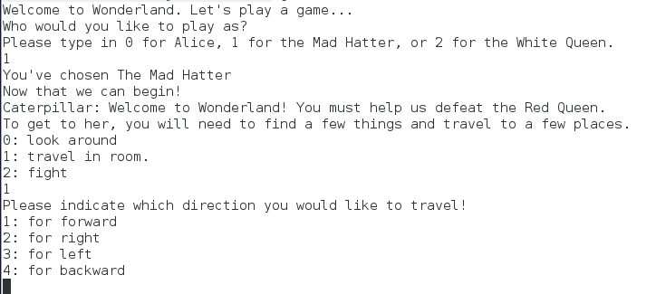

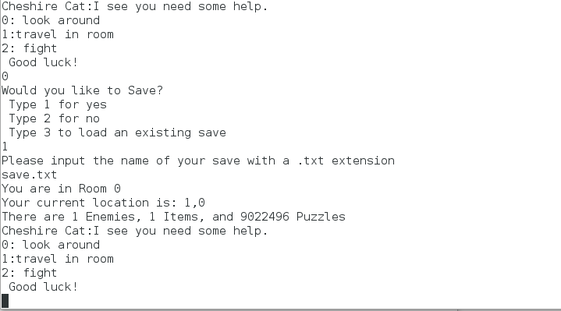
How to save your progress

