How to use this template: replace the grey example text and keep the paragraph styles. The styles carry the layout of The Art of Terraced Landscapes; please do not add your own bold, italics or font changes. Delete the blue notes before submission. Send the text and every photograph or artwork as a separate file (JPG or TIFF, 300 dpi) to submit@itla.si.
Photo essay | Artwork | Essay

Title of the contribution
Name SURNAME¹
¹ Institution or place, Country; e-mail: name.surname@example.org
Keywords
terraced landscapes; art; second keyword; third keyword

Introduction
A short text of about 1,000 words that introduces the photographs or artworks: the place, the people, the time, and what the images show about terraced landscapes and the cultures that made them.
Every image needs a caption: what it shows, place, year, and the author of the photograph or artwork. Images that are not yours need the permission of their author to be published under CC BY-SA 4.0.

Figure 1. Full-page photograph. Place, year. Photo: Name Surname.

Double-page photograph: printed across two facing pages (320 × 210 mm). Send the file at full size, 300 dpi, with 3 mm extra on every side (326 × 216 mm). Keep important details, faces and horizons away from the middle fold.
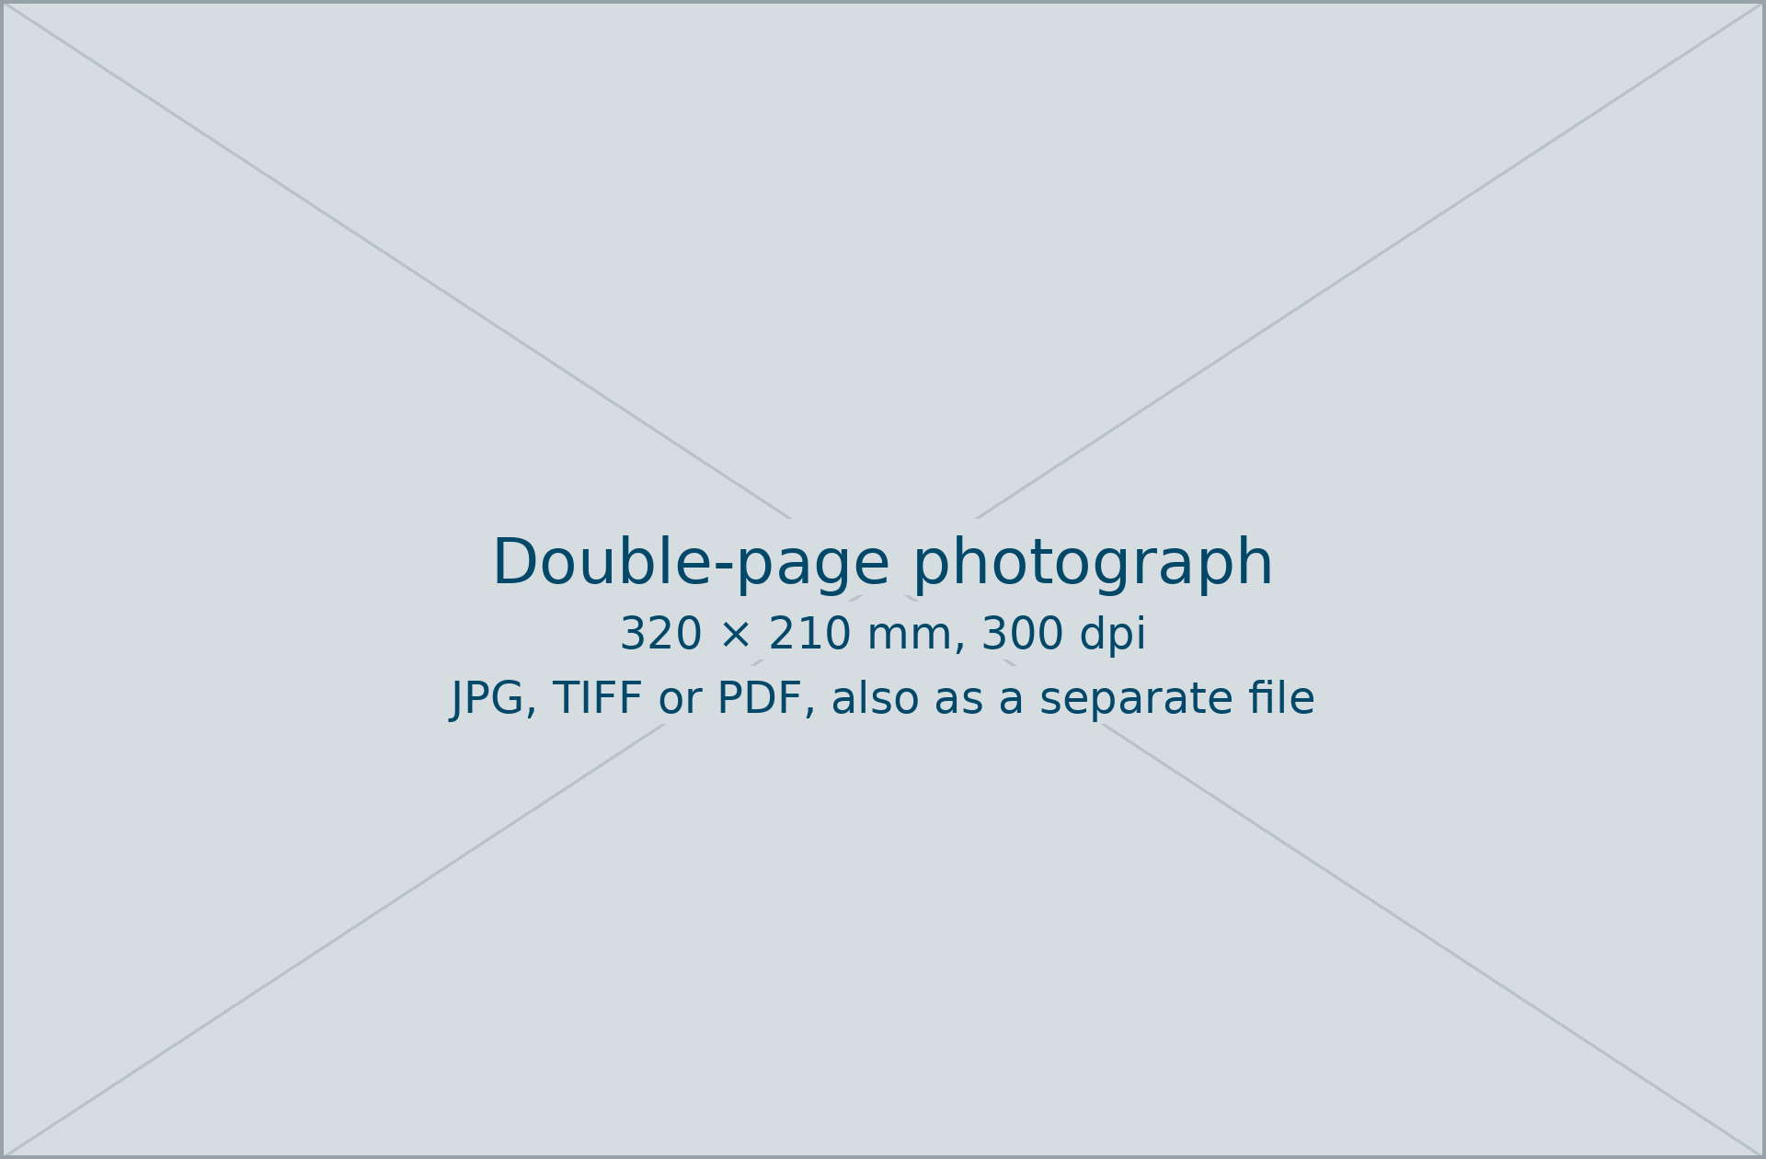
Figure 2. Double-page photograph. Place, year. Photo: Name Surname.

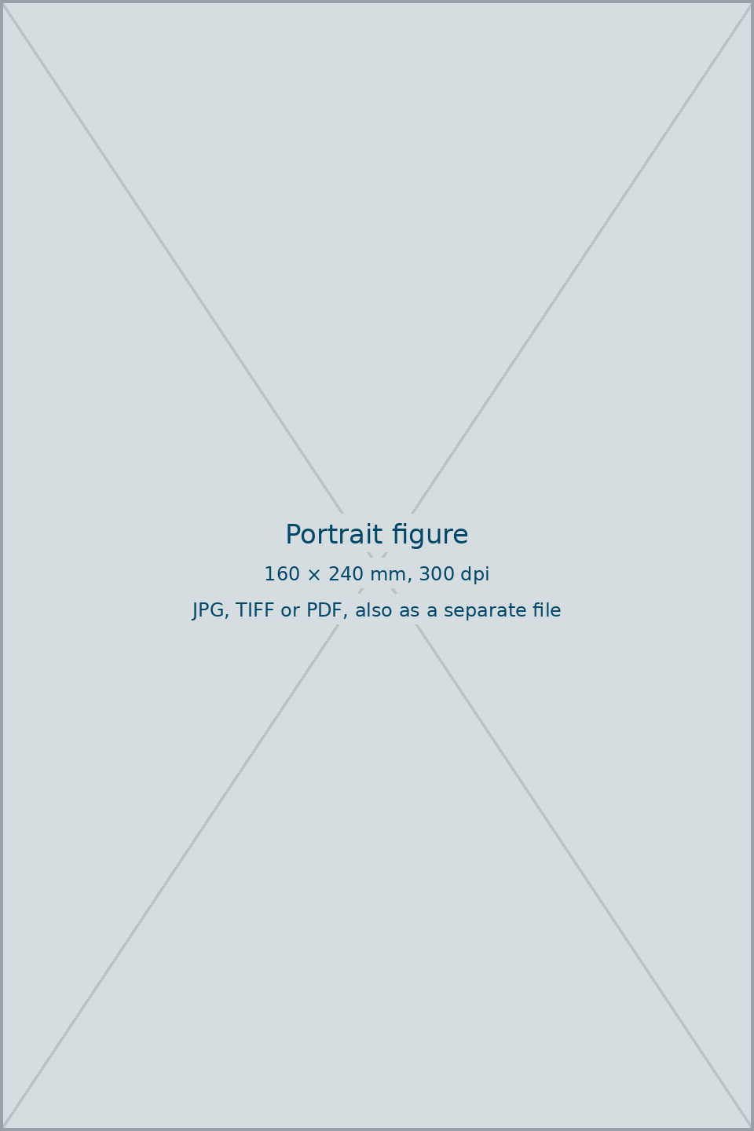
Figure 3. A portrait photograph or artwork, printed up to the full page. Place, year. Artwork: Name Surname.

Closing words
Optional: a few closing sentences, acknowledgements, or a note on the exhibition or project the images come from.

References
Harvard system. In the text: (Author, Year, p. X). The list is alphabetical by surname; several works by the same author by year, the oldest first; same author and year: 1989a, 1989b. Give the DOI where a work has one.
Author, A. and Author, B. (2020) Title of the article. Journal Name, 4(1), pp. 10–25. https://doi.org/10.xxxx/xxxxx
Author, C. (2018) Title of the book. City: Publisher.
Author, D. (2019a) Title of the chapter. In: Editor, E. (ed.) Title of the book. City: Publisher, pp. 45–60.
Organisation (2023) Title of the web page. Available at: https://www.example.org (accessed 15 June 2026).

About the authors
Name SURNAME is ... (plain text, justified, at most 500 characters including spaces, one paragraph per author).
Name SURNAME is ...

