How to use this template: replace the grey example text and keep the paragraph styles (Title, ITLA Authors, ITLA Abstract, Heading 1, Caption ...). The styles carry the layout of The Journal of Terraced Landscapes; please do not add your own bold, italics or font changes. Delete the blue notes before submission. Send the text and every figure as a separate file to submit@itla.si.
Article

Title of the contribution: short and informative
Optional subtitle
Name SURNAME¹, Name SURNAME²
¹ Institution, City, Country; e-mail: name.surname@example.org; ORCID: 0000-0000-0000-0000
² Institution, City, Country; e-mail: name.surname@example.org
Abstract
The abstract states the problem, how it was approached, what was found and why it matters for terraced landscapes. Plain text, at most 1,500 characters including spaces, no references and no abbreviations that are not explained.
Keywords
terraced landscapes; dry-stone walls; second keyword; third keyword; fifth keyword
At most 5 keywords, separated by semicolons.

1. Introduction
State the research problem and place it in the line of the journal and in the current call for papers. Review the relevant literature (Author, 2020) and end with the aim and the research questions of the study.
The main text has about 5,000 words and follows the IMRAD structure: Introduction, Materials and Methods, Results, Discussion, Conclusions. Number the sections.

2. Materials and methods

2.1 Study area
Describe the study area and why it was chosen. Insert each figure in the paragraph it belongs to, as below, and send it also as a separate file.
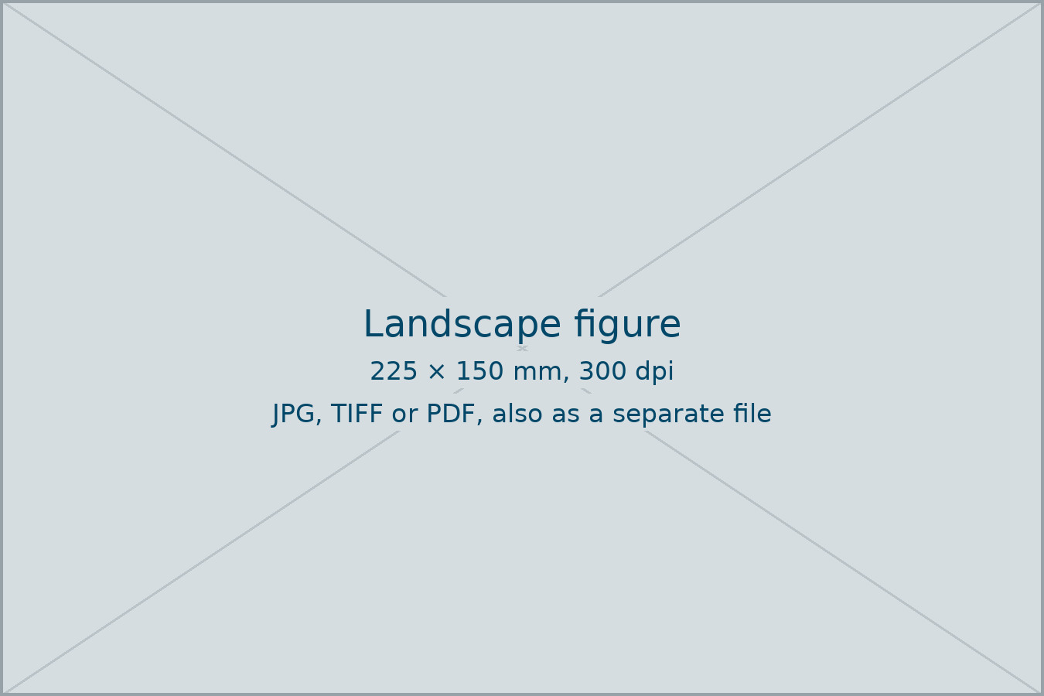
Figure 1. Short description of the figure. Location, year. Photo or drawing: Name Surname.

2.2 Data and analysis
Describe the data, the methods of collection and the analysis, so that the study can be repeated. Where the study involved people, state that they gave free, prior and informed consent.

3. Results
Present what was found. Tables are simple Word tables, numbered in sequence; the caption goes below the table (Table 1).
Site | Terrace type | Wall length (m)
Site A | Dry-stone, agricultural | 1,240
Site B | Earth, rice | 860
Site C | Dry-stone, abandoned | 2,105
Table 1. Short description of the table. Source: Name Surname, 2026.
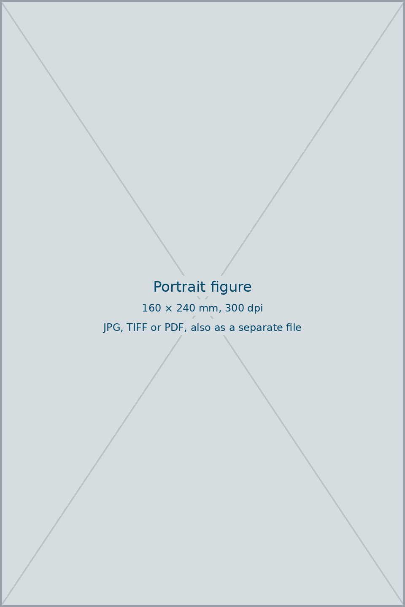
Figure 2. A portrait figure is printed 160 × 240 mm or smaller. Photo: Name Surname.

4. Discussion
Evaluate the findings, compare them with earlier studies and state the limits of the study.

5. Conclusions
Summarise the main contribution of the study and what follows from it for research and practice in terraced landscapes.

Acknowledgements
Thank the people and institutions who helped but are not authors.

Funding
Name the funders of the work and the grant numbers, or write: This research received no external funding.

Use of AI tools
Write which AI tool was used and for what (for example translation of section 2, or drafting of Figure 3), or write: No AI tools were used in preparing this contribution.

Conflicts of interest
Declare any financial or personal interest that could influence the work, or write: The authors declare no conflict of interest.

References
Harvard system. In the text: (Author, Year, p. X). The list is alphabetical by surname; several works by the same author by year, the oldest first; same author and year: 1989a, 1989b. Give the DOI where a work has one.
Author, A. and Author, B. (2020) Title of the article. Journal Name, 4(1), pp. 10–25. https://doi.org/10.xxxx/xxxxx
Author, C. (2018) Title of the book. City: Publisher.
Author, D. (2019a) Title of the chapter. In: Editor, E. (ed.) Title of the book. City: Publisher, pp. 45–60.
Organisation (2023) Title of the web page. Available at: https://www.example.org (accessed 15 June 2026).

About the authors
Name SURNAME is ... (plain text, justified, at most 500 characters including spaces, one paragraph per author).
Name SURNAME is ...

