600_02_A_Quarto

Tomaz Kastrun

Table of contents

# 1. Report on analysis of Iris datasets

## 1.1 Exploring data

Based on the group selected setosa, here is the table data.

Sepal.Length Sepal.Width Petal.Length Petal.Width Species  
1 5.1 3.5 1.4 0.2 setosa  
2 4.9 3.0 1.4 0.2 setosa  
3 4.7 3.2 1.3 0.2 setosa  
4 4.6 3.1 1.5 0.2 setosa  
5 5.0 3.6 1.4 0.2 setosa  
6 5.4 3.9 1.7 0.4 setosa

And calculating for Species setosa and number of observations 50.

## 1.2 1. Checking custom fits

This is a custom function fit:

Call:  
lm(formula = Petal.Length ~ Petal.Width, data = d)  
  
Residuals:  
 Min 1Q Median 3Q Max   
-0.43686 -0.09151 -0.03686 0.09018 0.46314   
  
Coefficients:  
 Estimate Std. Error t value Pr(>|t|)   
(Intercept) 1.32756 0.05996 22.141 <2e-16 ***  
Petal.Width 0.54649 0.22439 2.435 0.0186 *   
---  
Signif. codes: 0 '***' 0.001 '**' 0.01 '*' 0.05 '.' 0.1 ' ' 1  
  
Residual standard error: 0.1655 on 48 degrees of freedom  
Multiple R-squared: 0.11, Adjusted R-squared: 0.09144   
F-statistic: 5.931 on 1 and 48 DF, p-value: 0.01864

## 1.3 Running multiple regression

You can add options to run multiple regression

|  |
| --- |
| Figure 1 |

## 1.4 Adding multiple predictors on graph:

|  |
| --- |
| Figure 2: Iris scatterplot with multiple predictors |

## 1.5 Running multiple different code

### 1.5.1 Example with R

Here with using R Language.

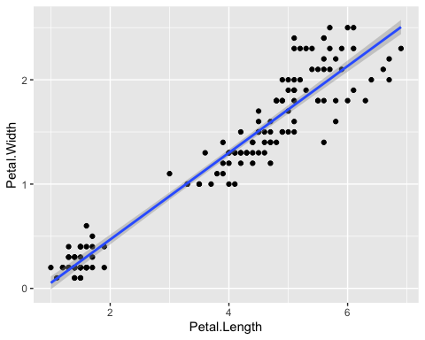

Iris scatter between Petal.Width and Petal.Length

### 1.5.2 Example with Python

Example with Python

a = 1

And overall it is irrelevant the origin of language. and mixing the languages

# 2. Conclusion

The results show bigger residuals and predicting the multiple variate regression without filtering the species, to be “interesting” idea.

|  |  |
| --- | --- |
|  | **Pay Attention**  This analysis is fictitious and does not provide any real results |