600_02_Quarto

Tomaz Kastrun

Table of contents

# 1. 1. Report on analysis of Iris datasets

## 1.1 1. Checking custom fits

This is a custom function fit:

library(tidyverse)  
s  
d <- iris  
fit <- lm(Petal.Length ~ Petal.Width, data = d)   
summary(fit)   
  
# and adding  
d$predicted <- predict(fit)   
d$residuals <- residuals(fit)   
  
d %>%   
 select(Petal.Length, predicted, residuals) %>%   
 head()

## 1.2 2. Running multiple regression

You can add options to run multiple regression

|  |
| --- |
| Figure 1 |

## 1.3 3. Adding multiple predictors on graph:

|  |
| --- |
| Figure 2: Iris scatterplot with multiple predictors |

## 1.4 4. Running multiple different code

### 1.4.1 4.1 Example with R

Here with using R Language.

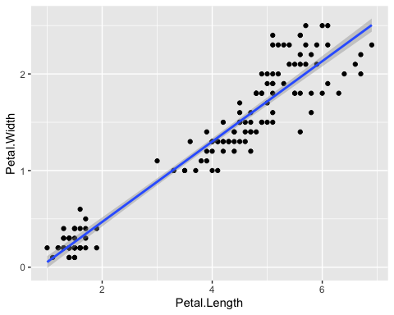

Iris scatter between Petal.Width and Petal.Length

### 1.4.2 4.2. Example with Python

Example with Python

a = 1

And overall it is irrelevant the origin of language. and mixing the languages

# 2. 2. Conclusion

The results show bigger residuals and predicting the multiple variate regression without filtering the species, to be “interesting” idea.

|  |  |
| --- | --- |
|  | **Pay Attention**  This analysis is fictitious and does not provide any real results |