600_02_A_Quarto

Tomaz Kastrun

Table of contents

# 1. Report on analysis of Iris datasets

## 1.1 Exploring data

Based on the group selected versicolor, here is the table data.

Sepal.Length Sepal.Width Petal.Length Petal.Width Species  
1 7.0 3.2 4.7 1.4 versicolor  
2 6.4 3.2 4.5 1.5 versicolor  
3 6.9 3.1 4.9 1.5 versicolor  
4 5.5 2.3 4.0 1.3 versicolor  
5 6.5 2.8 4.6 1.5 versicolor  
6 5.7 2.8 4.5 1.3 versicolor

And calculating for Species versicolor and number of observations 50.

## 1.2 1. Checking custom fits

This is a custom function fit:

Call:  
lm(formula = Petal.Length ~ Petal.Width, data = d)  
  
Residuals:  
 Min 1Q Median 3Q Max   
-0.8375 -0.1441 -0.0114 0.1984 0.6755   
  
Coefficients:  
 Estimate Std. Error t value Pr(>|t|)   
(Intercept) 1.7813 0.2838 6.276 9.48e-08 ***  
Petal.Width 1.8693 0.2117 8.828 1.27e-11 ***  
---  
Signif. codes: 0 '***' 0.001 '**' 0.01 '*' 0.05 '.' 0.1 ' ' 1  
  
Residual standard error: 0.2931 on 48 degrees of freedom  
Multiple R-squared: 0.6188, Adjusted R-squared: 0.6109   
F-statistic: 77.93 on 1 and 48 DF, p-value: 1.272e-11

## 1.3 Running multiple regression

You can add options to run multiple regression

|  |
| --- |
| Figure 1 |

## 1.4 Adding multiple predictors on graph:

|  |
| --- |
| Figure 2: Iris scatterplot with multiple predictors |

## 1.5 Running multiple different code

### 1.5.1 Example with R

Here with using R Language.

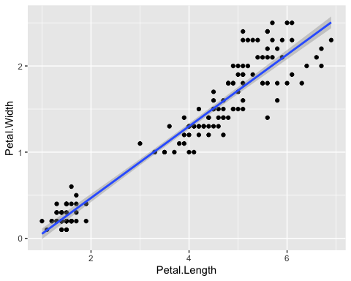

Iris scatter between Petal.Width and Petal.Length

### 1.5.2 Example with Python

Example with Python

a = 1

And overall it is irrelevant the origin of language. and mixing the languages

# 2. Conclusion

The results show bigger residuals and predicting the multiple variate regression without filtering the species, to be “interesting” idea.

|  |  |
| --- | --- |
|  | **Pay Attention**  This analysis is fictitious and does not provide any real results |