600_02_A_Quarto

Tomaz Kastrun

Table of contents

# 1. Report on analysis of Iris datasets

## 1.1 Exploring data

Based on the group selected virginica, here is the table data.

Sepal.Length Sepal.Width Petal.Length Petal.Width Species  
1 6.3 3.3 6.0 2.5 virginica  
2 5.8 2.7 5.1 1.9 virginica  
3 7.1 3.0 5.9 2.1 virginica  
4 6.3 2.9 5.6 1.8 virginica  
5 6.5 3.0 5.8 2.2 virginica  
6 7.6 3.0 6.6 2.1 virginica

And calculating for Species virginica and number of observations 50.

## 1.2 1. Checking custom fits

This is a custom function fit:

Call:  
lm(formula = Petal.Length ~ Petal.Width, data = d)  
  
Residuals:  
 Min 1Q Median 3Q Max   
-0.8410 -0.4146 -0.1057 0.2854 1.1706   
  
Coefficients:  
 Estimate Std. Error t value Pr(>|t|)   
(Intercept) 4.2407 0.5613 7.555 1.04e-09 ***  
Petal.Width 0.6473 0.2746 2.357 0.0225 *   
---  
Signif. codes: 0 '***' 0.001 '**' 0.01 '*' 0.05 '.' 0.1 ' ' 1  
  
Residual standard error: 0.5279 on 48 degrees of freedom  
Multiple R-squared: 0.1038, Adjusted R-squared: 0.08508   
F-statistic: 5.557 on 1 and 48 DF, p-value: 0.02254

## 1.3 Running multiple regression

You can add options to run multiple regression

|  |
| --- |
| Figure 1 |

## 1.4 Adding multiple predictors on graph:

|  |
| --- |
| Figure 2: Iris scatterplot with multiple predictors |

## 1.5 Running multiple different code

### 1.5.1 Example with R

Here with using R Language.

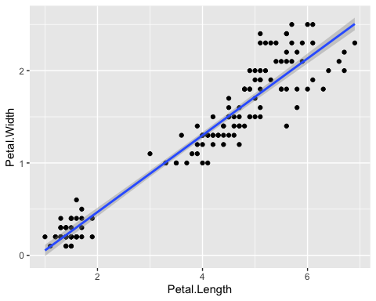

Iris scatter between Petal.Width and Petal.Length

### 1.5.2 Example with Python

Example with Python

a = 1

And overall it is irrelevant the origin of language. and mixing the languages

# 2. Conclusion

The results show bigger residuals and predicting the multiple variate regression without filtering the species, to be “interesting” idea.

|  |  |
| --- | --- |
|  | **Pay Attention**  This analysis is fictitious and does not provide any real results |