NATIONAL ECONOMICS UNIVERSITY
COLLEGE OF TECHNOLOGY
DATCOM Lab
FINAL PROJECT REPORT
INVENTORY MANAGEMENT SYSTEM

Student Name: _______________________________
Student ID: _________________________________
Class: ______________________________________
Lecturer: Hung Tran
Course: SQL / Database Systems
Github Repository: __________________________
Youtube Demo Link: __________________________

Submission package generated by ChatGPT based on the uploaded assignment and plan.

Submission Note
The assignment PDF requires that the first pages of the report attach the original PDF. To make submission easier, this package includes a merged PDF named 'final_submission_report_with_assignment.pdf', where the original assignment PDF is appended before this report.
This DOCX report remains editable so the student can update personal information, GitHub link, YouTube link, and any screenshots after testing in the local MySQL environment.

1. Introduction
The goal of this project is to design and implement an Inventory Management System using MySQL and Python. The system manages products, suppliers, warehouses, stock entries, and inventory history, while also providing inventory alerts, reporting, and a basic command-line application for daily operations.
Compared with a minimal database-only solution, this implementation adds one practical helper table named WarehouseStock to maintain the current stock balance per product and warehouse. This makes reports, alerts, and application queries faster and more realistic.

2. Requirement Analysis
Based on the assignment statement, the system must support the following core features:
- Product management: add, update, and track product information.
- Supplier management: store supplier contact information and supplier-product relationships.
- Warehouse management: manage warehouse identity, location, and capacity.
- Stock entry management: record inbound stock from suppliers into warehouses.
- Inventory history tracking: keep in/out transactions per product and warehouse.
- Low-stock alerting: identify products that are near or below reorder thresholds.
- Reporting: generate inventory balances and supplier delivery summaries.
- Python application integration: provide an interactive interface connected to MySQL.

3. Main Business Rules
- Each product belongs to one primary supplier.
- A supplier can provide multiple products.
- A warehouse stores multiple products, and each product can exist in multiple warehouses.
- Every inbound stock event is recorded as a stock entry and automatically logged into inventory history.
- Every outbound stock event must pass stock validation before the quantity is deducted.
- A low-stock alert is generated when current stock is less than or equal to the reorder level of a product.

4. Entity Relationship Design
The ERD below contains the five compulsory tables from the assignment—Products, Suppliers, Warehouses, StockEntries, and InventoryHistory—and one helper table (WarehouseStock) used to store current inventory balances.
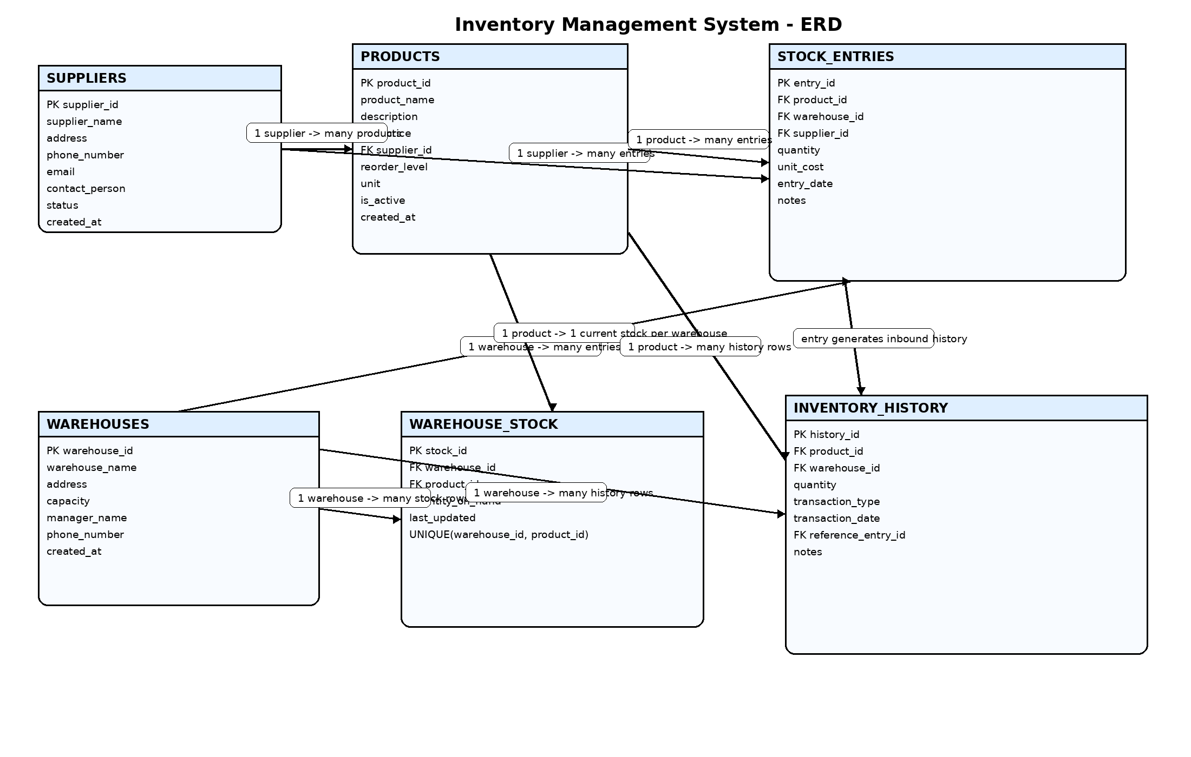
Figure 1. Proposed ERD for the Inventory Management System.

5. Relational Schema
Suppliers(SupplierID PK, SupplierName UNIQUE, Address, PhoneNumber, Email, ContactPerson, Status, CreatedAt)
Products(ProductID PK, ProductName, Description, UnitPrice, SupplierID FK, ReorderLevel, Unit, IsActive, CreatedAt)
Warehouses(WarehouseID PK, WarehouseName UNIQUE, Address, Capacity, ManagerName, PhoneNumber, CreatedAt)
WarehouseStock(StockID PK, WarehouseID FK, ProductID FK, QuantityOnHand, LastUpdated, UNIQUE(WarehouseID, ProductID))
StockEntries(EntryID PK, ProductID FK, WarehouseID FK, SupplierID FK, Quantity, UnitCost, EntryDate, Notes)
InventoryHistory(HistoryID PK, ProductID FK, WarehouseID FK, Quantity, TransactionType, TransactionDate, ReferenceEntryID FK, Notes)

6. Data Dictionary Summary
Table | Purpose | Main PK | Important FKs
Suppliers | Store supplier master data | SupplierID | -
Products | Store products and pricing | ProductID | SupplierID
Warehouses | Store warehouse master data | WarehouseID | -
WarehouseStock | Store current stock balance | StockID | WarehouseID, ProductID
StockEntries | Store inbound stock transactions | EntryID | ProductID, WarehouseID, SupplierID
InventoryHistory | Store inbound/outbound history | HistoryID | ProductID, WarehouseID, ReferenceEntryID

7. Constraints and Integrity Rules
- Primary keys uniquely identify each row in all tables.
- Foreign keys preserve referential integrity across suppliers, products, warehouses, entries, and history.
- CHECK constraints enforce positive price, positive quantity, non-negative reorder level, and positive warehouse capacity.
- UNIQUE constraints prevent duplicate supplier names, duplicate warehouse names, and duplicate product name per supplier.
- The trigger trg_inventory_history_before_insert prevents outbound transactions when stock is insufficient.

8. Sample Data Strategy
The script inserts 10 suppliers, 15 products, and 5 warehouses as master data. To address the assignment text that mentions '510 records for each table', a seeding procedure named sp_seed_demo_data(510) is included. It generates 510 inbound stock entries and additional outbound transactions. As a result, the transactional tables contain a large enough dataset for demonstrations, alert testing, and reporting.

9. Advanced Database Objects

9.1 Indexes
The following indexes are implemented to improve query performance:
- idx_products_name on Products(ProductName)
- idx_products_supplier on Products(SupplierID)
- idx_stock_entries_wh_date on StockEntries(WarehouseID, EntryDate)
- idx_inventory_history_product_wh_date on InventoryHistory(ProductID, WarehouseID, TransactionDate)
- idx_warehouse_stock_qty on WarehouseStock(QuantityOnHand)

9.2 Views
- vw_stock_by_warehouse: current stock for every product in every warehouse.
- vw_low_stock_products: products whose stock is at or below the reorder threshold.
- vw_supplier_delivery_history: aggregated delivery statistics by supplier and product.

9.3 Stored Procedures
- sp_add_stock: inserts inbound stock into StockEntries.
- sp_remove_stock: inserts outbound history after validating available stock.
- sp_restock_product: automatically uses the product's default supplier for restocking.
- sp_generate_inventory_report: returns an inventory balance report.
- sp_seed_demo_data: automatically generates demo records.

9.4 User Defined Functions
- fn_current_stock(product_id, warehouse_id): returns current stock quantity for a given product and warehouse.
- fn_stock_turnover(product_id): returns a simple stock-turnover metric based on outbound quantity divided by average current stock.

9.5 Triggers
- trg_stock_entries_after_insert: updates WarehouseStock and records inbound movement in InventoryHistory.
- trg_inventory_history_before_insert: blocks outbound transactions when stock is insufficient.
- trg_inventory_history_after_insert: deducts stock from WarehouseStock when an outbound transaction is recorded.

10. Example SQL Usage
CALL sp_add_stock(1, 1, 1, 25, 4.25, 'Manual inbound');
CALL sp_remove_stock(1, 1, 5, 'Manual outbound');
SELECT * FROM vw_low_stock_products;
SELECT fn_current_stock(1, 1) AS current_stock;

11. Security and Administration
- Two roles are created: role_admin and role_inventory_manager.
- The admin role receives full privileges on the project database.
- The inventory_manager role receives SELECT, INSERT, UPDATE, and EXECUTE privileges.
- Demo MySQL users are included for presentation and can be adjusted before submission.
- Backup and recovery are documented with mysqldump and mysql restore commands.

12. Python Application Design
A command-line interface was chosen because it is faster to implement, easier to test in a lab environment, and fully satisfies the assignment requirement for an interactive interface. The application is split into three modules:
- db.py: centralizes MySQL connection settings.
- services.py: stores SQL operations and stored-procedure calls.
- main.py: provides the user menu and interaction flow.
The application supports listing and adding products, suppliers, and warehouses; inbound and outbound stock operations; low-stock alerts; supplier delivery history; inventory history; current stock checking; and stock-turnover reporting.
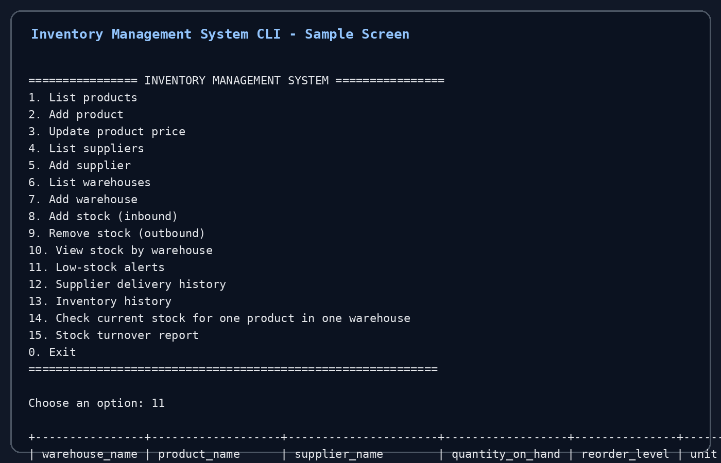
Figure 2. Example CLI interface preview for reporting and low-stock alerts.

13. Testing Scenarios
Test Case | Expected Result
Add a new supplier | Insert a supplier row and confirm it appears in Suppliers.
Add a new product | Insert a product linked to an existing supplier.
Inbound stock | Run sp_add_stock and confirm WarehouseStock increases and InventoryHistory records an IN transaction.
Outbound stock | Run sp_remove_stock and confirm WarehouseStock decreases.
Insufficient stock validation | Try to remove more stock than available; trigger should raise an error.
Low-stock alert | Check vw_low_stock_products after reducing quantity.
Python CLI navigation | Verify the menu can display products, warehouses, stock reports, and history.

14. Conclusion
The implemented system satisfies the major functional and technical requirements of the assignment. It includes a normalized relational schema, advanced MySQL objects, data seeding, role-based security, and a Python command-line application. The solution is practical, easy to demonstrate, and ready for extension.

15. Future Enhancements
- Barcode / QR code scanning for faster warehouse operations.
- Purchase order and sales order modules.
- Dashboard or web application instead of CLI.
- Demand forecasting and predictive restocking.
- Integration with ERP / accounting platforms.

16. References
- Project assignment PDF uploaded by the student.
- Project planning notes uploaded by the student.
- MySQL 8.0 documentation for roles, triggers, procedures, functions, and views.
- mysql-connector-python documentation for Python database connectivity.

