**FoodFact Testing Document**

**Tom Bernat**

# Instructions

Please use this file to document any testing of your website that you carried out. You are not expected to write a whole essay on this: two or three pages at most should suffice (including screenshots).

**Task 1. Cross-browser compatibility:**

I didn’t notice any difference between the different browser.

Mircosoft Edge:

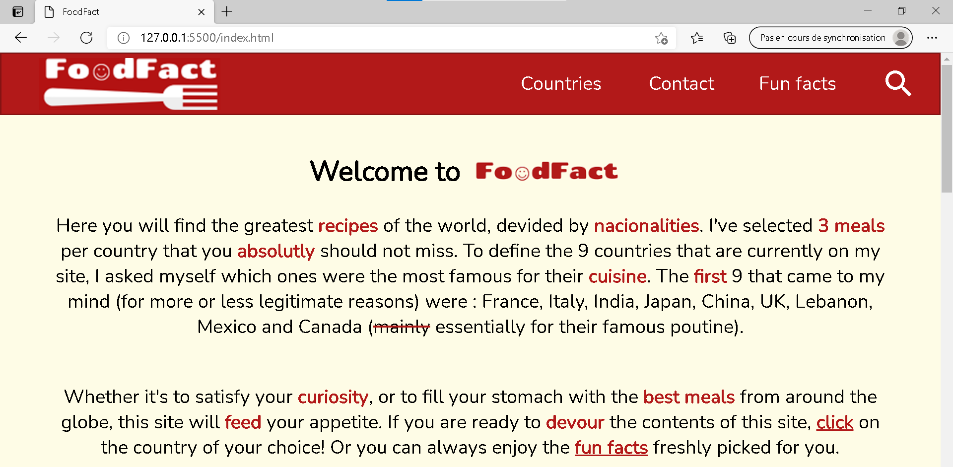

Mozilla:

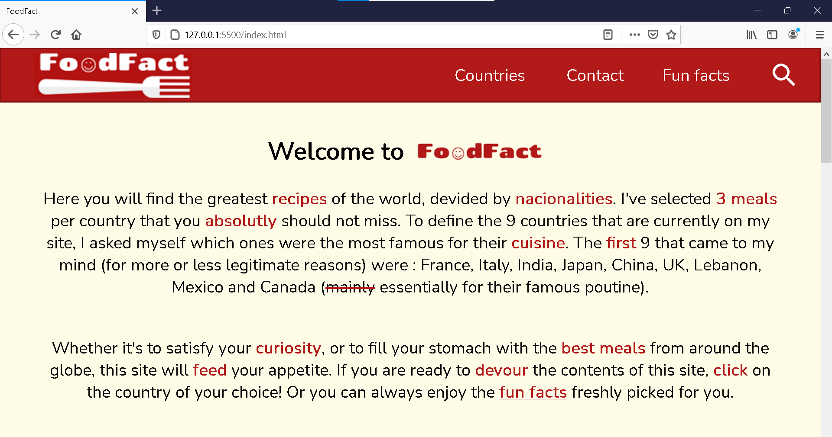

Chrome:

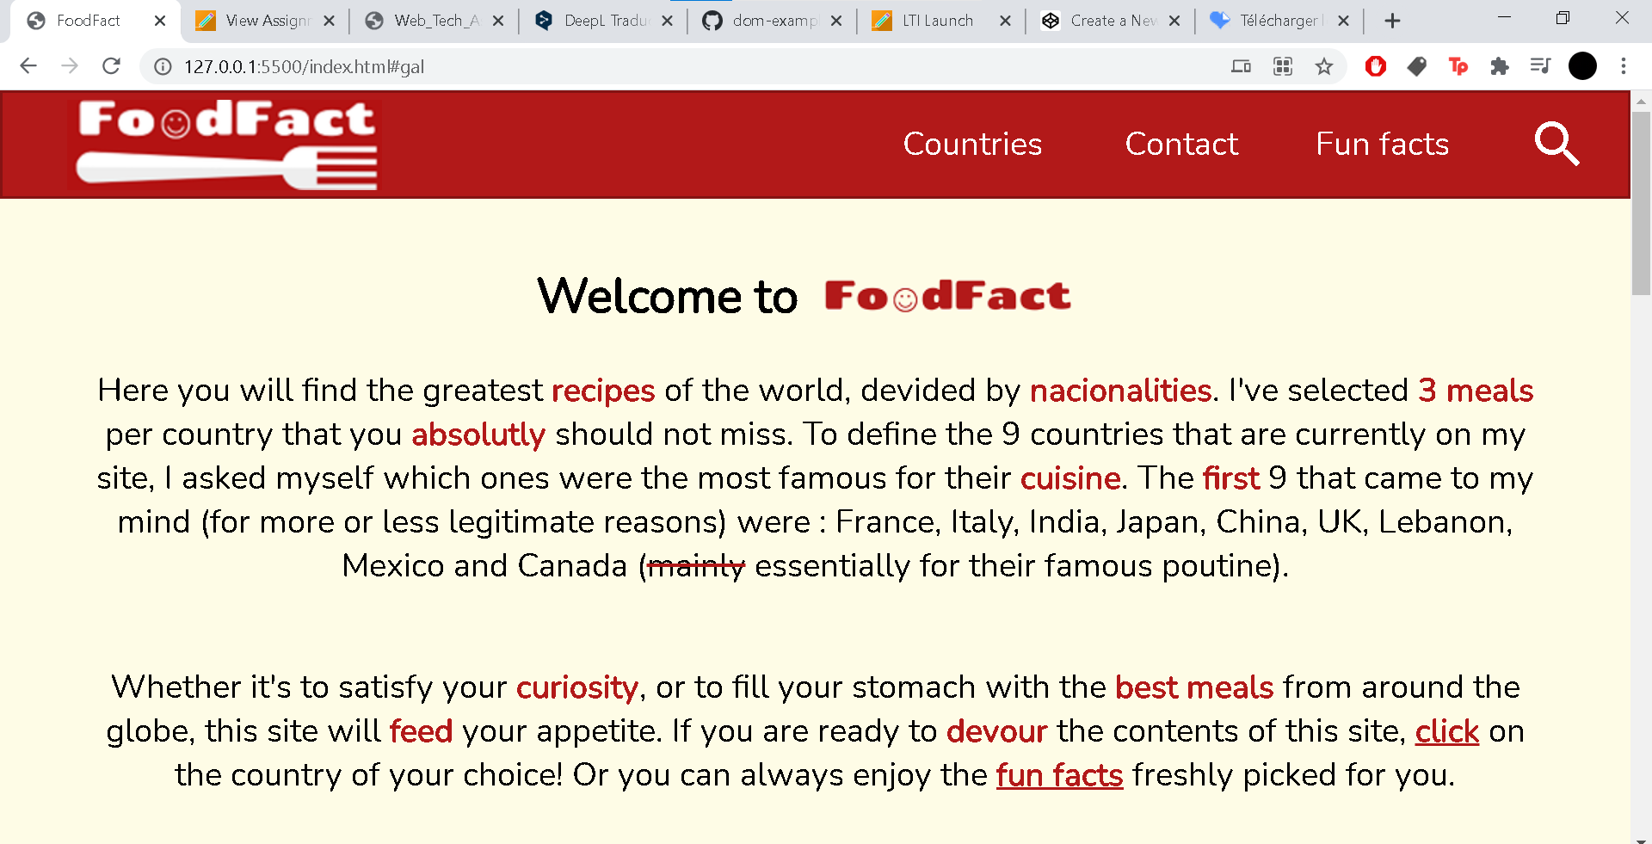

**Task 2. HTML/CSS Validation**

Use the W3C HTML and CSS validators to check your website (upload files to the validator to check them). List the pages and write something for each along the lines of:

1. I had this error: 

I found out I left two id=”here” that was unnecessary after a copy/paste operation.

1. Also had this error: 

I just forgot the quotes, so I putted them and the error is gone.

1. This:

I’ve putted this :

<meta charset="UTF-8">

in the head of the doc and it has cleared the error.

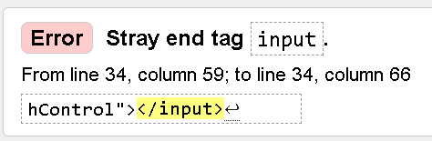

1. I just deleted the </input> element.

And now it looks like this: 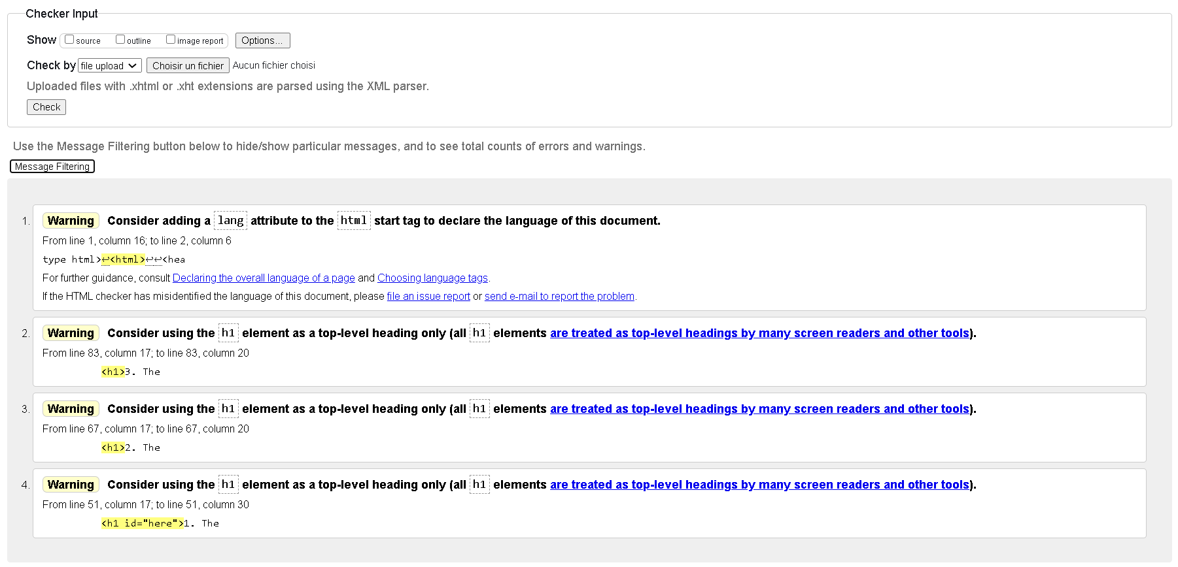

In the css file I had only one error:

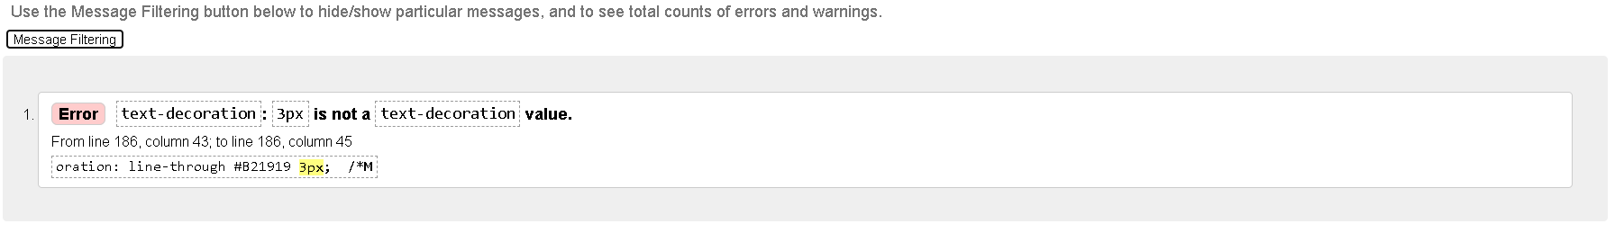

I simply had to delete the “3px” term, that was useless.

The result is:

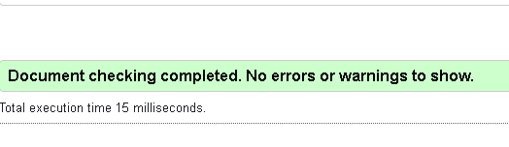

**Task 3. Peer review (via screen share or remote control)**

A friend browsed my site for about ten minutes. He told me that he found it functional, that it was easy to navigate between the different pages that make it up. He found the aesthetics clean, which he appreciated. He also liked the information on the different dishes, especially the fun facts.

The only downside for him was that the search bar did not work.