**Drawing / Painting Materials List**

Required and suggested materials for 2D Studio Courses

**WHERE TO FIND MATERIALS:**

You will need to use more than one of the following resources to find all the materials required expediently. It is your responsibility to locate and purchase your materials.

1. Local Art Stores: Always recommended as first choice
2. Campus Bookstore (sometimes very limited supplies)
3. Online:  dickblick.com/   jerrysartarama.com/   utrechtart.com/   artistcraftsman.com/
4. Michaels Arts and Crafts (limited selection)
5. Beverly's Fabric & Crafts (very limited selection)
6. Aaron Brother's (very limited selection)
7. Homedepot, Walgreens etc. (for non-art materials / hardware only)

***––––––––––––––––––––––––––––––––––––––––––––––––––––––––***

**AUDIO SUPPLIES:** required ☐

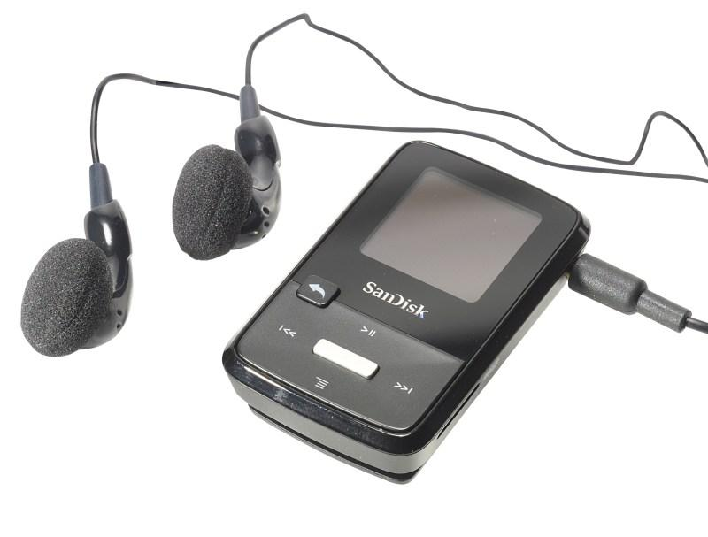   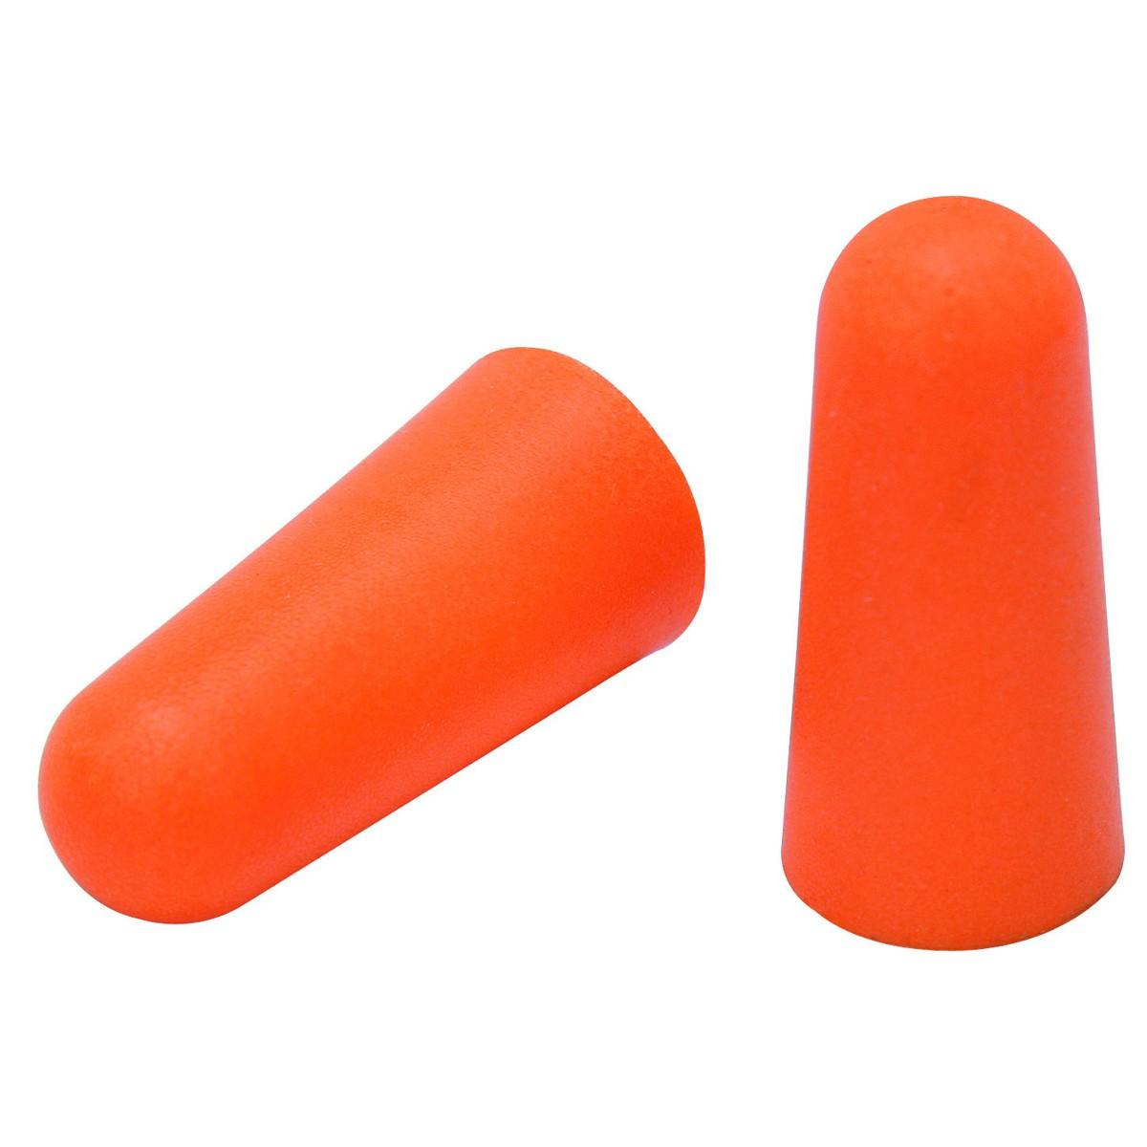

⊛ Headphones or Earplugs (must not be audible to other students)

⊛ 6 Scantron Sheets (Type 882 E)

**GRAPHITE SUPPLIES:** required ☐

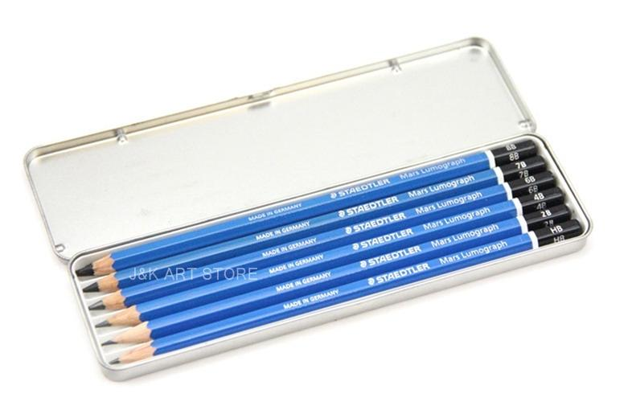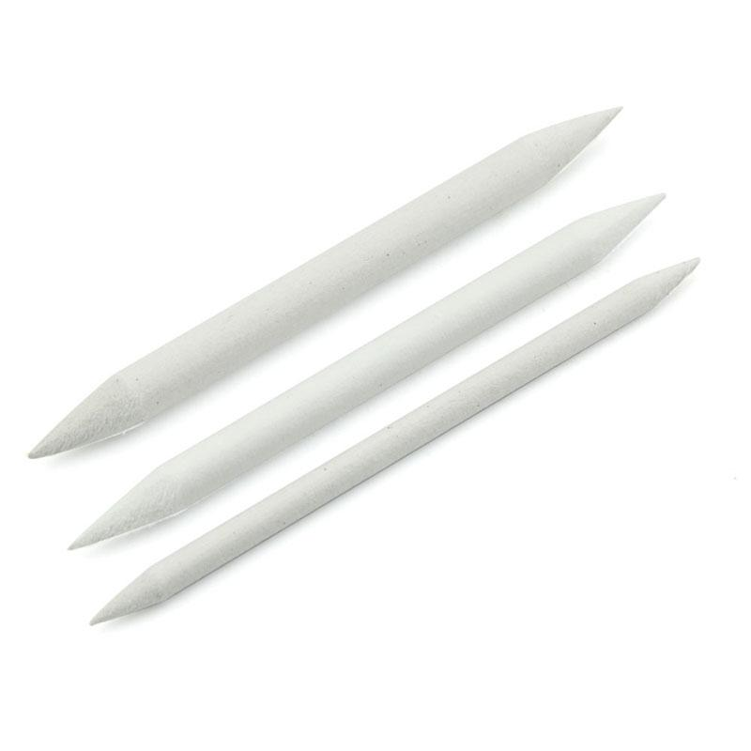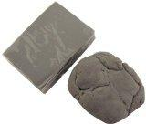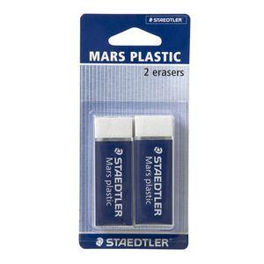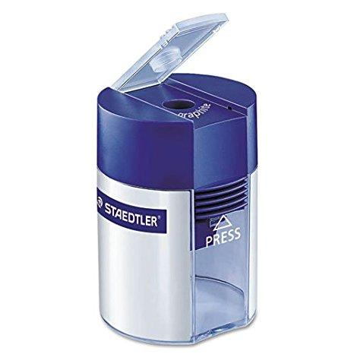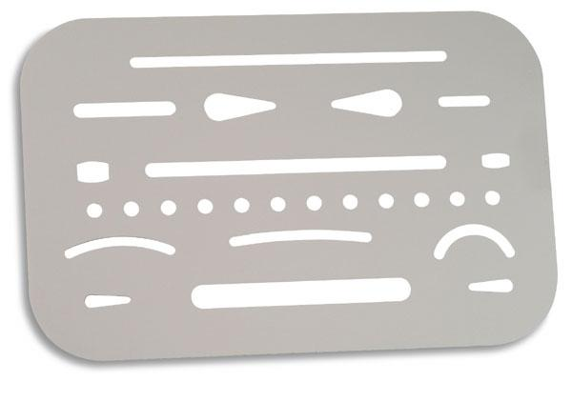

⊛ Pencil Set (6 pencils minimum, 6B,4B,2B,HB,2H,4H)

⊛ Tortillon Blending Sticks (large & small)

⊛ Kneaded Erasers (x2-5)

⊛ White Erasers (x2)

⊛ Pencil Sharpener (with shaving enclosure)

⊛ Metal Eraser Shield

**CHARCOAL SUPPLIES:** required ☐

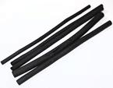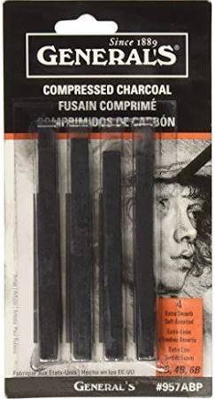 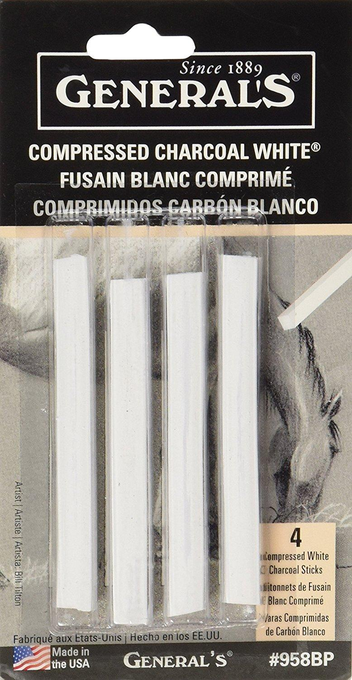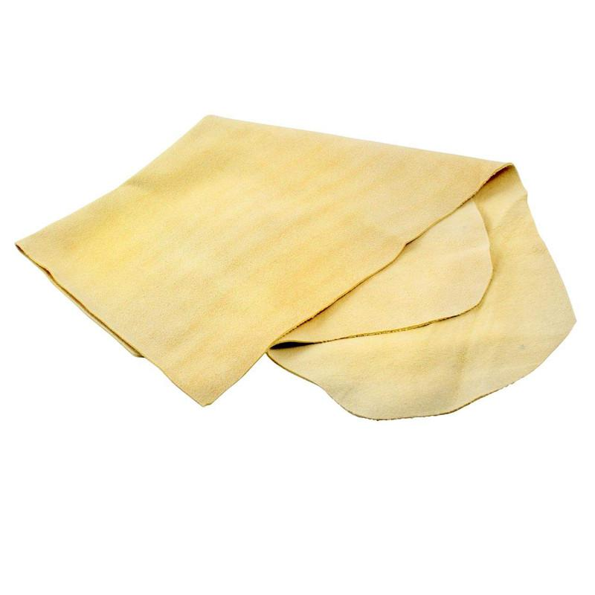

⊛ Vine Charcoal Sticks (x12-30)

⊛ Compressed Charcoal Sticks - Soft (x4-12)

⊛ White Charcoal Sticks - Soft (x4)

⊛ Chamois (For Blending)

**PAPER / NOTEBOOKS:** required ☐

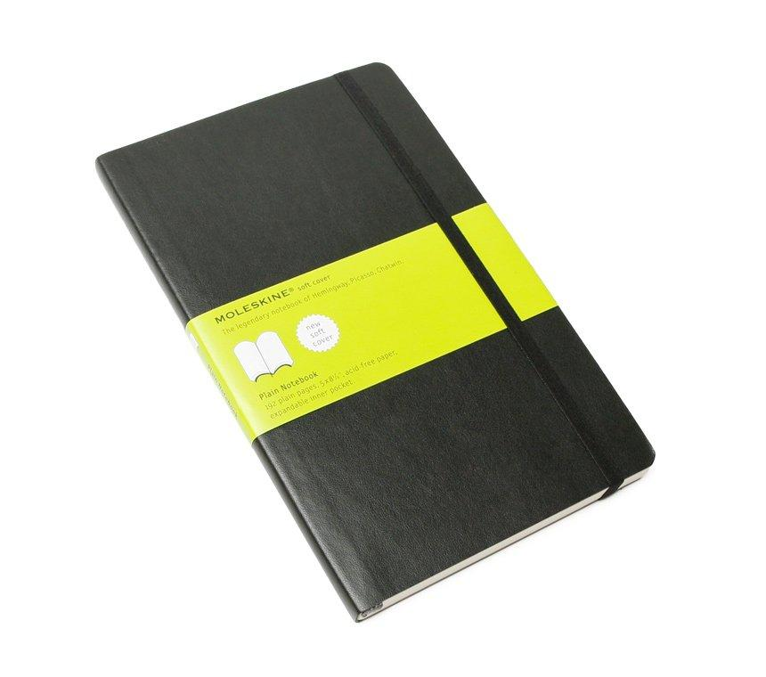 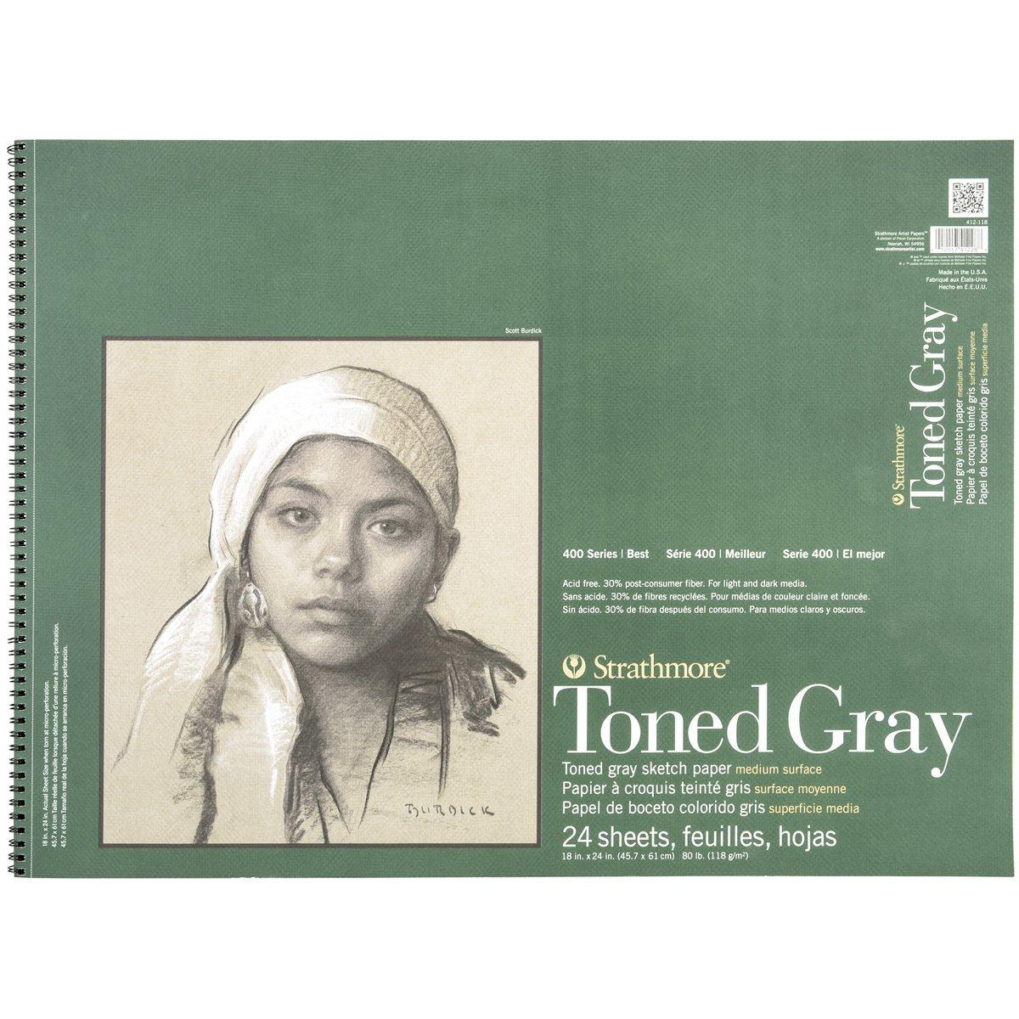 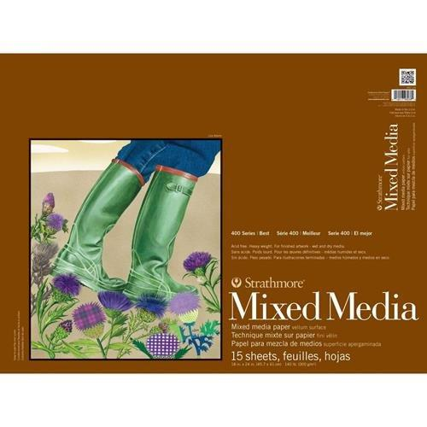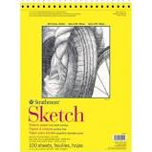

⊛ 8"x10" Sketchbook (100 sheets minimum / 200 pages)

⊛ Pad of 11x14 inch Artist Grade Drawing/Sketch Paper (Strathmore Recommended)

⊛ Pad of 18x24 inch Toned Paper (80 lb. 24 sheets)

**OR** Pad of 18x24 inch 140 lb. Mixed Media Paper (15 sheets)

**DRAFTING SUPPLIES:** required ☐

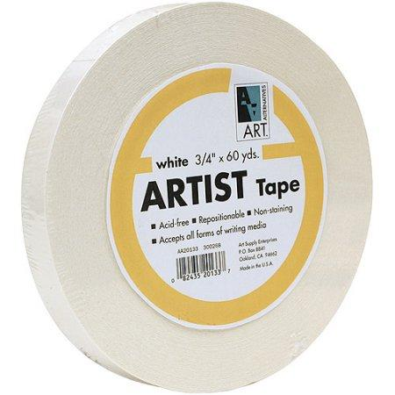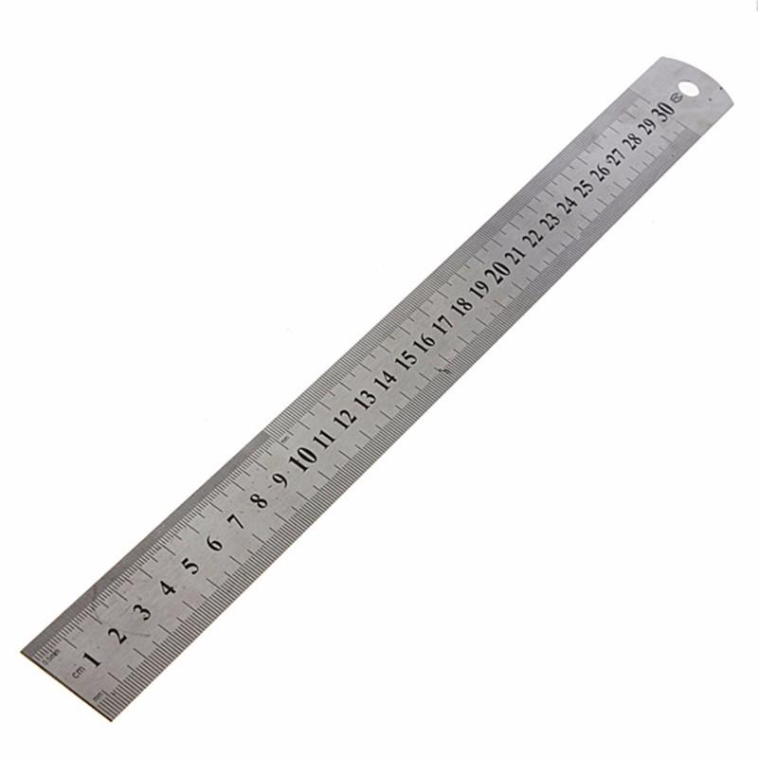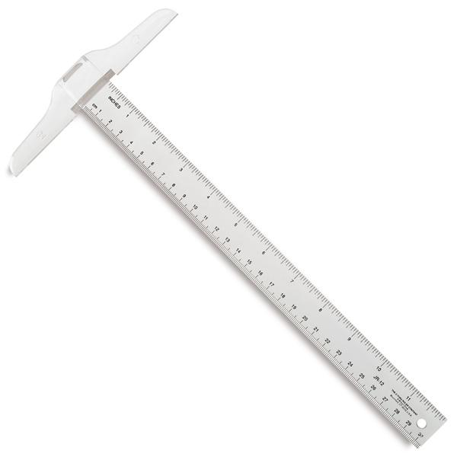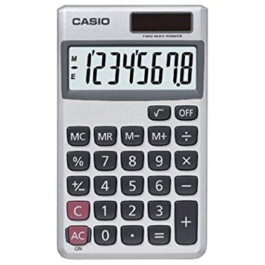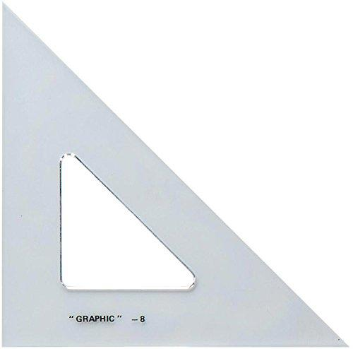

⊛ Artist's Tape, White

⊛ Metric Ruler and/or Small T-Square

⊛ Calculator

⊛ Small Drafting Triangle (Right Angle)

**INK SUPPLIES:** required ☐

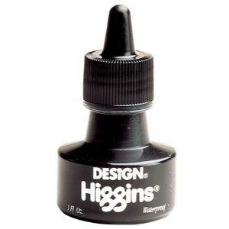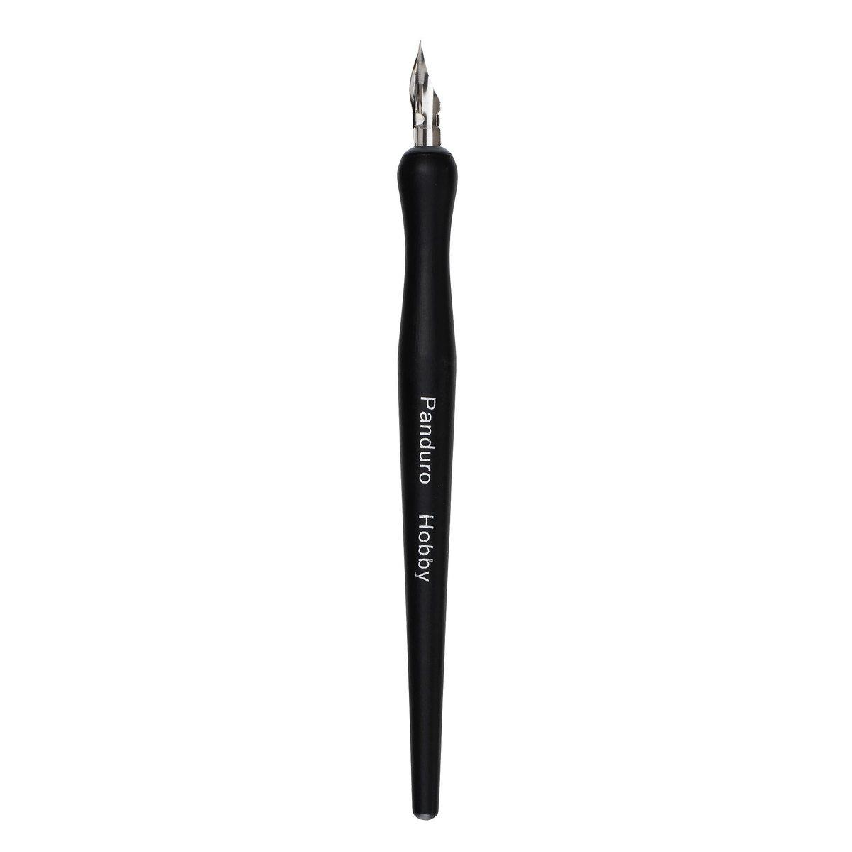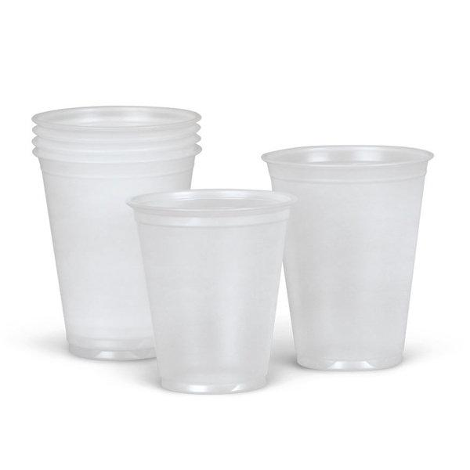

⊛ Ink (with built-in eye dropper)

⊛ Dip Pen Set (with small nib at least)

⊛ Disposable plastic cups (x3-6)

**WATERCOLOR SUPPLIES:** required ☐

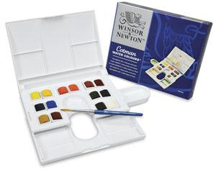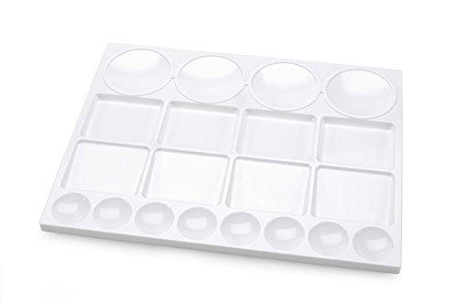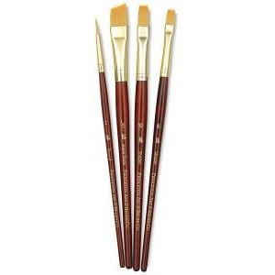

⊛ Water Color Pan Set and Palette (10 color minimum)

⊛ Synthetic Brush Set (x4 minimum, must be different sizes and shapes)

**OTHER DRY MEDIA:** required ☐

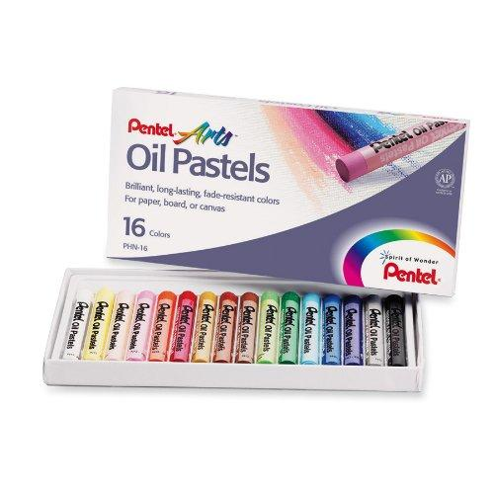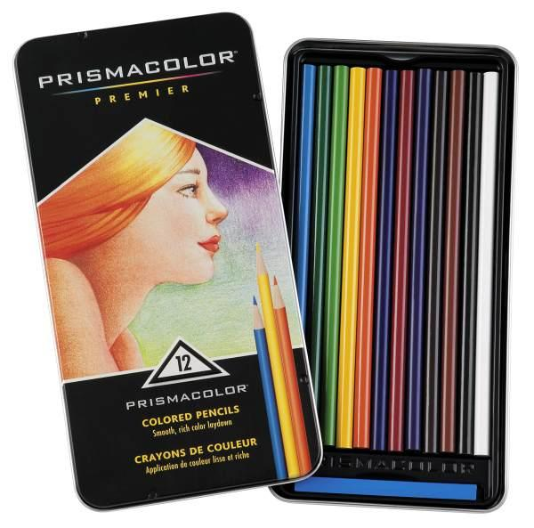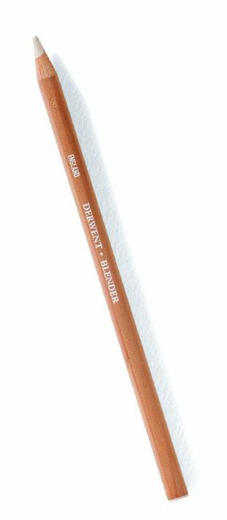

⊛ Oil Pastel Set (10 color minimum)

⊛ Colored Pencil Set (10 color minimum)

⊛ Colorless Blending Pencil (x1)

**OBSERVATIONAL SUPPLIES:** required ☐

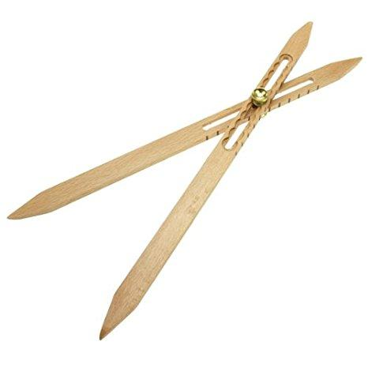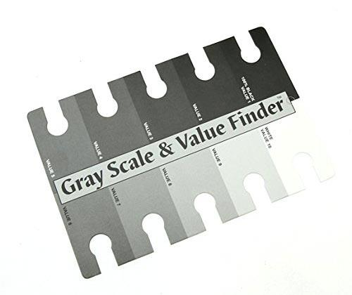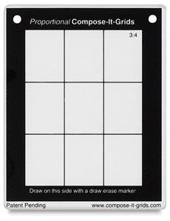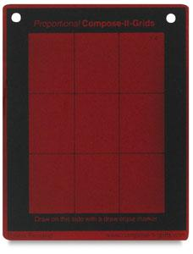

⊛ Scale Dividers

⊛ Value Scale / Grey Scale

⊛ "Compose It Grid" (translucent plastic sheet with black frame and grid lines)

⊛ Value Finder (red or green translucent plastic sheet)

**OTHER DRAFTING SUPPLIES:** required ☐

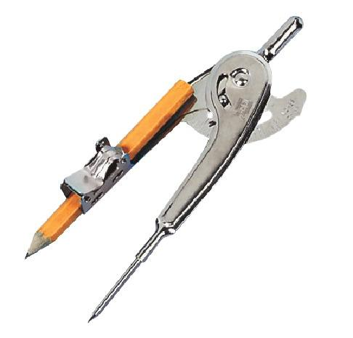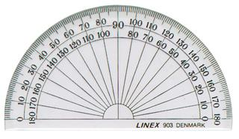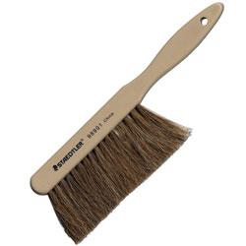

⊛ Compass (with removable pencil attachment point)

⊛ Protractor

⊛ Dusting Brush

**OTHER OBSERVATIONAL SUPPLIES:** required ☐

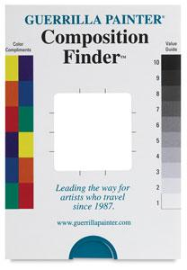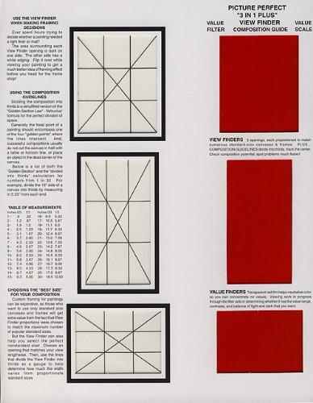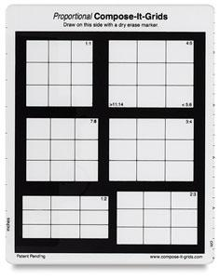

⊛ Value Scale / Compose It Grid / Value Finder combination tools (one not all)

**OIL PAINTING SUPPLIES:** required ☐

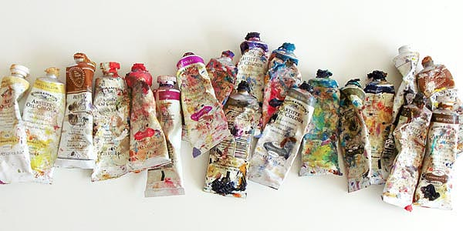 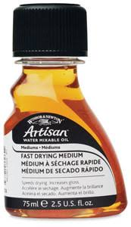 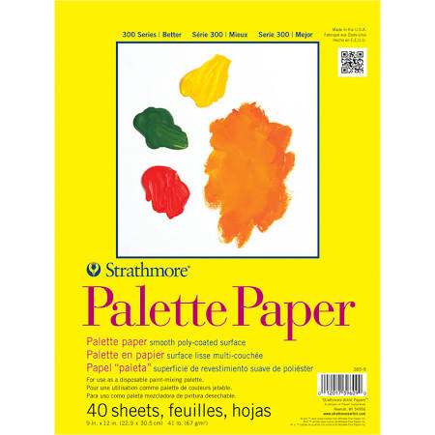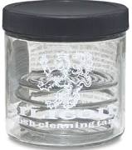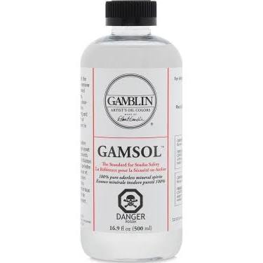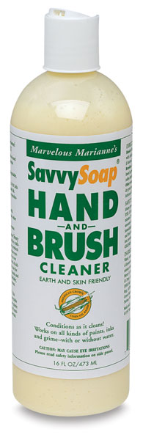

Basic / Affordable Oil Paint Set:

*All the following is required minimum if students choose to oil paint*

⊛ Windsor & Newton brand “Drying Linseed Oil”

⊛ Pad of Palette Paper (approx. 8”x11”)

⊛ Mix of brushes (x5-10)

- Different shapes / sizes, different materials (synthetic, hogs-hair, sable etc.)

⊛ Brush cleaning tank / jar (100% water-tight lid)

⊛ Gamblin brand “Gamsol” oil cleaner, enough to fill brush cleaning tank once/twice

⊛ SavvySoap brand “Hand & Brush Cleaner” (hand soap to remove oil paint)

⊛ Alizarin Red (Old Holland brand)

⊛ Indian Yellow (Gamblin brand)

⊛ Naples Yellow (Gamblin brand)

⊛ Yellow Ochre (Gamblin brand)

⊛ Cerulean Blue (Gamblin brand)

⊛ Ultramarine Blue (Gamblin brand)

⊛ Sap Green (Old Holland brand)

⊛ Raw Umber (Gamblin brand)

⊛ Ivory Black (Gamblin brand)

⊛ Titanium White (Gamblin brand)

*\*\* Choices regarding working surfaces (canvases, panels etc.) are left up to*

*the discretion of the student but should be discussed with instructor before purchase.*

**ACRYLIC PAINTING SUPPLIES:** required ☐

Basic / Affordable Acrylic Paint Set:

*All the following is required minimum if students choose to oil paint*

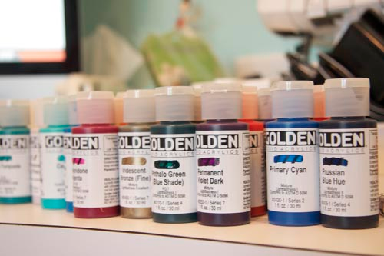 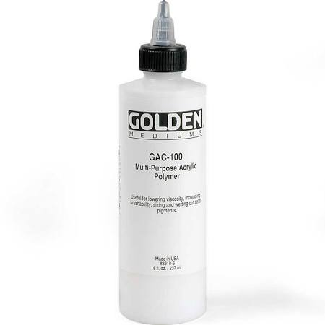 **

⊛ Range of Golden brand “Fluid Acrylic” paints (x10-20 minimum)

*\*\* Due to the nature of acrylic paint color choices are left to the discretion of the student*

*Colors should be picked based on intuitive taste of student but must make up a full chromatic*

*spectrum similar to the colors listed under oil paint (above).*

⊛ Golden brand “GAC-100” (thick transparent medium) 8oz.

⊛ Golden brand “Airbrush Medium” (thin transparent medium) 8oz.

⊛ Brush cleaning tank / jar (100% water-tight lid)

⊛ Pad of Palette Paper (approx. 8”x11”)

⊛ Mix of brushes (x5-10)

- Different shapes / sizes, different materials (synthetic, hogs-hair, **not** sable etc.)

*\*\* Choices regarding working surfaces (canvases, panels etc.) are left up to*

*the discretion of the student but should be discussed with instructor before purchase.*

**STORAGE / TRANSPORT SUPPLIES:** required ☐

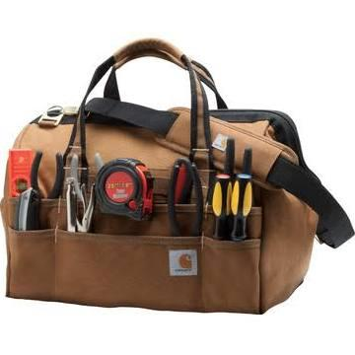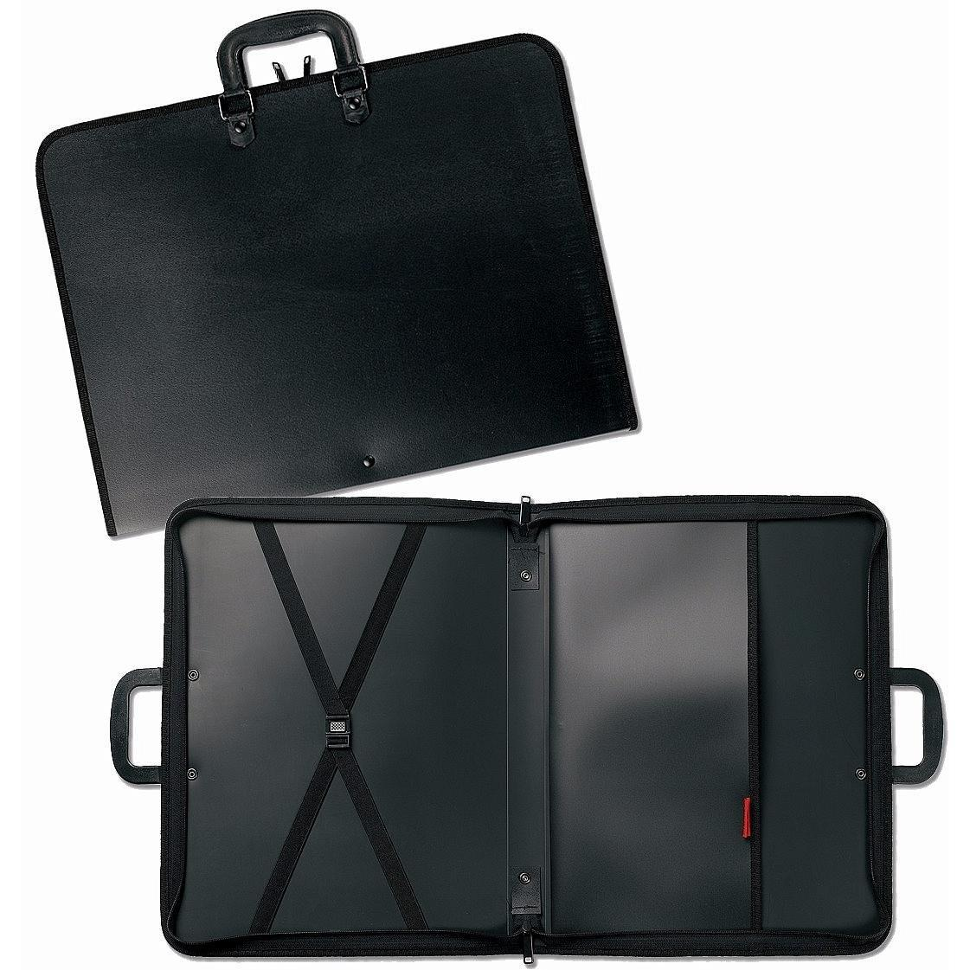

⊛ Tool Bag

⊛ Heavy Duty Studio Art Portfolio, 20 x 26 inch