Spring 2019, 2D Design

Project #4, Part 1 - Portrait Photomontage Collages **Due: April 4th - Critique**

**#4 PART 1 - PORTRAIT - PHOTOMONTAGE COLLAGES USING TEXTURE AND VALUE**

We’ll make 3 collages (8x10”) as the first step in our 4th project. The context and guidelines for the collage designs are listed below. This project builds on the skills you’ve gained in the line compositions and composite shape project.

**ELEMENTS:** The primary elements we’ll be exploring are **pattern, texture**, and **value**. **Pattern** is the repetition of an element or design motif. Patterns can be simple or complex and can serve to unify a design. **Texture** and **pattern** are related in that both utilize repeating elements. **Texture** describes the surface quality of a work and can be actual, implied or invented. We used a lot of invented textures in the line compositions project. In all design work, we must consider shape and **value** - the light & dark areas of our design whether applied to representational or abstract forms.

**PRINCIPLES:** The primary principles we’ll be exploring are **repetition, rhythm** and **contrast**. While we might think of **repetition** as uniform, **rhythm** involves repeating forms but with variation, or some irregularity or change. Rhythm can have a great impact on creating movement in a design. **Contrast** refers to difference, and can mean a great or subtle difference between light and dark, detail and emptiness, negative and positive shape, and materials or colors. Any element can be used to create contrast with what is near or surrounding it.

**TECHNIQUES:** Since the 20th century, **collage** has been considered a legitimate medium of the fine arts and consists of pasting down disparate pieces of colored or textured papers or materials into one composition. It allows us to work through composition ideas quickly, especially with the help of a scanner/printer or Xerox machine. **Photomontage** is a type of collage created by cutting, gluing, rearranging and overlapping two or more photographs into a new image which may form a composite photograph or a collage with photographic elements. Sometimes the resulting composite image is photographed so that a final image may appear as a seamless photographic print. For Part 2 of Project 4, we will be transferring our photomontage onto Bristol using the ink pens.

Step 1 - **COLLECT**: Take, Collect, Print/Copy black and white (or grayscale) photographs of someone you know. (Yourself, a family member, a friend, etc.). HAVE MULTIPLES for cutting & arranging! You can have copies of the same photo, or copies of a few different photos of the same person. Have other collage materials on hand (magazines, textured drawings, textured papers, patterns, graphics, shapes, elements you’re drawn to). Optional: manipulate photos using imgonline.com.ua to print & copy too.

Step 2 - **DESIGN**: Make the first 8x10 collage that uses photos of this person. The collage must also use repetition to show rhythm. Experiment with contrast. Write a brief paragraph on the back that explains how you are using these principles.

Step 3 - **COPY**: You or I will scan and print your collage. From this print, you’ll be asked to make 2 more versions of it that are different from the first one. You can cut the copies up and rearrange the elements, and still continue to use outside photos and collage materials as well. Think about the process you engaged in for the Line Compositions. What would it look like if you changed things around? Chose a new focal point? Repeated a different element? All work in black/white/gray only.

Step 4 - **CRITIQUE**: We’ll hang the 3 collages on 4/4 to get feedback from peers on the strongest design. Then we’ll begin the setup for the transfer onto Bristol using the ink pens. See examples on back>>>>>

Examples of “first” collage design:

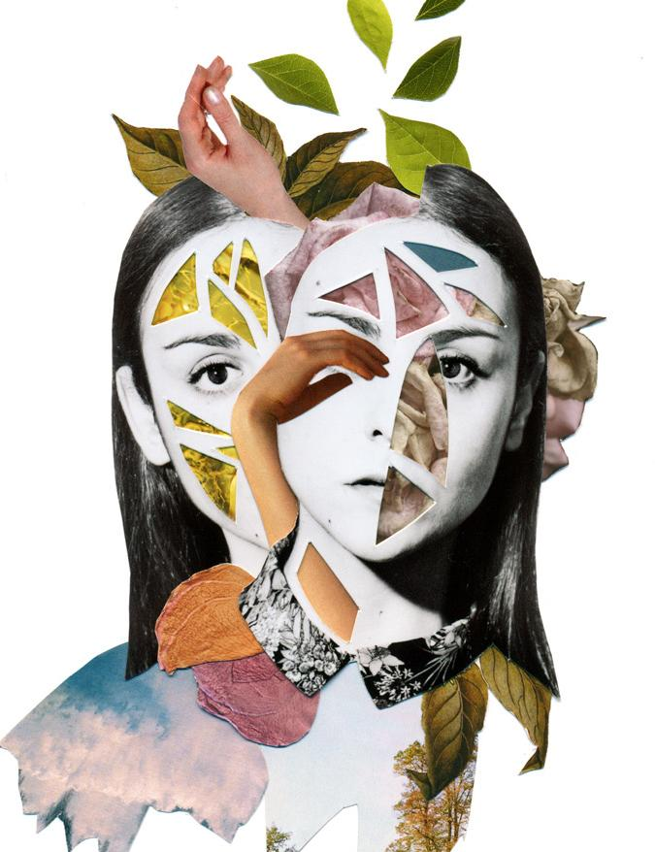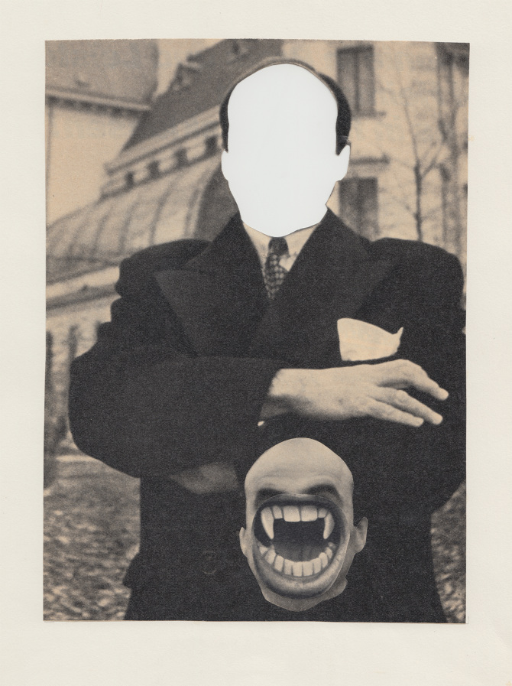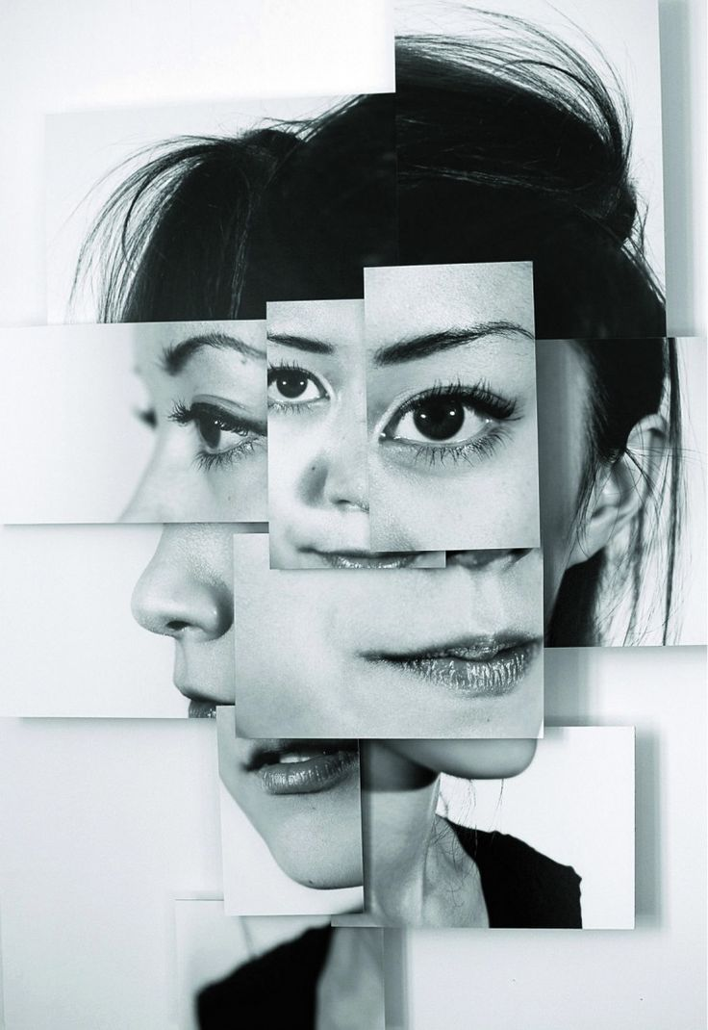

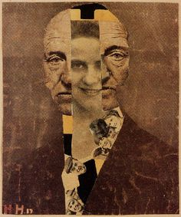

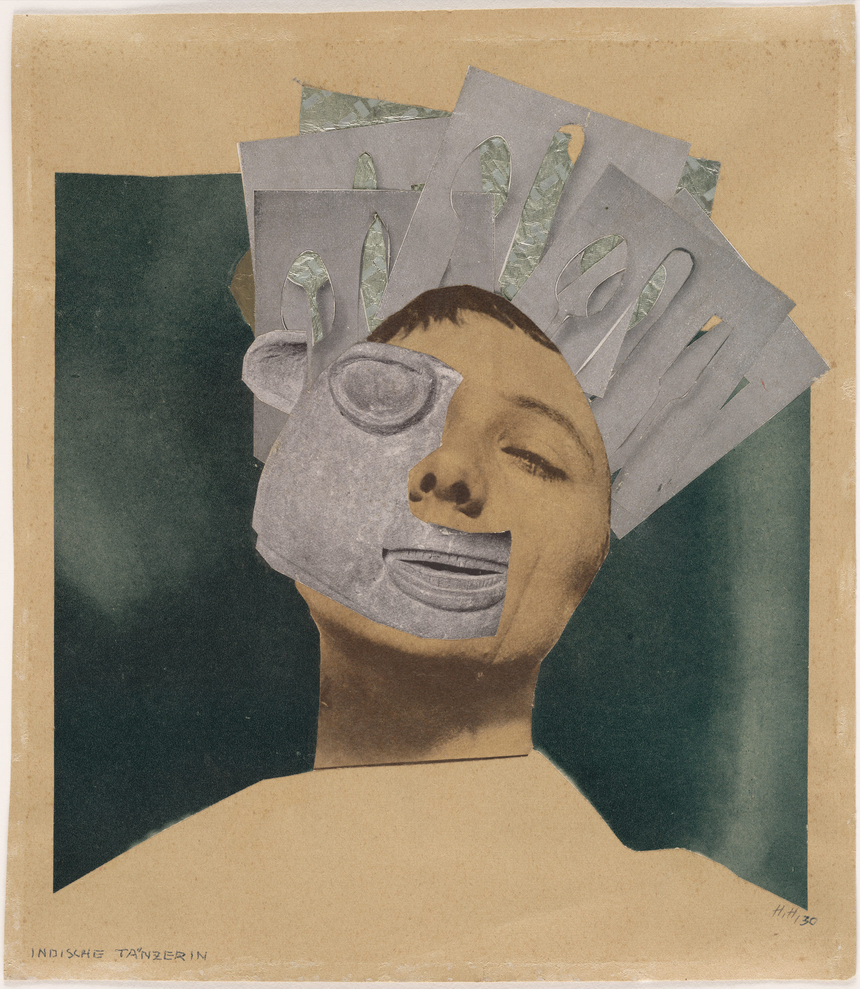

Example of a series of three collages: 