**Homework Assignment #03**

**Due Date:** Monday 2/10/2014 at the start of class.

**Assignment:**

Using the rule of thirds make a charcoal line drawing of a scene from a dream you’ve had, including a background scene and at least one figure.

**1 )** The subject of your drawing will be a dream that you have had. Please include at least one figure, either close up or far away.

**2 )** Use the **rule of thirds** grid from class to position the elements(things) in your drawing:

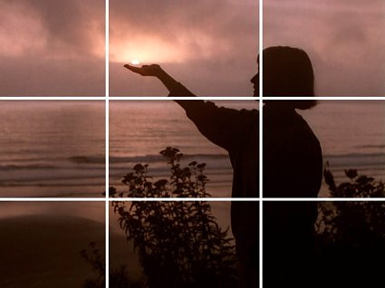

**3 )** Use a full range of line thicknesses, shapes and lengths.

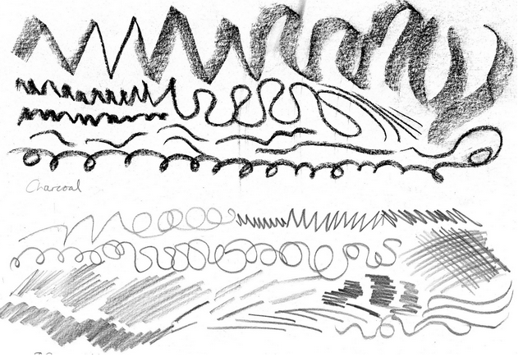

**4)** Please make use of **the entire page**, no tiny objects in empty space (if that is your dream please pick another dream or lie about it!).