**ART C111 50 - 2D DESIGN**

EXERCISE – DEPRESSING PAINTING

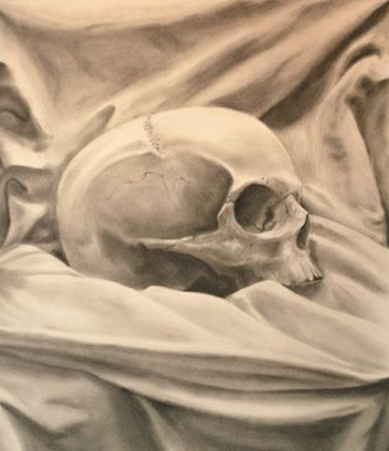

**DEPRESSING PAINTING:**

(a painting of a skull & fabric)

Skulls have been an elemental subject for artists for thousands of years. Painting a skull is not only an extremely challenging anatomical exercise, but it is also an contemplative exercise. You will paint or draw a skull placed on draped fabric and you will be graded on accuracy and detail. As you concentrate on the skull, use it as an excuse to think your own mortality (but stay positive!).

**REQUIREMENTS:**

1) Work on a paper or canvas 12” x 17” size or larger.

2) Fill the entire page.

3) Make a preliminary pencil sketch before starting.

4) Make a dynamic original composition (using handout provided, your notes and/or your textbook).

5) Your skull must be at least 10 inches on your paper.

6) You must fill the rest of the paper with fabric, no empty space.

7) Use a full value range.

**MATERIALS:** You may choose to work in one of the following:

A) **Charcoal Drawing**

- Compressed charcoal - Solid & kneaded erasers

- Vine charcoal - Blending tool (tissues, fingers or blending stick)

B) **Black & White Painting**

- Using complementary colors make a large pile of Mixed Black (Not black from the tube).

- Make your painting using only this Mixed Black and White.