**ART C111 50 - 2D DESIGN**

EXERCISE – EAR PAINTING

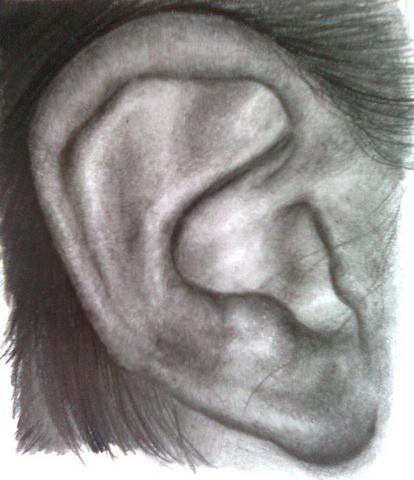

**EAR PAINTING:**

(a large painting of an ear)

The human ear is one of the strangest and most overlooked body parts. Its size and structure vary drastically from person to person and its anatomy is not as mechanical as many other structures on and in the body. You will focus on the ear of one of your peers and attempt to make the most accurate and detailed painting / drawing possible.

**REQUIREMENTS:**

1) Work on a paper or canvas 12” x 17” size or larger.

2) Fill the entire page.

3) Draw the ear from the side, as in the example above.

4) Make a preliminary pencil sketch before starting.

5) Your ear must be at least 10 inches wide on your paper.

6) You must fill the rest of the paper with hair or skin, no empty space.

7) Use a full value range.

**MATERIALS:** You may choose to work in one of the following:

A) **Charcoal Drawing**

- Compressed charcoal - Solid & kneaded erasers

- Vine charcoal - Blending tool (tissues, fingers or blending stick)

B) **Full Color Painting**

- Use any and all colors necessary.

- Shade your colors using a Mixed Black (Not straight black out of the tube).

- For skin tone mix complementary colors together to achieve a Mixed Brown (not out of the tube), then add white and small amounts red or yellow to experiment and adjust as needed.