**ART C111 50 - 2D DESIGN**

EXERCISE – EXISTENTIAL PAINTING

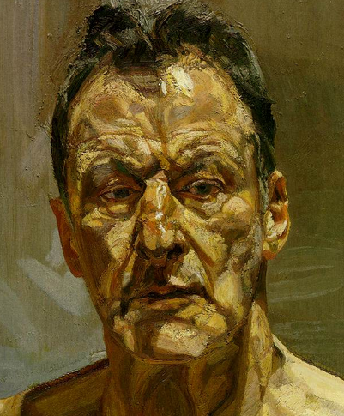

**EXISTENTIAL PAINTING:**

(a self portrait)

Self_portraits are another elemental subject for artists. The human face is extremely challenging anatomically, but painting one’s own face presents an even greater set of demands and challenges. As you paint yourself, contemplate your own existence and try to explore the boundary between *who* you are and *what* you are.

**REQUIREMENTS:** (Self Portrait by Lucian Freud, 1985)

1) Work on a paper or canvas 12” x 17” size or larger.

2) Fill the entire page.

3) Make a preliminary pencil sketch before starting.

4) Make a subtle composition (using handout provided, your notes and/or your textbook).

5) Your head must be at least 10 inches wide on your paper.

6) You must include a simple, out of focus background.

7) Use a light source and focus on shadows.

8) Use a full value range.

**MATERIALS:** You may choose to work in one of the following:

A) **Charcoal Drawing**

- Compressed charcoal - Solid & kneaded erasers

- Vine charcoal - Blending tool (tissues, fingers or blending stick)

B) **Full Color Painting**

- Use any and all colors necessary.

- Shade your colors using a Mixed Black (Not straight black out of the tube).

- For skin tone mix complementary colors together to achieve a Mixed Brown (not out of the tube), then add white and small amounts red or yellow to experiment and adjust as needed.