**ART C111 50 - 2D DESIGN**

EXERCISE – GEOMETRIC PAINTING

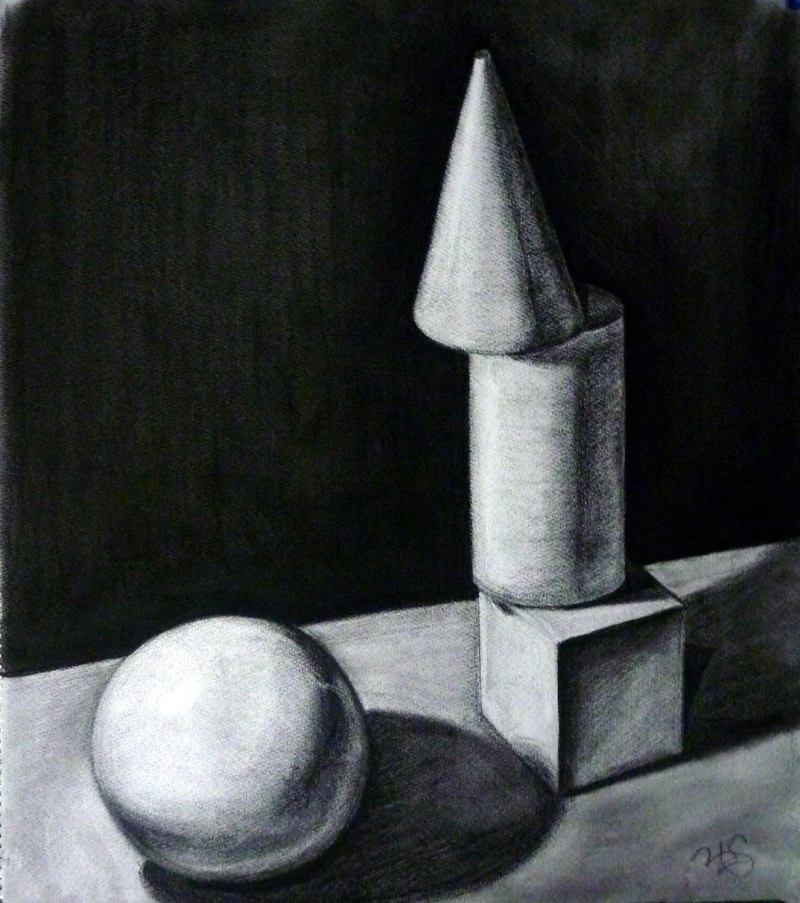

**GEOMETRIC PAINTING:**

(an imagined still life of shapes)

This is a still life that you will imagine using the 5 Basic Shapesincluded on the bottom of this page. These shapes can be used to simplify subjects found in nature, from simple objects like an apple (sphere) to complex subjects such as the human form (spheres, rectangular prisms, cylinders etc.). Learning to shade these will help you approach painting and drawing the world around you with more ease.

**REQUIREMENTS:**

1) Work on a paper or canvas 12” x 17” size or larger.

2) Fill the entire page.

3) Make a preliminary pencil sketch before starting.

4) You must include at least 4 geometric objects from the bottom of this page.

5) Make a dynamic original composition (using handout provided, your notes and/or your textbook).

6) Your shapes must be at least 5 inches wide on your paper.

7) At least 2 of these objects must be stacked on top of one another.

8) Include a horizon behind objects and a dark background.

9) Pick a single imagined light source and include cast shadows.

10) Use a full value range.

**MATERIALS:** You may choose to work in one of the following:

A) **Charcoal Drawing**

- Compressed charcoal - Solid & kneaded erasers

- Vine charcoal - Blending tool (tissues, fingers or blending stick)

B) **Monochromatic Painting**

- Choose **one** of the following Blue, Purple, Deep Green, or Deep Red.

- Shade your painting using a Mixed Black (Not straight black out of the tube).

- Make highlights using White.