**ART C111 50 - 2D DESIGN**

EXERCISE – GLASS PAINTING

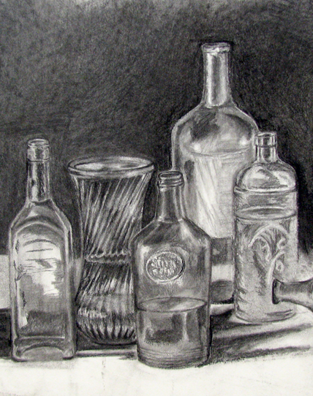

**GLASS PAINTING:**

(an all-glass still life)

Unlike most materials we regularly encounter, glass is translucent, meaning that it is partially or completely clear. Light does not pass through glass perfectly however, as light passes through glass it is bent, warping and distorting the images of the we see through it (spectacles, binoculars and microscopes use this same effect). In addition to this, bright objects can also show up as dim reflections on the surface of a glass object (this is why glass appears ‘shiney’).

You will draw or paint a still life of multiple glass objects that you will set up yourself, or that will be provided for you in class. When you draw or paint your glass still life, pay close attention to how the glass warps the images of things behind it, and pay attention to any reflections that you can see as well. You will be graded on detail and accuracy.

**REQUIREMENTS:**

1) Work on a paper or canvas 12” x 17” size or larger.

2) Fill the entire page.

3) Make a preliminary pencil sketch before starting.

4) Make a dynamic original composition (using handout provided, your notes and/or your textbook).

5) You must include at least 5 glass objects.

6) At least two of these things must be larger than 5 inches on your paper.

7) At least 2 of these objects must be in front of other objects.

8) Include a dark background behind objects.

9) you must include the cast shadows you observe.

10) Use a full value range.

**MATERIALS:** You may choose to work in one of the following:

A) **Charcoal Drawing**

- Compressed charcoal - Solid & kneaded erasers

- Vine charcoal - Blending tool (tissues, fingers or blending stick)

B) **Full Color Painting**

- Use any and all colors necessary, using as little black as possible (glass is made of color).

- When necessary, shade your colors using a Mixed Black.