**ART C111 50 - 2D DESIGN**

HANDOUT / ACTIVITY – LINEAR PERSPECTIVE

**STEP 01 - DRAW A HORIZON:**

Draw a horizontal line somewhere near the top of your paper.

**HORIZON:** 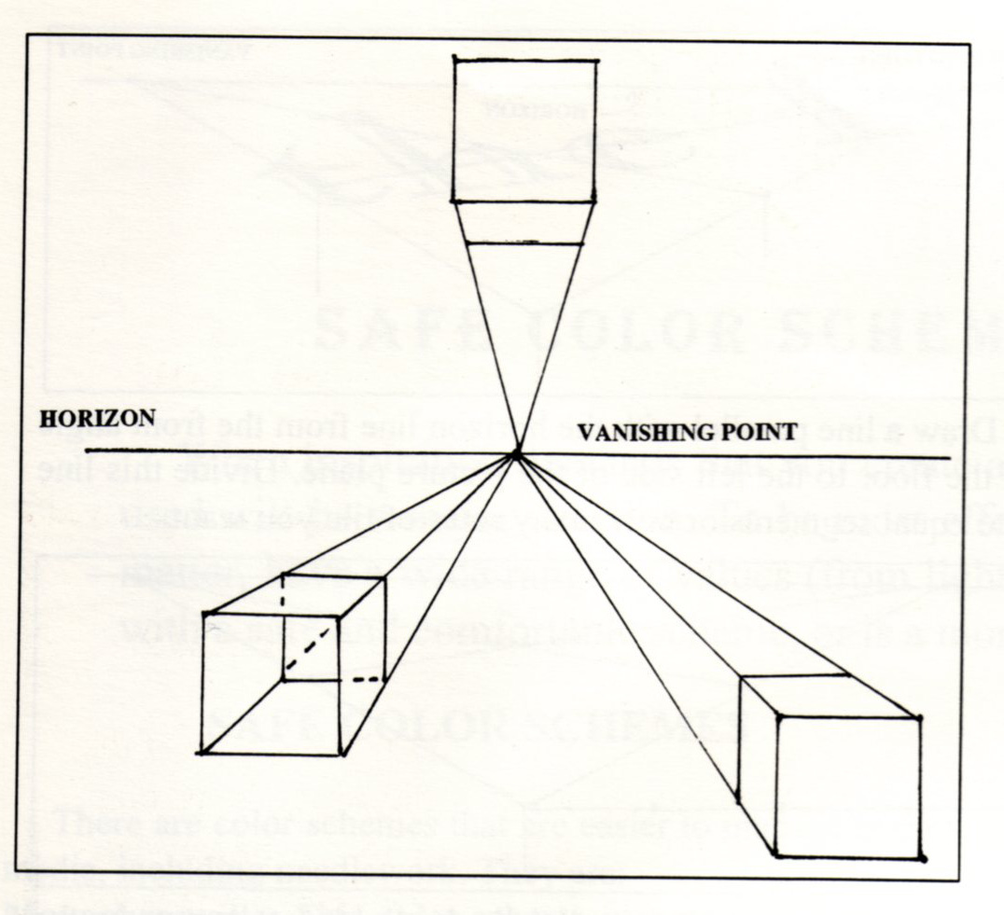

The horizon is the representation of where the earth meets the sky. You cannot always see it, for instance when you look up or down, but it always plays a critical role. Because the horizon represents the orientation of gravity, all objects in a scene are oriented in relation to the horizon. As objects move back in space, towards the horizon, they appear to be diminishing in size, eventually becoming too tiny to see or obscured by the curve of the earth. Note that if you look up or are very close to the ground the horizon moves lower in your feild of view, whereas if you look down or are very high up in the air the horizon appears to move up.

**VANISHING POINT:**

A vanishing point is a tool used by artists, not a *real thing* like a horizon. Vanishing points help us map out objects that contain straight lines or are placed in straight lines as they move back in space and diminish in size. Just like the horizon, vanishing points do not always have to appear on the paper, and in most natural situations they do not. An extremely orderly drawing of simple objects might require only one vanishing point. A drawing desperately trying to capture the hopeless complexity of real life might have hundreds.

**ONE POINT PERSPECTIVE:**

One point perspective is the use of a horizon and only one vanishing point that objects recede towards. As mentioned before, an extremely simple scene like the ones featured on this page can get away with only using one vanishing point because all the cubes (or houses) are oriented parallel to one another. Note that in one point perspective all horizontal lines are parallel to the horizon and all vertical lines are perpendicular to it. To make a one point perspective drawing use the following steps:

**EXERCIZE #1:** (1) Draw a horizon line as a *horizon*.

(2) Mark a point somewhere along this horizon line as your *vanishing point*.

(3) Lightly sketch cubes representing the general size and shape of objects you want to draw in your scene.

(4) Using a ruler make all the straight lines of the cubes either:

- parallel to the horizon

- perpendicular to the horizon

- radiating out from your vanishing point

(5) Now you can turn the cubes into real objects by adding details and erasing unnecessary lines.

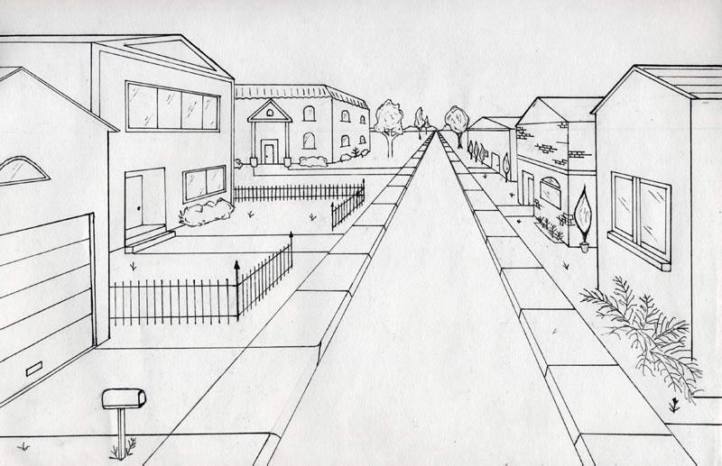

**EXAMPLE:**

Observe how most of the lines in this scene run parallel / perpendicular to the horizon or converge towards the vanishing point where the road disappears. The lines that do not conform to these are *detail lines*, these are lines that do not lie flat on the ground or stick up vertically from it.

**TWO POINT PERSPECTIVE:**

*Two point* perspective operates by the same basic mechanics as *one point* perspective, with the addition of another vanishing point. We need to do this when we start to rotate our basic cube forms. If we move these two vanishing points to the right or left we would observe the cubes they form *rotating* as they move. If we moved our vanishing points closer together we would see our perspective become more dramatic, if we move the vanishing points further apart, we would see the perspective normalize up to a point, and eventually break down when they were extremely far away from one another.

To make a drawing in two point perspective:

**EXERCIZE #2:** (1) Draw a horizon line.

(2) Mark 2 vanishing points somewhere along this horizon line, near the edges of your paper or even off of it.

(3) Lightly sketch cubes that represent the general size / shape of objects you want to draw in your scene.

(4) Using a ruler, make all the straight lines of the cubes either:

- perpendicular to the horizon

- radiating out from your vanishing point

(note that now we do not have lines that are parallel to the horizon)

(5) Now you can turn the cubes into real objects by adding details and erasing unnecessary lines.

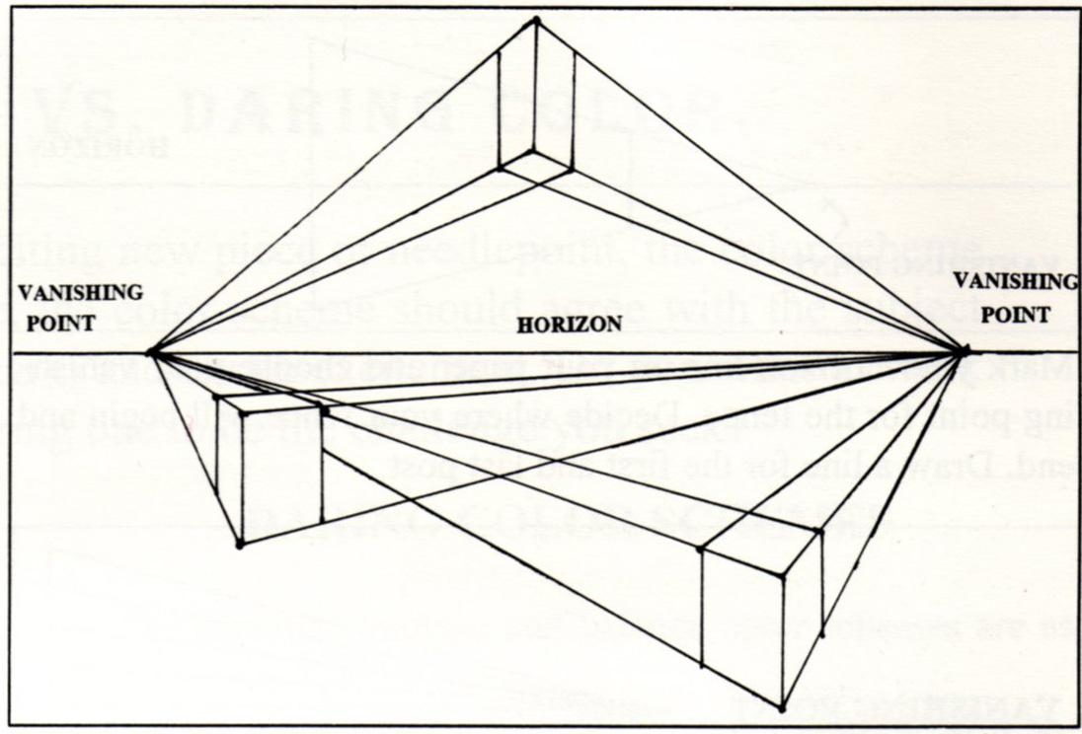

**NO HORIZONTAL LINES:**

Note that in two point perspective we do not have lines that are parallel to the horizon, although we still have directly vertical lines. The only time you will see a perfectly horizontal line in two point perspective is when something lines up directly with the horizon.

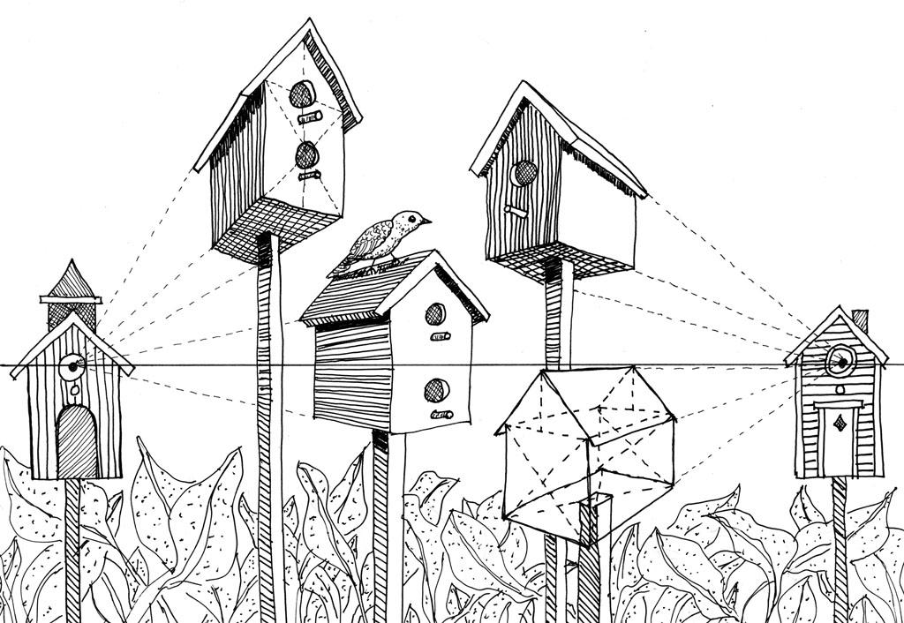

**EXAMPLE:** (LEFT) In this example notice that all the birdhouses are oriented on a parallel grid to one another. What would happen if one of the bird houses was rotated? You would need a whole new set of independent vanishing points. Also try to imagine the bird simplified into a small cube. Would it be in line with the established vanishing points?

**EXAMPLES:** 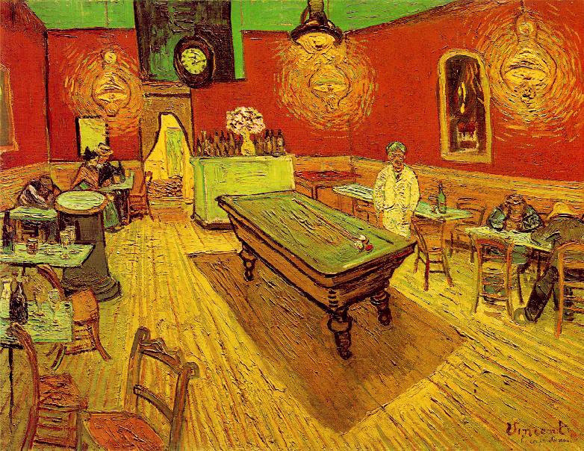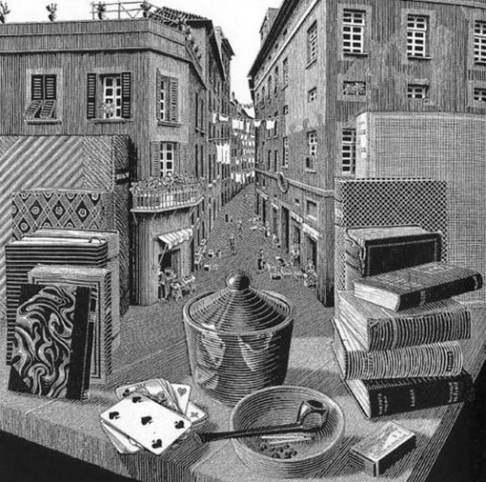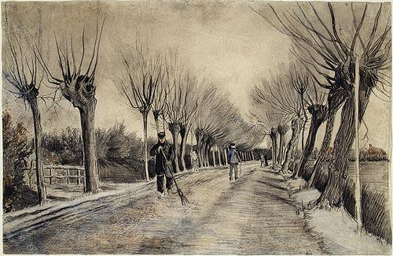

Artist’s usually dont map out their paintings and drawings using linear perspective before they start working, to do so would be unreasonably time consuming and would not result in a “perfect” looking painting. Instead Linear Perspective is used more as a tool to correct or adjust images that are drawn from reality. Observe the ways that these artists have employed different kinds of linear perspective and balanced these rules with observed details and imperfections to create a successful scene.

**ONE POINT PERSPECTIVE:** (RIGHT) In this Van Gogh drawing notice how the road gently curves off into space, and how the trees get smaller and closer together as they recede into space towards their single vanishing point.

**TWO POINT PERSPECTIVE:** (LEFT) In this Van Gogh painting pay attention to the pool table and the edges of the room. Imagine the locations of the two vanishing points and the horizon. One would vanishing point would be within the field of view near the top left. The other would be outside of the painting, off to the right.

**MULTI POINT PERSPECTIVE:** (RIGHT) In this M.C. Escher print pick one of the books and imagine where the two vanishing points for it would be. Now pick another book, would its vanishing points be in the same locations? The answer to this is no, this print shows how each object in reality has its own individual vanishing points and how complex a scene from reality can be. Escher is an example of an artist who usually did map out his images with linear perspective completely before making them. Imagine how long doing so would take to create this image.