**ART C111 50 - 2D DESIGN**

HANDOUT – KINDS OF PAINTINGS

**DIFFERENT KINDS OF PAINTINGS & DRAWINGS**

There are no rules to making art, but as people have made art over the centuries, certain *types* of paintings have evolved that artists seem to consistently use and that most art can be categorized into. These groups are not set in stone and often a painting will fit into two, three or all of these groups at the same time. Regardless of this they can be a helpful starting point for making and looking at art.

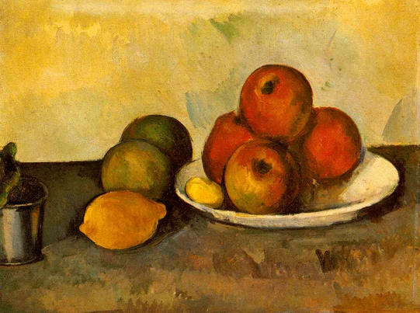

**STILL LIFE:**

Still life paintings are paintings of objects that don’t move. Usually they are objects that can fit on a table and very often are food-related items such as fruit, bottles or objects of beauty like flowers.

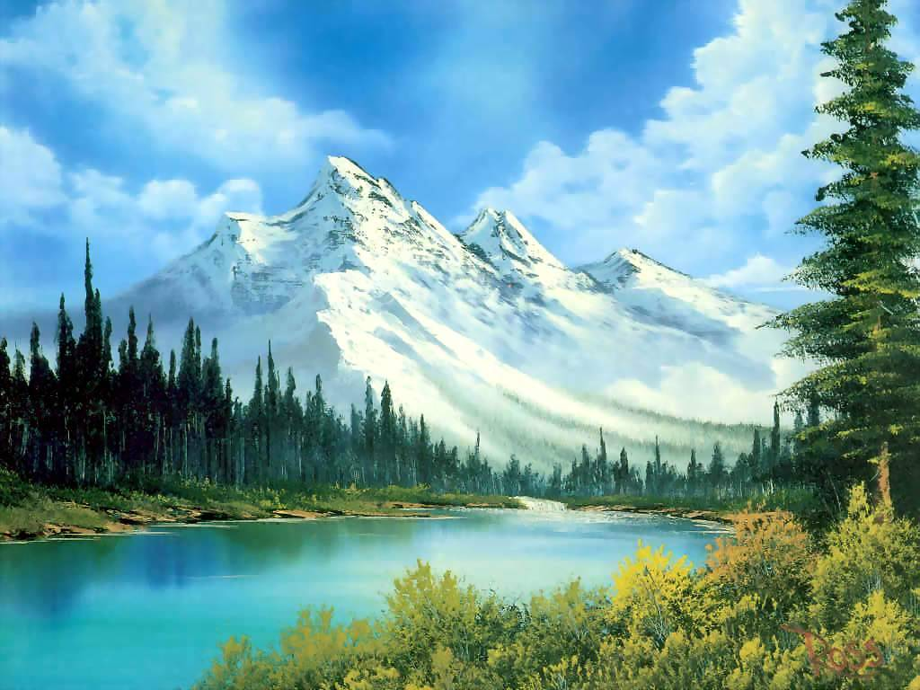

**LANDSCAPE:**

Landscapes are paintings (or drawings) of land. Most often they revolve around nature and will include the sky, mountains, bodies of water and/or trees. They also often include small people, animals or man-made structures such as buildings. 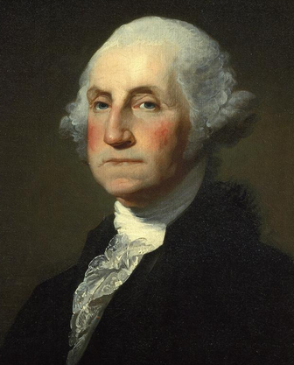

**PORTRAIT:**

Portraits are paintings (or drawings) of people. Bust portraits will generally only include the head and the shoulders, while full-figure portraits might include the entire body and/or multiple figures. Often elements of landscape or still life will be used in a portrait, but the person or people will always remain the clear center of attention.

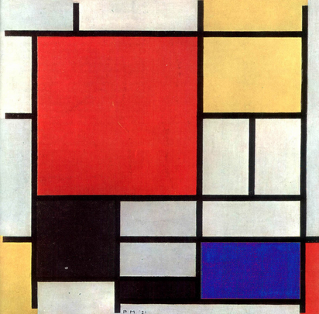

**ABSTRACT:**

Abstract works of art are paintings (or drawings) of shapes and colors. Although they don’t look like people, places or things they can often represent emotions or ideas that would be hard to paint directly or even to express in words. Abstract is the oldest and most mysterious kind of art, and it is often made by very confused or unhappy people.