**ART C111 50 - 2D DESIGN**

MIDTERM PROJECT - Painting Analysis

Due Date: Monday, **3/17/14**

- All of these steps should be followed in order.

- You will work on these steps in class and at home.

- You will be making an acrylic copy of your

painting (Step #08) a minimum of 20” x 20” (inches).

- All writing portions must be handwritten and printed in a

legible normal size. Projects that cannot be read will not pass.

- Grading This project will count towards your In-Class,

Homework, and Participation grades. Totalled this

project will be worth 30% of your grade.

**STEP #01 - FIND A PAINTING:**

Find a painting that you either love or hate in one of the books in the CCCC Library. Your cosen artwork must a painting and it must be found in one of the fine art books available in the library. The image of the painting must be a minimum of 6 inches on its largest side, smaller images cannot be used. Keep in mind you will be making a rough painted copy of this work.

**STEP #02 - COPY:**

Using the library photocopier make one normal black and white photocopy of the painting and one copy with the brightness turned up and the contrast turned down. Write down the Artist’s name, the name of the painting, the size, the material and the date.

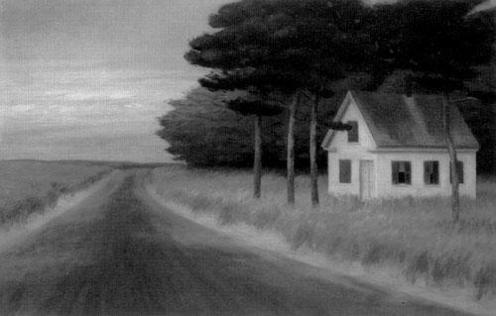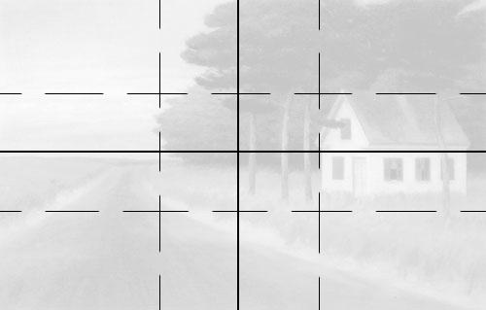

*Solitude*, 30” x 50”, Oil on Canvas, 1944

by Ed Hopper

**STEP #03 - ARTIST’S BIOGRAPHY:**

On a new page handwrite a 150 word synopsis of the artists life including:

- birth and death dates

- where the artist grew up, worked and lived

- major events during life

- what did the artist normally paint

- how did the artist paint

To find this information you may use books from the library and wikipedia, no other websites.

**STEP #04 - HISTORICAL CONTEXT:**

On a new page handwrite a 100 word synopsis of historical events and trends

that may have affected the artist including:

- wars

- economic events/trends

- social & political movements

- artistic movements

- inventions or innovations

To find this information you may use books from the library and wikipedia, no other websites.

**STEP #05 - GRID & SHAPES:**

Using your second lighter photocopy of the painting and a ruler, measure out and draw a grid showing the horizontal and vertical half-way-lines (solid pencil lines) and the horizontal and vertical thirds-lines (dotted pencil lines)

After this is done use a pencil to outline the major elements of the painting, simplifying them into lines, circles, triangles and squares. Once you feel you have the major elements of the painting simplified, pick the most important three or five of them and go over these shapes in black felt-tip marker.

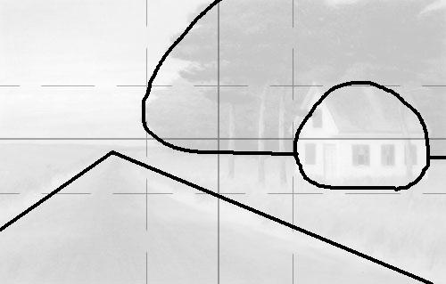

**STEP #06 - SUBJECT & FOCAL POINTS:**

On a new page handwritea 50 word synopsis of the main subject of the painting and the major elements that you outlined in step #05.

**STEP #07 - COMPOSITION BREAKDOWN:**

On a new page handwritea 125 word synopsis of the artist’s important uses of composition. These should be obvious from the gridded and outlined photocopy from step #05. You should include how and where the painting used or did not use:

- balance

- proportion

- repetition

- contrast

- harmony

- unity

- point of emphasis

- visual movement

(these elements are reviewed in a separate handout and/or in your textbook)

**STEP #07 - USE OF LINE, COLOR, VALUE,**

**TEXTURE AND SPATIAL ILLUSION:**

On a new page handwritea sentence for each of the following, describing how the artist used or didn’t use these elements in your chosen painting:

-Line

-Color

-Value

-Texture

-Spatial Illusion

(these elements are reviewed in a separate handout and/or in your textbook)

**STEP #07 - POSSIBLE MEANING:**

On a new page handwritea 150 word personal interpretation of your chosen painting. Based on what you have learned about the artist, the time in which they lived, the break down and use of the formal elements write about what you think the artist may have been trying to do (consciously or subconsciously) with this painting. What did he/she want us to think about, what was he/she trying to say, was the painting successful in all this and how does this painting reflect the artist?

**STEP #08 - PAINTED COPY:**

As mentioned you will be asked to make a hand painted acrylic copy of your chosen painting a minimum of 20” x 20” (inches).

**STEP #09 - PRESENTATION:**

You will hand in a stapled packet of all the materials asked for in the above steps along with your painted copy of your chosen painting on Monday 3/17/14. During class on Monday and the following Wednesday you will be asked to give a short presentation to the class outlining your analysis afterwhich a brief class discussion will occur.