**ART C111 50 - 2D DESIGN**

MIDTERM PROJECT SAMPLE

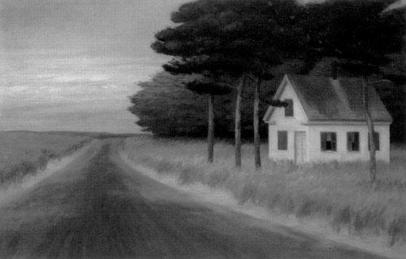

*Solitude*, 30” x 50”, Oil on Canvas, 1944 (by Ed Hopper)

**ARTIST BIOGRAPHY:**

Edward Hopper born in July 22, 1882, was a prominent [American](http://en.wikipedia.org/wiki/United_States) realist [painter](http://en.wikipedia.org/wiki/Painting) and [printmaker](http://en.wikipedia.org/wiki/Printmaker). He grew up in a well-to-do upper-middle class home and began making art at an early age. Not being able to live off of his work he was an illustrator and struggled to find his own style until his 40’s when he had a breakthrough and began painting in the way we remember him for today. While he was most popularly known for his oil paintings, he was equally proficient as a watercolorist and [printmaker](http://en.wikipedia.org/wiki/Printmaker) in [etching](http://en.wikipedia.org/wiki/Etching). He would take months at a time simply to compose a painting, sketching out slight alterations of the same basic scene again and again until it felt right. When he did make up his mind his paintings were produced relatively quickly as he was not a strict realist and was more concerned with color and placement of objects. Both in his urban and rural scenes, his spare and finely calculated renderings reflected his personal vision of modern American life, although what exactly that vision was is not easy to understand. His paintings generally deal with people in natural and urban landscapes, most often these figures are found at moments of stillness and reflection, staring off into space in contemplation. He died in 1967 at the age of 85.

**HISTORICAL CONTEXT:**

Hopper was born into an America that was still recovering from the Civil War, which ended in 1865. This was a time of rapid social and political progress, which was reflected in the work of many artists. Because of the military success of Northern culture, New York and other industrial cities experienced a long economic boom and took on a more dominant cultural role than ever before, the effect of these social and economic forces still shapes the landscape of American culture. Hopper would also live through World War I, World War II and the beginning of the Vietnam War, although he was too old to serve in any of these. Hopper would also live through the Great Depression in the 1930’s and 1940’s, and would witness America’s triumphant recovery, although because of his inherited economic status and artistic success he would not have felt the effects of this directly.

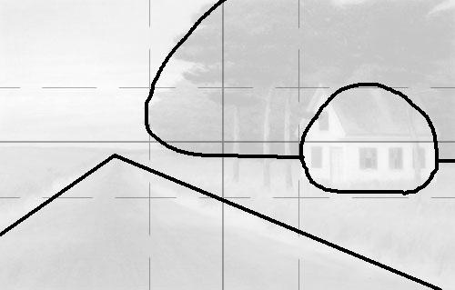

**SUBJECT & FOCAL POINTS:**

The subject of this painting is simple enough, it is an isolated house at the edge of a forest next to a long empty country road that leads off into a flat empty landscape with cold brooding clouds far in the distance. The focal points of this piece (outlined above in black) are without a doubt the house, the road, the forest and the sky.

**COMPOSITION BREAKDOWN:**

Drawn over the painting are lines marking the vertical and horizontal halves (grey lines) and thirds (dotted lines). On top of these are the basic geometric shapes the mark the main elements of the image (black lines). As we can see the sizes, shapes and placement of these main elements are composed into an off-balance composition. The house, which is the focal point of the painting is conspicuously located in the right-center third, while the dark forest takes up a majority of the upper-right quadrant, spilling over into the center vertical third. The road starts almost precisely in the bottom right hand corner of the painting and vanishes half way up the painting and at the left vertical quarter. The horizon, most obviously of all is lined up almost exactly on the horizontal midpoint of the painting.

**USE OF LINE, COLOR, VALUE,**

**TEXTURE AND SPATIAL ILLUSION:**

**LINE:** Hopper did not make use of any kind of outline in this piece, but the vertical lines of the trees, the horizon, and the lines defined by the geometry of the house play a crucial role in the success of this composition.

**COLOR:** The most important colors in this painting seem to be those of the sky and the forest. The sky is not a perfect blue, as it might be in many of his other works, nor is it charmingly speckled with peerfect white clouds. Rather, it is almost a solid mixture of grey, purple and blue, representing an overcast cloud bank that has a distinct foreboding mood. The trees play much the same role, they are a very dark mixture of green, blue and black whose darkness implies a deep mysterious and untamed forest looming behind the focal point of the house.

**VALUE:** The most important moment of dramatic value use is the darkness of the forest and the sky. As mentioned the dark space of the woods is looming and implies an infinite mysterious space. The darkness of the sky is not as dramatic, but it tells us a great deal about the weather, the temperature and the time of day, which seems to imply a cold still evening.

**TEXTURE:**  The textures in this painting seem to be similar to those we might find in reality, but importantly they seem to be softened and simplified. This feeds into the simplicity of the subject matter. This simplicity is found in many of Hopper’s paintings and is in part a result of his loose impressionistic painting style.

**SPATIAL ILLUSION:**  This piece makes very obvious use of classic spatial illusion with the road, which uses linear perspective to imply a great flat distance. The road starts at the bottom of the painting taking up its entire width, as we follow it up it rapidly shrinks into the distance towards the vanishing point on the horizon.

**PERSONAL INTERPRETATION:**

This painting (*Solitude*, 30” x 50”, Oil on Canvas, 1944) was made as WWII was coming to a close. Based on this and Hopper’s other works I believe this piece was expressing a kind of quiet celebration in the form of an idyllic landscape, completely safe and separated from the complex turmoil of the rest of the world. Most of hoppers work feature human beings, or at least more architecturally complex buildings, so simplicity must have been an intentional goal here either consciously or subconsciously. The road, going off into an infinite beautiful void might symbolize the progress oriented culture that Hopper had beared witness to throughout his life, the world that post-war America would undoubtedly be moving back towards. Because the house is so obviously isolated, this image may also in some sense represent Hopper’s economic and social removal from the culture around him. As was mentioned, he did not serve in WWI or WWII and he would not have been subject to the mal-effects of the Great Depression. In any case this painting captures a moody serenity and an isolated contemplative beauty expressed through inanimate objects.