**ART C111 50 - 2D DESIGN**

EXERCISE – STRANGE PAINTING

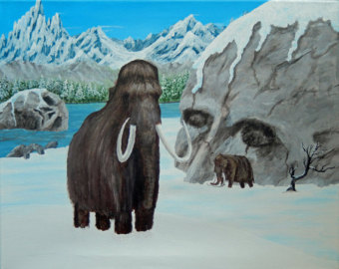

**STRANGE PAINTING:**

(an imagined landscape)

Close your eyes for 10_full_minutes and imagine a scene from 3,000,000 years in the past or 3,000,000 years in the future. Focus on what the landscape looks like, what color the sky is, what time of day is it, what kinds of plants or animals are around, what objects are there that you don’t understand? When you open your eyes write_5-10_sentences describing what you imagined. You will sketch out and then fully draw or paint this scene, turning your written portion in when you are done.

(note: there should be cast shadows in this painting)

**REQUIREMENTS:**

1) Work on a paper or canvas 12” x 17” size or larger.

2) Fill the entire page.

3) Make a preliminary pencil sketch before starting.

4) Make a dynamic original composition (using handout provided, your notes and/or your textbook).

5) You must include at least 5 objects or living things.

6) At least two of these things must be larger than 6 inches on your paper.

7) At least 2 of these objects must be interacting in some way.

8) Include a landscape behind objects.

9) Pick an imagined light source and include cast shadows.

10) Use a full value range.

**MATERIALS:** You may choose to work in one of the following:

A) **Charcoal Drawing**

- Compressed charcoal - Solid & kneaded erasers

- Vine charcoal - Blending tool (tissues, fingers or blending stick)

B) **Full Color Painting**

- Use any and all colors necessary.

- Shade your colors using a Mixed Black (Not straight black out of the tube).