**ART B1 - CRN: 50100 - ART APPRECIATION**

MIDTERM – Essay Questions

Instructions: Answer each prompt on a separate sheet of paper as fully as possible. Use information from your reading and from lectures to answer questions, the more specific information you include the higher your grade will be. When appropriate you are encouraged to reference other artists and art works seen in class and in your text. If you are picking between two prompts in response to an image extra credit will not be given for answering both prompts, please pick one only.

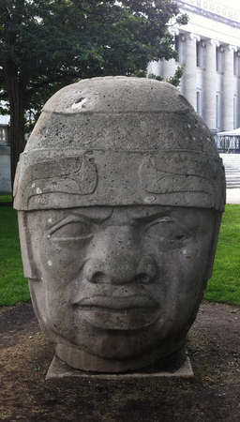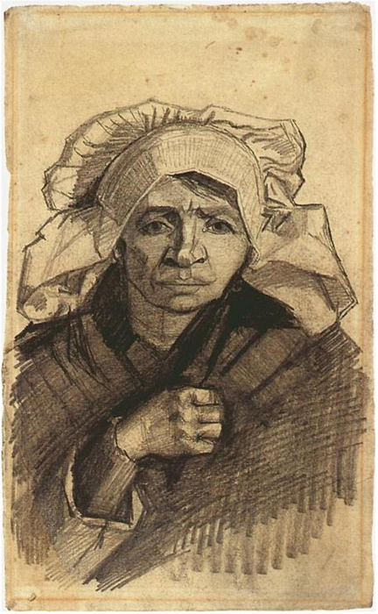

|  |  |
| --- | --- |
| 1 ) What kind of work of art do you think this is and why? What material do you think it is made of and why? When do you think it might have been made and why? Who do you think made it and why do you think they made it? | 2 ) What kind of work of art do you think this is and why? What material do you think it is made of and why? When do you think it might have been made and why? Who do you think made it and why do you think they made it? |

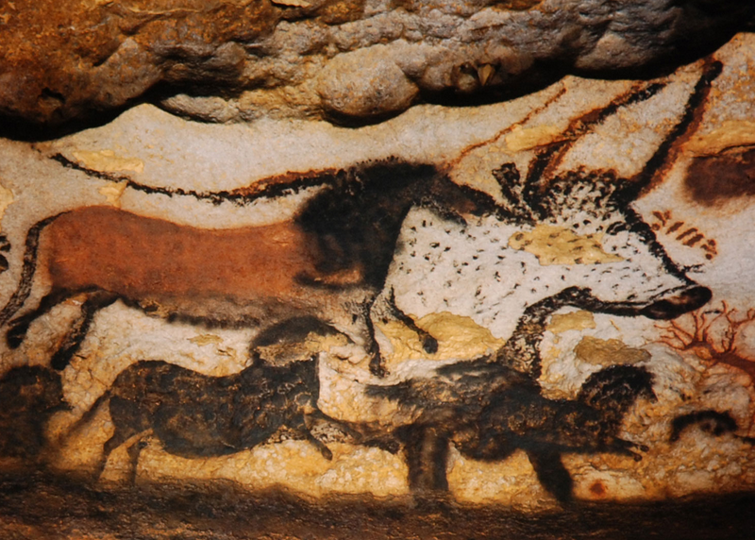

On a separate sheet of paper, answer one of the essay prompts

below in 8-15 sentences for the above image:

|  |  |
| --- | --- |
| 3A) How are different kinds of LINE and VALUE used in this image? What are different kinds of line and value? How does the use of these change or stay the same in different parts of this image? How does the use of these help us know what we’re looking at and what does it tell us about how these images were made? Include definitions of line and value in your answer. | 3B) Based on what you know about materials, what do you think this image was made on and what do you think it was made with? What specifically in this image tells you this? What are the basic tools that an artist needs to make any painted image? How might the tools and materials used by this artist differ from those used by an artist making a similar image today? |

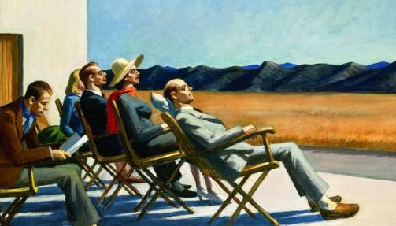

On a separate sheet of paper, answer one of the essay prompts

below in 8-15 sentences for the above image:

|  |  |
| --- | --- |
| 4A) Describe the formal qualities of this image as though the person reading your answer had never seen the image. Use the descriptive tools discussed in class and in your textbook. If you recognize an object (a person, car etc.) explain what in the image is telling you this. | 4B) Describe the basic content AND the metaphorical content you see in this image. Use the descriptive tools discussed in class and in your textbook. Be sure to fully explain WHY you are interpreting the image the way you are. In your answer include a brief definition of metaphor. |