**ART C111 50 - 2D DESIGN**

Handout - Brushes & Paint

**WHAT IS A BRUSH:**

Brushes are the time-tested, most effective, reliable and least expensive method of applying paint to a surface with accuracy and control. The first brushes were animal hair or vegetable fibres bound to one end of a stick, contemporary brushes are essentially the same, but are made with higher qualities of animal hair (or plastic imitation) and are made in regulated shapes and sizes for the varying needs of painters.

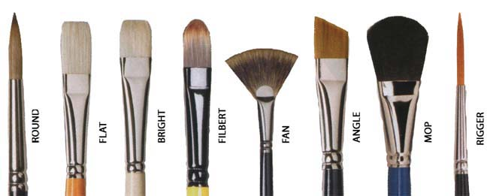

***Brush Shapes:*** Each of the brush shapes above make different shapes when used for painting, the *round* is generally used for making fine marks or thin linesThe *flat, bright,* and *filbert* brushes are essentially used to make paint marks similar to their apparent shapes, the longer the brush the more paint it can hold at one time, the shorter the brush the more control it allows for. The *fan* brush is used for making messy natural forms like clouds, trees and grass. It allows for little control and does not hold very much paint. The mop brush is generally used to blur paint that has already been applied to a surface, it is not usually appropriate to load this bush with paint. The *rigger* is used for making extremely thin graphic lines and is a rare brush for a painter to use regularly.

***Brush Sizes:***

**USING A BRUSH:**

***Loading / Unloading a Brush:***

***Brush Angle:***

***Multiple Brushes:***Brushes for different colors. Wiping off brushes regularly.

***Cleaning a Brush:*** Wiping a brush off on a rag regularly. Fully cleaning a brush before paint dries. Brush conditioner.

**WHAT IS PAINT:**

***Ingredients:***

***Tubes of Paint:*** Sizes, qualities, prices

***Types of Paint:***

***Opaque: Transparent:***

***Mediums:*** All different, some for drying, some extend wet time, some have fumes, some dont

**USING PAINT:**

***Mixing on Palette:***

***Masstone vs. Undertone***

***Good vs. Bad Mixtures:***

***Mixed vs. Tube Colors:*** Sometimes it is difficult or impossible to mix a particular color, a color straight from a tube will almost always have a higher saturation than a color that you mix yourself. The benefit of mixing your own colors becomes apparent in their *undertone.* In this state the mixture starts to break down and the complexity of the invisible mixture adds to the richness of a painting.