**COMPARATIVE ANALYSIS**

Class:__________________________

Due Date:_______________________

**Assignment:** Make a visual & written comparison of two works of historical art from different periods covered thus far in class.

**Requirements:**

1. Must include high-resolution print outs (black & white or color) of your chosen works of art, minimum size 8.5x11” each.
2. Must include a minimum of 10 typed or neatly handwritten points of comparison, minimum 3-5 sentences each.
3. You must use at least 10 of the vocabulary words covered in class properly, under-lining these vocabulary words.
4. You must adhere your images and written points of comparison to a rigid surface (i.e. cardboard, foamcore).
5. Assignments that are visually appealing will receive higher grades.
6. For each Point of Comparison:

A) First say whether they are the same or different.

B) Then explain how they are the same or different.

C) Then explain why they are the same or different.

Example: Form: (1) The forms used in these two sculptures are quite different. (2) The greek statue uses exaggerated geometric forms like triangles and rectangles while the Egyptian sculpture is more rounded and naturalistic. (3) We see this difference because one sculpture was produced during the Geometric period in Greece while the other was produced under the traditional Egyptian canon or style.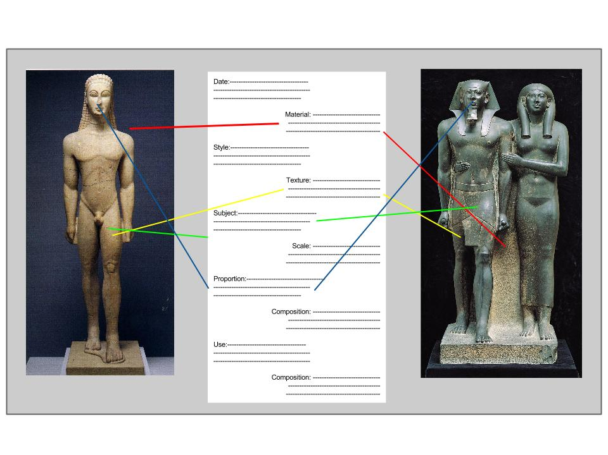

**Example:**

(yours must be larger than this)

**Points of Comparison (examples):**

1) Date 2) Material 3) Style 4) Composition 5) Texture 6) Subject 7) Scale 8) Proportion

**Vocabulary Words:**

1) Form 2) Subject 3) Composition 4) Material 5) Technique 6) Color 7) Texture 8) Scale 9) Proportion 10) Function